Supplementary Information
For
A Refined Perspective on Indian Ocean Dipole–Driven Surface Salinity Changes and the Salinity Dipole Index

Kokulathasan Thilaksanth¹, Gayan Pathirana^{1*}, Kyung-Min Noh², Aoyun Xue³, Dongxiao Wang^{4*}, and Zheng Meng⁴
¹Department of Oceanography and Marine Geology, Faculty of Fisheries and Marine Sciences & Technology, University of Ruhuna, Matara, Sri Lanka.
²Princeton University/Atmospheric and Oceanic Sciences Program, Princeton, New Jersey.
³ Bren School of Environmental Science and Management, University of California, Santa Barbara.
⁴School of Marine Sciences, Sun Yat-sen University: Southern Marine Science and Engineering Guangdong Laboratory, Zhuhai, China.

*Corresponding author
Email: upgpathirana@fish.ruh.ac.lk
Dr Gayan Pathirana, Department of Oceanography and Marine Geology, Faculty of Fisheries and Marine Sciences & Technology, University of Ruhuna, Matara, Sri Lanka.
Email: dxwang@mail.sysu.edu.cn
Professor Dongxiao Wang, School of Marine Sciences, Sun Yat-sen University: Southern Marine Science and Engineering Guangdong Laboratory, Zhuhai, China.

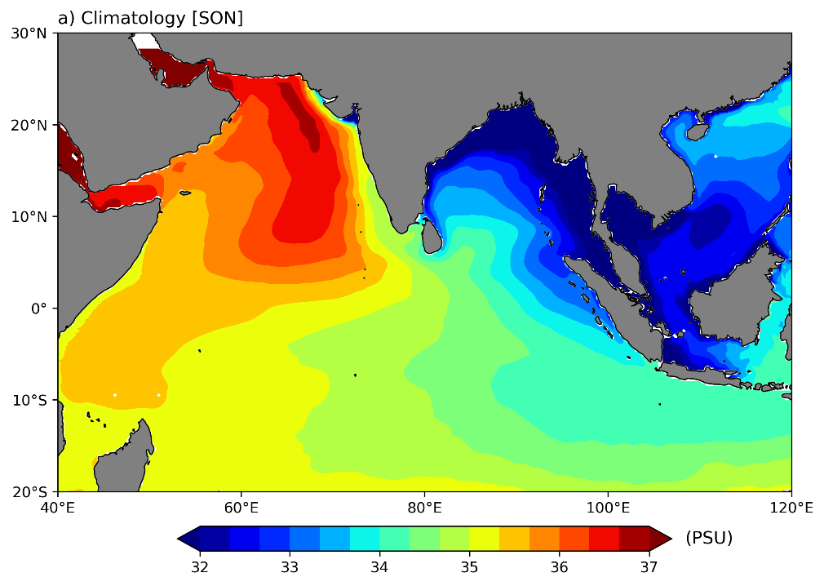

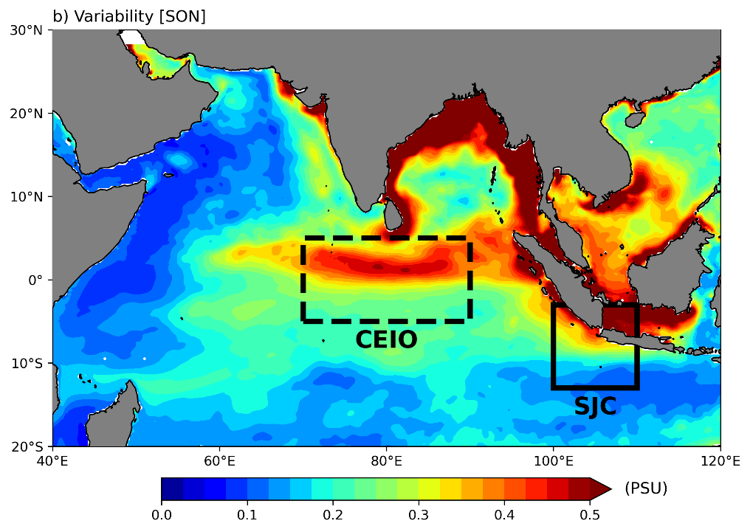

Fig. S1 Sea Surface Salinity (a) mean state and (b) interannual variability during 1993–2023. The selected period is September to November (SON). In (b), the black dashed and solid squares indicate the CEIO and SJC regions, respectively.

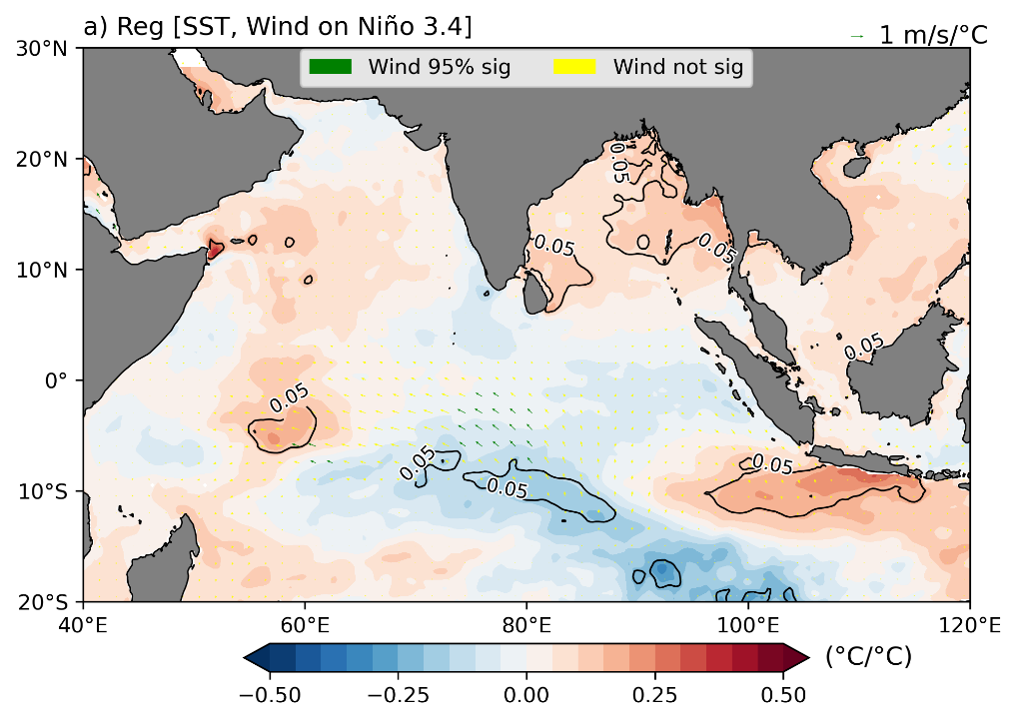

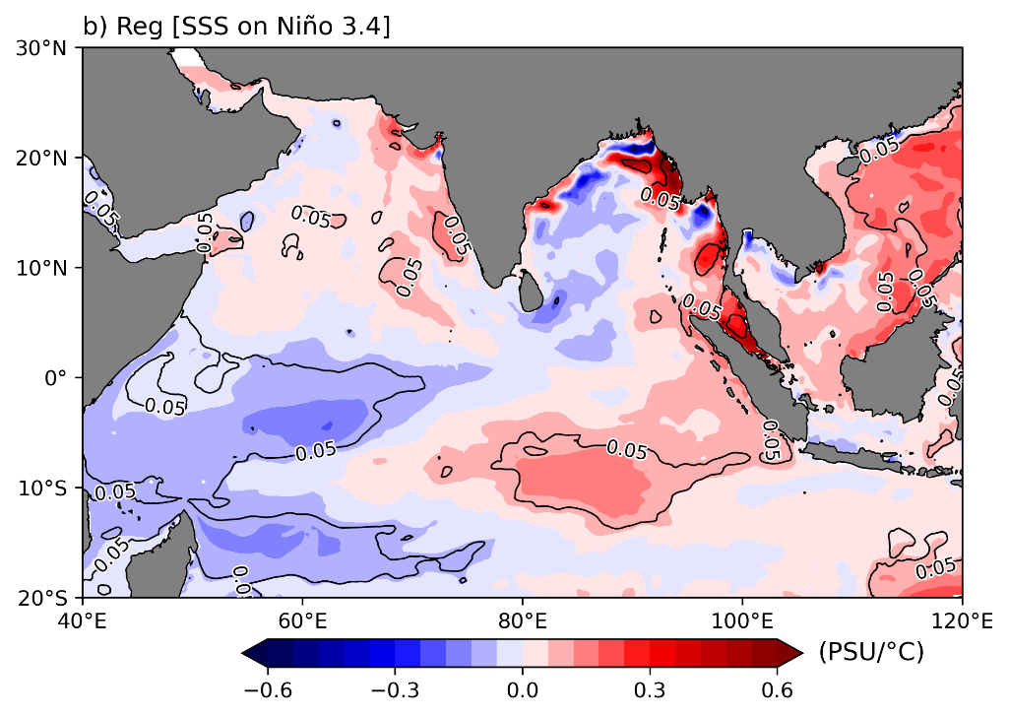

Fig. S2 Sea Surface Salinity (a) regression on Niño 3.4, b) regression on Niño 3.4. The chosen time is DJF and observations from 1993-2023. Significant regions at the 95% confidence interval are marked by contours.

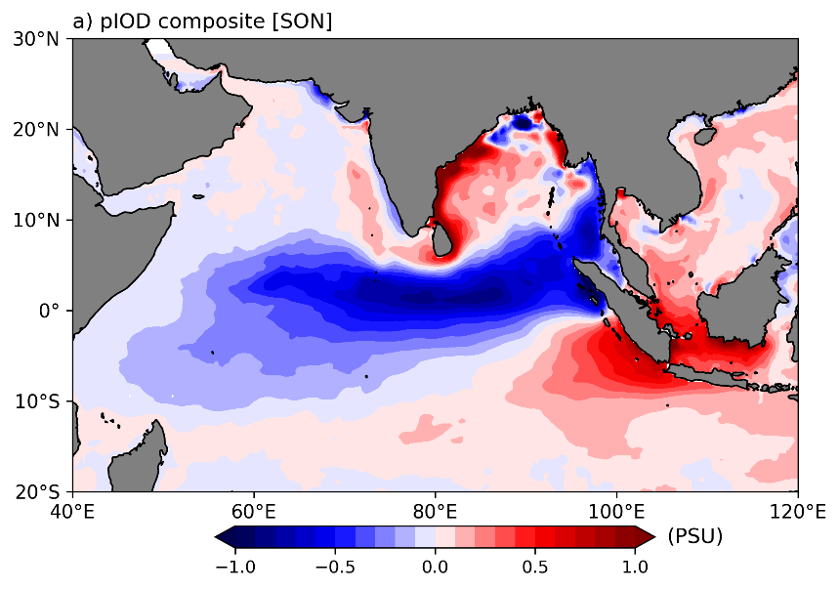
Fig. S3 Composites of SSSA, s for (a) positive IOD events (pIOD), (b) negative IOD events (nIOD), and (c) composite residual (pIOD+nIOD) for observations from 1993-2023. The chosen period is September to November. The black dots indicate statistically significant regions with a 95% confidence level. (c) significant difference between pIOD and nIOD.

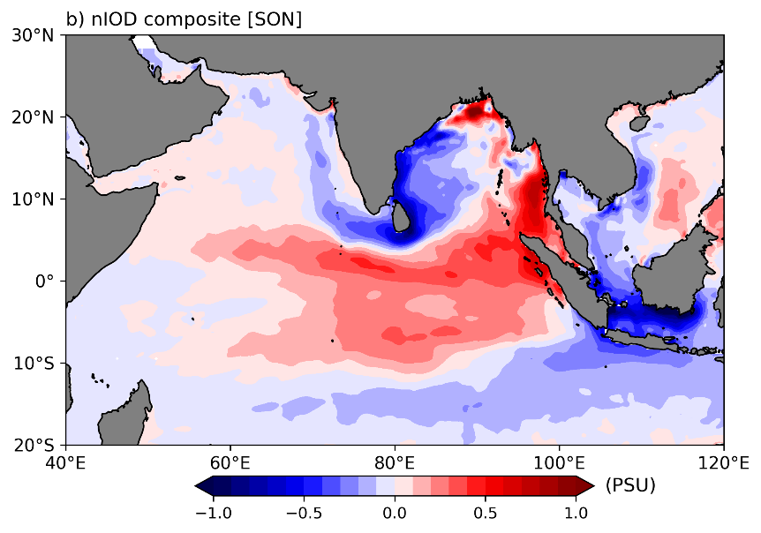
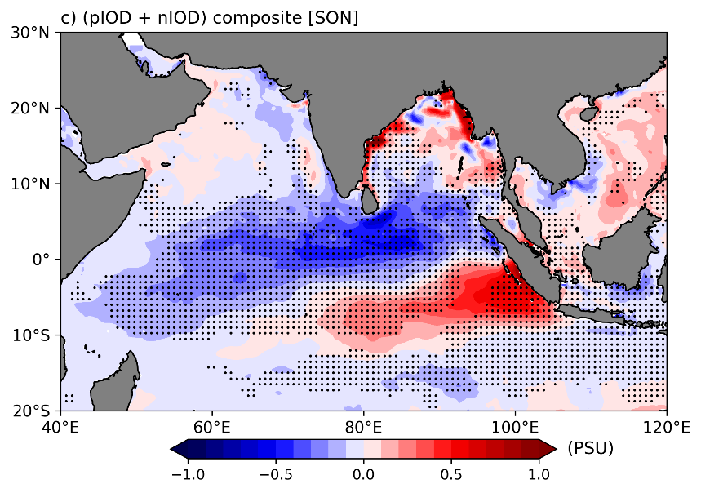

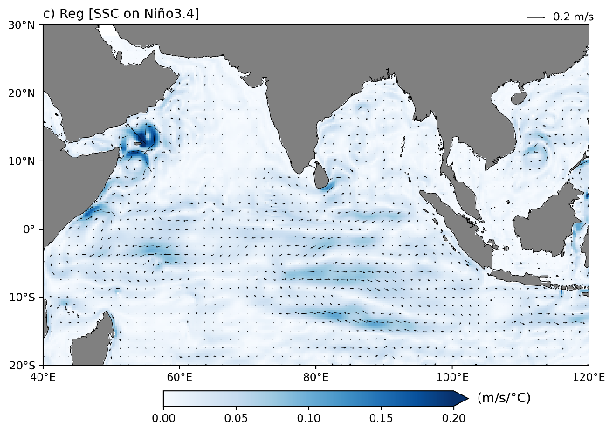
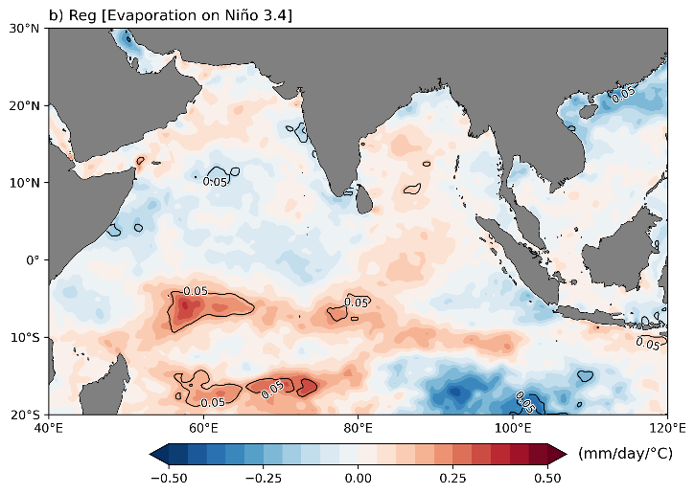
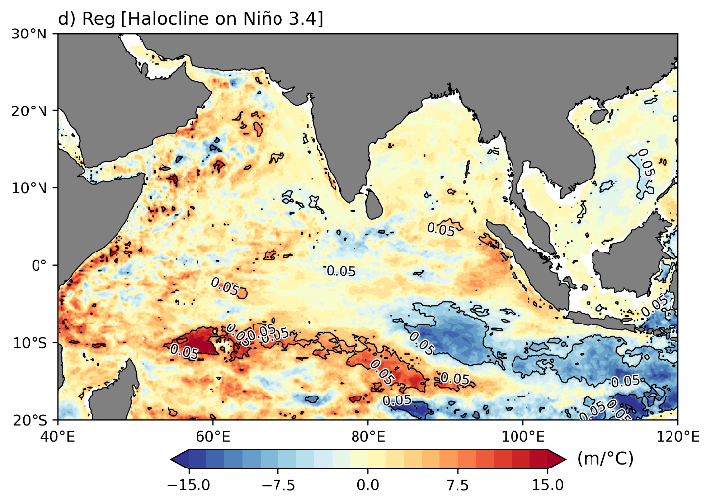
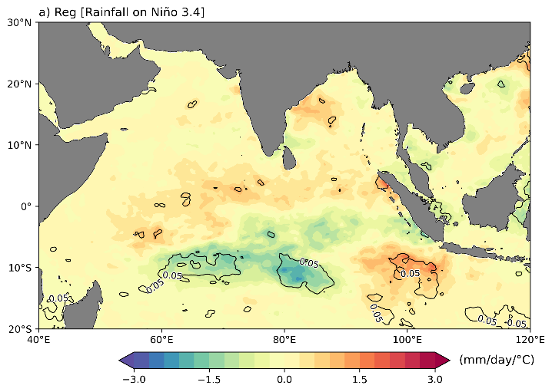
Fig. S4 (a) Regressed Rainfall on Niño 3.4, (b) Regressed Evaporation on Niño 3.4, (c) Regressed Sea Surface Current on Niño 3.4, and (d) Regressed Halocline on Niño 3.4, for observations from 1993-2023. The chosen period is September to November. Significant regions at the 95% confidence interval are marked by contours.

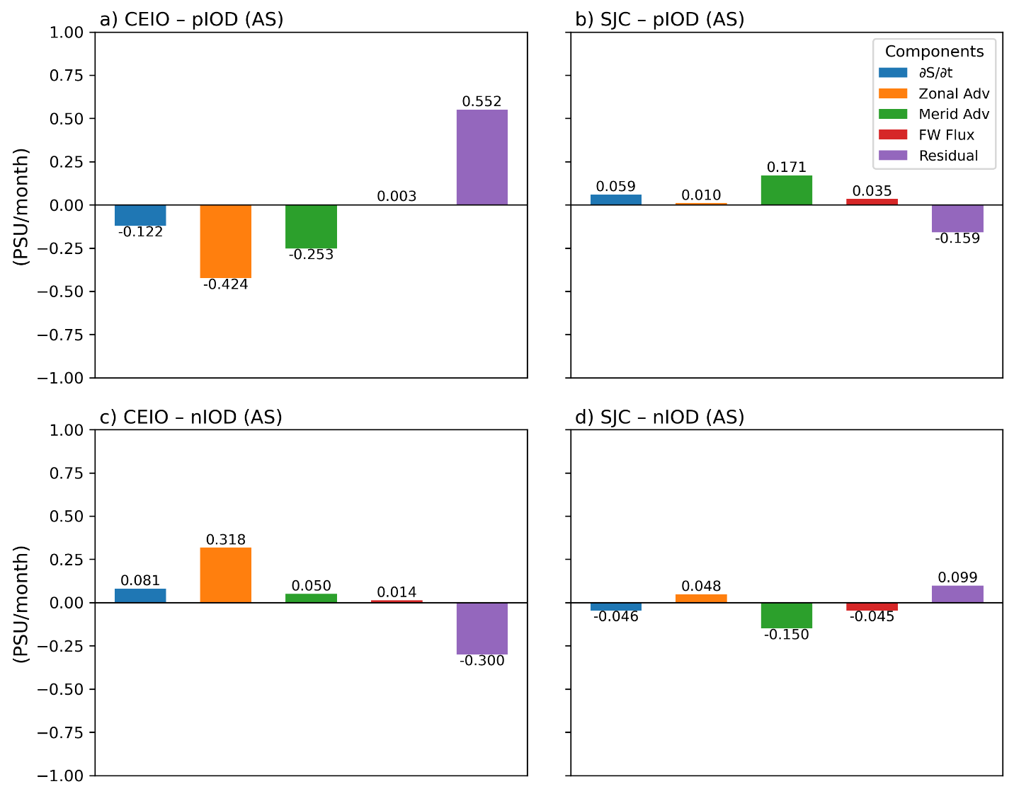
Fig. S5 Composited salinity budget components averaged over August–September during IOD events. (a,b) are the salinity budget components averaged CEIO and SJC regions for pIOD events, respectively. (c,d) Same as (a,b) for nIOD.

Positive IOD Years | Negative IOD Years
1994 | 1996
1997 | 1998
2006 | 2005
2015 | 2010
2019 | 2016
2023 | 2022
Table S1 List of positive (pIOD) and negative (nIOD) IOD years identified from the normalized DMI index during SON (1993–2023).

Model | Group
ACCESS-ESM1-5 | Commonwealth Scientific and Industrial Research Organization (CSIRO), Australia
CanESM5 | Canadian Centre for Climate Modelling and Analysis, Canada
CESM2 | NSF, Department of Energy, and National Center for Atmospheric Research (NCAR), USA
CESM2-WACCM | NSF, Department of Energy, and National Center for Atmospheric Research (NCAR), USA
CNRM-ESM2-1 | Centre National de Recherches Météorologiques – Centre Européen de Recherche et de Formation Avancée en Calcul Scientifique, France
GFDL-ESM4 | Geophysical Fluid Dynamics Laboratory, USA
IPSL-CM6A-LR | Institut Pierre Simon Laplace, France
MIROC-ES2L | Japan Agency for Marine–Earth Science and Technology; Atmosphere and Ocean Research Institute, The University of Tokyo; National Institute for Environmental Studies; and RIKEN Center for Computational Science, Japan
MPI-ESM1-2-HR | Max Planck Institute for Meteorology, Germany
MPI-ESM1-2-LR | Max Planck Institute for Meteorology, Germany
NorESM2-LM | Norwegian Climate Centre, Norway
NorESM2-MM | Norwegian Climate Centre, Norway
UKESM1-0-LL | Met Office Hadley Centre/UK
Table S2. CMIP6 model information. Source: Pathirana et al., 2024; Table S1.

Supplementary Table 3: Overview of Data Products, Time Period, Resolution, and Download Links.

Data | Period | Spatial resolution | Downloadable link
Sea surface salinity | 1993 - 2023 | 0.25° × 0.25° | https://data.marine.copernicus.eu/product/GLOBAL_MULTIYEAR_PHY_ENS_001_031/services
Sea surface temperature | 1993 – 2023 | 0.25° × 0.25° | https://data.marine.copernicus.eu/product/GLOBAL_MULTIYEAR_PHY_ENS_001_031/services
Wind | 1993 – 2023 | 0.25° × 0.25° | https://cds.climate.copernicus.eu/datasets/reanalysis-era5-single-levels-monthly-means?tab=overview
Precipitation | 1993 – 2023 | 0.25° × 0.25° | https://cds.climate.copernicus.eu/datasets/reanalysis-era5-single-levels-monthly-means?tab=overview
Evaporation | 1993 – 2023 | 0.25° × 0.25° | https://cds.climate.copernicus.eu/datasets/reanalysis-era5-single-levels-monthly-means?tab=overview
Sea surface current | 1993 – 2023 | 0.25° × 0.25° | https://data.marine.copernicus.eu/product/GLOBAL_MULTIYEAR_PHY_ENS_001_031/services
Subsurface temperature | 1993 – 2023 | 0.25° × 0.25° | https://data.marine.copernicus.eu/product/GLOBAL_MULTIYEAR_PHY_ENS_001_031/services
Subsurface Salinity | 1993 – 2023 | 0.25° × 0.25° | https://data.marine.copernicus.eu/product/GLOBAL_MULTIYEAR_PHY_ENS_001_031/services
CMIP6 Historical Simulations (SSS, DMI, and Niño 3.4) | 1850 – 2014 | 1° × 1° | https://esgf-node.llnl.gov/projects/cmip6/

