Supplementary Material
Patient | MRI  1h post 1st injection | MRI  4h post 1st injection | MRI  1h post 3rd injection
01-001 | 32 |  | 15
01-004 | 16 |  | 22
01-008 | 22 |  | 28
01-012 | 30
01-015 | 10 | 252 | 23
01-020 | 15
01-021 | 32
01-027 | 12 | 228
01-028 | 31 | 300 | 33
01-029 | 29 | 245 | 22
01-036 | 45 |  | 28
Median (Min – Max) | 29 (10 – 45) | 249 (228 – 300) | 23 (15 – 33)

Table 2: Time delay between completion of AGuIX administration and magnetic resonance imaging (MRI). The delay is given in minutes and represents the time elapsed between the completion of AGuIX administration and the MRI scan. Due to variations in patient weight, the administration duration can vary significantly, ranging from approximately 25 minutes for a 50 kg patient to about 40 minutes for an 80 kg patient (injection rate: 2 mL.min⁻¹). “NA” indicates missing values.

Region of interest | Mean (mm³) | Standard deviation (mm³)
Basal ganglia | 164 | 108
Brainstem | 227 | 148
Ventricle | 204 | 107
Grey matter | 183 | 104
White matter | 231 | 116
Hippocampus | 175 | 105
Metastasis | 210 | 125
Scalp | 166 | 75
Bone | 184 | 95
Vitreous humor | 218 | 121
Muscle | 218 | 214
Pituitary | 158 | 84
Venous sinus | 116 | 55
Carotid artery | 87 | 52

Table 1: Volume of Regions of Interest. The table presents the mean volumes and standard deviations for each region of interest, expressed in cubic millimeters. These measurements were computed from the data of the 11 patients analyzed in this ancillary study.

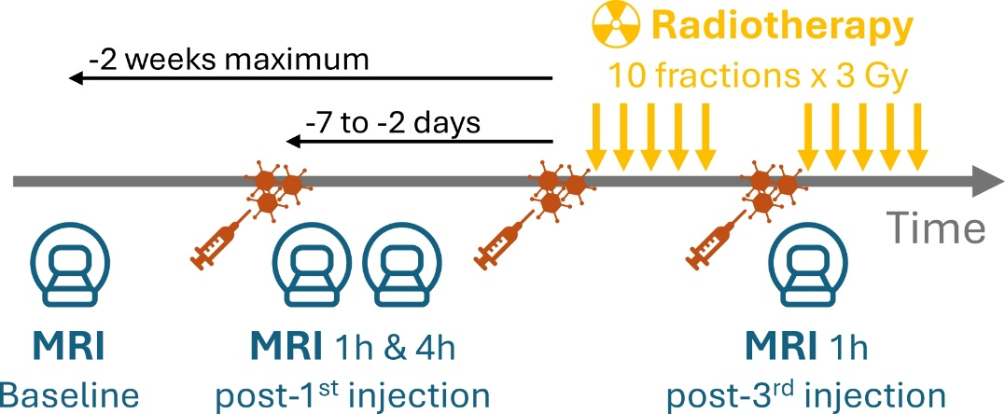
Figure S1: Design and timeline of the treatment and imaging schedule. The 10 fractions of radiotherapy (yellow arrows) are administered over 2 weeks (5 per week). AGuIX nanoparticle injections (orange) are given 2 to 7 days before treatment initiation for the first injection, and at the beginning of each week of radiotherapy for the subsequent two injections. Up to four magnetic resonance imaging (MRI) sessions are performed: a baseline scan up to 2 weeks before treatment start, followed by scans approximately 1 and 4 hours after the first injection, and finally, 1 hour after the third injection.

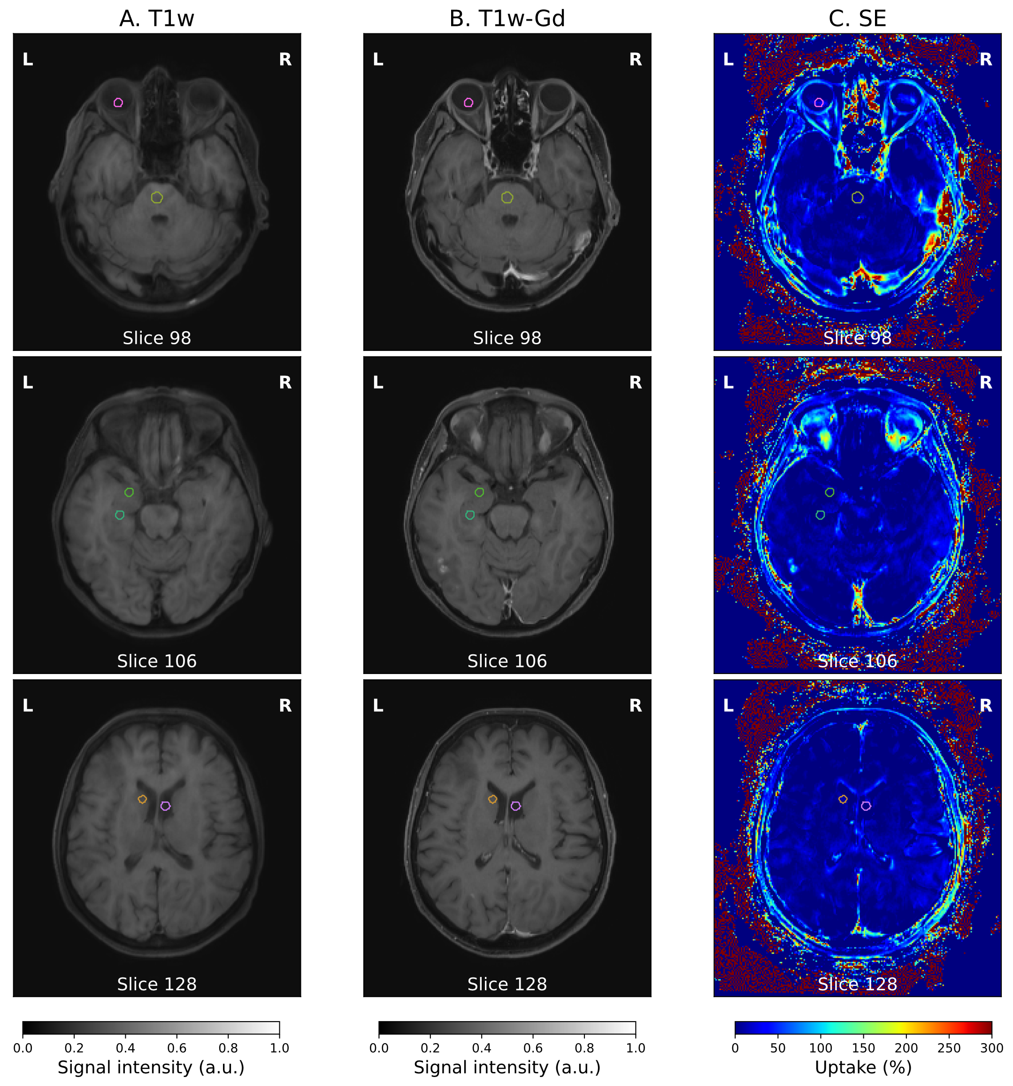
Figure S2: T1-weighted MRI, Gd-enhanced T1-weighted MRI, and derived signal enhancement maps for two patients from the trial. Three different slices are shown for one patient (rows) across two qualitative image types (A and B) and the corresponding quantitative signal enhancement map (C). Images were aligned using a rigid registration procedure, and selected regions of interest (ROIs) are highlighted with colored contours: vitreous humor (pink), brainstem (yellow), gray matter (green), hippocampus (cyan), basal ganglia (orange), and ventricle (light pink).
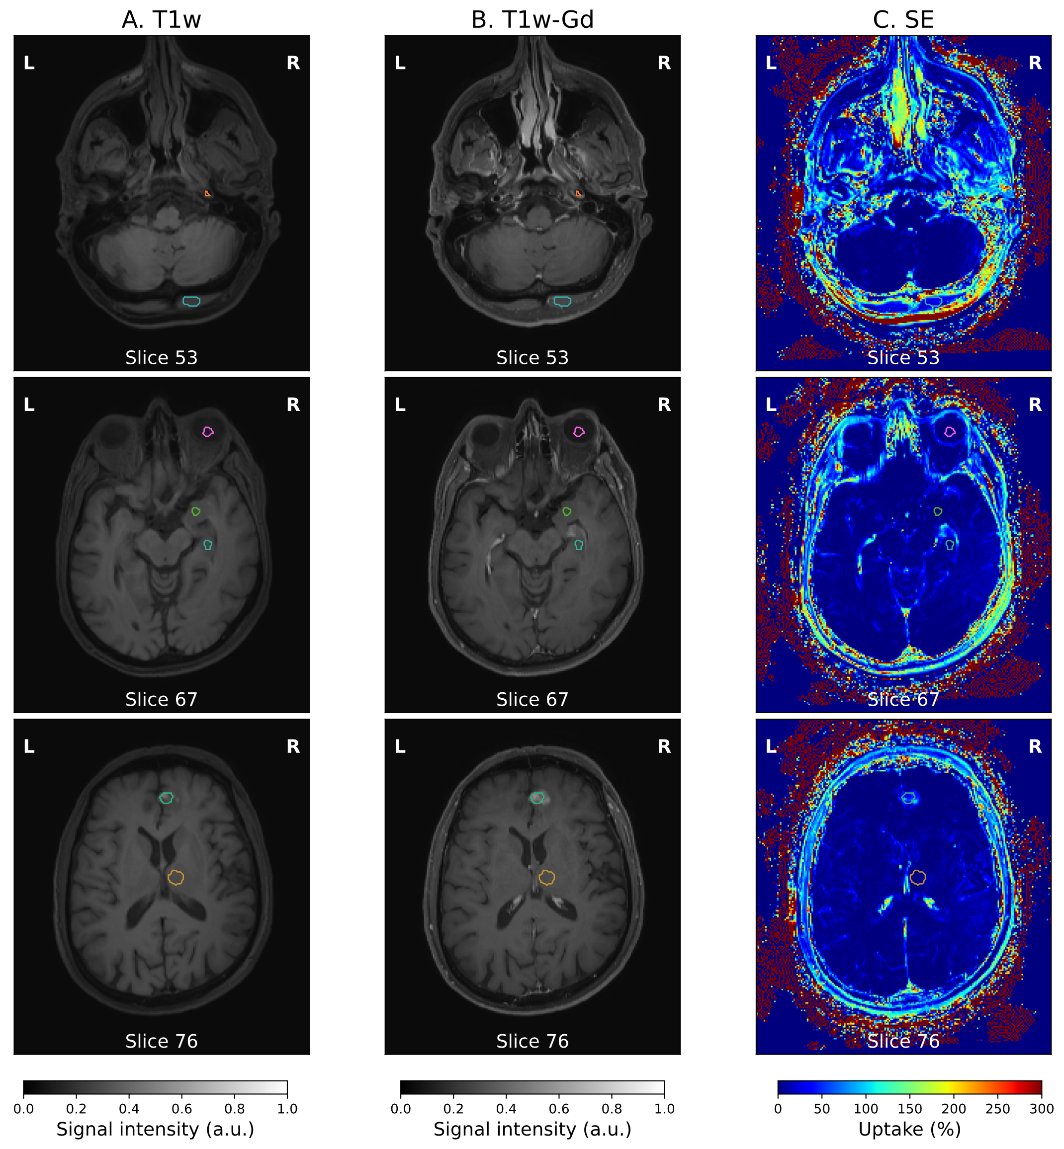
Figure S3: T1-weighted MRI, Gd-enhanced T1-weighted MRI, and derived signal enhancement maps for two patients from the trial. Three different slices are shown for one patient (rows) across two qualitative image types (A and B) and the corresponding quantitative signal enhancement map (C). Images were aligned using a rigid registration procedure, and selected regions of interest (ROIs) are highlighted with colored contours: carotid (orange), muscle (blue), vitreous humor (pink), grey matter (green), hippocampus (cyan), brain metastasis (light pink), and basal ganglia (orange).

