Supplementary Files

Tables

Table S1. Sociodemographic Characteristics of Participants (Unvaccinated)
 | Bulgaria | France | Germany | Italy |  | Poland | Spain |  | Sweden | UK
Female | 547 (51.17%) | 569  (51.35%) | 1144  (48.70%) | 556 (51.15%) |  | 598  (54.17%) | 561 (50.91%) |  | 538  (49.04%) | 632 (52.40%)
Age group
18-24 | 97  (9.07%) | 133  (12%) | 166  (7.07%) |  | 119  (10.95%) | 253  (22.92%) |  | 116  (10.53%) | 108  (9.85%) | 232 (19.24%)
25-34 | 265  (24.79%) | 271  (24.46%) | 346  (14.73%) |  | 212  (19.5%) | 295  (26.72%) |  | 281  (25.50%) | 298  (27.16%) | 442 (36.65%)
35-44 | 290  (27.13%) | 326  (29.42%) | 428  (18.22%) |  | 238  (21.9%) | 264  (23.91%) |  | 391  (35.48%) | 318  (28.99%) | 380 (31.51%)
45-54 | 306  (28.62%) | 347  (31.32%) | 464  (19.75%) |  | 282  (25.94%) | 181  (16.39%) |  | 246  (22.32%) | 220  (20.05%) | 95  (7.88%)
55-64 | 106  (9.92%) | 30  (2.71%) | 573  (24.39%) |  | 226  (20.79%) | 95  (8.61%) |  | 63  (5.72%) | 137  (12.49%) | 53  (4.39%)
65+ | 5  (0.47%) | 1  (0.09%) | 372  (15.84%) |  | 10  (0.92%) | 16  (1.45%) |  | 5  (0.45%) | 16  (1.46%) | 4  (0.33%)
Primary education | - | 14  (1.26%) | 179  (7.67%) | 50  (4.60%) |  | 23  (2.08%) | 4  (0.36%) |  | 49  (4.47%) | 30  (2.49%)
Secondary education | 69  (6.45%) | 124  (11.19%) | 1373 (58.85%) | 203  (18.68%) |  | 232  (21.01%) | 184  (16.70%) |  | 367 (33.45%) | 388 (32.17%)
Higher education | 437  (40.88%) | 469  (42.33%) | 393  (16.85%) | 519  (47.75%) |  | 534  (48.37%) | 315  (28.58%) |  | 195  (17.78%) | 356 (29.52%)
University degree | 563  (52.67%) | 501  (45.22%) | 388  (16.63%) | 315  (28.98%) |  | 315  (28.53%) | 599  (54.36%) |  | 486  (44.30%) | 432 (35.82%)
Christian | 892  (83.44%) | 378  (34.12%) | 1,150 (49.19%) | 753  (69.27%) |  | 863  (78.17%) | 505  (45.83%) |  | 378  (34.46%) | 561 (37.01%)
Muslim | 28  (2.62%) | 61  (5.51%) | 49  (2.10%) | 16  (1.47%) |  | 6  (0.54%) | 6  (0.54%) |  | 44  (4.01%) | 136 (8.97%)
Jewish | - | 7  (0.63%) | 3  (0.13%) | 4  (0.37%) |  | 5  (0.46%) | 2  (0.18%) |  | 5  (0.46%) | 9  (0.59%)
Employed | 893 (83.54%) | 822  (74.19%) | 1431 (60.92%) | 693  (63.75%) |  | 774  (70.11%) | 782  (70.96%) |  | 853  (77.76%) | 1014 (66.89%)
Had COVID-19
Severe disease progression | 88  (8.23%) | 38  (3.43%) | 41  (1.75%) | 54  (4.97%) |  | 67  (6.07%) | 35  (3.18%) |  | 70  (6.38%) | -
Mild disease progression | 341  (31.90%) | 164  (14.80%) | 85  (3.62%) | 125  (11.50%) |  | 262  (23.73%) | 131  (11.89%) |  | 219  (19.96%) | -
COVID-19 risk group status | 445 (41.63%) | 326 (29.42%) | 1213 (51.71%) | 291 (26.77%) |  | 405 (36.68%) | 305 (27.68%) |  | 226 (20.60%) | -
N | 1069 | 1108 | 2349 | 1087 |  | 1104 | 1102 |  | 1097 | 1206
Notes: COVID-19 risk group status was coded 1 if respondents were at increased risk for severe COVID-19 disease progression due to pre-existing chronic conditions such as diabetes, coronary heart disease or respiratory diseases, or due to risky lifestyle patterns related to smoking or obesity, and was coded 0 otherwise.

Table S2. COVID-19 Vaccination Rate by Country and Age Group
Country | Time of Survey | First shot % | Both shots  % | 18-24 first | 18-24 full | 25-49 first | 25-49 full | 50-59 first | 50-59 full | 60-69 first | 60-69 full | 70-79 first | 70-79 full | 80+ first | 80+ full
Germany | 9.-30.4.2021 | 25.3% | 8% | NA | NA | NA | NA | NA | NA | NA | NA | NA | NA | NA | NA
UK | 17.6.-2.7.2021 | 83.0% | 60.9% | 39.1% | 14.5% | 65.32% | 31.22% | 86.65% | 81.00% | 91.19% | 88.10% | 94.90% | 93.45% | 95.00% | 92.73%
Sweden | 15.-24.6.2021 | 56.8% | 34.2% | 11.5% | 6.4% | 31.4% | 10.2% | 79.9% | 29.5% | 88.4% | 66.6% | 95.0% | 79.8% | 94.4% | 89.2%
Spain | 15.-21.6.2021 | 59.9% | 36.5% | 7.8% | 5.4% | 31.6% | 12.2% | 86.7% | 53.4% | 93.1% | 29.9% | 97.8% | 96.1% | 100.0% | 100.0%
France | 15.-21.6.2021 | 60.2% | 30.9% | 37.8% | 5.4% | 46.5% | 12.4% | 66.6% | 28.9% | 76.2% | 49.5% | 88.6% | 72.7% | 79.1% | 68.0%
Italy | 15.-21.6.2021 | 62.3% | 31.4% | 29.3% | 8.8% | 42.6% | 15.6% | 70.4% | 29.2% | 81.2% | 41.2% | 87.0% | 47.0% | 94.8% | 87.6%
Bulgaria | 15.-21.6.2021 | 15.8% | 13.4% | 6.0% | 4.6% | 11.3% | 9.6% | 17.8% | 15.4% | 22.8% | 19.6% | 24.8% | 21.1% | 15.9% | 13.2%
Poland | 15.-21.6.2021 | 52.5% | 36.3% | 33.5% | 13.4% | 41.3% | 24.5% | 54.7% | 39.3% | 65.9% | 49.4% | 79.3% | 74.4% | 61.0% | 58.1%
Notes: The vaccination rates are reported for the point in time at which each survey was in field.

Table S3. Population Census Data for Key Sociodemographic Variables
Country | female | 18-24 years | 25-34 years | 35-44 years | 45-54 years | 55-64 years | 65+ years | low education | medium education | high education
Bulgaria | 51.53% | 6.15% | 12.5% | 14.6% | 14.4% | 13.6% | 21.6% | 21.5% | 52.9% | 25.6%
France | 51.67% | 8.09% | 11.6% | 12.4% | 13.3% | 12.6% | 20.4% | 22.3% | 42.4% | 35.3%
Germany | 50.66% | 7.41% | 12.7% | 12.3% | 14.4% | 14.9% | 21.8% | 20.1% | 52.7% | 27.2%
Italy | 51.29% | 6.91% | 10.7% | 13.0% | 16.1% | 14.1% | 23.2% | 39.0% | 43.1% | 17.9%
Poland | 51.60% | 7.26% | 14.2% | 16.1% | 12.6% | 13.4% | 18.2% | 12.9% | 58.1% | 28.9%
Spain | 50.99% | 7.54% | 10.2% | 15.4% | 15.9% | 13.3% | 19.6% | 38.2% | 25.8% | 36.0%
Sweden | 49.69% | 7.89% | 14.1% | 12.4% | 13.0% | 11.5% | 20.0% | 20.7% | 41.1% | 38.3%
UK(2019) | 50.63% | 8.52% | 13.5% | 12.6% | 13.7% | 12.1% | 18.4% | 19.1% | 40.2% | 40.6%

Table S4. Determinants of Vaccine Hesitancy Among Those Not Yet Vaccinated
 | Bulgaria | France | Germany | Italy | Poland | Spain | Sweden | UK
Female | 1.36*  (1.04 - 1.81) | 1.44***  (1.33 - 1.84) | 1.29***  (1.07 - 1.56) | 1.43***  (1.10- 1.86) | 1.24  (0.96 - 1.59) | 1.34  (0.90 - 2.00) | 1.04  (0.79 - 1.36) | 1.42**  (1.12 - 1.81)
Age group | 0.98  (0.87 - 1.11) | 1.18***  (1.05 - 1.32) | 0.80***  (0.75 - 0.85) | 1.52***  (1.37 - 1.69) | 1.12**  (1.02- 1.24) | 1.48***  (1-27 - 1.72) | 1.67***  (1.49 - 1.87) | 1.67***  (1.48 - 1.89)
Education | 0.76*  (0.60 - 0.96) | 0.88  (0.74 - 1.04) | 0.69***  (0.62 – 0.78) | 0.74***  (0.62 - 0.87) | 0.91  (0.77 - 1.08) | 0.84  (0.68 - 1.03) | 0.80***  (0.70 - 0.92) | 0.75***  (0.65-0.87)
Employment | 0.83  (0.56 - 1.24) | 0.97  (0.73 - 1.29) | 1.09  (0.89 – 1.33) | 0.91  (0.68 – 1.20) | 1.21  (0.92 - 1.59) | 0.56***  (0.39 – 0.80) | 0.62***  (0.45 - 0.86) | 0.92  (0.70-1.20)
N | 1069 | 1101 | 2285 | 1087 | 1098 | 1102 | 1097 | 1205
Notes: Coefficients are odds ratios (95% CI) based on logistic regressions. Outcome is an indicator variable for vaccine hesitancy that equals 1 if participants reported being either unsure whether they would get vaccinated or certain that they would not, and 0 otherwise. We included the experimental group as an additional control to adjust for the possible impact of the information treatments on vaccine hesitancy (coefficient not shown here).

Table S5. Underlying Reasons for Vaccine Hesitancy
Fear of Side Effects
Mentioned by Bulgaria: 252/784 (32%), Germany: 301/654 (46%), France: 171/617 (28%), Italy: 167/406 (41%), Poland: 257/703 (37%), Spain: 40/179 (22%), Sweden: 112/363 (31%), UK: 180/653 (28%) of participants who reported being hesitant
General Side Effects
- “There are dangerous deadly side effects of vaccines. Vaccinations can also backfire.”
[German, male, medium education, age group: 35-44 yrs]
- “I don't want to get any side effects of this untested vaccine like heart inflammation, blood clots and any other symptoms which are happening to people on a daily basis. I just want to live a normal life like before without any strange chemicals injected into my body.”
[British, female, higher education, age group: 35-44 yrs]
- “People die after vaccination. The vaccines are a medical experiment, no one wishes to take responsibility for its effects.”
[Polish, female, medium education, age group: 35-44 yrs]

Side Effects related to Pre-existing Medical Conditions
- “I’m allergic to various things, and they have recommended that I should not get vaccinated yet just in case."
[Spanish, female, higher education, age group: 25-34 yrs]
- “I suffer from an underlying chronic disease of the immune system, which can be disrupted if the immune system is triggered by a vaccine, with an uncertain outcome. I am not prepared to take any risks with my immune system, it has already done enough for me.”
[Swedish, male, higher education, age group: 55-64 yrs]
- “I have diabetes and a heart condition and am worried about the side effects of the vaccine.”
[Polish, female, medium education, age group: 55-64 yrs]

Side Effects related to Infertility/Harm to Child
- “I wish to get pregnant. I recently had a miscarriage and I do not want to risk any fertility problems because of this vaccine. I find that there is not enough evidence on the possible impact of the vaccine for pregnant women.”
[French, female, higher education, age group: 25-34 yrs]
- “I’m pregnant and do not want to risk damage to the fetus.”
[Swedish, female, higher education, age group: 25-34 yrs]

Prior Negative Experience with Vaccines/Medication
- “I am scared. I have had adverse reactions to vaccines in the past, and I’m a single parent to a young child living far from family.”
[British, female, higher education, age group: 35-44 yrs]
- “I lost my immunity through vaccination and my child was hospitalized due to vaccination. Therefore, I have a deep distrust with regards to vaccination and pharmaceutical companies in general.”
[Polish, female, higher education, age group: 35-44 yrs]
- “Since I normally do not take drugs, I have already been sick due to an antibiotic that I have taken once. With this vaccine it would be even worse. I think it makes no sense that I harm myself by injecting unknown substances into my body.”
[Italian, female, higher education, age group: 65+ yrs]

Concerns about Specific Vaccine Types
- “The people who have died of brain clots after vaccination with AstraZeneca have been women around 60 years of age. I'm 61, so I'm hesitant.”
[Swedish, female, medium education, age group: 55-64 yrs]
- “The RNA vaccine is a new technique and we do not yet have enough evidence on the effects of this genetic modification.”
[French, female, higher education, age group: 25-34 yrs]

Lack of Long-Term Evidence
Mentioned by Bulgaria: 137/784 (17%), Germany: 197/654 (30%), France: 269/617 (44%), Italy: 77/406 (19%), Poland: 178/703 (25%), 178/703 (25%), Spain: 36/179 (20%), Sweden: 68/363 (19%), UK: 155/653 (24%) of participants who reported being hesitant
Lack of Rigorous Evidence/Insufficient Testing
- "It seems to me that everything was done too quickly. Sometimes I think I'm a guinea pig."
[Italian, female, higher education, age group: 35-44 yrs]
- “There is no vaccine or cure for cancer and here is a new virus and suddenly a vaccine has been developed so quickly.”
[Polish, male, medium education, age group: 25-34 yrs]
- “We simply haven’t had enough research since the coronavirus appeared. We are sailing blind. I consider the vaccinated people as guinea pigs and I will wait to see for some time to know what the undesirable effects - if any - are.”
[French, female, higher education, age group: 25-34 yrs]
- “The normal time to check a vaccine is about 14 years, and even then, unintended effects can arise. It is like radioactivity, if you expose yourself to it, not at the moment but in 10 years, for example, a disease can arise. […] The smartest thing to do is to wait as long as possible to be safer, it doesn't matter if you can't travel or whatever, health comes first.”
[Spanish, female, higher education, age group: 35-44 yrs]

Fear of Unknown Long-Term Effects
- “You simply cannot know all of the long-term side effects until sufficient time has gone past. At the moment we are all just guinea pigs. We are the lab used for testing.“
[British, female, lower education, age group: 25-34 yrs]
- "I am always in favour of vaccination, always. But here there are no long-term studies at all. The virus has done so much damage. Is vaccination possibly also dangerous in the long-term? With thalidomide, they always said the drugs weren't dangerous."
[German, female, medium education, age group: 45-54 yrs]
- “There is insufficient data for clinical trials over an extended period, especially data on late manifestations of autoimmune diseases after vaccination. Normally, clinical trials are conducted over a long period to follow up all possible reactions.”
[Bulgarian, male, higher education, age group: 45-54 yrs]
Lack of Trust in Vaccine Effectiveness
Mentioned by Bulgaria: 79/784 (10%), Germany: 44/654 (7%), France: 68/617 (11%), Italy: 42/406 (10%), Poland: 49/703 (7%), Spain: 13/179 (7%), Sweden: 34/363 (9%), UK: 37/653 (6%) of participants who reported being hesitant
- “Even with vaccination it does not stop one from being infected nor from passing it on, therefore rendering the vaccine completely pointless.”
[British, female, medium education, age group: 35-44 yrs]
- “The virus is very variable. I doubt that by getting vaccinated I will be protected from corona virus in the future.”
[Bulgarian, female, higher education, 18-24 yrs]
- “I believe that the vaccines that have come out so far are not effective enough, these vaccines do not prevent infection, what they do is prevent symptoms. I prefer to wait for the Spanish vaccine to come out.”
[Spanish, male, higher education, age group: 25-34 yrs]
- “If we are facing a situation in which we have to get vaccinated several times to cover all conceivable - and unimaginable - mutations, then I am not interested in taking it. If it turns out that we can expect full protection with a vaccination shot on one, possibly two, occasions, then I can imagine getting it once it is confirmed. It is simply too early to make a decision.”
[Swedish, male, higher education, age group: 55-64 yrs]
Low Perceived Risk of COVID-19 Infection
Mentioned by Bulgaria: 97/784 (12%), Germany: 56/654 (9%), France: 62/617 (10%), Italy: 36/406 (9%), Poland: 46/703 (7%), Spain: 14/179 (8%), Sweden: 52/363 (14%), UK: 81/653 (12%) of participants who reported being hesitant
Sufficient Trust in Own Immune System
- “As a young person, I don't think the virus can have a big impact on me. I'd rather my immunity deal with it than to get a vaccine for which there is so little data.”
[Bulgarian, female, higher education, age group: 18-24 yrs]
- “I trust my own good immune system, I never get sick. In addition, I had the flu (and Covid-19 is nothing but a flu) 16 months ago and I was sick for two weeks before the hysteria started. I have since not taken any safety precautions and have hung out with people who had symptoms themselves. The best protection is to expose yourself and activate your own immune system.”
[Swedish, male, higher education, age group: 55-64 yrs]
Low Risk of Infection
- “I take care and I live in the countryside."
[French, female, higher education, age group: 45-54 yrs]
- “I don't interact with other people a lot so my risk of contracting the virus is almost zero.”
[German, female, medium education, age group: 55-64 yrs]

Doubt of Severity or even Existence of COVID-29
- “Vaccinations are only necessary for dangerous diseases. In my opinion, flu is not one of them.”
[German, male, lower education, age group: 35-44 yrs]
- "I do not think that for a moderately severe flu like this one those without any sicknesses and under 70 years of age need to be vaccinated."
[Italian, male, medium education, age group: 18-24 yrs]
- “I do not think that the coronavirus exists”.
[Polish, male, higher education, age group: 35-44 yrs]
Lack of Trust in Public Elites/ Authorities/ Pharmaceutical Companies
Mentioned by Bulgaria: 57/784 (7%), Germany: 51/654 (8%), France: 42/617 (7%), Italy: 35/406 (9%), Poland: 24/703 (3%), Spain: 22/179 (12%), Sweden: 35/363 (10%), UK: 58/653 (9%) of participants who reported being hesitant
Vaccination as a Means of State Control
- "I find this two-class society of vaccinated and non-vaccinated that our government is currently striving for cruel and do not want to support it!”
[German, female, medium education, age group: 25-34 yrs]
- “For me, COVID19 is a scam and a Chinese Communist health dictatorship; we should instead think about real problems, such as the considerable presence of the Camorra in Sarno (province of Salerno) and find cures for real diseases like cancer.”
[Italian, male, higher education, age group: 25-34 yrs]
- “The government is not going in the right direction in my opinion, I no longer trust their actions. My decision to not get vaccinated can be seen as an act of protest.”
[French, female, higher education, age group: 25-34 yrs]
- “Because there is a hidden agenda behind it and no way would I accept being poisoned for the elites’ gain”
[British, female, higher education, age group: 25-34 yrs]
- “I also have worries as to the motives of those 'pushing' the vaccine and feel that the idea of a 'vaccine passport' and 'track and trace' is actually more about controlling us than it is to do with the threat from Covid 19.”
[British, male, medium education, age group: 55-64 yrs]
- “I don't believe the government with regards to this vaccination - these people are murdering the people of Poland!”
[Polish, male, higher education, age group: 55-64]

Vaccination as Profit to Pharmaceutical Companies
- “I am not willing to risk my life to be a FREE guinea pig for pharmaceutical companies.”
[Italian, female, higher education, age group: 55-64 yrs]
- “I am not well informed, nor do I trust the reliability of the government or the pharmaceutical companies.”
[Spanish, male, medium education, age group: 25-34 yrs]
- “I think they are unsafe/unproven and I absolutely do not trust those making it (big pharma) or pushing it (Governments and media).”
[British, male, medium education, age group: 45-54 yrs]

Conspiracy Theories
- “There are a lot of deaths and medical consequences linked to the COVID-19 vaccine. The most influential people in this world, including Bill Gates, are not vaccinated themselves.”
[French, female, higher education, age group: 35-44 yrs]
- “Vaccination does not eliminate infection What then does it eliminate? The purpose is the globalist depopulation of the world and a great reset according to the NOW. One of the murderers Bill Gates admitted to this. I wonder why the head of one of the vaccine companies refused to vaccinate, justifying this with wanting to save enough vaccines for those more vulnerable. Why vaccinate if COVID-19 is completely curable within 2-3 days. Jerzy Zięba and recently the Polish Association of Physicians and Scientists spoke about it. After all, they are people of science, so why are YouTube and other videos blocked? I do not like being treated like an idiot and being told something illogical to believe in.”
[Polish, male, higher education, age group: 45-54 yrs]
- “Because it’s a lie, it’s an experimental shot using spike proteins that should not be Injected into the human body. They had to stop animal trials because they all died... now there are more than 5,000 recorded deaths and over 1.5 million injured. This is what is on https://vaers.hhs.gov/ and the number is definitely higher. It’s a sterilization, nothing less. Depopulation is what they want. It’s common knowledge.”
[British, male, medium education, age group: 35-44 yrs]
Other Reasons
Mentioned by less than 5% of vaccine-hesitant participants across countries
Insecurity Due to Contradictory/Insufficient Information
- “The conflicting information there is about the side effects of most vaccines, personally, I am waiting for the Russian vaccine to be approved in the EU.”
[Bulgarian, female, higher education, age group: 35-44 yrs]
- “There was a lot of conflicting information with regards to the timeframe of the second dose vaccines.”
[Swedish, male, higher education, age group: 35-44 yrs]
- “There is a lot of ambiguity with regards to this vaccine, including information provided by the producers and scientists themselves.”
[Polish, male, medium education, age group: 45-54 yrs]

Vaccination of High-Risk Group Perceived to be Sufficient
- “Once all at-risk groups are vaccinated, I don’t see any danger any longer.”
[German, male, higher education, age group: 25-34 yrs]

Fear of Needles
- “I am scared of syringes.”
[Swedish, male, medium education, age group: 25-34 yrs]
- “I have a needle phobia, which is holding me back.”
[British, female, medium education, age group: 25-34 yrs]
- “I am terrified of needles and doctors. If it were possible to receive an oral vaccine, I might take it.”
[Polish, female, higher education, age group: 18-24 yrs]

General Anti-Vaccination Sentiment
- “I have never accepted any vaccination, unless it was compulsory”.
[Polish, male, higher education, age group: 55-64 yrs]

Religious Motives
- “My faith forbids me to receive a vaccine.”
[Polish, male, higher education, age group: 25-34 yrs]
- “My belief and faith in God prevents me from getting the vaccine. If he comes for me to end my life in this world then I will be ready.”
[British, male, medium education, age group: 25-34 yrs]

Ethical Concerns
- “I don't want to be complicit in animal experimentation.”
[Spanish, non-binary, higher education, age group: 35-44 yrs]

Figures

Figure S1. Individual Medical Risk Reduction Treatment
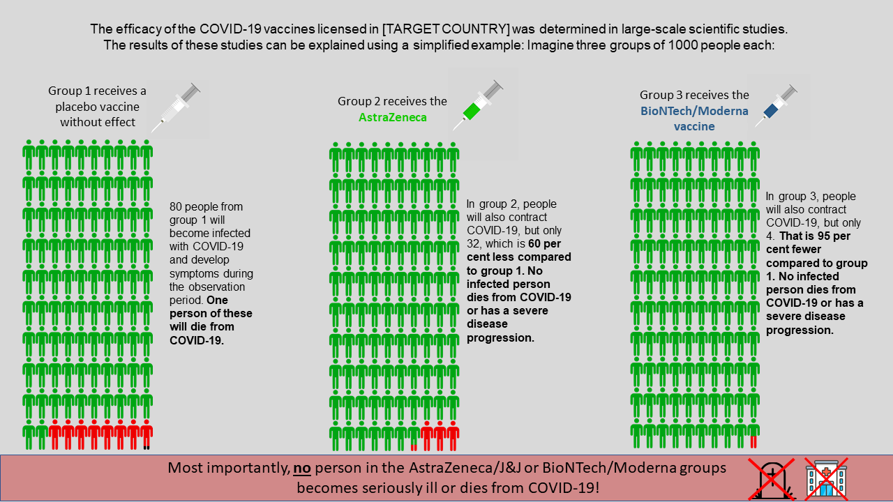

Figure S2. Altruism Treatment
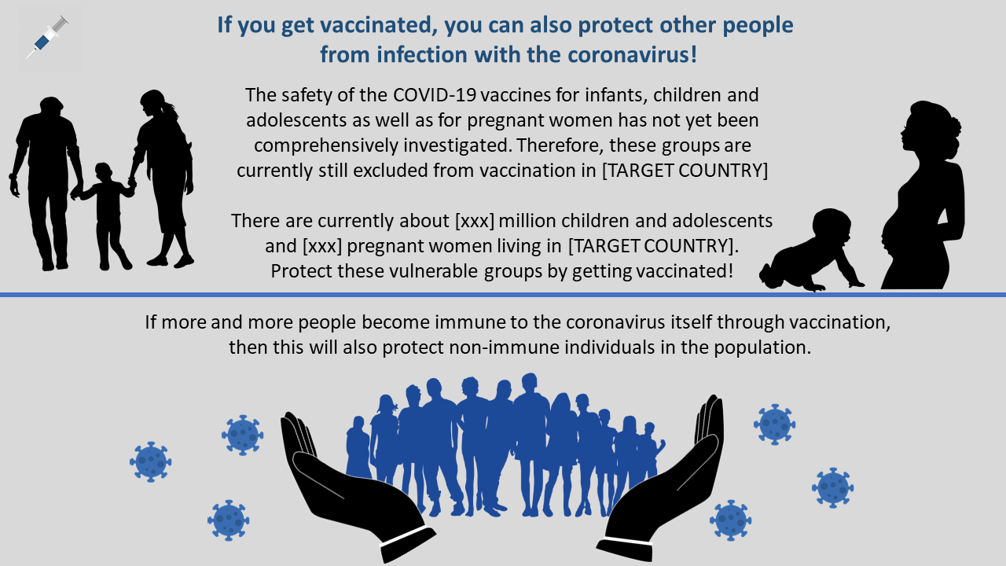

Figure S3. Exclusive Non-Medical Benefits for the Vaccinated Treatment
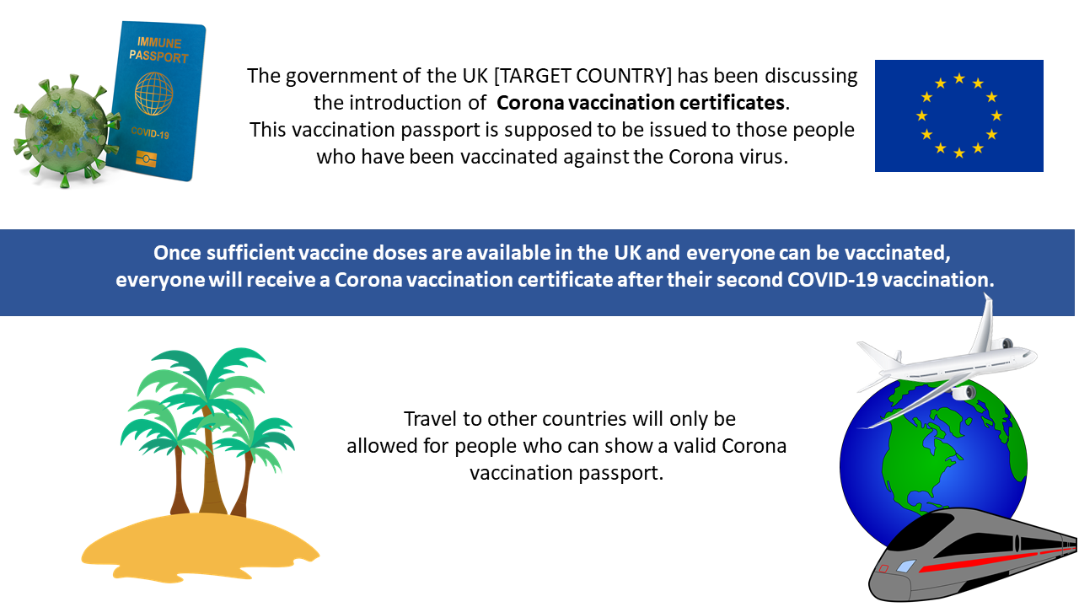

Figure S4. Hedonism/Return to Normality Treatment
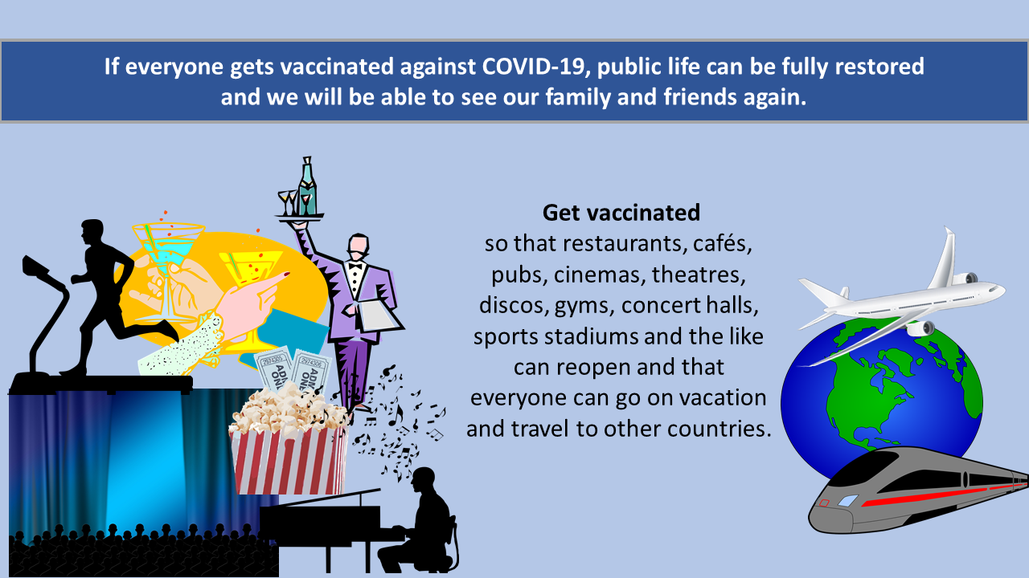

Figure S5. Respondents’ Agreement With the Following Statement: “I am confident that the
vaccination against COVID-19 is safe and has been sufficiently tested”
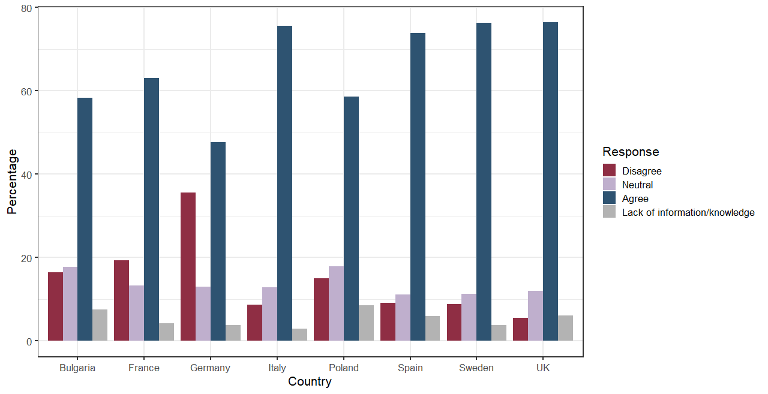

Figure S6. Respondents’ Agreement With the Following Statement: “I am concerned regarding the safety of COVID-19 vaccines because of the speed with which they have been developed and produced”
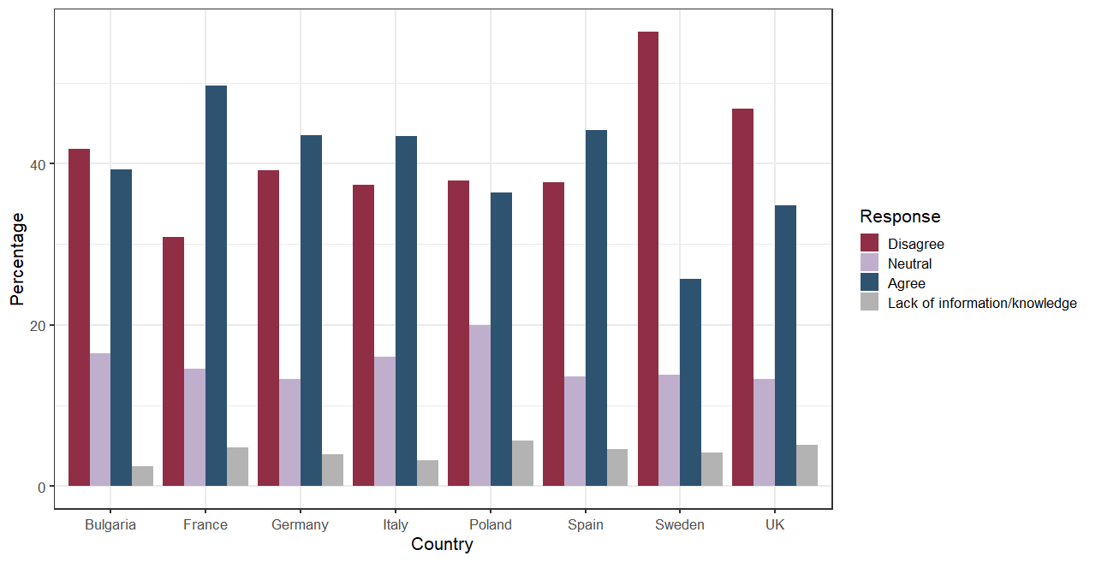

Figure S7. Respondents’ Agreement With the Following Statement: “The side effects that are associated with vaccination against COVID-19 are downplayed by health authorities”
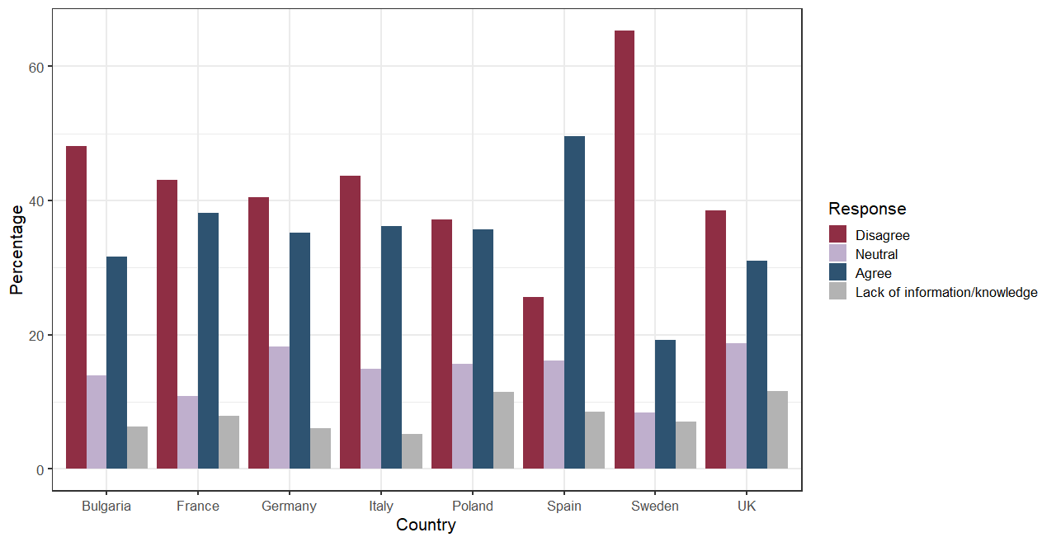

Figure S8. Respondents’ Agreement to the following Statement: “I am confident that the
[Vaccine Type] is safe and has been sufficiently tested”
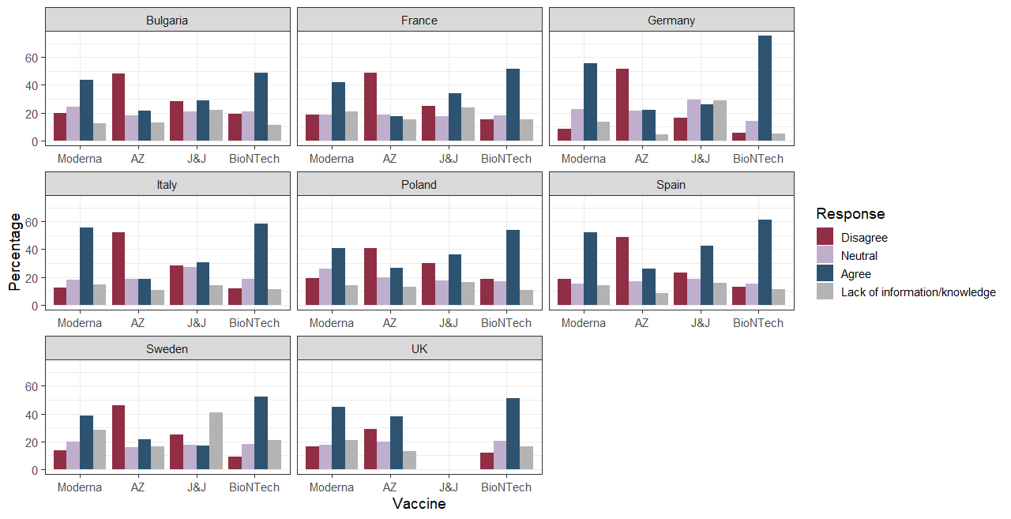

Figure S9. Respondents’ Agreement With the Following Statement: “I am concerned regarding the safety of the [Vaccine Type] because of the speed with which they have been developed and produced”
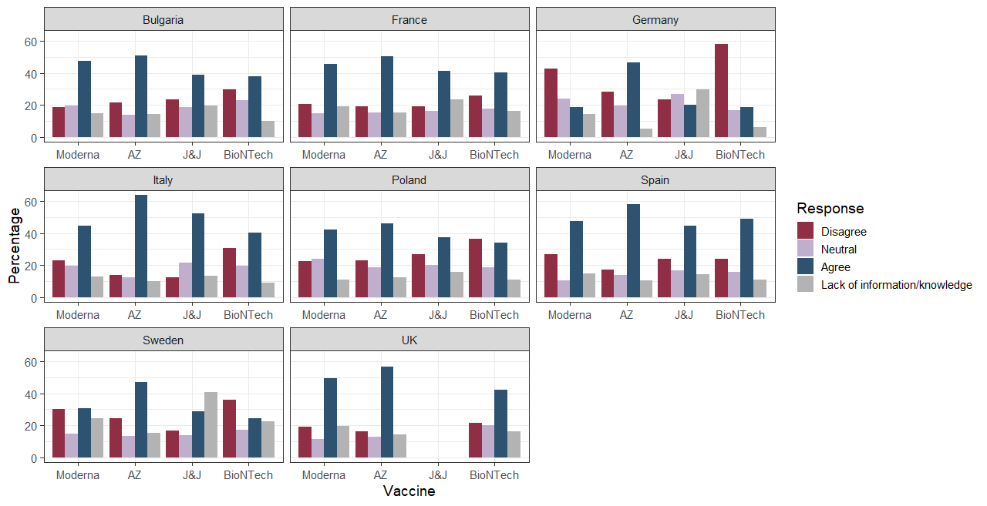

Figure S10. Respondents’ Agreement With the Following Statement: “The side effects that are associated with the [Vaccine Type] are downplayed by health authorities on purpose.” 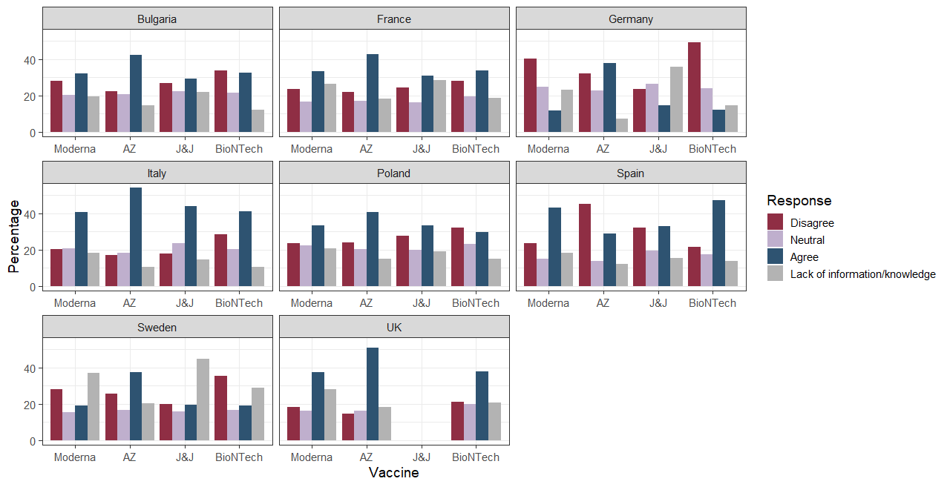

Figure S11. Respondents’ Agreement With the Following Statement: “When everyone is getting vaccinated against COVID-19, it is not essential for myself to get vaccinated”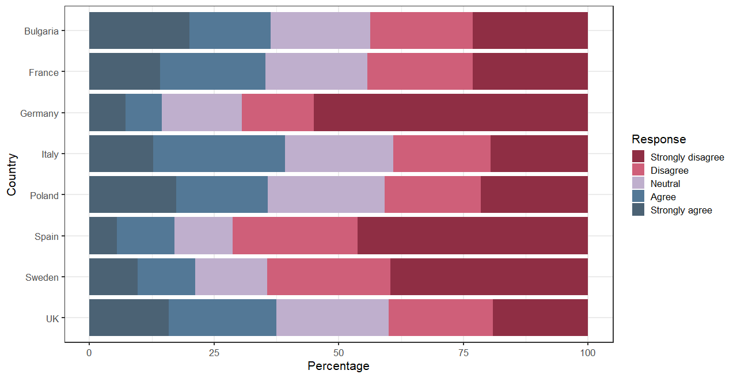

Figure S12. Respondents’ Agreement With the Following Statement: “Vaccination against COVID-19 helps primarily to overcome the disadvantages that I am experiencing due to the pandemic”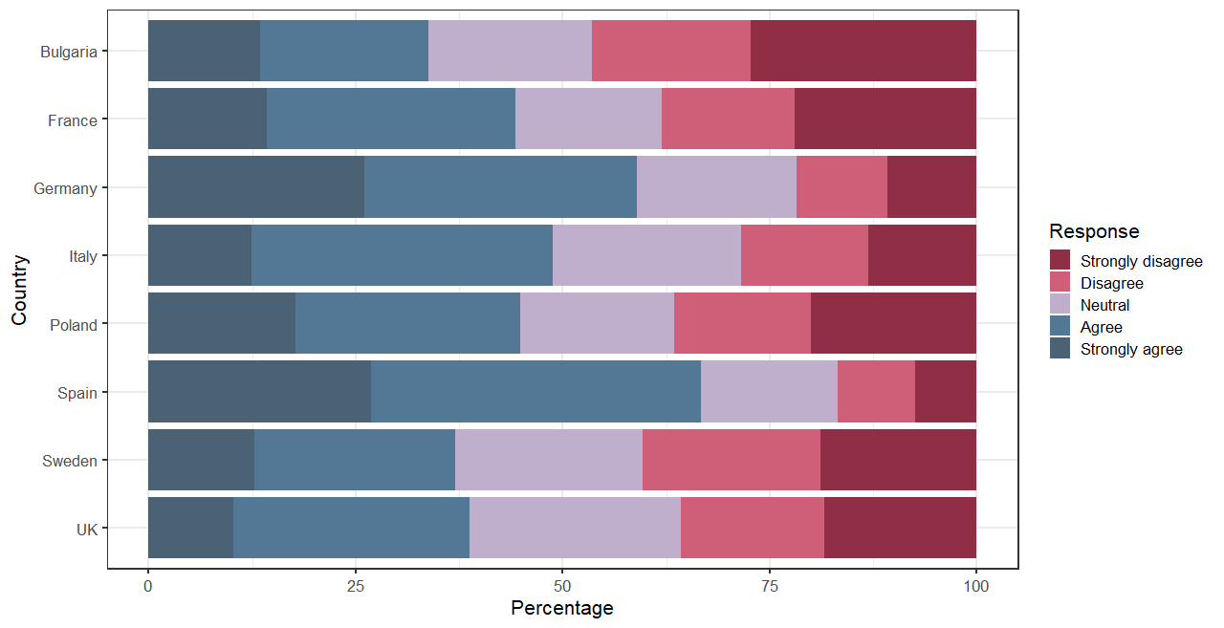

Figure S13. Respondents’ Agreement With the Following Statement: “If I get vaccinated against COVID-19, I can also protect people around me from an infection with the virus”
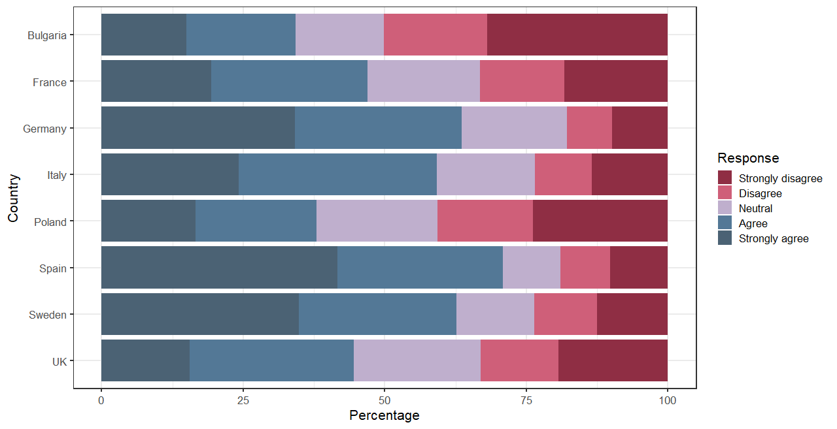
Figure S14. Respondents’ Agreement With the Following Statement: “If all risk groups are vaccinated against COVID-19, it no longer matters whether I also get vaccinated or not”
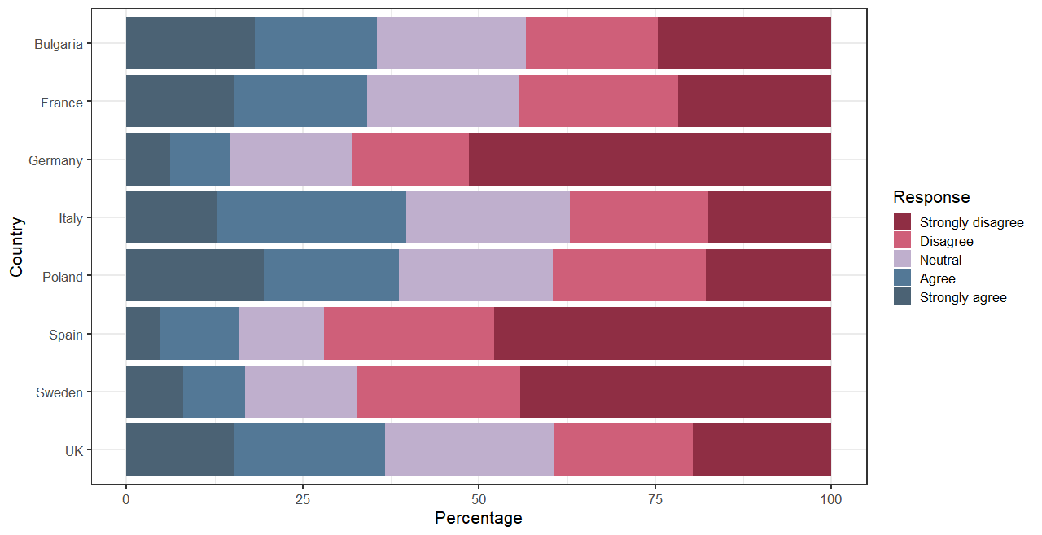

Figure S15. Treatment Effects on Vaccine Willingness: Germany
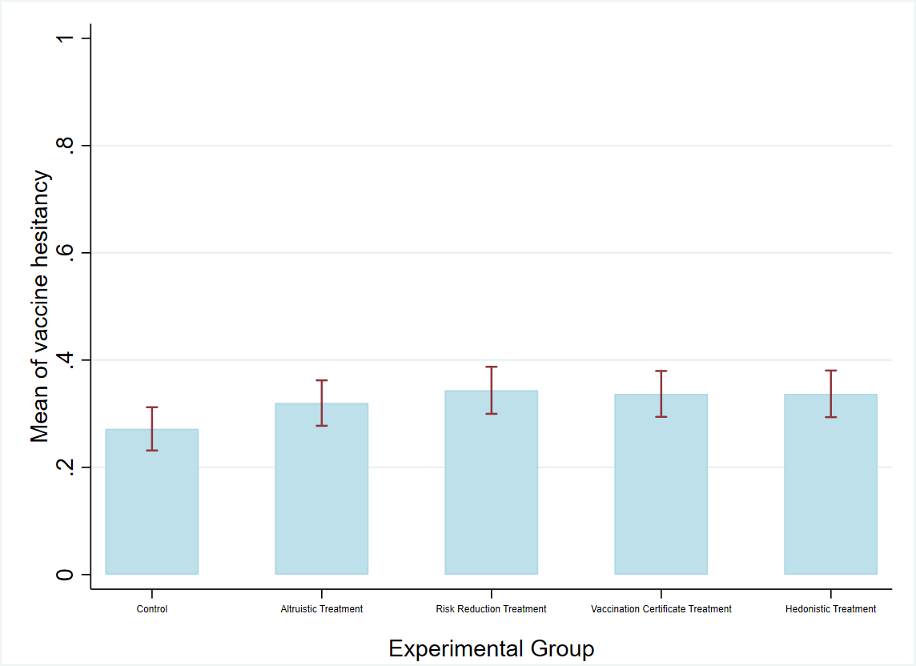

Figure S16. Treatment Effects on Vaccine Willingness: Bulgaria
Figure S17. Treatment Effects on Vaccine Willingness: France
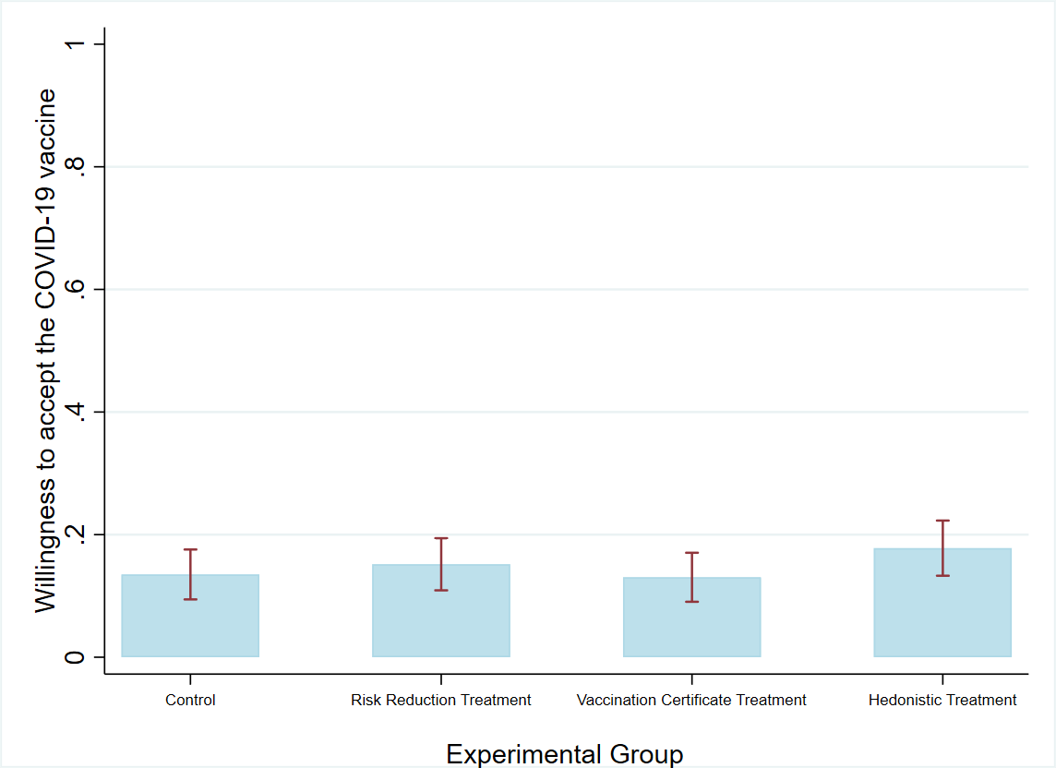

Figure S18. Treatment Effects on Vaccine Willingness: Italy
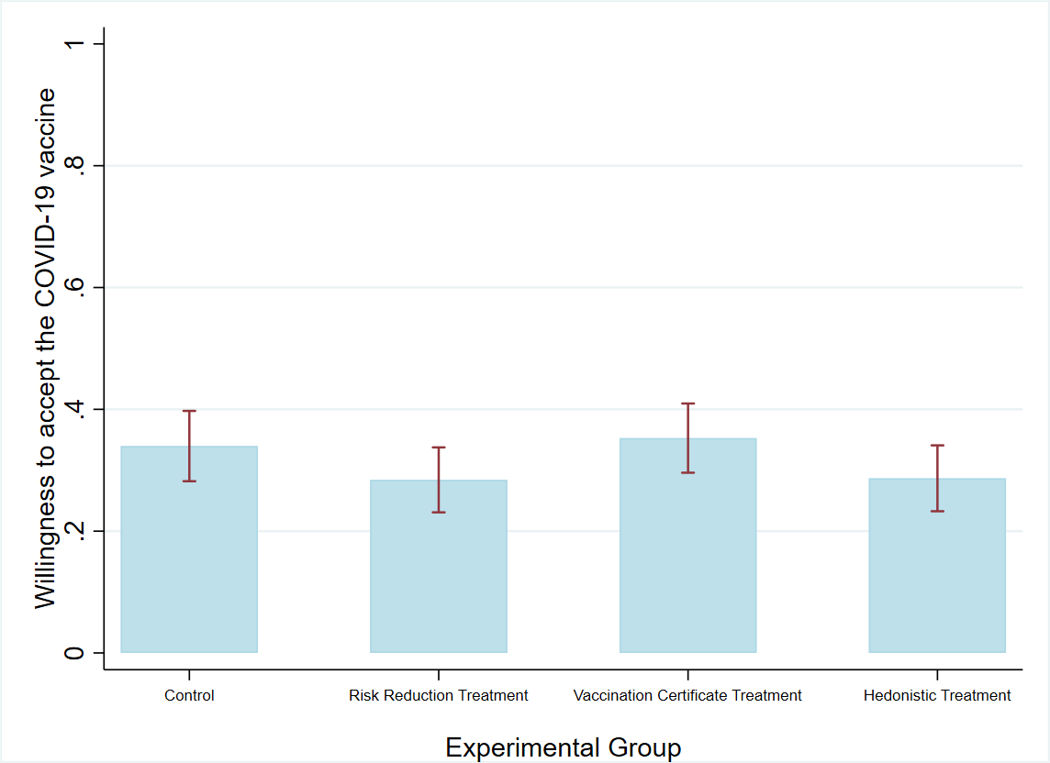

Figure S19. Treatment Effects on Vaccine Willingness: Poland
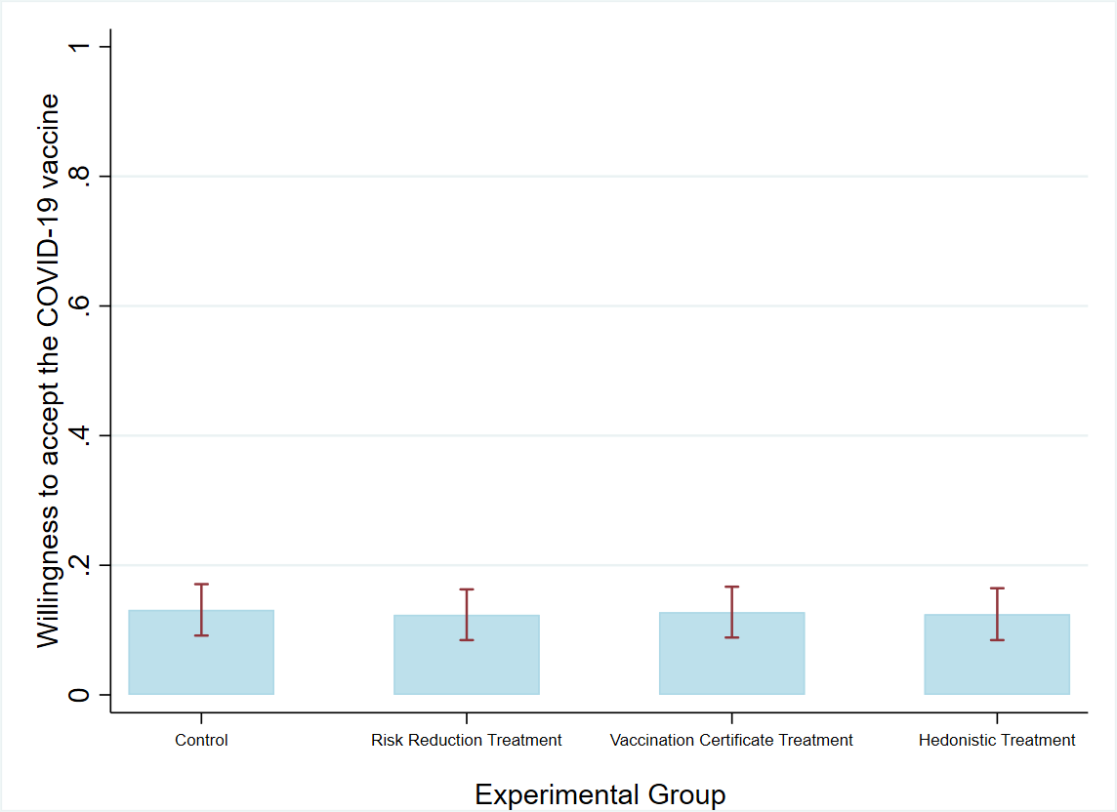

Figure S20. Treatment Effects on Vaccine Willingness: Spain
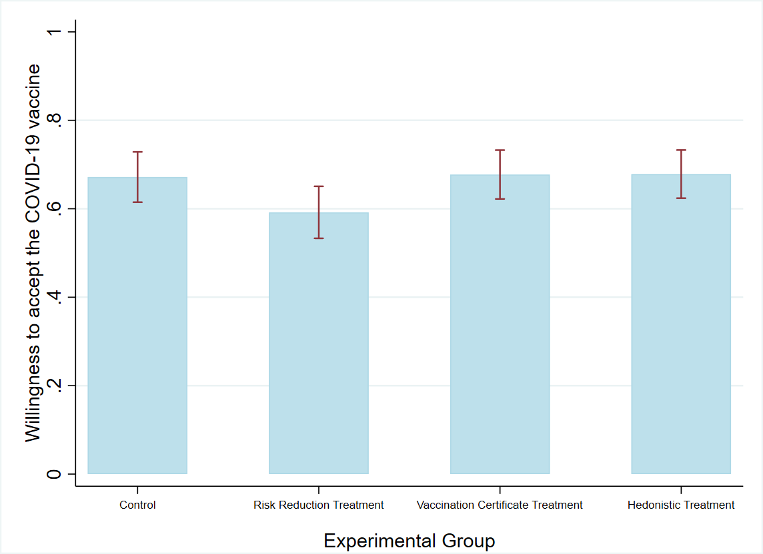

Figure S21. Treatment Effects on Vaccine Willingness: Sweden
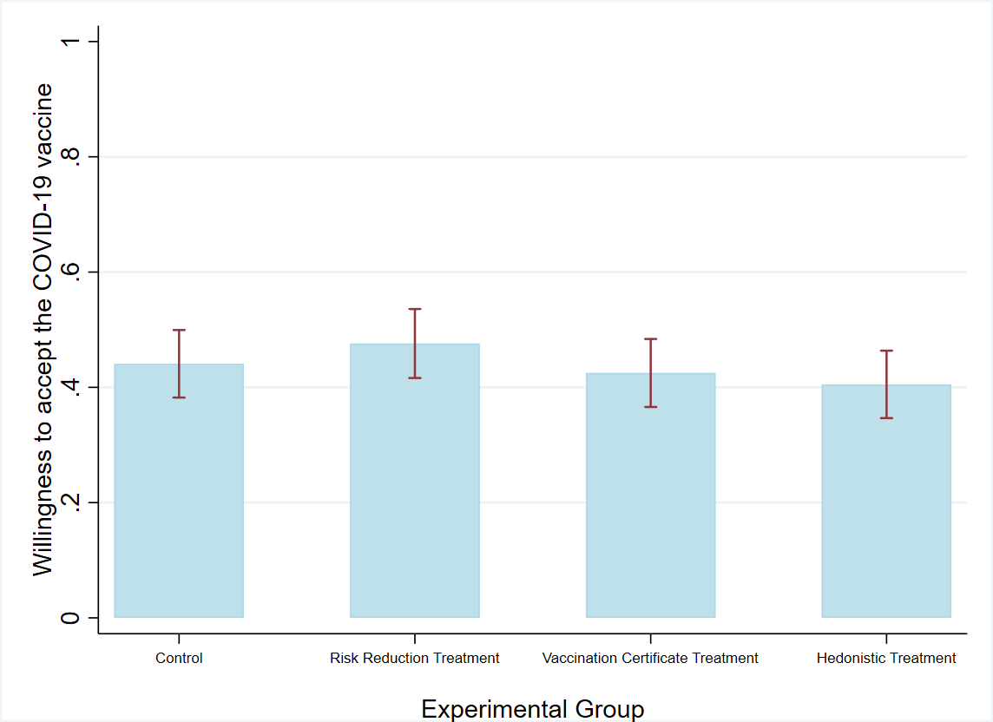

Figure S22. Treatment Effects on Vaccine Willingness: UK
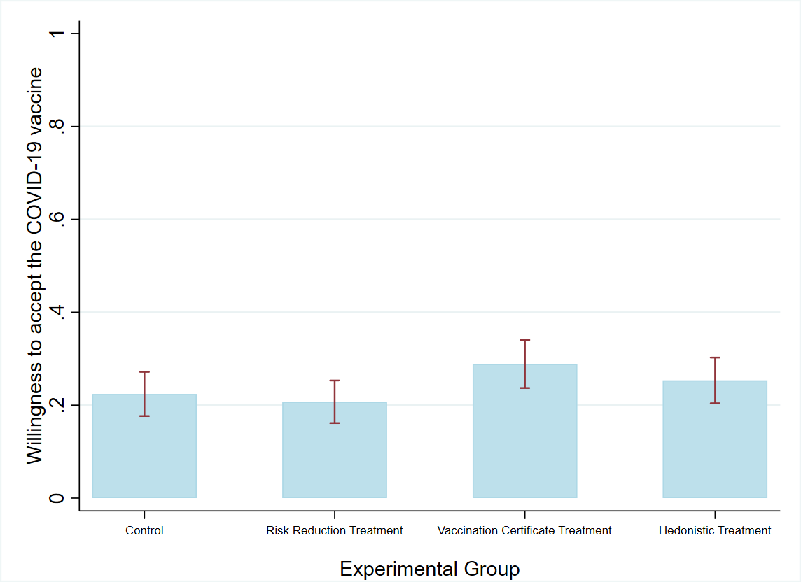

Figure S23. Model-Based Recursive Partitioning: Regression Tree for Risk Reduction Treatment Effects
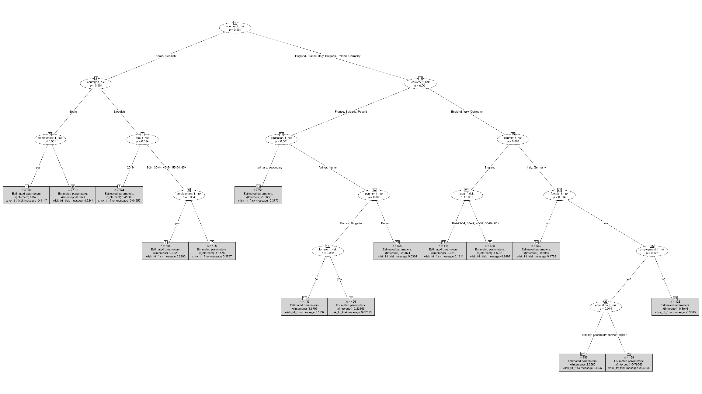
Figure S24. Model-Based Recursive Partitioning: Regression Tree for Exclusive Benefit Treatment Effects
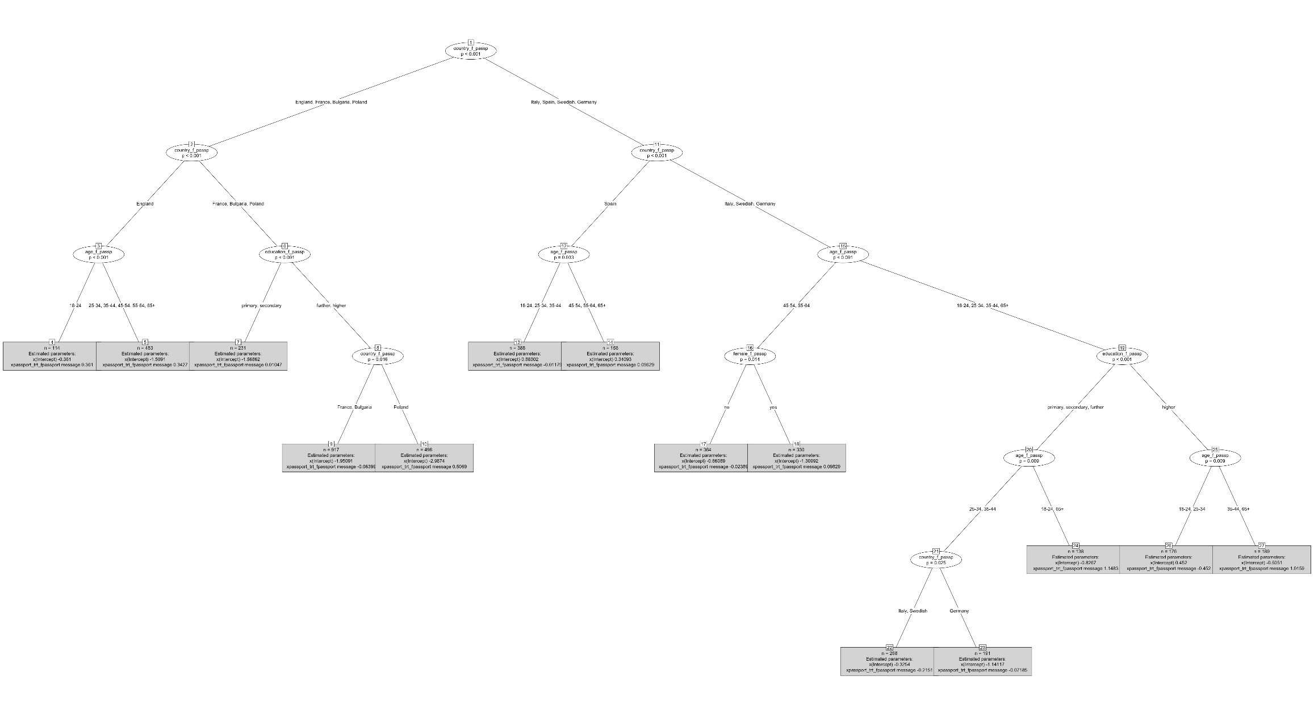
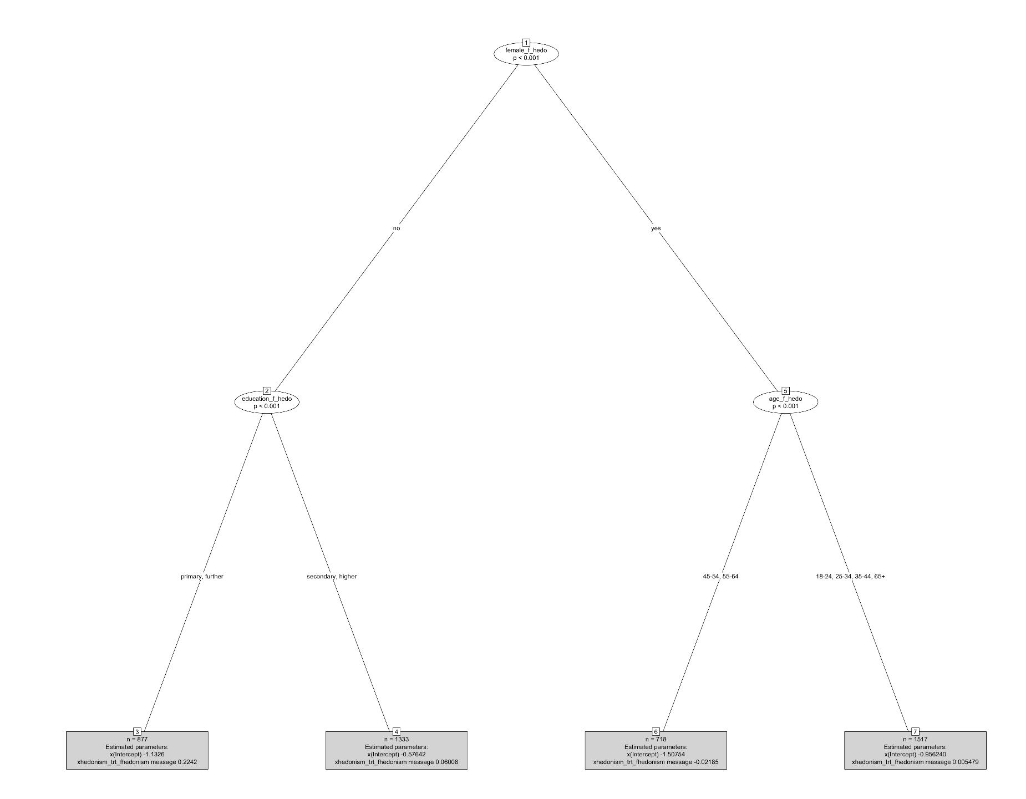
Figure S25. Model-Based Recursive Partitioning: Regression Tree for Hedonism Treatment Effects

