Table 4. Case examples of the AAS/OMI diagnostic dilemma

STEMI(+)OMI with CT aorta before Code STEMI
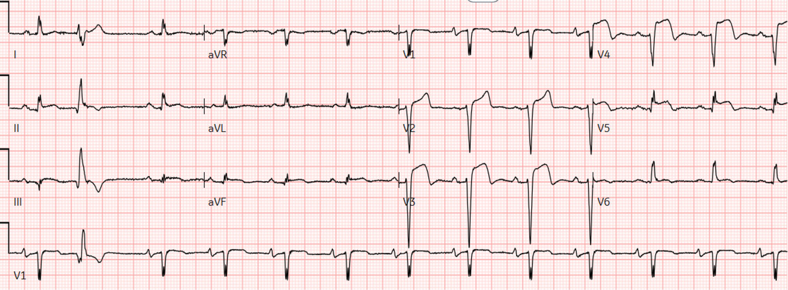
81 year-old with severe chest/back pain without AAS risk factors or deficits. ADD-RS = 1.
ECG STEMI positive, subacute LAD occlusion (anterior ST elevation with loss of R waves).
POCUS documented regional wall motion abnormalities without aortic flap. But because of the pain characteristics the patient was sent for CT to exclude AAS before code STEMI. Door-to-cath 1hr54 min, 100% LAD occlusion. First troponin 77,000ng/L, peak 480,000ng/L.
STEMI(-)OMI with CT aorta before Code STEMI
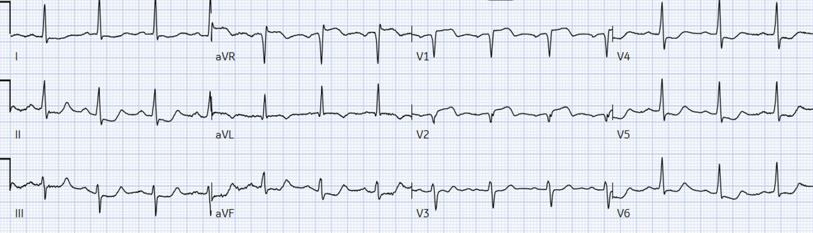
46 year-old with sudden chest pain and recent cocaine use. ADD-RS = 1.
ECG STEMI negative but subtle proximal LAD occlusion (ST elevation and hyperacute T wave V1-2 with reciprocal ST depression V5-6, and inferior ST depression reciprocal to biphasic T wave in aVL. No POCUS. Sent for CT to exclude AAS, then code STEMI. Door-to-cath 2h13min, 100% LAD occlusion. First troponin 9ng/L (normal), peak 75,000ng/L
STEMI(-)OMI with CT aorta then admit as NSTEMI with prolonged reperfusion delay
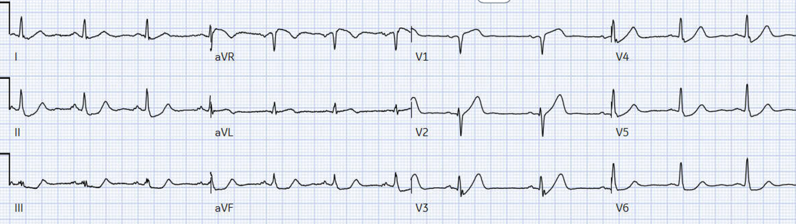
59 year-old with shortness of breath and mild chest pain. ADD-RS = 0.
ECG STEMI negative but subtle LAD occlusion (hyperacute T waves V1-3, including deWinter T wave in V3, with reciprocal ST depression V5-6, and ST elevation aVL with reciprocal ST depression inferior). No POCUS. CT ruled out dissection 3 hours after arrival and then admitted as NSTEMI. Door-to-cath 11 hours, 100% LAD occlusion. First troponin 65ng/L, peak 420,000ng/L.
STEMI(-)OMI with CT aorta then admitted as NSTEMI with prolonged reperfusion delay
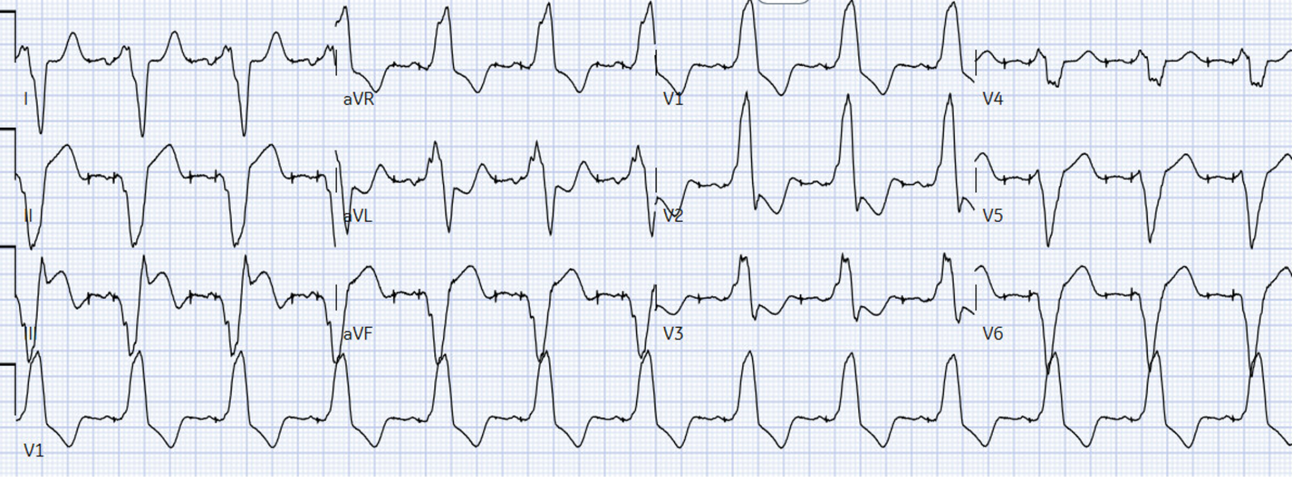
49 year-old with sudden chest pain. ADD-RS = 1.
ECG paced rhythm with inferior OMI (Modified Sgarbossa positive with excessive inferior ST elevation). No POCUS. First troponin 879ng/L and referred to cardiology as ACS. CT excluded AAS but then admitted as Non-STEMI. Door-to-cath 14 hours, 100% RCA occlusion, peak troponin 5,000ng/L.
AAS with abnormal ECG but no STEMI or OMI signs, and rapidly diagnosed
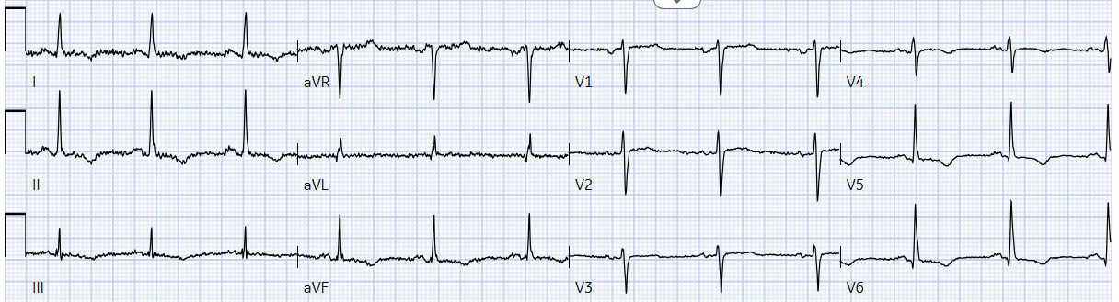
53 year-old with sudden severe chest pain and 50mmHg blood pressure differential. ADD-RS = 2. ECG had non-specific inferolateral T wave inversion interpreted as not showing STEMI or OMI, and treating physician noted they were old. CT chest revealed type A aortic dissection, door-to-CT time of 94 minutes.

