Supplementary Fig S1. Clustering of Streptococcus isolates based on gene presence/absence. Elbow plot illustrating the within-cluster sum of squares (WSS) for different values of k. The inflection point at k = 7 was used to determine the optimal number of clusters for UMAP partitioning.

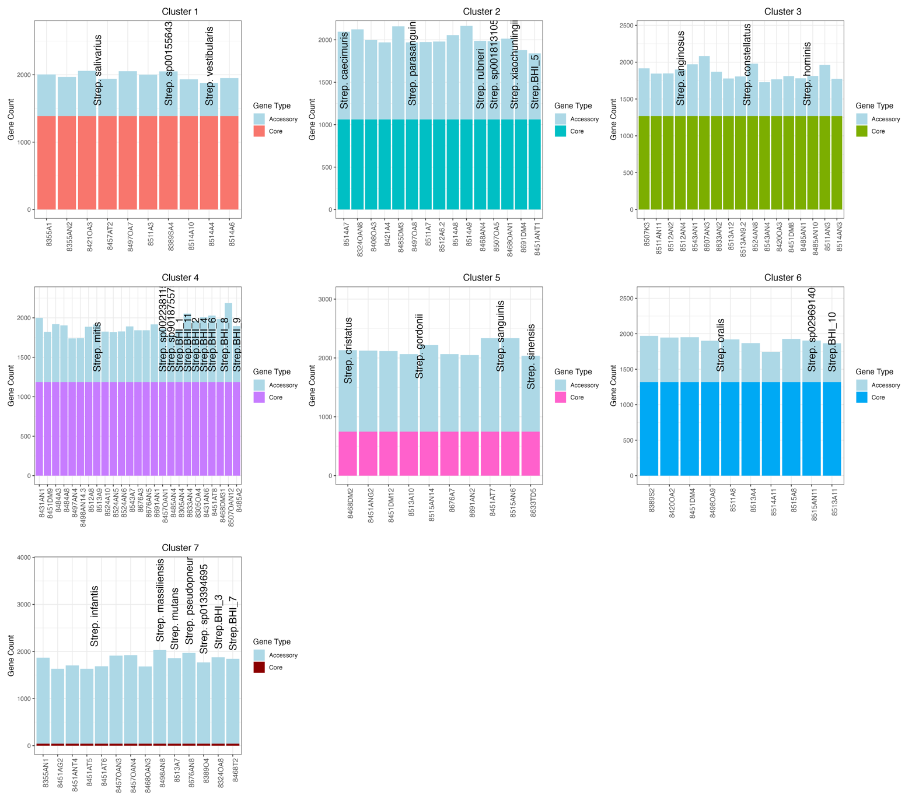
Supplementary Fig S2. Distribution of Core and Accessory Genes Across Species within UMAP Clusters of Streptococcus Isolates.
Figure illustrates the distribution of core and accessory genes across Streptococcus species within each of the seven UMAP clusters in Figure 2A. Each panel corresponds to a specific UMAP cluster, with isolates grouped by species along the x-axis. Stacked bars represent the total gene count (y-axis) for each isolate, divided into two categories: Core Genes (bottom portion of each bar) indicates genes shared across most isolates in that cluster. Accessory Genes (top portion of each bar, light blue) representing genes unique to individual isolates.

Supplementary Figure S3. Genomic characteristics of Streptococcus species with multiple isolates from HNC patients.
(A) Diagnostic scatter plot showing the relationship between the number of isolates per species and the size of the species’ pangenome (total CDS) or core genome. Each point represents a species, with pangenome size (x-axis) and core genome size (y-axis) calculated from non-rarefied datasets.
(B) Summary of key genomic features for species with ≥2 isolates. Bars show mean values per species with error bars representing standard deviation. Metrics include average GC content (%), average genome size (bp), number of core genes, and total predicted coding sequences (CDS) per species (pangenome size).

Supplementary Figure S4. Global sharing network and cluster size distributions of MGEs.
(A) Global sharing network of integrative and conjugative elements (ICEs), plasmids, and prophages detected across 132 Streptococcus isolates. Each node represents an isolate, and edges indicate shared MGE clusters between isolates. The network shows that certain MGEs are present across multiple patients, reflecting widespread population-level prevalence rather than direct person-to-person transfer.
(B) Distribution of MGE cluster sizes (number of isolates per cluster) for ICEs, plasmids, and prophages. ICEs formed the largest clusters, with some spanning >40 isolates, while plasmids reached up to 26 isolates. In contrast, prophage clusters were generally restricted, rarely exceeding 4 isolates, consistent with their host-specific integration patterns.

Supplementary Figure S5. Functional composition of mobile genetic elements (MGEs) stratified by patient and species.
(A) Stacked bar plots showing within-patient functional composition of MGEs after excluding hypothetical and uncharacterised proteins. ICEs were dominated by transposase/IS elements and metabolic/transport functions, whereas prophages carried higher proportions of recombination and replication genes. Considerable heterogeneity was observed between patients, with some harbouring ICE-dominated mobilomes and others enriched in prophage-associated functions.
(B) Stacked bar plots showing species-level functional composition of MGEs, also excluding hypothetical and uncharacterised proteins. S. salivarius and S. vestibularis mobilomes were enriched for metabolic/transport functions, S. mitis and S. oralis carried a larger fraction of recombination and phage-related genes, and S. constellatus was enriched for phage functions. Rare taxa contained few MGEs, often dominated by transposase or recombination modules.
Supplementary Fig. S6. Beta diversity of gene content across Streptococcus isolates.
(A) Principal Coordinates Analysis (PCoA) based on Jaccard distances calculated from presence/absence of all genes across 467 isolates. Cancer and healthy isolates are shape-coded; Streptococcus species are colour-coded; ellipses indicate 95% confidence intervals. PERMANOVA revealed significant separation by source (R² = 0.029, p = 0.001).
(B) Species-stratified PCoA plots across 12 matched Streptococcus species. Each panel shows the distribution of isolates by source, with corresponding 95% confidence ellipses. PERMANOVA performed per species (see Supplementary Table S6), showing variable degrees of separation (R² range: 0.016–0.296).

Supplementary Fig. S7. Comparative analysis of CAZyme composition and diversity between cancer and healthy Streptococcus isolates.

(A) Stacked bar plots displaying the proportional composition of CAZy classes (GH, GT, CBM, CE, AA, PL) across shared species by cohort.
(B) Violin plots showing the number of unique CAZyme families per isolate across matched species from cancer and healthy cohorts. Statistical comparisons were performed using the Wilcoxon rank-sum test.

(C) Enrichment analysis based on Fisher’s exact test (FDR-corrected), identifying CAZy classes that differ between cohorts. Arrows indicate the direction of enrichment (cancer vs. healthy), with colour representing species identity and bar length indicating –log₁₀ adjusted p-values.
Supplementary Fig. S8. Species-resolved gene enrichment differences between cancer-associated and healthy Streptococcus isolates.
Faceted volcano plots display the frequency difference (Healthy – Cancer) and statistical significance (–log₁₀ FDR-adjusted p-value) of gene presence across five representative Streptococcus species with significant differential enrichment. Each point corresponds to a gene, coloured by the group in which it is more prevalent. Labels highlight selected genes with large effect sizes. Differential enrichment was assessed using Fisher’s exact test followed by Benjamini–Hochberg correction for multiple comparisons.

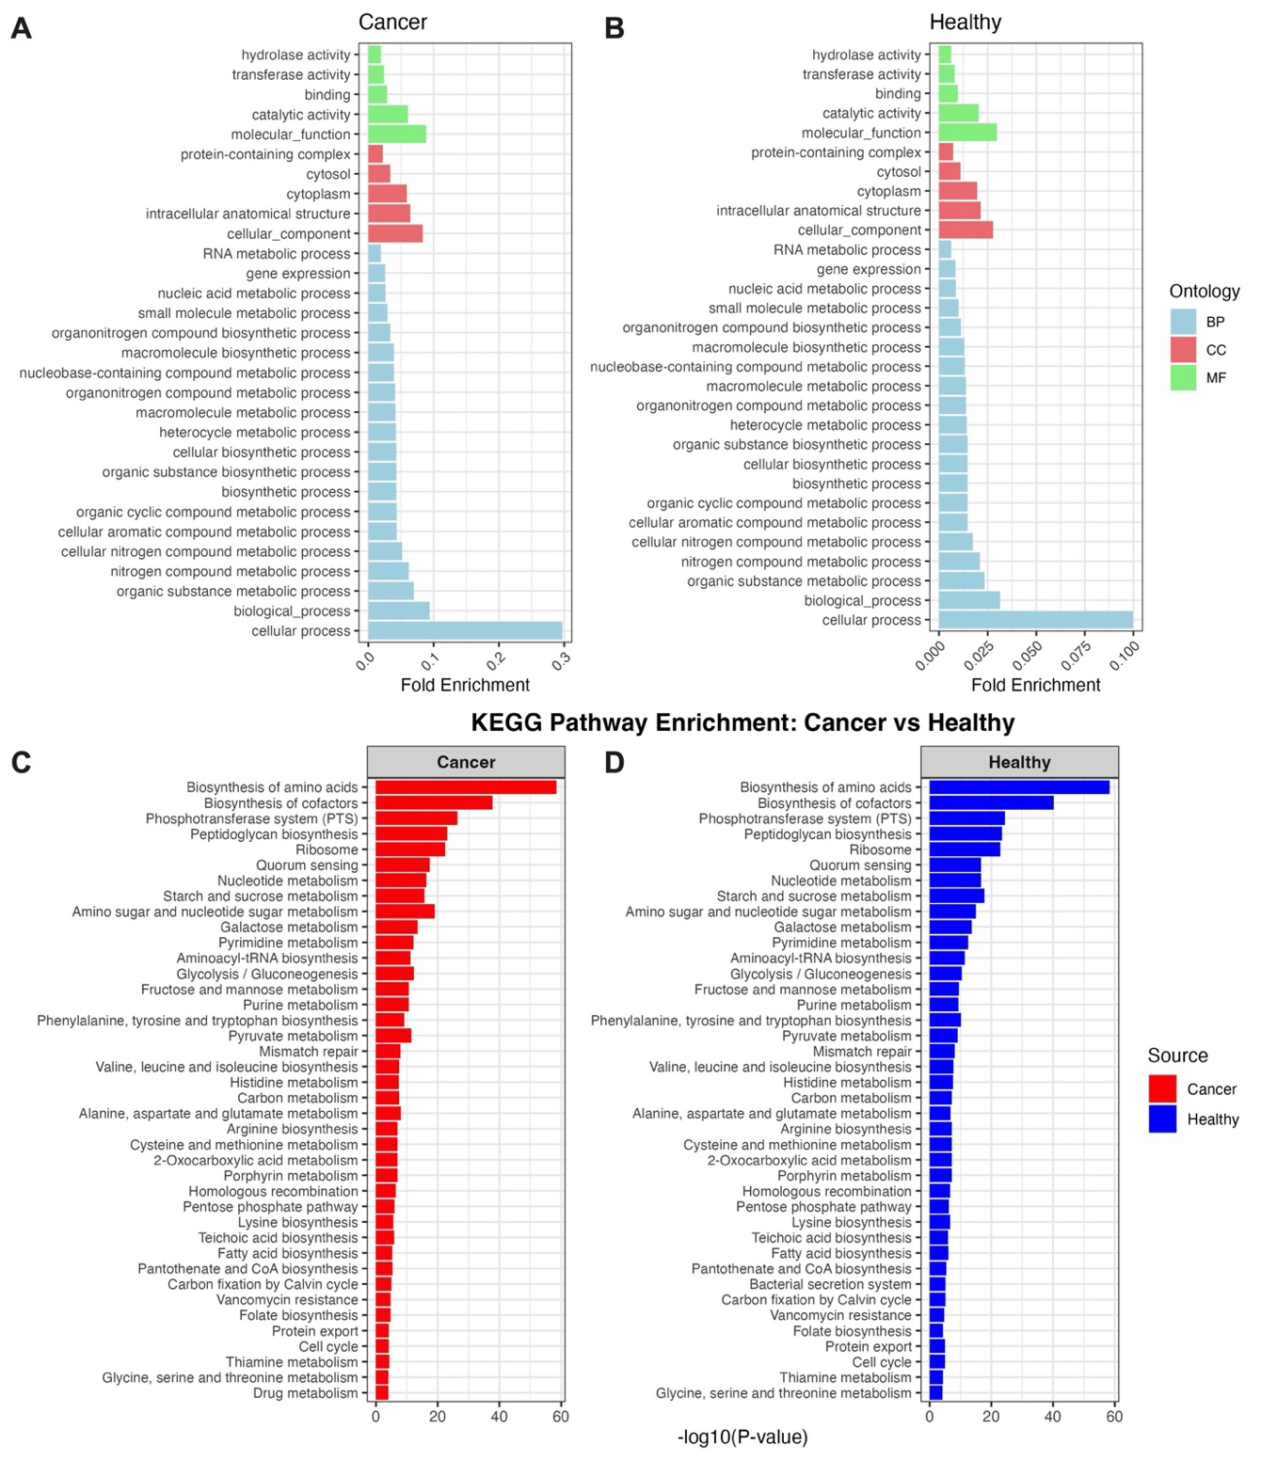Supplementary Fig. S9: Functional enrichment analysis of whole-genome gene content from Streptococcus isolates in cancer and healthy cohorts.
(A–B) Gene Ontology (GO) enrichment analysis comparing Streptococcus isolates from HNC patients (A) and healthy cohort (B), based on the full gene repertoire. GO terms are grouped by ontology: molecular function (MF, green), cellular component (CC, red), and biological process (BP, blue). Enrichment is quantified by fold enrichment relative to the total genome background.
(C–D) KEGG pathway enrichment of whole-genome gene content for cancer (C) and healthy (D) isolates. Bars indicate the significance of pathway enrichment, represented as –log₁₀ (p-value). Enriched pathways include metabolic, biosynthetic, and signalling functions, with distinct patterns observed between the two cohorts.

