Supplementary Material

Contents
Sample Size calculation 2
Ethics Approval 3
Eligibility Criteria 8
Consent Form 10
Questionnaire 12

Sample Size calculation

With a total population of 1190 across all RHAs and accounting for an 85% rate, the sample size is as follows such that n₀ is the initial sample size given by:

With a total population of N= 1190 across all RHAs and accounting for an 85% rate, the sample size is as follows such that n₀ is the initial sample size given by:
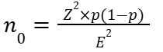
and n is the final sample where the Finite Population Correction (FPC) was applied and adjustment made for the response rate given by:
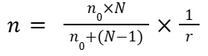
where
- Level of Confidence Measure (Z) = 1.96
- Margin of Error (E) = 0.05
- Baseline level (p) = 0.5
- Response rate (r) = 0.85
Hence, the Final Sample Size is approximately 342.

Ethics Approval

UWI Ethics Approval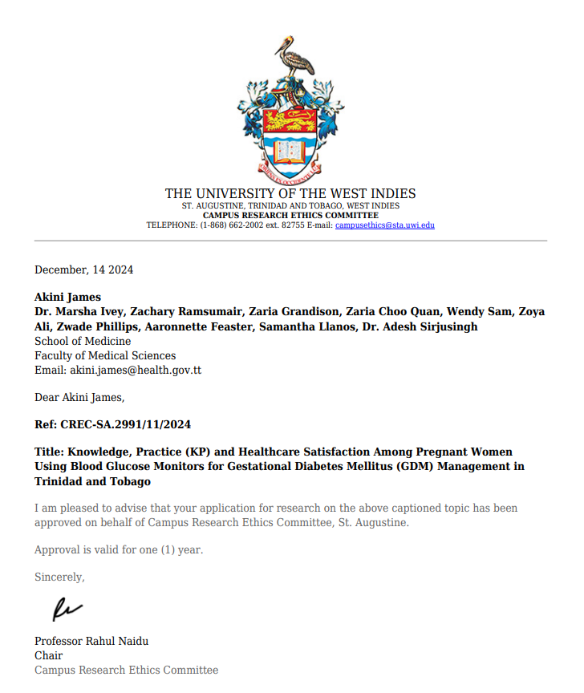
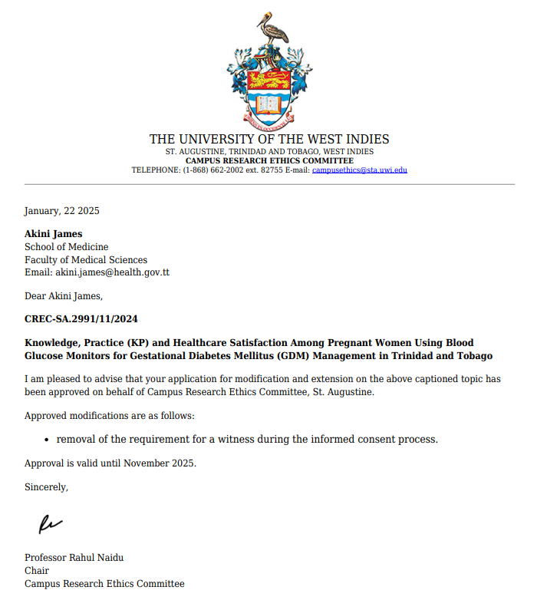

Ministry of Health Ethics Approval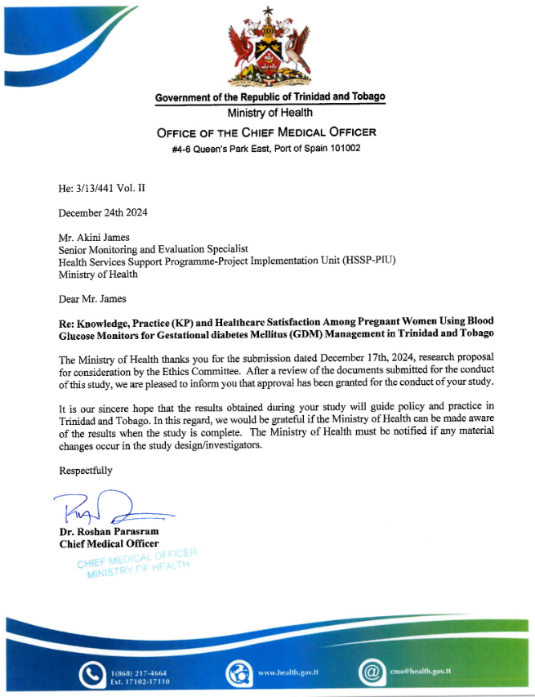
Tobago House of Assembly Ethics Approval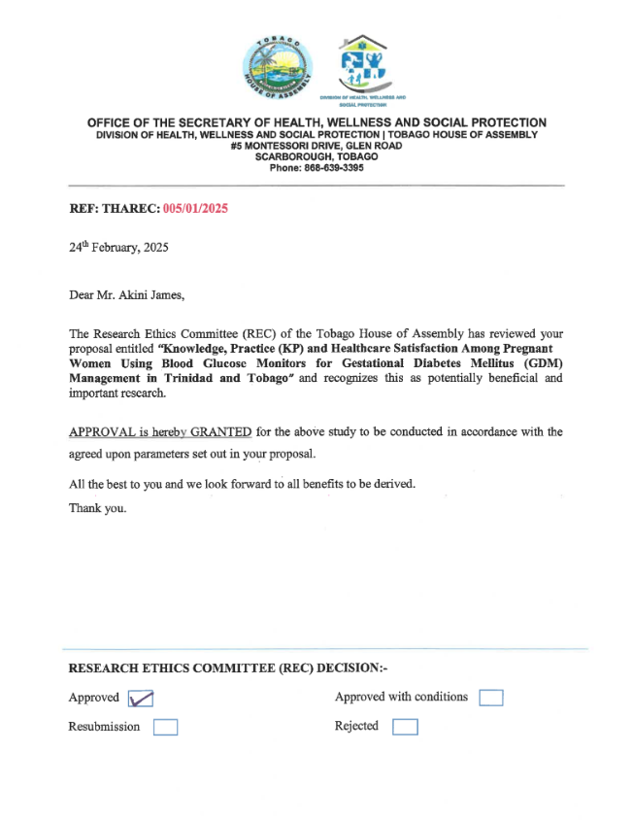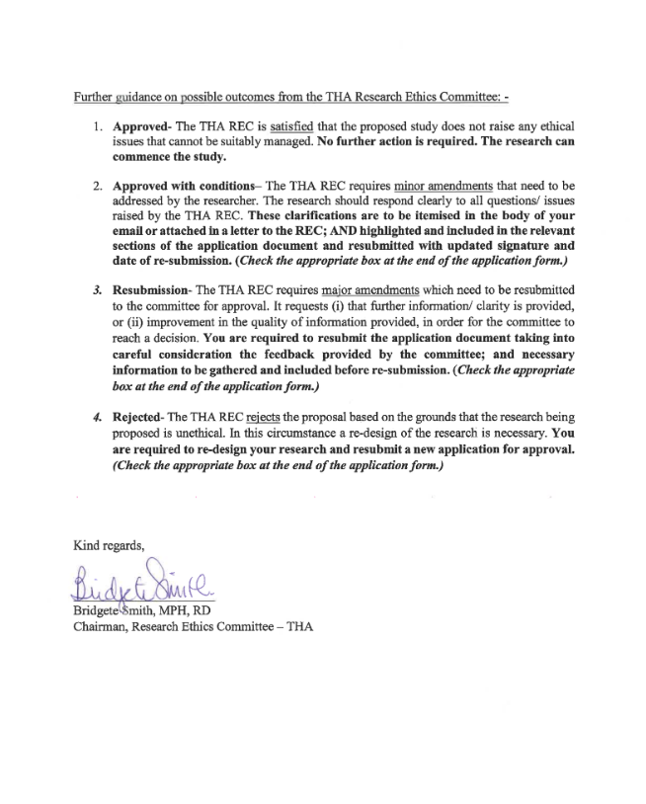

Eligibility Criteria
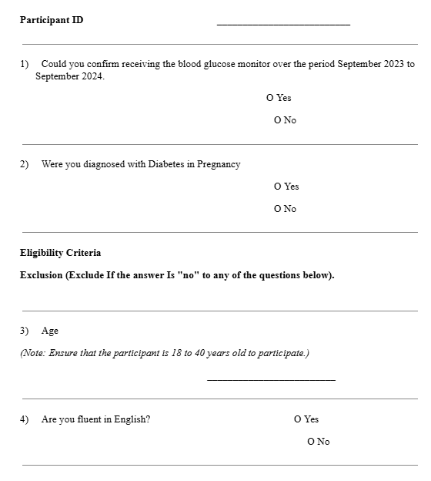

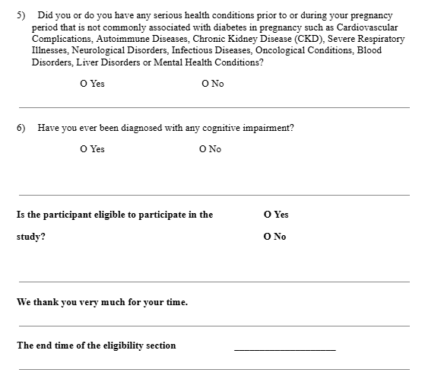

Consent Form
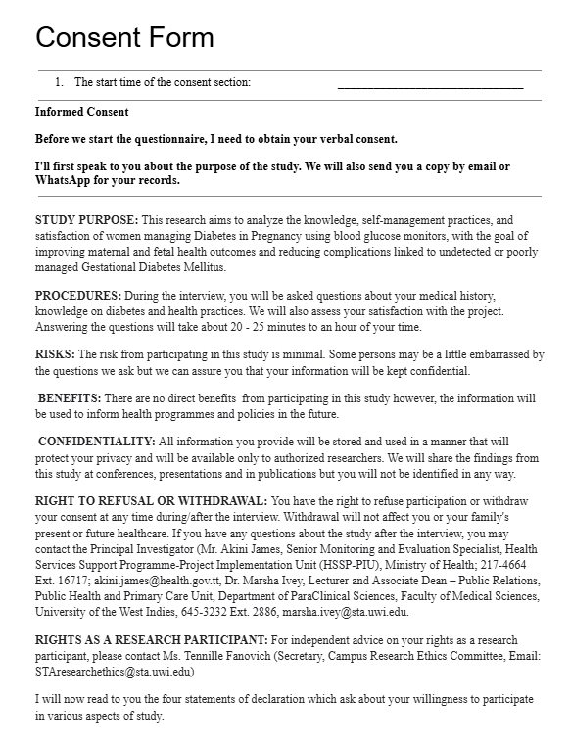
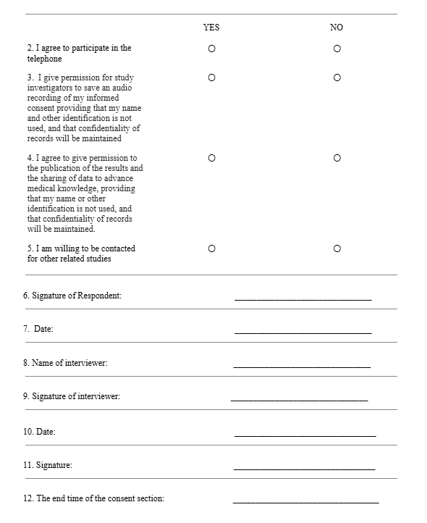

Questionnaire

Knowledge, Practice (KP) and Healthcare Satisfaction Among Pregnant Women Using Blood Glucose Monitors for Gestational Diabetes Mellitus (GDM) Management in Trinidad and Tobago
Section A - Demographic and Pregnancy History
To start, we’d like to ask a few questions about your background and pregnancy history to help us understand more about you and your experiences related to diabetes in pregnancy.
1. What is your age?
2. How tall are you (cm)?
3. What is your race?
- African
- East Indian
- Mixed (African and East Indian)
- Other
4. What is your usual weight when not pregnant (kg)?
5. How many pregnancies lasting 5 months (20 weeks) or more have you experienced in your lifetime?
6. How many of these pregnancies resulted in live births?
7. Are you currently pregnant? [If no, go to question 9]
- Yes
- No
8. How many weeks pregnant are you? [Go to question 10].
9. How old is your youngest child (months)?
10. Were you previously diagnosed with diabetes prior to your most recent pregnancy? [If no, go to question 12]
- Yes
- No

11. What type of diabetes were you diagnosed with prior to your most recent pregnancy? [Go to question 13].
- Type 1
- Type 2
- I don’t know

12. How many weeks pregnant were you when gestational diabetes was diagnosed?
13. Did you know anything about diabetes before your most recent pregnancy? [If nothing, go to question 15]
- Nothing
- A little
- Quite a lot
- A lot

14. Where did this knowledge come from? Select all that apply.
- from a relative or close friend with diabetes.
- from having gestational diabetes in a previous pregnancy.
- from reading books, newspapers or magazines.
- from the T.V.
- from your family doctor.
- another, please explain. __________________________________

15. How [do/did] you see about your diabetes? Select all that apply.
- antenatal clinic
- diabetes clinic
- antenatal clinic at another hospital.
- a private doctor
- other, please explain………………………………

16. Have you had gestational diabetes in a previous pregnancy?
- Yes
- No
- I don't know
- N/A

Section B - Knowledge
The next few questions will focus on your knowledge of diabetes during pregnancy.

17. People with diabetes have
- too much sugar in the blood.
- too little sugar in the blood.
- no sugar in the blood but plenty in the urine.
- I don't know.

18. Insulin is a hormone which
- increases sugar in the urine.
- increases sugar in the blood.
- allows sugar to enter the cells of the body.
- I don't know.
19. Diabetes is a disease
- for which there is no treatment
- that can be cured.
- that cannot be cured but can be controlled.
- I don't know.

20. If you have had gestational diabetes
- you will always develop diabetes in later life.
- you have an increased likelihood of developing diabetes in later life.
- there is little likelihood of developing diabetes in later life.
- I don't know.

21. If you have had gestational diabetes in one pregnancy, will it occur again in future pregnancies?
- it is unknown whether gestational diabetes will occur in future pregnancies.
- it is unlikely to occur again in future pregnancies.
- it is likely to occur again in future pregnancies.
- I don't know.

22. Being overweight
- increases the risk of getting diabetes.
- decreases the risk of getting diabetes.
- does not affect the risk of getting diabetes
- I don't know.
23. Regular exercise
- increases the risk of getting diabetes
- decreases the risk of getting diabetes.
- has no effect on the risk of getting diabetes.
- I don't know.

24. Exercise
- has no effect on the body.
- increases blood sugar levels.
- assists the action of insulin.
- decreases the production of insulin.
- I don't know.

25. A diet high in fat and sugar
- may cause weight gain
- decreases blood sugar levels.
- has no effect on the body.
- may cause weight loss.
- I don't know.
26. High blood pressure
- decreases insulin production.
- increases insulin production.
- has no effect on the risk of getting diabetes.
- increases blood sugar levels.
- I don't know.

27. Which of the following are signs and symptoms of diabetes? Select all that apply.
- weight gain
- excessive thirst
- passing excessive amounts of urine
- high blood pressure
- tiredness
- frequent vaginal infections
- anemia
- high cholesterol
- I don't know

28. Diabetes may cause health problems such as (Select all that apply).
- stroke
- anemia
- blindness
- heart attack
- kidney disease
- cancer
- I don't know

29. As part of a healthy lifestyle, it is recommended that you exercise
- occasionally
- 3 or 4 times a week for 30 to 60 minutes.
- vigorously at the gymnasium once a fortnight for 10 to 20 minutes only.
- I don't know
30. Which of the following types of exercise are recommended as part of a healthy lifestyle?
- walking briskly.
- cycling.
- swimming regularly
- bungee jumping.
- I don't’ know
31. A healthy diet includes foods which contain dietary fiber. Which of the following foods contain fiber?
- meat, fish and chicken.
- dairy products.
- bread and cereal.
- fruit vegetables.
- I don't know.

32. To achieve and maintain a healthy weight
- eat a diet high in fat and sugar.
- exercise regularly.
- eat a diet low in fat and sugar.
- do not overeat.
- If you drink alcohol, drink in moderation only.
- eat a diet low in cholesterol.
- do not use overeating as a method of lowering stress.
- I don't know.

Section C – Practice
The next few questions will focus on how you are currently managing or managed diabetes during pregnancy.

33. Do you monitor your blood glucose level regularly?
- Never
- Occasionally
- Frequently

34. Do you have a habit of recording your diet and weight?
- Never
- Occasionally
- Frequently

35. Do you stick with exercise?
- Never
- Occasionally
- Frequently
36. Do you follow the instructions of doctors or dieticians to eat a low-glucose, low-fat and low-oil diet on a daily basis?
- Never
- Occasionally
- Frequently

37. Do you follow the instructions of doctors or dieticians to control your daily total dietary intake?
- Never
- Occasionally
- Frequently

38. Do you bring candy with you for possible hypotension when doing exercise?
- Yes
- No

39. Do you actively acquire knowledge about GDM, its management and other relevant information regularly from doctors, books, the internet or APP?
- Never
- Occasionally
- Frequently

40. Would you ask the community medical service for help with controlling your blood glucose level?
- Yes
- No

41. Would you see a doctor immediately if your blood glucose level was not well controlled?
- Yes
- No

42. Do you receive prenatal examinations regularly?
- Yes
- No (missed >3 appointments)
Section D – Patient Satisfaction
The next few questions will focus on how satisfied you were with the healthcare services you received during pregnancy.

 | Strongly disagree (-3) | Disagree (-2) | Mildly disagree (-1) | Neutral (0) | Mildly agree (+1) | Agree (+2) | Strongly agree (+3)
The following three questions have to do with your overall satisfaction with diabetes in pregnancy care.
43. I am/was satisfied with my treatment
44. I am/was satisfied that the treatment I am/was receiving is/was the best for me
45. I am/was satisfied with my understanding of diabetes

The following three questions have to do with your current/previous relationship with the diabetes clinical care team
46. I feel my maternity diabetes team knows enough about my current level of diabetes control
47. I feel I have a good relationship with my maternity diabetes team
48. I am satisfied with my maternity diabetes team’s understanding of my diabetes
The following three questions have to do with satisfaction with the Diabetes in Pregnancy health system
49. I find the equipment I use to check my blood sugars is convenient
50. I feel the equipment I use to check my blood sugars is reliable
51. My blood sugar monitoring fits in with my lifestyle

Retained and Omitted Questionnaire Items Based on Reliability Testing
- Knowledge Scale (16 items total)
Items Retained for Reliability Analysis (Cronbach’s Alpha = 0.70):
Q17, Q18, Q20, Q22, Q23, Q24, Q25, Q27, Q29, Q30, Q31
Items Omitted:
Q19, Q21, Q26, Q28, Q32

- Practice Scale (10 items total)
All items retained (Cronbach’s Alpha = 0.70)

- Satisfaction Scale (9 items total)
Items Retained for Reliability Analysis (Cronbach’s Alpha = 0.80):
Q43, Q44, Q45, Q46, Q47, Q48, Q49, Q50
Item Omitted:
Q51

