Supplementary Information

“I've been dancing for as long as I can remember but I started Memphis Jookin at the age of 13. I grew up watching Michael Jackson dance as inspiration. At the age of 16 I got into Ballet training which is also how I was introduced to Modern dance, Flamenco, and Jazz. When I moved to Los Angeles at the age of 19, I made myself an open channel for dance and movement in general.” | “I started taking Jookin classes at the age of 7, which led to me branching out and teaching and training myself. I started battling at 9 years old and never stopped. I am now the Queen of Memphis Jookin for the 3rd year in a row.”
“I began dancing in a dance studio taking Hip-Hop, Street Jazz, Ballet & Tap when I was around 10 years old. I fell in love with Hip-Hop dance, and my teacher encouraged me to pursue my passion for it. He was a huge proponent of developing my ability to freestyle or improvise when I danced. I was introduced to Memphis Jookin years later and began formally studying that style and became a street dancer when I was 18. Jookin is primarily a form of improvised dance.” | “I started dancing in spite of me wanting to be just like my dad. I studied his movement and wanted to take it seriously so he brought me to a dance session. After that session, I became heavily inspired and started practicing every day. I got into battles and became one of the greatest Memphis Jookers of all time. I went from being nervous, crawling on the floor to being confident and ranking up to get my respect on that dance floor. Things took a toll on my career and it went from just doing it for fun winning competitions to actually making this my job and getting paid from it. My father passed last year of October and now I'm turning up hard for him.”
“15 years of training and countless performances. I would like to say I was raised in this dance.” | “I'm not supposed to tell people, but when I came out of my mom's stomach, I started dancing and then I gained a few assets like drawing, painting, making clothes, and film cinematography.”
Supplementary Table 1. Participants’ qualitative description of dance history.

Description of Flow during Choreography | Description of Flow during  Improvisation
“In a choreographed moment, I am fully immersed in what I am doing. The experience is very focused.” | “When I am improvising, I build into a flow state. It starts with how I feel in that moment and my body reacts to that truth. The imagination takes it from there and everything that comes to me in that moment comes out visually. The experience is blissful and I feel at my most peaceful state.”
“It feels like I'm on autopilot. It's effortless.” | “My mind empties and I am just experiencing the events as they happen with no judgment almost as if I'm watching a movie scene unfold in front of me. I feel very relaxed and sure that everything is ok, and that every twist and turn in the moments as they unfold is completely perfect. I find things to be fascinating, funny, unique and fresh.”
“Clean, full of energy.” | “I just let my body do what it feels when hearing in the music.”
“I was engaged with every step and was excited when it was over. Done. Work hard, play hard.” | “Thoughts come and go. I don't know how to explain it.”
“Simply put, it's just putting the right shape in its correct slot.” | “It's like doing a word problem or a puzzle, but I'm the creator.”
“It's the same. I already remember the routine so I am in the same state of flow when engaged in movement improvisation.” | “My flow state is based off of the moment and everything that's happening. No matter what goes on, I'm able to remain conscious of everything and how precious the moment is. I do not like to think about what will happen or what I am doing. It feels as if I'm meditating and sitting still. When I dance it feels as if every thought has left my mind and the only thing that matters is present is what I'm experiencing.”
Supplementary Table 2. Participants’ qualitative description of flow: Dancers described flow experience during choreographed dance (left) and improvisation (right).

Behavioral Outcomes | Correlation Coefficient (r_{s}) | Adjusted P-Value
Attention Regulation (MAIA) | 0.98 | 0.005*
Body Listening (MAIA) | 0.83 | 0.342
Emotional Awareness (MAIA) | 0.98 | 0.005*
Not-Distracting (MAIA) | 0.49 | 0.749
Noticing (MAIA) | 0.81 | 0.368
Not-Worrying (MAIA) | 0.68 | 0.749
Self Regulation (MAIA) | 0.55 | 0.749
Body (MIMS) | 0.89 | 0.148
Contentment (MIMS) | 0.70 | 0.749
Energy (MIMS) | 0.94 | 0.057
Intuition (MIMS) | 0.66 | 0.749
Mind (MIMS) | 0.66 | 0.749
Supplementary Table 3. Behavioral correlates of short dispositional flow. *p<0.05

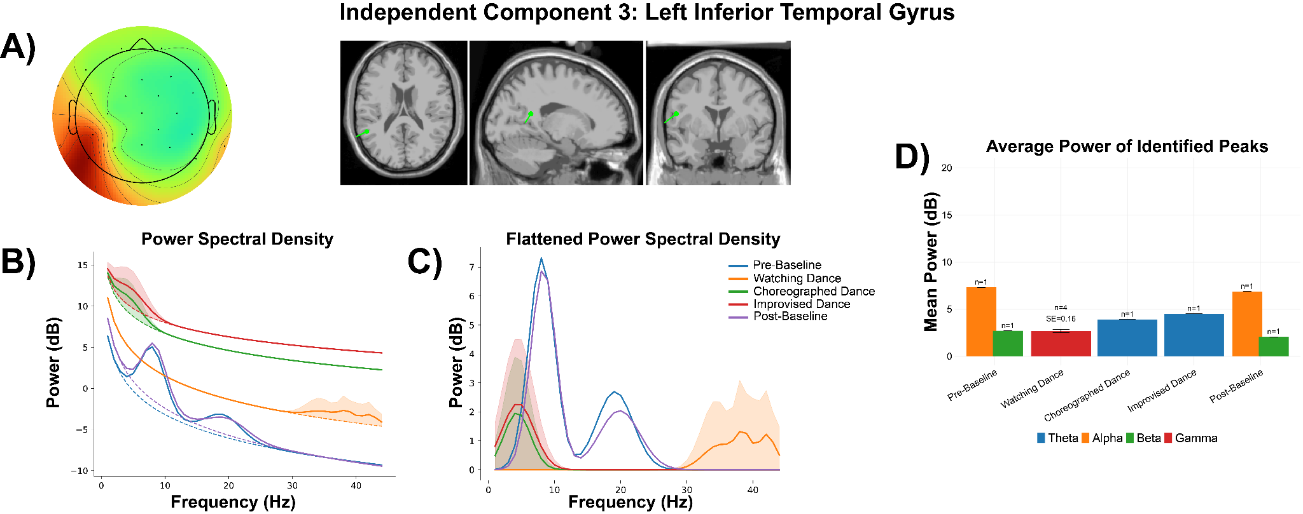

Supplementary Figure 1. Participant 1 - Independent Component 3. A) Topographical distribution, with a classification of 96.1% brain according to ICLabel. Dipole modeled for the component through DIPFIT, with MNI coordinates of [-52.4, -48.9, 16.9], a residual variance of 8.25%, and localization to the Left Inferior Temporal Gyrus on the AAL3 atlas. B) Power spectral density modeled through specparam for each experience, including average aperiodic fit (dotted line) and mean gaussian peaks (solid line). C) The aperiodic fits were removed from each modeled power spectra, providing a flattened spectra with only visible peaks. Shaded areas represent a full range of identified peaks (or lack thereof) for plots B and C. D) Average flattened power of identified peaks from the power spectra in Plot C split by experience and frequency band (Theta [4-8 Hz], Alpha [8-12 Hz], Beta [12-30 Hz], Gamma [30-45 Hz]). Number of peaks and standard error (SE) are shown above each bar. Error bars are +/- 1 standard error from the mean.

Left Inferior Temporal Gyrus: The left inferior temporal gyrus of Participant 1 generates a single peak for choreographed dance (power: 3.89 dB) and improvised dance (power 4.50 dB), demonstrating a pattern of theta activity taking place throughout the brain during movement sequences. While watching dance, activity was widespread for gamma, with 4 identified peaks ranging in power from 2.35 dB to 3.09 dB.

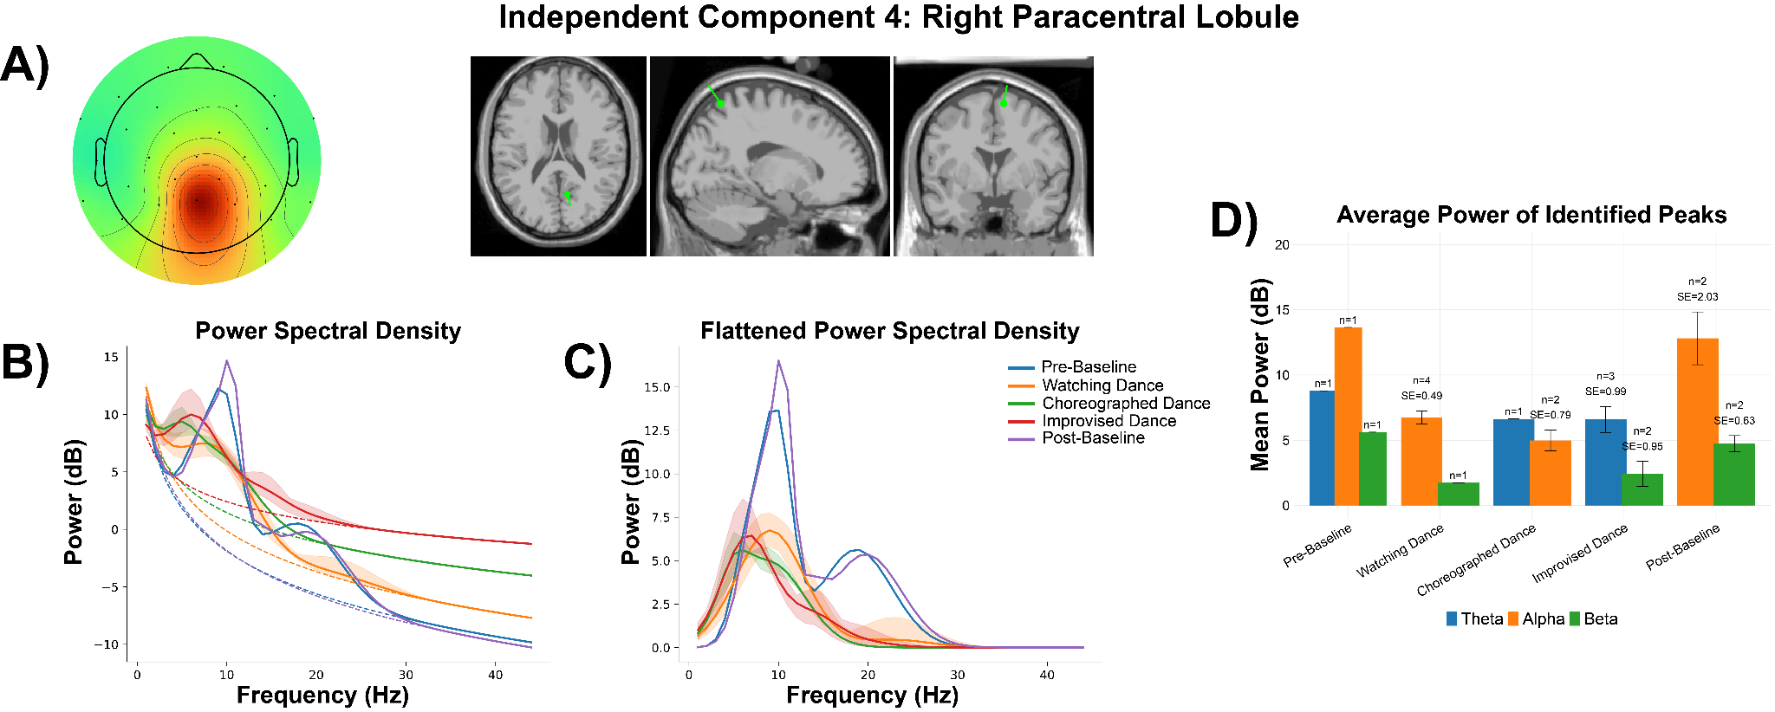

Supplementary Figure 2. Participant 1 - Independent Component 4. A) Topographical distribution, with a classification of 99.1% brain according to ICLabel. Dipole modeled for the component through DIPFIT, with MNI coordinates of [9.0, -61.3, 65.6], a residual variance of 1.87%, and localization to the Right Paracentral Lobule on the AAL3 atlas. B) Power spectral density modeled through specparam for each experience, including average aperiodic fit (dotted line) and average identified gaussian peaks (solid line). C) The aperiodic fits were removed from each modeled power spectra, providing a flattened spectra with only visible peaks. Shaded areas represent a full range of identified peaks (or lack thereof) for plots B and C. D) Average flattened power of identified peaks from the power spectra in Plot C split by experience and frequency band (Theta [4-8 Hz], Alpha [8-12 Hz], Beta [12-30 Hz]. No Gamma peaks (30-45 Hz) were identified. Number of peaks and standard error (SE) are shown above each bar. Error bars are +/- 1 standard error from the mean.

Right Paracentral Lobule: The activity observed in the right paracentral lobule of Participant 1 is similar to that observed in their left middle occipital gyrus. Choreographed dance (n_{peaks} = 1, min/max = 6.63 dB) and improvised dance (n_{peaks} = 3, min = 5.53 dB, max = 8.56 dB) displayed similar ranges in theta power. Watching dance was associated with similar levels of power, but in alpha (n_{peaks} = 4, min = 5.85 dB, max = 7.75 dB).

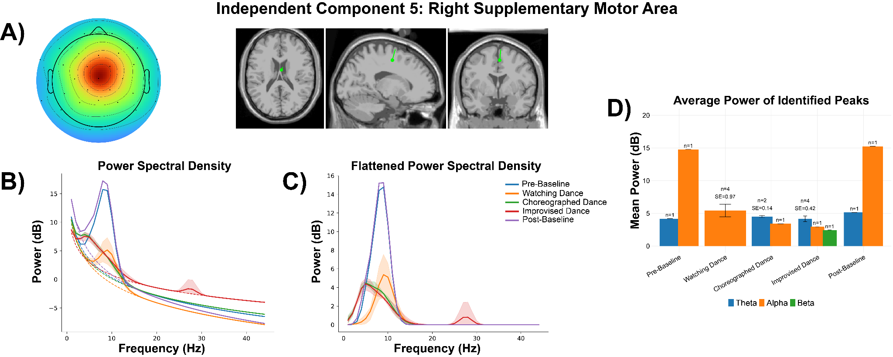

Supplementary Figure 3. Participant 1 - Independent Component 5. A) Topographical distribution, with a classification of 99.9% brain according to ICLabel. Dipole modeled for the component through DIPFIT, with MNI coordinates of [3.0, -5.3, 50.9], a residual variance of 1.20%, and localization to the Right Supplementary Motor Area on the AAL3 atlas. B) Power spectral density modeled through specparam for each experience, including average aperiodic fit (dotted line) and average identified gaussian peaks (solid line). C) The aperiodic fits were removed from each modeled power spectra, providing a flattened spectra with only visible peaks. Shaded areas represent a full range of identified peaks (or lack thereof) for plots B and C. D) Average flattened power of identified peaks from the power spectra in Plot C split by experience and frequency band (Theta [4-8 Hz], Alpha [8-12 Hz], Beta [12-30 Hz]. No Gamma peaks (30-45 Hz) were identified. Number of peaks and standard error (SE) are shown above each bar. Error bars are +/- 1 standard error from the mean.

Right Supplementary Motor Area: In the right supplementary motor area, we observe the same pattern of theta in choreographed (n_{peaks} = 2, min = 4.37 dB, max = 4.65 dB) and improvised dance (n_{peaks} = 4, min = 3.05 dB, max = 5.04 dB) experiences. Interestingly, this is one of the few components associated with higher frequency band activity during dance, specifically beta activity during improvised dance (n_{peaks} = 1, min/max = 2.44 dB).

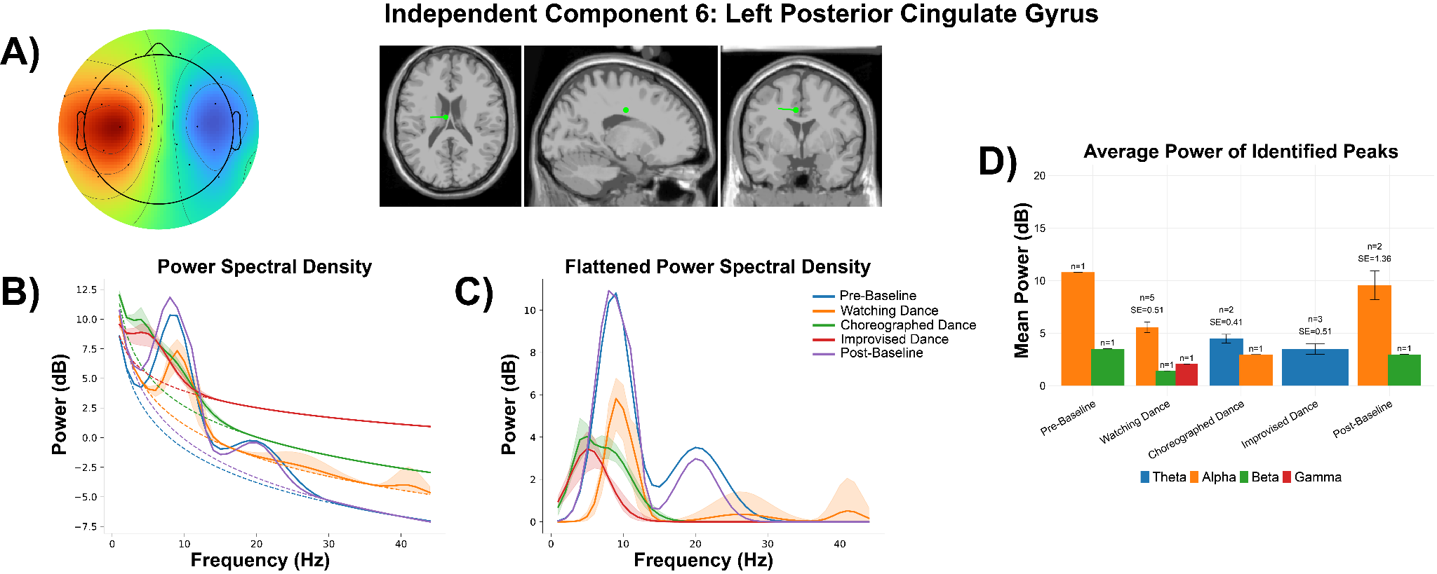

Supplementary Figure 4. Participant 1 - Independent Component 6. A) Topographical distribution, with a classification of 100% brain according to ICLabel. Dipole modeled for the component through DIPFIT, with MNI coordinates of [-6.1, -11.2, 36.0], a residual variance of 1.68%, and localization to the Left Posterior Cingulate Gyrus on the AAL3 atlas. B) Power spectral density modeled through specparam for each experience, including average aperiodic fit (dotted line) and average identified gaussian peaks (solid line). C) The aperiodic fits were removed from each modeled power spectra, providing a flattened spectra with only visible peaks. Shaded areas represent a full range of identified peaks (or lack thereof) for plots B and C. D) Average flattened power of identified peaks from the power spectra in Plot C split by experience and frequency band (Theta [4-8 Hz], Alpha [8-12 Hz], Beta [12-30 Hz], Gamma [30-45 Hz]). Number of peaks and standard error (SE) are shown above each bar. Error bars are +/- 1 standard error from the mean.

Left Posterior Cingulate Gyrus: In the left posterior cingulate gyrus, more peaks in theta are observed during choreographed (n_{peaks} = 2, min = 4.07 dB, max = 4.90 dB) and improvised dance (n_{peaks} = 3, min = 2.54 dB, max = 4.25 dB), with a higher range of power observed during choreographed dance. We also see activity in the frequency bands while watching dance, specifically a peak in beta (power = 1.42 dB) and gamma (power = 2.06 dB).

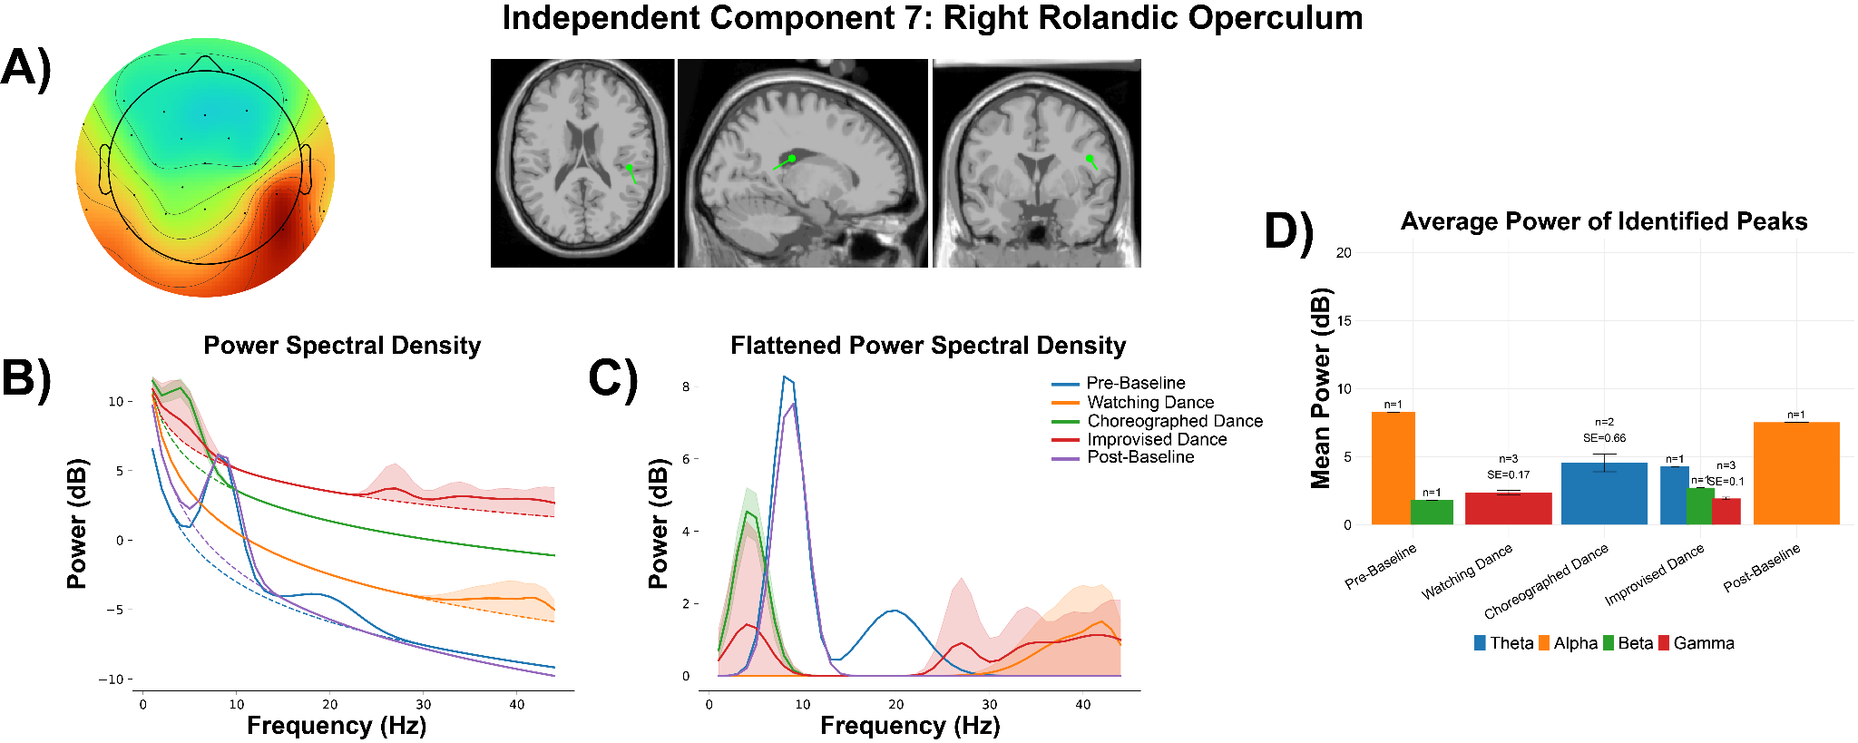

Supplementary Figure 5. Participant 1 - Independent Component 7. A) Topographical distribution, with a classification of 98.0% brain according to ICLabel. Dipole modeled for the component through DIPFIT, with MNI coordinates of [45.7, -26.7, 22.3], a residual variance of 11.92%, and localization to the Right Rolandic Operculum on the AAL3 atlas. B) Power spectral density modeled through specparam for each experience, including average aperiodic fit (dotted line) and average identified gaussian peaks (solid line). C) The aperiodic fits were removed from each modeled power spectra, providing a flattened spectra with only visible peaks. Shaded areas represent a full range of identified peaks (or lack thereof) for plots B and C. D) Average flattened power of identified peaks from the power spectra in Plot C split by experience and frequency band (Theta [4-8 Hz], Alpha [8-12 Hz], Beta [12-30 Hz], Gamma [30-45 Hz]). Number of peaks and standard error (SE) are shown above each bar. Error bars are +/- 1 standard error from the mean.

Right Rolandic Operculum: Although the typical pattern of theta activity is observed in the right rolandic operculum (Choreographed Dance: n_{peaks} = 2, min = 3.89 dB, max = 5.21 dB; Improvised Dance n_{peaks} = 1, min/max = 4.26 dB), this was a unique case where high frequency band activity spanned across beta (n_{peaks} = 1, min/max = 2.72 dB) and gamma (n_{peaks} = 1, min = 1.77 dB, max = 2.10 dB) during improvised dance.

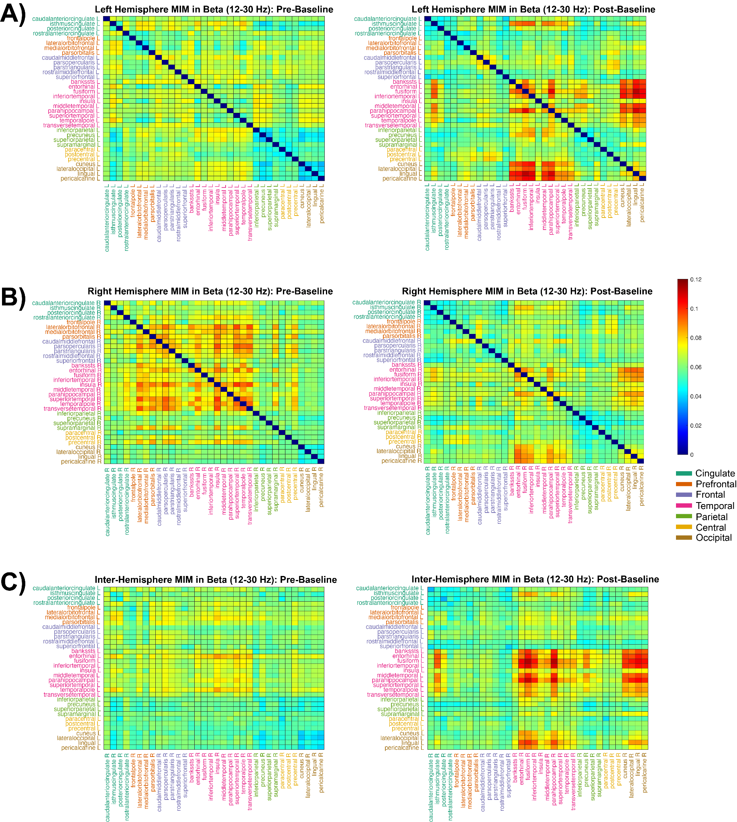

Supplementary Figure 6. Functional Connectivity in Beta (12-30 Hz). Intra-hemispheric MIM calculations between 34 regions of interest in 7 cortical areas (defined by the Desikan-Killiany atlas) in the left (top) and right (middle) hemispheres during pre-baseline (left) and post-baseline (right). Inter-hemispheric MIM calculations are shown in the bottom row, where the Y-axis represents regions in the left hemisphere and the X-axis represents regions on the right hemisphere.

Beta Connectivity: For beta, a different pattern emerged. The left hemisphere (n = 561) increased from M_{pre} = 0.063 to M_{post} = 0.065 (ΔM = 0.002, 95% CI [0.000, 0.003], d = 0.161; p_{perm} = .005; p_{holm} = .016) (Supplementary Figure 6A). The right hemisphere (n = 561), however, showed a decrease, M_{pre} = 0.068 to M_{post} = 0.063 (ΔM = -0.005, 95% CI [-0.006, 0.004], d = -0.519; p_{perm} < .001; p_{holm} = .005) (Supplementary Figure 6B). The interhemispheric network (n = 1,156) increased from M_{pre} = 0.062 to M_{post} = 0.064 (ΔM = 0.003, 95% CI [0.002, 0.004], d = 0.265; p_{perm} < .001; p_{holm} = .005). Beta changes were small in the left hemisphere, moderate in the right hemisphere, and small between hemispheres. Anatomically speaking, the observed changes were attributable to amplifications in intra-temporal coherence together with increased temporo-parietal and temporo-occipital coupling.
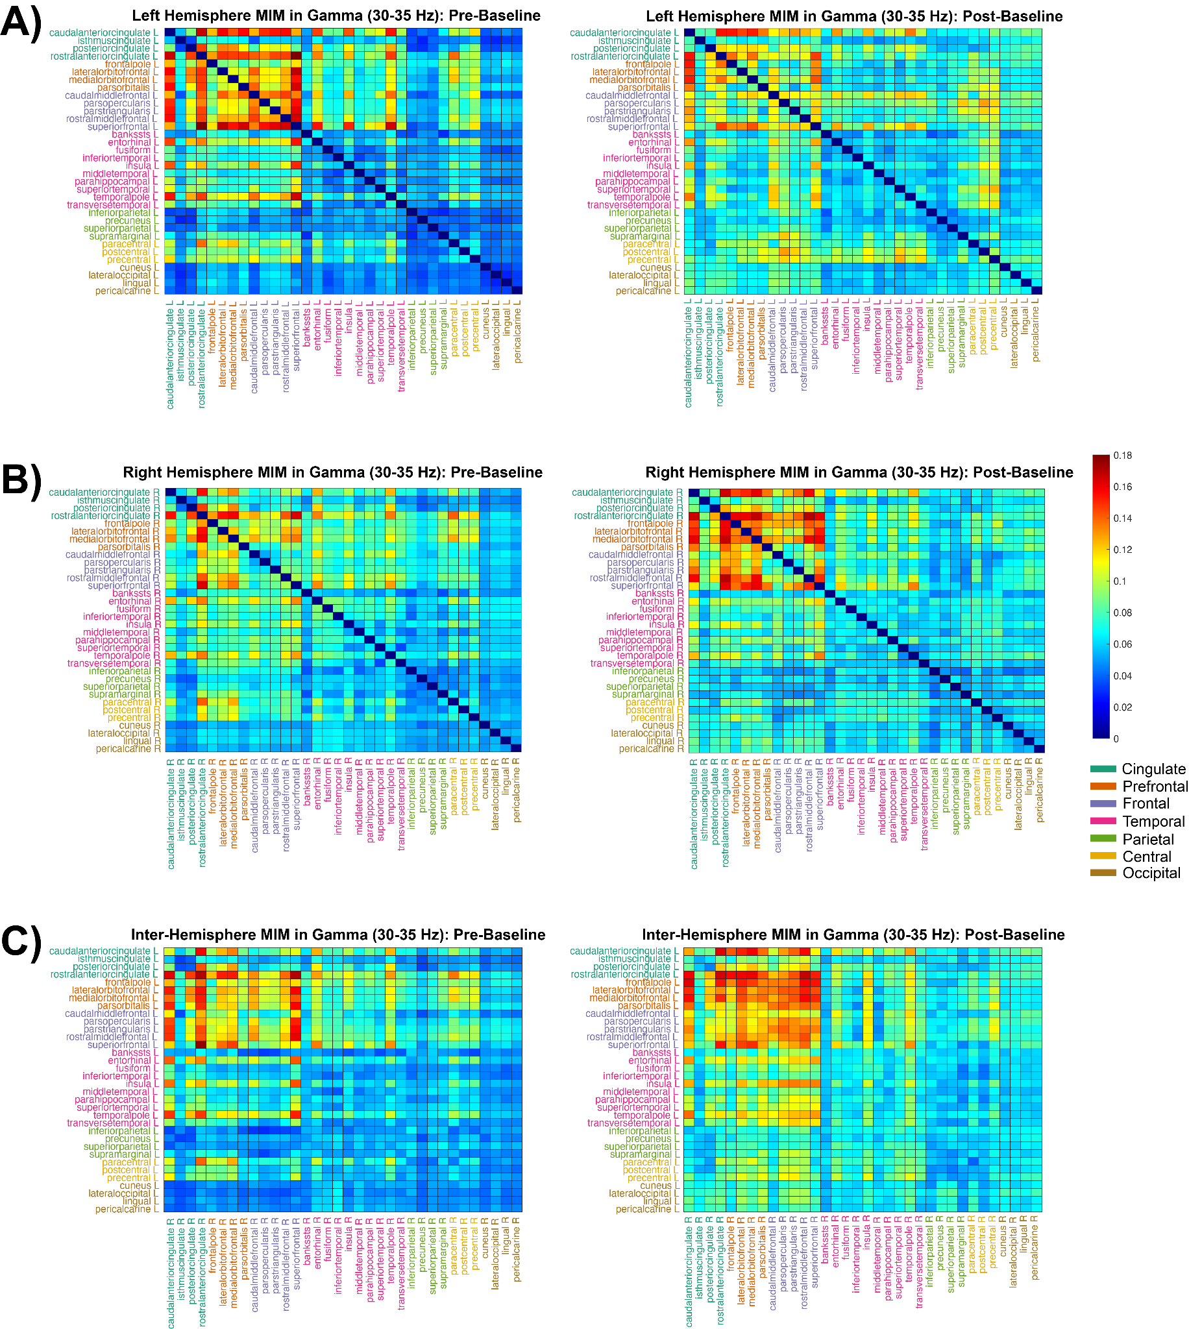

Supplementary Figure 7. Functional Connectivity in Gamma (30-35 Hz). Intra-hemispheric MIM calculations between 34 regions of interest in 7 cortical areas (defined by the Desikan-Killiany atlas) in the left (top) and right (middle) hemispheres during pre-baseline (left) and post-baseline (right). Inter-hemispheric MIM calculations are shown in the bottom row, where the Y-axis represents regions in the left hemisphere and the X-axis represents regions on the right hemisphere.

Gamma Connectivity: Finally, gamma connectivity exhibited significant pre–post increases across regions. The left hemisphere (n = 561) rose from M_{pre} = 0.071 to M_{post} = 0.077 (ΔM = 0.005, 95% CI [0.002, 0.008], d = 0.186; p_{perm} = 0.002; p_{holm} = 0.010) (Supplementary Figure 7A), with a small effect size. The right hemisphere (n = 561) demonstrated a similar increase from M_{pre} = 0.072 to M_{post} = 0.075 (ΔM = 0.003, 95% CI [0.000, 0.006], d = 0.131; p_{perm} = 0.021; p_{holm} = 0.042) (Supplementary Figure 7B). The interhemispheric network (n = 1,156) changed from M_{pre} = 0.069 to M_{post} = 0.081 (ΔM = 0.011, 95% CI [0.009, 0.013], d = 0.434; p_{perm} < .001; p_{holm} = 0.005), with a small to moderate effect size. Anatomically speaking, the observed increases occurred in intra-cingulate, cingulo-prefrontal, and fronto-prefrontal coherence, accompanied by similar patterns of coupling.

