Supplementary Figures
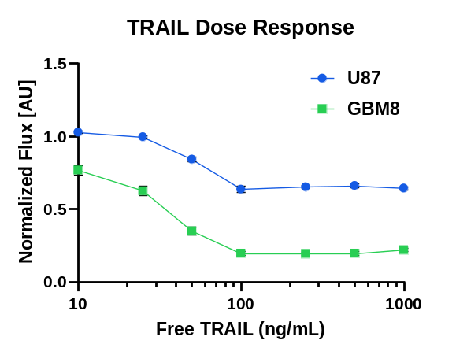
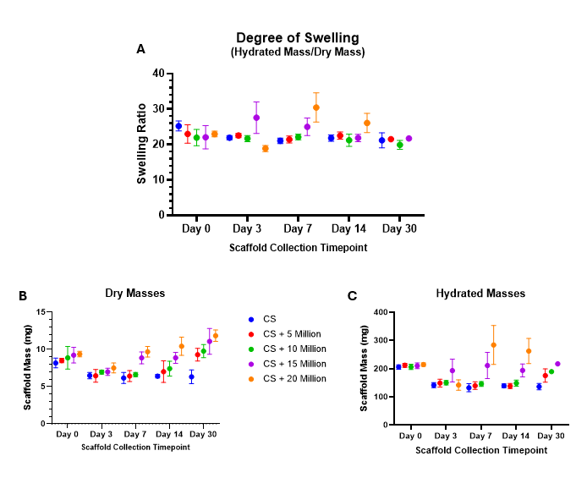
Supplementary Fig. 1. Various concentrations of recombinant TRAIL against U87-MG and GBM8 cell lines to determine toxicity.
Supplementary Fig. 2. Additional data from in vitro mass change study showing (A) the degree of swelling by scaffold density, calculated as the hydrated mass divided by the dry mass for each scaffold, (B) average dry masses and (C) average hydrated masses for scaffolds by cell density and timepoint.
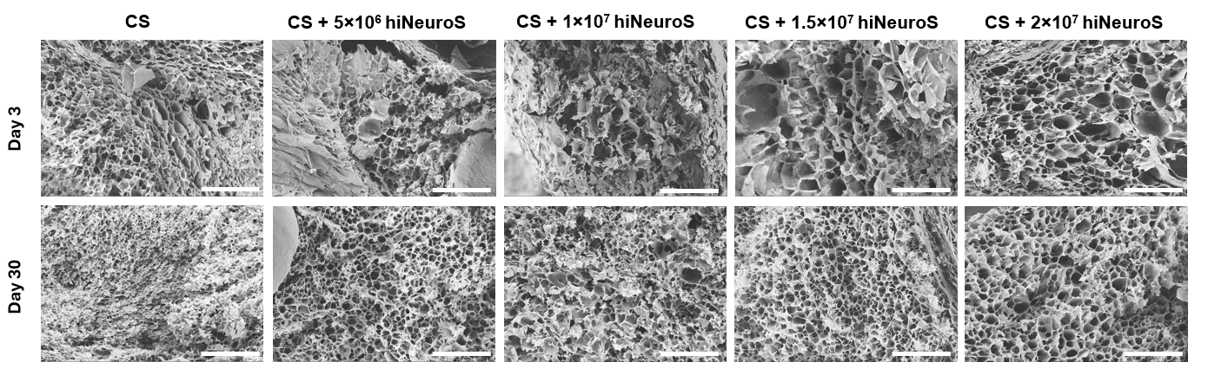
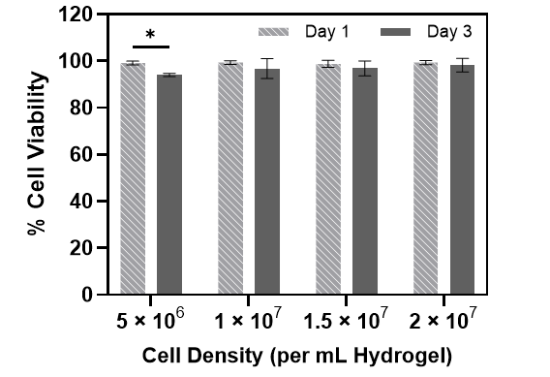
Supplementary Fig. 3. Scanning electron microscopy (SEM) images showing the cross-section of scaffolds collected at Day 3 and Day 30 timepoints of the in vitro mass change study. Images illustrate scaffold structure at increasing iNSC concentrations (scale bars, 100 μm; 750$×$ magnification).
Supplementary Fig. 4. Quantification of hiNeuroS viability within CS matrix at Day 3 relative to Day 1 for each cell density, analyzed using LIVE/DEAD assay and ImageJ cell counting.
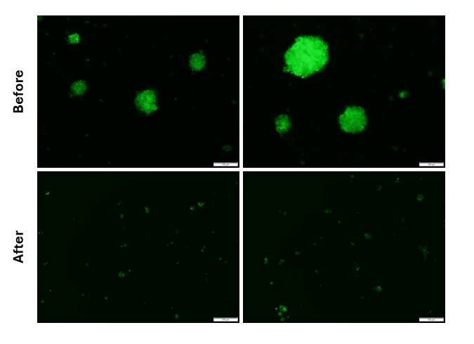
Supplementary Fig. 5. hiNeuroS cells before and after dissociation into single cells with accutase.

