Research Article
Supplementary material
UPLC-TQ MS Method Development and Validation for N-Nitroso-N-Desmethyl Methadone Detection in Methadone Hydrochloride Tablets: A Comprehensive Analysis
^{1, *}Rama Krishna Myneni, govardhan rao Thalluri², Ramakrishna K³
^{1,*} Senior Scientist, Analytical development, Stira pharmaceuticals LLC,161, Dwight place, Fairfield, Newjercy, 07004.
²PLSA Analytical, Supervisor QC and ARD, 40 Cotters Ln, East Brunswick, NJ 08816.
³Institute of Pharmaceutical Sciences and Research, Bhagwant University, Sikar Road, Ajmer-305023, Rajasthan, India.
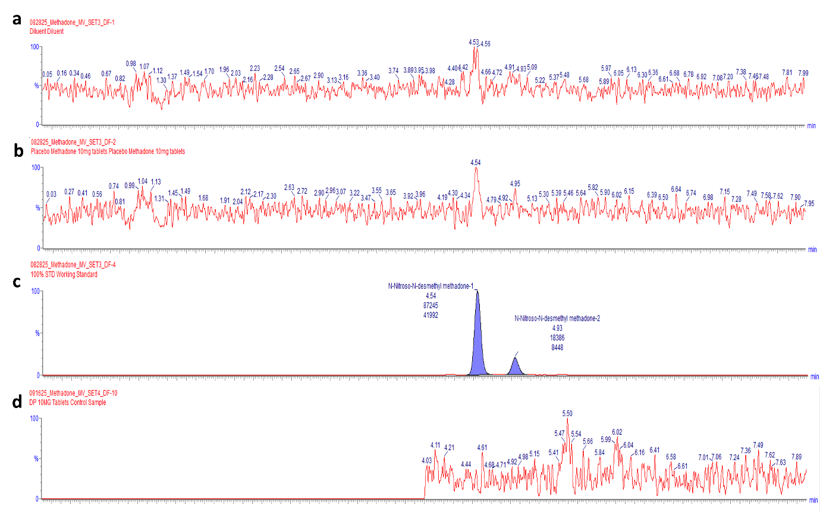
Figure S1. a. Typical chromatogram of Diluent, b. Typical chromatogram of Placebo 10mg and c. Typical chromatogram of Standard and d. Typical chromatogram of Drug Product 10mg control sample

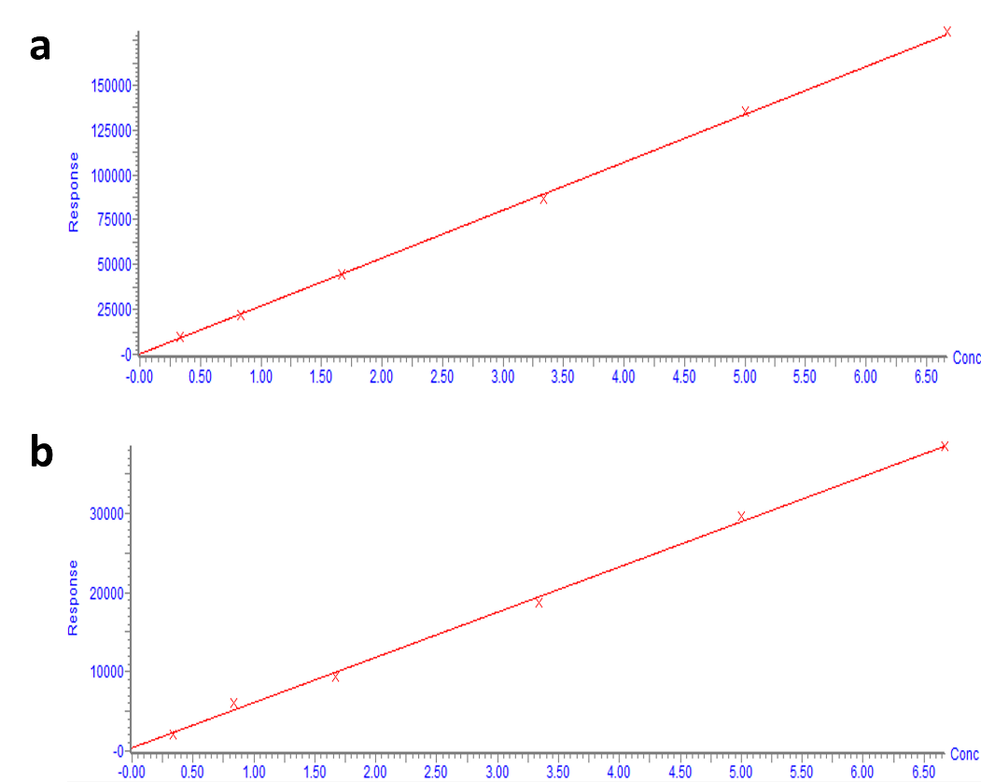
Figure S2. Linearity for N-Nitroso-N-Desmethyl Methadone
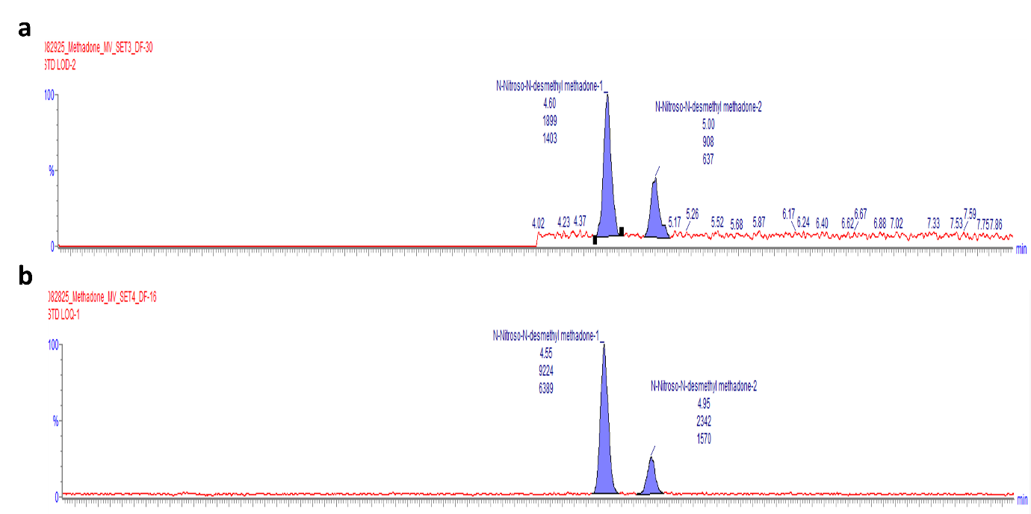
Figure S3. Typical chromatogram of Limit of Detection and Limit of Quantification
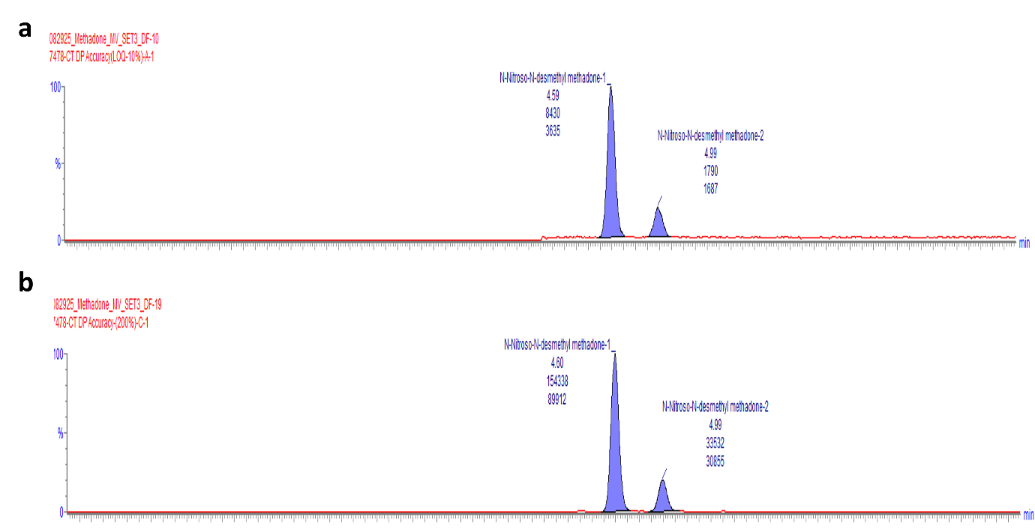
Figure S4: Typical chromatogram Accuracy-LOQ (10%) and Accuracy-200%

Table S1. Chromatographic Conditions
Parameter | Condition
Instrument | Waters Acquity I Class UPLC with Xevo TQS Micro MS
Column | ACQUITY UPLC BEH Shield RP 18 1.7 µm, 2.1 x 100 mm
Column Temperature | 35°C
Sample Temperature | 10°C
Flow Rate | 0.2 mL/min
Injection Volume | 5 µL
Run Time | ~8 minutes
Mobile Phase A | 5 mM Ammonium Acetate + 0.1% Formic Acid in Water
Mobile Phase B | Acetonitrile
Elution Program | Isocratic: 35% B / 65% A

Table S2. Mass Spectrometer Optimization Parameters and MRM Transitions
Parameter | Setting
Ion Mode | ESI Positive
Source Temperature | 120°C
Desolvation Temperature | 600°C
Desolvation Gas Flow | 600 L/hr
Cone Gas Flow | 150 L/hr
MRM Transitions | Parent Ion (m/z) > Daughter Ion (m/z) (Cone V / Collision eV)
Quantifier | 325.24 > 72.02 (22 V / 10 eV)
Qualifiers | 325.24 > 100.93 (22 V / 6 eV); 325.24 > 295.24 (22 V / 4 eV)

Table S3. System Suitability Results
Parameter | Peak-1 | Peak-2 | Acceptance Criteria
Standard Injection Area %RSD (n=6) | 1.0% | 1.9% | NMT 15.0%
Bracketing Standard Recovery-1 | 99.8% | 100.6% | Difference NMT 25%
Bracketing Standard Recovery-2 | 97.3% | 95.0% | Difference NMT 25%
Retention Time (min) | 4.55 | 4.94 | Report

Table S4. Linearity Results:
Parameter | Peak-1 Results | Peak-2 Results
Range (ng/mL) | 0.33 - 6.67 | 0.33 - 6.67
Slope | 26697.1 | 5709.4
Intercept | 242.55 | 402.77
Correlation Coefficient (r) | 0.9997 | 0.9979
Coefficient of Determination (r²) | 0.9995 | 0.9959

Table S5. Limit of Detection (LOD) and Quantification (LOQ) Results
Parameter | Concentration (ng/mL) | Mean S/N Ratio (n=6) | Precision (%RSD) | Acceptance Criteria
LOD | 0.066 | 563 | N/A | S/N ≥ 3
LOQ | 0.33 | 1664 | 2.1% | S/N ≥ 10, RSD ≤ 20%

Table S6. Method Precision Results (n=6)
Sample | Peak-1 Recovery (%) | Peak-2 Recovery (%) | Avg Recovery (%)
1 | 94.8 | 89.5 | 92.2
2 | 95.2 | 90.7 | 93.0
3 | 100.6 | 99.3 | 100.0
4 | 96.4 | 93.1 | 94.8
5 | 89.4 | 84.5 | 87.0
6 | 91.5 | 88.8 | 90.2
Mean | 94.7 | 91.0 | 92.9
% RSD | 4.1 | 5.4 | 4.7

Table S7. Intermediate Precision Results (n=6)
Parameter | Result | Acceptance Criteria
Mean Recovery | 98.1% | 80.0% - 120.0%
% RSD (n=6) | 1.5% | NMT 15.0%
Cumulative % RSD (n=12) | 3.7% | NMT 20.0%

Table S8. Accuracy Results (Drug Product)
Level | Amount Added (ppb) | Amount Found (ppb) | Mean Recovery (%) | Acceptance Criteria
LOQ (10%) | 0.3399 | 0.298 | 87.5% | 70.0% - 130.0%
100% | 3.3989 | 3.179 | 93.5% | 80.0% - 120.0%
200% | 6.7978 | 6.250 | 92.0% | 80.0% - 120.0%

Table S9. Robustness Results
Variation Condition | Peak-1 %RSD | Peak-2 %RSD | Peak-1 RT (min) | Peak-2 RT (min)
Control | 1.0 | 1.9 | 4.54 | 4.94
Low Flow (-0.02 mL/min) | 1.2 | 1.0 | 5.08 | 5.53
High Flow (+0.02 mL/min) | 1.0 | 2.3 | 4.12 | 4.48
Low Temp (-5°C) | 1.1 | 1.6 | 4.73 | 5.16
High Temp (+5°C) | 1.5 | 2.0 | 5.62 | 6.16

Table S10. Solution Stability Results
Solution | Time Point | % Difference | Acceptance Criteria
Standard | 24 Hours | 1.0% | NMT ±10%
Sample | 24 Hours | -3.0% | NMT ±20%

FIGURE LEGENDS:
Figure S1. Representative chromatograms of (a), (b) Diluent and Placebo showing as no interference observes at major analytes and in sample matrix and c) N-Nitroso-N-Desmethyl Methadone two isomeric peaks showing retention time of 4.54 & 4.93 minutes under optimized chromatographic conditions and confirming the specificity of the method.
Figure S2. Linearity Plots was generated by the software for N-Nitroso-N-Desmethyl Methadone was established from 0.33 ng/mL to 6.67 ng/mL, corresponding to 10% to 200% of the established specification limit, confirming the method should be indicating a strong linear relationship between concentration and peak area.
Figure S3. LOD representing the lowest detectable concentration was confirmed through analysis of appropriately diluted reference standards and LOQ represents the lowest quantification limit for the diluted reference standards as 0.33 ng/mL, or 0.33 ppb.
Figure S4. Accuracy for the -Nitroso-N-Desmethyl Methadone in placebo was established from LOQ to 200% with respective specification limit and shows the method should be accurate.

