SUPPLEMENTARY MATERIAL
Supplementary Methods
Generation of Primary Nasal Epithelial Cultures
Isolation of primary nasal epithelial cells and generation of mature nasal epithelial cultures was performed as previously described by Lam et al.¹. In brief, primary nasal epithelial cells were isolated from uninvolved nasal turbinate tissues collected from adult donors undergoing otolaryngological surgery for septorhinoplasty/septoplasty with turbinoplasty, endoscopic sinus surgery with septoplasty or turbinoplasty, or endoscopic skull base surgery. All tissue donors provided written informed consent, and approval was obtained from the Human Subjects Research Ethics Board at Western University (project ID: 119682).
Epithelial cells were detached by enzymatic digestion of turbinate tissues and isolated using a 40 µm cell strainer (Sarstedt Inc). T-25 flasks were coated with 0.2 mg/ml collagen (Advanced BioMatrix) for 30 minutes, and isolated cells were plated and expanded in PneumaCult-Ex plus media (STEMCELL Technologies) until seeding (passage 2) at 1.5x10⁵ cells/cm² on 24-well inserts (0.4 um pore size; PET membrane, STEMCELL Technologies). At confluence, media was removed from the apical chamber to establish an air-liquid interface (ALI) culture; basolateral media was replenished with PneumaCult-ALI media (STEMCELL Technologies) every two days.

Mature Nasal Epithelial Culture Processing and Imaging
Tissue processing and imaging of mature nasal epithelial cultures was performed as described by Lam et al.¹. In brief, mature nasal epithelial tissues (42 days post-ALI) were fixed with 3.7% formaldehyde (added both to apical and basal compartments) for 12-16 hours at 4°C, then embedded in an agarose-gelatin mixture to protect the fragile epithelial layer and preserve orientation during processing. Membranes were excised from 12 mm inserts, halved, and embedded cell-side up in warm agarose-gelatin. Embedded gels were trimmed, placed in tissue cassettes, and stored in 70% ethanol at 4°C before dehydration and paraffin infiltration using an automated tissue processor (Excelsior AS tissue processor, ThermoFisher Scientific). Paraffin-embedded tissues were then oriented and embedded into paraffin blocks, and sectioned at 10 µm using a microtome. Sections were transferred to warm water, mounted onto charged slides, and dried at 42°C overnight prior to Periodic acid Schiff (PAS), hematoxylin and eosin (H&E) or immunofluorescence (IF) staining.
PAS staining was performed for the detection of mucin-secreting goblet cells. Paraffin-embedded nasal epithelial sections (10 μm) were deparaffinized in xylene, rehydrated through a descending ethanol gradient, and dried. Tissues were rehydrated in ddH₂O for 5 min before PAS staining. Slides were incubated with periodic acid for 3 min, rinsed, then treated with Schiff’s reagent for 12 min, followed by a 5 min ddH₂O wash. Nuclei were counterstained with hematoxylin for 30 s and rinsed in tap water over 5 min. Slides were dehydrated through ascending ethanol and cleared in xylene. Stained tissues were mounted with Cytoseal (Epredia) and sealed with coverslips. Imaging was performed using a Zeiss Axio Vert.A1 microscope with a 20× objective and Axiocam 208 color camera.
H&E staining was performed for the detection of tissue architecture. Paraffin-embedded nasal epithelial sections (10 μm) were deparaffinized in xylene, rehydrated through a descending ethanol gradient. Tissues were incubated in hematoxylin for 30 s, followed by rinsing in tap water over 5 min. After staining in eosin for 90 s, slides were dehydrated via ascending ethanol concentrations and cleared in xylene. Finally, tissues were mounted using Cytoseal and imaged using a Zeiss Axio Vert. A1 microscope equipped with a 20× LD A-Plan objective and Axiocam 208 colour camera.
IF staining was performed to visualize molecular structures within nasal tissues. Paraffin-embedded 10 μm nasal epithelial sections were deparaffinized in xylene, rehydrated through a descending ethanol gradient, and dried before heat-induced antigen retrieval in sodium citrate buffer (Retriever 115 Volt, Electron Microscopy Sciences). Slides were blocked and incubated with primary antibodies diluted in blocking buffer (Normal donkey serum 10%, NaN₃ 0.01%, and Triton X-100 0.1% in PBS) for 1 h at 37°C in a humidified chamber. After PBS washes, slides were incubated with fluorophore-conjugated secondary antibodies for 30 min at 37°C. This process was repeated as needed for multiplex staining. p63 (Proteintech) and acetylated α-tubulin (Santa Cruz Biotechnology) were used as nasal epithelia markers. Tissues were then counterstained with Fluoromount G containing DAPI, and visualized using a Leica DM5500B fluorescence microscope with appropriate filter sets and objectives. Images were captured using a Leica DFC345 FX monochrome camera.
Scanning electron microscopy (SEM) was used to image ciliary structure. Mature nasal epithelial tissues (42 days post-ALI) were first washed apically with 0.1 M phosphate buffer three times to remove apical mucus, including a 10-minute incubation at 37°C. Then, they were fixed in 2.5% glutaraldehyde (added to both the apical and basolateral compartments) for 12–16 hours at 4°C. Fixed tissues were dehydrated through a graded ethanol series (30% to 100%), including 7 minute incubation at 20°C - 24°C for each ethanol concentration, followed by chemical dehydration with increasing concentrations of hexamethyldisilane (HMDS), and air-dried. Membranes were carefully excised from inserts, mounted onto SEM stubs with the epithelial side facing up, and coated with a 10 nm gold layer under vacuum. Samples were imaged using SEM at 10 kV, 5.7 mm working distance, and 1k magnification. This protocol was optimized for epithelial tissues grown on 12 mm, 0.4 µm pore-size inserts, and can be adapted based on tissue thickness.

Supplementary Figures
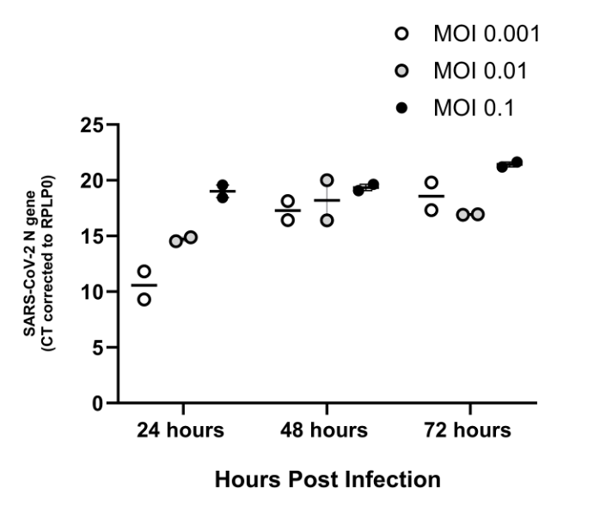
Supplementary Figure 1: Optimization of SARS-CoV-2 infection in nasal epithelium. Organotypic nasal epithelium was infected with various infectious titers (MOIs) of SARS-CoV-2. Infected cells were harvested at different time points post-infection (24h, 48h and 72h). Graph shows CT values of SARS-CoV2 N gene corrected against RPLP0 gene by RT-qPCR.

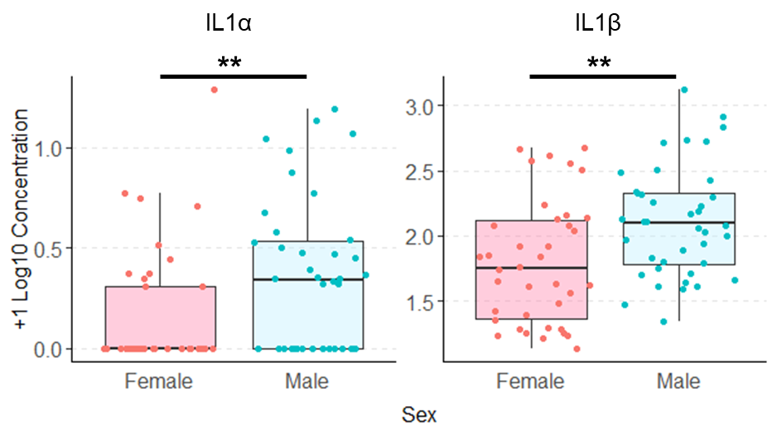
Supplementary Figure 2: Analyte concentrations differ by biological sex in the GWOH cohort. Female participants in the George Washington Occupational Health (GWOH) cohort had significantly lower levels of IL-1α and IL-1β (median 1.75 and 0.00 log10 (value+1) pg/ml, respectively) than male participants (median 2.09 and 0.34 log10 (value+1) pg/ml, respectively). Statistical tests were performed using the Wilcoxon rank sum test. Significance codes: 0 *** 0.001 ** 0.01 * 0.05.

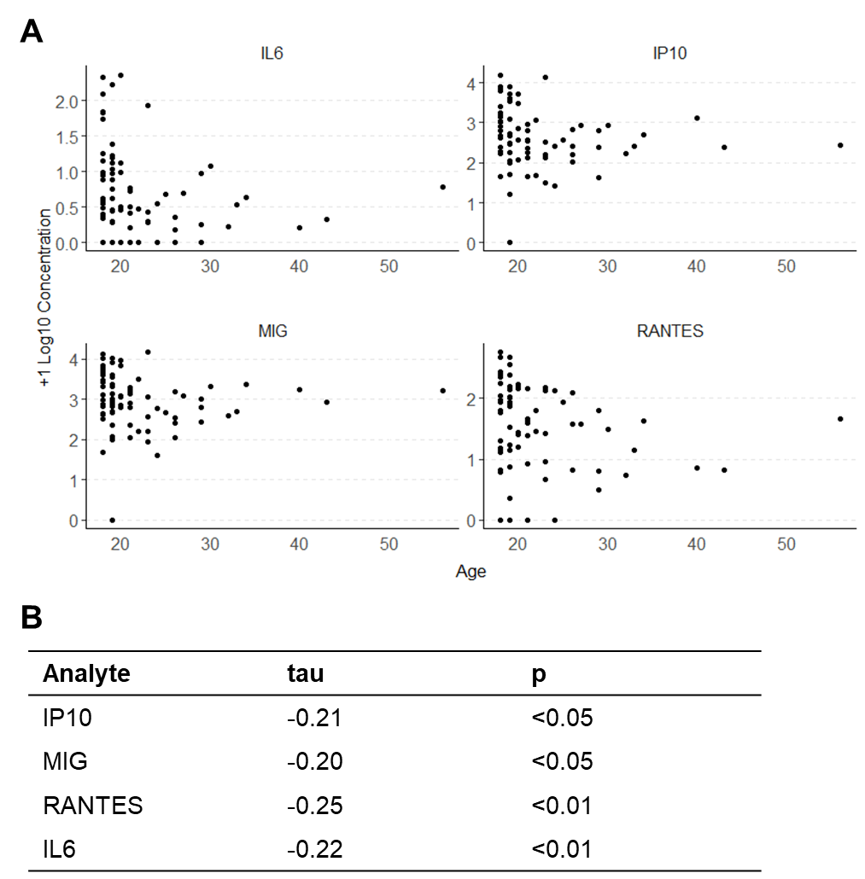
Supplementary Figure 3: Age correlates with immune analyte concentration in the GWOH cohort. (A) Age was negatively correlated with IL-6, IP-10, MIG and RANTES in the George Washington Occupational Health (GWOH) cohort. (B) Statistical tests were performed using Kendall’s rank correlation test.

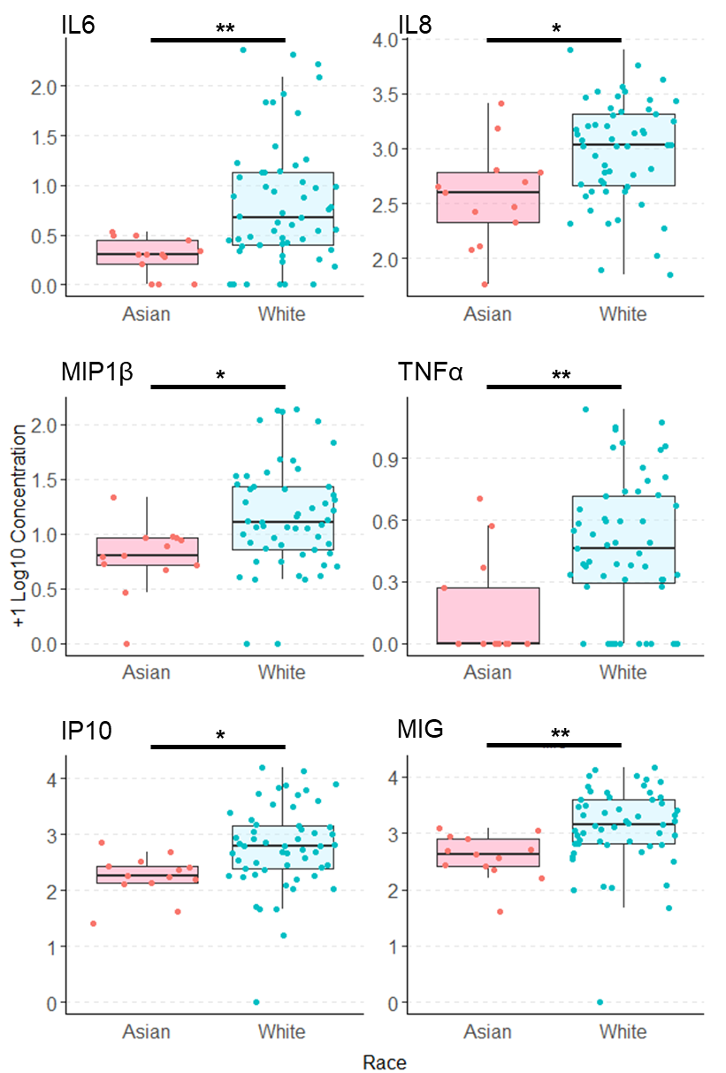
Supplementary Figure 4: Analyte concentrations differ by race in the GWOH cohort. Participants in the George Washington Occupational Health (GWOH) cohort who identified their race as Asian had lower concentrations of IL-6, IL-8, MIP-1β, TNF-α, IP-10, and MIG than white participants. Statistical tests were performed using the Dunn test. Significance codes: 0 *** 0.001 ** 0.01 * 0.05.

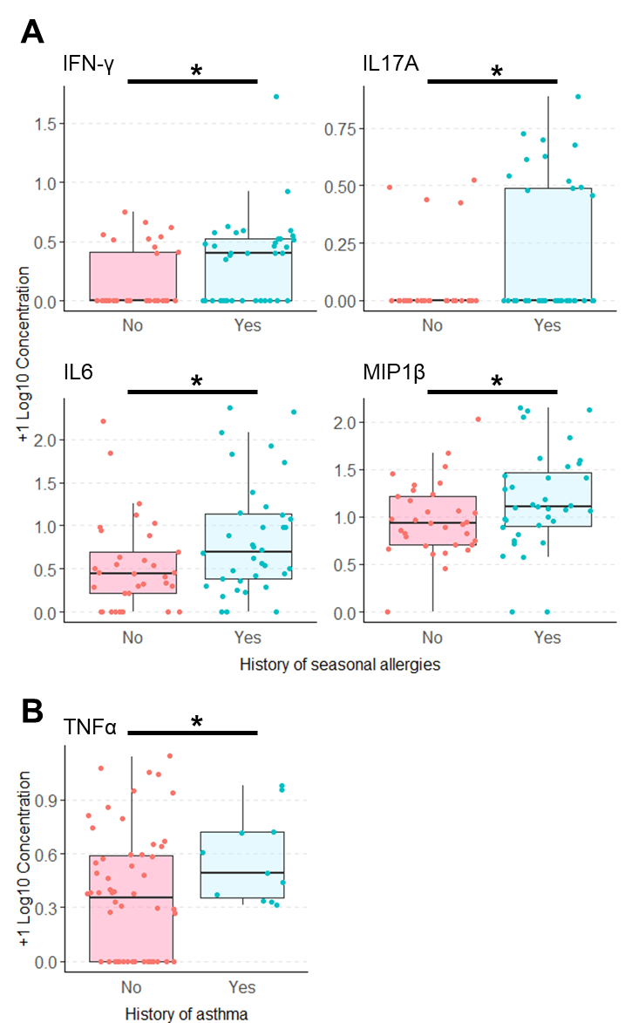
Supplementary Figure 5: Analyte concentrations differ by history of allergies and asthma in the GWOH cohort. (A) Participants in the George Washington Occupational Health (GWOH) cohort who reported a history of seasonal allergies (n=36) had higher levels of IFN-γ, IL-17A, IL-6, and MIP-1β than those without seasonal allergies (n=33). (B) Participants reporting a history of asthma (n=11) had higher TNF-α compared to those without (n=68). Statistical tests were performed using the Wilcoxon rank sum test. Significance codes: 0 *** 0.001 ** 0.01 * 0.05.

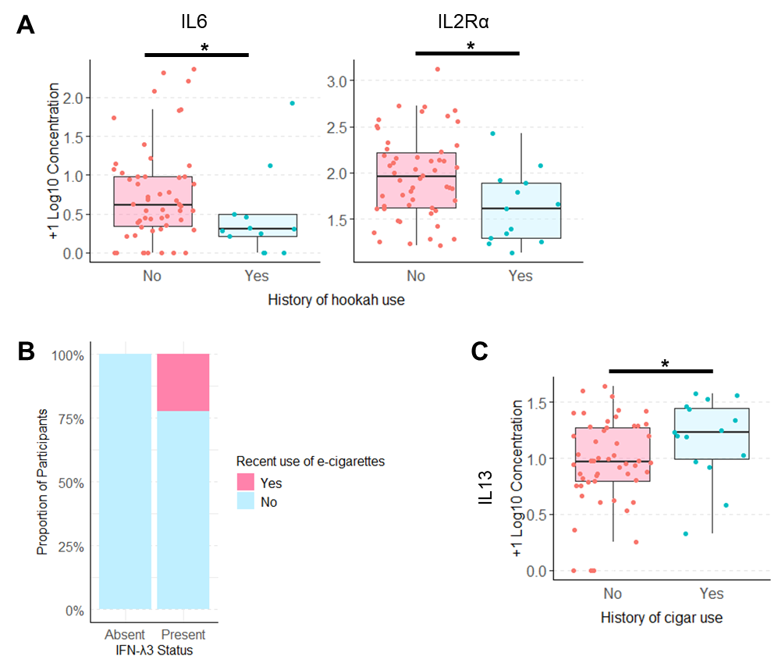
Supplementary Figure 6: Analyte concentrations differ by history of allergies and asthma in the GWOH cohort. (A) Participants of the George Washington Occupational Health (GWOH) cohort who reported hookah use had lower levels of IL1Rα and IL6 compared to those who did not. (B) All participants who were frequent electronic cigarette users (n=2) were more likely to have detectable IFN-λ3. (C) Participants who had a history of cigar use had higher levels of IL-13. For hookah and cigar use, statistical tests were performed using the Wilcoxon rank sum test; Fisher’s exact test was used for e-cigarette use. Significance codes: 0 *** 0.001 ** 0.01 * 0.05.

Supplementary Tables
Supplementary Table 1: Nasal inflammatory markers compared across immune clusters for the Healthcare Worker (HCW) cohort (n=87).
Analyte | Kruskal-Wallis p-value | Dunn Test
Analyte | Kruskal-Wallis p-value | p-value (adjusted)
Analyte | All groups | HCW1 vs HCW2 | HCW1 vs HCW3 | HCW1 vs HCW4 | HCW1 vs HCW5 | HCW2 vs HCW3 | HCW2 vs HCW4 | HCW2 vs HCW5 | HCW3 vs HCW4 | HCW3 vs HCW5 | HCW4 vs HCW5
IFN-α2 | 0.000 | 0.000 | 0.000 | 0.000 | 0.000 | 0.546 | 1.000 | 1.000 | 0.461 | 0.461 | 1.000
IFN-λ3 | 0.000 | 0.000 | 0.000 | 0.000 | 0.000 | 1.000 | 1.000 | 1.000 | 1.000 | 1.000 | 1.000
IFN-γ | 0.000 | 0.031 | 0.006 | 0.000 | 0.000 | 1.000 | 1.000 | 1.000 | 1.000 | 1.000 | 1.000
IL-1α | 0.265
IL-1β | 0.061
IL-6 | 0.000 | 0.014 | 0.838 | 0.711 | 0.203 | 0.005 | 0.000 | 0.000 | 0.711 | 0.212 | 0.711
IL-8 | 0.000 | 0.000 | 0.050 | 0.098 | 0.873 | 0.167 | 0.020 | 0.000 | 0.831 | 0.003 | 0.003
IL-10 | 0.079
IL-13 | 0.028 | 1.000 | 1.000 | 0.050 | 0.047 | 1.000 | 1.000 | 1.000 | 1.000 | 1.000 | 1.000
IL-17A | 0.111
IP10 | 0.000 | 1.000 | 1.000 | 0.034 | 0.000 | 0.832 | 0.008 | 0.000 | 0.106 | 0.000 | 0.000
MIG | 0.000 | 0.571 | 0.920 | 0.527 | 0.000 | 0.571 | 0.019 | 0.000 | 0.527 | 0.000 | 0.000
MIP-1β | 0.000 | 0.000 | 1.000 | 1.000 | 1.000 | 0.000 | 0.000 | 0.000 | 1.000 | 1.000 | 1.000
MUC5AC | 0.000 | 0.003 | 0.035 | 0.130 | 0.857 | 0.857 | 0.151 | 0.000 | 0.857 | 0.000 | 0.000
RANTES | 0.000 | 0.393 | 0.393 | 0.004 | 0.001 | 1.000 | 0.000 | 0.000 | 0.000 | 0.000 | 1.000
TNF-α | 0.000 | 0.000 | 1.000 | 1.000 | 1.000 | 0.000 | 0.000 | 0.000 | 1.000 | 1.000 | 1.000
Statistical tests were performed using a Kruskal-Wallis test followed by a post-hoc Dunn Test with FDR correction for significant results.

Supplementary Table 2: Nasal inflammatory markers quantified in the Healthcare Worker (HCW) and George Washington Occupational Health (GWOH) cohorts.
 | HCW |  |  |  |  | GWOH
Analyte | % Detect | 1st Qu | Med | 3rd Qu | Max | % Detect | 1st Qu | Med | 3rd Qu | Max
IFN-λ3 | 9 | <2.3 | <2.3 | <2.3 | 3284.0 | 11 | <1.5 | <1.5 | <1.5 | 85.1
IFN-α2 | 16 | <1.0 | <1.0 | <1.0 | 131.5 | 51 | <1.0 | 9.4 | 16.3 | 45.0
IL-1α | 100 | 11.9 | 20.2 | 29.7 | 146.0 | 100 | 40.3 | 86.7 | 174.7 | 1308.0
IP-10 | 62 | <1.1 | 28.7 | 91.0 | 1801.0 | 99 | 178.7 | 457.4 | 1049.0 | 15803.0
MIG | 67 | <1.5 | 65.3 | 136.7 | 2339.0 | 99 | 442.6 | 1007.0 | 2478.0 | 14678.0
RANTES | 31 | <0.9 | <0.9 | 10.1 | 172.3 | 94 | 12.6 | 43.4 | 135.8 | 576.5
IFN-γ | 11 | <0.2 | <0.2 | <0.2 | 9.6 | 44 | <0.2 | <0.2 | 2.0 | 51.6
IL-10 | 2 | <0.8 | <0.8 | <0.8 | 43.1 | 4 | <1.4 | <1.4 | <1.4 | 868.1
IL-13 | 4 | <0.1 | <0.1 | <0.1 | 1.4 | 96 | 6.3 | 13.2 | 21.6 | 42.2
IL-17A | 2 | <0.2 | <0.2 | <0.2 | 3.3 | 20 | <0.2 | <0.2 | <0.2 | 6.7
IL-1β | 6 | <0.2 | <0.2 | <0.2 | 36.5 | 43 | <0.2 | <0.2 | 1.8 | 18.2
IL-6 | 4 | <0.1 | <0.1 | 0.5 | 9.1 | 84 | 1.0 | 2.2 | 8.5 | 228.5
IL-8 | 98 | 23.99 | 62.1 | 148.7 | 2218.0 | 100 | 371.3 | 1304.0 | 1607.0 | 7866.0
MIP-1β | 13 | <0.7 | <0.7 | <0.7 | 26.8 | 96 | 5.3 | 10.1 | 20.2 | 138.5
TNF-α | 6 | <0.1 | <0.1 | <0.1 | 5.0 | 67 | <0.2 | 1.4 | 3.2 | 12.8
MUC5AC | 99 | 2.1 | 4.3 | 6.8 | 30.0 | 100 | 260.3 | 447.7 | 698.3 | 3006.0
Analyte concentrations are reported as pg/ml, except for MUC5AC, which was measured in ng/ml. % Detect: Proportion of participants with concentrations above the LLOD, Qu: Quartile, Med: Median.

Supplementary Table 3: Nasal inflammatory markers compared across immune clusters for the George Washington Occupational Health (GWOH) cohort (n=79).
Analyte | Kruskal-Wallis p-value | Dunn Test
Analyte | Kruskal-Wallis p-value | p-value (adjusted)
Analyte | All groups | GWOH1 vs GWOH2 | GWOH1 vs GWOH3 | GWOH1 vs GWOH4 | GWOH1 vs GWOH5 | GWOH2 vs GWOH3 | GWOH2 vs GWOH4 | GWOH2 vs GWOH5 | GWOH3 vs GWOH4 | GWOH3 vs GWOH5 | GWOH4 vs GWOH5
IFN-α2 | 0.000 | 0.759 | 0.343 | 0.052 | 0.282 | 0.730 | 0.000 | 0.006 | 0.000 | 0.000 | 0.759
IFN-λ3 | 0.000 | 0.000 | 0.000 | 0.000 | 0.000 | 1.000 | 1.000 | 1.000 | 1.000 | 1.000 | 1.000
IFN-γ | 0.000 | 0.010 | 0.684 | 1.000 | 1.000 | 0.147 | 0.004 | 0.004 | 1.000 | 0.623 | 1.000
IL-1α | 0.002 | 0.001 | 0.047 | 0.143 | 0.388 | 0.597 | 0.143 | 0.240 | 1.000 | 1.000 | 1.000
IL-1β | 0.000 | 0.000 | 1.000 | 1.000 | 1.000 | 0.000 | 0.000 | 0.027 | 1.000 | 1.000 | 1.000
IL-6 | 0.000 | 0.004 | 1.000 | 1.000 | 0.939 | 0.000 | 0.000 | 0.000 | 0.939 | 0.939 | 0.100
IL-8 | 0.000 | 0.000 | 0.190 | 0.003 | 0.792 | 0.007 | 0.252 | 0.000 | 0.210 | 0.210 | 0.003
IL-10 | 0.059
IL-13 | 0.000 | 1.000 | 1.000 | 0.027 | 0.001 | 1.000 | 0.000 | 0.000 | 0.002 | 0.000 | 0.183
IL-17A | 0.000 | 0.023 | 1.000 | 1.000 | 1.000 | 0.000 | 0.000 | 0.001 | 1.000 | 1.000 | 1.000
IP10 | 0.000 | 0.008 | 0.203 | 0.361 | 0.341 | 0.341 | 0.011 | 0.000 | 0.361 | 0.000 | 0.004
MIG | 0.000 | 0.000 | 0.011 | 0.049 | 0.618 | 0.407 | 0.039 | 0.000 | 0.618 | 0.000 | 0.002
MIP-1β | 0.000 | 0.000 | 0.693 | 0.374 | 0.975 | 0.000 | 0.001 | 0.000 | 0.975 | 0.152 | 0.036
MUC5AC | 0.001 | 0.276 | 1.000 | 0.189 | 1.000 | 0.189 | 1.000 | 0.017 | 0.073 | 0.721 | 0.005
RANTES | 0.000 | 0.011 | 0.384 | 0.384 | 0.384 | 0.205 | 0.046 | 0.000 | 0.661 | 0.001 | 0.002
TNF-α | 0.000 | 0.000 | 0.394 | 0.118 | 0.795 | 0.000 | 0.000 | 0.000 | 0.795 | 0.549 | 0.192
Statistical tests were performed using a Kruskal-Wallis test followed by a post-hoc Dunn Test with FDR correction for significant results.

