Supplementary Figure 1
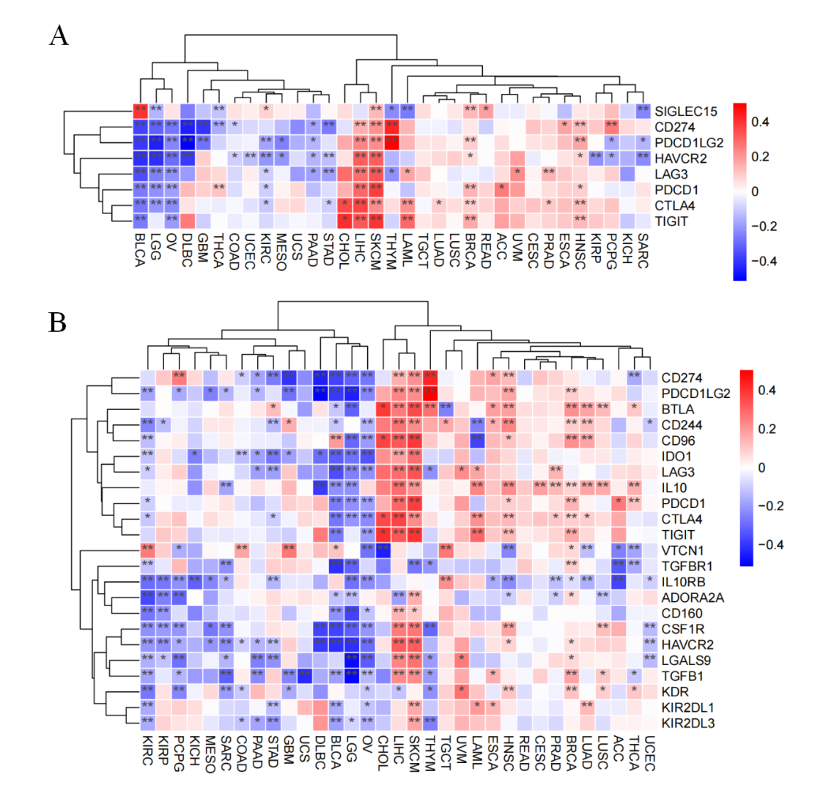

Supplementary Figure 2

Supplementary Figure 3

