Purinergic signalling
Systemic purinergic dysregulation in melanoma revealed by soluble P2X4 receptor fragments
Roland Martin Teras¹, Jyri Teras², Igor Kuprijanov³, Caroline Khaddaj³, Adriana Kalmõkova³, Liisi Karlep⁴ Ago Samoson⁴, Lauri Toom⁵, Airi Rump³, Sirje Rüütel Boudinot³
Corresponding author: Sirje Rüütel Boudinot sirje.ruutel@taltech.ee

Supplementary information

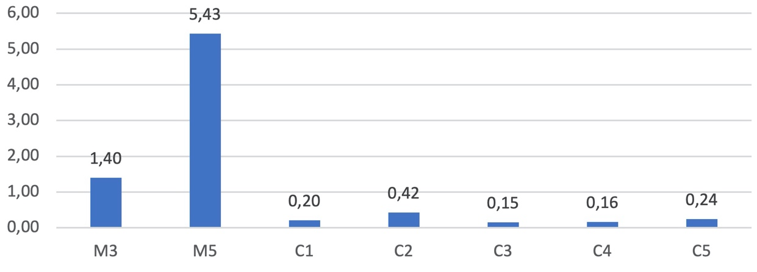

Fig. S1 P2X4 expression in blood leukocytes
P2X4 expression was analyzed in leukocytes isolated from peripheral blood samples using real-time quantitative polymerase chain reaction (RT-qPCR). Blood samples from two melanoma patients, five healthy controls, and one inter-plate control were included. In two melanoma patients, P2X4 expression was upregulated compared with healthy individuals. The x-axis shows relative expression normalized to a reference sample used for inter-plate comparison.

Purinergic signalling
Systemic purinergic dysregulation in melanoma revealed by soluble P2X4 receptor fragments
Roland Martin Teras¹, Jyri Teras², Igor Kuprijanov³, Caroline Khaddaj³, Adriana Kalmõkova³, Liisi Karlep⁴ Ago Samoson⁴, Lauri Toom⁵, Airi Rump³, Sirje Rüütel Boudinot³
Corresponding author: Sirje Rüütel Boudinot sirje.ruutel@taltech.ee

Supplementary information

Table S1 Metabolites quantified in serum from melanoma patients and controls, showing mean concentrations (µM) ± SD and concentration ranges. Data are shown for four melanoma patients and four healthy controls. NQ denotes not quantified (below detection limit). Glycerol was excluded due to likely contamination from the filtration process. Erythritol was detected in only one sample (M1; 1.6132 mM) and excluded from further analysis.

Metabolite | Melanoma Mean ± SD [Range] | Control Mean ± SD [Range]
1-Methylhistidine | 7.50 ± 1.57 [5.80 – 9.60] | 8.25 ± 1.00 [7.20 – 9.20]
2-Aminobutyrate | 18.00 ± 8.87 [7.60 – 27.20] | 21.45 ± 8.17 [11.40 – 28.20]
2-Hydroxybutyrate | 35.70 ± 12.91 [22.00 – 47.60] | 43.35 ± 16.37 [23.00 – 58.60]
2-Hydroxyisovalerate | 3.70 ± 2.28 [2.00 – 7.00] | 7.40 ± 7.11 [3.20 – 18.00]
2-Oxoisocaproate | 4.70 ± 2.54 [2.40 – 7.00] | 6.70 ± 3.54 [3.00 – 11.40]
3-Hydroxybutyrate | 56.45 ± 52.49 [21.80 – 134.40] | 147.25 ± 224.82 [15.80 – 483.80]
3-Methyl-2-oxovalerate | 5.90 ± 1.10 [4.60 – 7.00] | 7.40 ± 1.83 [5.80 – 9.60]
Acetate | 54.70 ± 44.06 [28.00 – 120.60] | 59.30 ± 22.73 [28.00 – 82.20]
Acetoacetate | 8.60 ± 7.42 [2.00 – 18.40] | 30.60 ± 55.37 [1.20 – 113.60]
Acetone | 25.70 ± 10.03 [12.40 – 36.20] | 38.75 ± 20.84 [11.80 – 57.20]
Alanine | 293.95 ± 137.91 [178.20 – 485.20] | 306.85 ± 68.93 [217.80 – 361.40]
Arabinose | 29.45 ± 22.92 [10.80 – 62.80] | 19.15 ± 6.01 [12.80 – 27.00]
Arginine | 77.10 ± 22.70 [60.20 – 110.60] | 76.25 ± 6.97 [68.80 – 85.60]
Asparagine | 42.30 ± 6.79 [34.20 – 48.20] | 49.05 ± 15.80 [34.40 – 63.60]
Aspartate | 17.95 ± 7.78 [9.60 – 25.80] | 20.75 ± 9.19 [12.20 – 28.80]
Betaine | 41.65 ± 7.38 [33.60 – 49.80] | 36.70 ± 18.15 [23.60 – 62.40]
Carnitine | 35.75 ± 9.94 [22.80 – 46.40] | 37.90 ± 8.78 [30.20 – 48.20]
Choline | 10.80 ± 1.80 [9.60 – 13.40] | 12.75 ± 2.74 [10.60 – 16.60]
Citrate | 118.75 ± 24.82 [93.40 – 151.60] | 134.95 ± 60.46 [74.20 – 212.60]
Creatine | 32.10 ± 19.61 [13.20 – 53.20] | 36.10 ± 25.65 [13.60 – 73.00]
Creatinine | 70.75 ± 7.41 [62.40 – 80.40] | 87.55 ± 36.93 [64.40 – 142.40]
Dimethyl sulfone | 15.95 ± 5.55 [9.80 – 23.00] | 20.50 ± 12.38 [6.20 – 36.00]
Dimethylamine | 1.90 ± 0.35 [1.60 – 2.40] | 1.85 ± 0.91 [1.20 – 3.20]
Ethanol | 318.25 ± 263.72 [159.40 – 711.80] | 200.40 ± 122.09 [55.40 – 354.20]
Formate | 231.35 ± 408.46 [20.00 – 844.00] | 26.05 ± 9.80 [17.40 – 38.80]
Fumarate | 1.60 ± 0.00 [NQ – 1.60] | NQ
Glucose | 5963.95 ± 2268.82 [3777.40 – 9149.40] | 4859.60 ± 1411.90 [3491.60 – 6170.00]
Glutamate | 93.20 ± 20.11 [72.80 – 116.20] | 77.30 ± 19.05 [65.20 – 105.40]
Glutamine | 421.05 ± 145.34 [240.80 – 557.60] | 502.80 ± 104.31 [414.40 – 621.60]
Glycine | 237.45 ± 108.40 [147.00 – 383.60] | 356.95 ± 130.01 [238.40 – 485.80]
Histidine | 69.05 ± 25.83 [30.60 – 84.20] | 77.15 ± 10.32 [62.00 – 85.20]
Hypoxanthine | 19.85 ± 14.27 [7.20 – 38.00] | 14.00 ± 10.54 [8.20 – 29.80]
Isoleucine | 65.50 ± 26.38 [41.40 – 94.60] | 53.85 ± 13.66 [35.60 – 67.40]
Lactate | 2519.00 ± 1641.89 [848.60 – 4431.40] | 2452.60 ± 294.10 [2041.00 – 2739.00]
Leucine | 109.55 ± 48.47 [59.20 – 158.00] | 103.15 ± 24.44 [70.40 – 125.40]
Lysine | 148.40 ± 44.73 [109.60 – 196.40] | 145.20 ± 36.93 [105.80 – 186.00]
Mannose | 92.93 ± 52.71 [NQ – 153.60] | 53.15 ± 25.66 [33.20 – 87.80]
Methanol | 101.05 ± 74.10 [59.60 – 212.00] | 196.00 ± 200.10 [41.20 – 485.60]
Methionine | 26.85 ± 8.71 [16.00 – 35.20] | 25.10 ± 8.39 [18.40 – 36.00]
N,N-Dimethylglycine | 3.80 ± 1.49 [2.20 – 5.80] | 3.00 ± 0.86 [2.20 – 4.20]
O-Acetylcarnitine | 7.00 ± 1.55 [5.60 – 9.20] | 9.05 ± 7.78 [3.40 – 20.00]
Ornithine | 60.55 ± 16.77 [41.20 – 81.60] | 74.80 ± 20.59 [55.00 – 103.40]
Phenylalanine | 55.45 ± 9.18 [45.20 – 66.60] | 50.30 ± 8.63 [40.80 – 61.60]
Proline | 230.00 ± 87.32 [117.20 – 318.60] | 212.55 ± 81.86 [123.80 – 317.60]
Pyroglutamate | 27.40 ± 8.67 [20.00 – 39.80] | 39.00 ± 12.94 [23.00 – 50.20]
Pyruvate | 59.65 ± 37.89 [15.00 – 101.00] | 38.30 ± 20.97 [9.40 – 59.60]
Sarcosine | 1.60 ± 0.40 [NQ – 2.00] | 2.65 ± 0.91 [2.00 – 4.00]
Serine | 105.05 ± 32.39 [79.80 – 152.60] | 134.55 ± 42.90 [83.80 – 183.60]
Succinate | 4.85 ± 2.48 [2.80 – 8.40] | 5.40 ± 2.57 [2.00 – 8.20]
Taurine | 122.20 ± 59.33 [51.40 – 187.00] | 96.25 ± 22.86 [75.80 – 119.20]
Threonine | 104.90 ± 31.50 [75.00 – 135.40] | 130.10 ± 34.94 [93.40 – 168.60]
Trimethylamine | 2.55 ± 0.93 [1.40 – 3.40] | 2.15 ± 1.39 [1.20 – 4.20]
Tryptophan | 6.15 ± 3.09 [3.20 – 10.40] | 5.27 ± 2.04 [NQ – 7.60]
Tyrosine | 85.55 ± 26.63 [47.00 – 104.40] | 69.55 ± 19.44 [51.80 – 91.40]
Urea | 4055.80 ± 2805.84 [2395.60 – 8245.80] | 2622.10 ± 1215.47 [859.00 – 3640.20]
Valine | 206.50 ± 82.67 [129.80 – 297.20] | 203.40 ± 43.39 [150.60 – 240.80]
myo-Inositol | 31.40 ± 6.59 [24.40 – 39.60] | 47.75 ± 11.90 [31.40 – 59.80]

Purinergic signalling
Systemic purinergic dysregulation in melanoma revealed by soluble P2X4 receptor fragments
Roland Martin Teras¹, Jyri Teras², Igor Kuprijanov³, Caroline Khaddaj³, Adriana Kalmõkova³, Liisi Karlep⁴ Ago Samoson⁴, Lauri Toom⁵, Airi Rump³, Sirje Rüütel Boudinot³
Corresponding author: Sirje Rüütel Boudinot sirje.ruutel@taltech.ee

Supplementary information
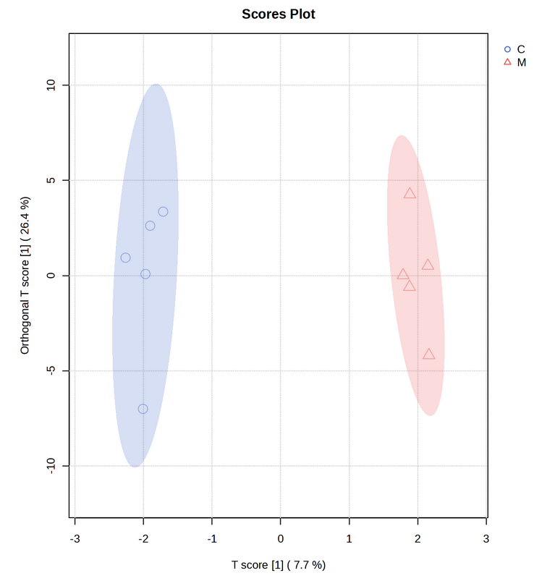
Fig. S2 OPLS-DA Scores Plot for Serum and Plasma Metabolites
M stands for melanoma patients and C for control subjects

Purinergic signalling
Systemic purinergic dysregulation in melanoma revealed by soluble P2X4 receptor fragments
Roland Martin Teras¹, Jyri Teras², Igor Kuprijanov³, Caroline Khaddaj³, Adriana Kalmõkova³, Liisi Karlep⁴ Ago Samoson⁴, Lauri Toom⁵, Airi Rump³, Sirje Rüütel Boudinot³
Corresponding author: Sirje Rüütel Boudinot sirje.ruutel@taltech.ee

Supplementary information
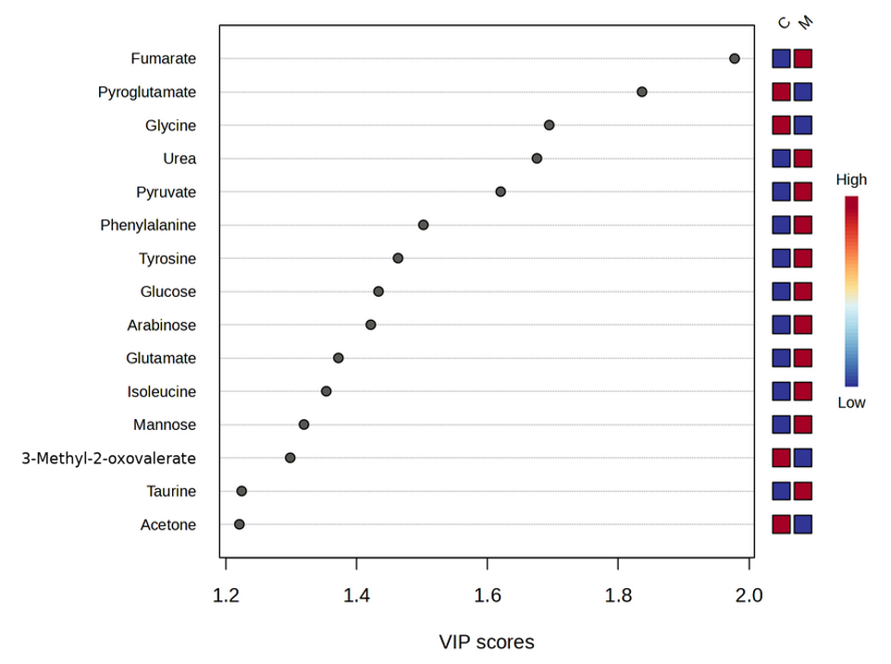

Fig. S3 OPLS-DA Model VIP scores plot for serum and plasma metabolites.
M stands for melanoma patients and C for control subjects

Purinergic signalling
Systemic purinergic dysregulation in melanoma revealed by soluble P2X4 receptor fragments
Roland Martin Teras¹, Jyri Teras², Igor Kuprijanov³, Caroline Khaddaj³, Adriana Kalmõkova³, Liisi Karlep⁴ Ago Samoson⁴, Lauri Toom⁵, Airi Rump³, Sirje Rüütel Boudinot³
Corresponding author: Sirje Rüütel Boudinot sirje.ruutel@taltech.ee

Supplementary information

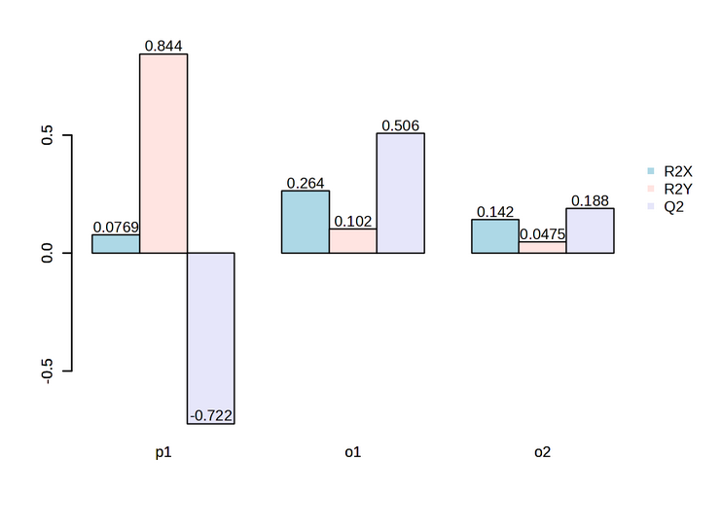
Fig. S4 OPLS-DA model overview for serum and plasma metabolites
High R²Y values combined with negative Q² values indicate that the model fits the observed data but does not provide reliable predictive performance, underscoring the limitations imposed by the small sample size.

Purinergic signalling
Systemic purinergic dysregulation in melanoma revealed by soluble P2X4 receptor fragments
Roland Martin Teras¹, Jyri Teras², Igor Kuprijanov³, Caroline Khaddaj³, Adriana Kalmõkova³, Liisi Karlep⁴ Ago Samoson⁴, Lauri Toom⁵, Airi Rump³, Sirje Rüütel Boudinot³
Corresponding author: Sirje Rüütel Boudinot sirje.ruutel@taltech.ee

Supplementary information
Table S2. Metabolites quantified in saliva from melanoma patients and controls, showing mean concentrations (µM) ± SD and concentration ranges. Data are shown for five melanoma patients and five healthy controls. NQ denotes not quantified (below the detection limit). Glycerol was excluded due to likely contamination from the filtration process.

Metabolite | Melanoma Mean ± SD [Range] | Control Mean ± SD [Range]
1,7-Dimethylxanthine | 5.53 ± 2.40 [NQ – 7.78] | 4.24 ± 4.33 [1.67 – 11.89]
2-Hydroxyisovalerate | 4.92 ± 1.83 [NQ – 7.44] | 3.74 ± 1.41 [NQ – 5.33]
3-Phenylpropionate | 52.56 ± 55.49 [NQ – 129.78] | 18.37 ± 12.51 [NQ – 32.67]
4-Hydroxyphenylacetate | 23.09 ± 10.78 [13.44 – 40.22] | 38.83 ± 23.81 [NQ – 65.78]
5-Aminopentanoate | 926.33 ± 595.91 [474.67 – 1948.67] | 405.64 ± 354.90 [19.33 – 824.89]
Acetate | 20732.38 ± 17334.42 [7861.89 – 51065.44] | 7723.36 ± 2906.85 [4325.44 – 10365.33]
Acetoin | 20.75 ± 18.16 [NQ – 40.44] | 56.33 ± 110.72 [2.67 – 254.33]
Alanine | 165.84 ± 245.29 [33.11 – 602.22] | 34.00 ± 19.56 [8.22 – 61.56]
Aspartate | 42.31 ± 40.15 [NQ* – 102.00] | NQ
Butyrate | 422.18 ± 253.73 [32.00 – 672.78] | 231.36 ± 157.07 [NQ – 415.67]
Cadaverine | 108.56 ± 98.64 [NQ* – 255.56] | 19.00 ± 15.13 [NQ – 36.44]
Carnitine | 5.17 ± 3.54 [NQ – 7.67] | 2.14 ± 2.75 [NQ – 6.22]
Choline | 45.16 ± 38.18 [7.56 – 101.33] | 12.49 ± 16.03 [3.89 – 41.11]
Creatine | 22.39 ± 12.32 [NQ – 36.11] | 13.00 ± 7.11 [5.89 – 22.33]
Creatinine | 11.31 ± 8.64 [4.56 – 26.33] | 5.42 ± 1.84 [2.22 – 6.78]
Desaminotyrosine | 40.29 ± 35.06 [11.22 – 97.33] | 21.22 ± 11.19 [NQ – 33.89]
Dimethyl sulfone | 16.87 ± 9.29 [9.78 – 29.44] | 25.53 ± 14.04 [5.00 – 37.33]
Dimethylamine | 8.71 ± 7.10 [4.33 – 21.22] | 4.00 ± 0.94 [2.44 – 4.89]
Ethanol | 5237.13 ± 8059.44 [95.11 – 18538.67] | 220.62 ± 60.87 [165.56 – 315.56]
Ethanolamine | 111.38 ± 154.58 [13.56 – 381.56] | 145.06 ± 111.49 [NQ – 223.89]
Formate | 479.18 ± 388.16 [18.22 – 839.22] | 514.84 ± 525.21 [23.56 – 1342.78]
Fucose | 157.69 ± 202.86 [33.78 – 502.78] | 67.47 ± 92.93 [4.00 – 228.22]
Galactose | 106.89 ± 64.74 [NQ – 182.33] | 69.33 ± 0.00 [NQ – 69.33]
Glutamate | 67.00 ± 0.00 [NQ – 67.00] | 64.19 ± 43.72 [NQ – 108.11]
Glutamine | 62.47 ± 54.44 [27.67 – 158.00] | 30.44 ± 14.56 [12.00 – 45.78]
Glycine | 575.89 ± 164.30 [302.33 – 745.33] | 233.82 ± 95.39 [116.78 – 356.00]
Histidine | 40.89 ± 38.97 [5.44 – 106.11] | 23.69 ± 11.41 [NQ – 35.33]
Isobutyrate | 154.51 ± 155.88 [39.67 – 391.33] | 62.53 ± 45.30 [7.44 – 128.89]
Isocaproate | 44.40 ± 60.11 [6.56 – 146.44] | 28.89 ± 23.25 [NQ – 55.22]
Isoleucine | 78.20 ± 90.11 [5.22 – 219.89] | 13.98 ± 8.69 [3.78 – 26.56]
Isovalerate | 62.27 ± 55.68 [16.22 – 137.89] | 37.97 ± 16.75 [NQ – 52.78]
Lactate | 1343.25 ± 2307.39 [NQ – 4787.00] | 348.07 ± 686.40 [3.11 – 1570.56]
Leucine | 170.40 ± 210.77 [23.67 – 525.56] | 32.14 ± 9.76 [NQ – 46.22]
Lysine | 190.16 ± 200.89 [38.33 – 538.22] | 59.53 ± 33.74 [33.00 – 118.56]
Malonate | 30.51 ± 26.96 [9.00 – 74.89] | 14.39 ± 7.00 [NQ – 24.44]
Methanol | 119.62 ± 40.26 [50.67 – 153.89] | 116.24 ± 71.45 [62.11 – 235.11]
Methionine | 60.83 ± 48.79 [NQ – 95.33] | 7.67 ± 0.00 [NQ – 7.67]
Methylamine | 41.18 ± 44.48 [5.89 – 118.33] | 16.38 ± 14.97 [4.11 – 40.44]
O-Phosphocholine | 10.89 ± 6.29 [NQ – 15.33] | 4.22 ± 0.00 [NQ – 4.22]
Ornithine | 62.36 ± 31.01 [NQ – 107.00] | 40.28 ± 30.82 [NQ – 86.22]
Phenol | 65.96 ± 101.49 [11.67 – 247.11] | 32.48 ± 8.72 [NQ – 42.00]
Phenylacetate | 60.67 ± 34.31 [25.67 – 117.78] | 49.06 ± 28.74 [NQ – 85.33]
Phenylalanine | 111.58 ± 98.26 [26.11 – 267.78] | 30.02 ± 9.59 [15.67 – 41.22]
Proline | 454.49 ± 351.90 [68.22 – 804.89] | 156.25 ± 115.85 [NQ – 326.33]
Propionate | 4149.24 ± 2916.24 [1959.89 – 8637.78] | 1868.93 ± 759.92 [877.22 – 2693.11]
Putrescine | 412.89 ± 284.85 [141.78 – 775.22] | 131.27 ± 77.10 [35.44 – 230.22]
Pyruvate | 97.78 ± 81.94 [NQ – 182.67] | 48.28 ± 81.05 [NQ – 169.33]
Sarcosine | 23.04 ± 11.85 [8.11 – 36.56] | 9.50 ± 5.15 [NQ – 16.11]
Succinate | 593.42 ± 1175.18 [12.78 – 2693.78] | 19.31 ± 24.99 [2.11 – 60.00]
Taurine | 405.73 ± 460.79 [111.00 – 1208.22] | 133.76 ± 62.58 [61.89 – 233.89]
Threonine | 71.28 ± 85.56 [NQ – 131.78] | NQ
Thymine | 35.56 ± 33.94 [NQ – 72.89] | 16.78 ± 0.00 [NQ – 16.78]
Trimethylamine | 16.69 ± 15.18 [3.44 – 39.44] | 5.16 ± 3.92 [1.67 – 10.56]
Tryptophan | 79.83 ± 30.88 [NQ – 101.67] | NQ
Tyrosine | 120.11 ± 109.77 [49.67 – 315.11] | 46.07 ± 16.01 [31.33 – 73.00]
Uracil | 34.33 ± 0.00 [NQ – 34.33] | 17.33 ± 11.79 [NQ – 25.67]
Urea | 302.59 ± 145.51 [NQ – 470.11] | 530.67 ± 389.07 [NQ – 805.78]
Valine | 197.13 ± 207.88 [12.56 – 492.89] | 36.53 ± 22.61 [9.56 – 67.22]
Xanthine | 31.07 ± 53.94 [3.22 – 127.44] | 21.00 ± 14.55 [NQ – 40.89]
β-Alanine | 13.00 ± 6.69 [5.22 – 22.78] | 6.67 ± 2.11 [NQ – 9.00]
*Aspartate and cadaverine were not quantified in M2 due to high noise level in the spectrum, however the signals do appear to be there for both, for aspartate at 2.8 ppm and for cadaverine at 1.5 ppm, at a comparable level to those in other melanoma samples.
Purinergic signalling
Systemic purinergic dysregulation in melanoma revealed by soluble P2X4 receptor fragments
Roland Martin Teras¹, Jyri Teras², Igor Kuprijanov³, Caroline Khaddaj³, Adriana Kalmõkova³, Liisi Karlep⁴ Ago Samoson⁴, Lauri Toom⁵, Airi Rump³, Sirje Rüütel Boudinot³ Corresponding author: Sirje Rüütel Boudinot sirje.ruutel@taltech.ee

Supplementary information
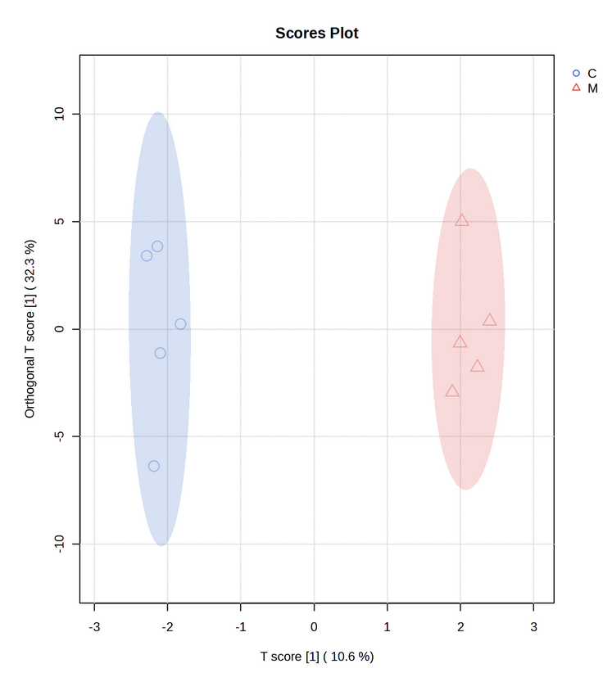
Fig. S5 OPLS-DA scores plot for saliva metabolites
M stands for melanoma patients and C for control subjects

Purinergic signalling
Systemic purinergic dysregulation in melanoma revealed by soluble P2X4 receptor fragments
Roland Martin Teras¹, Jyri Teras², Igor Kuprijanov³, Caroline Khaddaj³, Adriana Kalmõkova³, Liisi Karlep⁴ Ago Samoson⁴, Lauri Toom⁵, Airi Rump³, Sirje Rüütel Boudinot³
Corresponding author: Sirje Rüütel Boudinot sirje.ruutel@taltech.ee

Supplementary information

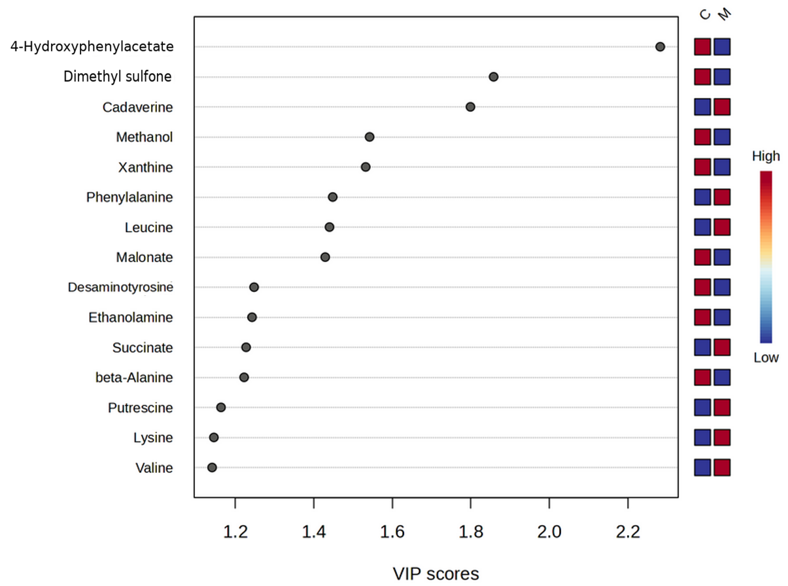

Fig. S6 (OPLS-DA model VIP scores plot for saliva metabolites
M stands for melanoma patients and C for control subjects

Purinergic signalling
Systemic purinergic dysregulation in melanoma revealed by soluble P2X4 receptor fragments
Roland Martin Teras¹, Jyri Teras², Igor Kuprijanov³, Caroline Khaddaj³, Adriana Kalmõkova³, Liisi Karlep⁴ Ago Samoson⁴, Lauri Toom⁵, Airi Rump³, Sirje Rüütel Boudinot³
Corresponding author: Sirje Rüütel Boudinot sirje.ruutel@taltech.ee

Supplementary information

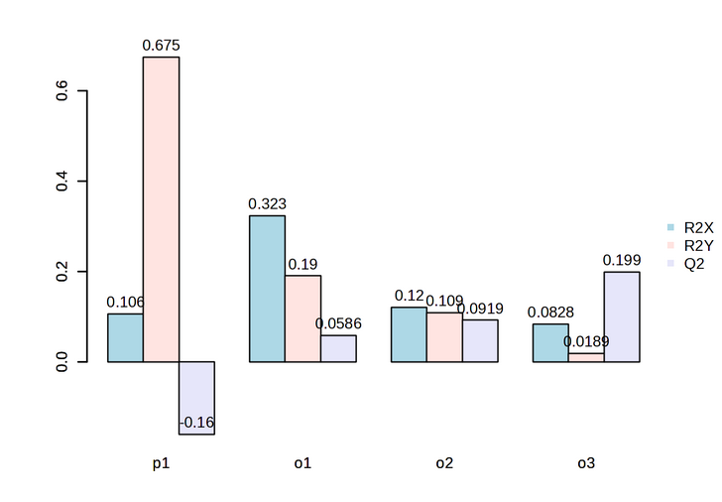

Fig. S7 OPLS-DA model overview for saliva metabolites
A high R²Y accompanied by a negative Q² suggests that the model captures variance in the training data but lacks predictive power, likely due to the limited sample size.

Purinergic signalling
Systemic purinergic dysregulation in melanoma revealed by soluble P2X4 receptor fragments
Roland Martin Teras¹, Jyri Teras², Igor Kuprijanov³, Caroline Khaddaj³, Adriana Kalmõkova³, Liisi Karlep⁴ Ago Samoson⁴, Lauri Toom⁵, Airi Rump³, Sirje Rüütel Boudinot³
Corresponding author: Sirje Rüütel Boudinot sirje.ruutel@taltech.ee

Supplementary information

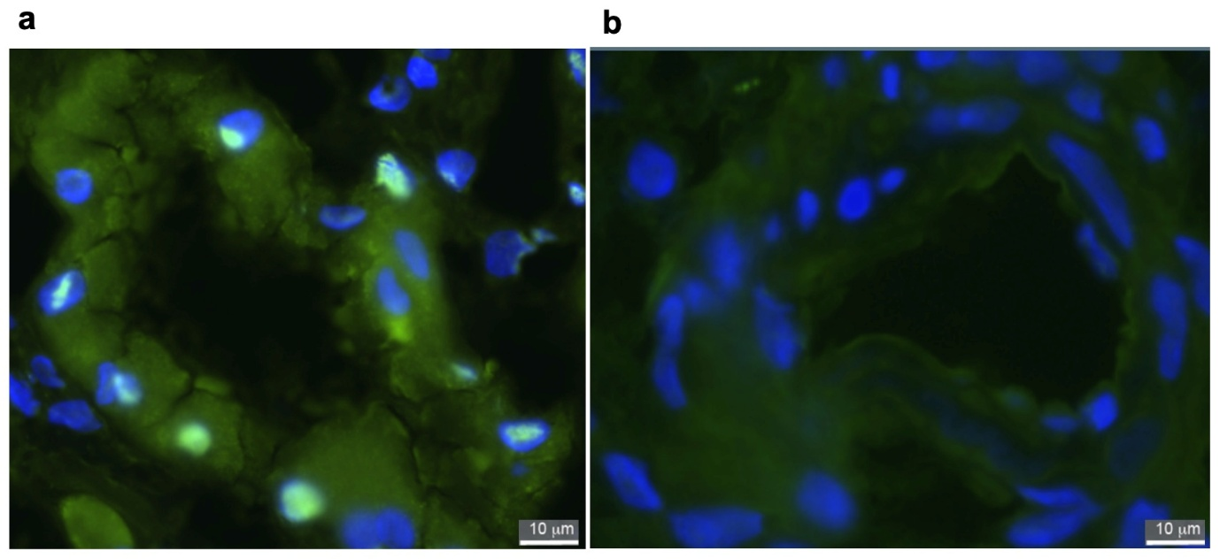

Fig. S8 P2X4 immunofluorescence in human kidney tissue
Representative immunofluorescence images of kidney epithelial cells from patients with (a) glomerulosclerosis and (b) membranous nephropathy. P2X4 immunoreactivity is shown in green, and nuclei are counterstained with DAPI (blue). Images illustrate P2X4 expression in renal epithelial structures under pathological conditions. Images courtesy of Birgit Truumees, Department of Pathology, North Estonia Medical Centre (2017). Staining was performed using a P2X4-specific antibody. Images are shown for illustrative purposes.

Fig. 3a gel | Fig. 3a image
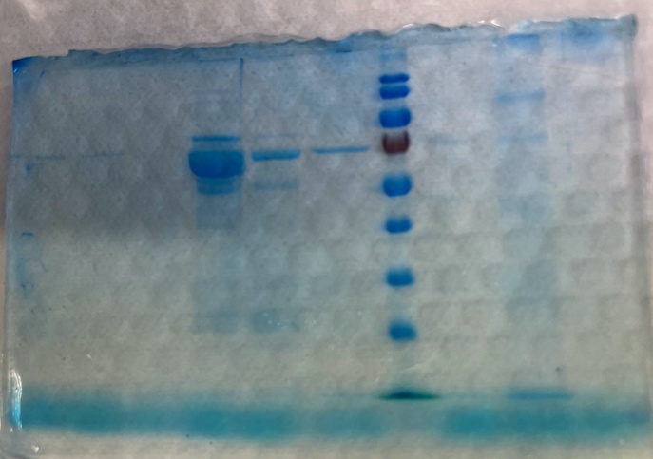 | 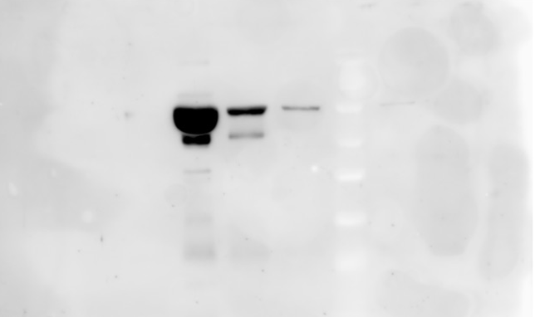
Fig. 3b gel | Fig. 3b image
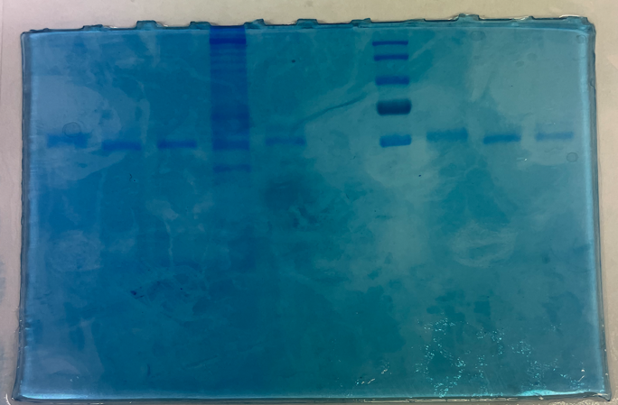 | 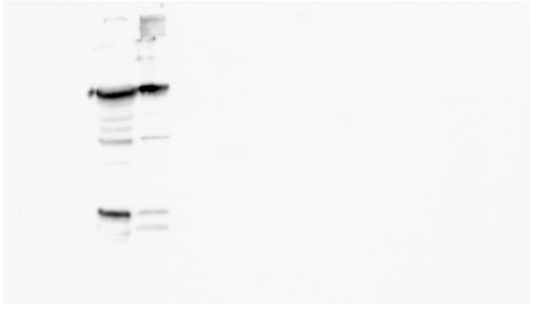
Fig. 4 gel | Fig. 4 image
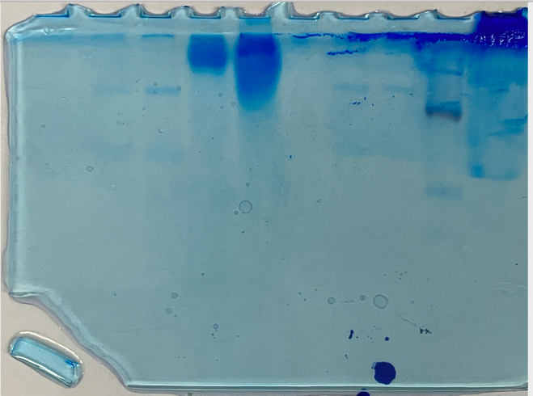 | 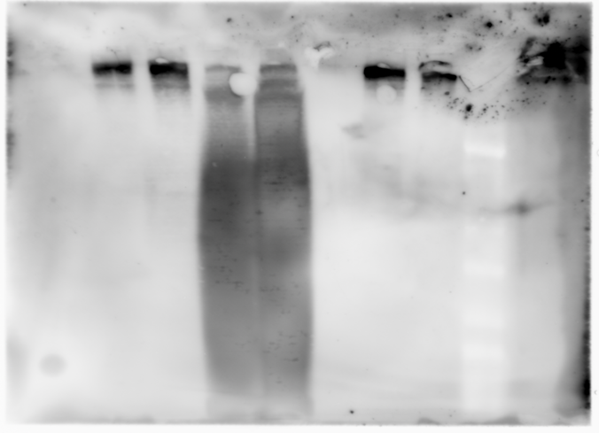

Fig. S9 Full uncropped gels and blots images.

