Supporting Information
Improving Interlayer Adhesion of 3D Printed PLA/PCL Blends Using Triblock Copolymers

¹H-NMR Spectroscopy
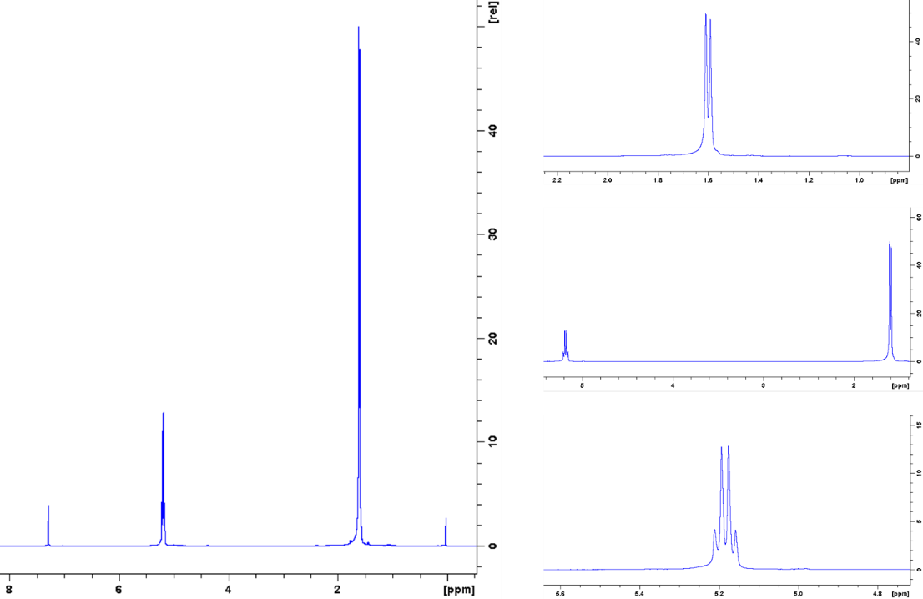
Figure 1S. ¹H-NMR test results for commercial 4032D PLA (ppm).

Filaments preparation
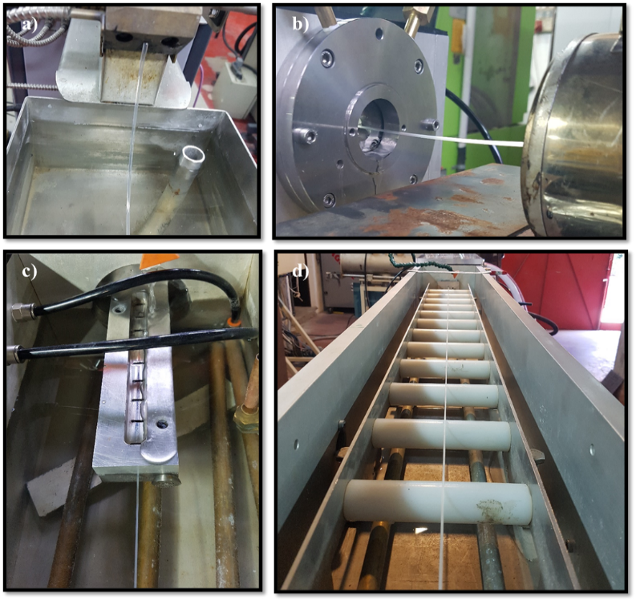
Figure 2S. Filament extrusion executed by a single screw extruder equipped with downstream components for filament production.

3D Printing
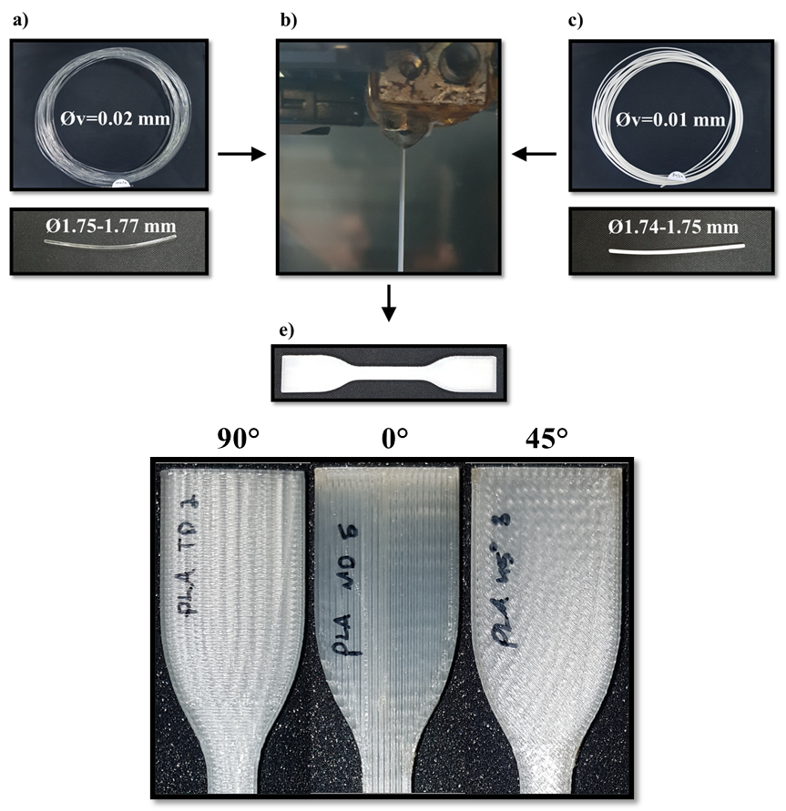
d)
e)
Figure 3S. The measured filament diameter and its variation for (a) PLA and (c) 80/20 w/w-based filaments. (b) filament emerges from the 3D printing nozzle. (d) 3D printed dogbone for tensile strength and toughness from PLA. (e) PLA dogbone printed in different orientations.

Mechanical Properties
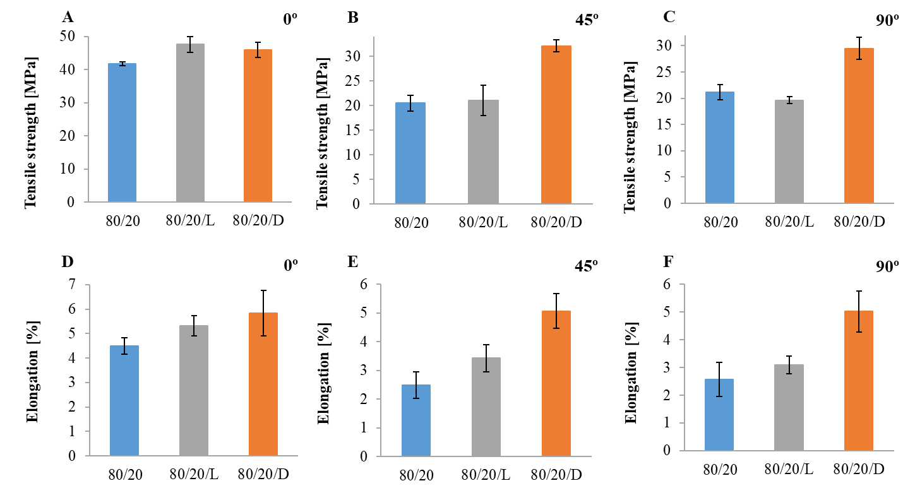
Figure 4S. Tensile strength and elongation at break of 80/20, 80/20/L and 80/20/D blends printed at different orientations (A+D) 0º, (B+E) 45º and (C+F) 90º.

Fracture mechanics
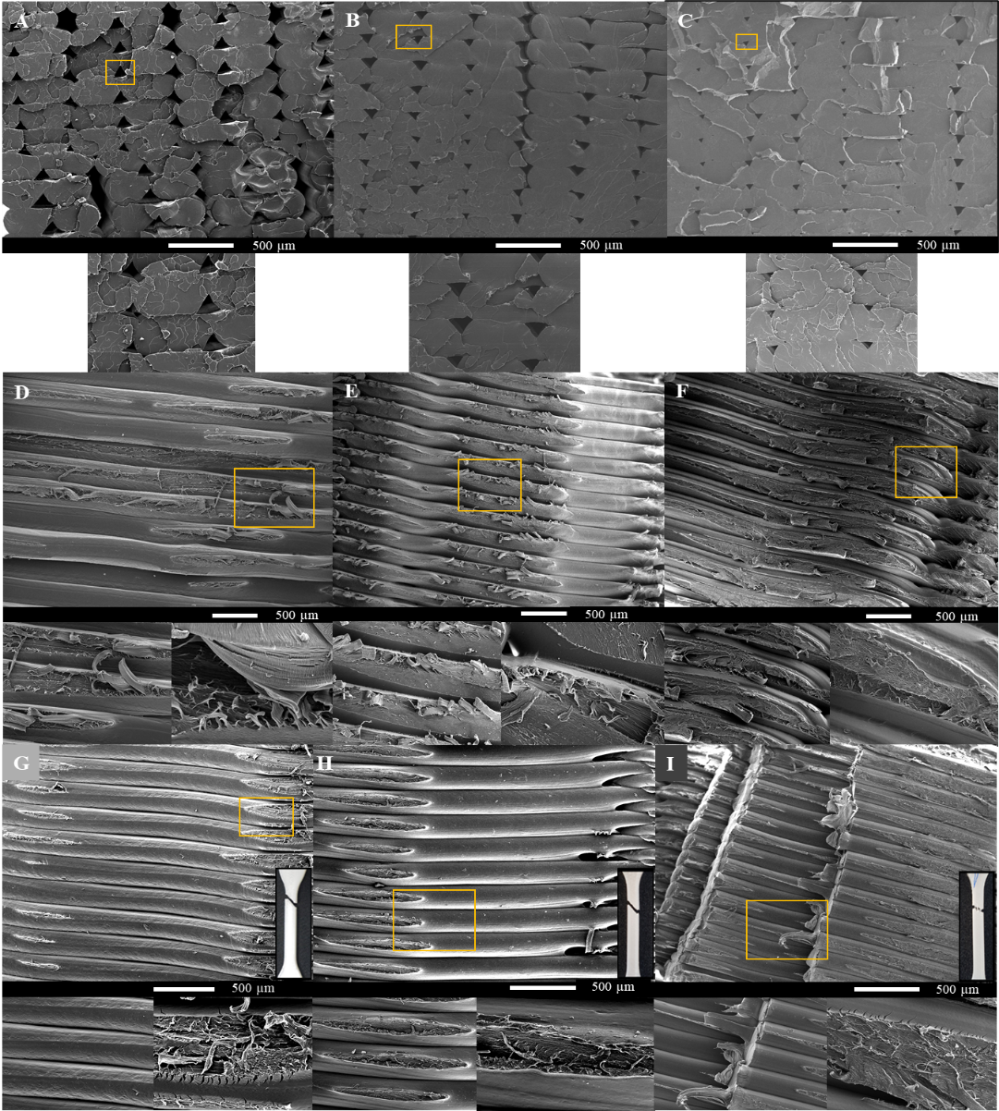
Figure 5S. SEM imaging of (A-C) section area of 0º printed specimens, (D-F) section area of 90º printed specimens and (G-I) section area of 45º printed specimens, when (A,D,G) 80/20 w/w PLA/PCL, (B,E,H) 80/20/L and (C,F,I) 80/20/D.

