Supplementary
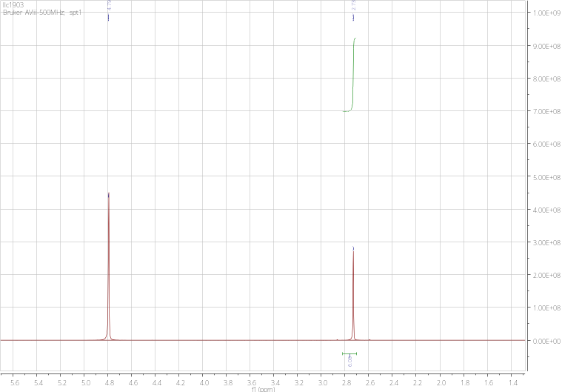
Fig. S1 ¹H NMR spectra of SPt-1
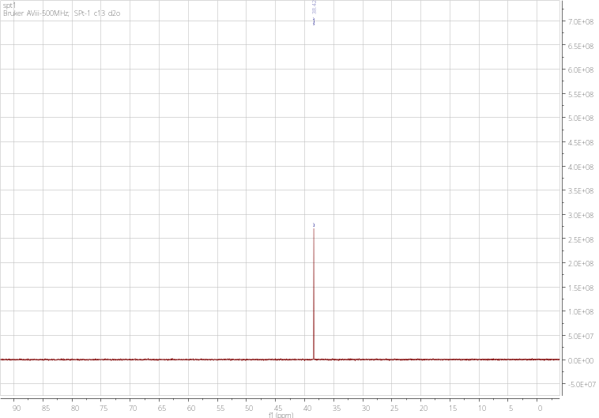
Fig. S2 ¹³C NMR spectra of SPt-1
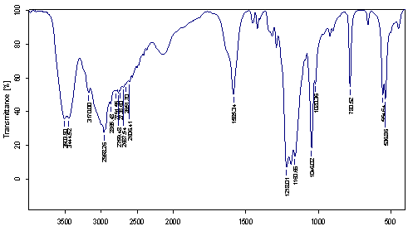
Fig. S3 IR spectra of SPt-1
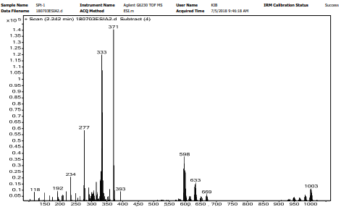
Fig. S4 MS spectra of SPt-1
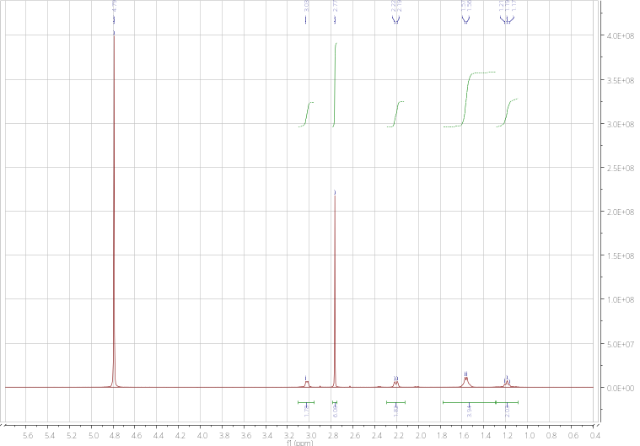
Fig. S5 ¹H NMR spectra of SPt-2
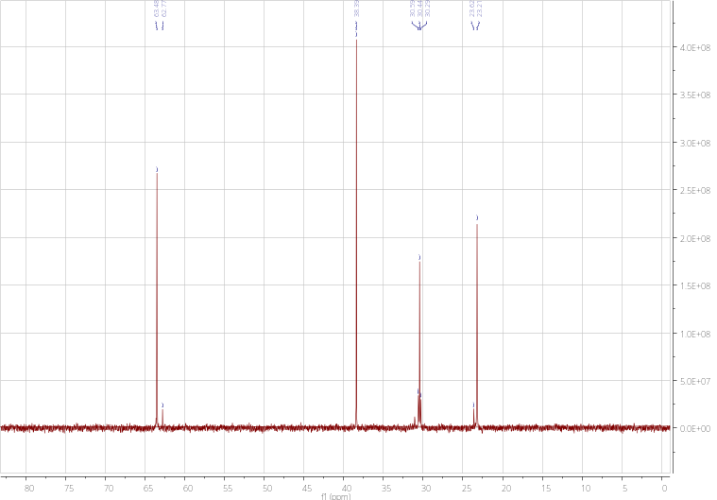
Fig. S6 ¹³C NMR spectra of SPt-2
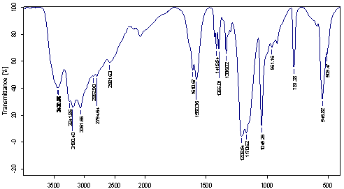
Fig. S7 IR spectra of SPt-2
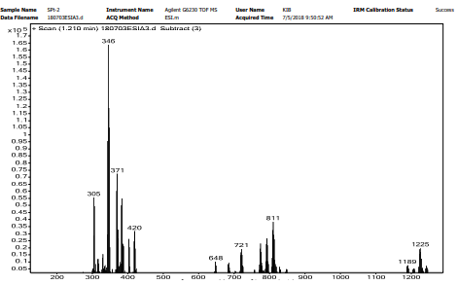
Fig. S8 MS spectra of SPt-2

