SUPPLEMENTARY FIGURES

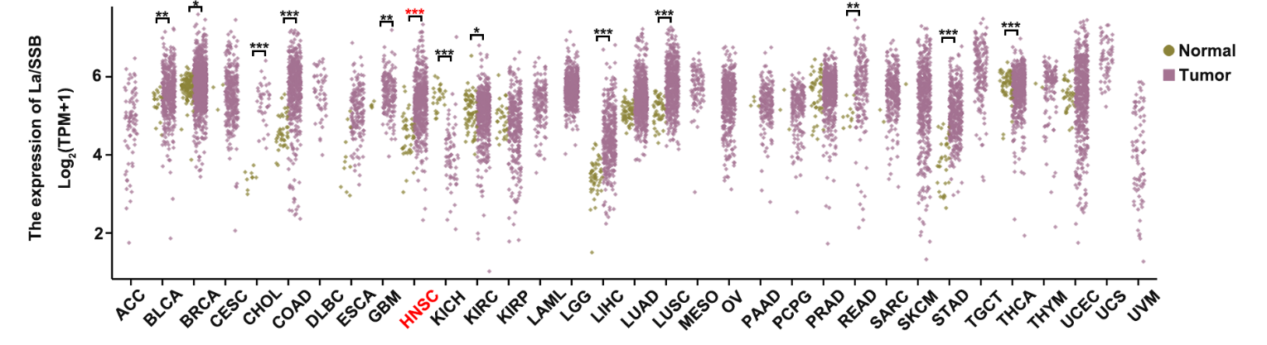
Figure S1. Pan-cancer expression profile of La/SSB in tumor versus ANM tissues from TCGA
Boxplots illustrate the differential expression of La/SSB across various cancer types based on TCGA data. Tumor tissues are compared with adjacent normal (ANM) tissues, and expression levels are presented as log2-transformed TPM values. Error bars represent mean ± SD; *P < 0.05, ***P < 0.001.

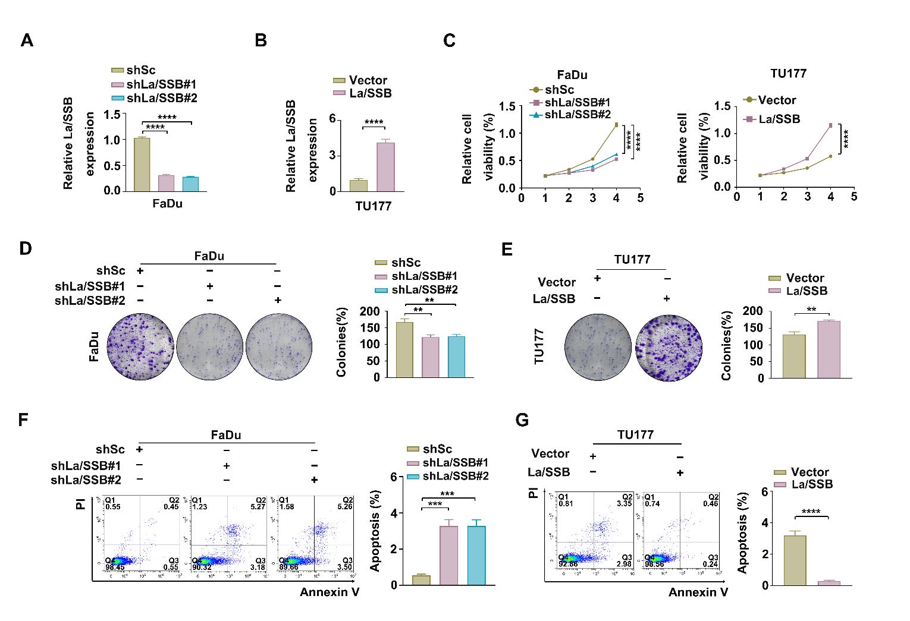
Figure S2. La/SSB enhances tumorigenic capacity of HNSC cells in vitro.
(A and B) FaDu cells were transduced with lentiviruses expressing shRNAs targeting La/SSB (shLa/SSB #1 and shLa/SSB #2) or a control scrambled sequence (shSc) (A). TU177 cells were transduced with either a control vector or lentiviruses encoding La/SSB (B). The expression levels of La/SSB were assessed using qRT-PCR. Error bars represent mean ± SD; ****P < 0.0001. (C-E) CCK-8 (C) and colony formation (D and E) were performed to evaluate cell proliferation. Scale bar, 100 μm. (E and F) Cells were analyzed for apoptosis using flow cytometry. Error bars represent mean ± SD. ***P < 0.001, ****P < 0.0001.

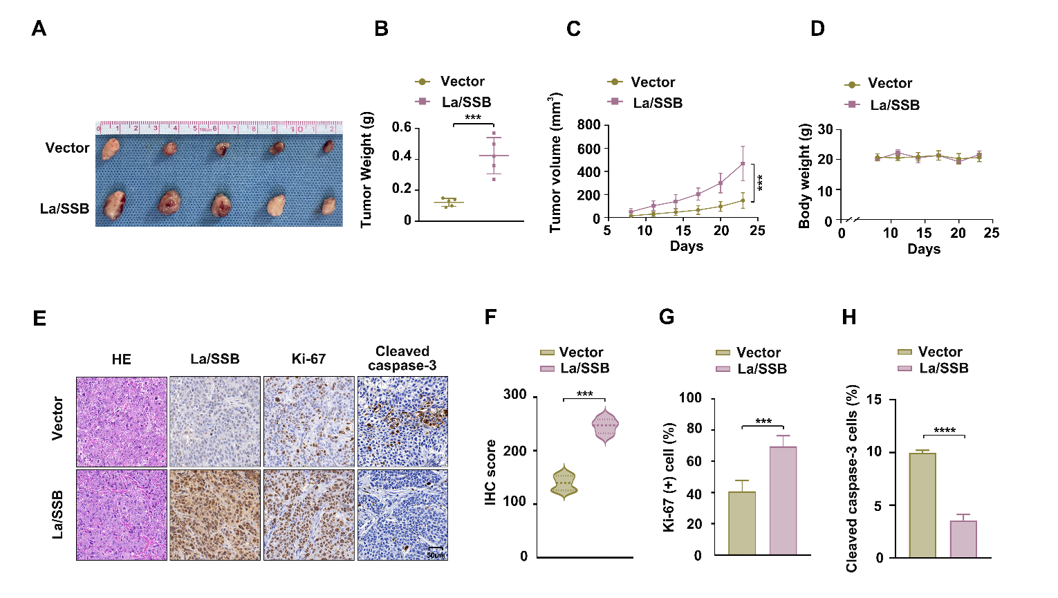
Figure S3. Overexpression of La/SSB promotes tumor cell proliferation in vivo.
(A-H) The indicated TU177 cells were subcutaneously injected into mice for monitoring tumor growth. Tumor images (A), tumor weight (B), tumor volume (C), body weight (D), and representative IHC images of La/SSB, Ki-67 and Cleaved caspase-3 (E) were shown. Scale bars, 50 µm. The quantitative analysis results for La/SSB, Ki-67 and Cleaved caspase-3 (F -H). Error bars, mean ± SD (n = 5 mice/group). ***P < 0.001, ****p<0.0001.

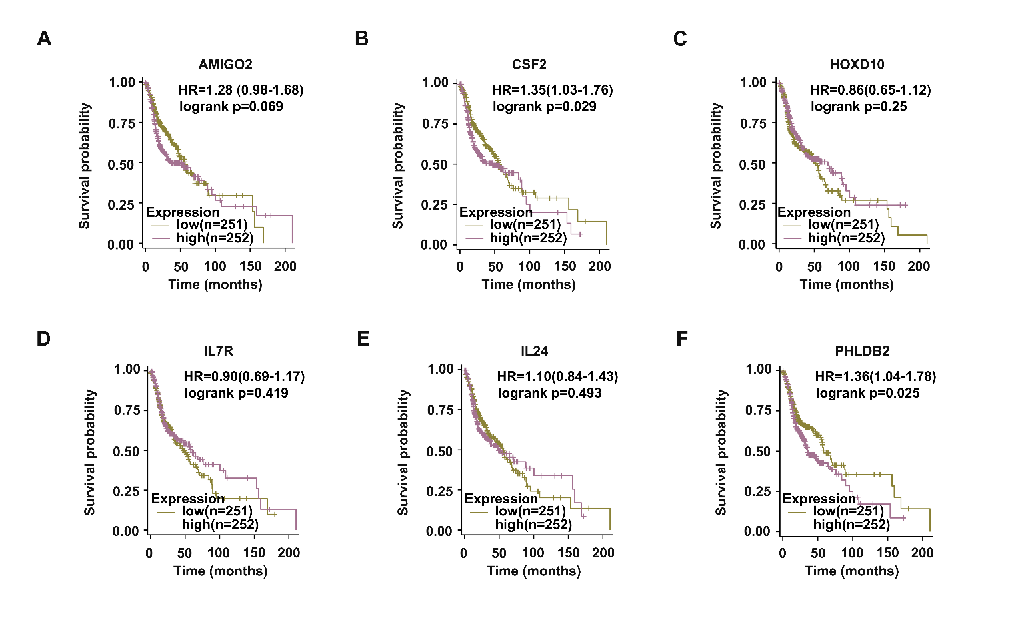
Figure S4. Analyze the expression profiles of the specified genes and their association with patient survival using the TCGA-HNSC dataset.
Kaplan-Meier survival analysis was conducted for HNSCC patients in the TCGA dataset, stratified into high (n = 251) and low (n = 252) expression groups based on the median expression levels of AMIGO2, CSF2, HOXD10, IL7R, IL24, and PHLDB2.

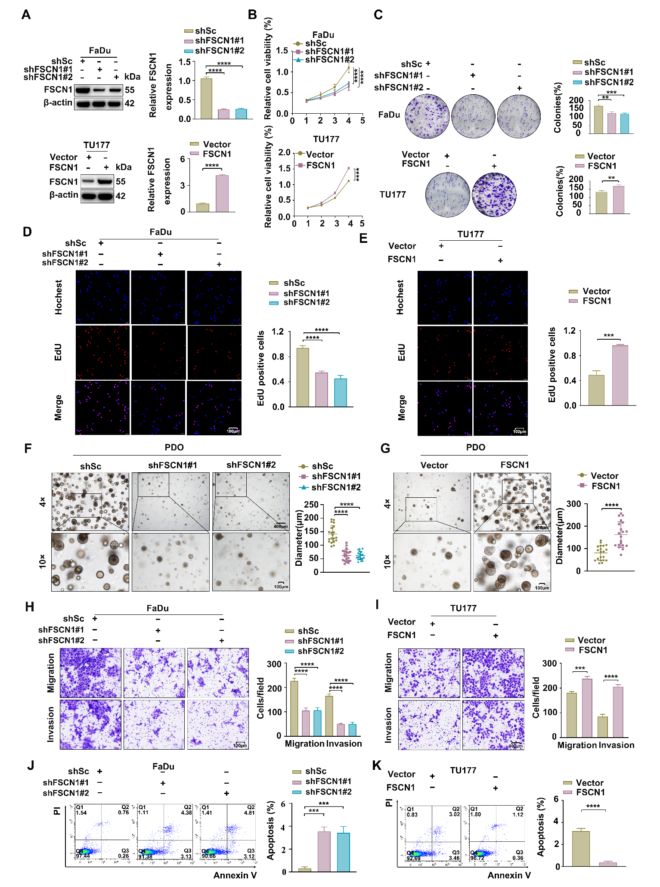
Figure S5. FSCN1 exhibits tumor promoter activities in HNSC cells.
(A) FaDu cells were transduced with lentiviruses expressing shRNAs targeting FSCN1 (shFSCN1#1 and sh FSCN1#2) or a control scrambled sequence (shSc). TU177 cells were transduced with either a control vector or lentiviruses encoding FSCN1. CCK-8 (B), colony formation (C) and EdU assays (D and E) were performed to evaluate cell proliferation. (F and G) Representative images of organoid diameter after knockdown or over-expression of FSCN1. Scale bar: 400 μm (low-magnification), 100 μm (high-magnification). Statistics of tumor organoid diameter (n=30). Error bars indicate mean ± SD. ****P < 0.0001. (H and I) Transwell assays showed the migration and invasion rates in FSCN1-knockdown FaDu cells and FSCN1-overexpressing TU177 cells. Scale bar: 100 μm. Error bars represent mean ± SD. ***P<0.001, ****P < 0.0001. (J and K) Cells were analyzed for apoptosis using flow cytometry. Error bars represent mean ± SD. **P < 0.05, ***P < 0.001, ****P < 0.0001.
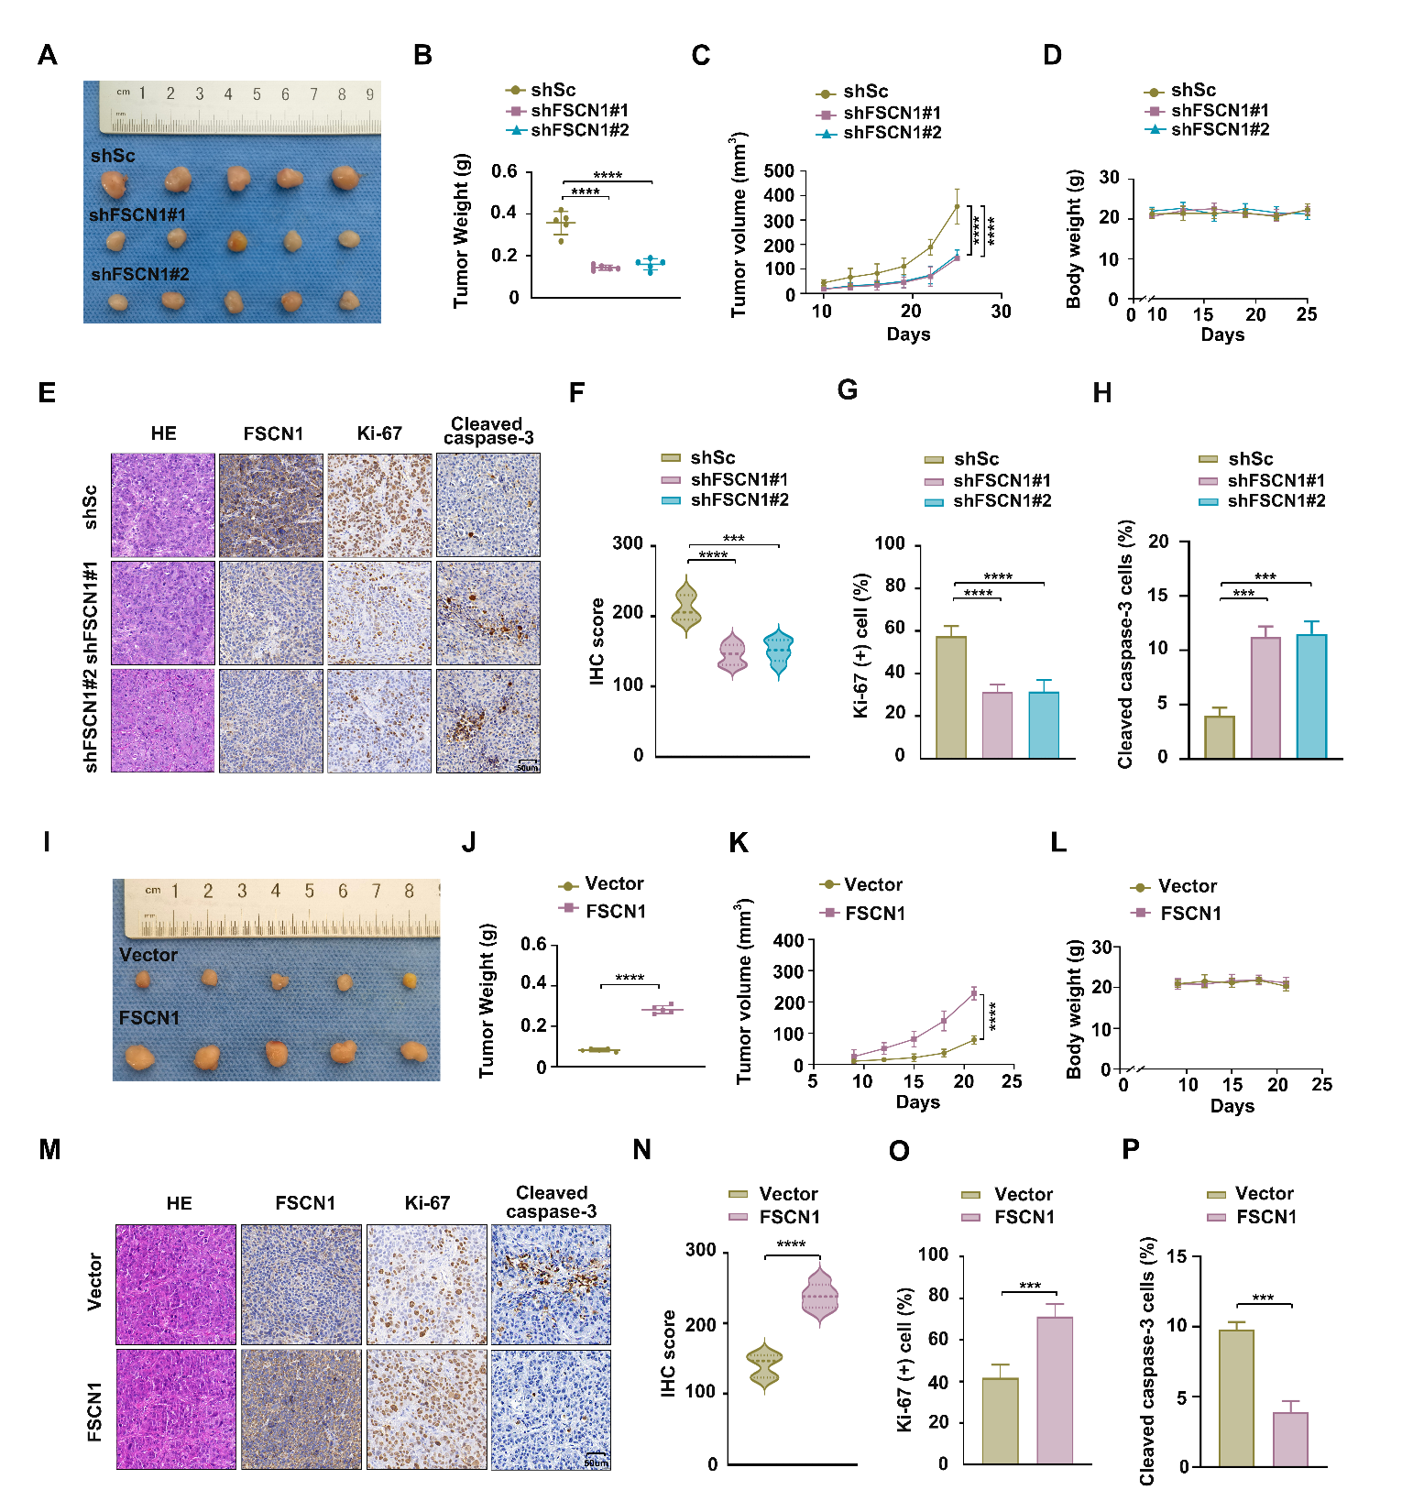
Figure S6. FSCN1 exhibits tumor promoter activities in vivo.
(A-H) The indicated TU177 cells were subcutaneously injected into mice for monitoring tumor growth. Tumor images (A), tumor weight (B), tumor volume (C), body weight (D), and representative IHC images of La/SSB, Ki-67 and Cleaved caspase-3 (E) were shown. Scale bars, 50 µm. The quantitative analysis results for La/SSB, Ki-67 and Cleaved caspase-3 (F-H). Error bars, mean ± SD (n = 5 mice/group). ***P < 0.001; ****P < 0.0001. (I-P) The indicated FaDu cells were subcutaneously injected into mice for monitoring tumor growth. Images of tumors (I), tumor weights (J), tumor volumes (K), body weight (L), and representative IHC staining for FSCN1, Ki-67 and Cleaved caspase-3 in xenograft tissues (M). Scale bar: 50 μm. The quantitative analysis results for FSCN1, Ki-67 and Cleaved caspase-3 (N-P). Error bars indicate mean ± SD. ****P < 0.0001.

SUPPLEMENTARY TABLES
Supplementary Table S3. Clinical features of 60 HNSC patients
Characteristics | Number of Cases (%)
Age
< 60 | 23(38.3)
≥ 60 | 37(61.7)
Gender
Female | 6(10)
Male | 54(90)
T Stage
T1 | 9(15)
T2 | 15(25)
T3 | 18(30)
T4 | 18(30)
lymph node metastasis
N0 | 36(60)
N+ | 24(40)
Distant metastasis
M0 | 59(98.3)
M1 | 1(1.7)
Tumor location
Hypopharynx | 24(40)
Larynx | 36(60)

Supplementary Table S4. Cell lines and growth medium
Cell line | Source | Tissue source | Complete growth medium
TU177 | Otwo Biotech Inc. (Shenzhen, China). | HNSC | RPMI 1640 (Gibco: Cat#11875093) + 10% FBS (Gibco: Cat#10099141C) + 1% penicillin/streptomycin (Beyotime, Cat# C0222)
LIU-LSC-1 | newly established cell line | HNSC | Epithelial Cell Complete Medium (VivaCell: Cat#C3650-0100) + 1% penicillin/streptomycin (Beyotime, Cat# C0222)
NOK | Otwo Biotech Inc. (Shenzhen, China). | Normal oral mucosal tissues | RPMI 1640 (Gibco: Cat#11875093) + 10% FBS (Gibco: Cat#10099141C) + 1% penicillin/streptomycin (Beyotime, Cat# C0222)
FaDu | ATCC (Manassas, VA, USA) | HNSC | RPMI 1640 (Gibco: Cat#11875093) + 10% FBS (Gibco: Cat#10099141C) + 1% penicillin/streptomycin (Beyotime, Cat# C0222)
TU686 | BeNa Culture Collection (Beijing, China) | HNSC | RPMI 1640 (Gibco: Cat#11875093) + 10% FBS (Gibco: Cat#10099141C) + 1% penicillin/streptomycin (Beyotime, Cat# C0222)
TU212 | Otwo Biotech Inc. (Shenzhen, China). | HNSC | RPMI 1640 (Gibco: Cat#11875093) + 10% FBS (Gibco: Cat#10099141C) + 1% penicillin/streptomycin (Beyotime, Cat# C0222)
HEK293T | ATCC (Manassas, VA, USA) | kidney; Embryo | DMEM (Gibco: Cat#11995065) + 10% FBS (Gibco: Cat#10099141C) + 1% penicillin/streptomycin (Beyotime, Cat# C0222)

Supplementary Table S5. Clinical features of 12 HNSC patients
Characteristics | Number of Cases (%)
Age
< 60 | 4(33.3)
≥ 60 | 8(66.7)
Gender
Female | 3(25)
Male | 9(75)
T Stage
T1 | 3(25)
T2 | 1(8.3)
T3 | 3(25)
T4 | 5(41.7)
lymph node metastasis
N0 | 10(83.3)
N+ | 2(16.7)
Distant metastasis
M0 | 11(91.7)
M1 | 1(8.3)
Tumor location
Hypopharynx | 5(41.7)
Larynx | 7(58.3)

Supplementary Table S6. Clinical characteristics of donor patients

Clinical characteristics of PDO donor patients
NO. | Age | Gender | T stage | Cancer lymph node metastasis | Distant metastasis | Cancer type | HPV  Status
Patient | 59 | Male | T4 | N2 | M0 | laryngocarcinoma | negative

Supplementary Table S7. Antibodies used in this study
Antibodies | Source | Application
Mouse monoclonal antibody anti-Ki-67 | Cell Signaling Technology (Cat# 9449) | 1:800 for IHC
Mouse monoclonal antibody anti-β-actin | Sigma-Aldrich (Cat #A1978) | 1:1000 for WB
Mouse monoclonal antibody anti-SSB | Abcam (Cat# ab75927) | 1:200 for IHC; 1:1000 for WB; 1:200 for IF
Mouse monoclonal antibody anti-FSCN1 | Santa Cruz (Cat #Sc- 21743) | 1:50 for IHC; 1:200 for WB
Rabbit monoclonal antibody anti-TFAP2C | Abcam (Cat# ab324045) | 1:50 for Chip
Rabbit monoclonal antibody anti-TFAP2C | Abcam (Cat# ab218107) | 1:250 for IHC; 1:1000 for WB
Goat Anti-Mouse IgG HRP | Abcam (Cat# ab6789) | 1:2000 for WB
Goat Anti-Rabbit IgG HRP | Abcam (Cat# ab6721) | 1:2000 for WB
Rabbit monoclonal antibody anti-GAPDH | Cell Signaling Technology (Cat #2118) | 1:1000 for WB
Rabbit polyclonal antibody anti-p63 | Proteintech (Cat # 12143-1-AP) | 1:200 for IHC
Mouse monoclonal antibody anti-Cytokeratin 13 | Proteintech (Cat #66684-1-lg) | 1:1000 for IHC
Rabbit polyclonal antibody anti-Cleaved Caspase-3 | Cell Signaling Technology (Cat# 9661) | 1:400 for IHC; 1:400 for IF

Supplementary Table S8. Primer sequences for qRT-PCR used in this study
Prime name | Primer sequence (5'-3')
(human) La/SSB FORWARD | AATTTGCCACGGGACAAGTTT
(human) La/SSB REVERSE | TGTTGTTAGACGGTTCAACCTG
(human) β-actin FORWARD | CCTGGCACCCAGCACAAT
(human) β-actin REVERSE | GGGCCGGACTCGTCATAC
(human) FSCN1 FORWARD | CCAGGGTATGGACCTGTCTG
(human) FSCN1 REVERSE | GTGTGGGTACGGAAGGCAC
(human) TFAP2C FORWARD | TGAAGAGGATTGCGAGGATCG
(human) TFAP2C REVERSE | AGATGCGAGTAATGGTCGGC

Supplementary Table S9. Targeting sequences for shRNẠs used in this study
Note | Sequences (5'-3')
shSc | TTCTCCGAACGTGTCACGT
shLa/SSB#1 | CCGTCTAACAACAGACTTTAA
shLa/SSB#2 | CTGGCCAGAAGTACAAAGAAA
shFSCN1#1 | CAAAGACTCCACAGGCAAATA
shFSCN1#2 | AGAATGCCAGCTGCTACTTTG
shTFAP2C#1 | CCTCAGCTCTACGTCTAAATA
shTFAP2C#2 | ATGGAGAAACACAGGAAATAA

Supplementary Table S10. Primers used for ChIP Assays in this study
 | Sense (5'-3') | Antisense (5'-3')
La/SSB binding site  (PCR) | TAACTGGCCGGTACCGTTCTGGGGCTCAAGGCCCT | CTTGATATCCTCGAGGGCCGGGCACTGAGATAACT
La/SSB binding site  (qPCR) | AAGCAGGATGGCAAGAAGGTG | GGCCGGGCACTGAGATAACT

