SUPPLEMENTARY INFORMATION
Inverse Design of High-Entropy Superalloys Using Machine Learning and Generative Artificial Intelligence
François Rousseau^{a, *}, Thierry Belmonteª, Frédéric Sur^{b}, Alexandre Nominéª
ª Institut Jean Lamour, Université de Lorraine, Campus Artem, 2 allée André Guinier, 54011 Nancy, France
^{b} Laboratoire Lorrain de Recherche en Informatique et ses Applications, Université de Lorraine, Campus Scientifique, 615 Rue du Jardin-Botanique, 54506 Vandœuvre-lès-Nancy, France
* email: francois.rousseau@univ-lorraine.fr

Table of content
1. METHODOLOGICAL FRAMEWORK 4
1.1. Target Property Matrix 4
1.2. Descriptors Engineering 6
1.3. Outlier Detection & Cleaning of Data 13
1.3.1. Data Preparation and Standardization 13
1.3.2. Local Outlier Factor (LOF) 14
1.3.3. Isolation Forest 16
1.3.4. k-Nearest-Neighbors Residuals 16
1.3.5. HuberRegressor Residuals 17
1.3.6. Combined Outlier Mask and Rationale 18
1.4. Descriptors Selection 19
1.4.1. Spearman Rank Correlation 20
1.4.2. Mutual Information 21
1.4.3. XGBoost Embedded Importance 23
1.4.4. Recursive Feature Elimination with Cross‐Validation (RFECV) 24
1.4.5. Integration and Thresholding 25
1.5. Supervised Machine Learning 34
1.6. Summary Flowchart 35
2. CONSTRUCTION & INTERPRETATION OF ML SURROGATES 40
2.1. Creep 40
2.2. High-Temperature Oxidation 43
2.3. Formation Enthalpy 45
2.4. Bulk Modulus 47
2.5. Shear Modulus 49
2.6. Melting Point 51
2.7. Density 53
2.8. Summary 54
3. STOCHASTIC BRUTE-FORCE SCREENING OF 5-ELEMENTS HEA 57
3.1. Generation of HEA: Composition Space and Randomization 57
3.2. Scoring & Pareto Front 61
3.3. Ashby Charts: Legacy Superalloys vs Pareto-optimal 70
3.4. Analysis of the Role of Elements 76
3.4.1. XGBoost Forest Analysis (feature importance, permutation importance, SHAP values) 79
3.4.2. Partial Dependence Analysis 86
4. GENERATIVE EXPLORATION & FRONTIER EXPANSION 101
4.1. Data Preparation and Condition Specification 101
4.2. CVAE Architecture and Adaptive Training Strategy 103
4.3. Generative Exploration Loop and Filtering 106
4.4. Latent Space Augmentation via Hamming-Based Sampling 108
4.5. Simplex Steepest-Ascent on Pareto Front Compositions 112
4.6. Results and Candidate Analysis 115
4.6.1. Ward Linkage Clustering and Medoid Selection 118
4.6.2. Pareto Front Computation and Compression 119
4.6.3. Ashby Chart Visualization and Materials Selection 121
4.7. Analysis of the Pareto Front & Selection 128
4.7.1. Analysis of the Correlations between Elements in the Pareto Front 130
4.7.2. Ward Clustering on CLR-Transformed Compositions and Analysis 132
4.7.3. Experimental Validation and Iterative Integration 136

METHODOLOGICAL FRAMEWORK

Target Property Matrix
To engineer a high-entropy superalloy (HESA) that merges high strength, thermal stability, and environmental resistance, it is essential to identify the key properties that collectively define “good” performance. Drawing upon both high-entropy alloy (HEA) and conventional superalloy literature, the following physical quantities form the Target Property Matrix, which guides descriptor engineering (Section Descriptors Engineering) and property-driven model development (Section Supervised Machine Learning).
High-temperature strength is primarily governed by creep resistance. This property is enhanced by the precipitation of ordered $γ'$ (L1₂) phases within an FCC matrix ¹. Reported activation energies range from 378 to 548 kJ mol⁻¹ and stress exponents from 3 to 6.5 ², reflecting the dominant role of microstructural kinetics in long-term deformation. Dual-phase microstructures (e.g., FCC/ L1₂ or FCC + BCC in the 25–32% and 68–76% range) can balance strength and ductility, with elongations above 20% in some cases ³. However, the formation of intermetallics such as Laves phases or Ni₃Ti at grain boundaries can significantly degrade creep performance ⁴.
Resistance to high-temperature oxidation is essential for aerospace and turbine applications. Superalloys typically employ Al and Cr to form protective oxide layers (e.g. alumina), while HEAs with refractory elements like Mo, Ta, and Si have shown promising oxidation resistance. Measuring the oxidation rate constant ($K_{A}$) provides quantitative insight into surface stability under thermal cycling.
Low density is advantageous for lightweight structural applications. HESAs incorporating light elements such as Li, Mg, and Al can achieve densities below 5 g·cm⁻³ ⁵. However, care must be taken to preserve ductility and avoid unfavorable phase formation when reducing density ⁶. The Target Property Matrix therefore includes density as a trade-off metric against strength and thermal stability.
Elastic moduli – Young’s, shear, and bulk – are key indicators of stiffness and sound structural response. Their values often correlate with descriptors like valence electron concentration and atomic size mismatch ³. High moduli support better load-bearing capacity, while concurrently informing hardness and vibrational stability.
Despite configurational entropy favoring solid-solution stability in HEAs, enthalpic contributions ($ΔH_{mix}$) must remain moderate to avoid intermetallic formation. Ideal ranges lie between −10 and +5 kJ/mol ⁷ (so between -0.1 and 0.05 eV/atom). A high $Ω$ parameter – defined as
$$Ω≡\frac{T_{m}ΔS_{mix}}{\left|ΔH_{mix}\right|}$$ | $$( STYLEREF 1 \backslash s 1 SEQ Équation \backslash * ARABIC \backslash s 1 1)$$
– (with $Ω$ > 1) signals entropy-dominated solid solution stability. Inclusion of melting points – often above 1 700 K for HESAs – and critical phase transformation temperatures (e.g. BCC stability thresholds) further inform alloy resilience under extreme conditions ⁸.
Processing history – including cooling rate, aging, or additive manufacturing – strongly affects microstructure by controlling phase size, boundary density, and defect populations ². Interstitial elements such as C, N, O can strengthen but in excess promote embrittlement (e.g. HCP phases or carbides) ⁹. Thus ductility metrics and volume fractions of secondary phases (e.g. coherent $γ'$, Laves, carbides) are incorporated to ensure a balanced mechanical profile ^{10,11}.
HEAs derive much of their novelty from sluggish diffusion and the so-called cocktail effect – where multiple principal elements interact to produce emergent behaviors not found in binary alloys ¹². The formation of undesirable intermetallics at grain boundaries is a major failure mode; their avoidance is ensured by tracking formation enthalpies and solid-solution stability indicators ¹³.
These properties are interdependent. For instance, adding L1₂-forming elements improves creep resistance but may reduce ductility or elevate density. Adding light elements reduces weight but can compromise oxidation resistance or phase stability. Similarly, increasing configurational entropy by adding more principal elements promotes solid-solution stability but may influence moduli and formation enthalpy unfavorably.
To effectively select and optimize HESA compositions, the methodology incorporates these properties into a unified matrix. In subsequent stages, surrogate models predict them, data cleaning and descriptor selection refine predictor sets, and Pareto-based decision layers identify designs that best satisfy multi-objective criteria – thereby integrating physical insight and data-driven rigor into a reproducible alloy-design workflow.

Descriptors Engineering
In this machine learning process workflow, direct learning from raw elemental symbols is dismissed in favor of physics-informed, composition-derived features. First, by translating each atom into quantitative physical quantities, the model is exposed to the underlying thermochemical and electronic drivers of stability and functionality, rather than forcing it to infer these from arbitrary string tokens. Second, this strategy permits extrapolation to chemistries entirely absent from the training set – e.g. alloys containing rare or novel elements – since any element with known atomic properties can be featurized; learning from features allows to make predictions on elements never seen during training. Finally, limiting descriptors to composition alone removes dependence on crystal structure, enabling predictions for conjectured alloys whose lattice symmetry has yet to be determined.
To cover a broad range of physical effects – size, electronic structure, thermodynamics, and periodic trends – 42 descriptors are initially computed from each normalized composition. Although high-dimensional, the subsequent training pipelines use feature-importance ranking and the inherent sparsity mechanism of XGBoost to select the most informative subset per target property.
The descriptor used in the pipeline fall into several different categories:
- Atomic Size and Distortion
- Average Atomic Radius (avg_radius) and Standard Deviation (std_radius)
– mean and spread of elemental metallic radii reflect ideal lattice parameters and size disorder.
- Radius‐Mismatch Parameter ($δ$)
$δ≡\sqrt{\sum_{i}{{c_{i}\left(1-{r_{i}}/{\overline{r}}\right)}^{2}}}$​ quantifies relative size variance; $δ < 0.06$ is often cited as necessary for single‐phase HEA formation.
- Maximum/Minimum Radius Ratios (max_r_ratio, min_r_ratio)
Identify extreme size outliers, which can trigger local strain and segregation.
- Virtual Density Descriptor (d_virt).
$d_{virt}≡\frac{{10}^{7}}{N_{A}}\frac{\overline{M}}{{\overline{r}}^{3}}$​, with average atomic weight $\overline{M}$ and radius $\overline{r}$, is an empirical proxy for packing efficiency, and proved to be efficient to predict actual density.
2. Electronic Structure
- Average and Standard deviation Pauling Electronegativity (avg_eneg, std_eneg)
Influence bond polarity and mixing enthalpy; high $Δ_{eneg}$ often correlates with intermetallic formation ²³.
- Electronegativity Range (range_eneg). Difference between maximum and minimum Pauling values; large spreads can drive ordering.
- Average and Standard deviation Allen Electronegativity (avg_en_allen, std_en_allen)
Alternative scale based on spectroscopic data, useful in oxide and intermetallic contexts ²⁴.
- First Ionization Energy (IE1) (avg_IE1, std_IE1), correlates with cohesive energy and vacancy formation ²⁵.
- Electron Affinity (EA) (avg_EA, std_EA), affects charge transfer tendencies in alloys.
- Valence-Electron Count (VEC) (avg_VEC, std_VEC). These electrons are the one participating in the chemical bond.
- Fraction of d-Electrons (frac_d). Ratio of d‐orbital occupancy to total valence electrons; reflects propensity for metallic bonding and d-band effects. The special role of d-shell electrons arises from their intermediate energy (allowing multiple oxidation states), directional shapes (dictating complex geometry), and the presence of both filled and empty orbitals (enabling diverse bonding modes). Together, these features give rise to the rich redox, catalytic, magnetic, spectroscopic, and structural chemistry that defines the transition‐metal elements.
- Average and Standard deviation d-Shell Principal Quantum Number (avg_d_shell_n, std_d_shell_n). Distinguish 3d vs. 4d/5d metals, influencing electron localization.
3. Subshell Occupancies
- Average and Standard deviation Occupancies of s, p, d, f Subshells (avg_s, std_s, etc.)
Detailed breakdown of valence electron distribution; rarely used in HEA literature but potentially informative for complex bonding ²⁵.
4. Periodic Trends and Position
- Average and Standard deviation Group Number (avg_group, std_group)
- Average and Standard deviation Period Number (avg_period, std_period)
- Average and Standard deviation Mendeleev Number (avg_mendeleev_no, std_mendeleev_no)
The Mendeleev (or Pettifor) scale orders elements by chemical similarity and has been effective in phase‐map predictions; refined definitions have been proposed to better correlate with electronic structure ²⁶.
5. Stoichiometry and Composition
- Stoichiometric Entropy (stoich_entropy)
$${ΔS}_{mix}≡-\sum_{i}{x_{i}\log{x_{i}}}$$ | $$( STYLEREF 1 \backslash s 1 SEQ Équation \backslash * ARABIC \backslash s 1 2)$$
Central to HEA design; near‐equimolar alloys have $ΔSₘᵢₓ > 1.5$, driving single‐phase stability.
- Number of Unique Elements (unique_elements), proxy for chemical complexity.
6. Thermodynamic Mixing
- Miedema Mixing Enthalpy (DeltaH_mix). Sum of binary $ΔHₘᵢₓ$ contributions from the Miedema model; a negative $ΔHₘᵢₓ$ can favor ordering or intermetallics formation if too large in magnitude. It actually corresponds to a physical quantity to be predicted – the formation energy at 0K – and it is directly provided by the pymatgen library. Presumably, the value provided by the library cannot be very accurate since it is available for any composition, it is therefore used as a mere “feature” for the trainings, and the formation energy is obtained from a learning database focusing on the area of interest (stable metals-only materials).
7. Mass and Density
- Average and Standard deviation Atomic Weight (avg_weight, std_weight), the basic mass scale.
- Average and Standard deviation Melting Point (avg_melting_point, std_melting_point). Inform high‐temperature processability, high-temperature behavior and entropy‐temperature ratios.
8. Ionic and Atomic Number
- Average and Standard deviation Atomic Number (avg_Z, std_Z). Correlate with core‐electron screening and cohesive energy.

Outlier Detection & Cleaning of Data
In any data‐driven investigation, the presence of outliers can distort statistical summaries, impair model training, and ultimately lead to spurious conclusions. Prior to any machine‐learning step on creep‐related properties, a four‐fold outlier detection pipeline is implemented, combining (1) Local Outlier Factor (LOF), (2) Isolation Forest, (3) k-Nearest-Neighbors residual analysis (kNN), and (4) HuberRegressor residual analysis. By flagging any sample identified as anomalous by any method, the aim is to achieve a robust, conservative cleaning criterion that removes points exhibiting unusual local density, isolation characteristics, or anomalous responses relative to their peers or to a robust regression model.

Data Preparation and Standardization
Before applying any outlier detector, all feature columns $X$ and the target variable $y$ are converted to floating‐point numeric formats. Missing entries are dropped to avoid spurious distance or density calculations. A $Z$‐score standardization is then applied:
$$X_{scaled}=\frac{X-μ_{X}}{σ_{X}}$$ | $$( STYLEREF 1 \backslash s 1 SEQ Équation \backslash * ARABIC \backslash s 1 3)$$
using StandardScaler, ensuring that each feature has zero mean and unit variance. Standardization is critical for methods based on Euclidean distances (LOF, kNN) and isolation by random splits (Isolation Forest), since features of large scales would otherwise dominate the detection process.

Local Outlier Factor (LOF)
LOF is a density‐based algorithm that assigns to each sample a score reflecting how isolated it is with respect to its neighborhood. For a given data point $i$, the local reachability density (LRD) is computed, based on the average reachability distance to its $k$ nearest neighbors:
- $N_{k}(i)$ denotes the set of the $k$ nearest neighbors of point $i$, as determined by Euclidean distance in the standardized feature space.
- $d(j,l)$ is the Euclidian distance between $j$ and $l$
- $d_{k}(l)$ (the $k$-distance of $l$) is the distance from $l$ to its own $k$^{th} nearest neighbor.
- ${reach_dist}_{k}\left(j,l\right)=\max\left\{d\left(j,l\right),d_{k}(l)\right\}$ is the reachability distance between $j$ and $i$, which means the true distance between $j$ and $i$ and at least the $k$-distance of $l$. With this definition, each neighbor $l∈N_{k}(j)$ stands at a distance $d_{k}(l)$ of $j$.
- All this allows to define:
$${LRD}_{k}(j)={\left(\frac{1}{\left|N_{k}(j)\right|}\sum_{l∈N_{k}(j)}{{reach_dist}_{k}\left(j,l\right)}\right)}^{-1}$$ | $$( STYLEREF 1 \backslash s 1 SEQ Équation \backslash * ARABIC \backslash s 1 4)$$
If $j∈N_{k}(l)$, ${reach_dist}_{k}\left(j,l\right)= d_{k}(l)$, if $j∉N_{k}(l)$, ${reach_dist}_{k}\left(j,l\right)= d\left(j,l\right)$. In other words, points $j$ surrounded by closely packed neighbors $l$ often have a ${reach_dist}_{k}\left(j,l\right)= d\left(j,l\right)$, and therefore ${LRD}_{k}(j)≈1/{{\overline{d\left(j,l\right)}}_{l∈N_{k}(j)}}$, a high value, potentially infinite in case of duplicate points. On the contrary, points $j$ in sparse regions have ${LRD}_{k}(j)≈1/{{\overline{d_{k}(l)}}_{l∈N_{k}(j)}}$, a (much) smaller value. The value of ${LRD}_{k}(j)$ reflects the local density. This is illustrated on Figure 1.
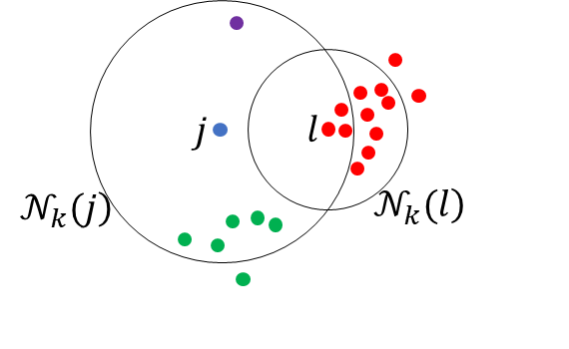
Figure 1: Detecting an Outlier with Local Density Analysis
This figure features a point $j$ associated to a low local density, with neighbors experiencing a higher density (or even clusters, marked by a different color for each). As a consequence, most $k$-neighbors $l$ of $j$ do not have $j$ among their $k$-neighbors, i.e. most of the time ${reach_dist}_{k}\left(j,l\right)= d\left(j,l\right)$ with $d\left(j,l\right)$ significantly bigger than $d_{k}(l)$, and therefore ${LRD}_{k}(j)≈1/{{\overline{d\left(j,l\right)}}_{l∈N_{k}(j)}}$, a value indicating a locally relatively low density compared to ${LRD}_{k}(l)≈1/{{\overline{d_{k}(m)}}_{m∈N_{k}(l)}}$ for instance.

The density of $i$ to that of its neighbors $j$ can then be compared:
$${LOF}_{k}(i)=\frac{\sum_{j∈N_{k}(i)}{{LRD}_{k}(j)}}{k×{LRD}_{k}(i)}$$ | $$( STYLEREF 1 \backslash s 1 SEQ Équation \backslash * ARABIC \backslash s 1 5)$$
A LOF score significantly greater than 1 indicates that $i$ lies in a region of lower density than its neighbors and is thus probably an outlier.
Implementation: scikit‐learn’s LocalOutlierFactor was used with $k=20$ neighbors and a contamination fraction (contamination=lof_frac, default 0.05). The algorithm labels points with negative fit_predict output (-1) as outliers. LOF is particularly adept at discovering local clusters of anomalies that global methods might miss.

Isolation Forest
Isolation Forest isolates anomalies rather than profiling normal points. Random splits on random features recursively partition the data; anomalies, being few and different, tend to require fewer splits to isolate. The average path length from root to leaf across an ensemble of isolation trees yields an anomaly score: shorter paths imply a higher likelihood of being an outlier.
Implementation: IsolationForest(contamination=iso_frac, random_state = 0) is fitted on the standardized features. Samples predicted as -1 by the forest are flagged as outliers. Because it relies on random feature subsampling and random split values, Isolation Forest captures global and axis‐aligned anomalies that might escape density‐based detectors.

k-Nearest-Neighbors Residuals
This residual‐based method exploits the known relationship between inputs $X$ and the target $y$. Presumably, each sample’s response can be approximately predicted by averaging the responses of its $k$ nearest neighbors in feature space. The residual for sample $i$ is
$$r_{i}=\left|y_{i}-y_{N_{k}(i)}\right|$$ | $$( STYLEREF 1 \backslash s 1 SEQ Équation \backslash * ARABIC \backslash s 1 6)$$
where $y_{N_{k}(i)}$​ is the mean target of the $k$ nearest neighbors of $i$. Large residuals indicate that the point’s behavior deviates strongly from its peers.
Implementation: With NearestNeighbors(n_neighbors=knn_k), the $k=10$ closest samples for each $i$ are identified. Residuals $r_{i}$are computed​, then set a threshold at $μ_{r}+2 σ_{r}$ (mean plus two standard deviations). Any point with $r_{i}$​ above this threshold is marked as anomalous. This approach specifically catches outliers in the response dimension, even if their features lie in dense regions.

HuberRegressor Residuals
Huber regression is a “robust” linear model that combines least‐squares for inliers with Huber’s loss for outliers – this specific loss justifies the “robust” qualification: the classic squared loss is abandoned in favor of a loss less sensitive to outliers. After fitting the model $\hat{y}=β_{0}+β^{⊤}X$, the standardized residuals
$$s_{i}=\frac{\left|y_{i}-\hat{y_{i}}\right|}{σ_{resid}}$$ | $$( STYLEREF 1 \backslash s 1 SEQ Équation \backslash * ARABIC \backslash s 1 7)$$
are computed, where $σ_{resid}$​ is the standard deviation of the residuals. Points with $s_{i}$​ above a chosen threshold (here, 2.5) are considered outliers. Indeed, many real‐world phenomena are reasonably smooth and can be locally approximated by linear relationships in transformed or standardized feature space. A linear fit will capture the “center” of the cloud of points even if the true mapping is curved. A high value of $s_{i}$ means that $y_{i}$ lies far from the fitted hyperplane, beyond what the model considers normal variation, or that $X_{i}$ may be in a region where the model had little data to learn from, so they exert undue pull on a plain least‐squares fit. In both cases, it justifies to assume $\left(X_{i},y_{i}\right)$ to be an outlier.
Implementation: HuberRegressor(max_iter=huber_max_iter) is fitted – with an increased iteration limit to ensure convergence – and compute absolute residuals. Dividing by the residual standard deviation allows a unit‐less comparison. Samples exceeding the Huber threshold (2.5) are flagged. This method excels at identifying influential points that would otherwise bias an ordinary least squares model.

Combined Outlier Mask and Rationale
Once four Boolean masks are obtained, the final outlier indicator is defined by their sum. The rates of outliers hold remarkably steady across properties (see Figure 2), despite wildly different data origins (DFT vs. experiments vs. AI‐derived). This was expected:
- LOF and IsolationForest were both set to 5% contamination by default, so each alone will call about 5% of points “outliers.”
- kNN and Huber residual thresholds ($≈2σ$) each capture another ∼2–3% tail.
- When counting exactly one method flagging a given point, the result is about 5% (LOF) + 5% (IsoForest) + 2% (kNN) + 0.6% (Huber) minus overlap, and in total about 12%.
All the datasets – no matter the property – belong to the same standardized feature space (same descriptors, same scaling). Even if the true $y(X)$ relationship differs, the distribution of points in $X$-space looks similar once standardized, so density‐based and split-based detectors behave similarly. Every measurement or calculation method has some intrinsic noise or occasional artifact. The pipeline is simply catching that baseline noise at about the same rate everywhere.
The strategy adopted is to be conservative with dataset known for the poor quality of the data (eliminate any suspected outlier) – “creep” and “high-temperature oxidation” datasets –, ignore potential outliers when the machine learning reaches excellent $R²$ on the whole data – “density” dataset –, and adopt a moderate strategy (dismiss data with a score of 3 or 4) with other quantities. It will be validated with different trials and learning comparisons during the machine learning process.
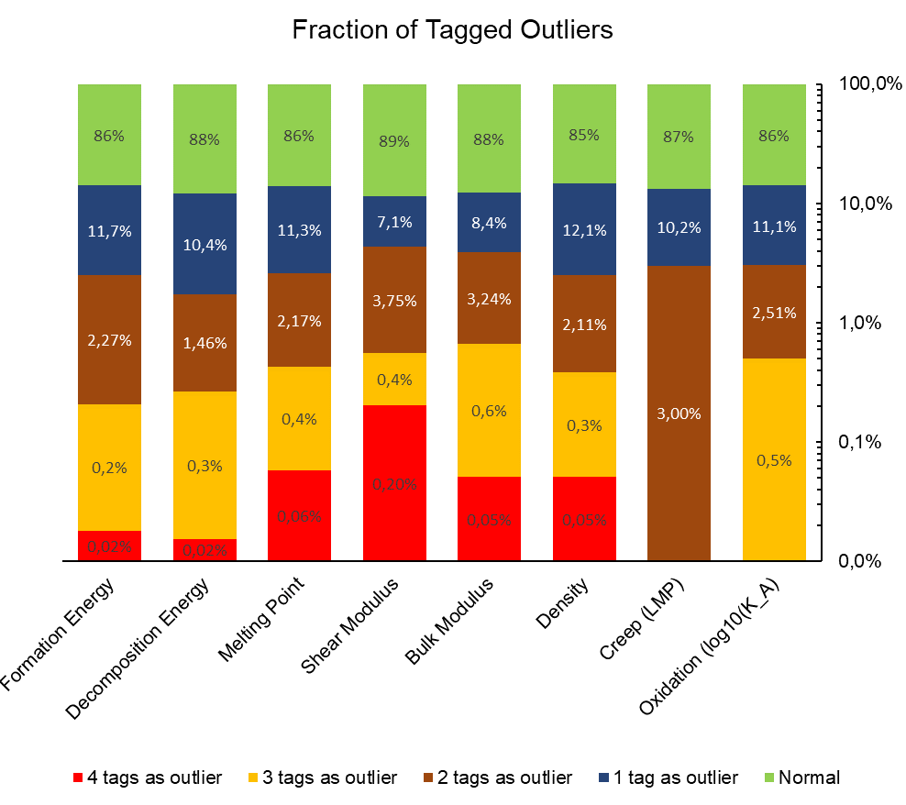
Figure 2: Outlier Scores for each Physical Quantity to be Learned
The outlier detection is done using four different methods: Local Outlier Factor, Isolation Forest, k-Nearest-Neighbor, and Huber Regression. In the context of each learning to be done, each data receives a score between 0 (normal) and 4 (tagged as outlier by each method). The results are presented in percentage of the global dataset.

Descriptors Selection
Effective feature (descriptor) selection is a critical step in the development of predictive models, particularly when the number of candidate descriptors is large relative to the available data. In this work, an ensemble‐inspired pipeline is employed to identify the most informative descriptors among 42 candidates. The pipeline comprises four complementary selection methods – Spearman rank correlation, Mutual Information (MI), XGBoost embedded importance, and Recursive Feature Elimination with Cross‐Validation (RFECV) – applied repeatedly on bootstrap resamples. By averaging scores or ranks across bootstraps and applying method‐specific thresholds, the approach seeks to improve stability and mitigate overfitting, collinearity, and sampling variability. In the following sections, the principles, strengths, and limitations of each method are detailed, and how their integration yields a reliable final descriptor set for downstream modeling is described.

Spearman Rank Correlation
Spearman’s rank correlation coefficient measures the strength and direction of a monotonic relationship between each descriptor $x_{j}$​ and the continuous target variable $y$. Unlike Pearson’s correlation, which assumes linearity, Spearman’s $ρ$ is computed on the ranks of the data, rendering it sensitive to any strictly monotonic association, whether linear or nonlinear:
- Each raw value $x_{i}$​ is replaced by its rank $R(x_{i})$, i.e. its position when the $x$-values are sorted ascending (smallest → rank 1, next → rank 2, …). Tied values receive the average of their occupied ranks.
- The same is done for the $y_{i}$​ to get ranks $R(y_{i})$.
$$ρ=\frac{\sum_{i=1}^{n}{\left(R\left(x_{i}\right)-\overline{R_{x}}\right)}\left(R\left(y_{i}\right)-\overline{R_{y}}\right)}{\sqrt{\sum_{i=1}^{n}{{\left(R\left(x_{i}\right)-\overline{R_{x}}\right)}^{2}}}\sqrt{\sum_{i=1}^{n}{{\left(R\left(y_{i}\right)-\overline{R_{y}}\right)}^{2}}}}$$ | $$( STYLEREF 1 \backslash s 1 SEQ Équation \backslash * ARABIC \backslash s 1 8)$$
Implementation: for each bootstrap replicate, the absolute value of $ρ$ is computed for all descriptors, yielding a vector of scores. Averaging these scores over $n$ repeats produces a robust estimate of each descriptor’s monotonic association strength.

Mutual Information
Mutual information (MI) quantifies the reduction in uncertainty of the target $y$ given knowledge of a descriptor $x_{j}$​. Formally,
$$I\left(X_{j},y\right)=\sum_{x_{j},y}{p(x_{j},y)\log{\frac{p(x_{j},y)}{p\left(x_{j}\right)p(y)}}}$$ | $$( STYLEREF 1 \backslash s 1 SEQ Équation \backslash * ARABIC \backslash s 1 9)$$
and $p(x_{j},y)/(p(x_{j} )p(y))$ is exactly the factor by which the actual co-occurrence probability deviates from what one would predict if $X_{j}$​ and $Y$ were independent. It underpins both Pointwise Mutual Information ($PMI\left(x_{j},y\right)=\log\left(p(x_{j},y)/(p(x_{j} )p(y))\right)$, the “local surprise”) and mutual information (“average surprise”: $I\left(X_{j},y\right)=E_{\left(X_{j},y\right)}PMI(X_{j},y)$). Mutual Information captures any statistical dependency – linear or nonlinear, monotonic or non‐monotonic – between a single descriptor and the target.
Implementation: the mutual_info_regression estimator from scikit‐learn employs k‐nearest‐neighbors density estimation to approximate MI for continuous variables. Scores are computed on each bootstrap sample and then averaged.

XGBoost Embedded Importance
Tree‐based models such as XGBoost compute feature importance metrics intrinsically during model training. Common measures include “gain” (improvement in loss from splits on a feature), “cover” (number of observations affected), or “frequency” of splits. Embedded importance exploits the model’s structure, reflecting how each feature contributes to predictive performance in the context of all others. The “weight” (the number of times a feature is used for a split), or the “gain” (the average decrease of the loss every time the feature was used for a split) are common indicators to assess the importance.
Implementation: an XGBoost regressor is fitted to each bootstrap sample, with fixed hyperparameters (e.g., 100 trees, max depth 4). The resulting feature_importances_ vector – by default, gain‐based – is recorded and averaged over repeats.

Recursive Feature Elimination with Cross‐Validation (RFECV)
RFECV is a wrapper method that recursively removes the least important features (according to an estimator) and evaluates model performance via cross‐validation at each subset size. This yields a performance curve (grid scores) as a function of the number of retained features. The subset size maximizing cross-validated performance is chosen, and the corresponding feature ranking and support mask are output.
Implementation: for each bootstrap iteration:
- Instantiate an XGBoost regressor as the base estimator.
- Apply RFECV with step=1, ensuring one feature is eliminated per iteration.
- Use a stratified (or regular) k-fold CV with a scoring metric such as negative mean squared error.
- Record both the final ranking_ array (1 for selected features, ascending integers for eliminated ones) and the grid_scores_ (mean CV score per feature count).
Averaging the rankings across repeats yields a stable rank mean, while averaging grid scores provides insight into the expected CV performance for each subset size.
For the sake of homogeneity with the three previous methods, the ranks $\overline{r}$ provided by the RFECV method are converted into scores (and represented as such in bar-plots) by defining $s_{RFECV}\left(j\right)=\max_{i∈descriptors}\left({\overline{r}}_{i}\right)-{\overline{r}}_{j}$. This allows to adopt similarly an elbow method for threshold – which consists at defining as threshold the farthest point from the straight line linking the first and last point of the series –, and makes more sense for integration with the scores of other methods.

Integration and Thresholding
In order to be able to define a concise yet robust subset of descriptors for machine‐learning of materials properties, a three‐stage pipeline is developed. It integrates four distinct feature‐ranking algorithms into a unified, data-driven selection process – illustrated in the following paragraphs with graphs related to the “shear modulus” descriptors selection. After computing absolute Spearman correlations, mutual information estimates, XGBoost-embedded importance, and recursive feature‐elimination rankings for each descriptor, the goal is to reconcile these four perspectives without imposing arbitrary cut-off parameters. Instead, hierarchical clustering is employed to remove redundancy, bootstrap‐based stability analysis to gauge consensus across sampling variability, and the geometric “elbow” method to determine selection thresholds at every step.
First, the strong correlations that often exist within descriptor sets used in materials data analysis must be addressed. Even descriptors that capture subtly different aspects of composition or structure can exhibit Pearson correlations of 0.9 or above, leading to multicollinearity in predictive models and inflated importance measures that reflect multiple copies of the same underlying signal. To mitigate this, the absolute Pearson correlation matrix over the cleaned dataset is computed, correlation coefficients are transformed into a distance metric by taking $d≡1-\left|r\right|$, and an average‐linkage hierarchical clustering is performed (this clustering is based on the mean of all pairwise distances between points in two clusters.). By cutting the resulting dendrogram at a distance threshold corresponding to $\left|r\right|≥0.95$, the descriptors are partitioned into clusters of near‐duplicates and only one representative per cluster is retained – since within a cluster the descriptors are “equivalent”, the choice of their representative does not matter (see Figure 3). This step preserves the breadth of physicochemical information while greatly reducing numerical instability and computational cost for downstream procedures.
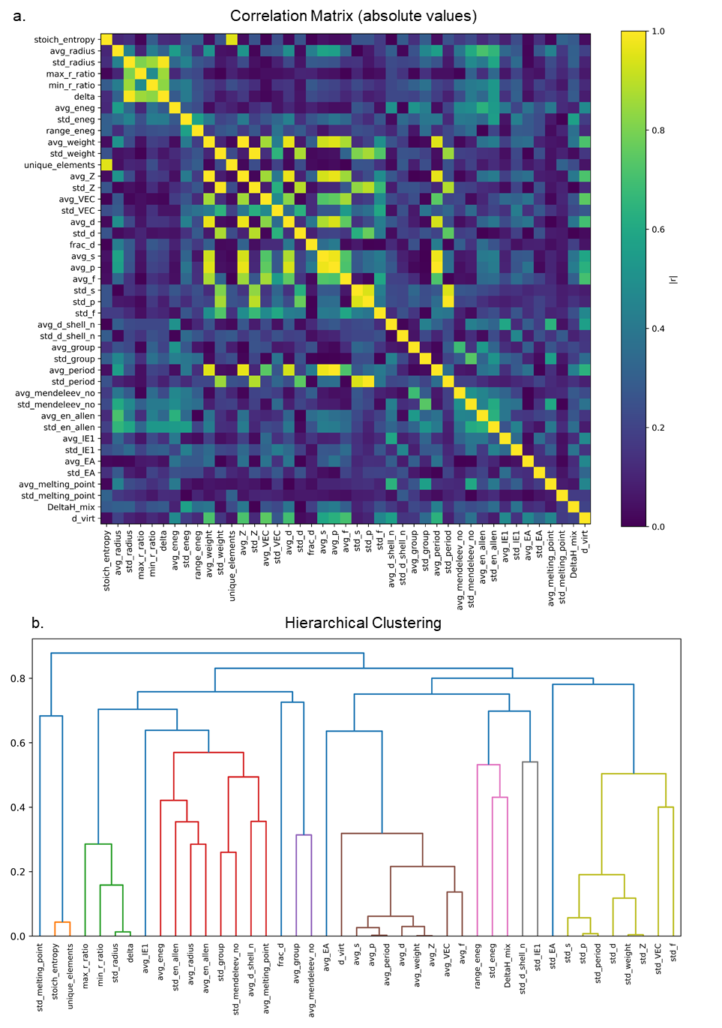
Figure 3: Analysis of Descriptors Redundancy & Clustering (Shear Modulus)
Descriptors can be highly correlated. Before assessing their relative importance to predict a given quantity, it is therefore necessary to “group” them. This is done by assessing their correlation coefficient (a) and regroup them in clusters using the average-linkage hierarchical clustering represented in the dendogram (in this study, when the distance is below 0.05) (b). In principle, the correlations should not change while considering different physical targets. However, the amount of available data can be limited (for instance in case of creep or high-temperature oxidation), and the associated dendogram may lead to additional descriptors merging.

With the reduced descriptor set in hand, each descriptor’s relevance to the target property under four complementary lenses is evaluated. In each of $B=50$ bootstrap iterations, A bootstrap sample covering 80% of the data is generated, and absolute Spearman rank correlation, mutual information regression, XGBoost feature-importance scoring, and recursive feature elimination with cross-validation (RFECV, using XGBoost as the estimator) are applied in sequence. For each method, the importance values (or elimination ranks for RFECV) obtained in every bootstrap sample are averaged across the $B$ iterations, yielding four mean-score vectors. This averaging smooths out sampling variabi. Spearman correlation captures monotonic univariate relationships; mutual information uncovers more general nonlinear dependencies; XGBoost importance reflects each descriptor’s contribution to reducing squared error in a tree‐ensemble; and RFECV rank measures the order in which descriptors are eliminated in a wrapper‐style search that directly optimizes cross-validated performance. The four scores can be visualized on Figure 4 for the case of shear modulus.
Rather than imposing a fixed rule – such as “retain all descriptors whose cumulative importance exceeds 30%” or “keep the top decile of RFECV ranks” (a naïve approach) –these arbitrary thresholds are replaced with the elbow method. For each mean‐score vector, descriptors are sorted in descending order of importance (or, in the case of RFECV, the average rank is inverted so that lower ranks become higher “scores”), then the elbow point is determined by locating the feature index at which the sorted‐score curve reaches its maximum deviation from the straight line joining its two endpoints. This geometric crossover signifies the transition from a small group of highly informative descriptors to a long tail of marginally useful ones. By selecting all descriptors up to the elbow index, each method yields a data-adaptive subset that responds to the actual shape of its own importance spectrum, without manual tuning.
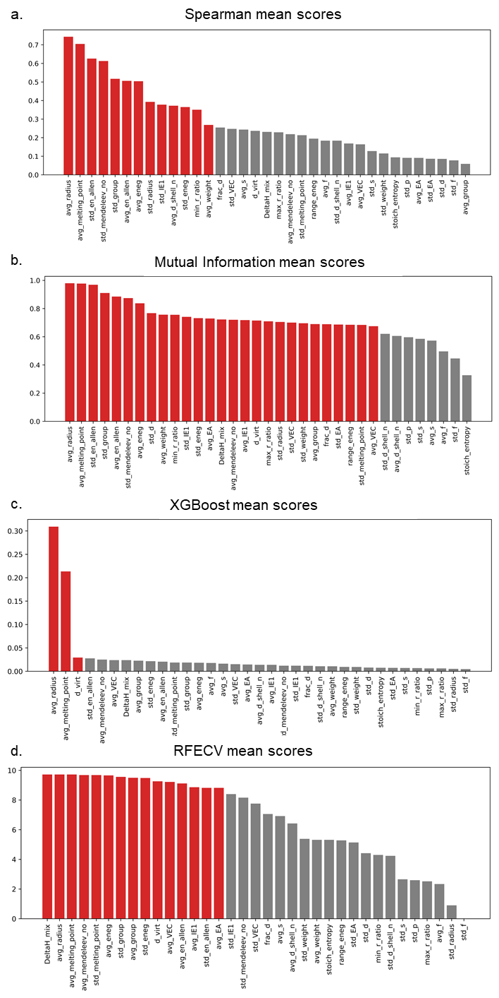
Figure 4: Representation of the 4 Scores of the Descriptors Selected by the Clustering (Shear modulus)
The bar plots represent the scores obtained by the descriptors for each selection method: (a) Spearman score, (b) Mutual Information score, (c) XGB Embedded score and (d) RFECV score. The descriptors selected by the elbow method appear in red, others appear in grey.

Following per-method elbow selection, a binary indicator matrix is assembled, in which each row corresponds to a descriptor and each column to one of the four methods. A “1” entry denotes that the descriptor was chosen by that method’s elbow, and “0” otherwise. A consolidated stability score $S_{d}$​ for each descriptor is then computed, as the average of its four indicator values. This stability score measures the degree of consensus: a value of 1 indicates unanimous selection across all methods, whereas 0.25 corresponds to selection by only one method. By collapsing four heterogeneous criteria into a single, interpretable metric, descriptors that consistently emerge as important under diverse analytic paradigms are highlighted.
To determine the final descriptor set, the elbow method is used once again – this time to the sorted stability scores $S_{d}$​. Descriptors are ranked by decreasing stability, the graph $S_{d}$​ versus rank is plotted, and the point of maximum perpendicular distance from the line connecting the endpoints is located. Descriptors above this stability elbow are retained for subsequent modeling (see Figure 5). This final elbow‐based cutoff ensures that a compact feature set, in which each descriptor has demonstrated strong, cross-method agreement in repeated subsamples of the data, is preserved.
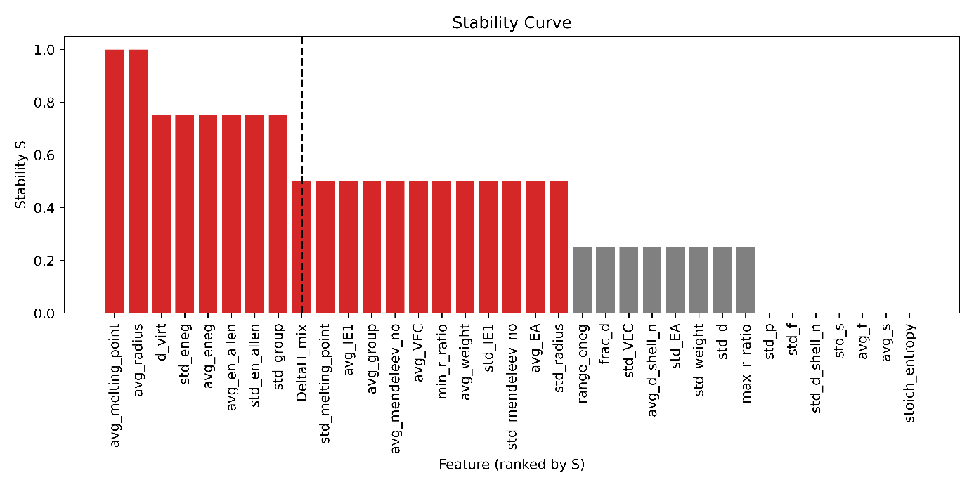
Figure 5: Final Selection of the Descriptors through the “Stability Score” (shear modulus)
The Stability Score $S_{d}$ is the average value of the Boolean selected / not selected by each 4 methods. There again, the selection is done through the elbow method (in red). The dash line marks the elbow. By construction, the values are distributed in plateau, with many descriptors obtaining the exact same elbow stability score: all these descriptors are selected, and the fraction of descriptors with a score strictly better than this plateau is implemented as subsample in the coarse tuning in the learning process. As a result, 20 descriptors (instead of the full 42 set) will be used as input for shear modulus training, and trials to reduce it down to 8 will be attempted during the coarse tuning phase.

Through this three-stage integration and thresholding procedure – comprising redundancy reduction, stability aggregation, and elbow-based selection – descriptor subsets are obtained that (i) are free of near-duplicate information, (ii) remain robust to sampling variability, (iii) are supported consistently across multiple complementary ranking methods, and (iv) are sized according to intrinsic inflection points in the importance distributions rather than arbitrary hyperparameters.

Supervised Machine Learning
The hybrid hyperparameter-tuning pipeline combines a two-stage search strategy – coarse grid halving followed by fine-grained Bayesian optimization – with robust engineering practices to maximize predictive performance while preserving reproducibility and interpretability. First, a coarse search is performed using HalvingGridSearchCV, which systematically explores a user‐defined grid of XGBoost parameters (e.g., number of trees, tree depth, subsample fraction, gamma, and minimum child weight) while progressively allocating more resources to the most promising candidates. By discarding poorly performing parameter combinations early, halving search reduces computational cost relative to exhaustive grid search.
Once the coarse search has identified a high‐performing region of hyperparameter space, a transition to fine tuning via OptunaSearchCV is performed. Optuna leverages adaptive sampling over continuous and integer distributions to focus on the optimal settings. The search range is seeded around the best coarse parameters (for example, ±30% around the number of trees or ±1 around the maximum depth), and the procedure allows up to 200 trials or a 15 000-second timeout for convergence. By combining early halving with adaptive Bayesian optimization, the approach achieves both breadth (global exploration) and depth (local exploitation), accelerating convergence toward an optimal model configuration.
Following training, the script conditionally saves the best model only if the new test $R²$ exceeds all previous records for that study case. This ensures that, when the set of hyperparameters is changed manually, only models exhibiting genuine performance improvements are retained; in a way, this is a three steps process, starting with a manual tuning. Each saved artifact includes not only the trained XGBRegressor and its parameters, but also the list of feature columns, the target column, and a summary of training and test performance (R² and RMSE), all serialized together into a pickle file.
By integrating robust cross‐validation, interactive hardware checks, conditional model serialization, and comprehensive visualization, this hybrid pipeline ensures that each model is not only finely tuned for predictive accuracy but is also transparent, reproducible, and readily interpretable – key criteria for high‐impact scientific machine‐learning applications.

Summary Flowchart
The methodology developed in this thesis follows an iterative, three-stage paradigm – data preparation, modeling & interpretation, and generative design & validation – to accelerate the discovery of high-entropy alloys for target applications. Rather than treating each step in isolation, the workflow emphasizes tight feedback loops and clearly defined quality gates, ensuring that every prediction is both statistically robust and physically meaningful.
In the data preparation stage, the first step consists in translating high-level design goals (e.g., target strength, operating temperature) into quantifiable descriptors – atomic radii, electronegativity differences, mixing enthalpies, etc. Diverse sources such as DeepMind GNOME, the Materials Project and community-contributed datasets supply the raw composition–property data. A broad candidate pool of descriptors is then computed and multiple outlier-detection tests (e.g., Local Outlier Factor, Isolation Forest, k-Nearest Neighbors and Huber regression) are applied to remove erroneous or spurious entries. This cleansing ensures that subsequent models learn from reliable, physically plausible examples.
Next, in the modeling and interpretation stage, feature-selection techniques (Spearman rank correlation, mutual information, XGBoost-embedded importance, and RFECV) are employed to remove redundant or non-informative descriptors. The surviving features feed into supervised learners – random forests, gradient boosted trees and deep networks – that are trained and validated against well-characterized single-phase HEAs (e.g. those mapped by Wei Chen et al. ²⁷). Rather than relying on black-box outputs, each model’s uncertainty and feature contributions are examined. Ensemble spreads and SHAP-style analyses are used to identify the key atomic-scale mechanisms driving performance.
Finally, in generative design & validation, both algorithmic optimizations are exploited (e.g. stochastic brute-force on large generated dataset) and generative-AI techniques to propose entirely new compositions biased toward desired properties. Candidates are ranked via multi-objective metrics – Pareto-front analyses of strength, density, cost and stability – and the best-performers advance to experimental validation. Feedback from characterization then informs both data curation and model retraining, closing the loop. The whole process is summarized as a flowchart on Figure 6.
By interweaving data integrity checks, interpretable modeling and generative hypothesis testing within a single, coherent cycle, this framework delivers physically guided, high-confidence predictions and fast-tracks the development of next-generation high-entropy alloys.
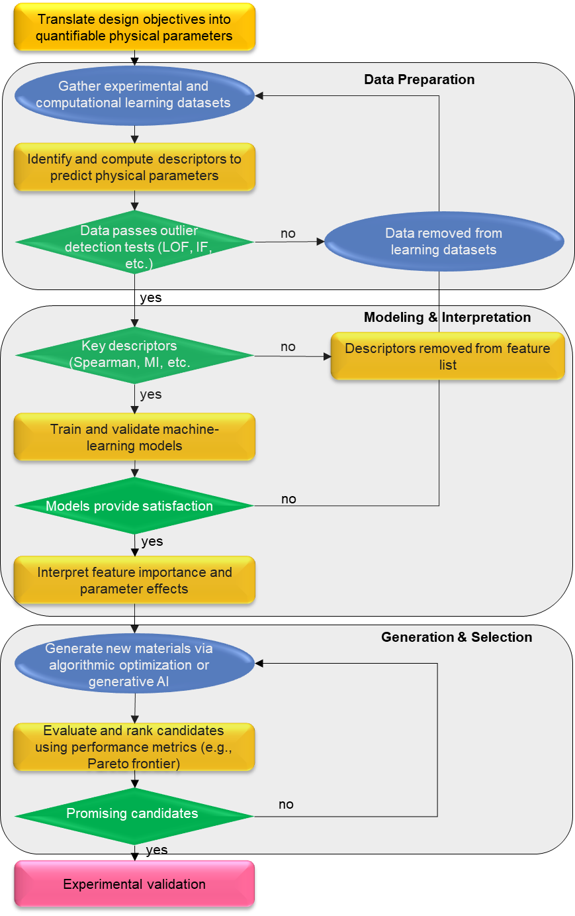
Figure 6: Workflow for Generative Artificial Intelligence & Machine Learning Driven Materials Discovery Targeted to a Specific Application.
Phase 1 (Data Preparation): translate design objectives into physical parameters, gather and curate experimental/computational datasets, compute descriptors and perform outlier detection.
Phase 2 (Modeling & Interpretation): execute feature selection (e.g., Spearman correlation, mutual information), train and validate ML models, and interpret key feature contributions.
Phase 3 (Generation & Selection): generate candidate compositions via algorithmic optimization or generative AI, then evaluate and rank them using multi-objective metrics such as the Pareto front.
Decision diamonds indicate quality-control gates; color bands group each methodological phase.

CONSTRUCTION & INTERPRETATION OF ML SURROGATES
The results of the process described in section 1.6 are presented as graphs (respectively bar graphs to display the feature selection for each surrogate model, and parity plots to feature the performance of the model on the test base) for the different targets:
- Creep (respectively Figure 7 and Figure 8)
- High-temperature oxidation (respectively Figure 9 and Figure 10)
- Formation enthalpy (respectively Figure 11 and Figure 12)
- Bulk modulus (respectively Figure 13 and Figure 14)
- Shear modulus (respectively Figure 15 and Figure 16)
- Melting point (respectively Figure 17 and Figure 18)
- Density (respectively Figure 19 and Figure 20)

Creep

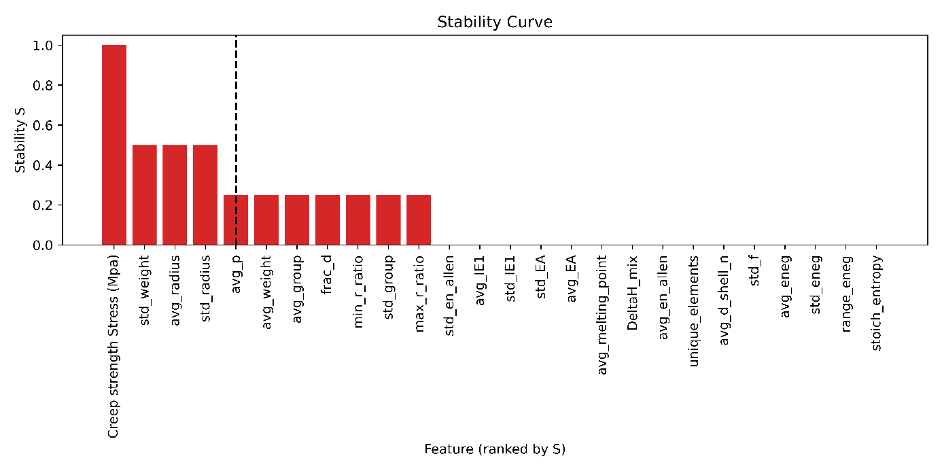
Figure 7: Features (or Descriptors) Selection for Creep (LMP) as a target.
Red bars indicate features selected by the pipeline. The XGBoost procedure is parametrized so that features located before the elbow of the curve (to the left of the dashed line) are systematically included.
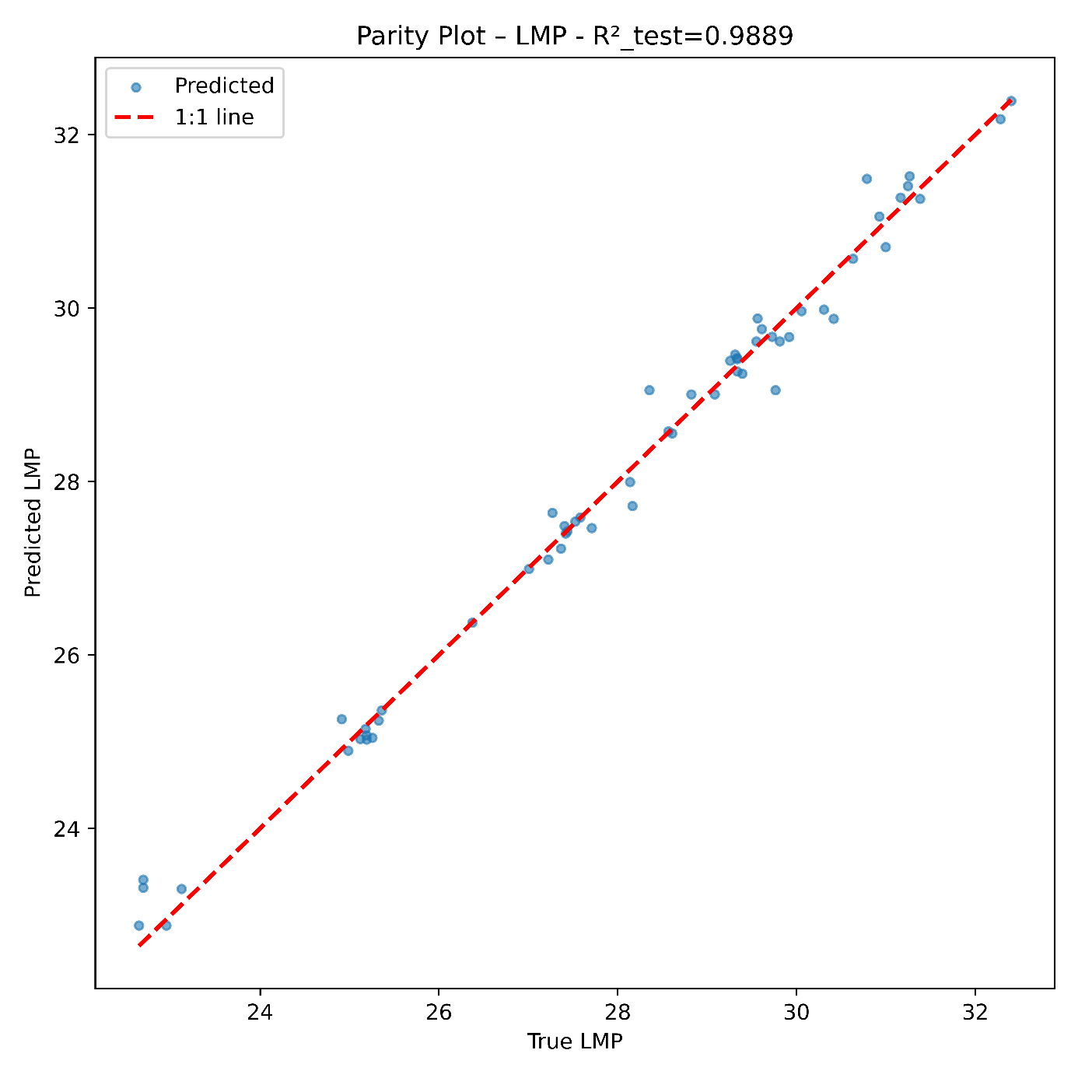
Figure 8: Predicted Values for the Creep (LMP) versus Real Values.
On the test base, this training reached almost $R²=0.99$, an excellent score.

High-Temperature Oxidation

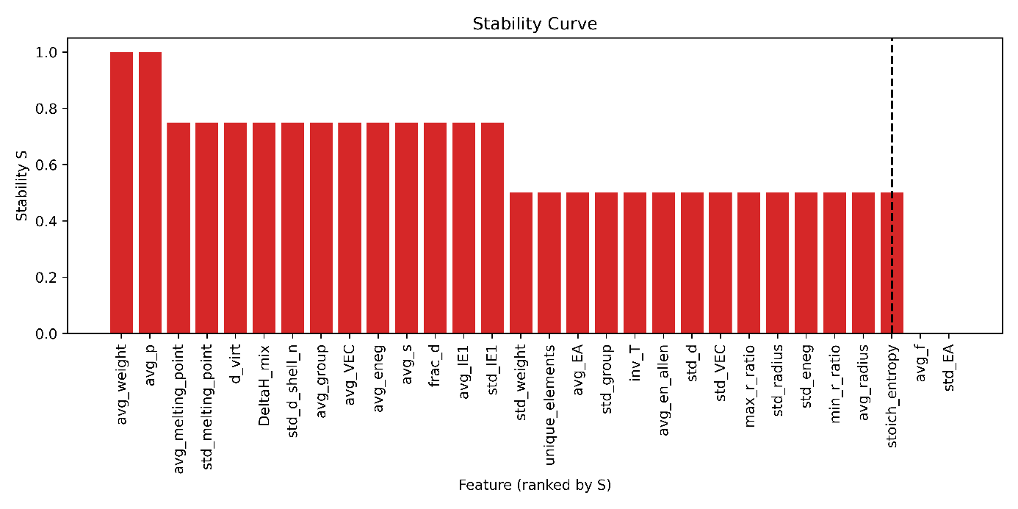
Figure 9: Features (or Descriptors) Selection for High-Temperature Oxidation ($\log_{10}{K_{A}}$) as a target.
Red bars indicate features selected by the pipeline. The XGBoost procedure is parametrized so that features located before the elbow of the curve (to the left of the dashed line) are systematically included.

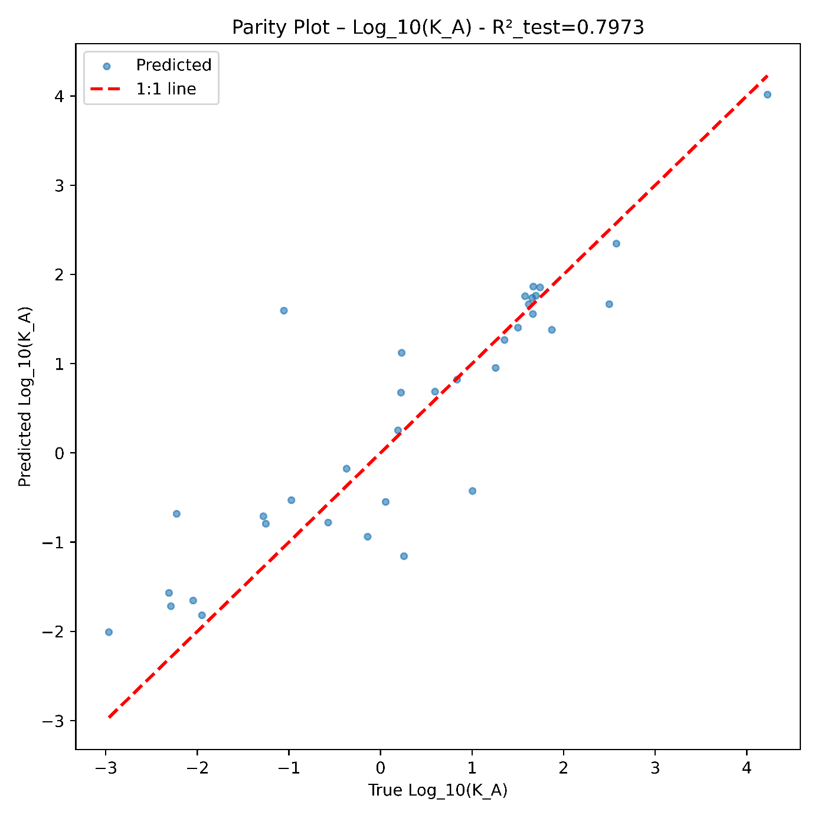
Figure 10: Predicted Values for the High-Temperature Oxidation ($\log_{10}{K_{A}}$) versus Real Values.
On the test base, this training reached almost $R²=0.80$, a decent score. A higher accuracy was not reachable given the intrinsic limitations of the dataset. High-temperature oxidation measurements are difficult to reproduce, strongly process-dependent, and often reported using heterogeneous protocols. Moreover, many experimental entries originate from older studies, which introduces additional variability.

Formation Enthalpy

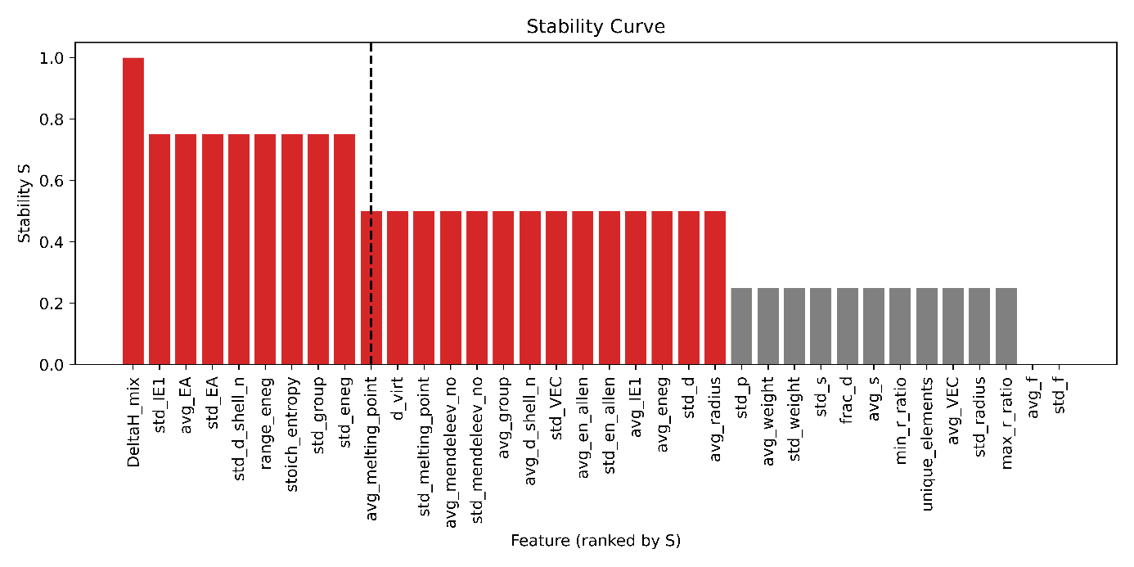
Figure 11: Features (or Descriptors) Selection for Formation Enthalpy (eV / at.) as a target.
Red bars indicate features selected by the pipeline. The XGBoost procedure is parametrized so that features located before the elbow of the curve (to the left of the dashed line) are systematically included.

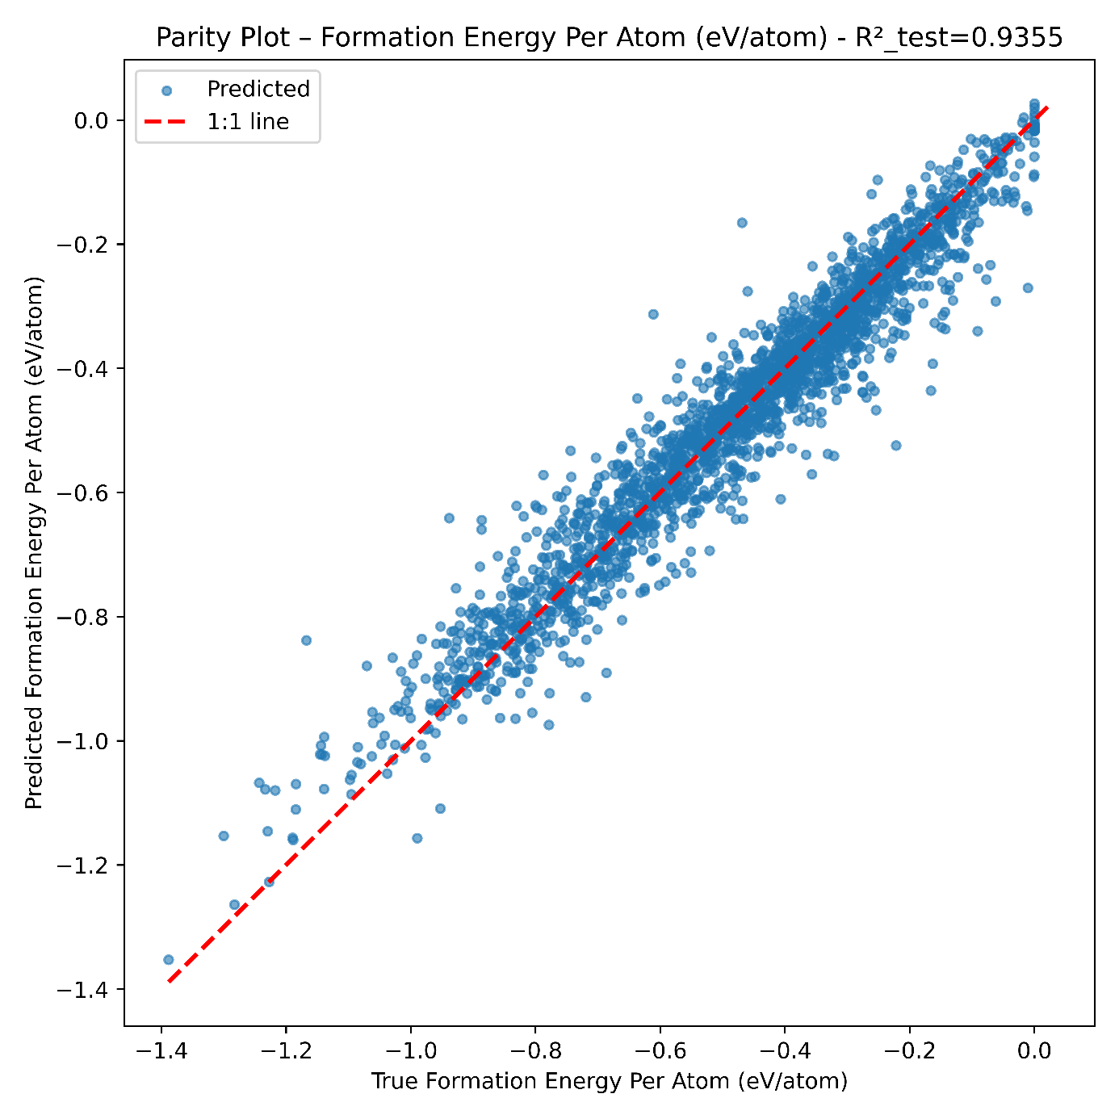
Figure 12: Predicted Values for the Formation Enthalpy (eV / at.) versus Real Values.
On the test base, this training reached almost $R²=0.94$.

Bulk Modulus

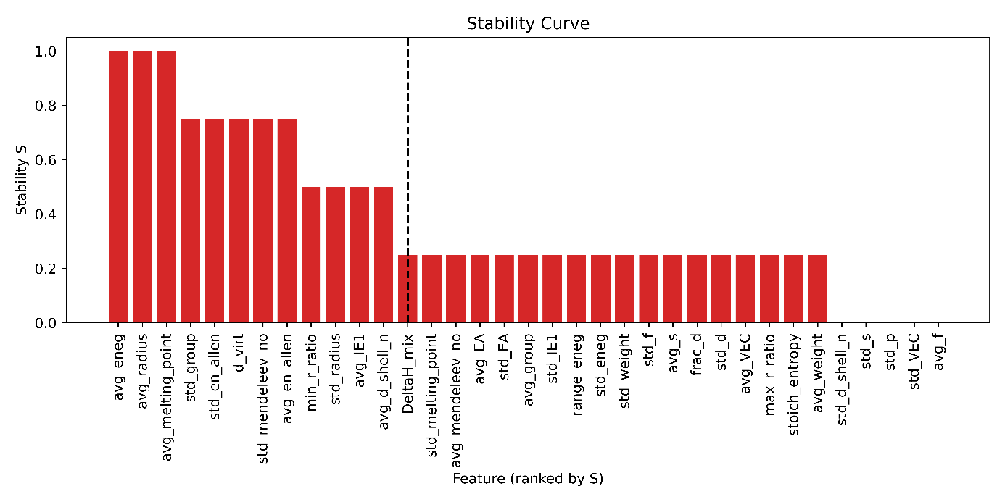
Figure 13: Features (or Descriptors) Selection for Bulk Modulus (GPa) as a target.
Red bars indicate features selected by the pipeline. The XGBoost procedure is parametrized so that features located before the elbow of the curve (to the left of the dashed line) are systematically included.
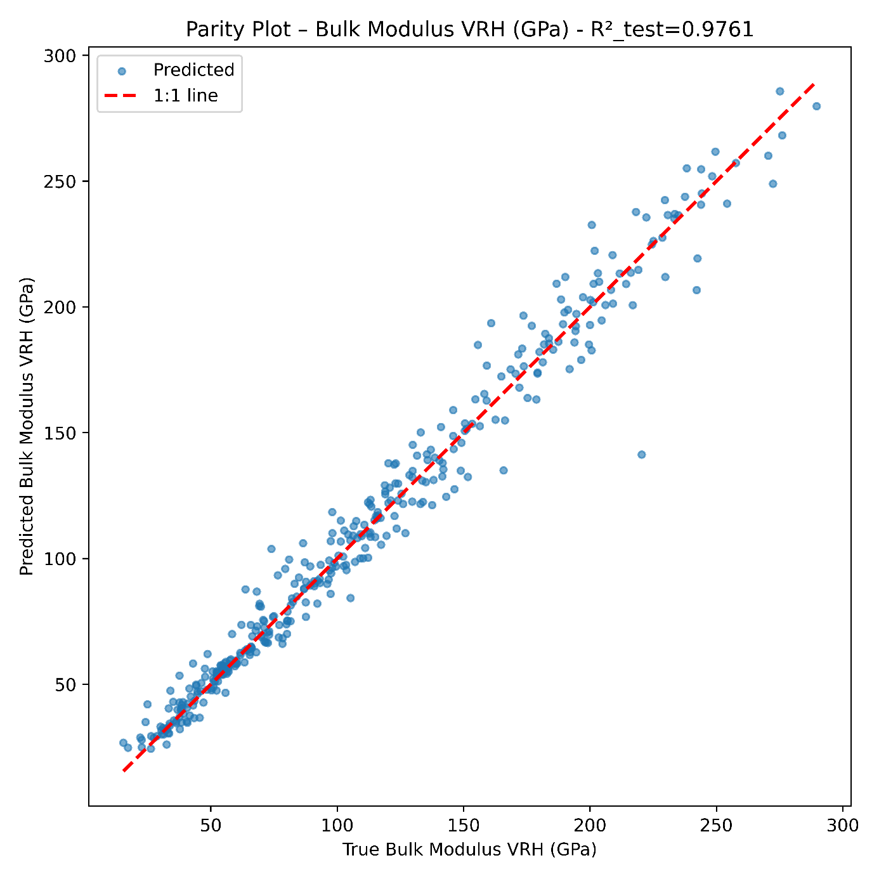
Figure 14: Predicted Values for the Bulk Modulus (GPa) versus Real Values.
On the test base, this training reached almost $R²=0.98$, an excellent score.

Shear Modulus

Figure 15: Features (or Descriptors) Selection for Shear Modulus (GPa) as a target.
Red bars indicate features selected by the pipeline. The XGBoost procedure is parametrized so that features located before the elbow of the curve (to the left of the dashed line) are systematically included.

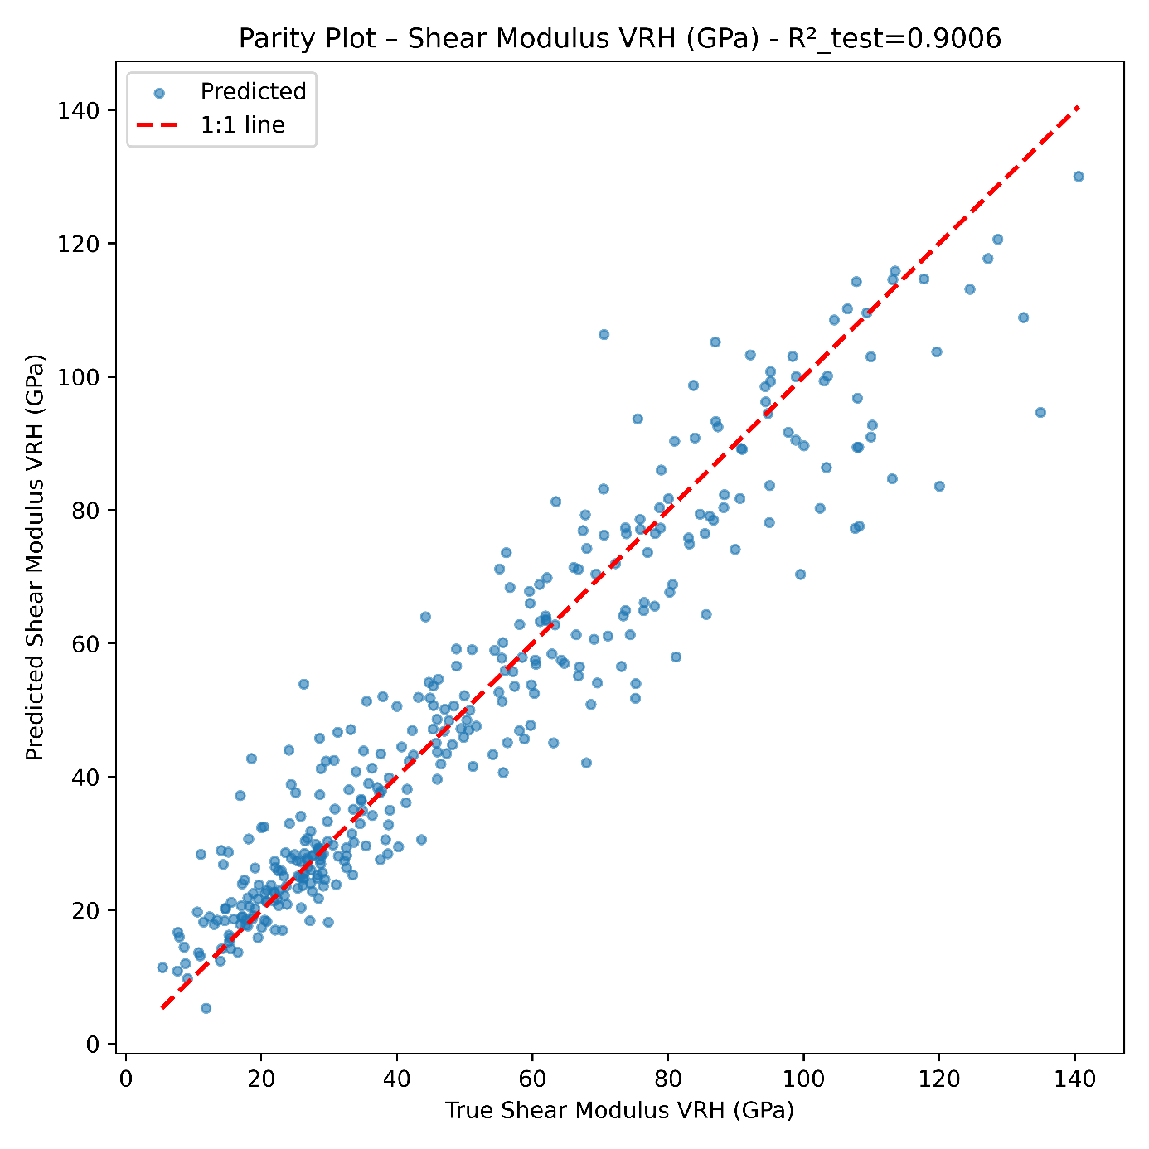
Figure 16: Predicted Values for the Shear Modulus (GPa) versus Real Values.
On the test base, this training reached almost $R²=0.80$, a good score.

Melting Point

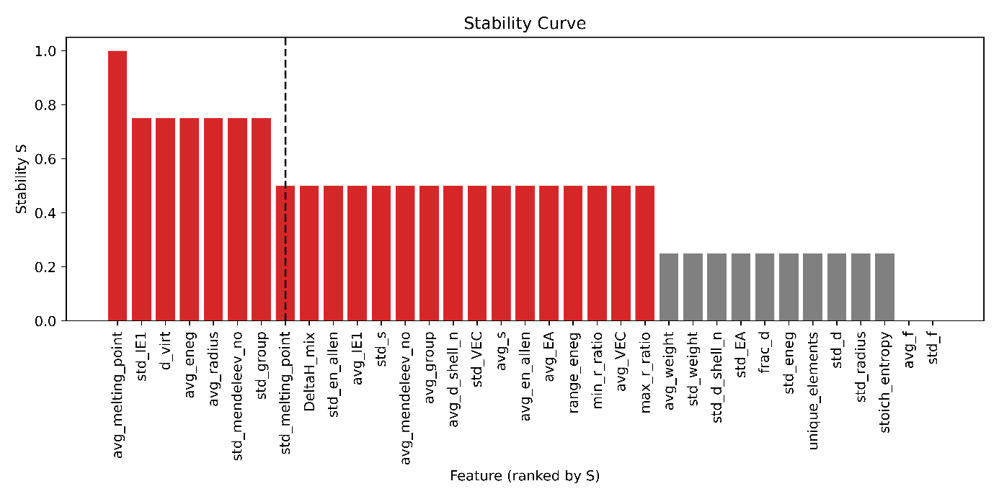
Figure 17: Features (or Descriptors) Selection for Melting Point (K) as a target.
Red bars indicate features selected by the pipeline. The XGBoost procedure is parametrized so that features located before the elbow of the curve (to the left of the dashed line) are systematically included. Logically, the average melting point is the most relevant descriptor for this feature.

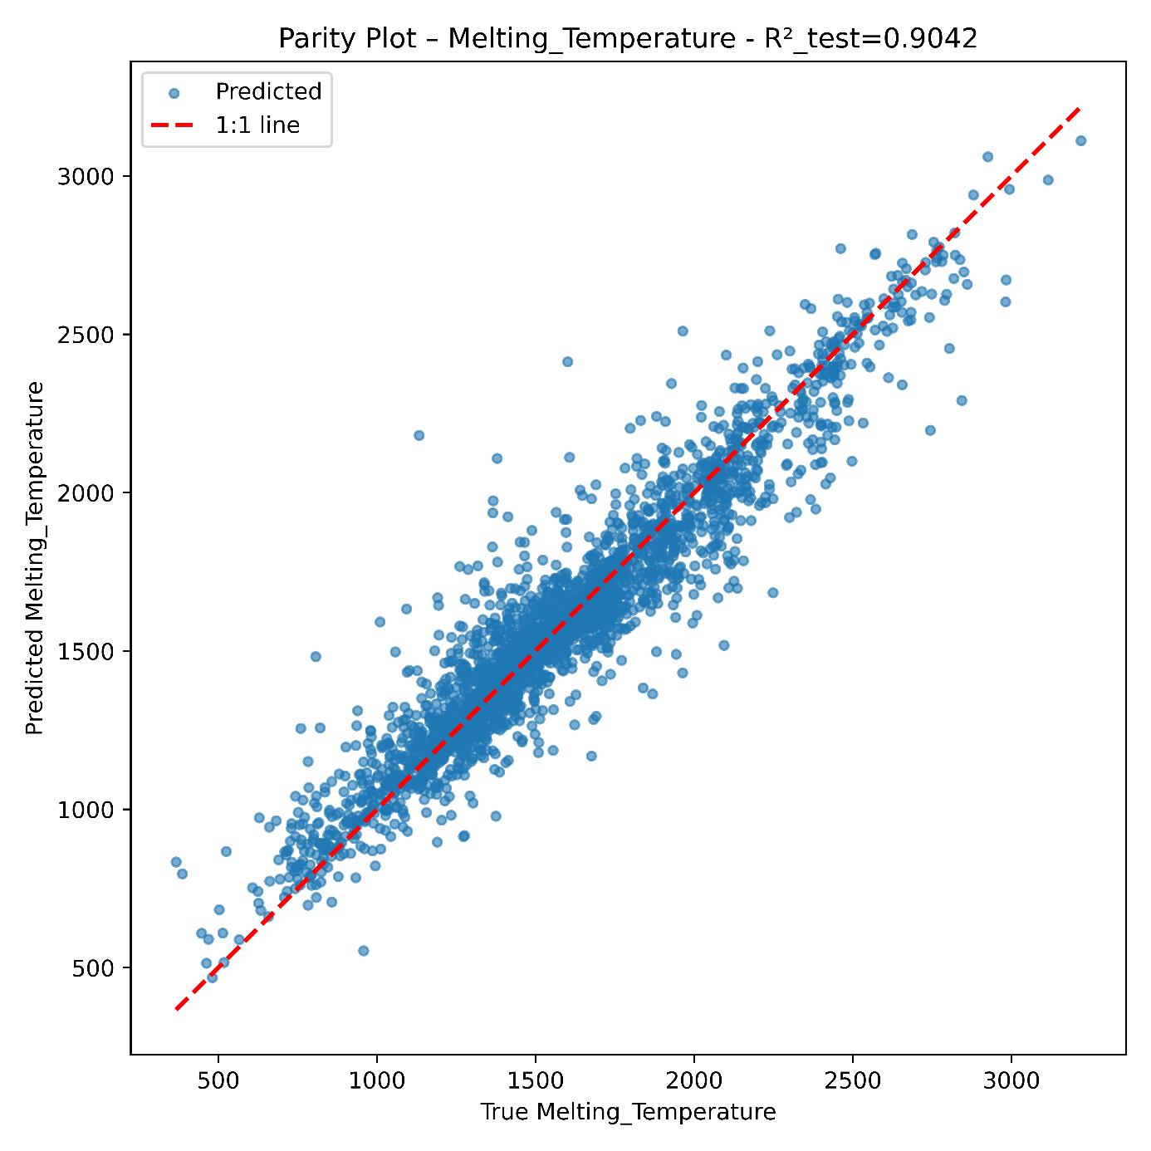
Figure 18: Predicted Values for the Melting Point (K) versus Real Values.
On the test base, this training reached almost $R²=0.90$, a good score.

Density
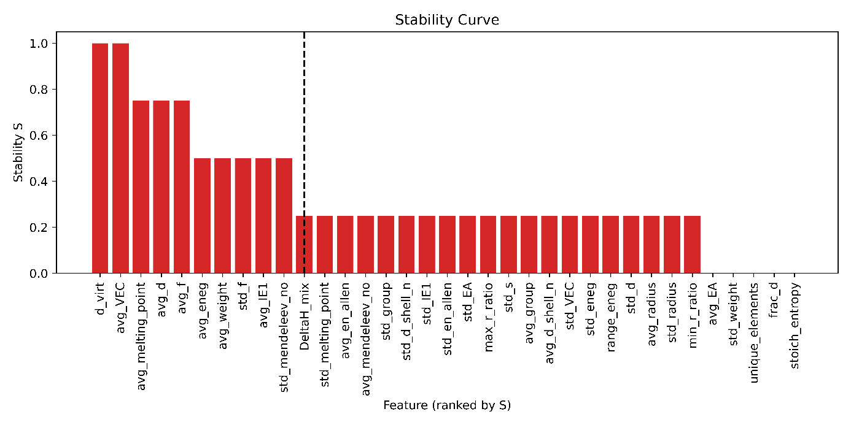
Figure 19: Features (or Descriptors) Selection for Density as a target.
Red bars indicate features selected by the pipeline. The XGBoost procedure is parametrized so that features located before the elbow of the curve (to the left of the dashed line) are systematically included.

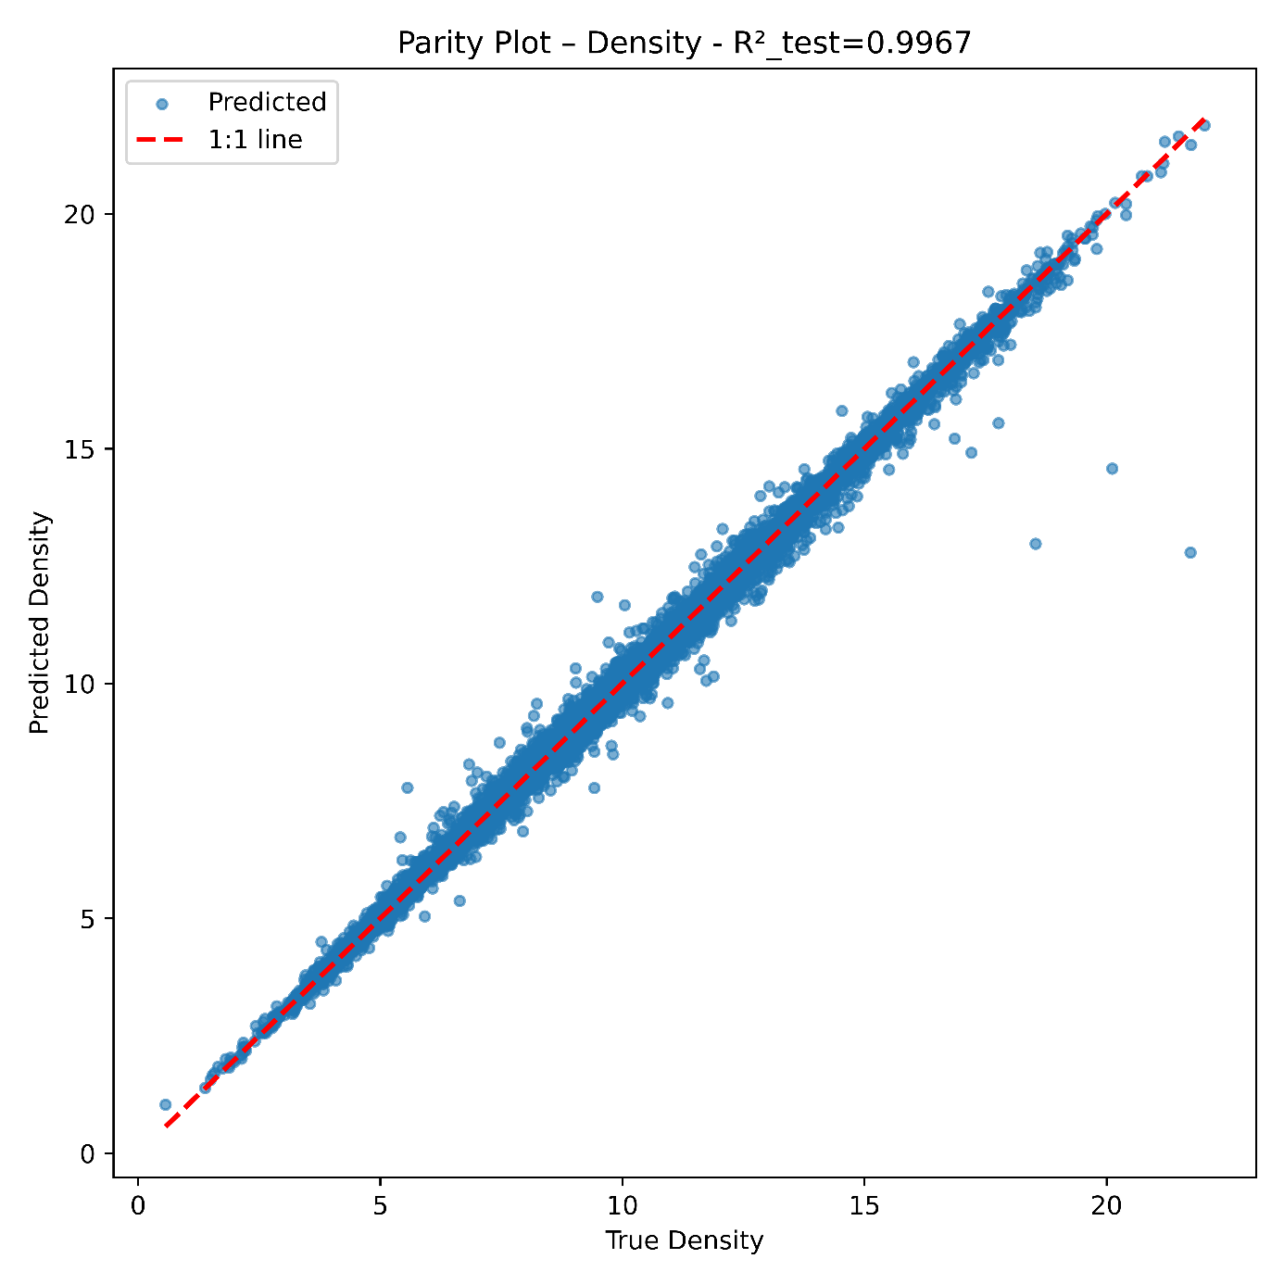
Figure 20: Predicted Values for the Density versus Real Values.
On the test base, this training reached almost $R²=1.00$, the best score. The quality of training significantly raised when d_virt, a proxy to compacity defined as the ratio of the average weight over the cube of the average radius was introduced as a descriptor.

Summary
The adopted workflow produced robust and accurate results. Outlier detection and feature-selection procedures systematically improved model stability, yielding $R²$ values above 0.9 for most properties. Without outlier handling, test-set performance exhibited significantly higher variance. Table 1 summarizes the main outcomes of the training and validation process.

Target | Source of Data | Size of dataset | Outlier score threshold | Number of selected features | $R²$ reached on test dataset
Creep (LMP) | Scientific Literature | 295 | 0/4 | 11 | 0.99
HT Oxidation | Scientific Literature | 172 | 0/4 | 28 | 0.80
Formation Enthalpy | Materials Project (DFT) | 11061 | 2/4 | 23 | 0.94
Bulk Modulus | Materials Project (DFT) | 1898 | 1/4 | 30 | 0.98
Shear Modulus | Materials Project (DFT) | 1749 | 0/4 | 20 | 0.90
Melting Point | MPContribs (GNN) | 13880 | 2/4 | 23 | 0.90
Density | Deep Mind (GNN) & Materials Project (DFT) | 238787 | 4/4 | 30 | 1.00
Table 1: Targets Learning Summary

STOCHASTIC BRUTE-FORCE SCREENING OF 5-ELEMENTS HEA

Generation of HEA: Composition Space and Randomization
High-entropy alloys (HEAs) constitute a paradigm shift in alloy design, mixing five or more principal elements at equal or near-equal compositions to form single crystalline phases stabilized by high configurational entropy and favorable enthalpic interactions. Despite the vast chemical space – 658 008 possible equimolar quinary alloys drawn from a set of 40 common metallic elements – only a few dozen have been experimentally realized, largely clustered around body-centered cubic (BCC) structures. Accelerating discovery in this domain thus requires efficient computational screening to identify promising compositions and to elucidate the thermodynamic drivers of phase stability.
Chen et al. unveil the chemistries that are likely to form high-entropy alloys ²⁷.
Moderate deviations from equimolarity can still yield single-phase HEAs, provided a few simple thermodynamic and geometric criteria are satisfied:
- Maintain high configurational entropy
Although ${ΔS}_{mix}$ is maximized at equimolarity, modest off‐equimolar compositions can still provide sufficient ${ΔS}_{mix}$ to stabilize a random solid solution at high temperature. In this work, compositions are therefore required to satisfy $1.31<{ΔS}_{mix}<2.32$, a range reported to favor solid-solution formation in HEAs ²⁸.
- Keep mixing enthalpy moderate
The free‐energy criterion ${ΔG}_{mix}={ΔH}_{mix}-T{ΔS}_{mix}$ must remain negative with respect to any competing intermetallics: ${ΔG}_{mix}<0$.
- Limit atomic‐size mismatch ($δ$)
According to Hume-Rothery rules, the relative atomic‐size variance $δ=\sqrt{\sum_{i}{{x_{i}\left(1-{r_{i}}/{\overline{r}}\right)}^{2}}}$​ must typically remain below ~6 % to prevent elastic‐strain–induced phase separation ^{29–32}. Off-equimolar changes should therefore not introduce extreme size mismatch.
- Ensure a high ${{Ω=T}_{m}{ΔS}_{mix}}/{{ΔH}_{mix}}$ parameter
The condition ${ΔG}_{mix}<0$ ensures $Ω> 1$. A value $Ω> 1.1$ at the synthesis temperature (often $≳ 0.9 T_{m}$) guarantees that entropy outweighs enthalpy, thus favoring a disordered solid solution ^{29–32}.
- Check valence‐electron concentration (VEC) for structure control
While not part of the core thermodynamic model, monitoring VEC can help predict whether the phase will adopt BCC (VEC ≲ 6.8) or FCC (VEC ≳ 8.0) symmetry, facilitating targeted microstructural design ^{29–32}.

To explore off-equimolar regions around the 30 201 candidates quinary HEA compositions, the procedure follows two main steps: semi-random stoichiometry generation and an initial thermogeometric filtering stage.

- Semi-random stoichiometry generation
$X$ denotes a uniform random variable on $[0, 1]$. For each of the 30 201 base compositions:
- Ten “baseline” series were generated by assigning each of the five elements a raw stoichiometry of $X$, prior to normalization.
- Twenty system-focused series were generated to probe Al–Fe and Ti-rich variants:
    - For Al–Fe, ten series in which Al and Fe receive raw stoichiometries of $2 + X$, while the remaining three elements each receive $X$.
    - For Ti, ten series in which Ti receives $3 + X$ and all other elements receive $X$.
- One hundred “uniformly biased” series were generated by assigning every element a raw stoichiometry of $1 + X$. Since $1 + X ≥ 1$, this guarantees that after normalization each element’s atomic fraction $xᵢ ≥ 0.1$ (10 at. %).

In each case, the five raw stoichiometries were normalized to sum to unity to produce a valid composition vector. This procedure yields a diverse library of about 3 million semi-random, off-equimolar quinary alloys clustered around both global and system-specific compositional neighborhoods.

- First-pass rough thermogeometric filtering
To focus on compositions most likely to form single-phase HEAs, four simple exclusion criteria were applied:
- Any composition containing Os was discarded on practical grounds: Os is extremely scarce and expensive, and it raises handling and environmental-toxicity concerns.
- Compositions with ${ΔS}_{mix}<1.2$ were removed.
- The weighted average VEC $\sum_{i=1}^{5}{c_{i}{VEC}_{i}}$ was required to lie within $[6, 9]$.
- Compositions with $δ > 0.07$ were excluded to avoid excessive elastic strain and phase separation.

After this filtering, the remaining subset:
- contains fewer than one million alloys (which is necessary for practical computation),
- excludes osmium,
- preserves sufficiently high configurational entropy,
- lies within a favorable VEC window, and
- maintains acceptable atomic-size mismatch.

Under these conditions, the ${ΔG}_{mix}$-based model predicts the formation of single-phase HEAs. A more stringent filtering could have been applied at this stage. However, retaining some lower-quality candidates is beneficial for training: restricting the learning set to only the very best alloys would introduce a strong selection bias.

Scoring & Pareto Front
The roughly filtered dataset contains about 600 000 presumed HEAs. Naturally, the way it was generated led to a different distribution of elements compared to the list of compositions provided by Chen et al. The frequency of presence of elements in the filtered dataset is presented in the graph below (Figure 21).
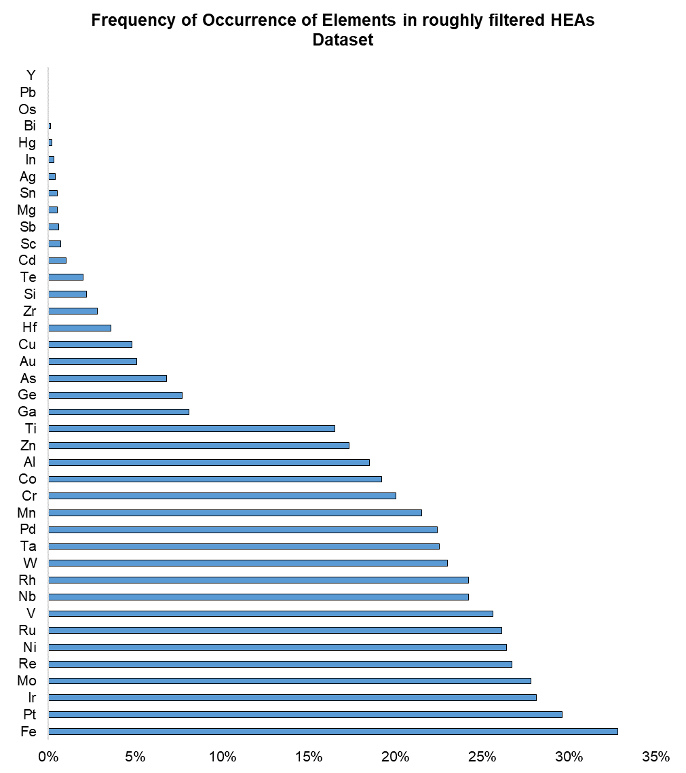
Figure 21: Frequency of occurrence of elements in the roughly filtered dataset.
For each element, the value represents the fraction of HEAs in the dataset that contain this element.

A few comments can be made about these frequencies. Fe is the prevalent element at 33%. More generally, the compositions are close to the Cantor‐alloy family (Co-Cr-Fe-Mn-Ni): Ni (26%), Mn (22%), Cr (20%) and Co (19%). This 3d‐transition‐metal backbone composition is rather in line with the composition of legacy super alloys.
Platinum-Group Metals (PGM) are highly frequent: Pt (30%), Ir (28%), Ru (26%), Rh (24%) and Re (27%), above heavier refractory metals like Nb (24%) or W (23%). No doubt this ranking will be turned upside down when considering prices, carbon footprint or supply risk. On the contrary, cheap, light elements such as Si (2.2%), Mg (0.5%), Ti (17%) and Al (19%) remain at low grades, in spite of their advantage for cost‐sensitive or weight‐sensitive applications. In Ni‐based classic super alloys, Al and Ti are minor (a few at. % each) additions to a Ni‐rich matrix. Here, with Ni only ~26%, true $γ'$ chemistries (Ni–Al–Ti) are not realized. A non‐equimolar sweep (e.g. Ni > 50%) would be required to mimic superalloy compositions.

Working with this cleaned HEA composition database, the set of atomistic descriptors is computed – in a chunked, parallelized fashion. Simultaneously, the eight pre‐trained regression models (pickle files) to predict key physical properties are loaded: formation energy ($E_{f}$), bulk modulus ($B$), shear modulus ($G$), density ($ρ$), melting point ($T_{m}$), creep resistance (LMP) at 100 MPa, and the decimal logarithm of the parabolic constant ($\log_{10}{K_{A}}$) for high-temperature oxidation at normal oxygen pressure (1 atm. with 20% O₂). From these, two additional quantities mentioned previously are derived: the $G/B$ ratio and the dimensionless $Ω$ parameter. The database was enriched with these values.
Then ten heuristic “g–scores” are evaluated, each in $[0,1]$ (see Table 2 and Figure 22), intended to gauge a material’s suitability across multiple criteria:
- $g_{1}$ (creep resistance) via sigmoid filter centered between 20–26 LMP units.
- $g_{2}$ (high $Tₘ$) via sigmoid between 1200–1800 K.
- $g_{3}$ (low density) via sigmoid between 6 and 9 on $ρ$.
- $g_{4}$ (BCC‐favoring VEC) via Gaussian window over $\overline{VEC} ∈[6.87,8$] valence electron per atom.
- $g_{5}$ (ductility) via Gaussian on $δ$‐mismatch in $[0.03,0.066]$.
- $g_{6}$ (ductile $G/B$ behavior) via sigmoid between 0.5 and 0.6 on $G/B$.
- $g_{7}$ (resistance to intermetallic formation) via Gaussian on $E_{f}∈[–0.156,0.052]$ eV/atom ³³.
- $g_{8}$ ($Ω$ for solid‐solution stabilization) via sigmoid between 1.0–1.2.
- $g_{9}$ (high configurational entropy) via Gaussian on ${ΔS}_{mix}∈[1.31,2.32] R$.
- $g_{10}$ (resistance to oxidation at high-temperature) via sigmoid between -0.25 and 0.25 – this value derives from a logarithm of the growth rate of the oxidation layer: the smaller is the better.

Oxidation at high-temperature is often characterized by the “parabolic constant” $K$ (in mg²cm⁻⁴h⁻¹) or its logarithm, roughly proportional to the inverse of the temperature in kelvin ³⁴. In a recent paper ³⁵, it can be observed that the range of values for $\log_{10}{\tilde{K}}$ is about $[-14, -10]$ at $T=1000C$, or rather $\log_{10}{K∈[-0.4, -4.4]}$ if $\tilde{K}$ (in g²cm⁻⁴s⁻¹) is converted in mg²cm⁻⁴h⁻¹. In the NASA study TM-105934 ³⁶, Barrett defines the values of $K$ to be “good” when below 0.5 ($\log_{10}{K<-0.3}$) and “excellent” when below 0.2 ($\log_{10}{K<-0.7}$). The final window that was eventually retained balances both indications.

The g-scores were appended to each row alongside the raw physical predictions. After computing all ten heuristic g-scores, a uniform performance threshold is imposed to isolate only those HEA compositions that demonstrate baseline suitability across every metric. Specifically, only alloys for whose scores $g_{i}≥0.3$ are retained. This cutoff guarantees that no single property falls below a minimal acceptable level, thereby ensuring that every candidate possesses at least moderate creep resistance, melting point, density, ductility, oxidation resistance, and so forth – by construction, $g_{i}≥0.5$ is ideal, but globally too demanding. By applying this “all-$g_{i}>0.3$” filter, the database shrank from hundreds of thousands of random quinary alloys to a more manageable set of a few thousand compositions that are, in principle, eligible for next-generation superalloy applications.
With this filtered pool in hand, a Pareto-front analysis is carried out on the vector of ten scores $g={(g_{1},…,g_{10})}^{⊤}$. In multi-objective optimization, a Pareto front (or Pareto frontier) consists of those solutions that are nondominated: no other candidate is strictly better in all objectives simultaneously. Concretely, alloy $A$ dominates alloy $B$ if $g_{i}(A)≥g_{i}(B)$ for every $i$ and $g_{j}(A)>g_{j}(B)$ for at least one property $j$. The Pareto-optimal set thus captures the “best” trade-offs among competing criteria, without privileging any single metric.
Identifying this nondominated subset serves two crucial purposes. First, it preserves diversity: rather than converging to a handful of extremes, the Pareto front spans the full spectrum of balanced performance profiles – high-creep-resistance vs. low-density, superior oxidation resistance vs. maximal ductility, and so on. Second, it ensures efficiency: downstream efforts focus only on compositions that are competitive across all ten dimensions. By contrast, dominated alloys, which underperform in every respect compared to at least one peer, are useless for the analysis.
From a methodological standpoint, this filtration and Pareto-selection pipeline offers a clear test of the brute-force screening phase. If the resulting front comprises hundreds of diverse, nondominated quinary alloys – many of which lie on or beyond the performance envelope of classical superalloys – then the random exploration has already uncovered a rich starting set. These candidates can then seed a generative‐AI workflow, providing the CVAE with high-quality examples that span the true Pareto frontier of HEA performance. Conversely, if the Pareto front is sparse or poorly distributed, it signals that brute-force sampling may require adjustment (e.g., focusing on specific element subsets or adjusting g-score thresholds) before entrusting an AI model to learn from the data.
In this study, the “all-$g_{i}>0.3$” filter yielded approximately 300 alloys that proved to be nondominated. These 300 Pareto-optimal candidates exhibit complementary trade-offs – some cluster near the highest creep resistance, others balance moderate strength with light density, etc. This rich, multi-dimensional ensemble demonstrates that even uninformed brute-force enumeration can locate promising regions in the vast quinary space. It also provides a robust foundation for the CVAE training set in Chapter GENERATIVE EXPLORATION & FRONTIER EXPANSION, where generative exploration will aim to expand and refine this frontier further.
A summary of the different targets and their associated score, physical quantity, threshold or range values, and sources supporting these choices, is presented in Table 2.

SCORES | Physical Scope | Physical Quantity | Target Range | Unit | Filter Type | Sources
$$g_{1}$$ | Creep resistance | Larson-Miller Parameter | $$> 23$$ |  | sigmoid, $[20,26]$ | ³⁷
$$g_{2}$$ | Operates at high-temperature | Melting Point | $$>1500$$ | K | sigmoid $[1200,1800]$
$$g_{3}$$ | Weight | Density | $$<7.5$$ |  | sigmoid $[6,9]$ | ³⁸
$$g_{4}$$ | Crystal system (BCC) | Valence electron per atom | $$∈[6.87,8]$$ | electron per atom | gaussian window | ³⁹
$$g_{5}$$ | Mechanical behavior (ductility) | $δ$ mismatch | $$∈[0.03,0.066]$$ |  | gaussian window | ^{29–32,40}
$$g_{6}$$ | Mechanical behavior (ductility) | Shear / bulk moduli ratio (Pugh Criteria) | $$>0.55$$ |  | sigmoid $[0.5,0.6]$ | ⁴¹
$$g_{7}$$ | No intermetallic formation | Formation enthalpy | $$[–0.156, 0.052]$$ | eV/atom | gaussian window | ³³
$$g_{8}$$ | Solid solution stabilization | $$Ω$$ | $$>1.1$$ |  | sigmoid $[1.0,1.2]$ | ^{29–32}
$$g_{9}$$ | High configurational entropy | Stoichiometric entropy | $$[1.31,2.32]$$ |  | gaussian window | ²⁸
$$g_{10}$$ | Resistance to high-temperature oxidation | $$\log{K_{A}}$$ | $$>0$$ |  | sigmoid $[-0.25,0.25]$ | ^{35,36}
Table 2: Summary of the Physical Performance Objectives, the Quantitative Values and the Associated Filters
The table summarizes the quantified objectives that were fixed according to the observations made in the scientific literature about HESA, and details how the performance targets are translated into numerical scores. This scoring approach drives the AI-driven method applied for new materials discovery until it can be presented to a human mind.

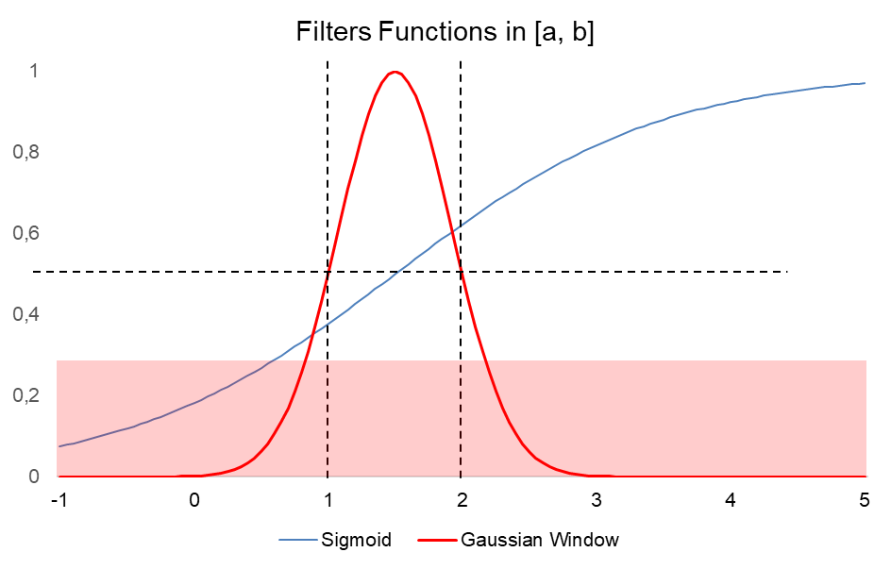
Figure 22: Mathematical Filtering Functions to Establish Scores
To convert the “distance to target” for a given for a physical quantity to a “score” in $[0,1]$ (the higher, the better), a quantitative threshold or range is established (see Table 2).
- If the objective is to ensure that the quantity remains within a certain range (e.g. VEC), the value is converted into a number through a Gaussian function centered on that range, and reaching exactly 0.5 at the boundaries of the range red curve). This ensures that values $x$ out of this range quickly have $g_{i}\left(x\right)<0.3$ and are therefore dismissed – light red area.
- If the objective is to be above a certain threshold (e.g. $Ω$) or below (e.g. the density), a sigmoid function is used instead (blue curve), using a range as parameters: it reaches 0.5 in the center, $1/(1+e^{-1/2})≈0.38$ at the lower boundary, and about 0.62 at the upper boundary. The choice of the range $[a,b]$ determines both the threshold $g_{i}(\left(a+b\right)/2)=0.5$ and the form factor of the sigmoid, governing its growth band and how small a value can be before being rejected.
On the example presented here, the range associated to both the Gaussian window and the sigmoid is $[1,2]$. The vertical dash lines $y=a$ and $y=b$ help visualize the range, while the horizontal line materializes the full width at half maximum of the Gaussian curve. Materials with $g_{i}\left(x\right)<0.3$ (light red area) are rejected.

Ashby Charts: Legacy Superalloys vs Pareto-optimal
The previous subsection presented the scoring framework and Pareto-front selection for the extensive database of randomly generated quinary High-Entropy Alloys (HEAs). Having narrowed down the dataset to non-dominated candidates, this subsection employs Ashby charts to visually explore and compare the performance landscape of these Pareto-optimal HEAs relative to established “legacy” superalloys. Ashby charts represent pairs of critical material properties, allowing intuitive visualization of trade-offs and identifying regions of optimal performance. In this study, physical properties known to be crucial for superalloy applications are selected, specifically those properties reliably predicted by the machine-learning surrogates: Young’s modulus, bulk and shear moduli, melting temperature, creep resistance, density, formation energy, and high-temperature oxidation resistance.
First, the Pareto-optimal HEAs is clustered using hierarchical Ward linkage clustering, which groups alloys according to their compositional similarity. For interpretability, each cluster was succinctly labeled using simplified chemical formula notation highlighting dominant elements. This labeling was performed by removing any element whose fractional contribution fell below a predefined threshold (5%), thus providing concise and meaningful cluster identifiers. The color-coded clusters shown in the charts facilitate rapid identification of compositional trends and their association with specific property regimes.
Five pairs of properties were plotted:
- Shear modulus vs. bulk modulus (Figure 23): this combination directly reflects alloy stiffness and elastic response, crucial for structural integrity and durability under mechanical stress.
- Creep resistance (Larson-Miller Parameter, LMP) vs. formation energy (Figure 24): creep resistance characterizes long-term high-temperature mechanical stability, while formation energy indicates phase stability and susceptibility to undesirable intermetallic formation.
- Density vs. melting point (Figure 25): crucial for identifying lightweight alloys with robust thermal stability, essential for aerospace applications.
- High-temperature oxidation resistance (logarithm of the parabolic constant, $\log{K_{A}}$) vs. melting point (Figure 26): evaluates alloy robustness in oxidizing environments and thermal stability simultaneously, both highly relevant for turbine blades and similar high-temperature components.
- Young’s modulus vs. density (Figure 27): Balances structural rigidity with lightweight construction, a classic design trade-off in aerospace materials.
Visual inspection of these Ashby charts reveals highly promising outcomes. Notably, the brute-force-generated HEAs exhibit performance distributions comparable to, and in several cases superior to, those of well-established legacy superalloys. For example, in the density–melting point diagram, many Pareto-optimal alloys extend into a high melting point (over 2000 K) yet relatively low-density domain (below 8 g/cm³), rarely accessed by traditional superalloys. Similarly, the creep resistance vs. formation energy chart demonstrates that some Pareto-optimal HEAs achieve high creep resistance alongside favorable formation energies, suggesting stable phases without excessive brittleness or intermetallic vulnerability. In stiffness-related diagrams (shear and bulk modulus, Young’s modulus vs. density), several HEA clusters populate areas with distinctly attractive property combinations, suggesting substantial potential for achieving lighter yet equally stiff or even stiffer structures compared to legacy materials.
This outcome is particularly striking given that these alloys were generated through a purely random, brute-force sampling strategy. Such promising performance profiles strongly indicate that the chemical diversity inherent to HEAs provides significant untapped potential for future alloy development. Moreover, this initial evidence lends substantial credibility to subsequent generative AI-based exploration methods, which are expected to more efficiently and strategically probe the composition space, guided by patterns uncovered during brute-force enumeration.
In conclusion, these Ashby charts not only confirm the feasibility of brute-force approaches to identify promising new superalloys but also reinforce the immense potential of High-Entropy Superalloys (HESAs). By integrating these highly-performing candidates into the subsequent generative AI learning phases, it is expected that novel alloy compositions surpassing traditional limits will be systematically uncovered.
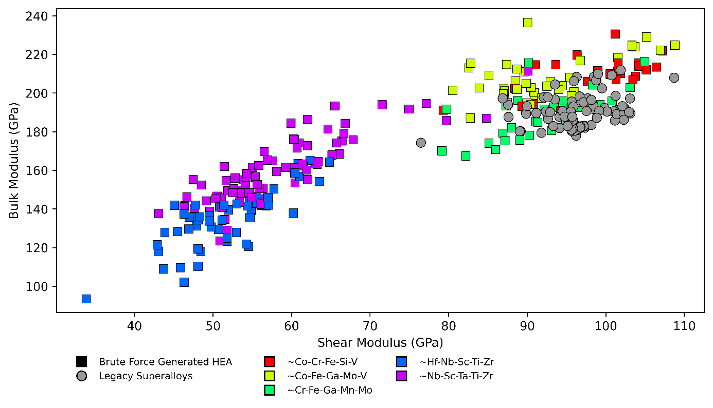
Figure 23: Shear Modulus vs. Bulk Modulus for Legacy Superalloys and Brute-Force-Generated HEAs.
Pareto-optimal HEAs (squares, color-coded by dominant elemental clusters) exhibit broad coverage and, in several cases, superior combinations of shear and bulk moduli compared to traditional Ni-based superalloys (gray circles). The chemical composition refers to the medeoid of the Ward linkage cluster, and this notation ignores elements whose content is below 5%. Notably, alloys from clusters dominated by Co, Fe, and V display attractive modulus combinations ideal for structural applications requiring simultaneous stiffness and toughness.

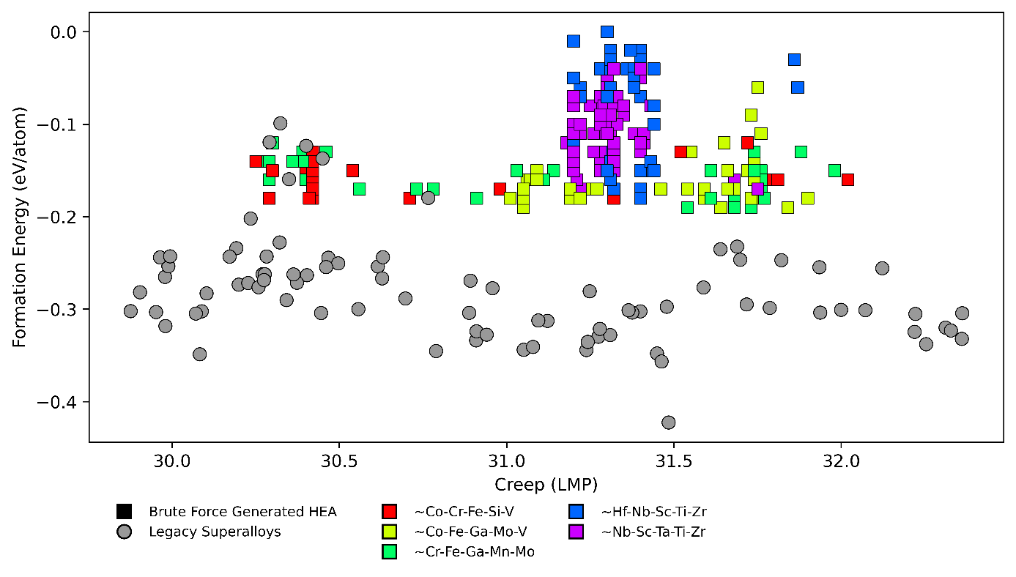
Figure 24: Creep resistance (LMP) vs. Formation Energy for Legacy Superalloys and Pareto-optimal HEAs.
All HEA clusters demonstrate excellent creep resistance (LMP over 30), combined with more moderate formation energies than legacy super alloys, indicating the possibility to find HEA candidates within the proper range to avoid intermetallics formation.

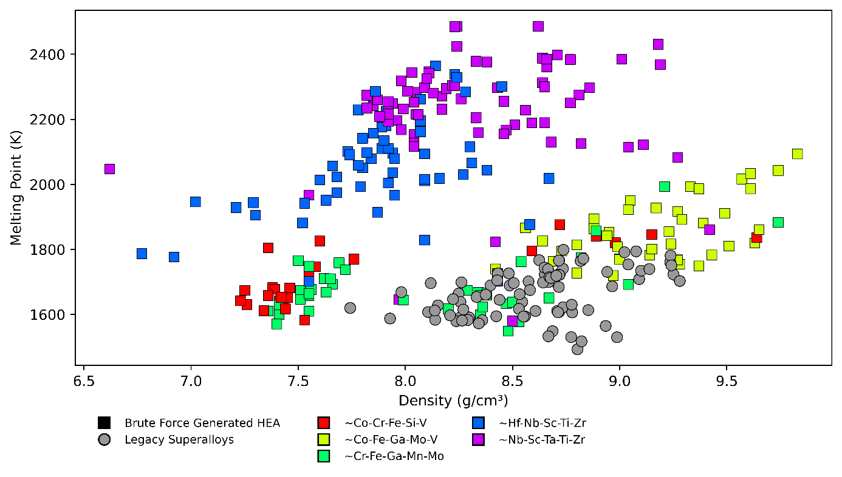
Figure 25: Melting Point vs. Density for Legacy Superalloys and Pareto-optimal HEAs.
The HEA dataset uncovers compositions with melting points notably higher (over 2200 K) and densities lower than traditional Ni-based superalloys. Particularly, Nb-Sc-Ta-Ti-Zr dominated clusters emerge as promising candidates for aerospace applications where lightweight and thermal stability are simultaneously required.

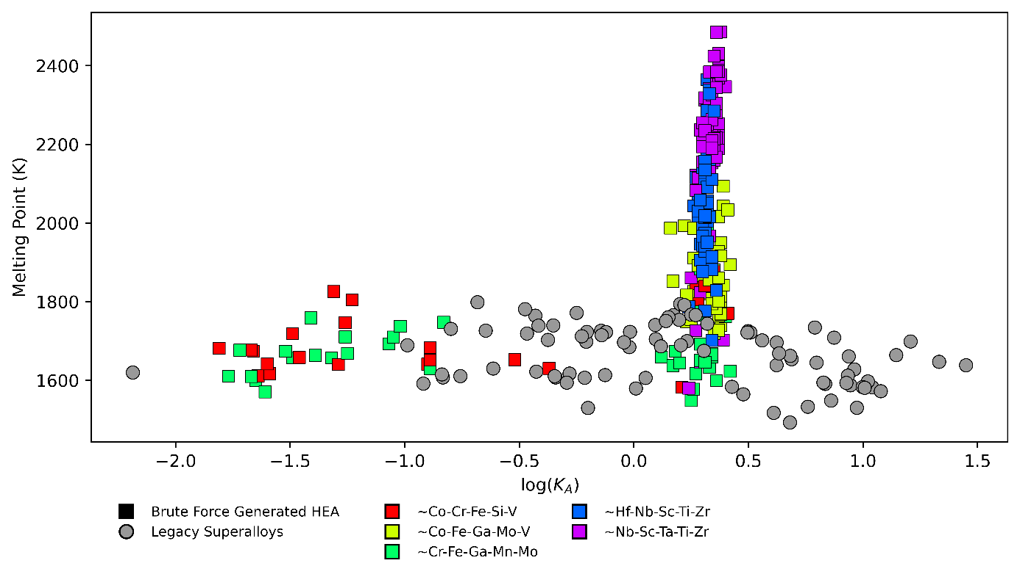
Figure 26: High-Temperature Oxidation Resistance ($\log{K_{A}}$) vs. Melting Point for Legacy Superalloys and Pareto-optimal HEAs.
Pareto-optimal HEAs exhibit markedly improved oxidation resistance (lower $\log{K_{A}}$ values) coupled with exceptionally high melting points. This positions certain Nb- and Sc-rich HEAs well beyond legacy superalloys in terms of combined thermal stability and oxidation performance, making them particularly attractive for high-temperature oxidizing environments.

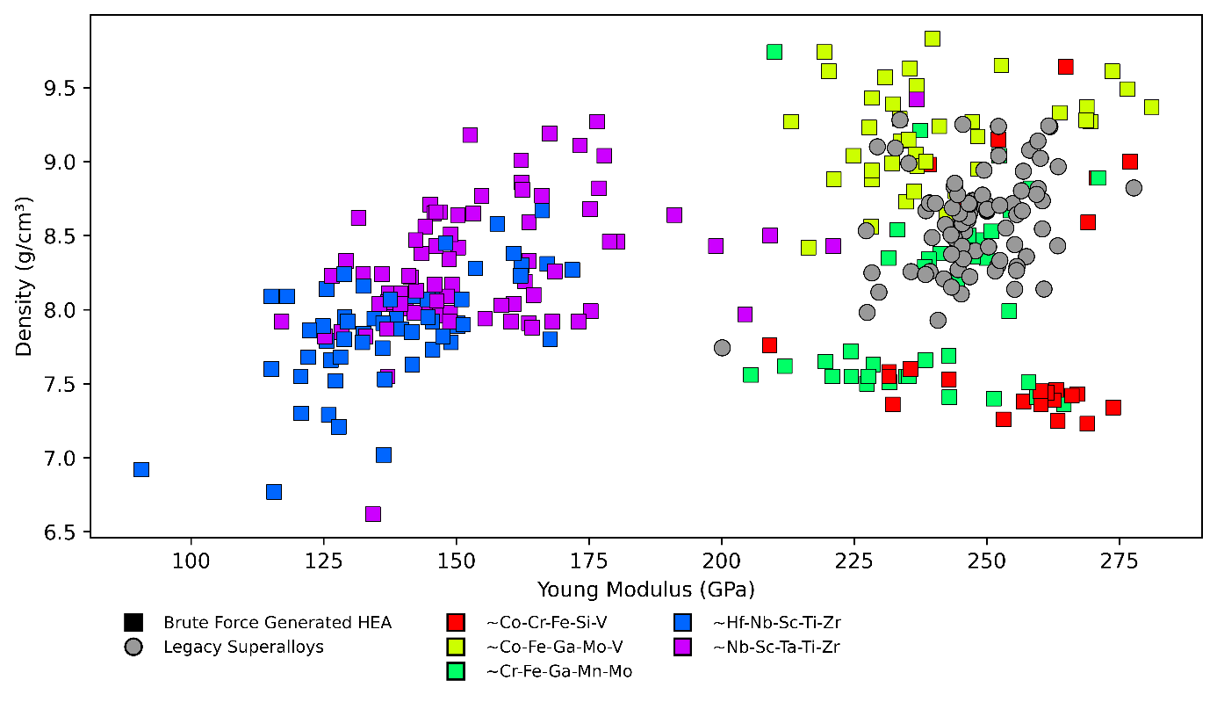
Figure 27: Young’s modulus vs. density for legacy superalloys and brute-force-generated HEAs.
Pareto-optimal HEAs reveal advantageous combinations of high stiffness and moderate-to-low densities, notably in clusters dominated by Cr, Fe, Co, Mo. This demonstrates potential to significantly reduce component weight without compromising structural rigidity, surpassing many legacy Ni-based superalloys (gray circles) and underscoring the value of exploring the high-entropy alloy design space.

Analysis of the Role of Elements
The design of advanced High-Entropy Alloys (HEAs) for high-performance applications, such as next-generation superalloys, requires a deep understanding of the relationship between chemical composition and material properties. In particular, alloy designers seek to identify which elements contribute positively or negatively to target properties like creep resistance, melting temperature, or oxidation resistance.
The goal of this work is to build a reliable and interpretable modeling framework that quantitatively links the presence and proportion of individual elements in an alloy to various performance indicators. To achieve this, machine learning techniques are employed, specifically XGBoost regression models accelerated on GPU, and interpreted the models using SHAP (SHapley Additive exPlanations) values. These methods allow to capture non-linear and context-specific relationships while maintaining interpretability at both global and individual levels.
Each alloy in the dataset is initially described by its normalized chemical composition, for example, “Al0.1Fe0.2Cr0.3Ni0.3Co0.1”. These strings are parsed to extract the element names and their corresponding atomic fractions. This information is used to build a matrix in which each row corresponds to an alloy and each column to a chemical element. If an element is absent from a composition, its fraction is set to zero.
Since the sum of all atomic fractions in each row is constrained to equal 1, the resulting matrix is a compositional dataset. Standard machine learning algorithms perform poorly under this constraint due to inherent collinearity and distortion of distances ⁴². To address this, a centered log-ratio (CLR) transformation is applied. The CLR method proceeds in three steps:
- A very small pseudo-count $ε≪1$ is added to avoid division by zero.
- Each row is renormalized so that its elements sum to 1.
- The logarithm of each value is computed, and the mean of the log-values in the row is subtracted to center the data.
This transformation $CLR:x_{i}↦\log\left(\frac{x_{i}+ε}{\sum_{k=1}^{n}{\left(x_{k}+ε\right)}}\right)-\frac{1}{n}\sum_{j=1}^{n}{\log\left(\frac{x_{j}+ε}{\sum_{k=1}^{n}{\left(x_{k}+ε\right)}}\right)}$ ensures that the data no longer suffers from the compositional constraint, making them suitable for regression and interpretation.
For each target performance indicator (scores $g₁$ to $g₁₀$), an independent regression model using XGBoost, a tree-based ensemble algorithm known for its speed and accuracy, is trained. The models are trained on a GPU, enabling efficient handling of large datasets.
Hyperparameters such as tree depth and number of boosting rounds are optimized via Bayesian optimization using the Optuna framework. Five-fold cross-validation is applied during tuning to ensure robust generalization.
After optimization, a final model is trained for each score on the full training data and evaluated on a held-out test set. The coefficient of determination ($R²$) is used as the primary metric to assess prediction accuracy. The performance of the training on the test database can be visualized on the parity plot (Figure 28) and the distribution of the residuals (Figure 29).

XGBoost Forest Analysis (feature importance, permutation importance, SHAP values)
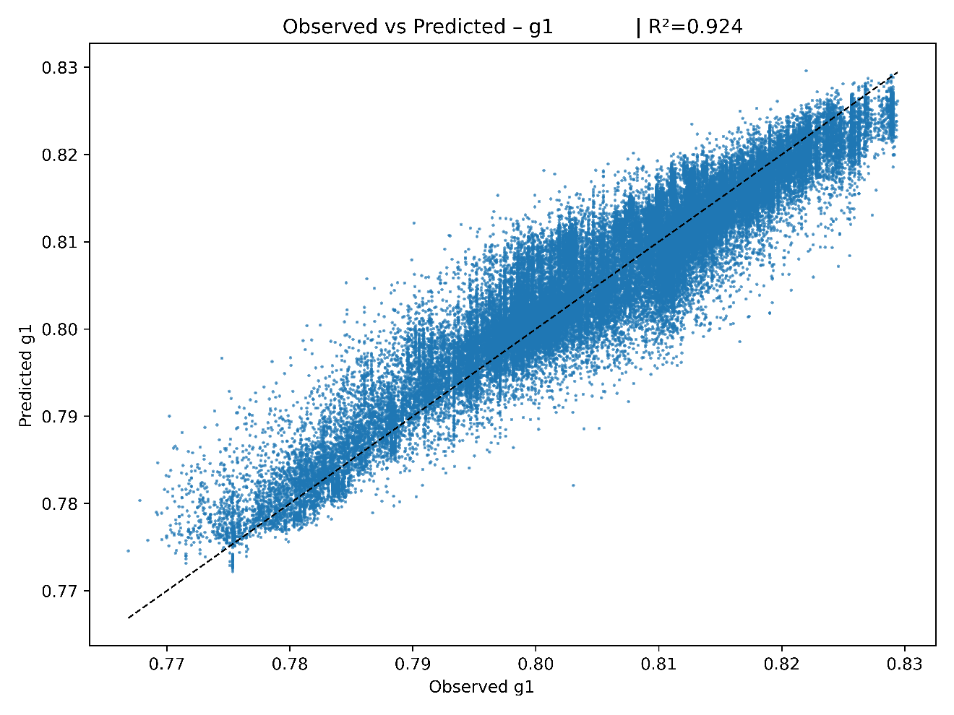
Figure 28: Accuracy of Prediction of Creep (LMP), on the Test Set represented as Predicted vs Observed.
The prediction is made directly from the CLR composition – contrary to the previous approach using descriptors – for its aim is not to deliver thorough predictions, but to be a tool for statistical analysis of the roles of elements through the “forest” analysis.
This scatter plot compares the model predictions to the actual measured values for a given score (e.g., creep resistance). Each point represents one alloy. The closer the points lie to the diagonal line, the more accurate the model.
The purpose of this figure is to evaluate how well the model generalizes to unseen data. A tight cluster around the diagonal with minimal spread indicates high accuracy. Deviations from this diagonal may reveal systematic biases or errors in the model.
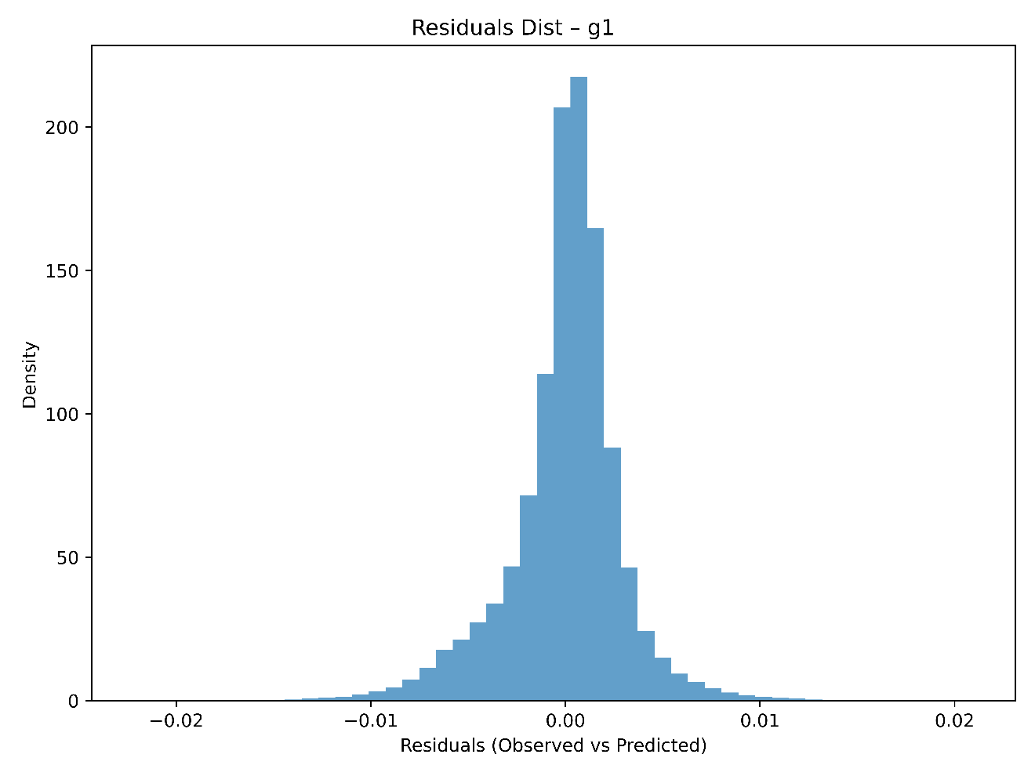
Figure 29: Distribution of the Residuals (differences observed between observed and predicted creep LMP).
This histogram shows the distribution of residuals, i.e., the differences between observed and predicted values. A shape roughly centered near zero and roughly symmetric suggests no large aggregate bias. This plot complements the scatter plot by providing insight into the spread and symmetry of prediction errors. Skewed or multi-modal residuals may suggest model misfit or the presence of non-modeled effects.

Once a trained model is at disposal, it can be analyzed to assess the role of the features. The bar chart on Figure 30 shows the importance of each chemical element in the XGBoost model, based on the number of times it was used to split decision trees (split frequency). A higher bar indicates that the element was frequently used to make decisions and likely has a strong effect on the target score.

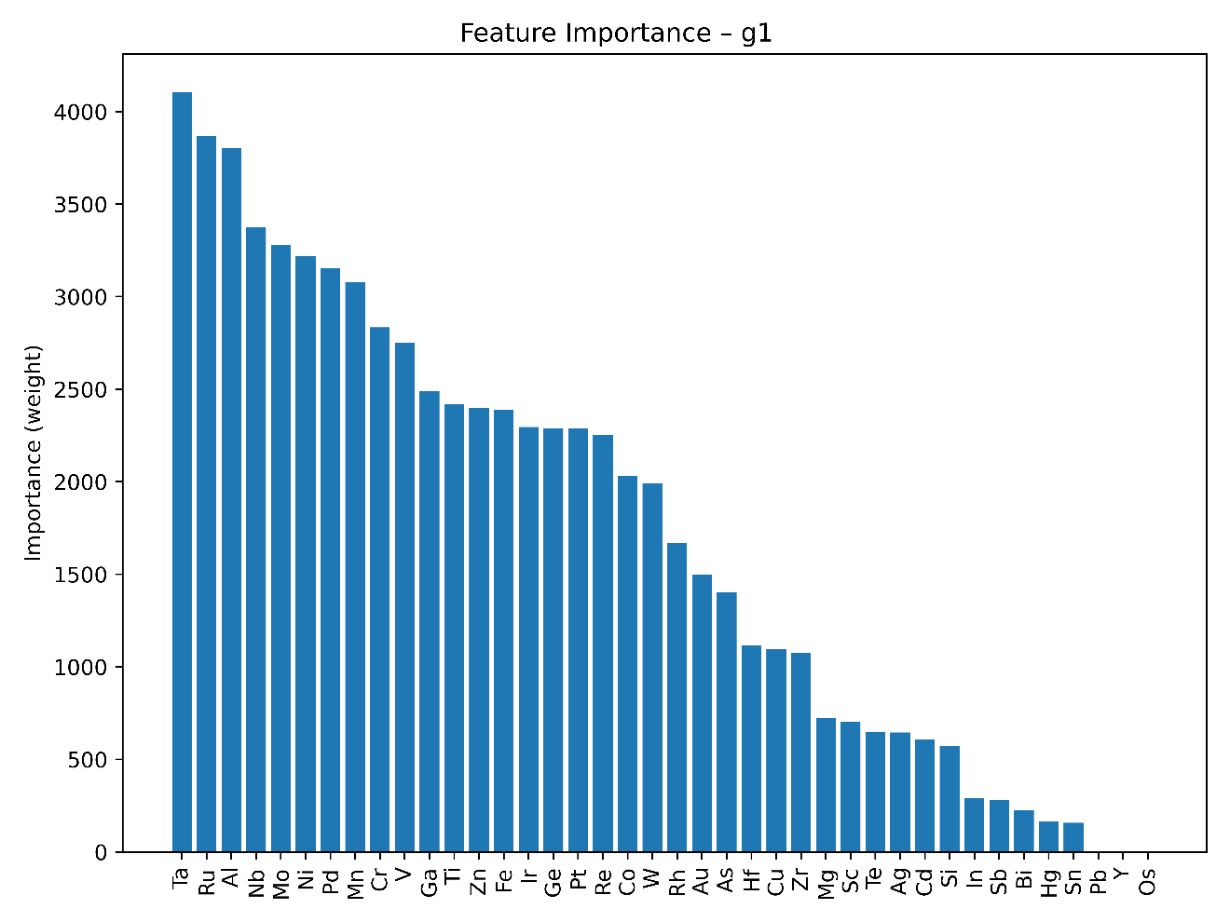
Figure 30: Feature Importance of Elements in Creep LMP Prediction
The “importance” counts the number of times a given element was used to split decision trees in the XGBoost trained model.
This global importance metric provides a first approximation of which elements are influential. However, it does not capture interactions or directionality of effect (positive vs. negative influence).
Permutation importance is a model-agnostic inspection technique in scikit-learn that quantifies each feature’s contribution by measuring how much a fitted model’s performance degrades when the feature’s values are randomly shuffled – thereby breaking its relationship with the target and revealing the degree to which the model relies on that feature. The procedure first computes a baseline score (e.g., accuracy or $R²$) on a held-out dataset, then, for each feature and across multiple repeats, permutes its values, re-evaluates the model, and averages the drop in performance to produce both an importance estimate and its variance. Because it works with any fitted estimator – linear or highly nonlinear, transparent or opaque – permutation importance (Figure 31) provides intuitive feature rankings without needing access to internal parameters, highlights drivers of model generalization when applied to validation data, and avoids biases inherent in impurity-based measures (such as favoring high-cardinality features).
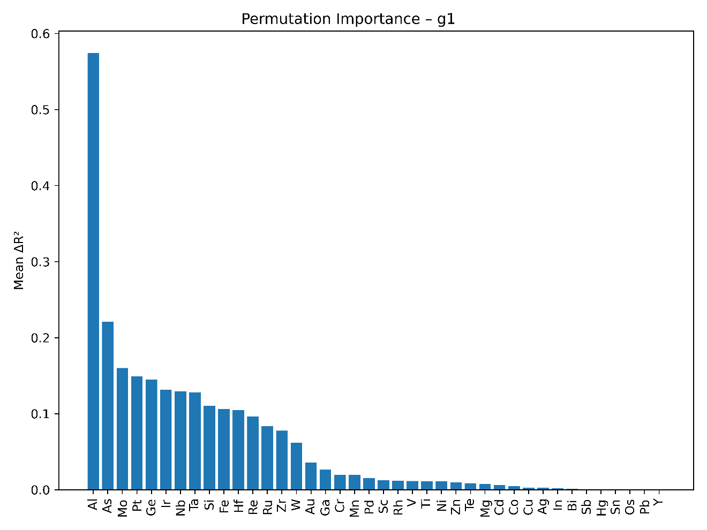
Figure 31: Permutation Importance of Elements in Creep LMP Prediction
Permutation importance measures the actual drop in predictive performance on unseen data when feature values are shuffled. This out-of-sample evaluation corrects biases toward high-cardinality or highly correlated features.

The permutation importance plot shows the impact of each feature on the model’s predictive power. Unlike split frequency, permutation importance measures the actual contribution of each feature to the model’s accuracy, making it more robust and informative for interpretation.
A SHAP (SHapley Additive exPlanation) analysis provides both local and global views of model behavior. In this work, two complementary global visualizations are used: a SHAP summary plot (Figure 32) and a SHAP feature-importance bar plot based on the mean absolute SHAP value (Figure 33). Together, they indicate which elemental fractions drive the creep LMP predictions and how variations in each element affect the score.
The SHAP summary plot in Figure 32 displays, for each feature, the full distribution of SHAP values across all alloys. Each point corresponds to one alloy–feature pair; its position on the x-axis is the SHAP value (negative values decreasing the predicted g-score, positive values increasing it), its vertical position identifies the feature, and its color encodes the original feature value (blue = low, red = high). The vertical spread of the cloud shows how heterogeneous the local contributions are. In this representation, a dense cluster of red points located at positive SHAP values for a given element indicates that high contents of this element systematically increase the target score, whereas a cluster of red points at negative SHAP values indicates that high contents tend to reduce the score.

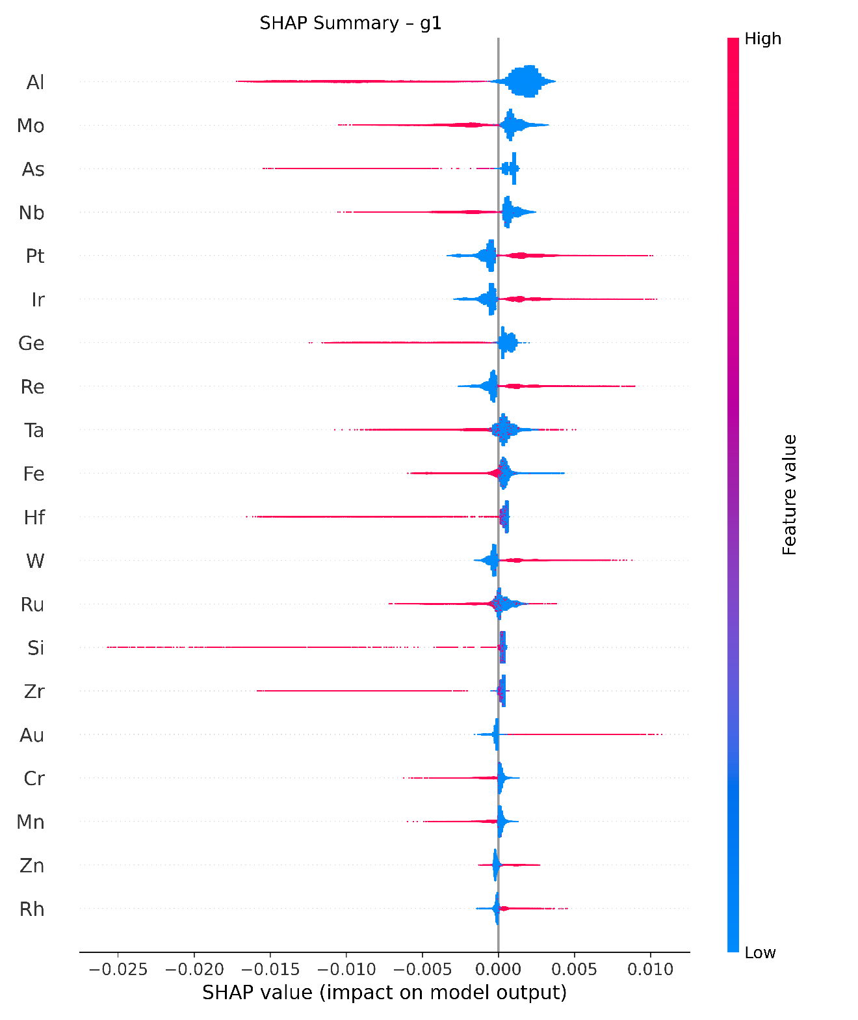
Figure 32: SHAP Summary Plot of Elements in Creep LMP Prediction
Since the SHAP value always relates on the g-scores, defined to reach 1 when the performance is optimal, and 0 when it is the worst, elements with a good contribution always follow this pattern: blue below zero (diminishing the content of this element is detrimental to performance) and red above zero. Harmful elements for the performance considered obviously follow the opposite pattern.
Figure 33 then summarizes the same information into a global importance ranking by plotting, for each feature, the mean absolute SHAP value. This bar plot ignores the sign of the contributions and reports only their average magnitude, providing a concise measure of how strongly each element influences the predictions on average. It thus complements both the permutation-importance plot, which is based on performance degradation, and the summary plot (Figure 32), which reveals the distribution and direction of local effects.

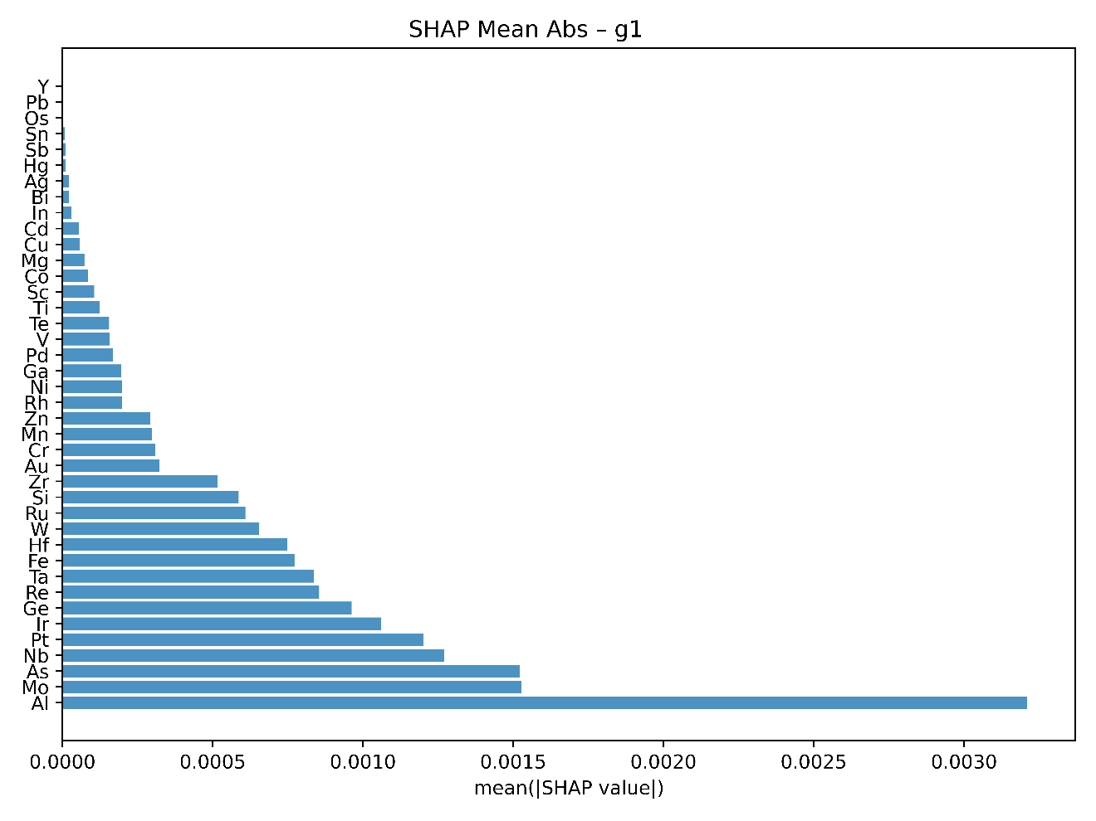
Figure 33: Mean Absolute SHAP Value for each Element
This bar plot summarizes the mean absolute SHAP value for each element, providing an average measure of its contribution magnitude across the dataset. Unlike feature importance, this captures both linear and non-linear effects. This figure complements the permutation plot and can confirm or refine which features matter most globally.

Partial Dependence Analysis
The analysis described here aims precisely at this objective: quantifying how each chemical element impacts significant physical quantities associated with HESA performance.
In the preceding analyses, various statistical tools have already been presented to estimate the global contribution of chemical elements – namely, the Feature Importance, Permutation Importance, SHAP Summary Plots, and Mean Absolute SHAP Values⁴³. While these metrics are particularly adapted to explain a local prediction, when it comes to explaining a general trend like the “role” of one element regarding a given property, synthesizing information about every single prediction into a single scalar (for the sake of representation, see for instance Figure 34) becomes an uneasy task, complexified by the side-effects of working on a simplex: indeed, if a material with 1% Re has a lower melting point than the materials, it does not mean than Re lowers the melting point, but more likely that the average content of Re in the database is above 1%. Therefore, to achieve a clearer and more straight forward understanding of elemental roles, the current approach employs a simple though robust statistical method known as Partial Dependence Analysis.
Intuitively, the partial dependence function quantifies the average impact of changing one element’s proportion, keeping other compositional parameters randomly distributed. Thus, this method isolates and clarifies the direct effect of a single element, even within complex alloy compositions where numerous interactions between elements exist.
The method adopted here involved applying partial dependence analysis separately to five meaningful physical properties of interest:
- Resistance to Creep: evaluated via the Larson-Miller Parameter (LMP), a key criterion for prolonged high-temperature serviceability.
- Density: an important criterion when considering lightweight structural materials.
- Melting Temperature: closely linked to the ability to operate under high thermal loads.
- Resistance to High-Temperature Oxidation: measured through the logarithm of the parabolic rate constant $\log_{10}{K_{A}}$, which strongly influences durability at elevated temperatures.
- Bulk Modulus: indicating stiffness and structural stability.

The analytical procedure was conducted as follows:
- Definition of Reference Expectation:
For each physical property, a large set of synthetic alloy compositions was randomly generated, conforming to realistic constraints (e.g., the total proportion of elements always summing up to unity, and alloys containing between five and seven distinct elements). Predictions were then calculated using the previously trained Gradient Boosting models. The mean predicted value across these randomly-generated alloys provided the reference expectation, representing a baseline expectation of each physical quantity.
- Partial Dependence Expectation Calculation:
To quantify the impact of each element $j$, another set of synthetic alloys was generated, this time with a fixed elemental fraction (30%) of the element under study, while the remaining fraction (70%) was randomly allocated among other elements. Predictions were again computed, yielding an expectation specific to the constrained element proportion.

- Statistical Quantification:
The difference between the partial dependence expectation (with the element fraction fixed) and the global reference expectation reflects the average shift induced by imposing the presence of the element. To accurately characterize this difference, three complementary metrics were computed:
- Relative Delta (Mean Shift): The relative difference in expectation, scaled by the global mean value of the property, offering a normalized interpretation of element’s impact direction and magnitude.
- Standard Deviation: The relative standard deviation of predictions with the element fixed, indicating the dispersion and reliability of the expectation shift.
- Proportion of Positive Contributions: Defined as the proportion of individual predictions exceeding the reference expectation, this metric provides a direct probabilistic insight into how consistently an element’s presence enhances or deteriorates a given physical property.

The synthesis of these metrics into coherent conclusions about each element’s role relies on a carefully structured visualization strategy, using two complementary heatmaps:
- Heatmap of Relative Delta with Standard Deviation (Figure 35):
This first visualization presents, for each physical quantity and each element, the magnitude and reliability of the mean shift (Relative Delta). The colors indicate clearly identified positive or negative effects, considering the uncertainty range defined by the standard deviation. Concretely, an element showing strong and reliably positive impact (large positive delta with small standard deviation) is highlighted, whereas elements with ambiguous effects (small delta compared to the standard deviation) are visually distinguished.
- Heatmap of Positive Contribution Proportions (Figure 34):
This second heatmap complements the first by representing the consistency with which an element enhances a property. Elements consistently improving a property will yield high values close to 1, while those negatively impacting the property will approach values closer to 0.

By cross-analyzing these two heatmaps, one obtains comprehensive and interpretable insights regarding the elements. This approach precisely answers two fundamental questions guiding the research:
- Direction and Magnitude of Influence: Which elements significantly enhance or deteriorate specific physical properties?
- Consistency of Influence: Which elements consistently impact positively (or negatively) the property, versus those whose influence is ambiguous or inconsistent?

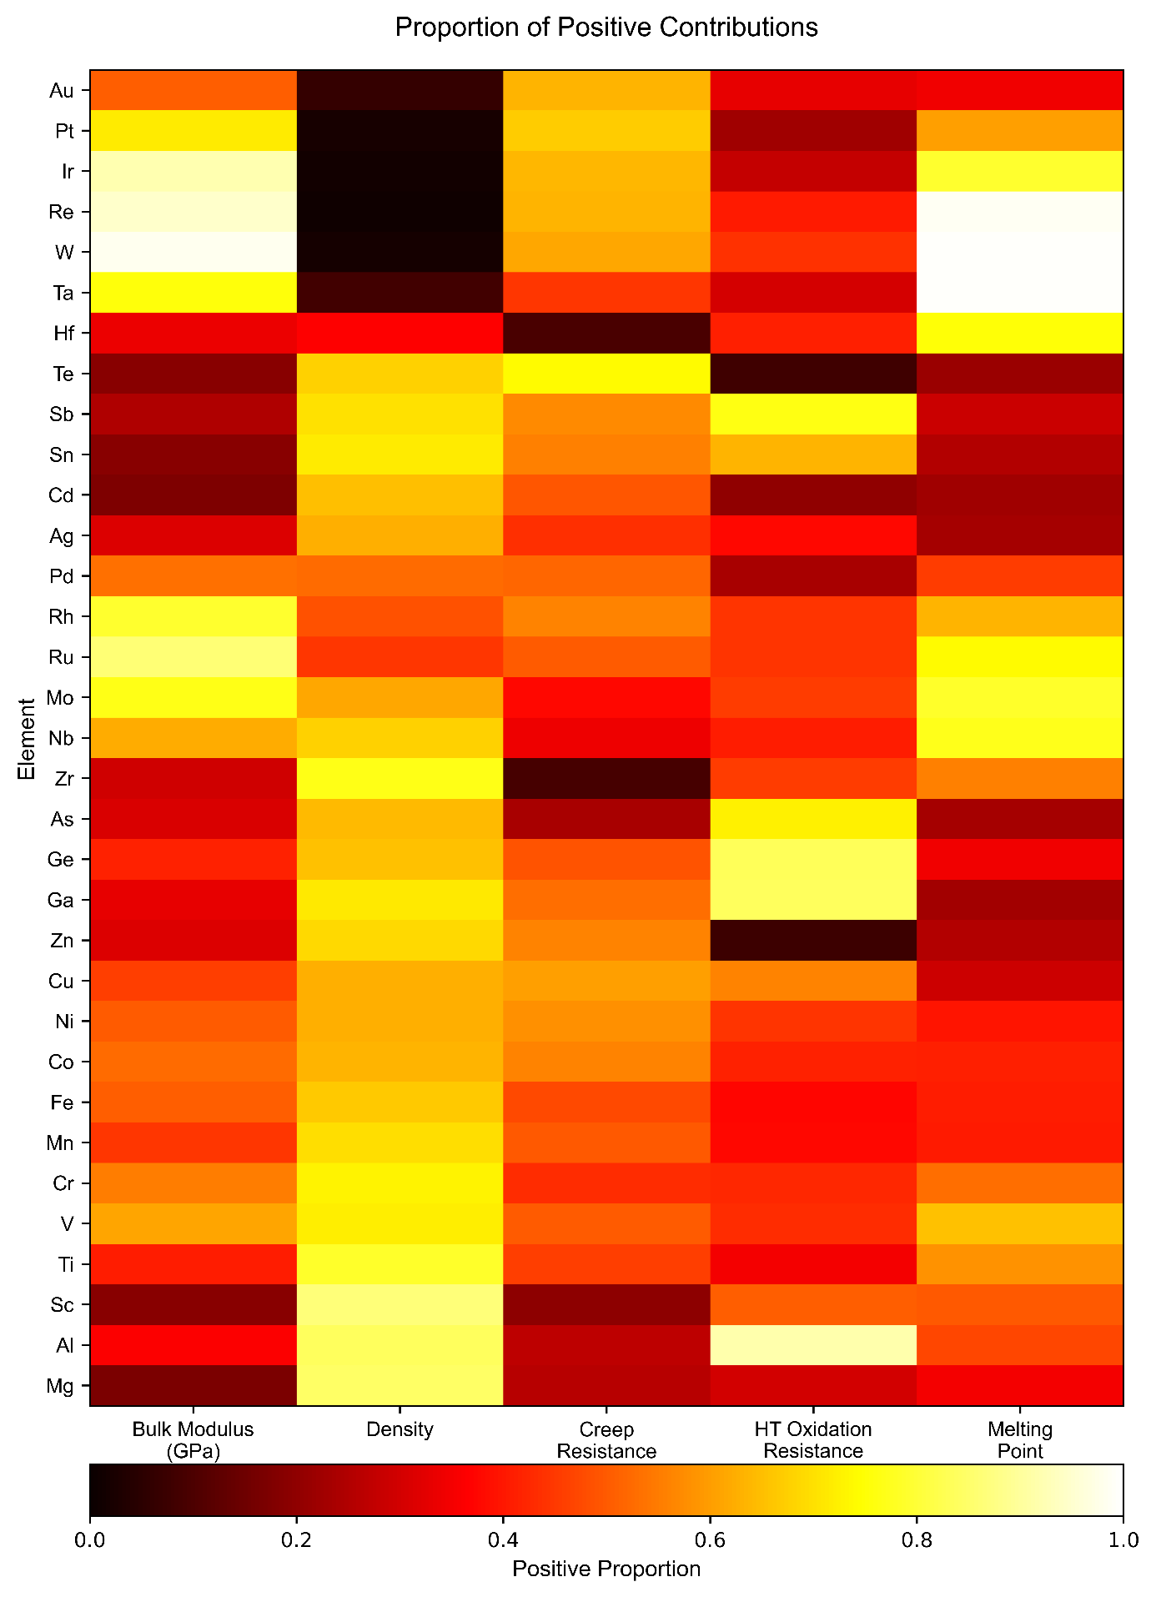
Figure 34: Proportion of Positive Contributions to Physical Properties of Alloys
Heatmap representing the proportion of positive contributions for each element towards five key physical properties of interest in High-Entropy Superalloys (HESAs). Higher values (in yellow) indicate that increasing the element's content (at a fixed proportion of 30%) generally improves the considered physical property, while lower values (in black) suggest a negative impact.

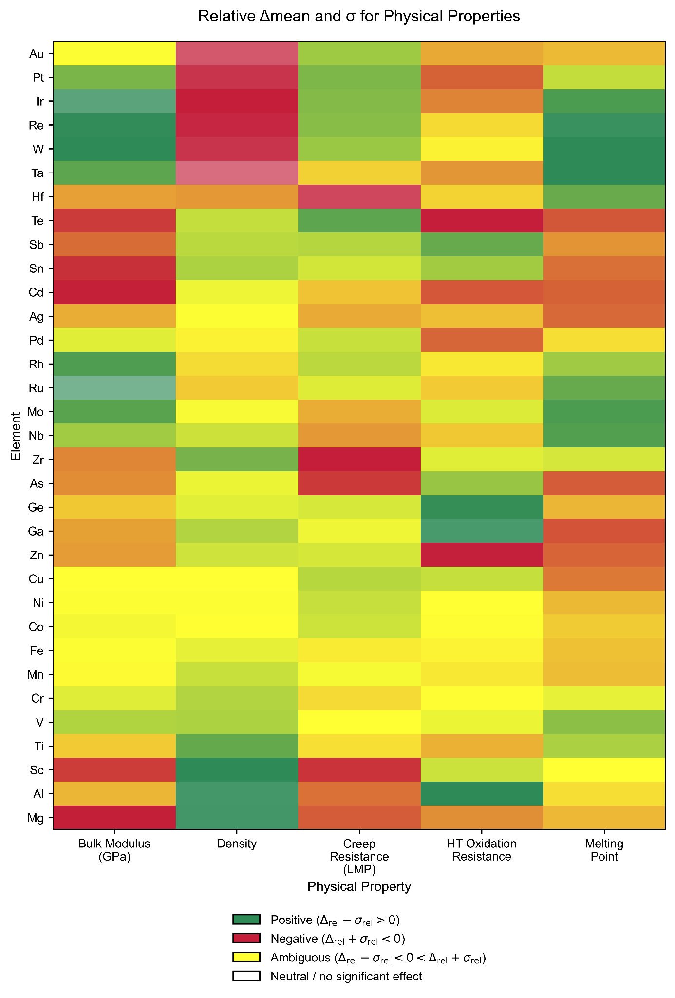
Figure 35: Mean Shift & Standard Deviation of Physical Properties
Heatmap depicting the significance and directionality of each element’s effect (when forced at a fixed proportion of 30%) on the five considered physical properties. Green regions correspond to consistently positive effects (mean relative Δ significantly above zero), red indicates consistently negative effects (mean relative Δ significantly below zero), yellow denotes ambiguous impacts (mean ± standard deviation includes zero), and white reflects neutral or negligible impacts.

Both heatmaps provided (Figure 34 and Figure 35) summarize clearly the roles played by various elements in influencing the physical properties critical for the design of effective High-Entropy Superalloys (HESAs). These visualizations derive from Partial Dependence analyses conducted on robust machine learning models, allowing to quantitatively assess the impact of systematically fixing each element at a substantial atomic fraction (30%) within random compositions.

GENERATIVE EXPLORATION & FRONTIER EXPANSION

Data Preparation and Condition Specification
A rigorous data preparation pipeline is essential to ensure that the Conditional Variational Auto-Encoder (CVAE) learns meaningful relationships among alloy compositions and respects the causal chain linking elemental makeup to final performance scores. The dataset comprises approximately 700 000 quinary and higher-order alloy compositions, for which a consistent suite of physicochemical descriptors, surrogate-model property estimates, and ten normalized performance scores $g_{i}$ was computed. Each sample therefore preserves a complete lineage, from raw composition through descriptor space to predicted physical quantities and, ultimately, to the scalar scores guiding alloy selection.
To encode composition in a form suitable for neural-network models, the centered log-ratio (CLR) transformation is applied to the atomic fractions of each constituent element. CLR encoding removes the unit-sum constraint inherent to compositional data and embeds all fractional proportions within an unconstrained Euclidean space. In practice, the elemental fractions for each alloy are read and mapped via the CLR transform, yielding a vector whose dimensionality corresponds to the number of alloying elements minus one. This compact, continuous representation constitutes the first block of features in the input matrix $X$.
Beyond composition, the descriptor set includes atomic-size mismatch parameters, mixing enthalpies, electronegativity differences, valence-electron concentrations, and data-driven spectral features extracted from density-of-states predictions, among others. The surrogate models use these descriptors to predict continuous physical quantities such as elastic modulus, yield strength, ductility indices, thermal conductivity, and melting point. Each of these predicted properties was transformed into a dimensionless score $g_{i}∈[0,1]$ via a smooth scaling function that penalizes values outside desirable ranges. Collectively, these ten scores quantify a material’s overall “goodness” across multiple objectives.
Having defined the input representations, the conditioning vector $Y$ was specified to focus generative modeling on alloys exhibiting uniformly high performance. Specifically, each individual score $g_{i}$​ was required to exceed 0.3, ensuring that no single property falls below a minimal acceptable threshold. In addition, the sum of the ten scores was constrained to be at least 5.0, corresponding to an average score of 0.5 per property, thereby enforcing a balanced high-performance profile across all targeted criteria. Finally, to emphasize synergy among all objectives, the product $\prod_{i}{g_{i}}$ was originally considered​​, but in practice replaced it with the sum of natural logarithms $\sum_{i}{\ln{g_{i}}}$ for numerical stability and smoother gradient behavior. These three criteria – per‐score minimum, total‐score minimum, and logarithmic sum threshold – are concatenated to form the vector $Y$, which is supplied to both encoder and decoder during CVAE training.
To ensure a sufficient density of examples near the high-performance frontier, the raw dataset was enriched with perturbed compositions generated around the Pareto front obtained from an initial brute-force search. The enrichment procedure adds Gaussian noise to the elemental fractions of Pareto-optimal alloys, randomly varies atomic percentages within ±2 at.%, and introduces one or two trace elements at low concentrations to explore neighboring chemistries. For each newly generated composition, descriptors, surrogate predictions, and the ten $g_{i}$ scores are recomputed, and only those compositions that satisfy the $Y$ constraints are retained. This targeted augmentation ensures that the CVAE encounters ample positive examples during training, thereby improving its ability to model the conditioned high‐performance manifold.
The final training dataset thus comprises rows of the form:
$$X=\left[CLR\left(c\right),d,\hat{p},g\right]$$ | $$\left( STYLEREF 1 \backslash s 4 SEQ Équation \backslash * ARABIC \backslash s 1 1\right)$$
and $Y=\left[{class}_{1}\left(\min_{i}{g_{i}}\right),{class}_{2}\left(\sum_{i}{g_{i}}\right)\right]$ | $$\left( STYLEREF 1 \backslash s 4 SEQ Équation \backslash * ARABIC \backslash s 1 2\right)$$
where $c$ is the vector of atomic fractions, $d$ the descriptor set, $\hat{p}$​ the surrogate XGBoost predictions of the materials properties, and $g$ the normalized scores. Practically, the three classes are 0-1 values depending on the comparison to a threshold. By preserving the logical progression from composition to score and by carefully defining the conditioning signals, a foundation is established on which the CVAE can learn both to reconstruct existing alloys and to generate novel candidates that satisfy stringent multi-objective performance criteria.

CVAE Architecture and Adaptive Training Strategy
In designing the Conditional Variational Auto-Encoder (CVAE) for high-entropy single-phase alloy generation, the network topology was selected to balance sufficient representational capacity with computational tractability. Both the encoder and the decoder are implemented with two fully connected hidden layers. The first hidden layer contains 64 neurons, a choice motivated by the need to project the high‐dimensional (~100) input vector $X$ – comprising CLR‐transformed compositions, physicochemical descriptors, surrogate model predictions, and performance scores – into a more compact feature space without excessive compression loss. By keeping the layer size below the raw input dimensionality, the network is prevented from trivially memorizing the data and is instead encouraged to learn meaningful feature combinations.
The encoder and decoder each comprise two fully connected hidden layers with ReLU activations; only the encoder’s two output heads (the mean $μ$ and the log-variance $\log\left(σ^{2}\right)$) and the decoder’s final layer are linear. The second hidden layer has 32 neurons, forming an additional bottleneck that encourages abstraction while retaining sufficient information for accurate reconstruction. From this layer, two parallel linear projections parameterize the latent Gaussian: one 16-dimensional vector for $μ$ and one 16-dimensional vector for $\log\left(σ^{2}\right)$, yielding a latent variable $z∈R^{16}$ via the reparameterization trick.
A sweep over latent dimensionalities from 8 to 24 was performed, and a size of 16 was found to provide a balanced operating point. Very small latent dimensions degrade reconstruction and constrain generative diversity, whereas very large ones tend to erode KL regularization, encouraging memorization and a less smooth latent manifold. At 16 dimensions, the model achieves low reconstruction error while preserving a well-shaped, regularized latent space that supports robust sampling and property-conditioned generation.
Rather than relying on a fixed‐weight training loss, an adaptive training schedule was implemented to guide the CVAE through successive learning phases (a strategy to improve convergence inspired from successful attempts of other researchers ^{81,82}). At the outset, only the reconstruction loss is active. In this “warm‐up” period, the network is trained exclusively to minimize mean squared error between each input vector $X$ and its reconstruction $\hat{X}$, allowing the encoder–decoder pipeline to establish a baseline mapping without the pressure to regularize the latent distribution. After a preset number of epochs, the Kullback–Leibler (KL) divergence term is introduced with a small initial weight $β$. Over subsequent epochs, $β$ is increased linearly (as a percentage of its target value) until the average KL loss stabilizes around 0.1 – a value empirically shown to produce a well‐shaped Gaussian latent manifold without collapsing the encoder’s output onto the prior.
Once the KL term is stabilized, an entropic regularization loss is introduced, weighted by a factor $γ$, to remain in the HESA entropy range in the decoder’s outputs:
$$L=L_{recon}+{βL}_{KL}+γL_{entropy}$$
This loss penalizes random entropies, effectively enforcing a target latent‐space entropy to remain approximatively in a $\left[1.2,2.2\right]$ range. The schedule for $γ$ mirrors that of $β$: it ramps up gradually until the measured entropy of the encoded distributions falls within a narrow window around the target. Both $β$ and $γ$ schedules are defined in the script, allowing reproducible experiments and easy adjustment.
With a stable latent manifold ($L_{recon}$<RECON_THRESHOLD) and controlled entropy ($L_{KL}$<KL_THRESHOLD), a reward term is then added into the loss function to bias generation toward high‐scoring alloys. This reward is computed as $L_{reward}=-〈α,g〉$, where $α/{\left\|α\right\|}$ ​is the fixed ponderation vector – several runs with different ponderations were conducted to explore spaces corresponding to different priorizations. The factor $\left\|α\right\|$ begins at zero and increases incrementally with each epoch. At every training step, if the current model’s reward exceeds a predefined threshold, an active‐learning subroutine described in subsection 4.3 is triggered to generate a batch of candidate compositions. Each candidate is decoded under the fixed condition vector Y, then subjected to an entropic viability filter and rescored via the surrogate property models.
If any candidates pass the per‐score threshold $g_{i}>0.3$, $\left\|α\right\|$ is further increased to intensify the reward signal and accelerate exploration of that high‐performance subspace. Conversely, if no candidates survive the filters, $\left\|α\right\|$ is reduced and revisit the $β$ and $γ$ schedules to reinforce reconstruction and latent‐space regularity. This feedback loop continues until the reward‐guided loss consistently yields viable candidates at each epoch.
In combination, this adaptive strategy – warm‐up reconstruction, progressive KL and entropy regularization, and reward integration with candidate filtering – ensures that the CVAE not only learns to reconstruct known alloy chemistries but also to generate novel compositions that satisfy stringent multi‐objective criteria. By automating loss-weight adjustments in response to model performance, the training protocol robustly navigates the trade-offs between fidelity, diversity, and targeted exploration, thereby enabling efficient discovery of promising high-entropy alloys.

Generative Exploration Loop and Filtering
To translate the trained CVAE into a practical materials-discovery engine, a generative exploration loop is implemented that iteratively proposes new alloy compositions, evaluates their viability, and adjusts the training loss to emphasize high-performing regions of composition space. This loop is orchestrated by a training driver with candidate evaluation. At each training epoch, after computing the reconstruction, KL, and entropy terms, a scheduling callback generates a synthetic batch and uses its scores to update the reward weights $α$. This batch is an adaptive objective-shaping (self-paced) mechanism. A real “active learning” done later with the final augmentation (subsection 4.2), where top-ranked generated candidates are labeled and fed back to retrain the model.
First, a batch of latent samples $z∼N(0,I)$ is drawn and they are decoded under the fixed condition vector $Y=\left[\min_{i}{g_{i}}≥0.4,\sum_{i}{g_{i}}≥5\right]$. The number of samples per epoch, denoted $n$, is specified in the configuration file; typical values range from 200 to 500, balancing exploration throughput against computational cost. Decoding yields a corresponding set of raw composition vectors in CLR‐space, which are immediately subjected to an entropic viability filter: the Shannon entropy of each decoded mixture’s elemental distribution is computed, and any sample whose entropy falls below a minimum threshold $ε_{min}$​ is rejected. This filter removes implausible or overly concentrated compositions – situations where the decoder has collapsed to a near‐singular element mixture rather than a true high-entropy alloy.
Next, all remaining candidates are passed through the surrogate property models. For each candidate, the full set of continuous physical predictions (elastic modulus, yield strength, ductility, etc.) is recomputed, transformed into normalized scores $g_{i}$​, and then the condition vector $Y$ is reassembled to verify whether each individual $g_{i}$ still exceeds the minimum threshold (0.3). Any candidate failing even one of these checks is discarded, ensuring that only truly high-quality alloys survive the filtering stage.
The training procedure progresses gradually over many epochs. First, $β$ is increased slowly until the KL loss $L_{KL}$ enters an empirically identified target range; only then is the reward term activated by progressively increasing $\left\|α\right\|$. Once $\left\|α\right\|$ exceeds a predefined threshold, candidate alloys are generated and evaluated at each epoch. When the first candidates satisfy both the entropy and $g_{i}$ filters, the model is already in an advanced stage of learning, and the large size of the training database allows substantial improvements to be achieved at every subsequent epoch. If at least one candidate remains, the generation loop is deemed successful for that epoch, and surviving candidates are saved. The process goes on, with an increased reward factor $\left\|α\right\|$ in the loss function – $\left\|α\right\|$ is multiplied by a fixed percentage. This steeper reward gradient in subsequent epochs further biases the CVAE toward regions of latent space that produce high-scoring alloys. By gradually intensifying $\left\|α\right\|$, the model is encouraged to refine its latent manifold to concentrate probability mass on the most promising chemistries.
Conversely, if no decoded samples clear the entropy and $g_{i}$ thresholds, this is interpreted as a sign that the current latent manifold or decoder mapping is insufficiently calibrated for high-performance generation. In that case, $\left\|α\right\|$ is decremented to reduce the pressure of the reward term, and the schedules for $β$ and $γ$ are revisited, temporarily holding $γ$ constant or even rolling it back slightly to reinforce reconstruction accuracy. This corrective mechanism prevents the network from over-biasing toward high rewards at the expense of generative fidelity, ensuring that subsequent epochs restore balance between reconstruction, regularization, and performance bias.
This generate–filter–adapt cycle repeats at every epoch until a convergence criterion is met – either a maximum number of epochs is reached or the reconstruction loss starts diverging. Throughout training, key metrics are logged: entropy statistics, average $g_{i}$​ scores of decoded batches, and the evolution of $\left\|α\right\|$, $β$, $γ$ and their associated losses. These diagnostics indicate that the training dynamics remain stable and that the CVAE progressively refines its ability to generate valid high-entropy alloys.
Finally, once training concludes, all candidates that passed the filters across every epoch are aggregated and de-duplicated, then appended to the master training database. This “self-training” step enriches the sample distribution available for the next CVAE runs, closing the loop between discovery and model refinement. In this way, the generative exploration loop not only yields novel alloy suggestions in real time but also continually expands the CVAE’s knowledge of the high-performance alloy frontier, setting the stage for increasingly effective inverse design in subsequent iterations.

Latent Space Augmentation via Hamming-Based Sampling
Although the CVAE’s latent manifold provides a smooth, continuous representation of chemically plausible alloys, its ability to generate meaningful candidates remains intrinsically limited by the compositions seen during training. As discussed in 3 STOCHASTIC BRUTE-FORCE SCREENING OF 5-ELEMENTS HEA, the quinary HEA space was initially explored using the thermodynamic map of Chen et al., which identifies compositions that are likely to form high-entropy solid solutions ²⁷. These chemistries occupy only a very small fraction of the full combinatorial space, and therefore introduce a bias that confines the generative model’s “imagination” to a narrow region.
To formalize the exploration of the broader composition space, alloy compositions are viewed as constant-weight codewords in the sense of coding theory. Each alloy is encoded as a binary vector of length 39 (one position per element), with exactly $w = 5$ entries equal to one, indicating the presence of five alloying elements. The Hamming distance between two such codewords is the number of positions at which they differ. If two quinary alloys share $t$ common elements, their binary encodings have Hamming distance $d = 2(w - t)$. Imposing a minimum Hamming distance $d_{min}$ ($d_{min}=6$ for instance) is equivalent to constraining the maximum number of shared elements, and thus to enforcing that any two selected alloys are separated by at least a certain number of substitutions in composition space:
$$2\left(w-t\right)≥d_{min}⇒t≤w-\frac{d_{min}}{2}=5-3=2$$
In coding-theory terms, this corresponds to constructing a constant-weight code that “covers” the design space with well-separated codewords.
This viewpoint is particularly useful when the number of allowed elements and the maximum number of constituents per alloy are large (e.g. up to eight elements or more): the total number of combinations becomes astronomically high, and only a sparse, well-dispersed subset of compositions can be evaluated. A Hamming-based sampling scheme then provides a principled way to select such a subset: starting from an empty set, candidate codewords are examined in turn and retained only if their Hamming distance to all previously chosen codewords exceeds 𝑑min. The result is a collection of alloys that are mutually distant in terms of composition, thereby “paving” the space with non-overlapping Hamming balls and ensuring that every unexplored region lies close to at least one evaluated alloy.
In the present study, the practical situation is more favorable. The search is restricted to equimolar, five-element alloys drawn from 39 candidate elements, so that the total number of distinct compositions $\left(\begin{matrix}39 \\ 5\end{matrix}\right)=575757$ remains tractable on a modern workstation. Instead of selecting a sparse Hamming code, the algorithm therefore enumerates all quinary combinations and evaluates each of them. In this regime, enforcing a minimal Hamming distance 𝑑min reduces to the trivial condition $d_{min}=1$, which simply guarantees that no two selected codewords are identical. The Hamming formalism is thus used here mainly as a unifying language to describe composition space, while the actual exploration corresponds to an exhaustive scan of the equimolar 5-element subspace.
Even in this exhaustive setting, the constant-weight / Hamming-distance interpretation remains useful. It provides a natural framework for generalizing the present workflow to richer design spaces (e.g. up to eight constituents per alloy, or larger pools of candidate elements), where full enumeration would no longer be feasible. In such cases, replacing the exhaustive scan by a true Hamming-distance-based covering – using $d_{min}≥3$ or $d_{min}≥5$ to cap the number of shared elements – would allow the generation of a maximally diverse but computationally manageable subset of alloys, which could then be used to augment the CVAE training data in the same way as in this quinary study.
The second idea consists in refining the stoichiometries of these new alloy compositions through gradient ascent optimization. An equiatomic stoichiometry of 0.2 for each of the five selected elements may seem natural because it maximizes configurational entropy. However, this assumption does not fully exploit the opportunity to fine-tune other critical physical properties relevant to HEA formation and performance. Because several of these properties are differentiable or can be approximated by differentiable functions, gradient ascent is introduced to systematically optimize them.
Specifically, three explicitly differentiable quantities that are central to HEA stability and performance are targeted: stoichiometric entropy, the average number of valence electrons per atom, and the atomic-radius mismatch. Additionally, two other critical properties – melting temperature and density – were approximated by the weighted averages of the elemental properties, which are effectively differentiable concerning stoichiometric fractions in HEAs due to their single-phase, solid-solution nature. Indeed, it has been established in the literature that the melting temperature of an HEA closely approximates the stoichiometric average of its constituents' melting points, making it amenable to gradient-based optimization.
To implement gradient ascent in practice, the optimization objective is defined as the sum of the logarithms of the five targeted property functions:
$$Objective=\sum_{i=1}^{5}{\log{f_{i}}}$$ | $$( STYLEREF 1 \backslash s 4 SEQ Équation \backslash * ARABIC \backslash s 1 3)$$
This formulation was particularly advantageous as it converted multiplicative optimization objectives into additive ones, thereby simplifying numerical convergence and neutralizing disparities in property scales. In practice, a proportional improvement in any targeted property consistently resulted in a comparable impact on the overall objective, effectively eliminating concerns related to differing units or magnitudes across properties.
For properties intrinsically requiring maximization, such as melting temperature and stoichiometric entropy, direct inclusion into the objective function was straightforward. However, properties that required precise control within a specified optimal window – such as the atomic radius mismatch – necessitated an additional transformation. Exponential penalty functions were introduced to discourage deviations from the desired property ranges:
$$f\left(δ\right)=exp\left(-α\left[\max\left(0,δ-δ_{max}\right)+max⁡(0,δ_{min}-δ)\right]\right)$$ | $$( STYLEREF 1 \backslash s 4 SEQ Équation \backslash * ARABIC \backslash s 1 4)$$
This transformation effectively converted the problem of maintaining property values within a certain interval into a continuous maximization problem, fully compatible with gradient ascent.
Stoichiometric vectors were iteratively updated by computing numerical gradients using finite differences and applying fixed-norm updates along the gradient direction:
$$w_{new}=w_{old}+\frac{∇f(w_{old})}{\left\|∇f(w_{old})\right\|}u$$ | $$( STYLEREF 1 \backslash s 4 SEQ Équation \backslash * ARABIC \backslash s 1 5)$$
where $w$ represents the stoichiometric fractions, and $u$ controls the update magnitude. Iterations continued until either convergence or non-physical stoichiometries (negative or zero fractions) emerged.
This combined approach – discrete Hamming sampling followed by stoichiometric gradient ascent – not only significantly broadened the compositional space explored by the CVAE but also markedly increased the likelihood of identifying new alloys that simultaneously satisfied all necessary property constraints. Consequently, many newly generated alloys emerged within previously unexplored regions of the multi-dimensional physical property space, thus enriching the CVAE’s latent manifold with additional, potentially valuable, samples. This integrated augmentation strategy therefore represents a substantial methodological advancement, enhancing both the depth and breadth of the generative model's capability to discover innovative high-entropy single-phase alloys.

Simplex Steepest-Ascent on Pareto Front Compositions
Building upon the demonstrated effectiveness of the previous gradient-ascent procedure in identifying alloy compositions that populate the Pareto front, the approach was extended to explicitly leverage the best-performing alloys obtained in earlier optimization cycles. Each alloy already positioned on the Pareto front was used as a new initialization point, from which further gradient-based optimization of its stoichiometry was performed. The rationale was straightforward: since these alloys already demonstrated favorable combinations of material properties, they represent promising regions of composition space from which additional incremental improvements might be attained.
This optimization differed fundamentally from the previously implemented method because the objective function in this iteration no longer relied exclusively on strictly differentiable quantities. Instead, the function F was designed either as a soft-minimum across the property-based scores $g_{i}$ or as the sum of their logarithms, depending on the optimization run. The soft-minimum formulation ensures that improvements target the weakest score among the set, while the logarithmic sum offers a balanced approach, simultaneously enhancing all scores in a multiplicative sense. Both approaches allowed flexible and effective optimization across diverse, competing material property objectives.
Given that certain descriptors and material properties employed in this approach are computed through external Python libraries, their numerical evaluations do not consistently accommodate infinitesimally small variations in stoichiometry. Consequently, exact differentiability of these quantities was no longer guaranteed, necessitating an adapted numerical approach to gradient estimation. To circumvent this limitation, a first-order finite difference scheme is implemented, using sufficiently large finite differences (denoted by epsilon, $ε≈{10}^{-2}$) to surpass the numerical resolution limits inherent to these external computational libraries. This strategy aims at capturing meaningful directions of property improvement without being masked by numerical noise.
In practice, this optimization was implemented using a simplex-based (the total stoichiometry is set to 1) steepest ascent method. Here, each alloy composition is represented as a point constrained to the standard simplex, where stoichiometric fractions sum exactly to unity. The gradient of the objective function with respect to alloy composition was approximated by perturbing each element's fraction slightly and measuring the resulting change in objective value. More formally, given a current alloy composition $x$, the approximate gradient for each element $e_{i}$ was calculated as:
$$\frac{∂F}{∂x_{i}}≈\frac{F\left(\left(1-ε\right)x+ϵe_{i}\right)-F(x)}{ε}$$ | $$( STYLEREF 1 \backslash s 4 SEQ Équation \backslash * ARABIC \backslash s 1 6)$$
where $e_{i}$ is the basis vector representing a pure perturbation toward the i-th element.
Each optimization step involved projecting this estimated gradient onto the simplex, ensuring valid stoichiometric compositions throughout the optimization process. Additionally, a backtracking line-search strategy with adaptive step sizes was employed to guarantee robust convergence. If an attempted step resulted in no improvement greater than a predefined threshold, the step size was halved repeatedly until either improvement was achieved or the step size became negligible, indicating convergence.
During this optimization, the composition was dynamically allowed to introduce new elements not initially present in the starting alloy if such inclusion provided a positive directional derivative in the objective function. The maximum number of elements permitted in any alloy was set to six, providing flexibility while constraining complexity.
The strength of this optimization lies precisely in its capacity to iteratively refine alloys already identified as high-performing, thereby further exploring the local regions around these promising compositions. Despite the inherent numerical challenges due to non-differentiability, the chosen finite-difference scheme and simplex projection effectively mitigated these issues, allowing meaningful progress toward improved alloy designs.
Ultimately, this enhanced gradient-based optimization, starting from Pareto-optimal compositions, proved highly successful in practice. It generated numerous new alloys that not only continued to satisfy stringent property constraints but also systematically improved upon previously identified solutions. This outcome demonstrates the robustness and efficacy of combining numerical gradient approximations with strategic initialization, significantly extending the capability of generative design methods to pinpoint and refine novel, high-performance alloy compositions.

Results and Candidate Analysis
Having trained the CVAE and enriched its training corpus via Hamming‐based sampling and gradient‐based stoichiometric refinements – including simplex steepest-ascent optimization starting from previously identified Pareto-optimal compositions – (the whole process is presented as a flowchart on Figure 36), a comprehensive unified dataset of candidate alloys drawn from four distinct yet complementary sources is assembled: (1) the top performers identified by brute‐force enumeration (filtered to satisfy $g_{i}>0.3$ for each of the ten normalized scores), (2) a set of classic, Ni‐based superalloys for which stoichiometric composition were found and descriptors and scores were recomputed, (3) the CVAE‐generated alloys that survived both the entropic and $g_{i}$​ filters, and (4) additional compositions generated via the new gradient-augmented methods described in sections Latent Space Augmentation via Hamming-Based Sampling and Simplex Steepest-Ascent on Pareto Front Compositions. This expanded dataset initially encompassed several thousand alloy compositions, containing numerous duplicates and near‐duplicates, necessitating systematic reduction and refinement for interpretability and practical analysis.
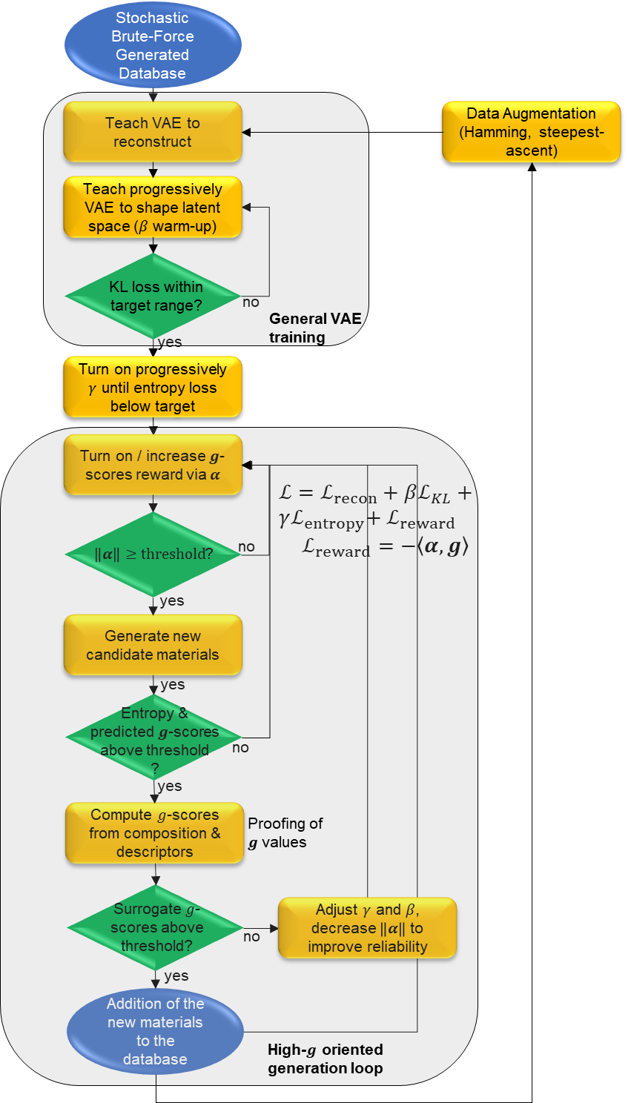
Figure 36: CVAE Learning & Generation Flowchart
This flowchart summarizes the process that was implemented to generate new alloys using the CVAE: (i) ensure reconstruction (ii) $β$ warm-up to implement the KL loss (iii) $γ$ warm-up to implement an entropy loss (iv) implementation of a linear reward depending on the $g$-scores (v) generation loop to generate candidates; these are saved if surrogates confirm their $g$-scores fulfill the requirements; losses are adapted if the CVAE failed to make decent predictions (vi) the new total dataset is enriched with Hamming filling and simplex steepest-ascent method, and used as a new training database for the CVAE.

Ward Linkage Clustering and Medoid Selection
Hierarchical clustering provides a principled way to group similar compositions without prespecifying cluster count. each alloy is represented by its normalized composition vector (i.e. the CLR‐encoded atomic fractions) and applied Ward’s linkage criterion, which at each step merges the pair of clusters whose union minimizes the increase in total within‐cluster variance. This variance‐minimizing property makes Ward clustering especially well‐suited to compositional data, where Euclidean distances between CLR‐vectors reflect geodesic separations on the simplex.
The stoichiometric strings were first parsed into numerical vectors, and a complete-linkage hierarchical clustering was performed to obtain the linkage matrix $Z$. Discrete clusters were then extracted by cutting the dendrogram at a fixed Euclidean distance threshold of 0.25 in CLR space, selected empirically to yield approximately a few thousand clusters. At this cut level, each cluster consists of compositions that differ only by small perturbations in one or two elemental fractions.
Within each cluster, a single representative (the medoid) was selected, defined as the composition with the minimal average Euclidean distance to all other members. In contrast to the centroid, which may not correspond to a chemically valid composition, the medoid is guaranteed to coincide with an observed alloy, thereby preserving interpretability. Medoid selection was implemented by computing the pairwise distance matrix for each cluster and choosing the index with the smallest row-sum of distances.
This two-step procedure – Ward linkage followed by medoid extraction – reduced the CVAE-enriched candidate set from approximately 15 000 raw outputs to around 5 000 unique representatives. By collapsing locally dense regions of composition space into single exemplars, redundancy was eliminated while maximizing diversity. The resulting dataset preserves both extreme and intermediate chemistries and provides a streamlined foundation for subsequent Pareto-front analysis and comparative visualization.

Pareto Front Computation and Compression
After medoid reduction, the refined CVAE set was merged with the brute-force search results, established superalloy reference databases, and the additional compositions generated through gradient-based optimization. To identify the most promising candidates under multi-objective criteria, the Pareto frontier was computed, defined as the set of alloys for which no other composition in the dataset simultaneously achieves superior values across all ten performance scores.
Algorithmically, an alloy is marked as nondominated if no other alloy achieves scores that are greater than or equal in all objectives $g_{i}$, with at least one score being strictly greater. This standard Pareto-filtering procedure requires pairwise comparisons across all candidates, but remains computationally tractable for datasets of a few thousand entries. The resulting frontier isolates compositions that offer an optimal balance among strength, ductility, density, melting point, oxidation resistance, and the other targeted properties, without sacrificing one objective to improve another.
The Pareto front plays two complementary roles: it reduces the combined dataset to a high-performing core, and it preserves diversity by ensuring that no two nondominated alloys dominate one another. However, the initial frontier remained large, comprising several thousand nondominated compositions, which hampers interpretability and visualization. To further streamline the dataset for human analysis, a secondary hierarchical clustering using Ward’s linkage was applied with a more restrictive Euclidean distance threshold. As before, medoid extraction within each cluster was used to identify representative compositions, substantially reducing redundancy while retaining diversity in alloy chemistries.
This final compression step markedly reduced the Pareto set from several thousand alloys to a concise yet representative set of a few hundred medoids. The resulting compressed Pareto front serves multiple crucial purposes: it offers a clear and accessible summary suitable for detailed analysis by domain experts; it enables straightforward visualization and exploration of alloy performance trade-offs through Ashby-style property charts; and it ensures the elimination of duplicate and near-duplicate compositions, enhancing interpretability.
In sum, this two-stage clustering and compression strategy, enhanced by gradient-based optimization approaches, effectively synthesized the comprehensive alloy exploration into a practical, interpretable shortlist. The selected candidates robustly represent the explored compositional diversity, highlighting optimal balances among multiple, competing material properties. This refined set provides a focused basis for future experimental validation and deeper materials discovery investigations.

Ashby Chart Visualization and Materials Selection
To contextualize the refined and compressed Pareto‐front alloys within established material landscapes, a suite of detailed Ashby‐style property charts is generated. Each chart juxtaposes pairs of critical material properties, including density versus melting point (Figure 39), shear modulus versus bulk modulus (Figure 40), Young’s modulus versus density (Figure 37), creep resistance versus formation energy (Figure 41), and high‐temperature oxidation rate versus melting point (Figure 38).
The visualization process involved plotting alloys with distinct marker shapes and colors, systematically encoding both their provenance and compositional cluster identity. Marker shapes explicitly indicated the alloy’s generation method – square for brute‐force enumeration (“Brute Force HEA”), diamond for generative models (“Generative CVAE”), pentagon for those refined through combined Hamming and gradient‐based stoichiometric augmentation (“Hamming & Gradient Augmentation”), star for simplex steepest-ascent optimization (“Annealing”), and circles for legacy Ni-based superalloys (“Classic superalloys”). Colors were assigned based on hierarchical Ward linkage clustering results, with each cluster succinctly labeled using a shortened formula notation (~Fe-Cr-Al), clearly highlighting the dominant elemental constituents.
The simplified cluster labeling strategy improved interpretability by focusing on prominent chemical components. It is implemented by filtering elements with fractional contributions below a predefined threshold (5%), thereby providing concise, meaningful cluster identifiers that enhance quick visual recognition on the Ashby charts.
These Ashby‐style visualizations serve multiple strategic purposes. Firstly, they allow rapid identification of property‐space domains where generative methods, particularly those augmented with gradient-based optimization, extend the frontiers beyond classical superalloys and brute‐force generated alloys, highlighting genuinely novel performance trade‐offs. Secondly, overlaying datasets from different origins clearly illustrates whether AI‐generated candidates merely replicate known alloys or distinctly populate previously unexplored regions of the alloy composition space. Lastly, the dual encoding scheme (shape and color) simplifies the experimental selection process, enabling immediate identification of candidate alloys tailored to specific application requirements, such as alloys exhibiting high stiffness combined with low density, or those offering high melting points with minimal supply risks.
Ultimately, these Ashby charts act simultaneously as diagnostic tools, evaluating the exploration efficacy of generative and optimization methods, and as practical decision‐support aids for experimental alloy selection. They translate complex, multi-dimensional property scores into intuitive two‐dimensional visual spaces, facilitating efficient prioritization and experimental validation of promising alloy candidates.

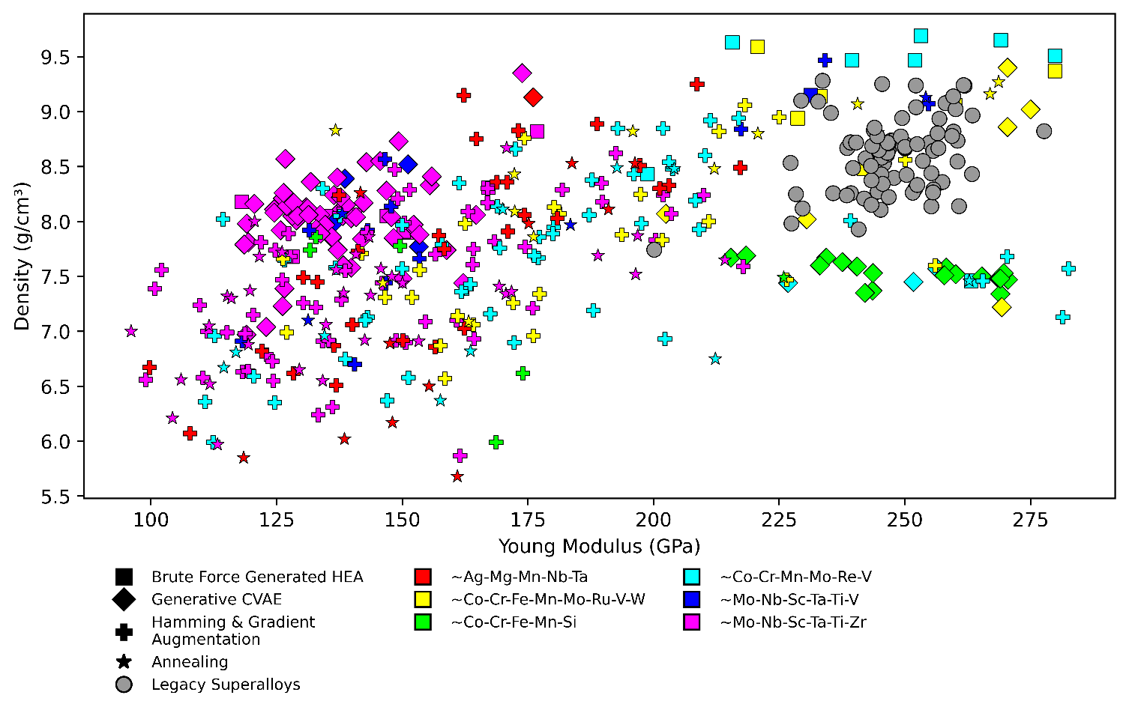

Figure 37 : Young’s Modulus vs. Density
Ashby diagram representing the trade-off between Young's modulus and density for candidate alloys. Alloys are distinguished by origin: squares for brute-force generated high-entropy alloys (HEAs), diamonds for conditional variational autoencoder (CVAE)-generated HEAs, crosses for alloys refined through combined Hamming and gradient-based augmentation, stars for alloys optimized via simplex steepest-ascent (annealing), and circles for legacy Ni-based superalloys. Clusters, indicated by distinct colors and abbreviated chemical labels, highlight prominent compositional families. The generative methods notably identify alloys with competitive stiffness-to-weight ratios, extending beyond traditional alloy domains and suggesting promising new lightweight structural materials.

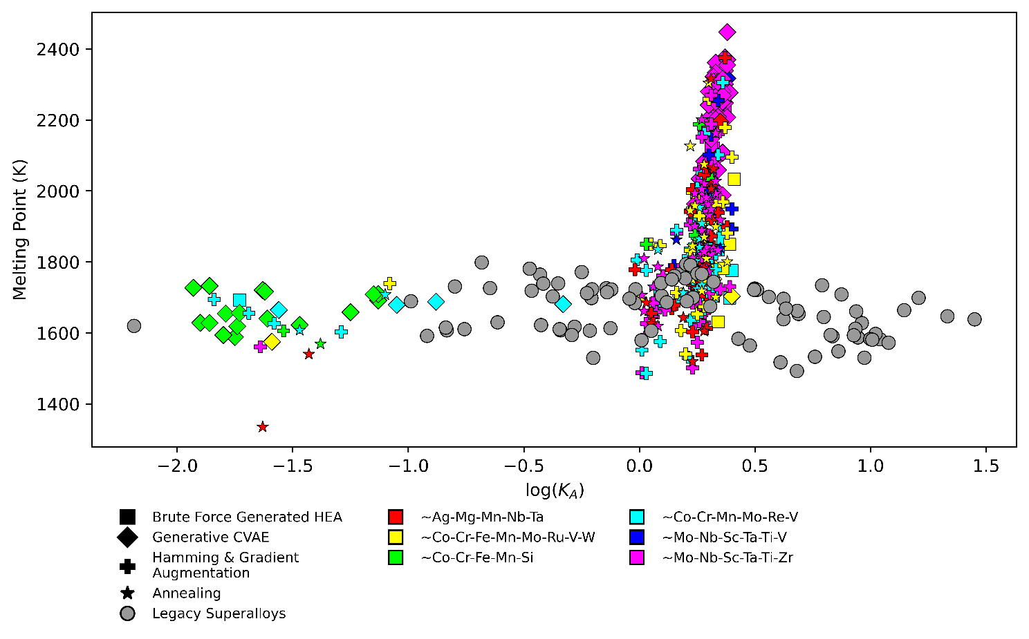

Figure 38: High-Temperature Oxidation Constant ($\log\left(K_{A}\right)$​) vs. Melting Point
Ashby chart illustrating the relationship between high-temperature oxidation rates ($\log\left(K_{A}\right)$)​ and melting points for the alloy candidates. Marker shapes denote alloy provenance, as described in Figure 37. The prominent vertical cluster indicates alloys with moderate oxidation resistance but exceptionally high melting points, primarily generated through CVAE and augmented gradient methods. Notably, generative alloys (diamonds) systematically populate regions characterized by superior melting points coupled with advantageous oxidation profiles, underscoring the relevance of the approach for high-temperature applications.

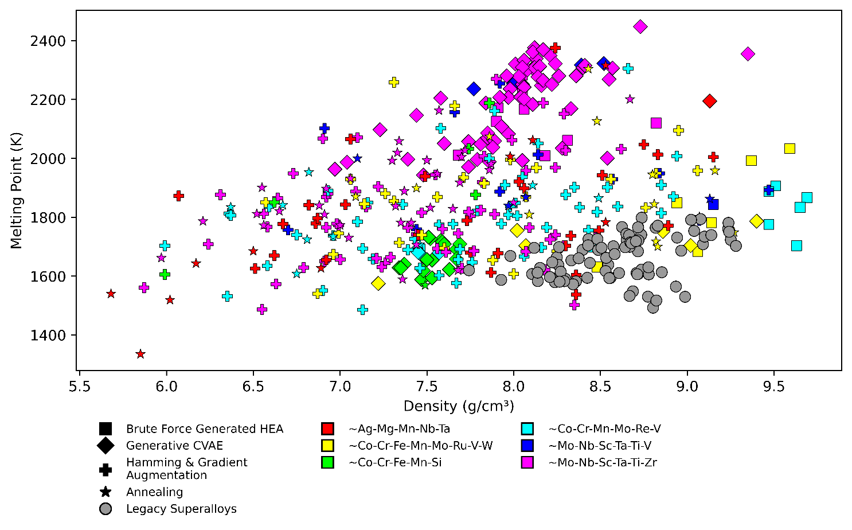

Figure 39: Density vs. Melting Point
Ashby diagram depicting density against melting point, critical properties for aerospace and energy applications. Markers reflect the alloy generation methodology. Generative and gradient-optimized alloys (diamonds, crosses, stars) occupy high-performance domains characterized by elevated melting temperatures with moderate-to-low densities. These generative compositions consistently exceed the melting points observed in classical superalloys, indicating novel alloys with enhanced thermostructural capabilities and potentially lighter-weight solutions for demanding applications.

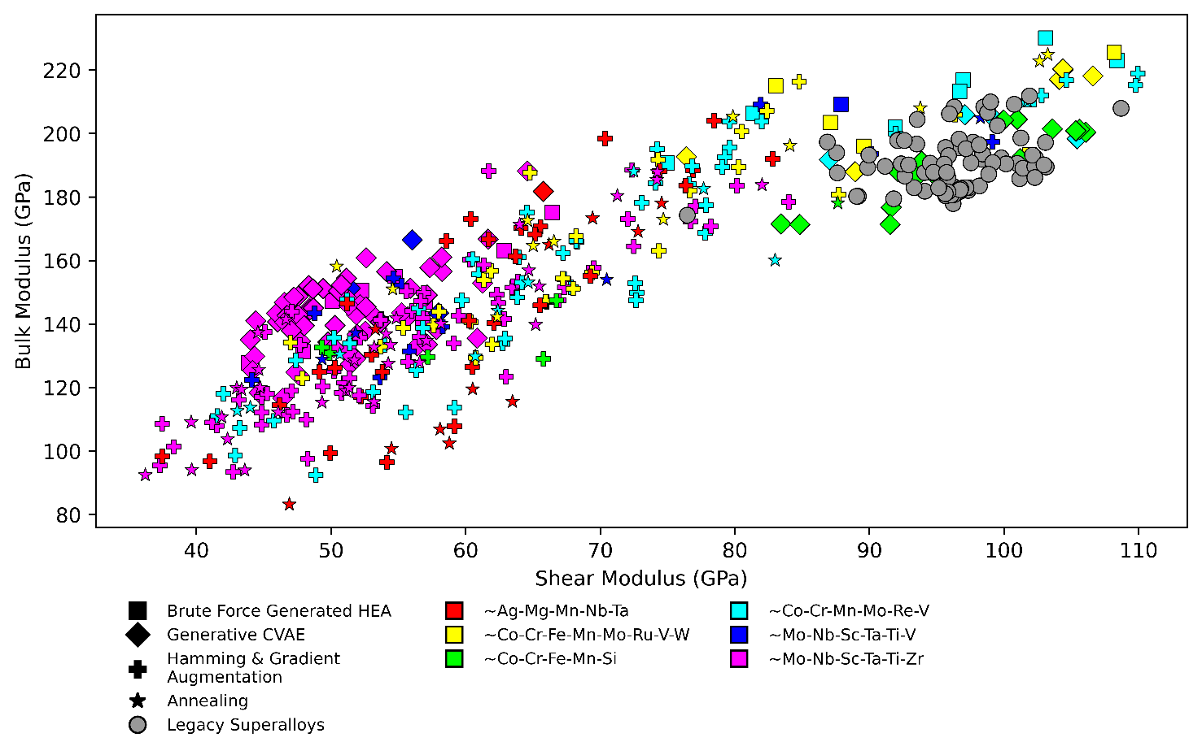

Figure 40: Shear Modulus vs. Bulk Modulus
Property space showing the relationship between shear and bulk moduli of candidate alloys. Marker shapes indicate alloy origin, while colors denote distinct compositional clusters. The generative CVAE and gradient-based alloys expand the known trade-offs while abiding by the specified $G/B$ range (Pugh criteria), notably populating regions with lower shear & bulk moduli compared to legacy alloys. However, some of them reach high-modulus values which suggests significant mechanical robustness and potential suitability for applications demanding exceptional strength and structural integrity under multidirectional loading conditions.

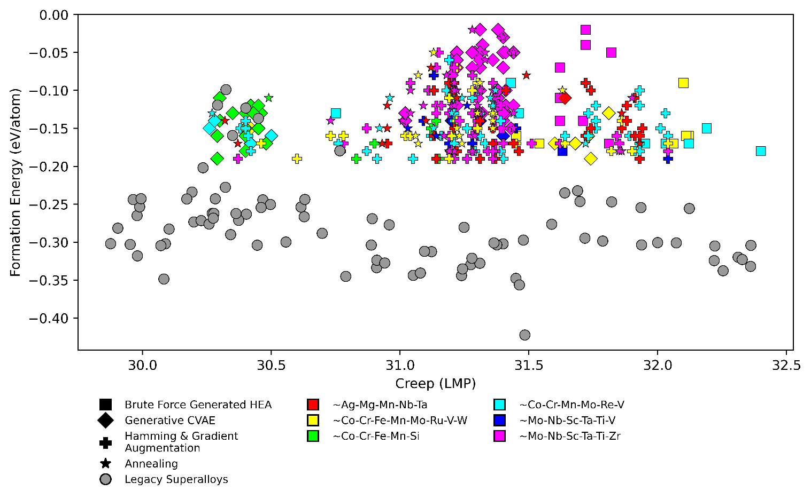
Figure 41: Creep Resistance (LMP) vs. Formation Energy (eV/atom)
Ashby-style chart illustrating the interplay between creep resistance (expressed as Larson-Miller Parameter, LMP) and formation energy, crucial metrics for high-temperature stability and the prevention of formation of intermetallics. Legacy superalloys predominantly feature favorable low formation energies but vary widely in creep resistance. Generative and optimized alloys notably populate upper regions of the creep-resistance domain, revealing compositions that simultaneously maintain desirable formation energetics and enhanced creep performance, thus highlighting significant potential for high-temperature structural applications.

Analysis of the Pareto Front & Selection
In this section, the objective is to extract, in an objective and reproducible manner, the compositional criteria that distinguish the most promising high-entropy superalloys (HESA) generated by the CVAE pipeline. The goals are twofold:
- Quantify the individual and synergistic influence of each element (or combination of elements) on critical performance metrics (e.g. melting temperature, creep resistance, oxidation resistance).
- Formulate scientifically grounded recipes – “typical compositions” that maximize targeted properties – by linking statistical findings to established physical mechanisms (solidification behavior, solution-hardening, oxide-scale formation, diffusion-controlled creep).
To achieve these goals, data-science techniques specifically adapted to compositional materials datasets are employed. This approach allows to navigate a high-dimensional design space of thousands of candidate alloys, identify coherent “families” of compositions, and draw conclusions that are both robust (statistically significant) and physically interpretable.
Not all predicted quantities contribute equally to a materials-design decision. Accordingly, a subset of properties is selected that (i) are critical for high-temperature structural performance and (ii) exhibit low mutual correlation, thereby capturing complementary aspects of alloy behavior. It is presented on Table 3.

Property | Symbol | Rationale
Melting point | $T_{m}$(K) | Fundamental limit for service temperature.
Creep resistance | LMP | Dimensionless Larson–Miller parameter: direct measure of time-to-failure at stress.
Oxidation resistance | $\log{K_{A}}$ | Kinetic constant for oxide-scale growth: lower values indicate slower oxidation.
Density | $ρ$ | Mass efficiency: crucial for applications where weight matters (aerospace, turbines).
Bulk modulus | $B$ (GPa) | Resistance to volumetric compression: correlates with high-temperature stiffness.
Shear modulus | $G$ (GPa) | Resistance to shear deformation: relates to hardness and yield strength.
Pugh ratio | $$G/B$$ | Ductility indicator: $G/B<0.5$ implies ductile behavior; $G/B>0.5$ indicates brittleness.
Table 3: Set of Physical Properties Retained to Analyze the Pareto Front

Young’s modulus ($E$) – which is derivable from $B$ and $G$ – is omitted to avoid redundancy. Other quantities (formation energy, decomposition energy, atomic-size mismatch, valence electron concentration, $Ω$-parameter) are valuable for microstructural or thermodynamic analyses but lie outside the immediate scope of high-temperature mechanical and environmental performance.

Analysis of the Correlations between Elements in the Pareto Front
A key challenge in compositional materials science is understanding how specific elements – or groups of elements – synergistically contribute to desired properties. A central question arises: can combinations of elements that consistently yield superior high-temperature performance in high-entropy superalloys (HESA) be identified in a systematic manner? Addressing this requires quantifying both the frequency and the strength of elemental co-occurrence within the Pareto-optimal compositions.
To this end, a correlation network is constructed using the CLR-transformed compositions of the alloys located on the Pareto front. This network visualizes pairwise correlations (Pearson coefficient, $\left|r\right|$) between elements, effectively highlighting element pairs whose proportions tend to rise and fall together (positive correlations) or inversely vary (negative correlations) across high-performing alloys. Representing these relationships graphically clarifies which combinations are favored, suggesting underlying physical mechanisms such as solution strengthening, optimized solidification pathways, or enhanced oxidation resistance through compatible oxide-scale formation.
Figure 42 presents this correlation network explicitly. Nodes represent individual elements, scaled according to their mean atomic fraction within Pareto-optimal compositions. Edges connect pairs of elements whose correlation coefficients are significant ($\left|r\right|≥0.3$, and weaker associations at $\left|r\right|≥0.25$ in grey). Edge thickness directly reflects the strength of these correlations. Elements strongly interconnected – those with three or more robust associations ($\left|r\right|≥0.3$) – are indicated by a navy-blue outline, signifying their centrality to successful alloy formulations.
This visualization underscores key elemental clusters and central players (notably elements positioned within the inner circle, excluding Sn which is scarce and potentially anomalous). Identifying such core groups and combining it with the analysis performed on the role of elements in physical properties (Figure 34 and Figure 35) provides insights into the compositional strategies most frequently employed by Pareto-optimal HESAs, thereby guiding rational alloy design with statistically supported, physically meaningful relationships.
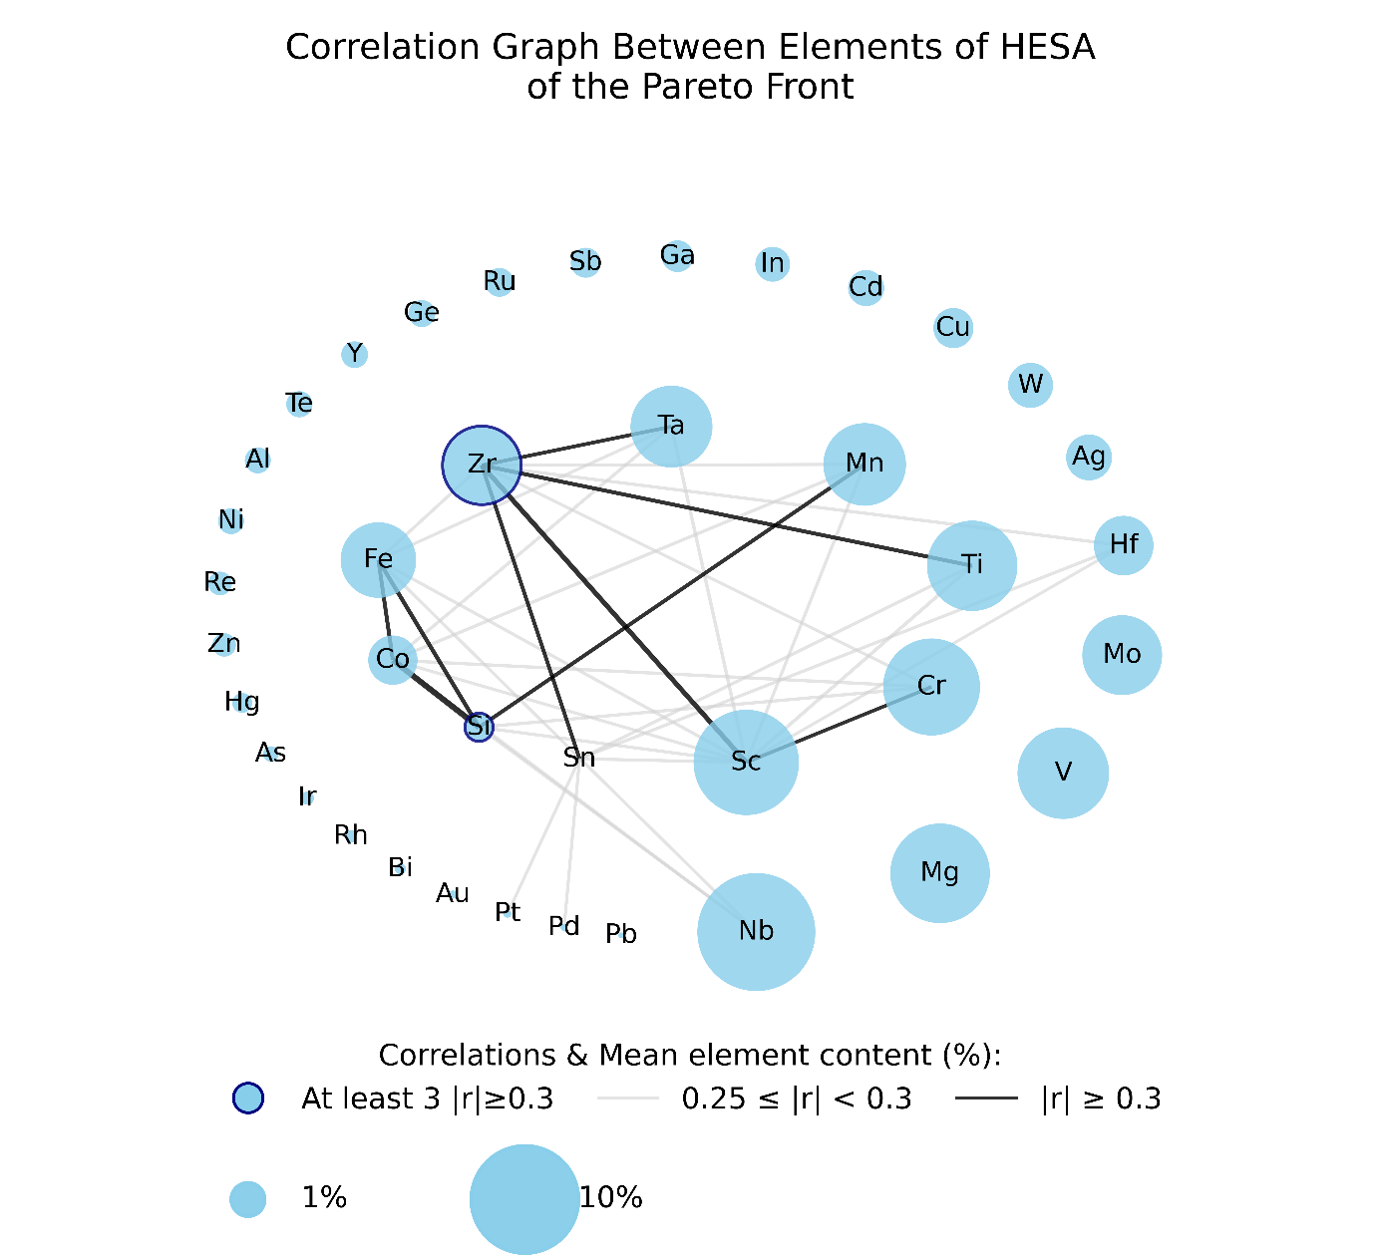
Figure 42: Correlation Network of Elemental Compositions (CLR) on the HESA Pareto Front.
Each node denotes a chemical element, with its area proportional to the element’s mean atomic fraction across all Pareto‐optimal alloys (reference circles: 1% and 10% mean content, as shown in the legend). Edges join pairs of elements whose Pearson correlation coefficient satisfies $\left|r\right|≥0.3$ – and in light grey pairs whose correlation coefficient satisfies $\left|r\right|≥0.25$; their thickness scales linearly with $\left|r\right|$, so that thicker bonds indicate stronger positive or negative correlations. A node bound with at least 3 “strong” edges ($\left|r\right|≥0.3$) is highlighted with a navy-blue ring.

This graph reveals the main successful combination of elements that were observed, as well as their individual frequency, shedding light of their importance and the clusters identified in the Pareto front.

Ward Clustering on CLR-Transformed Compositions and Analysis
After centering and log-ratio transforming the compositional data into the matrix.
$$Z_{CLR}={\left[z_{ij}\right]}_{m×n}∈R^{m×n}$$ | $$( STYLEREF 1 \backslash s 4 SEQ Équation \backslash * ARABIC \backslash s 1 7)$$
With $n=39$ being the number of elements, and $m$ the number of alloys in the selection. A clustering based on Ward linkage method is performed on the selection of candidates into $K$ discrete “chemical families”. The Ward linkage algorithm builds the $K$ clusters by aggregating pairs of clusters in a way that minimizes the increase of the within-cluster inertia (or variance). The total within-cluster sum of squares (WCSS) is a decreasing function of the number of clusters (see Figure 43), and a balance has to be found between sparsity (limited number of clusters) and “reasonable” clustering (limited WCSS). The elbow point – where additional clusters yield only marginal WCSS reduction – indicates a natural segmentation of the composition space.
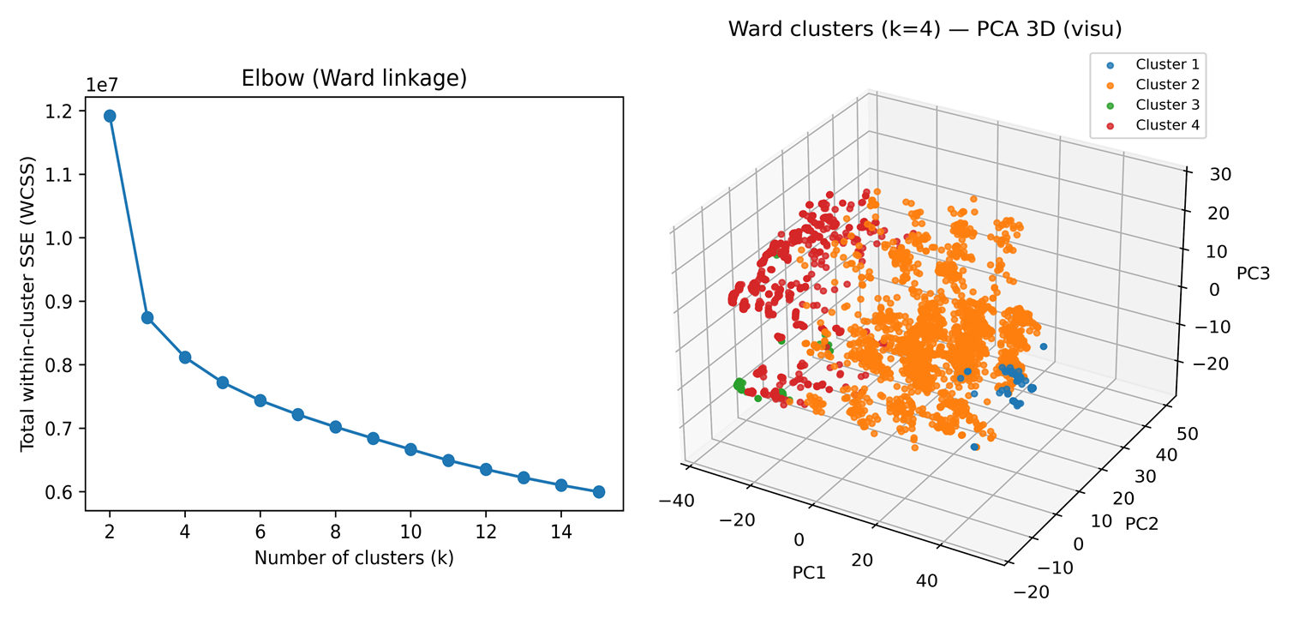
Figure 43 : Choice of $K$ in the Ward Clustering Method
The graph on the left edge shows the Within-Cluster Sum of Squares (WCSS), a classic metric to define the best value for $K$ in $K$-mean clustering. This graph shows a significant gain until $K=4$, then the decrease of WCSS slows down: this value is retained to perform the clustering.
The 3D graph on the right edge represents the 4 clusters in the latent space defined by the 3 first principal components PC1, PC2 and PC3.

To characterize each family quantitatively, cluster-wise statistics for all seven selected physical properties $\left\{T_{m},LMP, \log{K_{A}},ρ,K,G,G/B\right\}$ are computed. For cluster $k$, the following quantities are reported:
- Mean
$$\overline{y_{k,j}}=\frac{1}{\left|C_{k}\right|}\sum_{i∈C_{k}}{y_{i,j}}$$ | $$( STYLEREF 1 \backslash s 4 SEQ Équation \backslash * ARABIC \backslash s 1 8)$$
Where $y_{i,j}$ is the $j$-th physical property of alloy $i$.
- Standard deviation
$$s_{k,j}=\sqrt{\frac{1}{\left|C_{k}\right|-1}\sum_{i∈C_{k}}{{\left(y_{i,j}-\overline{y_{k,j}}\right)}^{2}}}$$ | $$( STYLEREF 1 \backslash s 4 SEQ Équation \backslash * ARABIC \backslash s 1 9)$$
This denominator $\left|C_{k}\right|-1$ ensures an unbiased estimate of the true population variance.
By comparing these summaries across clusters, it becomes possible to draw clear contrasts: one family may exhibit the highest average LMP with low variance, indicating robust creep resistance, whereas another may display outstanding oxidation resistance but a lower melting point. These quantitative descriptors are summarized in Figure 44, which reports, for each of the four clusters, the mean and standard deviation of the seven key properties: melting point, creep resistance, high-temperature oxidation, density, bulk modulus, shear modulus, Pugh ratio. Together with the compositional analysis above, this statistical characterization turns an unwieldy set of thousands of CVAE-generated candidates into a manageable palette of chemically meaningful alloy families, each with a clear expectation of physical behavior.
In summary, the combined pipeline CLR transform → Ward Clustering → property statistics will hopefully transform an unwieldy set of thousands of CVAE-generated candidates into a more manageable palette of chemically meaningful recipes, each accompanied by statistically expectations of physical behavior.

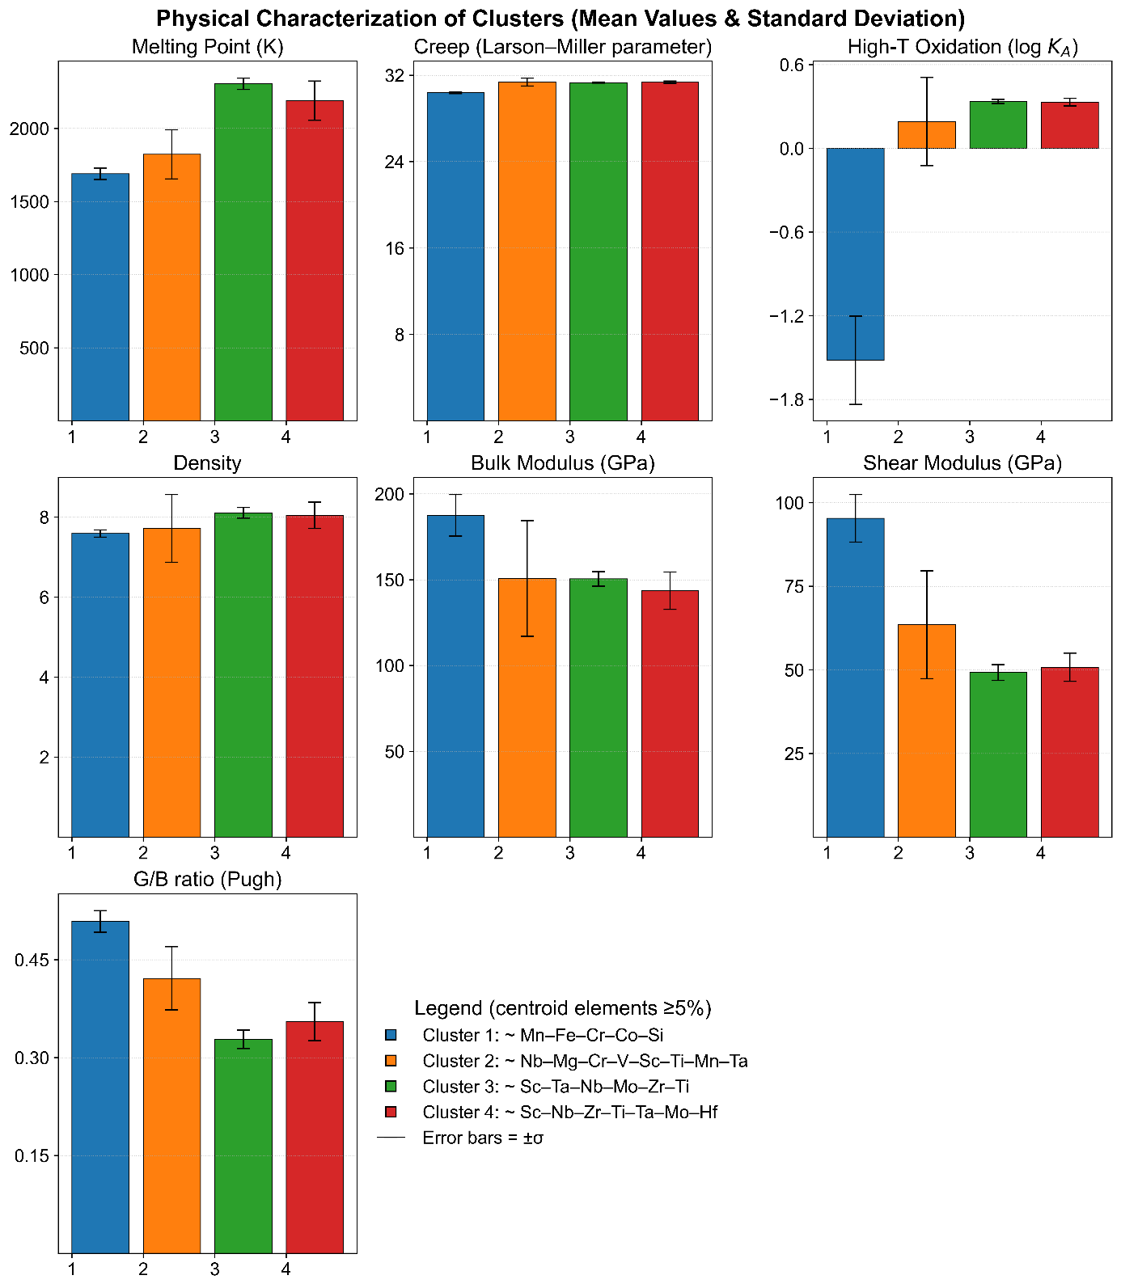
Figure 44 : Physical Characterization of Clusters (Mean Value & Standard Deviation)
Physical characterization of the 4 clusters that were defined through Ward clustering, by providing the average value and standard deviation within each cluster of the physical quantities mentioned above. This shows that while alloys belonging to the green & red clusters reach the highest melting point, alloys from the blue cluster are promising, regarding their resistance to high-temperature oxidation and bulk & shear moduli, or density. The variations within the cluster do not question the rankings vs physical properties.
The clusters are chemically roughly described by the composition of their centroid (summarized as the list of elements with a content over 5% in the legend).

Bibliography
1. Chen, S. et al. Extraordinary creep resistance in a non-equiatomic high-entropy alloy from the optimum solid-solution strengthening and stress-assisted prec ipitation process. Acta Materialia 244, 118600 (2023).
2. Yang, T. et al. Control of Nanoscale Precipitation and Elimination of Intermediate-Temperature Embrittlement in Multicomponent High-Entropy Alloys. SSRN Journal https://doi.org/10.2139/ssrn.3477998 (2019) doi:10.2139/ssrn.3477998.
3. Singh, P. et al. Theory-guided design of duplex-phase multi-principal-element alloys. Acta Materialia 272, 119952 (2024).
4. Ezatpour, H. R. & Torabi-Parizi, M. Effect of Ti content on achieving development of mechanical properties and wear resistance of CoCrFeNiMoTix high entropy alloy. Journal of Materials Research and Technology 29, 5447–5463 (2024).
5. Zhang, L., Li, H. & Xiao, Z. Criteria of predicting phase formation for MSi2-Type High-Entropy refractory metal silicides. Materials & Design 231, 112060 (2023).
6. Jeong, I.-S. & Lee, J.-H. Single-phase lightweight high-entropy alloys with enhanced mechanical properties. Materials & Design 227, 111709 (2023).
7. Zhang, Y., Zhou, Y. J., Lin, J. P., Chen, G. L. & Liaw, P. K. Solid-Solution Phase Formation Rules for Multi-component Alloys. Advanced Engineering Materials 10, 534–538 (2008).
8. Feng, R., Liaw, P. K., Gao, M. C. & Widom, M. First-principles prediction of high-entropy-alloy stability. npj Comput Mater 3, (2017).
9. Zhang, W., Yan, D., Lu, W. & Li, Z. Carbon and nitrogen co-doping enhances phase stability and mechanical properties of a metastable high-entropy alloy. Journal of Alloys and Compounds 831, 154799 (2020).
10. Miracle, D. B. & Senkov, O. N. A critical review of high entropy alloys and related concepts. Acta Materialia 122, 448–511 (2017).
11. Pickering, E. J. & Jones, N. G. High-entropy alloys: a critical assessment of their founding principles and future prospects. International Materials Reviews 61, 183–202 (2016).
12. Tsai, K.-Y., Tsai, M.-H. & Yeh, J.-W. Sluggish diffusion in Co–Cr–Fe–Mn–Ni high-entropy alloys. Acta Materialia 61, 4887–4897 (2013).
13. Gao, Michael C. High-Entropy Alloys: Fundamentals and Applications. (Springer, 2018).
14. Jain, A. & Bligaard, T. Atomic-position independent descriptor for machine learning of material properties. Phys. Rev. B 98, (2018).
15. Goodall, R. E. A. & Lee, A. A. Predicting materials properties without crystal structure: deep representation learning from stoichiometry. Nat Commun 11, (2020).
16. Janet, J. P. & Kulik, H. J. Resolving Transition Metal Chemical Space: Feature Selection for Machine Learning and Structure–Property Relationships. J. Phys. Chem. A 121, 8939–8954 (2017).
17. Isayev, O. et al. Universal fragment descriptors for predicting properties of inorganic crystals. Nat Commun 8, (2017).
18. Choudhary, K., DeCost, B. & Tavazza, F. Machine learning with force-field-inspired descriptors for materials: Fast screening and mapping energy landscape. Phys. Rev. Materials 2, (2018).
19. Karamad, M. et al. Orbital graph convolutional neural network for material property prediction. Phys. Rev. Materials 4, (2020).
20. Tian, X. et al. Atomistic graph networks for experimental materials property prediction. (2021).
21. A., V. et al. Learning Atoms from Crystal Structure. (2024).
22. Zhang, R., Seth, S. & Cumby, J. New generalized crystallographic descriptors for structural machine learning. Acta Crystallogr A Found Adv 77, C476–C476 (2021).
23. Electronegativity. Wikipedia (2025).
24. Lang, P. F. Revisiting Electronegativity and Electronegativity Scales. J. Chem. Educ. 102, 424–429 (2025).
25. Ramprasad, R., Batra, R., Pilania, G., Mannodi-Kanakkithodi, A. & Kim, C. Machine learning in materials informatics: recent applications and prospects. npj Computational Materials 3, 54 (2017).
26. Allahyari, Z. & Oganov, A. R. Nonempirical Definition of the Mendeleev Numbers: Organizing the Chemical Space. J. Phys. Chem. C 124, 23867–23878 (2020).
27. Chen, W. et al. A map of single-phase high-entropy alloys. Nature Communications 14, 2856 (2023).
28. Nutor, R. K. et al. Phase Selection, Lattice Distortions, and Mechanical Properties in High-Entropy Alloys. Advanced Engineering Materials 22, 2000466 (2020).
29. Tan, L. et al. Design Principles of low-activation High Entropy Alloys. Journal of Alloys and Compounds 907, 164526 (2022).
30. Chauhan, P., Chopra, S. & Thangaraju, S. Inter-Dependency Relationships in High-Entropy Alloys: Phase Stability Criteria. Advanced Engineering Materials 21, 1900251 (2019).
31. Nutor, R. K. et al. Phase Selection, Lattice Distortions, and Mechanical Properties in High-Entropy Alloys. Advanced Engineering Materials 22, 2000466 (2020).
32. Yang, X. & Zhang, Y. Prediction of high-entropy stabilized solid-solution in multi-component alloys. Materials Chemistry and Physics 132, 233–238 (2012).
33. Tan, L. et al. Design principles of low-activation high entropy alloys. Journal of Alloys and Compounds 907, 164526 (2022).
34. 5_Oxidation of pure metals.pdf.
35. Taylor, C. D. & Tossey, B. M. High temperature oxidation of corrosion resistant alloys from machine learning. npj Materials Degradation 5, 38 (2021).
36. Barrett, C. A. A Statistical Analysis of Elevated Temperature Gravimetric Cyclic Oxidation Data of 36 Ni- and Co-Base Superalloys Based on an Oxidation Attack Parameter. https://ntrs.nasa.gov/citations/19930008880 (1992).
37. Rozman, K. A., Detrois, M., Jablonski, P. D., Gao, M. C. & Hawk, J. A. Effect of Mn in CrCoFeNiMn high entropy alloy on creep performance.
38. Sun, Y. & Ni, J. Machine Learning Advances in High-Entropy Alloys: A Mini-Review. Entropy 26, (2024).
39. Guo, S., Ng, C., Lu, J. & Liu, C. T. Effect of valence electron concentration on stability of fcc or bcc phase in high entropy alloys. Journal of Applied Physics 109, 103505 (2011).
40. Zhang, Y. & Peng, W. jie. Microstructural control and properties optimization of high-entrop alloys. Procedia Engineering 27, 1169–1178 (2012).
41. Kamran, S., Chen, K. & Chen, L. Ab initio examination of ductility features of fcc metals. Phys. Rev. B 79, 024106 (2009).
42. Bennett, A. R., Lundstrøm, J., Chatterjee, S., Thaysen-Andersen, M. & Bojar, D. Compositional data analysis enables statistical rigor in comparative glycomics. Nature Communications 16, 795 (2025).
43. Molnar, C. Interpretable Machine Learning: A Guide for Making Black Box Models Explainable. (2025).
44. Sun, Y. J., Xiong, K., Li, Z. B., Zhang, S. M. & Mao, Y. First-Principles Study of Structural, Mechanical, and Thermodynamic Pr operties of Refractory Metals (Rh, Ir, W, Ta, Nb, Mo, Re, and Os). MSF 993, 1017–1030 (2020).
45. Wei, N. et al. First-principles study of the phase stability and the mechanical prope rties of W-Ta and W-Re alloys. AIP Advances 4, (2014).
46. Zheng, S. & Wang, S. First-Principles Design of Refractory High Entropy Alloy VMoNbTaW. Entropy 20, 965 (2018).
47. Hu, Y. L. et al. First-principle calculation investigation of NbMoTaW based refractory high entropy alloys. Journal of Alloys and Compounds 827, 153963 (2020).
48. Giese, S. et al. The Importance of Diffusivity and Partitioning Behavior of Solid Solut ion Strengthening Elements for the High Temperature Creep Strength of Ni-Base Superalloys. Metall Mater Trans A 51, 6195–6206 (2020).
49. Haußmann, L., ur Rehman, H. ur, Matschkal, D., Göken, M. & Neumeier, S. Solid Solution Strengthening of Mo, Re, Ta and W in Ni during High-Tem perature Creep. Metals 11, 1909 (2021).
50. Cao, C. M. et al. Creep behaviour and microstructural evolution of Alx CrMnFeCoNi high-entropy alloys. Materials Science and Technology 35, 1283–1290 (2019).
51. Smith, T. M. et al. Phase transformation strengthening of high-temperature superalloys. Nat Commun 7, (2016).
52. Srikanth, M., Annamalai, A. R., Muthuchamy, A. & Jen, C.-P. A Review of the Latest Developments in the Field of Refractory High-En tropy Alloys. Crystals 11, 612 (2021).
53. Tsao, T.-K., Yeh, A.-C., Kuo, C.-M. & Murakami, H. High Temperature Oxidation and Corrosion Properties of High Entropy Superalloys. Entropy 18, 62 (2016).
54. Dehury, R. K., Kumar, R., Joshi, Y. G. & Gupta, V. Elemental Influence on Oxidation Behaviour of Cantor‐Based and Refract ory High Entropy Alloys: A Critical Review. Adv Eng Mater 26, (2024).
55. Sun, A. et al. Fabrication, high-temperature mechanical behavior, and oxidation resis tance of high entropy alloys: A review. J. Micromech. Mol. Phys. 08, 99–122 (2023).
56. Liu, S. et al. Oxidation behaviors and mechanical properties of L12-strengthened high -entropy alloys at 700 ℃. Corrosion Science 206, 110499 (2022).
57. Yang, J.-J. et al. Improvement in oxidation behavior of Al0.2Co1.5CrFeNi1.5Ti0.3 high-ent ropy superalloys by minor Nb addition. Journal of Alloys and Compounds 825, 153983 (2020).
58. Gorr, B. et al. High-Temperature Oxidation Behavior of Refractory High-Entropy Alloys: Effect of Alloy Composition. Oxid Met 88, 339–349 (2017).
59. Tang, Z. et al. Rapid Experimental Screening of High‐Entropy Diborides for Superior Ox idation Resistance. Adv Funct Materials 34, (2023).
60. Liu, H., Liu, L. & Xin, C. Effect of alloying elements on the structure and mechanical properties of NbMoTaWX (X = Cr, V, Ti, Zr, and Hf) refractory high-entropy alloy s. AIP Advances 11, (2021).
61. Tseng, K.-K. et al. Effects of Mo, Nb, Ta, Ti, and Zr on Mechanical Properties of Equiatom ic Hf-Mo-Nb-Ta-Ti-Zr Alloys. Entropy 21, 15 (2018).
62. Tong, Y. et al. Influence of alloying elements on mechanical and electronic properties of NbMoTaWX (X = Cr, Zr, V, Hf and Re) refractory high entropy alloys. Intermetallics 126, 106928 (2020).
63. Nugraha, F., Aulia, M. F. & Achmad, T. L. Effect of Alloying Compositions on the Stacking Fault Energy and Elast icity of FeNiCrAlCo and FeNiCrAlCu: A First-principles Study for Fe-ba sed High Entropy Superalloy Design. E3S Web Conf. 543, 03009 (2024).
64. Wang, S. Q. & Ye, H. Q. First-Principles Studies on the Component Dependences of High-Entropy Alloys. AMR 338, 380–383 (2011).
65. Hillel, G. et al. Understanding the Role of the Constituting Elements of the AlCoCrFeNi High Entropy Alloy through the Investigation of Quaternary Alloys. Metals 10, 1275 (2020).
66. Song, Y. et al. Effects of co-alloying Al and Cu on the corrosion behavior and mechani cal properties of nanocrystalline FeCrNiCo high entropy alloys. Corrosion Science 213, 110983 (2023).
67. Liu, Y. et al. Mechanical properties of CrFeCoNiCux (0 ≤ x ≤ 0.3) H EAs from first-principles calculations. RSC Adv. 10, 41324–41331 (2020).
68. Wagner, C. et al. Effects of Cr/Ni ratio on physical properties of Cr-Mn-Fe-Co-Ni high-e ntropy alloys. Acta Materialia 227, 117693 (2022).
69. Expectation–maximization algorithm. Wikipedia (2025).
70. Sur, F. Introduction à l’apprentissage automatique.
71. Csiszár, I. \I\-Divergence Geometry of Probability Distributions and Minimization Problems. Annals of Probability 3, 146–158 (1975).
72. S. Kullback & R. A. Leibler. On Information and Sufficiency. The Annals of Mathematical Statistics 22, 79–86 (1951).
73. Information theory and statistics - Solomon Kullback.pdf.
74. Neyman, J. & Pearson, E. S. IX. On the problem of the most efficient tests of statistical hypotheses. Philosophical Transactions of the Royal Society of London. Series A, Containing Papers of a Mathematical or Physical Character 231, 289–337 (1997).
75. Kullback–Leibler divergence. Wikipedia (2025).
76. Kingma, D. P. & Welling, M. An Introduction to Variational Autoencoders. FNT in Machine Learning 12, 307–392 (2019).
77. Kingma, D. & Welling, M. Auto-Encoding Variational Bayes. ICLR (2013).
78. Zeng, C., Khan, Z. & Post, N. Data-efficient and interpretable inverse materials design using a disentangled variational autoencoder. AI & Materials https://doi.org/10.55092/aimat20250002 (2024) doi:10.55092/aimat20250002.
79. Lee, C.-Y., Jui, C.-Y., Yeh, A.-C., Chang, Y.-J. & Lee, W.-J. Inverse design of high entropy alloys using a deep interpretable scheme for materials attribution analysis. Journal of Alloys and Compounds 976, 173144 (2024).
80. Tung, Y. C., Debnath, A. & Reinhart, W. F. Evaluating generative models for inverse design of high-entropy refractory alloys. https://scholarsphere.psu.edu/resources/c2ae7ae3-9cbd-4d10-a6e5-6a8c29bf37c4 (2022).
81. Xu, Y. et al. Exploring Optimized Organic Fluorophore Search through Experimental Data-Driven Adaptive β-VAE. JACS Au 5, 3082–3091 (2025).
82. Sønderby, C., Raiko, T., Maaløe, L., Sønderby, S. & Winther, O. Ladder Variational Autoencoders. Arxiv (2016).
83. Pincus, R. Aitchison, J.: The Statistical Analysis of Compositional Data. Chapman and Hall, London - New York 1986, XII, 416 pp., £ 25,00. Biometrical Journal 30, 794–794 (1988).

