Appendix 4 Factors included in the final CLD on patients’ demand for low-value care
Core theme | Factors | Definition
Biomedical factors | Chronic problem | A persisting or reoccurring medical problem, symptom, or disease.
Biomedical factors | Salient health problem | A noticable or relevant health issue, symptom, or disease.
Biomedical factors | Severity of health problem | The intensity of the experienced health issue.
Cognitive bias | Anticipated regret aversion | A tendency to avoid possible regret in the future by demanding unnecessary care in the present.
Cognitive bias | Asymmetry of risks and benefits | A tendency to overestimate the benefits and underestimate the risks of low-value care treatments.
Cognitive bias | Confirmation bias | A tendency to seek or interpret medical information or care recommendations that correspond to their viewpoints, and disregard or dispute contradicting recommendations and information.
Cognitive bias | Imperative action bias | A tendency to feel obliged to act, because action is better than inaction.
Cognitive bias | Imperative knowledge bias | A tendency to gain more information related to their health status, because this is better than being ignorant.
Cognitive bias | Publication bias | A tendency of researchers or publishers to focus on the positive research results and to neglect or negative or non-significant results.
Cognitive bias | Risk aversion | A tendency of patients to avoid or reduce uncertainties, dangerous situations, and risks as much as possible.
Economic factors | Consumerism | The idea that healthcare is perceived as a consumption good and patients can, therefore, shop around by visiting various healthcare providers to receive their desired care.
Economic factors | Health insurance payments | Contributions that are paid to be insured for medical expenses.
Economic factors | Income abundance | Having a substantial amount of wealth or financial prosperity that can be spent on unnecessary treatments. For example, spending money on an unnecessary full body scan.
Economic factors | Marketing by media | Presenting information in such a manner that it generates profits for the presenting actor and causes patients to demand low-value care.
Emotions | Fear and anxiety | When patients are afraid of uncertainties, such as illnesses, overlooking potential diseases, or possible outcomes of diseases.
Emotions | Loss of control | To assert control over their situation by displaying an active role in their decision-making process.
Emotions | Perceived insecurity | Patients feel uncertain about their health status.
Interaction with the provider | Ability to act of provider | The possibility of the healthcare provider to provide care.
Interaction with the provider | Authority acceptance | Acknowledging and embracing recommendations and care provided by the healthcare provider
Interaction with the provider | Communication of uncertainty by providers | When healthcare providers discuss uncertainties with their patients related to the patient's experienced health problem or symptoms.
Interaction with the provider | Interaction with the provider | The process where patients and providers communicate with eachother.
Preferences and expectations | Patient expectations | When patients think or expect that their healthcare provider wants to povide care.
Interaction with the provider | Perception of integrity of providers | Perception of patients about the integrity of healthcare providers.
Interaction with the provider | Perception of medical competency | Perception of patients about the capacities of healthcare providers.
Interaction with the provider | Practice variation | Differences in recommendations of care by various healthcare providers
Preferences and expectations | Provider expectations | When healthcare providers think or expect that their patients want to receive care.
Interaction with the provider | Trust in the provider | The reliance and belief that patients have in their healthcare provider.
Knowledge-related factors | Demand of low-educated patients | When low-educated patients demand low-value care.
Knowledge-related factors | Health literacy | The ability of patients to comprehend medical or health-related information.
Knowledge-related factors | High education | Patients with a degree that is valued as above average.
Knowledge-related factors | Lack of evidence | When information about the harmfull or marginal effect of low-value care is absent or insufficient.
Knowledge-related factors | Not accepting the concept of overuse | Rejecting or questioning the credibility of evidence-based recommendations and overuse messaging to avoid low-value care interventions, such as overtreatment and overdiagnosis
Knowledge-related factors | Outspokenness | The assertiveness and vocallness of patients to demand low-value care.
Knowledge-related factors | Quality of distributed information | The quality of Information about treatments and services that is provided to patients.
Knowledge-related factors | Unawareness | Lacking realization and information that certain treatments have no or only marginal health benefits, and are possibly even harmful.
Preferences and expectations | Beliefs | Patients’ beliefs are formed by personal convictions, which function as cornerstones that shape patients’ attitudes, preferences, and expectations towards medical care. These beliefs tend to make patients susceptible to perceive low-value care as a default or necessary treatment, which causes these patients to demand low-value care
Socio-cultural factors | Experiences of social network | When relatives and acquaintances pressure or encourage patients to seek low-value care by sharing their personal observations or experiences.
Socio-cultural factors | Cultural background influence | The influence of foreign medical practices that influence patients to demand low-value care in the Netherlands
Socio-cultural factors | Entitlement to care | When patients consume unnecessary and excessive healthcare, because this is perceived as a right.
Socio-cultural factors | Practices | Medical-related customs or habits that are common for patients to receive care
Socio-cultural factors | Stage of life | Age- and life phase related factors that result in patients’ low-value care demand.
Dependent variable | Low-value care demand | When patients demand care that provides little to no health benefits and can be harmful to patients.

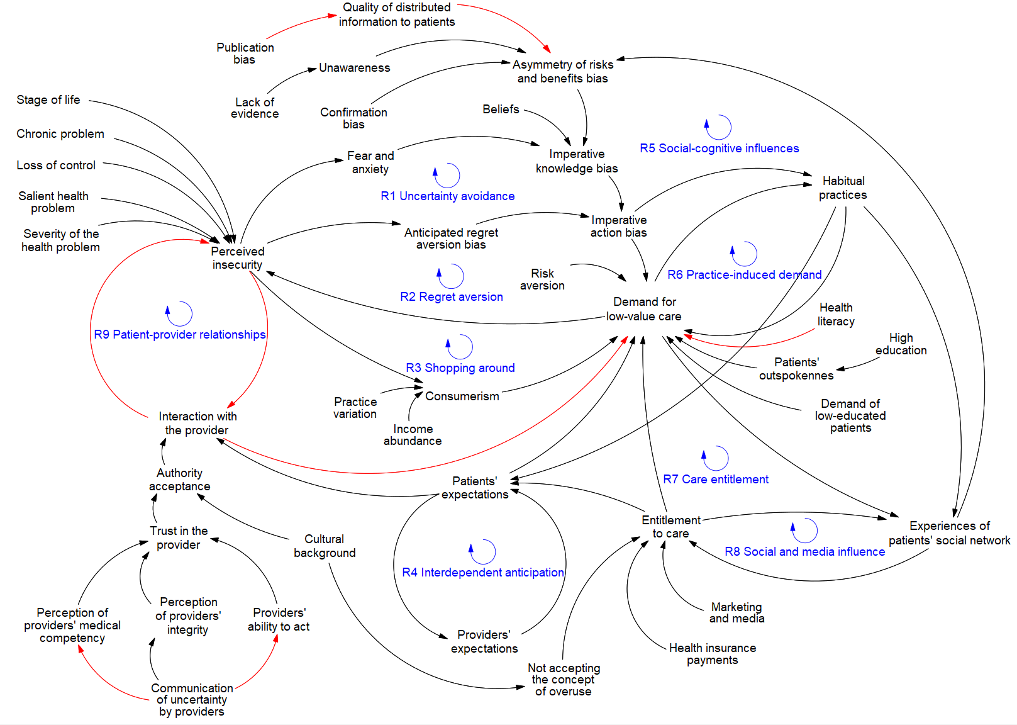
Appendix 4 Figure 1 - Final causal loop diagram on patients’ demand for low-value care

