Supporting information for “Low-noise X-ray PIN photodiodes made of perovskite single crystals by Solution-processed doped epitaxial growth”
Xin Wang¹*, Yubing Xu¹, Yuzhu Pan¹, Yuwei Li¹, Ji Xu¹, Jing Chen¹, Jun Wu¹, Qing Li¹, Xiaobing Zhang¹, Zhiwei Zhao¹, Elias E. Elemike², Damian C. Onwudiwe², Javed Akram³, Wei Lei*

¹Joint International Research Laboratory of Information Display and Visualization, School of Electronic Science and Engineering, Southeast University, Nanjing 210096, China
²Chemistry Department of North West University, South Africa
³COMSATS University Islamabad, Islamabad, Pakistan
E-mail: 230159424@seu.edu.cn, lw@seu.edu.cn

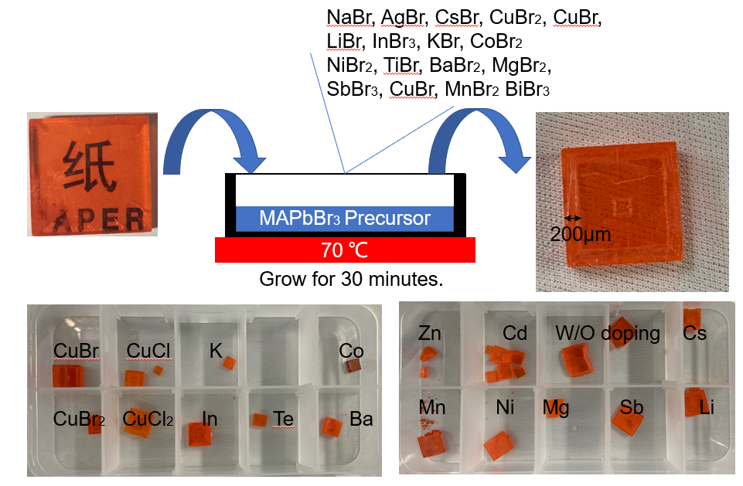
Figure S1. Process to grow doped MAPbBr₃ MHPSC with different dopants.

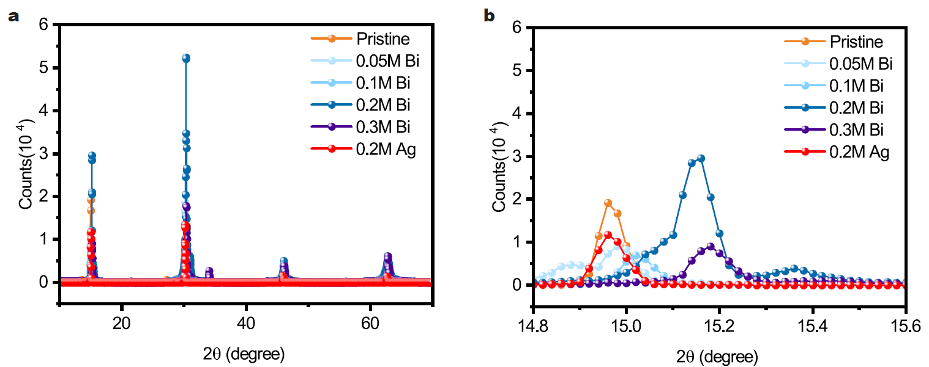
Figure S2. XRD data of the doped MAPbBr₃ MHPSCs wither different Bi concentration and Ag concentration.

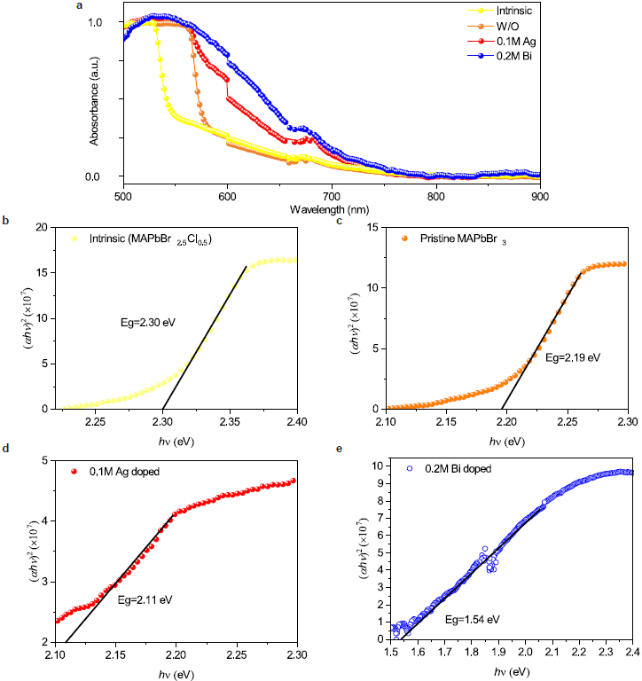
Figure S3. a, Absorption of MHPSCs including intrinsic layer, W/O doped MAPbBr₃, Ag doped MAPbBr₃, and Bi doped MAPbBr₃. b, Optical band gap estimation from absorption of intrinsic layer. c, Optical band gap estimation from absorption of pristine MAPbBr₃.d, Optical band gap estimation from absorption of Ag-doped MAPbBr₃ (0.1M). e, Optical band gap estimation from absorption of Bi-doped MAPbBr₃ (0.2M).

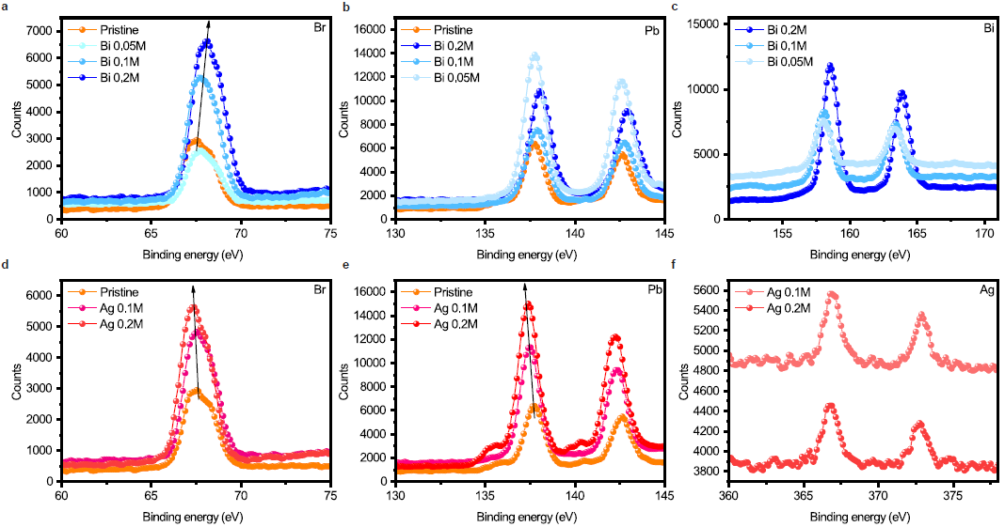
Figure S4. XPS results of the doped MAPbBr₃. a. Br binding energy from 60 eV to 70 eV in Bi doped MHPSC. b. Pb binding energy from 130 eV to 145 eV in Bi doped MHPSC. c. Bi binding energy from 152 eV to 171 eV. d. Br binding energy from 60 eV to 70 eV in Ag doped MHPSC. e. Pb binding energy from 130 eV to 145 eV in Bi doped MHPSC. f. Ag binding energy from 360 eV to 378 eV

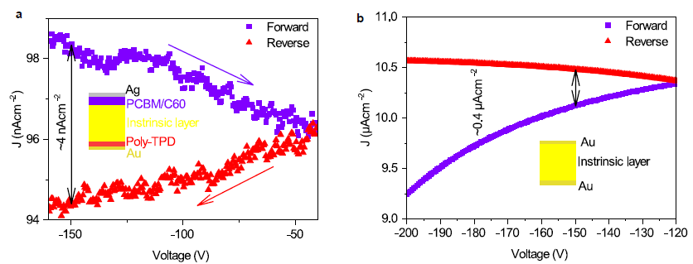
Figure S5. XPS results of the doped MAPbBr₃. a. Voltage bias scan from -160 V to -40 V of the spin-coated PIN photodiode (Ag/PCBM/C60/ MAPbBr_{2.5}Cl_{0.5}/poly-TPD/Au). b. Voltage bias scan from -200 V to -120 V, Au/MAPbBr_{2.5}Cl_{0.5}/Au.

The current-density-voltage hysteresis induced current density difference is ~4 nAcm⁻² and ~0.4μAcm⁻² under -150V bias for Ag/PCBM/C60/ MAPbBr_{2.5}Cl_{0.5}/poly-TPD/Au photodiode and Au/MAPbBr_{2.5}Cl_{0.5}/Au diode respectively.
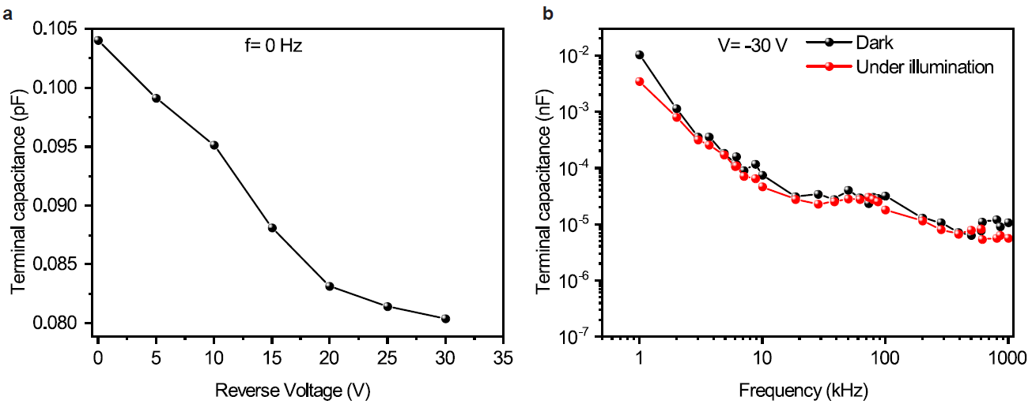
Figure S6. a, Terminal capacitance-voltage curve at 0 Hz. b. Terminal capacitance-frequency at -30 V.

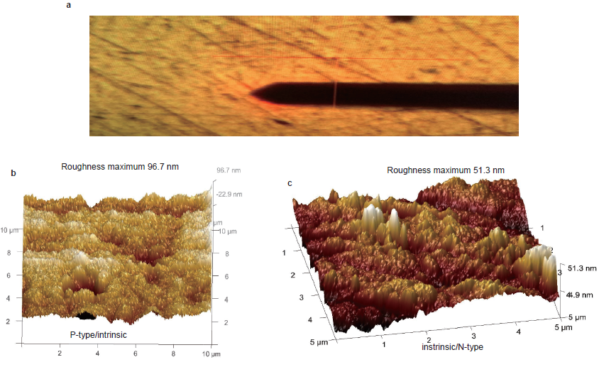
Figure S7. a, Optical photo of the sample in KPFM experiment. b. 3D roughness of the interfaces near n-type and intrinsic layers. c. 3D roughness of the interfaces near p-type and intrinsic layers.

To find the position of the interface in KPFM experiment, the colors of doped MAPbBr₃ and MAPbBr_{2.5}Cl_{0.5} MHPSCs are different as shown in Figure S6a. The left part in yellow color is MAPbBr_{2.5}Cl_{0.5} and the right part looks redder is doped MAPbBr₃.
In tapping mode, no clear interface could be found based on roughness as shown in Figure S6b and Figure s6c.
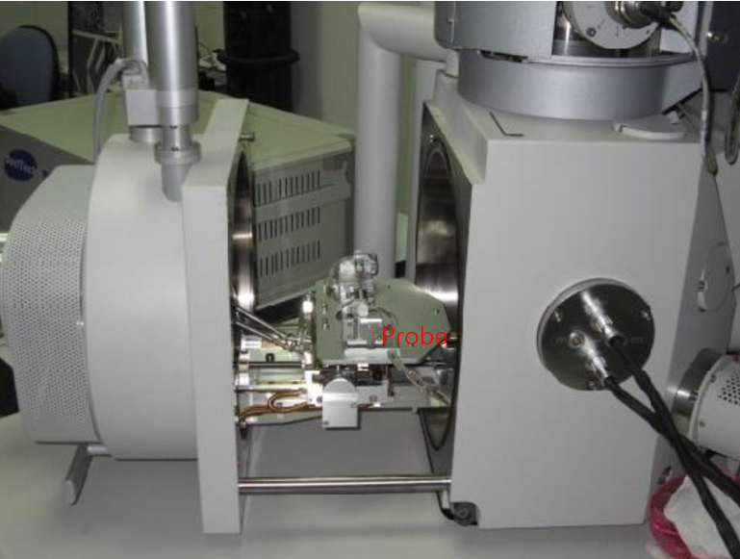
Figure S8. Illustration of the SCR measurements experiment in SEM cavity.

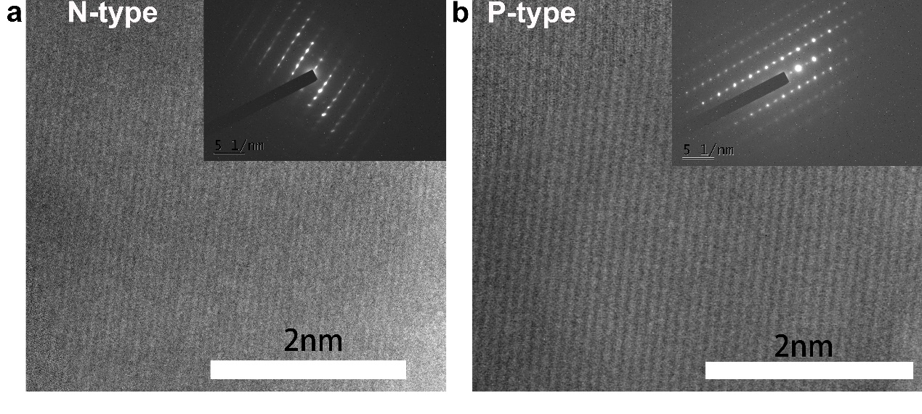
Figure S9. Typical HR-TEM photos and electron diffraction of the N-type and P-type layer.

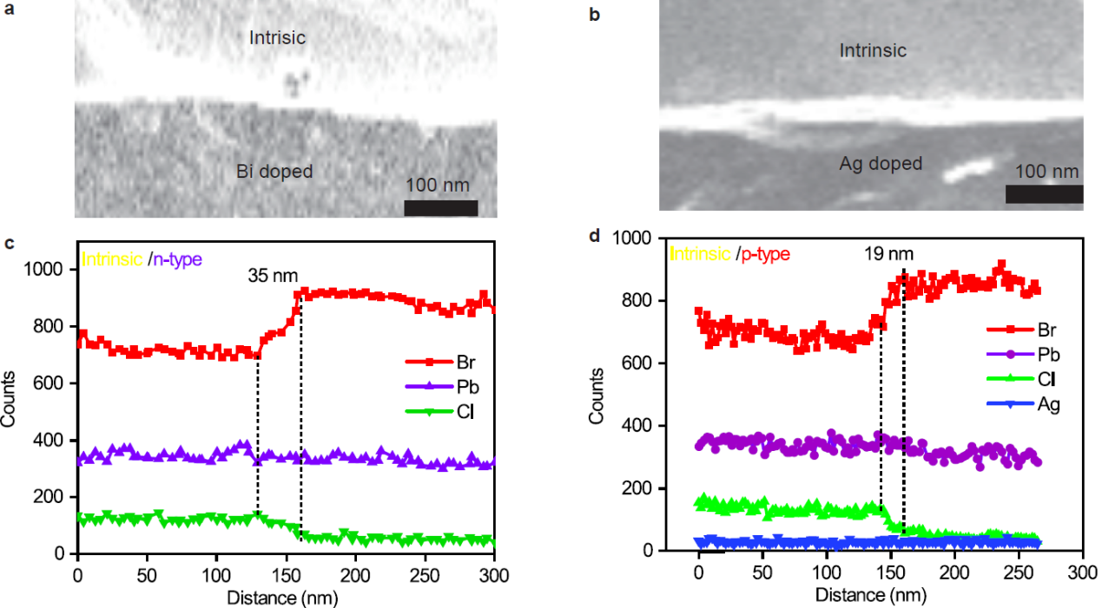

Figure S10. a, SEM photo of the interface between intrinsic/n-type. b, SEM photo of the interface between intrinsic/p-type. c, Line file of intrinsic/n-type interface. d, Line file of intrinsic/p-type interface.

Due to the EDX peak of Bi and Pb is very approaching, it is not possible to distinguish Bi element from Pb in this experiment.

Material (single crystals) | Structure | μτ(cm²V⁻¹) | J_{dark}(nAcm⁻²) | Noise current (fAHz^{-0.5}, 1mm²) | Time_{fall}(μs) | References
MAPbBr_{2.5}Cl_{0.5} | Epitaxial PIN | $$1.6×{10}^{-2}$$ | 11.45 (511 Vcm⁻¹) | 3.05 | 0.75 | This work
MAPbBr_{2.94}Cl_{0.06} | Cr/MHPSC/C₆₀/Cr | $$1.8×{10}^{-2}$$ | 5 (18V) | 50 | 84 | ¹
MAPbI₃ | Ga/Pb/MAPbI₃/Al | $$8.1×{10}^{-4}$$ | 30 (20V) | - |  | ²
MAPbI₃ | PN junction | $${10}^{-3}$$ | 4 (30V) | - | 21 | ³
CsPbBr₃ | ITO/ CSPbBr₃/Ag  Ga/ CSPbBr₃/Au | $$1.34×{10}^{-3}$$ | 5~27 (10V)  83.3 (100V) | - | 2.86 | ^{4,5}
MAPbBr₃ | PN MAPbBr₃ | - | 200 (3V) | - | - | ⁶
Cs₂AgBiBr₆ | Au/Cs₂AgBiBr₆/Au | $$6×{10}^{-3}$$ | 1.66 (5V) | 0.32 | - | ⁷
(NH₄)₃Bi₂I₉ | Ag/(NH₄)₃Bi₂I₉/Ag | $$1.1×{10}^{-2}$$ | 13.6 (10V) | 20 | 8.2 | ⁸
Cs₃Bi₂I₉ | Au/ Cs₃Bi₂I₉/Au | 9.79$×{10}^{-4}$ | 18.6(500Vcm⁻¹) | 2.2 | - | ⁹
The X-ray performance of the X-ray photodiode is compared with previous work as shown in table 1.

Reference:
1 Wei, H. et al. Dopant compensation in alloyed CH3NH3PbBr3-xClx perovskite single crystals for gamma-ray spectroscopy. Nat Mater 16, 826-833, doi:10.1038/nmat4927 (2017).
2 He, Y. et al. Resolving the Energy of γ-Ray Photons with MAPbI3 Single Crystals. ACS Photonics 5, 4132-4138, doi:10.1021/acsphotonics.8b00873 (2018).
3 Wang, X. et al. Ultrafast Ionizing Radiation Detection by p–n Junctions Made with Single Crystals of Solution‐Processed Perovskite. Advanced Electronic Materials 4, doi:10.1002/aelm.201800237 (2018).
4 Xu, Q. et al. CsPbBr3 Single Crystal X-ray Detector with Schottky Barrier for X-ray Imaging Application. ACS Applied Electronic Materials 2, 879-884, doi:10.1021/acsaelm.9b00832 (2020).
5 He, Y. et al. High spectral resolution of gamma-rays at room temperature by perovskite CsPbBr3 single crystals. Nat Commun 9, 1609, doi:10.1038/s41467-018-04073-3 (2018).
6 Liang, F. X. et al. Fabrication of MAPbBr3 Single Crystal p‐n Photodiode and n‐p‐n Phototriode for Sensitive Light Detection Application. Adv. Funct. Mater., doi:10.1002/adfm.202001033 (2020).
7 Pan, W. et al. Cs2AgBiBr6 single-crystal X-ray detectors with a low detection limit. Nature Photonics 11, 726-732, doi:10.1038/s41566-017-0012-4 (2017).
8 Zhuang, R. et al. Highly sensitive X-ray detector made of layered perovskite-like (NH4)3Bi2I9 single crystal with anisotropic response. Nature Photonics 14, 101-110, doi:10.1038/s41566-019-0466-7 (2019).
9 Zhang, Y. et al. Nucleation-controlled growth of superior lead-free perovskite Cs3Bi2I9 single-crystals for high-performance X-ray detection. Nat Commun 11, 2304, doi:10.1038/s41467-020-16034-w (2020).

