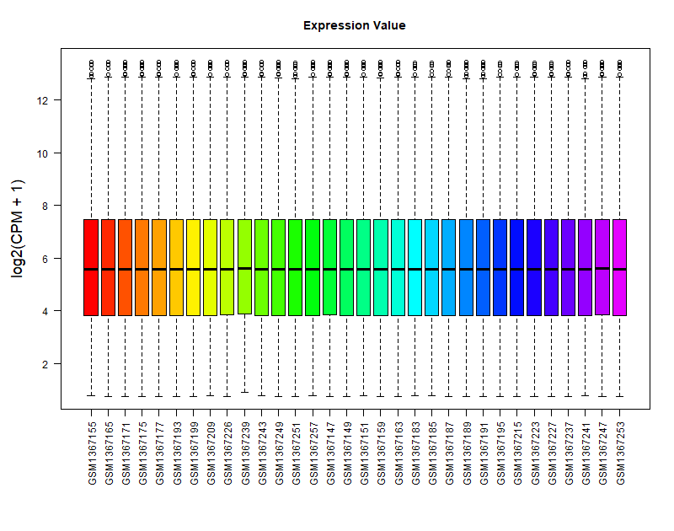
Supplement Figure 1: Box plot of sample data from GSE56716.
Supplement Figure 2: Box plot of sample data from GSE6718.
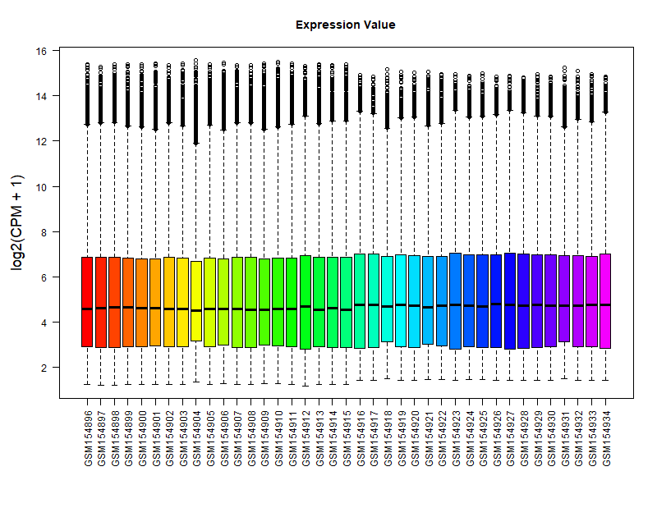
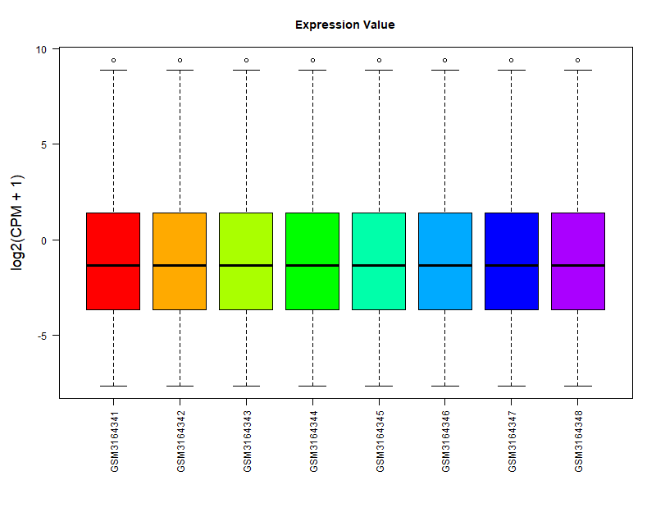
Supplement Figure 3: Box plot of sample data from GSE115068.
Supplement Figure 4：qPCR results of p21 under different concentrations of HTR2B selective agonist.
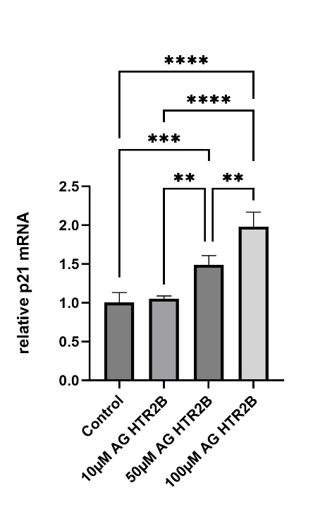
Supplement Figure 5：Enrichment pathway results of highly expressed genes in the aged group of GSE56716.
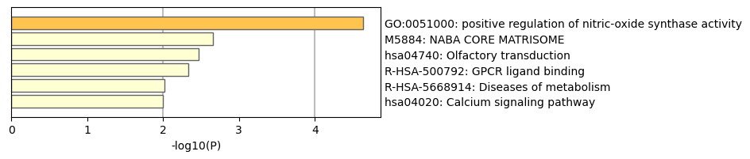

Supplement Figure 6： Enrichment pathway results of highly expressed genes in the aged group of GSE115068.
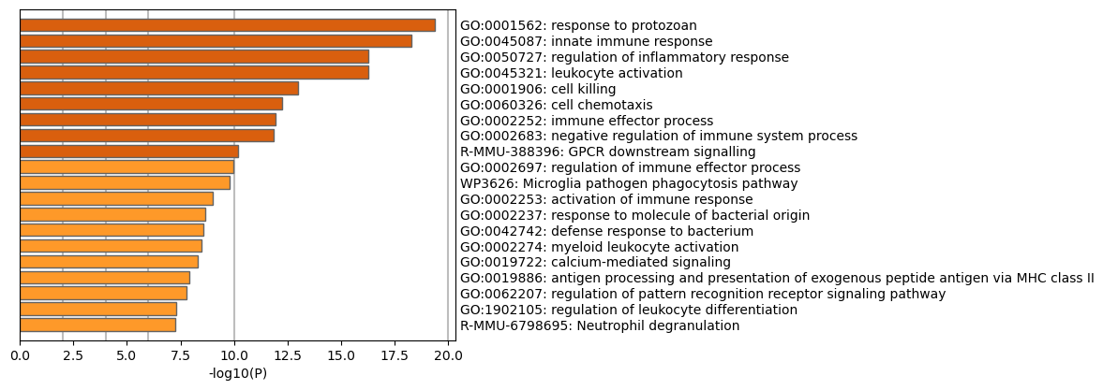
Supplement Figure 7：Venn diagram of overlapping targets between obesity and the JPHTHX Formula.
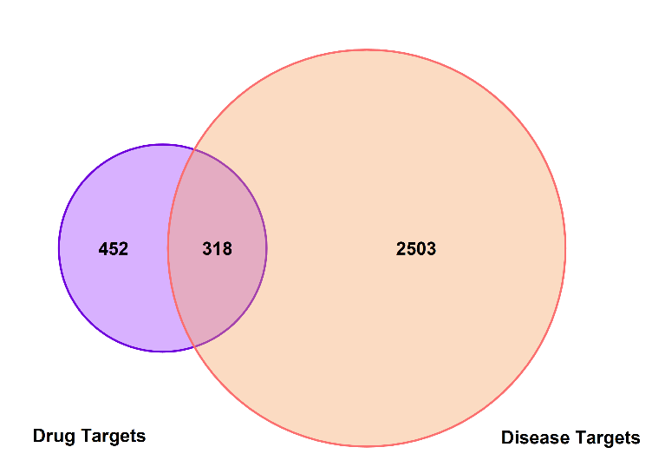
Supplement Figure 8：Ranking of core targets in JPTHX Formula based on PPI topological analysis.
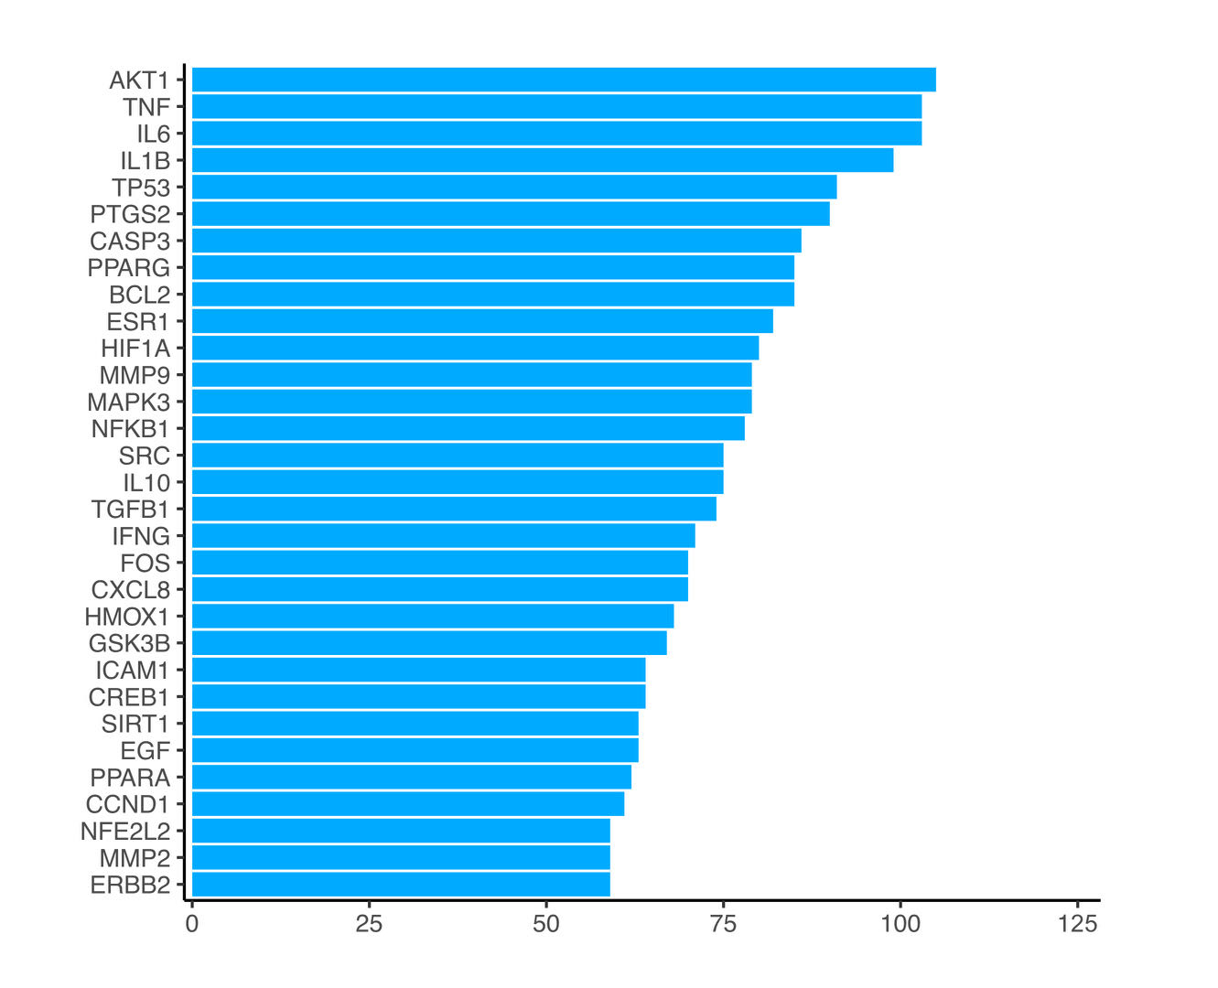

Supplement Figure 9：Pathway Enrichment Analysis
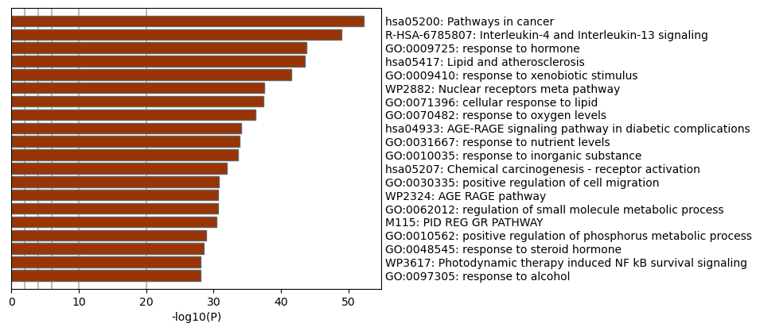
Supplement Table 1
Gene | Forward 5'-3’ | Reverse 3’-5’
HTR2B | ATTGCCCTCTTGACAATCATGT | GGAATAACCAGGCAGGACAC
β-actin | GTGACGTTGACATCCGTAAAGA | GCCGGACTCATCGTACTCC
p16 | CGCAGGTTCTTGGTCACTGT | TGTTCACGAAAGCCAGAGCG
p21 | CCTGGTGATGTCCGACCTG | CCATGAGCGCATCGCAATC
pparγ | GGAAGACCACTCGCATTCCTT | GTAATCAGCAACCATTGGGTCA

