Supporting information

Supporting Tables (Nine Tables, Tables S1-S7)

Supporting Figures (Four Figures, Figure S1-S3)

Supporting Tables
Table S1. Pfam domain architecture of the identified NAC genes in M. sinostellata.
Table S2. Genome assembly information used for the genome-wide identification of NAC genes.
Table S3. Amino acid sequences of the NAC transcription factor family in M. sinostellata.
Table S4. Physicochemical properties of the NAC proteins in M. sinostellata.
Table S5. Detailed annotation of cis-acting regulatory elements in the promoters of MsNAC genes.
Table S6. Duplicated MsNAC gene pairs and their calculated Ka/Ks ratios.
Table S7. Primer sequences used for RT-qPCR validation.
Supporting Figures
Figure S1. Differential expression analysis of M. sinostellata transcripts under waterlogging stress. Volcano plots display differentially expressed genes (DEGs) from pairwise comparisons of root (R), stem (S), and leaf (L) tissues between control (CK) and waterlogging (WL) conditions at 0, 6, and 72 hours. Significantly upregulated and downregulated genes are highlighted in red and blue, respectively.
Figure S2. K-means clustering of MsNAC gene expression patterns. Expression profiles of MsNAC genes across root, stem, and leaf tissues at different time points (0 h, 6 h, 72 h) under waterlogging stress are grouped into distinct clusters based on similar expression trends.
Figure S3. Co-expression network of MsNAC genes. Correlation analysis among MsNAC genes in M. sinostellata. Blue and red connecting lines represent significant positive and negative correlations (p-value < 0.05), respectively.
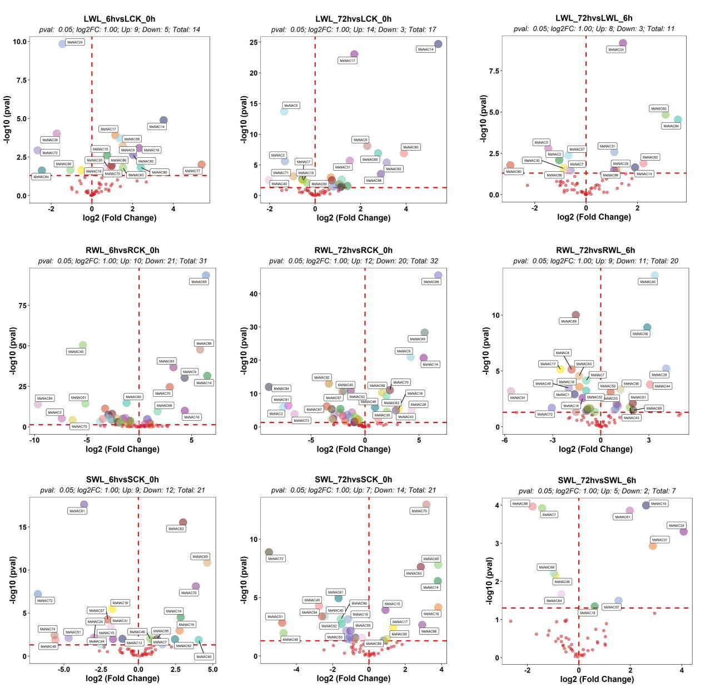
Figure S1. Differential expression analysis of M. sinostellata transcripts under waterlogging stress. Volcano plots display differentially expressed genes (DEGs) from pairwise comparisons of root (R), stem (S), and leaf (L) tissues between control (CK) and waterlogging (WL) conditions at 0, 6, and 72 hours. Significantly upregulated and downregulated genes are highlighted in red and blue, respectively.
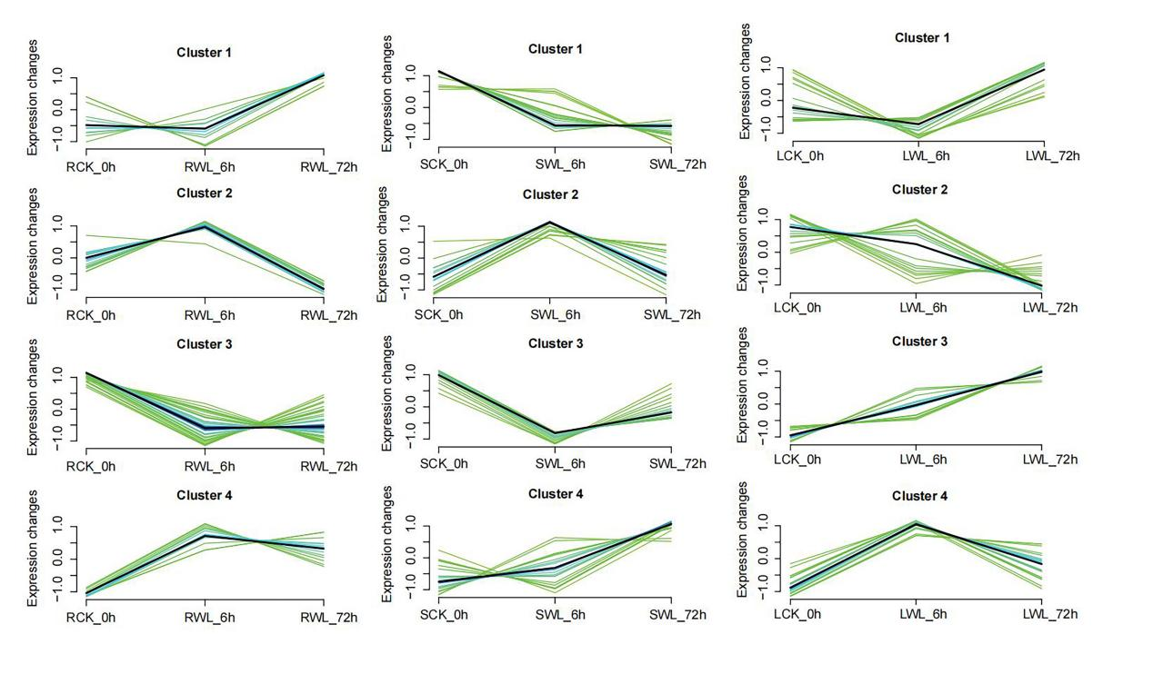
Figure S2. K-means clustering of MsNAC gene expression patterns. Expression profiles of MsNAC genes across root, stem, and leaf tissues at different time points (0 h, 6 h, 72 h) under waterlogging stress are grouped into distinct clusters based on similar expression trends.

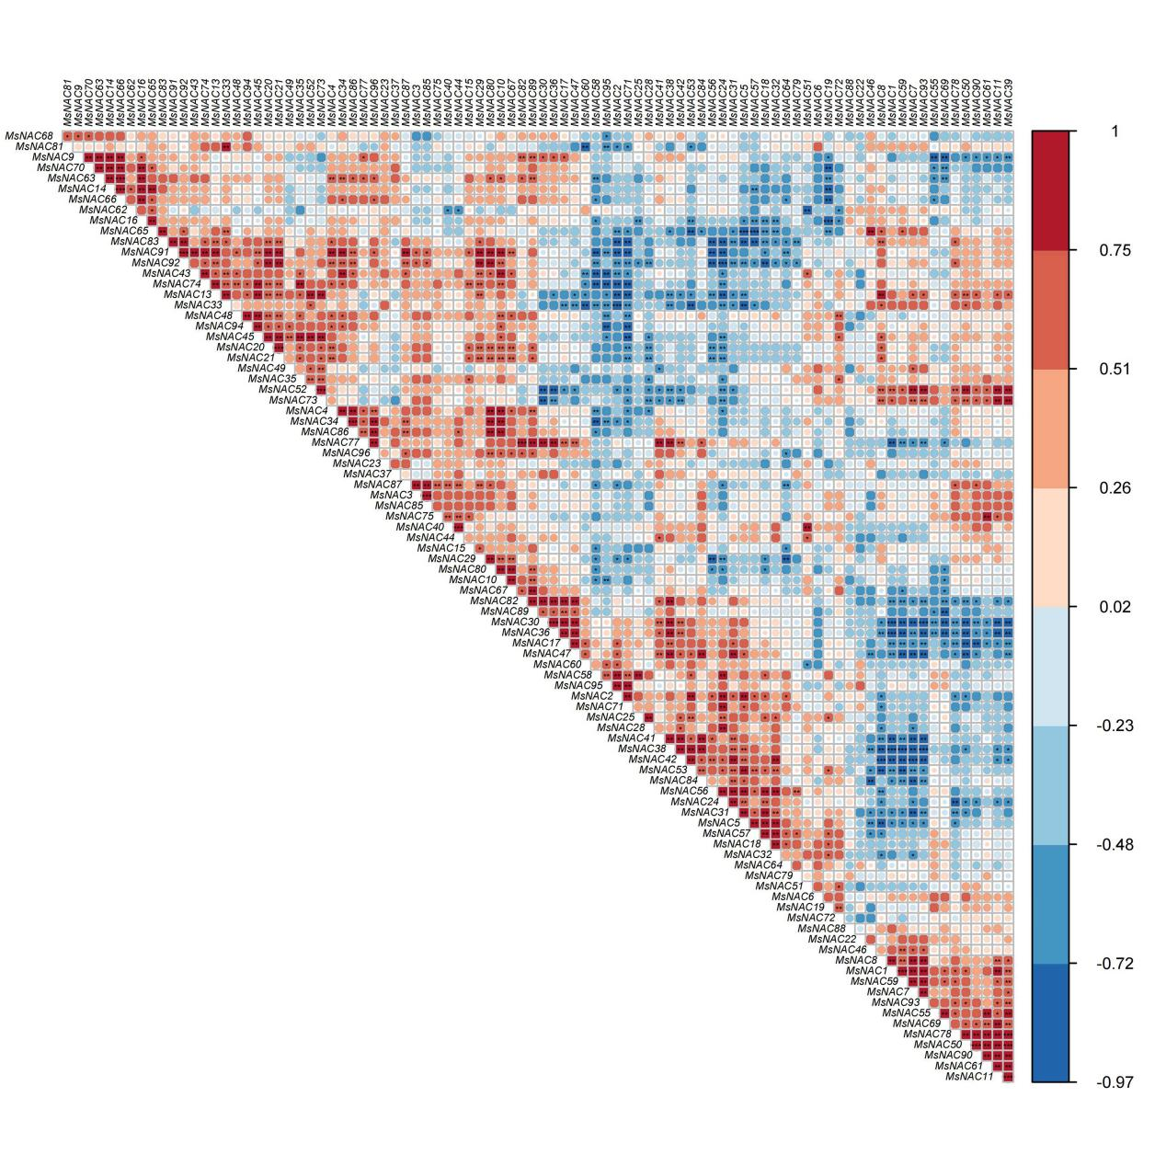
Figure S3. Co-expression network of MsNAC genes. Correlation analysis among MsNAC genes in M. sinostellata. Blue and red connecting lines represent significant positive and negative correlations (p-value < 0.05), respectively.

