Supplementary information
Table S1. The locations of the study sites, mimic frequencies, and the prey colours. The order of the experiments, and the assignment of a mimic frequency to a park, was randomised, and the colours were assigned systematically to balance the design of the experiment.
 |  |  | Colour
Date | Locations | Study site | Control | Treatment | Mimic frequency
Dec, 2016 - Jan, 2017 | 22°86’ N, 108°34’ E | Shishan Park (SP) | Pink | Yellow | 0
Jan - Feb, 2017 | 22°84’ N, 108°28’ E | Xinxu river Park (XRP) | Pink | Yellow | 0.8
Feb, 2017 | 22°83’ N, 108°32’ E | Peoples’ Park (PP) | Pink | Yellow | 0.4
Mar, 2017 | 22°86’ N, 108°37’ E | Medicinal Botanical Garden (MBG) | Yellow | Pink | 0.2
Nov, 2017 | 22°86’ N, 108°29’ E | Flower Park (FP) | Yellow | Pink | 1
Dec, 2017 | 22°84’ N, 108°24’ E | Xiangsi Lake Park (XLP) | Yellow | Pink | 0.6
Nov, 2016 | 35°01’ N, 135°48’ E | Yoshidayama (YM) | Pink | Yellow | 0.2
Dec, 2016 | 35°02’ N, 135°49’ E | Fudo Onsen (FO) | Yellow | Pink | 0.8
Dec, 2016 | 35°03’ N, 135°49’ E | Manshu-in (MI) | Yellow | Pink | 0.4
Jan, 2017 | 35°03’ N, 135°47’ E | Takara-ga-ike 1 (TGI1) | Yellow | Pink | 0
Dec, 2017 | 35°03’ N, 135°46’ E | Takara-ga-ike 2 (TGI2) | Pink | Yellow | 0.6
Jan, 2018 | 35°02’ N, 135°46’ E | Shimagamo Jinga (SJ) | Pink | Yellow | 1

Table S2. P-values for post-hoc comparisons among the differences in taste rejection among the different mimic frequencies.
 |  | Taste rejection |  |  | Relative taste rejection
Nanning |  | Treatment  R²m=0.43 R²c=0.45 | Control (n.s.)  R²m=0.11 R²c=0.36 | Treatment  R²m=0.61 R²c=0.65 |  | Control (n.s.)  R²m=0.14 R²c=0.4
Nanning | 0 vs 0.2 | 1 | - | 0.34 |  | -
Nanning | 0 vs 0.4 | 0.6 | - | 0.1 |  | -
Nanning | 0 vs 0.6 | 0.051 | - | < 0.001 |  | -
Nanning | 0 vs 0.8 | 0.2 | - | < 0.001 |  | -
Nanning | 0 vs 1 | 0.0012 | - | < 0.001 |  | -
Nanning | 0.2 vs 0.4 | 0.65 | - | 0.99 |  | -
Nanning | 0.2 vs 0.6 | 0.062 | - | 0.0027 |  | -
Nanning | 0.2 vs 0.8 | 0.17 | - | < 0.001 |  | -
Nanning | 0.2 vs 1 | 0.0011 | - | < 0.001 |  | -
Nanning | 0.4 vs 0.6 | 0.79 | - | 0.0095 |  | -
Nanning | 0.4 vs 0.8 | 0.0025 | - | < 0.001 |  | -
Nanning | 0.4 vs 1 | < 0.001 | - | < 0.001 |  | -
Nanning | 0.6 vs 0.8 | < 0.001 | - | < 0.001 |  | -
Nanning | 0.6 vs 1 | < 0.001 | - | < 0.001 |  | -
Nanning | 0.8 vs 1 | 0.01411 | - | 0.013 |  | -
Kyoto |  | Treatment  R²m=0.3002 R²c=0.3369 | Control  R²m=0.2524 R²c=0.3824 | Treatment  R²m=0.065 R²c=0.155 |  | Control  R²m=0.211 R²c=0.34
Kyoto | 0 vs 0.2 | 1 | 0.72 | 1 |  | 0.72
Kyoto | 0 vs 0.4 | 0.0069 | 0.33 | 0.017 |  | 0.39
Kyoto | 0 vs 0.6 | 0.0038 | 0.0045 | 0.019 |  | 0.0057
Kyoto | 0 vs 0.8 | 0.88 | 0.97 | 0.98 |  | 0.98
Kyoto | 0 vs 1 | 1 | < 0.001 | 1 |  | < 0.001
Kyoto | 0.2 vs 0.4 | 0.0045 | 0.98 | 0.025 |  | 0.99
Kyoto | 0.2 vs 0.6 | 0.0025 | 0.084 | 0.027 |  | 0.11
Kyoto | 0.2 vs 0.8 | 0.82 | 0.99 | 0.99 |  | 0.98
Kyoto | 0.2 vs 1 | 0.99 | 0.0015 | 1 |  | 0.0023
Kyoto | 0.4 vs 0.6 | 1 | 0.32 | 1 |  | 0.31
Kyoto | 0.4 vs 0.8 | 0.15 | 0.77 | 0.1 |  | 0.79
Kyoto | 0.4 vs 1 | 0.033 | 0.011 | 0.02 |  | 0.011
Kyoto | 0.6 vs 0.8 | 0.1 | 0.02 | 0.11 |  | 0.02
Kyoto | 0.6 vs 1 | 0.02 | 0.71 | 0.023 |  | 0.73
Kyoto | 0.8 vs 1 | 0.99 | < 0.001 | 0.99 |  | < 0.001

Table S3. Bray–Curtis's and Jaccard's distance were calculated to examine the dissimilarity of bird diversity among 12 study sites (4 day’s point count data were combined).
 |  |  | Nanning |  |  |  |  |  | Kyoto
 |  |  | SP | MBG | PP | XLP | XRP | FP | TGI1 | YM | MI | TGI2 | FO
Jaccard's index | Nanning | MBG | 0.49
Jaccard's index | Nanning | PP | 0.65 | 0.59
Jaccard's index | Nanning | XLP | 0.60 | 0.60 | 0.62
Jaccard's index | Nanning | XRP | 0.60 | 0.59 | 0.68 | 0.51
Jaccard's index | Nanning | FP | 0.50 | 0.61 | 0.68 | 0.60 | 0.58
Jaccard's index | Kyoto | TGI1 | 0.99 | 0.99 | 0.99 | 0.99 | 1.00 | 0.99
Jaccard's index | Kyoto | YM | 0.99 | 0.99 | 0.99 | 0.99 | 1.00 | 0.99 | 0.35
Jaccard's index | Kyoto | MI | 0.99 | 0.99 | 0.99 | 0.99 | 1.00 | 0.99 | 0.74 | 0.77
Jaccard's index | Kyoto | TGI2 | 0.98 | 0.98 | 0.97 | 0.98 | 1.00 | 0.98 | 0.50 | 0.48 | 0.68
Jaccard's index | Kyoto | FO | 1.00 | 1.00 | 1.00 | 1.00 | 1.00 | 1.00 | 0.64 | 0.62 | 0.76 | 0.80
Jaccard's index | Kyoto | SJ | 1.00 | 1.00 | 1.00 | 1.00 | 1.00 | 1.00 | 0.66 | 0.59 | 0.80 | 0.62 | 0.76
Bray–Curtis's index | Nanning | MBG | 0.32
Bray–Curtis's index | Nanning | PP | 0.48 | 0.42
Bray–Curtis's index | Nanning | XLP | 0.43 | 0.43 | 0.45
Bray–Curtis's index | Nanning | XRP | 0.43 | 0.42 | 0.52 | 0.34
Bray–Curtis's index | Nanning | FP | 0.34 | 0.44 | 0.51 | 0.43 | 0.40
Bray–Curtis's index | Kyoto | TGI1 | 0.98 | 0.98 | 0.98 | 0.98 | 1.00 | 0.98
Bray–Curtis's index | Kyoto | YM | 0.99 | 0.98 | 0.98 | 0.98 | 1.00 | 0.98 | 0.22
Bray–Curtis's index | Kyoto | MI | 0.99 | 0.98 | 0.98 | 0.98 | 1.00 | 0.98 | 0.58 | 0.62
Bray–Curtis's index | Kyoto | TGI2 | 0.97 | 0.96 | 0.95 | 0.95 | 1.00 | 0.97 | 0.33 | 0.32 | 0.51
Bray–Curtis's index | Kyoto | FO | 1.00 | 1.00 | 1.00 | 1.00 | 1.00 | 1.00 | 0.47 | 0.45 | 0.61 | 0.66
Bray–Curtis's index | Kyoto | SJ | 1.00 | 1.00 | 1.00 | 1.00 | 1.00 | 1.00 | 0.49 | 0.42 | 0.67 | 0.45 | 0.61

Supplementary figure legends
Figure S1. Photographs depicting a red-whiskered bulbul (Pycnonotus jocosus) (a) and an oriental magpie-robin (Copsychus saularis) (b) attacking the prey, and examples of prey that were rejected after tasting the prey (c and d).

Figure S2. The proportion of prey that were taste rejected by birds at different mimic frequencies for the control in Nanning (a) and Kyoto (b). The letters indicate commonalities among groups. Black dots represent mean of each column. Each box represents 10 data points.

Figure S3. The proportion of prey that were taste rejected by birds at different mimic frequencies for the control in Nanning (a) and Kyoto (b). The letters indicate commonalities among groups. Black dots represent mean of each column. Each box represents 10 data points.

Figure S4. The proportion of taste rejection (a) and relative taste rejection (b) in Nanning and Kyoto. Black dots represent mean of each column. Each box represents 60 data points.

Figure S5. Bird richness (a) and abundance (b) in Nanning and Kyoto. Black dots represent mean of each column. Each box represents 4 data points from point-counts.
Figure S1

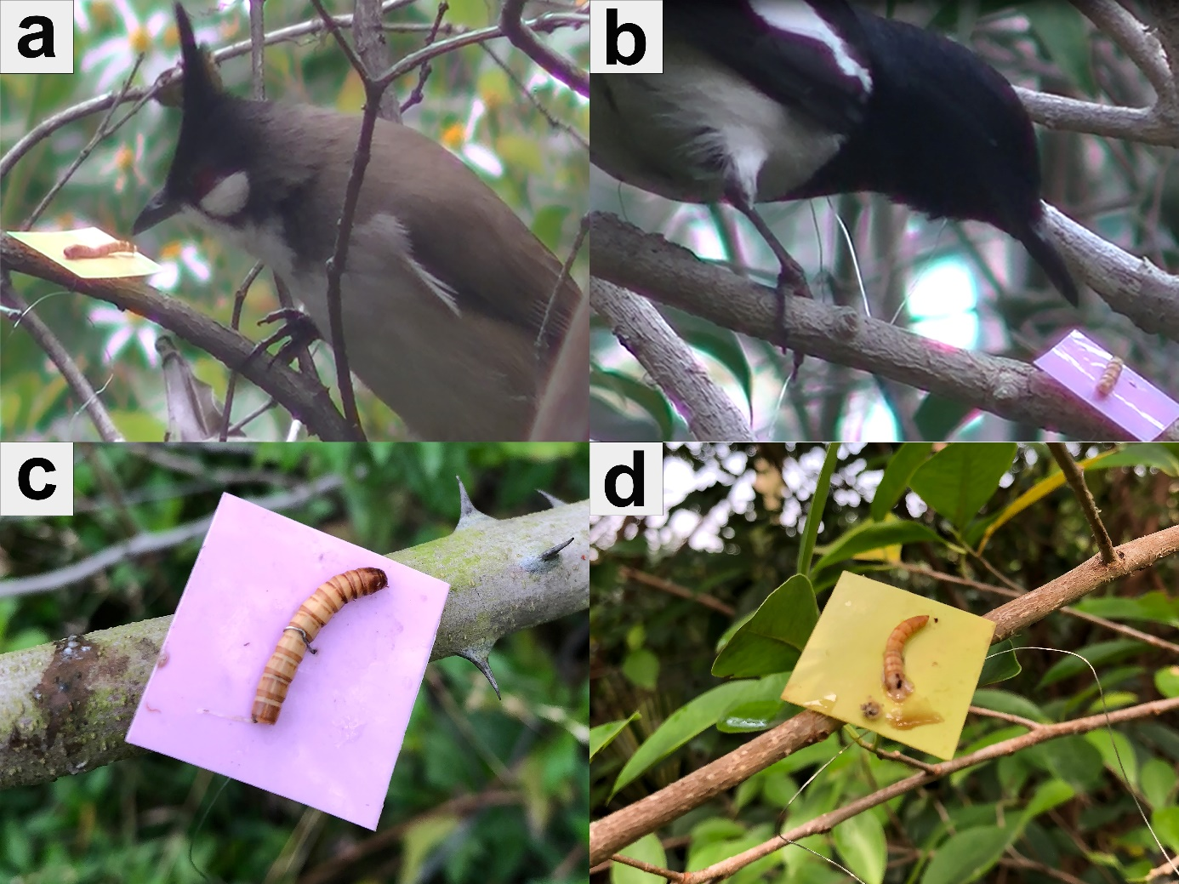

Figure S2

Figure S3

Figure S4

Figure S5

