Supplement A

Establishment of the Dataset
Table A1. Biosafety Categories and Explanations
Biosafety Categories | Explanations
Human Infectious Diseases and Disorders | Infectious diseases and conditions that affect humans.
Animal Infectious Diseases and Disorders | Infectious diseases and conditions that affect animals.
Plant Infectious Diseases and Disorders | Infectious diseases and conditions that affect plants.
Biotechnology Safety | New or improved biotechnologies, including those used in clinical trials and specialized biotechnological applications. If biotechnology safety is addressed, there is no need to separately mention clinical trial safety. For treatments related to diseases where it is not explicitly stated whether they are human or animal diseases (e.g., bone fractures, which are common to both humans and animals), only biotechnology safety needs to be mentioned.
Clinical Biosafety | Primarily concerns the biosafety associated with clinical trials in drug development or any clinical biological hazards clearly identified during the treatment of diseases.
Laboratory Biosafety | Relates to biosafety within laboratory settings, such as laboratory operations, potential leaks, and P4 laboratories.
Genetic Resource Safety | Refers to the protection and management of genetic resources, ensuring that these resources are not misused, lost, or destroyed.
Biological Resource Safety | Involves the protection and management of terrestrial wildlife, inland fisheries, and marine animal resources. It also includes the protection of forest resources, grassland resources, wild plant resources, and marine plant resources, as well as the safety management of microbial resources such as bacteria and fungi.
Biodiversity | Refers to the richness and variability of biological species on Earth.
Species Invasion | Refers to the introduction and/or spread of non-native species beyond their natural or historical range, which threatens biodiversity.
Antimicrobial Resistance | Refers to the resistance of organisms, such as bacteria, to drugs and antibiotics.
Bioterrorism | Terrorist activities carried out via the use of biological agents (e.g., bacteria, viruses, or toxins).
Bioweapons Threat | Biological weapons, also termed biological agents and biological warfare agents, which include bacteria, viruses, protozoa, parasites, and fungi that can be intentionally used as bioterrorism or biological warfare weapons.
Others | Any category that does not fall under the above classifications is considered "Other."

This paper designs an interdisciplinary dataset, which is divided into three components based on task types: automatic recognition, entity extraction, and automatic classification. The automatic recognition component requires the collection of the article's JCR subject information, WOSID number, keywords, publication year, and article type (review/article). Entity extraction focuses on extracting research objects and research methods from the article abstract, while the automatic classification component is aimed at identifying the research background of interdisciplinary studies.
The WOSID number is used for subsequent data organization. The JCR subject information, keywords, publication year, research objects, research methods, and research background classifications are employed for the interdisciplinary feature analysis. The article type (review/article) serves as a reference for identifying research methods. When the article type is classified as "review," the research method is also categorized as "review." However, errors were identified in the article type annotations within the WOS database, as several reviews were incorrectly labeled as "article." As a result, fine-tuning of a large language model is required to obtain more accurate research method classifications.
The identification of research objects primarily involves searching the article’s title and keywords, while the research method requires a combination of the article’s title, keywords, and full abstract. An article may contain multiple research methods, research objects, and research backgrounds. Regarding the research background, this study focuses on the field of biosafety. Therefore, the research background is categorized based on the Biosafety Law of the People's Republic of China, which includes 14 biosafety categories. The biosafety categories and their respective explanations are provided in Table A1.

Acquisition of Fine-Tuning Training and Test Datasets
Based on the interdisciplinary dataset, this study combines DeepSeek-V2 (DeepSeek-AI, Liu, et al., 2024) with manual annotations and modifications to batch-generate training and test datasets for the large language model. DeepSeek-V2 is a mixture of experts model (MoE), with a model parameter count of 236 B. It achieves high inference speed by activating fewer parameters during inference. In terms of general performance, DeepSeek-V2 performs well in the MMLU test. Regarding cost efficiency, DeepSeek-V2 offers a reduction in training costs compared to the DeepSeek-V1 (DeepSeek-AI, Bi, et al., 2024) version. Moreover, DeepSeek-V2 has lower operational costs and the best cost-performance ratio, making it the model of choice for generating both training and test datasets in this study.
First, 1,553 papers in the field of biosafety were randomly selected, and their abstracts, keywords, titles, publication dates, article types, JCR subjects, and WOSID numbers were collected. Based on the interdisciplinary dataset, DeepSeek-V2 was then applied to batch extract data from each article, including JCR subject, WOSID number, keywords, publication year, article category (review/article), research object, research method, and research background. After manual corrections to the extracted dataset, the data was processed into a fine-tuning format compatible with prompt learning strategies. The final dataset, which consisted of 1,553 entries, was divided into a training dataset (1,303 entries) and a test dataset (250 entries).

Model Performance Evaluation Method
The model's performance is evaluated using the ROUGE (Recall-Oriented Understudy for Gisting Evaluation) (Lin, 2004) and BLEU (BiLingual Evaluation Understudy) (Papineni et al., 2001) metrics. ROUGE focuses on the completeness of information, while BLEU emphasizes the accuracy of information.
ROUGE is a set of commonly used evaluation metrics for large model generation quality. It measures the similarity between the generated text and reference text. The calculation method is as follows:
$$\begin{aligned}ROUGE-N=\frac{\sum_{Sϵ\left\{Reference\right\}}{\sum_{{gram}_{n}ϵS}{C{ount}_{match}\left({gram}_{n}\right)}}}{\sum_{Sϵ\left\{Reference\right\}}{\sum_{{gram}_{n}ϵS}{Count\left({gram}_{n}\right)}}}\#（1）\end{aligned}$$
Herein, Reference refers to the reference answer, and gram_{n} represents n-grams。ROUGE-1 measures the recall of unigrams, which is the number of unigrams that appear in both the reference text and the generated text. ROUGE-2 measures the recall of bigrams, which calculates how many consecutive word pairs appear in both the reference text and the generated text.
Herein, Reference refers to the reference answer, and gramn represents n-grams。ROUGE-1 measures the recall of unigrams, which is the number of unigrams that appear in both the reference text and the generated text. ROUGE-2 measures the recall of bigrams, which calculates how many consecutive word pairs appear in both the reference text and the generated text.
ROUGE-L measures the recall of the longest common subsequence (LCS), and is calculated as follows:
$$\begin{aligned}R_{lcr}=\frac{LCS\left(X,Y\right)}{m}\#（2）\end{aligned}$$
$$\begin{aligned}P_{lcr}=\frac{LCS\left(X,Y\right)}{n}\#（3）\end{aligned}$$
$$\begin{aligned}F_{lcr}=\frac{\left(1+β^{2}\right)R_{lcr}P_{lcr}}{R_{lcr}+{β^{2}P}_{lcr}}\#（4）\end{aligned}$$
Whereas LCS refers to the longest common subsequence between two strings. X is the predicted value and Y is the reference value. β is used to control the weight between recall R_{lcr} and precision P_{lcr}.
BLEU metric can also be used to evaluate the performance of natural language processing tasks. It measures accuracy by comparing the overlap of word phrases between the predicted value and the reference value. The calculation is as follows:
$$\begin{aligned}BLEU-N=\frac{\sum_{Cϵ\left\{Candidate\right\}}{\sum_{{gram}_{n}ϵC}{C{ount}_{match}\left({gram}_{n}\right)}}}{\sum_{Cϵ\left\{Candidate\right\}}{\sum_{{gram}_{n}ϵC}{Count\left({{gram}_{n}}^{'}\right)}}}\#\left(5\right)\end{aligned}$$
where Candidate refers to the generated value.

Results of Prompt Template Construction
Unlike common tasks such as move recognition, entity extraction, topic identification, or classification, interdisciplinary analysis not only requires extracting information such as keywords and subject terms, but also information such as the discipline to which the text belongs and the year of publication. Therefore, when conducting interdisciplinary analysis based on published literature, it is necessary to obtain more bibliographic attribute information. In addition, traditional interdisciplinary analysis often focuses on the analysis of subject terms and keywords. However, subject terms and keywords may contain random fragments of research background, research objects, and research methods, yet it is difficult to identify the actual research objects, research methods, and research background contained therein. Accordingly, this study constructed an interdisciplinary dataset (see Methods section for details). To achieve better output results, two prompt templates were designed based on the interdisciplinary dataset.
The information extraction process of the first prompt template can be divided into three parts: move recognition, entity extraction, and automatic recognition (Fig A1). The move recognition part mainly includes "research background," "research objectives and research context," "research results," and "research significance." The entity extraction part mainly includes "research objects," "research methods," and "biosafety issues." The automatic recognition part mainly includes "year of publication," "discipline," "literature keywords," and "WOSID." This portion of data is primarily used for interdisciplinary analysis; by associating attributes such as research methods, research objects, and disciplines, it is possible to obtain information on different disciplines’ research perspectives, pathways, and temporal characteristics. However, during the fine-tuning process it was found that the move recognition task greatly reduces the performance of the large language model. It often requires a large amount of time, and the output data are difficult to manually evaluate and revise.
The second prompt template directly focuses on the information required for studying the characteristics of interdisciplinary behavior. It is constructed directly based on the first part of the dataset, with the move recognition task removed, and the extraction of biosafety information modified into biosafety classification (Fig A1). Moreover, building on the first prompt template, the contents of each section are further broken down, with 2-3 example entries provided for each. Testing shows that this approach performs well: the large language model can better understand the meaning of each section and achieve efficient data output. The details of the prompt information are provided in the Supplement.
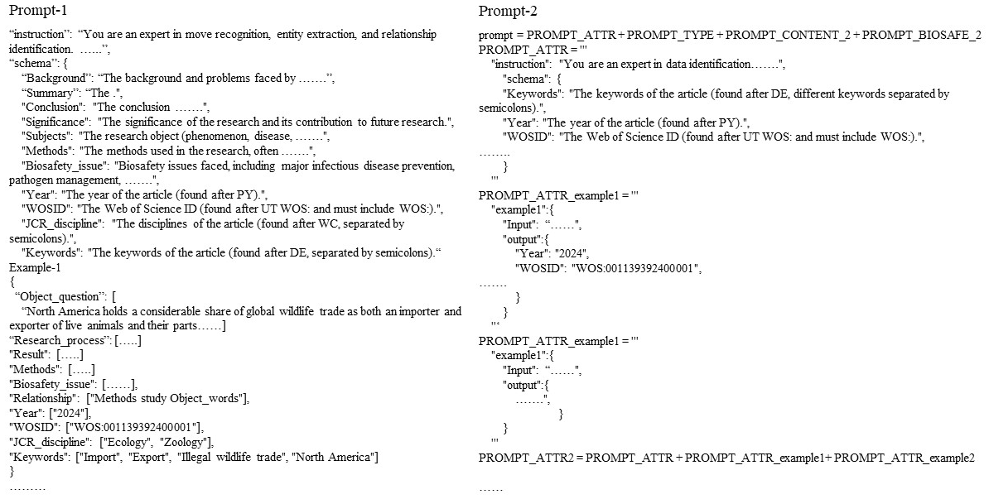
Fig. A1 Schematic diagram of the prompt templates for extracting interdisciplinary information.

Fine-tuning Effects of the Large Language Model
After the large language model converged, its fine-tuning performance was measured using the ROUGE and BLEU metrics, with results shown in Table A2. Both ROUGE and BLEU scores exceeded 90, indicating that the fine-tuned model performed well. However, it should be noted that relatively simple tasks such as automatic identification of existing text during the fine-tuning process may inflate the overall evaluation scores.
To further test the model, one biosafety-related study was randomly selected for dialogue testing with the fine-tuned model, and results were compared with those of the non-fine-tuned model. The test paper’s research object was "Illegal wildlife trade," the research method was "review," the biosafety issue was "biodiversity," the publication year was "2024," and the disciplines were "Ecology" and "Zoology." The keywords included "Import," "Export," "Illegal wildlife trade," and "North America" (see Fig A2).
This information was input into the fine-tuned LLaMA3.1-8B-Chat model, the original LLaMA3.1-8B-Chat model, the DeepSeek-V2 model, and the ChatGPT4o model for testing. The results (Fig A2) show that for the automatic extraction tasks of "year," "discipline," "keywords," and "WOSID," all four models performed well without output fabrication. However, in extracting and identifying "research object," "research method," and "biosafety issue," the non-fine-tuned models encountered issues. Specifically, LLaMA3.1-8B-Chat and DeepSeek-V2 extracted a substantial amount of irrelevant data for the research object and failed to recognize "review" as a research method. ChatGPT4o fabricated data during the biosafety issue classification task. In contrast, the fine-tuned model efficiently and accurately handled all of these tasks.
Overall, the fine-tuned model demonstrated strong performance, enabling efficient and precise extraction of data relevant to interdisciplinary analysis. Therefore, this study applied the fine-tuned model to conduct batch processing on the remaining dataset.
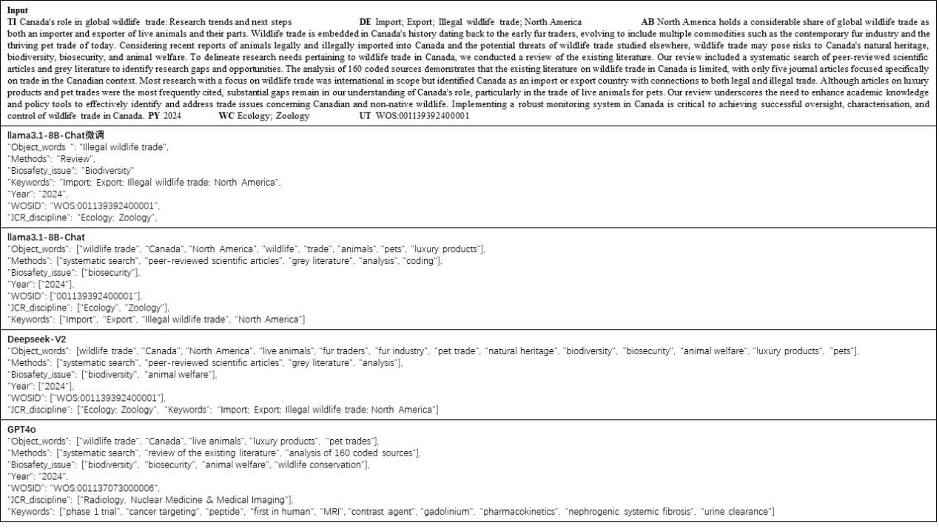
Fig. A2. Comparison of generation performance across different models

Table A2. Evaluation results of fine-tuning performance for the large language models
Evaluation metrics for fine-tuning performance of the large language model | Score
Predict_bleu-4 | 91.94788393574296
Predict_rouge-1 | 92.71573373493976
Predict_rouge-2 | 93.1655514056225
Predict_rouge-l | 95.73685983935744

Construction of the Interdisciplinary Knowledge Graph Analysis Method
Unlike traditional knowledge graphs, the knowledge graph constructed in this study contains a large amount of complex knowledge, particularly within the two entity categories of research objects and research methods, which include numerous domain-specific terms that are difficult to interpret. Moreover, because the field of biosafety encompasses extensive interdisciplinary research, it is challenging to analyze these domain-specific terms solely based on the disciplinary categories of the literature. Interpreting the interdisciplinary knowledge graph in the biosafety field thus presents a significant challenge. To address this issue, this study developed an analysis method for the interdisciplinary knowledge graph using clustering, classification, and other techniques, providing tools to further understand research objects, research methods, and biosafety categories within the graph (Fig A3). Ultimately, this approach enables rapid interpretation of interdisciplinary biosafety literature, overcoming the limitation that keywords alone cannot capture or distinguish research background, research objects, and research methods.
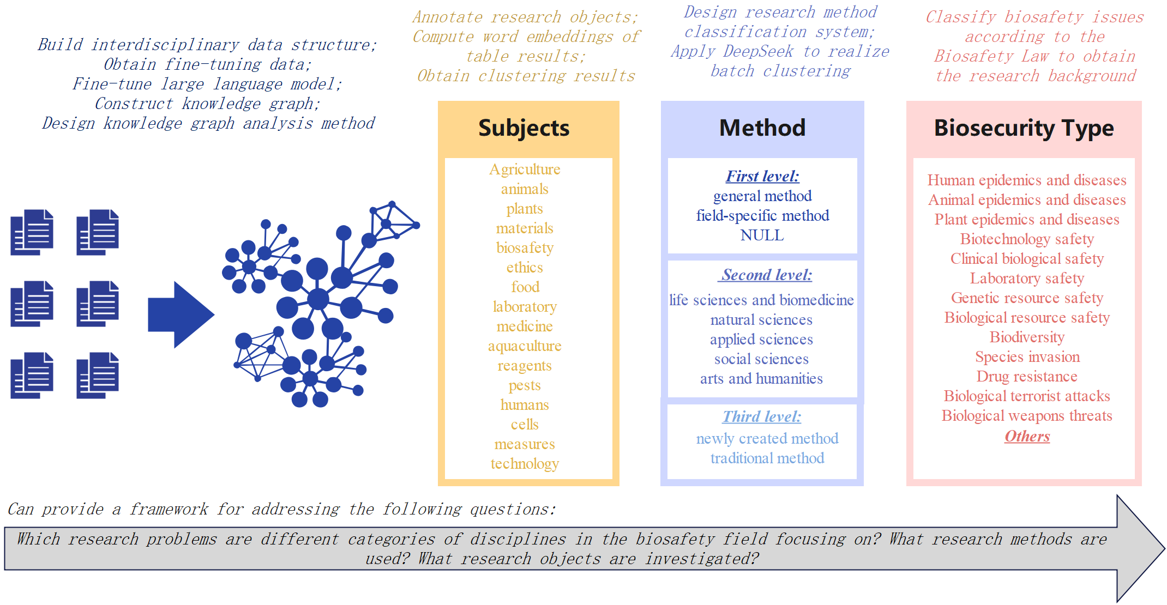
Fig. A3. Construction of the Interdisciplinary Knowledge Graph Analysis Method

Research Objects Analysis
In the field of biosafety, the disciplinary overlap is highly complex, and research objects often extend across multiple domains, thereby involving a wide range of discipline-specific terminologies. General-purpose models such as BERT are unable to fully capture the meanings of research objects in this field and thus fail to generate accurate word embeddings. When clustering is conducted using methods such as k-means, cosine similarity, or hierarchical clustering, terms from different disciplinary domains are distributed almost uniformly across categories, making it difficult to distinguish differences between them. Single-domain models, such as Bio-BERT trained exclusively on biological data, can effectively embed terms within the biological sciences. However, biosafety also encompasses many non-biological domains, such as nanoscience—which provides innovative materials for disease treatment—and the social sciences, which focus on ethical considerations. For such non-biological terms, single-domain models also fail to generate effective embeddings, thereby limiting their ability to cluster research objects in biosafety. To address this problem, this study first employed a large language model (LLM) to annotate each article’s research objects by specifying the meaning of each specialized term. For example, "Contrast Agent" was annotated as a chemical reagent, "2,3-butanediol" as a compound, "African Swine Fever" as an animal disease, "Bactrocera fruit flies" as a pest, and "Enrofloxacin" as an antibiotic. Since the annotation labels are mostly composed of words familiar in daily life, embedding models can more readily understand and distinguish their meanings. Nevertheless, while LLMs performed well, annotation errors may still occur and require human correction. After the initial round of annotation, a format check was conducted to remove corrupted text or garbled symbols, followed by re-annotation of these problematic parts. The corrected dataset was then used for subsequent embedding and clustering analysis.
Based on the annotated terms, this study selected BERT, BioBERT, and BGE models as vectorization models, and applied k-means and cosine similarity as clustering methods. By combining the three models with the two clustering methods, six methodological combinations were obtained. Comparative analysis showed that the BGE model performed best for embedding, while cosine similarity produced clearer clustering and visualization results; therefore, this combination was adopted. When applying cosine similarity for clustering, it was necessary to predefine cluster centers. However, the research object data were found to be highly complex and diverse, encompassing annotated terms from multiple disciplines and involving multiple levels and categories, which made the selection of cluster centers challenging. For example, "pesticide droplets," "rural chicken surveillance," and "Ammonia gas; poultry litter" were annotated as agriculture-related research objects; "equine influenza," "rabbit welfare," and "swine oral virome" as animal-related research objects; "Raw cow’s milk," "anthocyanin-rich vegetables," "nonnutritive sweeteners," and "genetically modified food" as food-related research objects; "Tilapia farms," "mariculture," and "diseases of aquatic organisms" as aquatic-related research objects; "personal protective equipment," "China’s Biosecurity Law," "biodefense; biosecurity," and "emergency infrastructures" as research focused directly on biosafety; and "plant pathogen," "plant virus," and "marine plant" as plant-related objects. Cross-disciplinary overlaps were present in the above examples. For instance, "Avian Influenza H5N1" can be regarded simultaneously as a human disease and an animal disease, while the term itself also belongs to the category of viruses. If cluster centers were set by biological attributes (e.g. animal, plant, virus), the resulting distinctions would be blurred. Therefore, drawing on preliminary k-means results, the initial set of cluster centers included: "technology," "pathogen," "medicine," "disease," "aquaculture," "animal," "plant," "product," "laboratory," "toxicity," "prevention," "ecology," "ethics," "agriculture," "food," and "pests." However, substantial overlaps were observed among "toxicity," "pathogen," "disease," and "prevention. "Moreover, biosafety research also directly addresses biosafety itself, as seen in entries such as "biosafety controversy," "biosafety committees," and "institutional biosafety committees."
Therefore, when the cluster centers were revised to: "agriculture," "animal," "plant," "materials," "biosafety," "ethics," "food," "laboratory," "medicine," "aquaculture," "reagents," "pests," "human," "cells," "measures," "technology," "biomolecules," and "ecology," improved clustering results were obtained. However, upon detailed examination of each category, further issues were noted: the "plant" category contained numerous crops; "medicine" included many drugs applicable to humans; "ethics" contained research objects such as biosafety law, which should belong to "biosafety"; the "human" category mixed human-derived viruses with public health emergency-related human activities; and the "reagents" category was overly detailed, causing chemical products such as toxic chemical compounds to be incorrectly classified due to lack of proper categories. Hence, after multiple iterations, overlapping categories were merged and ambiguous categories were removed, resulting in the final clustering scheme comprising 12 categories: "ecology," "pests and diseases," "life mechanisms," "physicochemical processes and products," "technology," "materials," "equipment and tools," "biosafety," "medicine," "agriculture," "food," and "aquaculture." Each category was further refined by specifying the annotated terms to be included (see Table A3).

Table A3. Cluster Centers for Research Object Clustering
No. | Category | Annotations on the Cluster Center Computation
1 | Ecology | Ecology, Environment, Biodiversity
2 | Pests and Diseases | Viruses, Bacteria, Diseases, Toxicity, Pests Harmful Microorganisms
3 | Life Mechanisms | Biomolecules, Life Processes, Genetics, Biochemistry
4 | Physicochemical Processes and Products | Physical Processes, Chemical Processes, Chemical Products, Physical Products, Agents
5 | Technology | Biological Technologies, Chemical Technologies, Nanotechnologies, Technologies
6 | Materials | Nanomaterials, Biomaterials, Materials
7 | Equipment and Tools | Medical Equipment, Experimental Equipment, Tools, Laboratory, Diagnostic Tools
8 | Biosafety | Policy, Population Migration, Agreements, Conventions, Humanitarian Crisis, Biosafety, Biological Weapons
9 | Medicine | Medical, Drugs, Drug Toxicity, Drug Resistance, Anatomy, Diagnostic Tools
10 | Agriculture | Crops, Farms, Farmers, Animal Husbandry, Livestock Farms, Agriculture
11 | Food | Food, Food Preservation, Food Products
12 | Aquaculture | Aquatic Organisms, Aquaculture, Marine Organisms

Based on the cluster centers obtained, this study first used the BGE model to calculate the cluster center for the words contained in each category, thus obtaining the final cluster center for each category. Subsequently, the BGE model was applied to compute the word embeddings of the research objects in each article, and the articles were clustered using the cosine similarity method to obtain the final clustering results (Fig A4). Both the visualization and the clustered data indicate that the above cluster centers can effectively distinguish the research objects in the field of biosafety. Specifically, the "Ecology" category contains 911 articles, "Pests and Diseases" contains 5,648 articles, "Life Mechanisms" contains 963 articles, "Physicochemical Processes and Products" contains 710 articles, "Technology" contains 1,323 articles, "Materials" contains 2,407 articles, "Equipment and Tools" contains 652 articles, "Biosafety" contains 1,575 articles, "Medicine" contains 729 articles, "Agriculture" contains 1,351 articles, "Food" contains 182 articles, and "Aquaticulture" contains 354 articles. The results show that, from 1981 to the present, the biosafety field has primarily focused on research related to pests and diseases, followed by materials, technology, and agriculture.
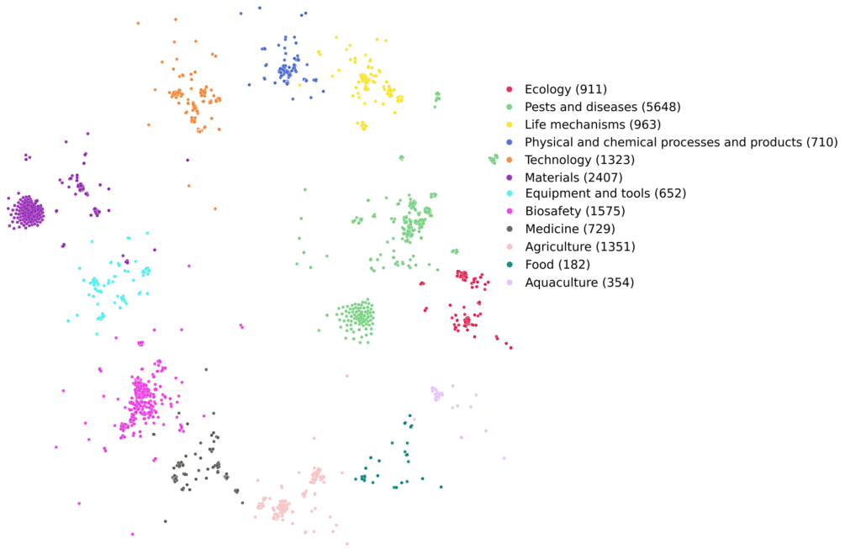
Fig. A4. Clustering results of research objects in the field of biosafety.

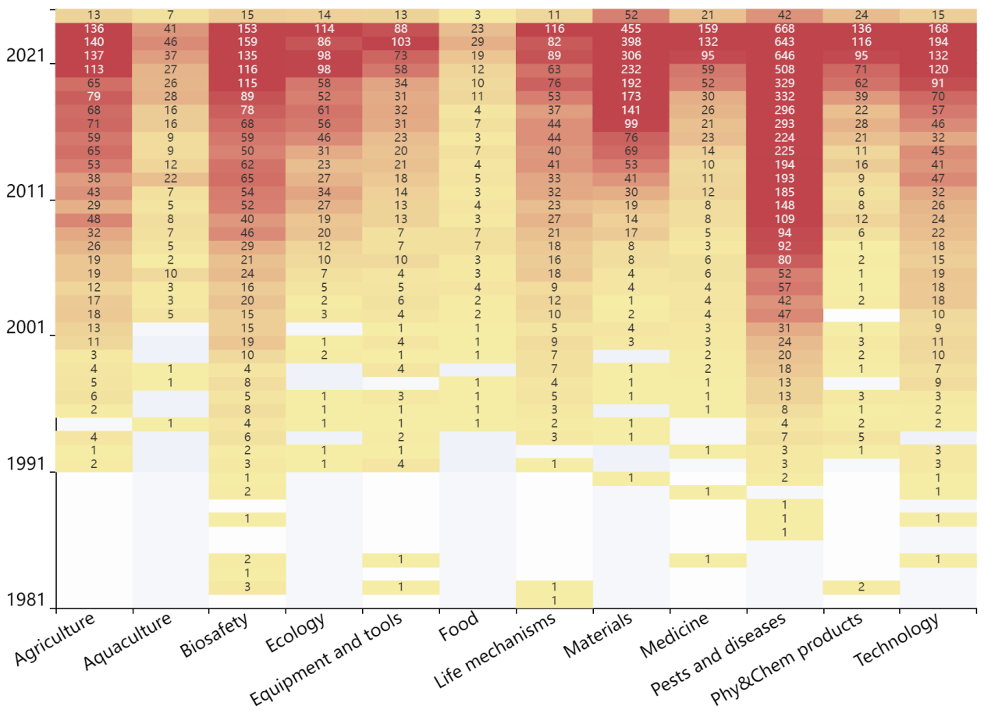
Fig. A5. Temporal changes in research objects

To further explore the evolution of research objects in the field of biosafety, this study analyzed their distribution across different years (Fig A5). The results show that research objects in biosafety have gradually diversified over time. In the early stages of the field, the focus was on life mechanism-related content. In 1981, one article was published, primarily investigating DNA-related topics. In 1982, seven articles were published in the field of biosafety, of which three focused directly on biosafety itself, covering "BIOSAFETY CONTROVERSY," "BIOSAFETY COMMITTEES," and "INSTITUTIONAL BIOSAFETY COMMITTEES." The remaining four articles addressed research objects such as equipment and tools, life mechanisms, and physico-chemical processes and products.
In the following years, research outputs in the field of biosafety were relatively limited, and research objects were scattered across multiple areas, including biosafety itself, equipment and tools, life mechanisms, materials, medicine, pests and diseases, physico-chemical processes and products, as well as related technologies. After 1991, research began to show a growth trend, and by 1994, all types of research objects were covered, though their distribution remained relatively dispersed. Between 1995 and 2005, research trends gradually became clearer, with the field increasingly focusing on pests and diseases as well as biosafety itself. From 2005 to 2015, studies on biosafety itself and pest- and disease-related research continued to grow, while research on agriculture, life mechanisms, materials, and technologies also began to increase year by year. Since 2015, research has shown that, apart from the food and ecology categories, all other types of research objects have received widespread attention. Among them, pests and diseases have consistently been the most studied research object category. Attention to materials-related research objects has risen sharply since 2011, while research on biosafety itself received significant focus in the early stages of the field but has grown more slowly compared with the pests and diseases category. Additionally, although research objects related to food and ecology have generally received lower attention, they have also shown a gradual year-on-year increase.

Research Methods Analysis
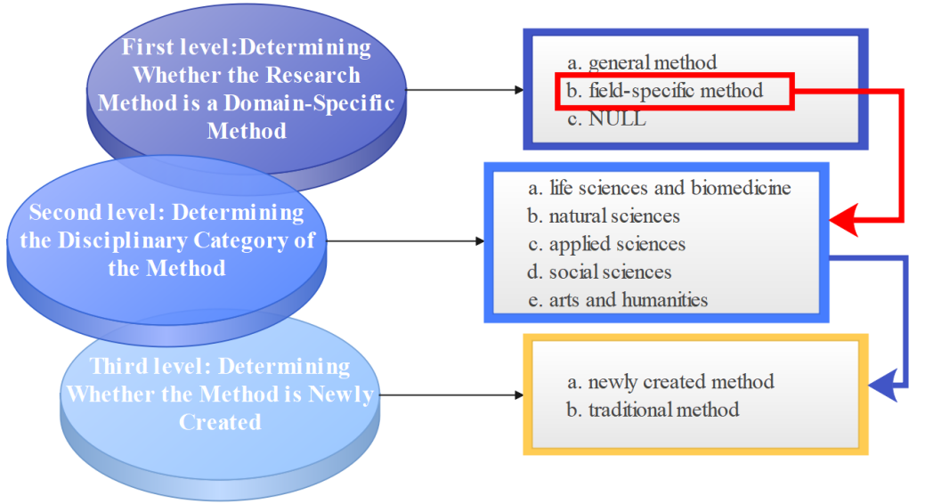
Fig. A6. Categorization of Research Methods

Compared with the diverse and complex research objects that are often difficult to interpret, research methods in the field of biosecurity are relatively limited in variety and easier to understand. In this study, research method data extracted from biosecurity literature were systematically organized and hierarchically classified (Fig A6).
The first-level classification focuses on distinguishing which research methods are field-specific professional methods. At this level, research methods were divided into three categories: general methods, domain-specific methods, and unknown methods. General methods include approaches applicable across disciplines, such as review methods, classification methods, survey methods, systematic reviews, and meta-analyses. Domain-specific methods include professional techniques unique to the field, such as gene editing, nanosystem creation, and PCR. Unknown methods typically come from older publications lacking abstracts or from papers where research methods were not explicitly stated in the abstract. This category accounts for a small proportion of biosecurity literature, comprising only 301 articles (1% of the total).
For articles categorized into the general methods or unknown methods groups at the first-level classification, no further classification was conducted. For those categorized into the domain-specific methods group, a second-level classification was performed. The second-level classification addresses the disciplinary attribution of research methods. Following the Web of Science categorization framework for major disciplinary domains, professional fields were grouped into five broad categories: life sciences and biomedicine, natural sciences, applied sciences, social sciences, and arts and humanities. Building upon the second-level classification, the third-level classification incorporated the dimension of methodological innovativeness, distinguishing between newly created methods and traditional methods. If a research method contained innovation-related terms such as "synthesized," "developed," or "create," it was classified as a newly created method; all others were categorized as traditional methods.
After the classification schema was finalized, large-scale batch processing was conducted using DeepSeek V3, deployed on AICloud Feiyun. The processed data were then subjected to rigorous manual checks, including error check and correction for garbled text, verification of large language model misclassifications, spelling errors, and formatting inconsistencies. The final outcome was the classified dataset of cross-disciplinary research methods in the field of biosecurity. The distribution of articles across the different categories is shown in Table A4.
The results show that domain-specific methods account for the largest proportion of all research methods, with life sciences and biomedical methods being the most widely applied among them. Among the existing domain-specific methods, traditional approaches are most favored by researchers. In addition, about 30% of the literature employed general methods to conduct biosecurity-related research.

Table A4. Categorization of Research Methods in the Field of Biosecurity
Level | Category | Number of Articles
Frist level | general method | 5001
Frist level | NULL | 301
Frist level | field-specific method | 11503
Frist level | general method & field-specific method | 10
Second level | applied sciences | 821
Second level | applied sciences & social sciences (mix1) | 15
Second level | arts and humanities | 11
Second level | life sciences and biomedicine | 6876
Second level | life sciences and biomedicine & applied science & social sciences (mix2) | 1
Second level | life sciences and biomedicine & applied sciences (mix3) | 18
Second level | life sciences and biomedicine & natural sciences (mix4) | 97
Second level | life sciences and biomedicine & social sciences (mix5) | 25
Second level | natural sciences | 2171
Second level | natural sciences & applied sciences (mix6) | 11
Second level | natural sciences & social sciences (mix7) | 4
Second level | social sciences | 1463
Third level | newly created method | 1522
Third level | traditional method | 9943
Third level | newly created method & traditional method | 48

To gain deeper insights into the development and evolution of research methods in the field of biosecurity, and to uncover underlying patterns, this study conducted a visualization analysis of their temporal trends (Fig A7). The results indicate that, during the early stage of biosecurity research (pre-1995), studies primarily employed general methods, life sciences and biomedical methods, as well as social science methods. A small number of studies between 1991 and 1995 also introduced applied sciences and natural sciences methods into biosecurity research. From 1995 to 2005, all categories of research methods showed steady growth. Between 2005 and 2015, methods from different domains began to be combined to jointly address problems, resulting in the emergence of multiple interdisciplinary method combinations. Since 2015, the use of single-domain research methods has continued to grow steadily, while the number of cross-domain combination methods has also increased.
Overall, the results indicate that general methods and life sciences & biomedical methods were the first to be applied in biosecurity research and have become the two most important approaches for addressing biosecurity issues. Although social science methods were introduced relatively early, they only began a steady growth phase around 2015. Natural science methods, despite a later start, have shown rapid growth after 2015 and are gradually gaining importance in biosecurity research. Applied science methods started late as well, and their overall growth has been relatively moderate. Multidisciplinary hybrid methods are still in the early stages of development, with limited research attention and not yet widely adopted.
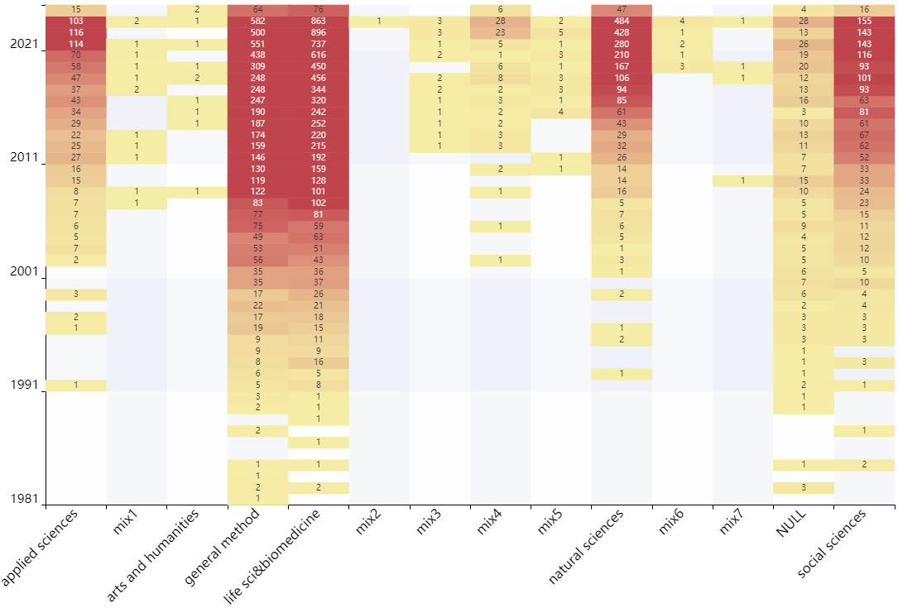
Fig. A7. Temporal trends in research methods within the biosecurity field.
Note: On the x-axis, mix1 = "applied sciences & social sciences"; mix2 = "life sciences and biomedicine & applied sciences & social sciences"; mix3 = "life sciences and biomedicine & applied sciences"; mix4 = "life sciences and biomedicine & natural sciences"; mix5 = "life sciences and biomedicine & social sciences"; mix6 = "natural sciences & applied sciences"; mix7 = "natural sciences & social sciences" .

Biosafety Categories Analysis
In the literature of the biosafety field, biosafety categories can be understood as the research background of the publications. Exploring the research background of a paper helps clarify its positioning and applicability, providing a reference for subsequent researchers in screening similar studies. Currently, there are still some debates regarding the classification within the biosafety field. In this study, the division of biosafety categories primarily follows the modules mentioned in the Biosafety Law of the People’s Republic of China, with specific categories shown in Table 1. Biosafety categories were identified from the paper’s topic and abstract using the fine-tuned LLaMA3.1 model, then checked and corrected via the knowledge graph, ultimately outputting the biosafety categories for all publications from the knowledge graph.
To further explore the evolution of different biosafety research categories and reveal their development trends and patterns, this study systematically analyzed the changes over time in the number of publications for each biosafety category (Fig A8). The results indicate that in the early stages of biosafety research, the field initially focused on biotechnological and laboratory-related biological threats, and later shifted attention to human infectious diseases and animal infectious diseases. Before 1995, except for plant-related infectious diseases, biodiversity, bioterrorism, and biological weapons, all other biosafety categories already had publications included in the dataset. Between 1995 and 2005, all research categories in biosafety received varying degrees of attention, with biotechnological and animal infectious disease-related topics receiving wider focus. Additionally, human infectious diseases, laboratory safety, and species invasion attracted interest from a portion of researchers. After 2015, biotechnological and animal infectious disease topics continued to receive prominent attention, while mixed categories, "other" categories, clinical biosafety, human infectious diseases, and species invasion saw rapid growth in attention. Notably, publications on human infectious diseases surged explosively after 2019, followed by a decline in 2023, likely influenced by the course of the COVID-19 pandemic.
Meanwhile, research attention to plant infectious diseases, biological resources, and antimicrobial resistance steadily increased. In contrast, categories such as biodiversity, bioterrorism, biological weapons, and genetic resource security showed no significant growth trend. The limited availability of publicly accessible research on bioterrorism and biological weapons may contribute to the lower academic attention in these areas. Moreover, some studies may involve sensitive information and therefore are not published in academic journals, further restricting the accessible literature.
Fig A8 shows that widely studied biosafety issues generally have an initial development phase, during which research is often sporadic. However, studies on bioterrorism and biological weapons did not display this pattern, further supporting the notion that relevant research may not have been publicly published. Research on biodiversity and genetic resources remains in an early-stage development phase, suggesting potential for increased attention from researchers in the future.
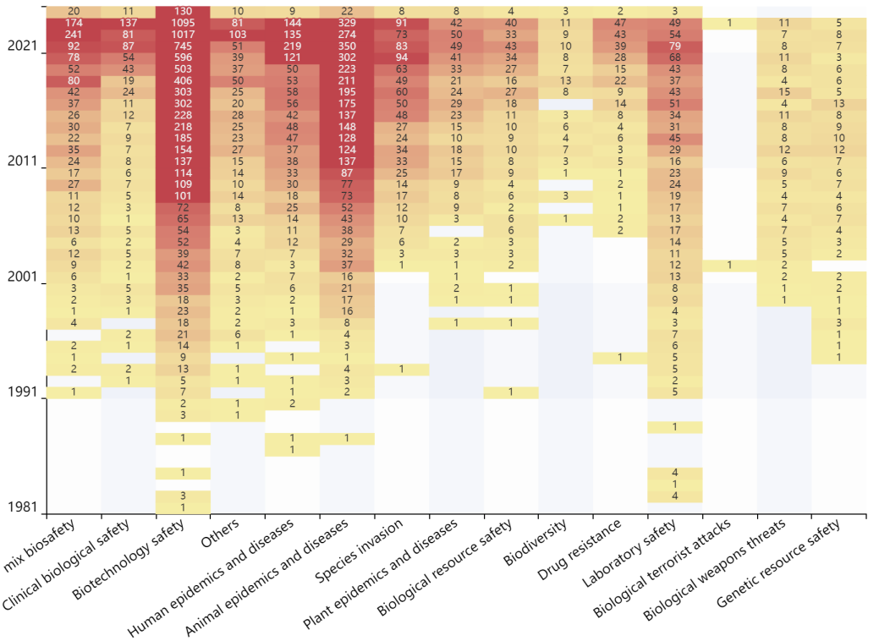
Fig. A8. Temporal changes in biosafety categories.

Fig A9 visualizes the category associations within the Mix Biosafety category to further analyze research details in the biosafety field. The results show that the strongest association exists between human infectious diseases and animal infectious diseases, likely driven by the increasing number of zoonotic diseases reported over the years. Diseases that were originally only transmissible among animals, such as HIV and BSE, can infect humans, leading to more reported zoonoses.
Fig A9 visualizes the category associations within the Mix Biosafety category to further analyze research details in the biosafety field. The results show that the strongest association exists between human infectious diseases and animal infectious diseases, likely driven by the increasing number of zoonotic diseases reported over the years. Diseases that were originally only transmissible among animals, such as HIV and BSE, can infect humans, leading to more reported zoonoses.
Other strongly associated pairs include biotechnology safety-animal epidemics and diseases, biological resource safety-animal epidemics and diseases, biological resource safety-biotechnology safety, biotechnology safety-clinical biological safety, and animal epidemics and diseases-drug resistance. Many of these combinations repeatedly involve animal epidemics and diseases and biotechnology safety. The frequent combination of animal epidemics and diseases with other categories may be due to: 1) Treating animal infectious diseases often requires biotechnology support; 2) Many experiments use model animals such as mice or monkeys, so initial biotechnology attempts and resistance experiments are conducted via animals; 3) Bioresources include animals, creating an inherent overlap between bioresources and animal infectious diseases. The prevalence of biotechnology safety in multiple combinations is likely because it has broad applications: it can be used for treating animal infectious diseases, studying bioresource distribution, and clinical disease treatment. By analyzing single and combined biosafety categories (Fig A8 and Fig A9), the developmental trajectory of genetic resource safety is further clarified. The results indicate that while biological resource safety research progresses independently, it also intertwines with other biosafety fields, promoting coordinated development across the entire domain.
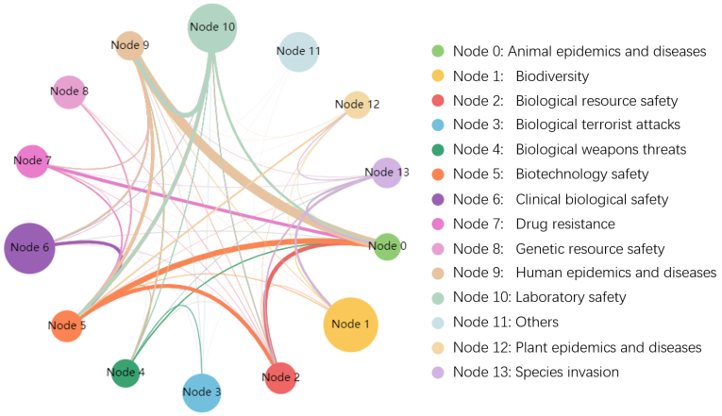
Fig. A9. Associations and linkages among different biosafety categories within the Mix Biosafety category.

In addition, laboratory safety forms numerous linkages, including laboratory safety- animal epidemics and diseases, laboratory safety-biotechnology, and laboratory safety-human epidemics and diseases combinations. This is likely because laboratories contain various pathogens and serve as the origin of many biotechnologies. Animal epidemics and diseases modified through biotechnology in the laboratory can pose threats to humans, and the potential release of human pathogens from laboratories is a key concern in biosafety. Moreover, during biotechnology development, the accidental release of certain reagents in the laboratory or the inherent potential hazards of biotechnology itself can also 0become focal points of attention in the biosafety field.

References
DeepSeek-AI, Bi, X., Chen, D., Chen, G., Chen, S., Dai, D., Deng, C., Ding, H., Dong, K., Du, Q., Fu, Z., Gao, H., Gao, K., Gao, W., Ge, R., Guan, K., Guo, D., Guo, J., Hao, G., … Zou, Y. (2024). DeepSeek LLM: Scaling Open-Source Language Models with Longtermism (Version 1). arXiv. https://doi.org/10.48550/ARXIV.2401.02954
DeepSeek-AI, Liu, A., Feng, B., Wang, B., Wang, B., Liu, B., Zhao, C., Dengr, C., Ruan, C., Dai, D., Guo, D., Yang, D., Chen, D., Ji, D., Li, E., Lin, F., Luo, F., Hao, G., Chen, G., … Xie, Z. (2024). DeepSeek-V2: A Strong, Economical, and Efficient Mixture-of-Experts Language Model (Version 5). arXiv. https://doi.org/10.48550/ARXIV.2405.04434
Lin, C.-Y. (2004). ROUGE: A Package for Automatic Evaluation of Summaries. Text Summarization Branches Out, 74–81. https://aclanthology.org/W04-1013/
Papineni, K., Roukos, S., Ward, T., & Zhu, W.-J. (2001). BLEU: A method for automatic evaluation of machine translation. Proceedings of the 40th Annual Meeting on Association for Computational Linguistics - ACL ’02, 311. https://doi.org/10.3115/1073083.1073135

