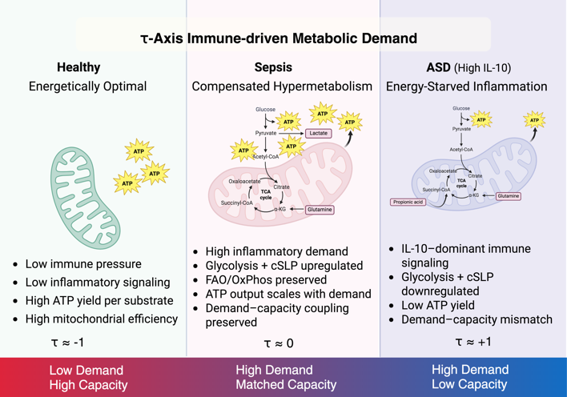

Abstract Figure: The τ-Axis maps immune-driven metabolic demand against cellular energy capacity, distinguishing compensated inflammation (sepsis) from pathological demand–supply mismatch in IL-10–dominant ASD

