
Figure S1 USP9X is positively correlated with PD-L1 expression in different PDAC cell lines
Protein expression of USP9X and PDL1 in PDAC cells were measured by western blotting.

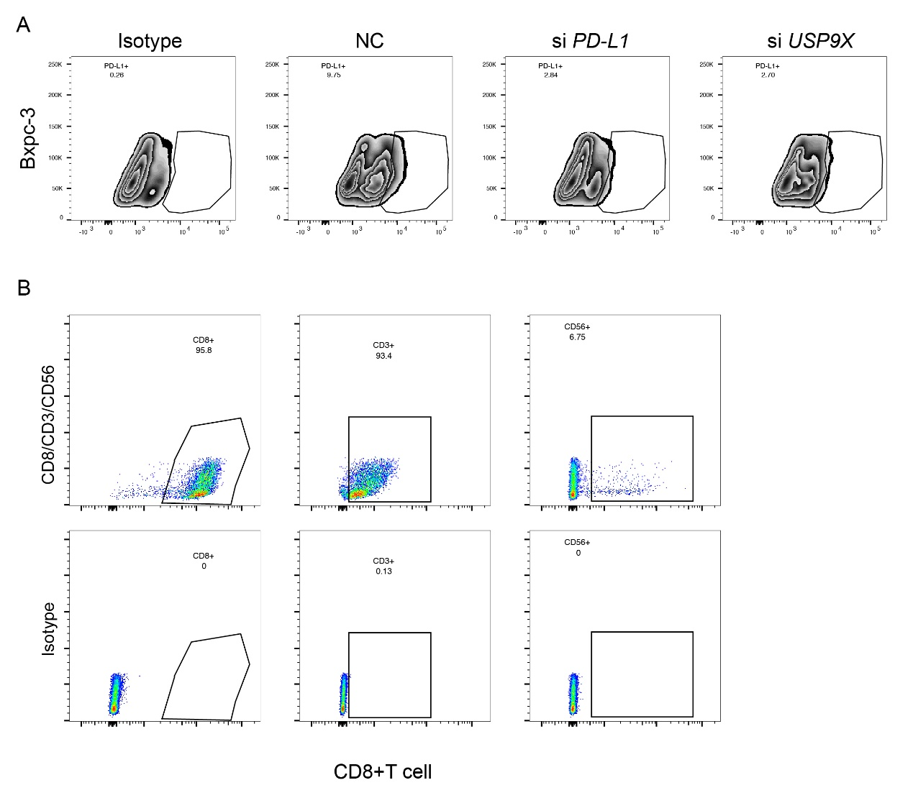

Figure S2 Inhibition of USP9X enhanced the anti-tumor effect of T cells
A. Targeted intervention of related protein expression in PDAC.
B. Sorting and identification of CD8⁺ T cell. Peripheral blood T cells were activated by CD3/CD28 stimulation in vitro and identified by flow cytometry.

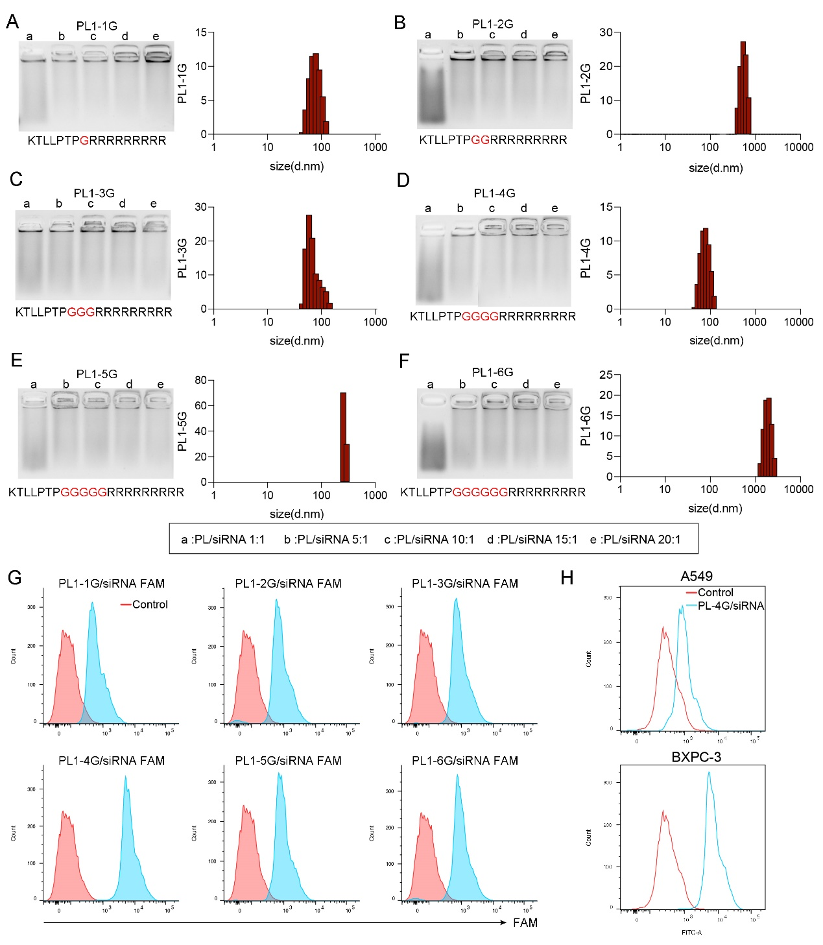
Figure S3 Characterization of peptide nanoparticles
A-F. Binding sizes of peptides with different lengths to siRNA.
G. Fluorescence intensity of different binding peptides.
H. Transfection efficiency of self-assembling peptides in various cell types.

