Supplementary Information

Kirchhoff’s Current Law Under Parallel Temperature Gradient: The Fundamental Principle Governing Thermoelectric Generator
Zong-wei Zhang†^{1, 2}, Jian-feng Cai†^{1, 2}, Chuan-dong Zhou¹, Zhe Guo^{1, 2}, Qiang Zhang^{1, 2}, Jin-qu Feng¹, Ai-long Yang¹, Chen-hao Han¹, Zhou-min Jiang¹, Guo-qiang Liu^{1, 2*}, Jun Jiang^{1, 2*}
¹Ningbo Institute of Materials Technology and Engineering, Chinese Academy of Sciences, Ningbo 315201, China.
²Center of Materials Science and Optoelectronics Engineering, University of Chinese Academy of Sciences, Beijing 100049, China.
†These authors contributed equally.
*Corresponding authors
Guo-Qiang Liu: liugq@nimte.ac.cn;
Jun Jiang: jjun@nimte.ac.cn

Content
1. Materials and Methods;
2. Thermoelectric properties of P-type PbTe materials;
3. Thermoelectric properties of N-type PbTe materials;
4. Fabrication of PbTe TE legs;
5. Interface characterization of the n-type PbTe TE leg;
6. Interface characterization of the p-type PbTe TE leg;
7. The setup for single-leg thermoelectric conversion performance measurement;
8. Thermoelectric conversion performance of the P1 leg;
9. Thermoelectric conversion performance of the P4 leg;
10. Thermoelectric conversion performance of the P6 leg;
11. Thermoelectric conversion performance of the N1 leg;
12. Thermoelectric conversion performance of the N2 leg;
13. Thermoelectric conversion performance of the N5 leg;
14. The fabrication of PbTe TE modules;
15. Measurement setup for thermoelectric conversion performance of TE modules;
16. Thermoelectric conversion performance of the A_{p} = A_{n} module (P1, N1);
17. Thermoelectric conversion performance of the module (P1, N1);
18. Temperature-dependent thermoelectric conversion performance of A_{p} = A_{n} module and module (P1, N1);
19. Reproducibility verification of the thermoelectric conversion performance of the A_{p} = A_{n} module (P1, N1);
20. Short-circuit current for four A_{p} = A_{n} modules (P1, N1) composed of P1 leg and N1 leg;
21. Thermoelectric conversion performance of the (P1, N2) module;
22. Thermoelectric conversion performance of the (P6, N2) module;
23. Thermoelectric conversion performance of the (P4, N5) module;
24. Optical image of the thermoelectric module (P6, N5);
25. Thermoelectric conversion performance of the A_{p} = A_{n} module (P6, N5);
26. Thermoelectric conversion performance of the power optimized module (P6, N5);
27. Thermoelectric conversion performance of the efficiency optimized module (P6, N5);
28. Temperature-dependent open-circuit voltage and short-circuit current for the A_{p} = A_{n} module, the power-optimized module, and the efficiency-optimized module (P6, N5);
29. Setting parameters for the finite element simulation of the TE module;
30. Simulation of thermoelectric conversion performance for single leg;
31. Simulation of thermoelectric conversion performance for P1-N1 couple;
32. Simulation of temperature distribution on TE legs and P-N couple under short-circuit condition;
33. Method for calculating the voltage distribution in the thermoelectric leg for the single-leg and TE-couple models;
34. Average zT and short-circuit current of PbTe thermoelectric materials;
35. Reported efficiencies and average zT values of representative PbTe-based thermoelectric modules;
36. References

- Materials and Methods
Raw materials
Pb (pieces, 99.99%, Alfa Aesar), Te (pieces, 99.999%, Alfa Aesar), Na (pieces, 99.95%, Alfa Aesar), Sr (pieces, 99.99%, Alfa Aesar), Ga (pieces, 99.99%, Alfa Aesar), Ge (pieces, 99.99%, Aladdin), Se (shots, 99.99%, Aladdin), Mn (pieces, 99.99%, Aladdin), Cu (power, 99.99%, Aladdin), S (pieces, 99.999%, Aladdin), In (shots, 99.99%, Aladdin), PbI₂ (powder, 99.99%, Aldrich), Ag (powder, 99.99%, Aladdin).
Synthesis
The raw elements were weighed according to the nominal stoichiometry and sealed in quartz tubes. The tubes containing raw elements were flamesealed under a high vacuum of 10⁻⁴ Pa. For N-type PbTe, the quartz tubes were then heated to 1323 K for 12 h and held at this temperature for 6 h before furnace cooling. For p-type materials, the tubes containing raw elements were then held at 1323 K for 6 h before being quenched in water. The cooled ingots were annealed at 873 K for three days. After melting, the ingots of n-type PbTe were ground into powder by hand for 10 min and then sintered by hot-pressing at 823 K under a pressure of 50 MPa for 5 min to obtain a high-density (>98%) bulk material. The ingots of P-type PbTe were ground into powder by hand for 10 min in glove box and then sintered by hot-pressing at 823 K under a pressure of 60 MPa for 10 min to obtain a high-density (>97%) bulk material.
Thermoelectrical performance characterization
The efficiency of a thermoelectric (TE) material is defined by the dimensionless figure of merit zT = S²σT/κ, where S is the Seebeck coefficient, σ is the electrical conductivity, T is the operational temperature and κ is the thermal conductivity, composed of the electronic contribution (κ_{el}) and lattice contribution (κ_{lat}). The as-prepared PbTe material was cut into a rectangular bar (3 × 3 × 12 mm³) and a disk (12.7 mm in diameter, 2 mm thick) for electrical and thermal property measurements, respectively. The sample’s electrical conductivity and Seebeck coefficient were assessed using the ULVAC-RIKO ZEM-3 instrument (Japan) in a controlled helium atmosphere, with measure ments taken over a temperature range of 300 K to 850 K. To prevent volatilization at high temperatures, which could interfere with the measurements, the sample surface and the probe contact positions were coated with boron nitride spray. The thermal conductivity (κ) was calculated using the equation κ = ρDC_{p}, where ρ represents the density obtained through the Archimedes method, D represents the thermal diffusivity measured using a laser flash apparatus (Netzsch LFA 457), and C_{p} is the specific heat measured by a differential scanning calorimetry thermal analyzer (Netzsch, DSC 404 F3).
Interface analysis and characterization
The microstructure was investigated by scanning electron microscopy (SEM, Quanta FEG 250, FEI). The phase composition was characterized using an energy-dispersive spectrometer attached to the scanning electron microscope. The contact resistivity (ρ_{c}) of the junctions was measured using a homemade four-probe measurement system (FYDZ-15). The probe moved from one end of the contact metal layer to the other across the contact interface while a series of voltages were recorded using an alternating current of 100 mA passing through the junctions. The ρ_{c} is defined as: , where A is the area of the cross section, V_{jump} is the voltage jump, I is the test current and R_{c} is the contact resistance at the interface.
Module fabrication
Two composite structures are designed for the thermoelectric legs: Ni/N-type PbTe/FeSb and Ni/P-type PbTe/SnTe/FeSb. During fabrication, PbTe, FeSb, and SnTe powders are first co-sintered via hot pressing, with FeSb serving as the high-temperature-side barrier layer of the thermoelectric legs. The sintered billet has a diameter of 20 mm and a height slightly exceeding 10 mm. The low-temperature side is trimmed by electrical discharge machining (EDM) to precisely control the total thickness to 10 mm. Subsequently, a Ni layer is electroplated on the low-temperature side to construct the low-temperature interface. After electroplating, the billet is diced into thermoelectric legs of the designed dimensions, and the height error of the legs fabricated by this process can be controlled at the micrometer level (see Fig. S3).
The module assembly process is illustrated in Fig. S13. A 20 mm × 20 mm direct bonded copper (DBC) substrate is adopted, with each substrate carrying 7 pairs of thermoelectric legs. Nano-silver paste is used as the high-temperature-side bonding medium, and the surface of the high-temperature-side copper plate is silver-plated to achieve reliable bonding. Sn42Bi58 solder is selected for the low-temperature side. Solder application is completed using a ball placement station, followed by precise assembly of the thermoelectric legs onto the copper-clad plate with a mold. Soldering is performed on a hot plate: the high-temperature side is directly in contact with the hot plate for heating, while the low-temperature side is heated via thermal conduction. The soldering temperature is set at 563 K, with a holding time of 10 min.
Finite element simulation
Finite element simulation analysis was conducted on the basis of material physical properties and artificially defined boundary conditions by COMSOL.¹ The properties of the thermoelectric materials were characterized, the properties of the structural materials (copper, alumina, etc.) were obtained from the default material database and the simulation boundary conditions were determined according to Table S1. By changing the load resistance value, the values of the output voltage U and the heat flow Q of the thermoelectric module under different currents can be obtained. The internal resistance R_{in}, output power P and conversion efficiency η can thus be calculated.
Efficiency measurements
The output power P and conversion efficiency η of the TE module under different temperature differences were measured in a vacuum using a homemade measurement system (Fig. S6 and S12). All data were recorded under near steady-state conditions after a period of thermal equilibrium. The internal resistance R_{in} can be obtained from the I–V characteristics. The current and voltage were directly measured using an electronic load. The voltage accuracy is 0.001 V, and the current accuracy is 0.0001 A. A Cu block with known thermal conductivity was used as a heat flow meter, while four tiny K-type thermocouple probes with a diameter of only 1.6 mm were embedded in the heat flow meter to measure the temperature drop along the heat flow direction (Fig. S6 and S12). The heat flow Q was estimated in accordance with the one-dimensional Fourier law. $Q_{out}=\frac{κ_{\text{Cu}}×A_{Cu}}{L_{Cu}}×T_{cu}$, where κ_{Cu}, A_{Cu}, ΔT_{Cu} and L_{Cu} are the thermal conductivity, cross-sectional area, temperature difference and vertical distance, respectively, of the heat flow meter. The cold-side temperature (T_{C}) was maintained at 293 K using a cooling system. A piece of graphite paper (0.2 mm thick) and thermal grease were used to improve the thermal conduction on the hot side between the heater and the module and on the cold side between the module and the heat flow meter. The module’s T_{H} and T_{C} were measured using a K-type thermocouple (1.6 mm in diameter) inserted into the heater and a K-type thermocouple wire (1.6 mm in diameter) placed at the interface between the module’s cold end and the heat flow meter.
- Thermoelectric properties of P-type PbTe materials
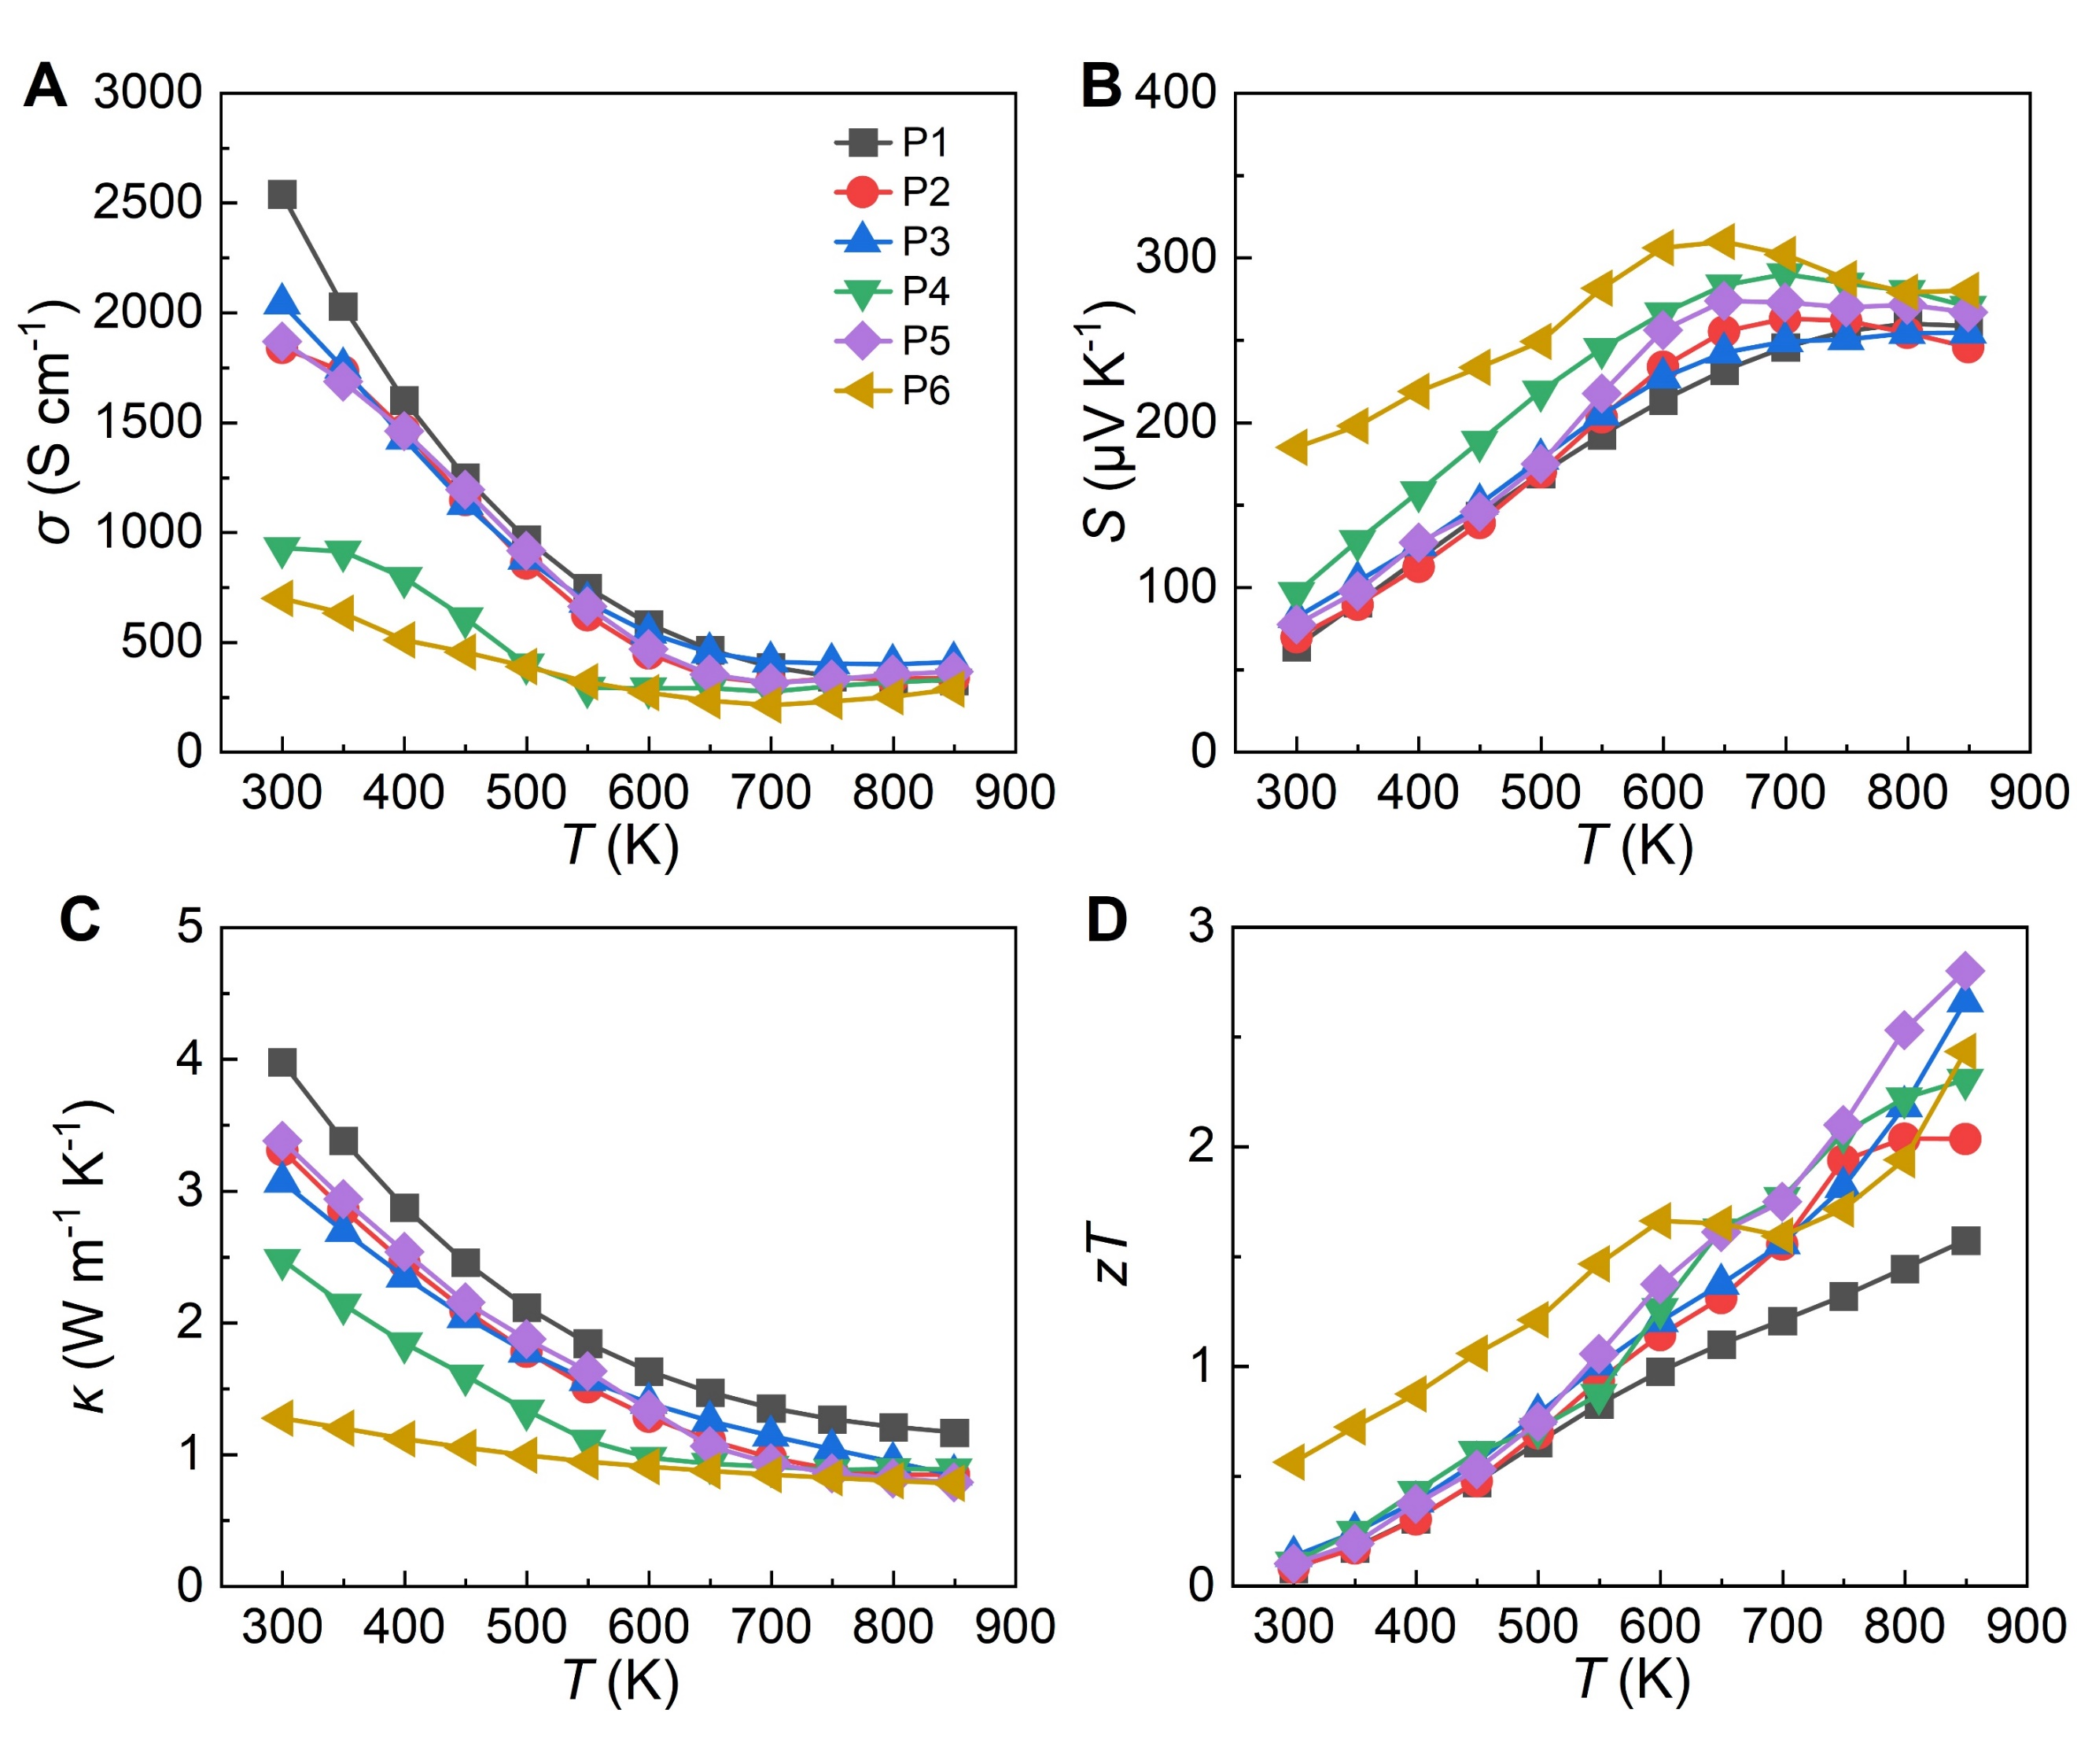
Fig. S1. Thermoelectric properties of P-type PbTe materials. P1: Pb_{0.98}Na_{0.02}Te, P2: Pb_{0.94}Na_{0.02}Mn_{0.04}Te_{0.8}S_{0.1}Se_{0.1}, P3: Pb_{0.97}Na_{0.02}Sr_{0.01}Te, P4: Pb_{0.95}Na_{0.04}Ge_{0.01}Te, P5: Pb_{0.98}Na_{0.02}Te+5wat.%AgInSe₂, P6: Pb_{0.89}Na_{0.02}Mn_{0.09}Te. Temperature-dependent (A) Seebeck coefficient, (B) electrical conductivity, (C) thermal conductivity, and (D) zT.
- Thermoelectric properties of N-type PbTe materials
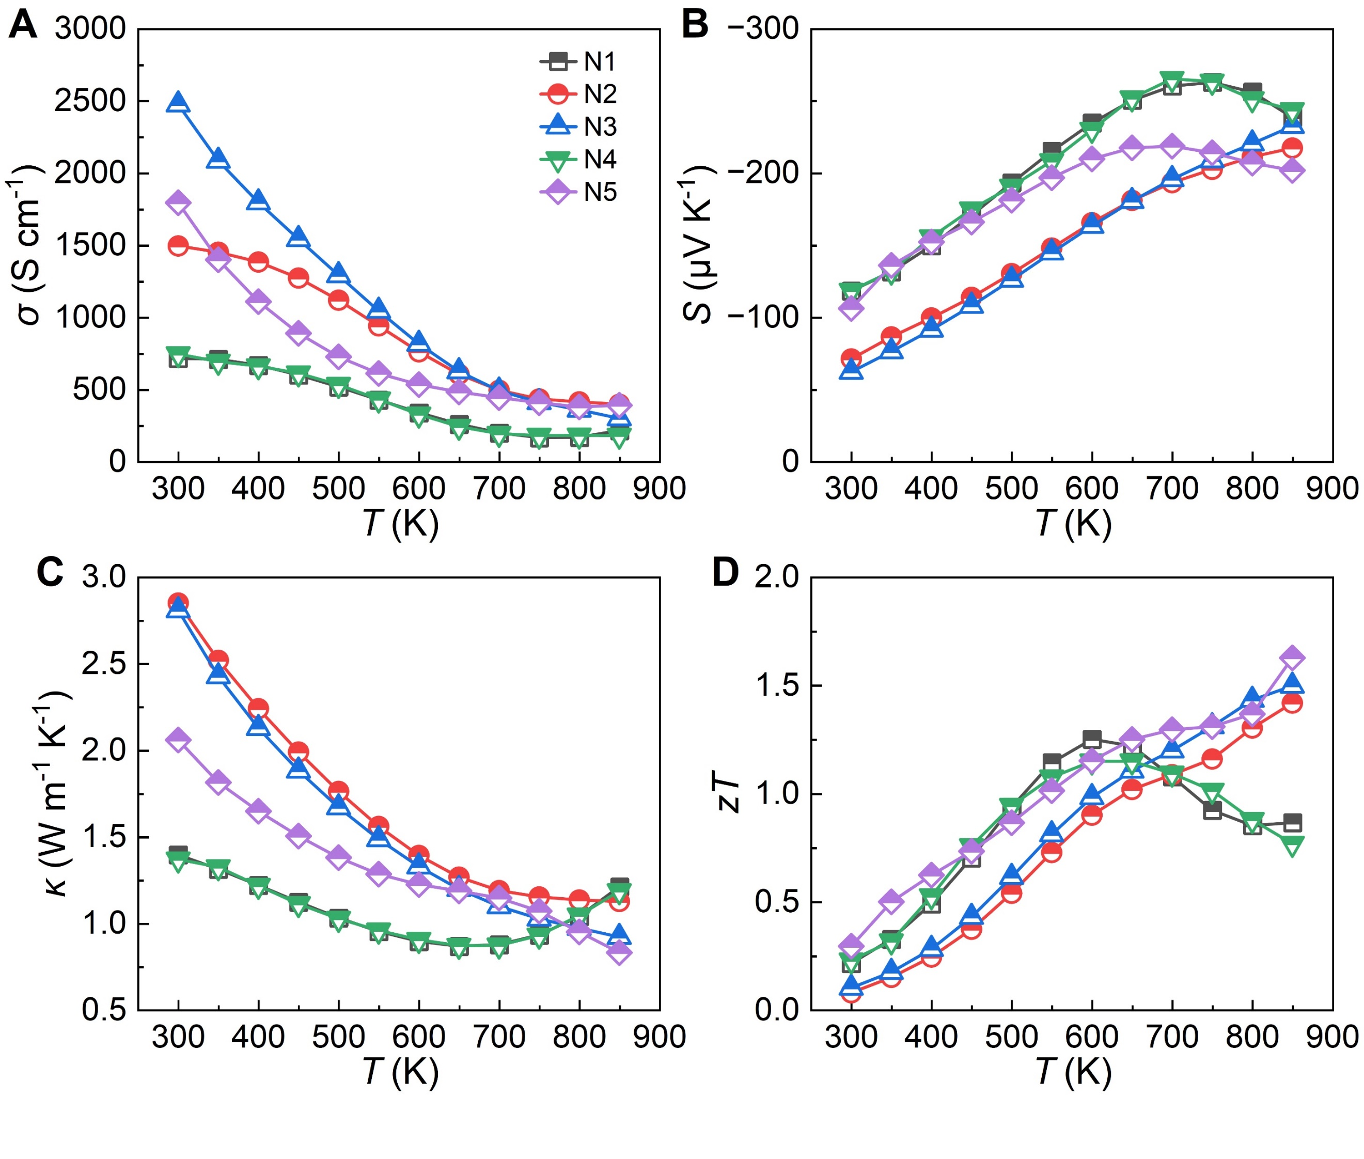
Fig. S2. Thermoelectric properties of N-type PbTe materials. N1: Pb_{0.87}Sb_{0.01}Ge_{0.12}Te, N2: Pb_{0.91}Sb_{0.01}Ge_{0.08}Te, N3: PbTe_{0.99}I_{0.01}, N4: Pb_{0.87}Ga_{0.01}Ge_{0.12}Te, N5: Pb_{0.93}Ge_{0.05}Cu_{0.02}Te_{0.96}Se_{0.04}. Temperature-dependent (A) Seebeck coefficient, (B) electrical conductivity, (C) thermal conductivity, and (D) zT.
- Fabrication of PbTe TE legs
Fig. S3. Fabrication process of PbTe TE legs. (A) Fabrication of the high-temperature side interface by induction sintering, where the p-type interface is PbTe–SnTe–FeSb and the n-type interface is PbTe–FeSb. The low-temperature side of the PbTe materials was cut by electrical discharge machining (EDM) to ensure identical heights for both p-type and n-type legs. Ni and Sn layers were electroplated on the low-temperature side. (b) Height statistics of the PbTe thermoelectric legs.
- Interface characterization of the n-type PbTe TE leg
Fig. S4. Characterization of interface morphology and contact resistivity of n-type PbTe TE legs. (A) The SEM image and EDX elemental maps of the n-type PbTe–FeSb interface. (B) Distance-dependent resistance of an n-type PbTe thermoelectric leg (3.5 mm × 3.5 mm × 10 mm). Inset: magnified view of the PbTe–FeSb interface showing the resistance jump.
- Interface characterization of the p-type PbTe TE leg
Fig. S5. Characterization of interface morphology and contact resistivity of p-type PbTe TE legs. (A) The SEM image and EDX elemental maps of the p-type PbTe–SnTe–FeSb interface. (B) Distance-dependent resistance of an p-type PbTe thermoelectric leg (3.5 mm × 3.5 mm × 10 mm). Inset: magnified view of the PbTe–SnTe–FeSb interface showing the resistance jump.
- The setup for single-leg thermoelectric conversion performance measurement
Fig. S6. Photograph of the thermoelectric legs and the four-probe measurement setup used for thermoelectric conversion efficiency testing. (A) PbTe thermoelectric leg, (B) Four-probe measurement setup for the thermoelectric conversion performance of a single leg.
- Thermoelectric conversion performance of the P1 leg
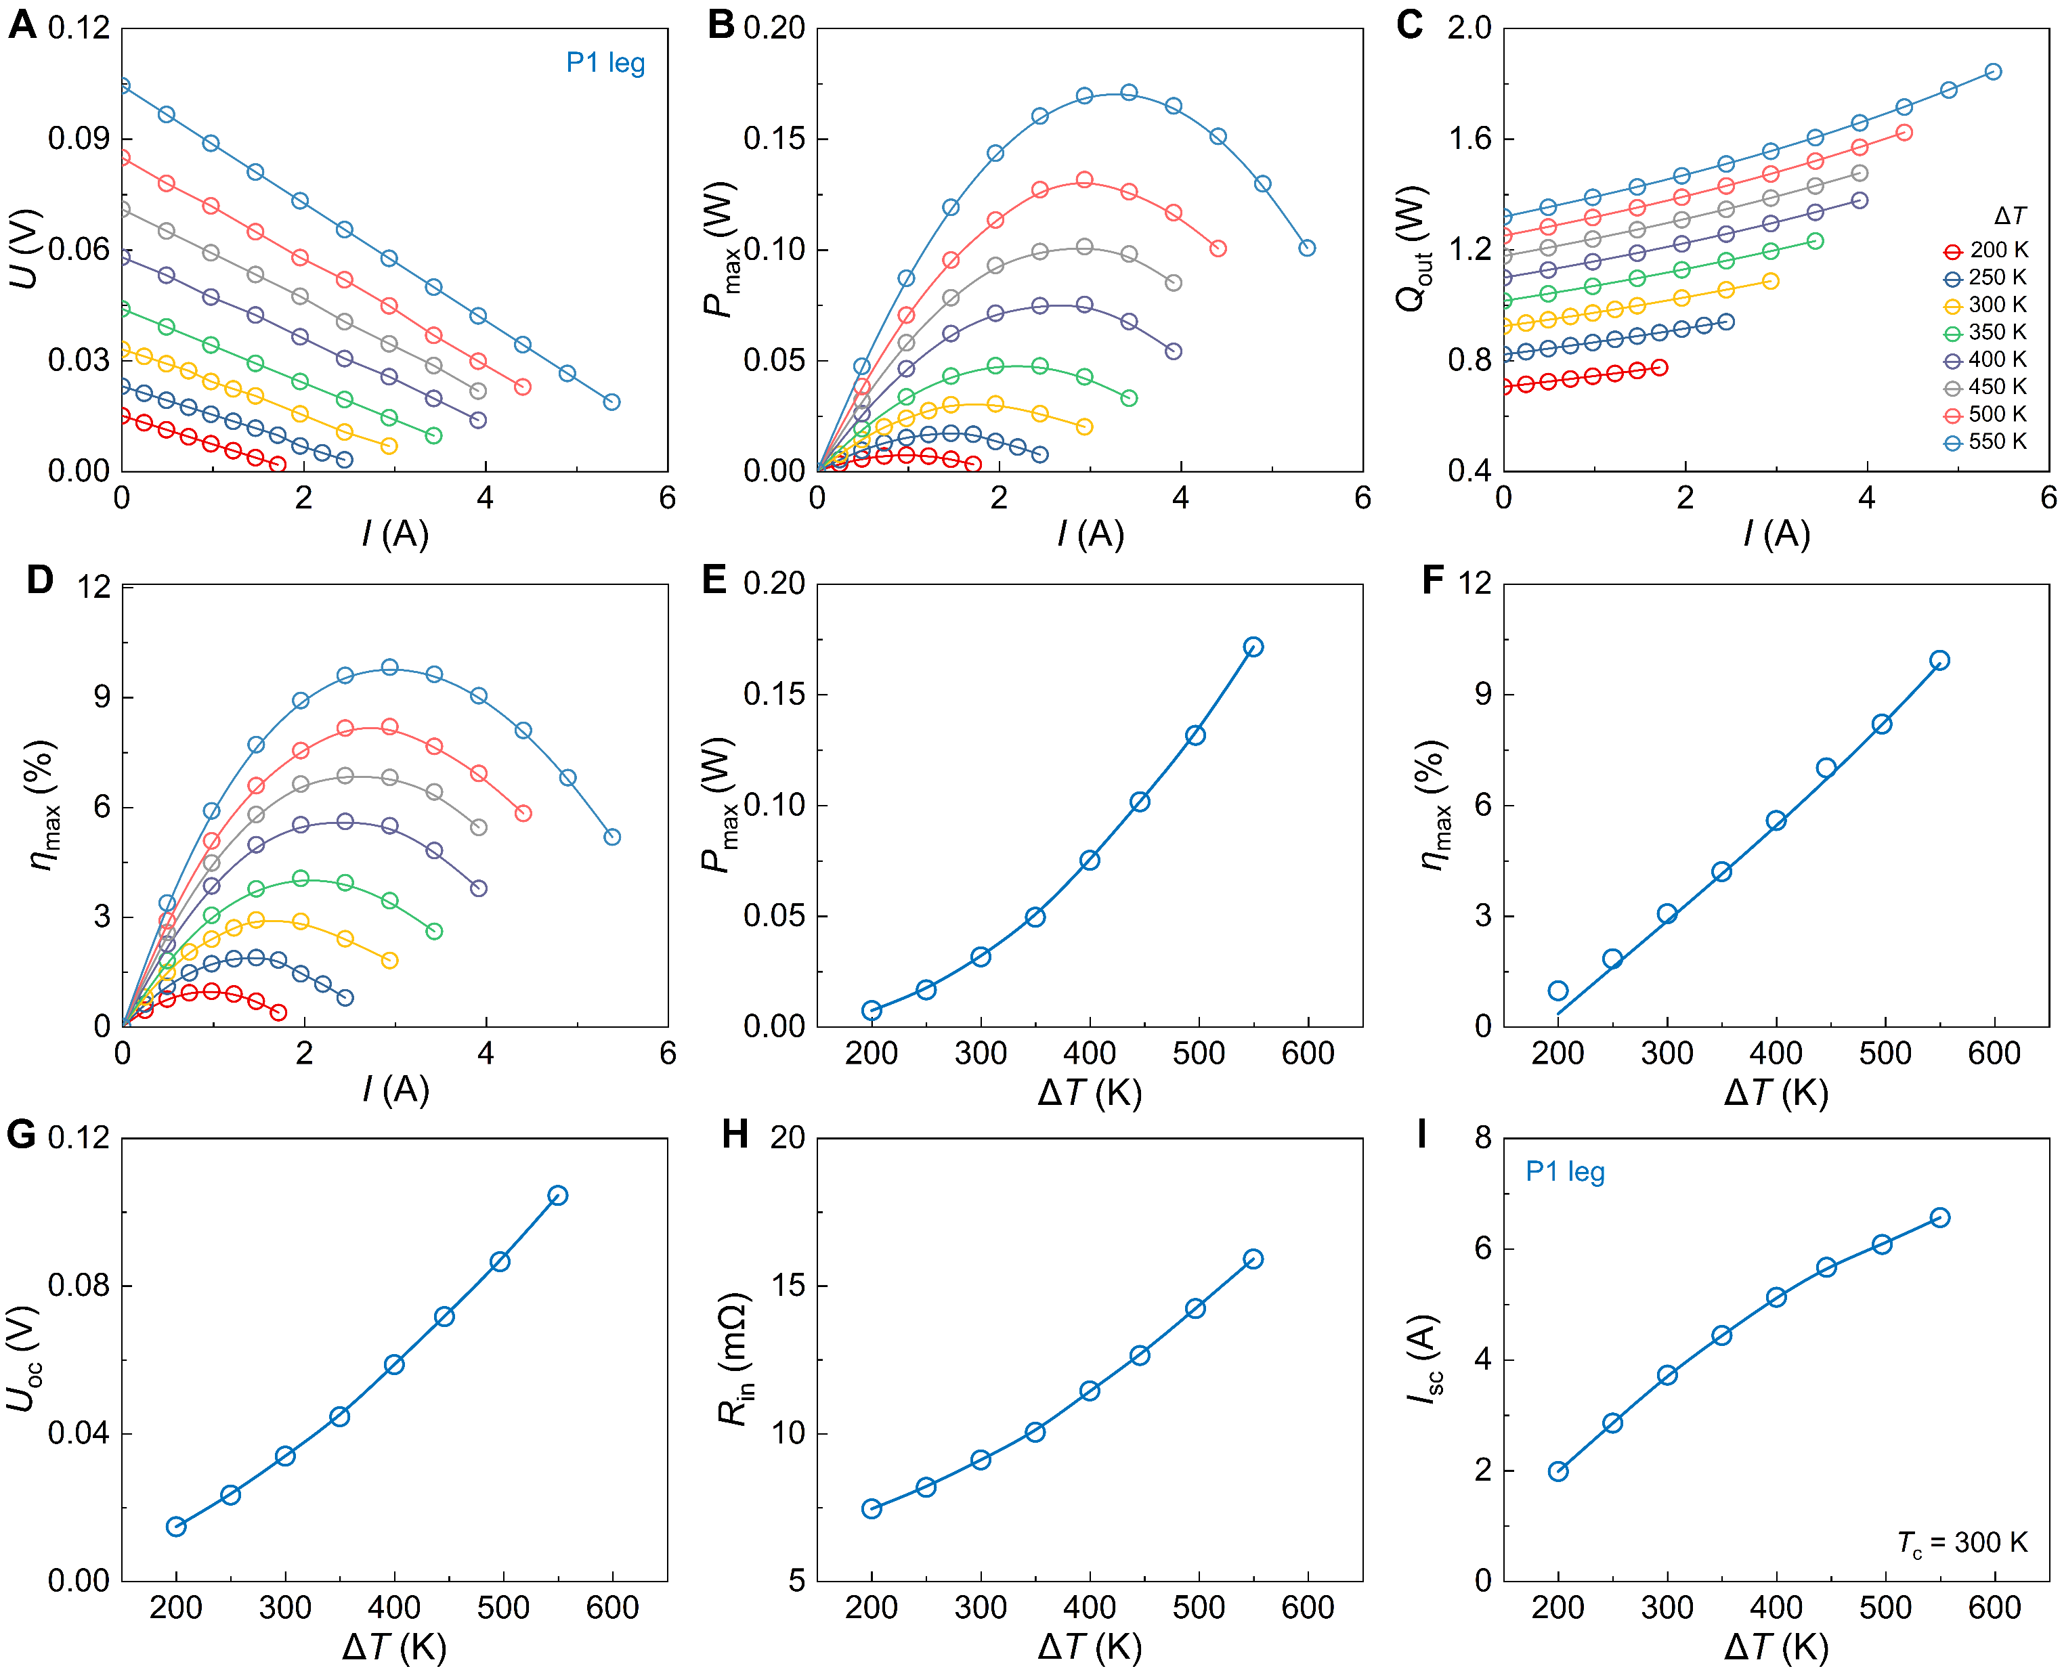
Fig. S7. Thermoelectric conversion performance of the P1 leg. (A) Current-dependent a. output voltage, (B) output power, (C) heat flux, and (D) conversion efficiency as functions of current at different temperature differences. (E) Maximum output power, (F) maximum efficiency, (G) open-circuit voltage, (H) internal resistance, and (I) short-circuit current as a functions of temperature difference.
- Thermoelectric conversion performance of the P4 leg;
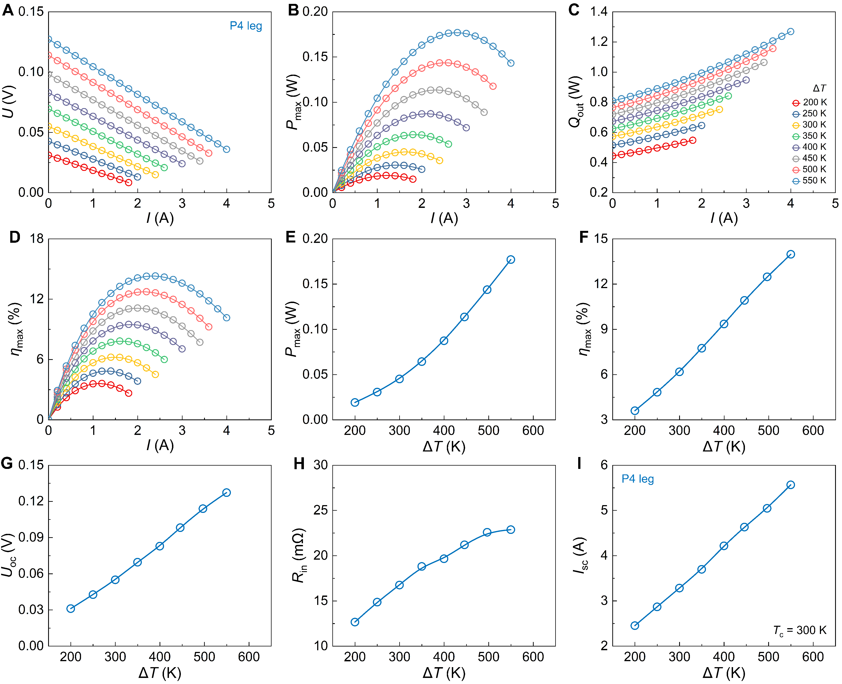
Fig. S8. Thermoelectric conversion performance of the P4 leg. (A) Current-dependent a. output voltage, (B) output power, (C) heat flux, and (D) conversion efficiency as functions of current at different temperature differences. (E) Maximum output power, (F) maximum efficiency, (G) open-circuit voltage, (H) internal resistance, and (I) short-circuit current as a functions of temperature difference.
- Thermoelectric conversion performance of the P6 leg
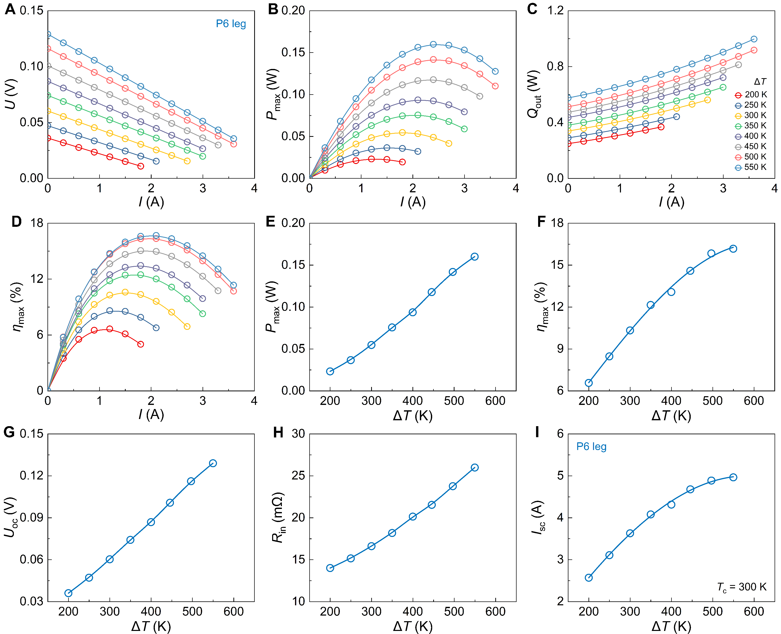
Fig. S9. Thermoelectric conversion performance of the P6 leg. (A) Current-dependent a. output voltage, (B) output power, (C) heat flux, and (D) conversion efficiency as functions of current at different temperature differences. (E) Maximum output power, (F) maximum efficiency, (G) open-circuit voltage, (H) internal resistance, and (I) short-circuit current as a functions of temperature difference.
- Thermoelectric conversion performance of the N1 leg
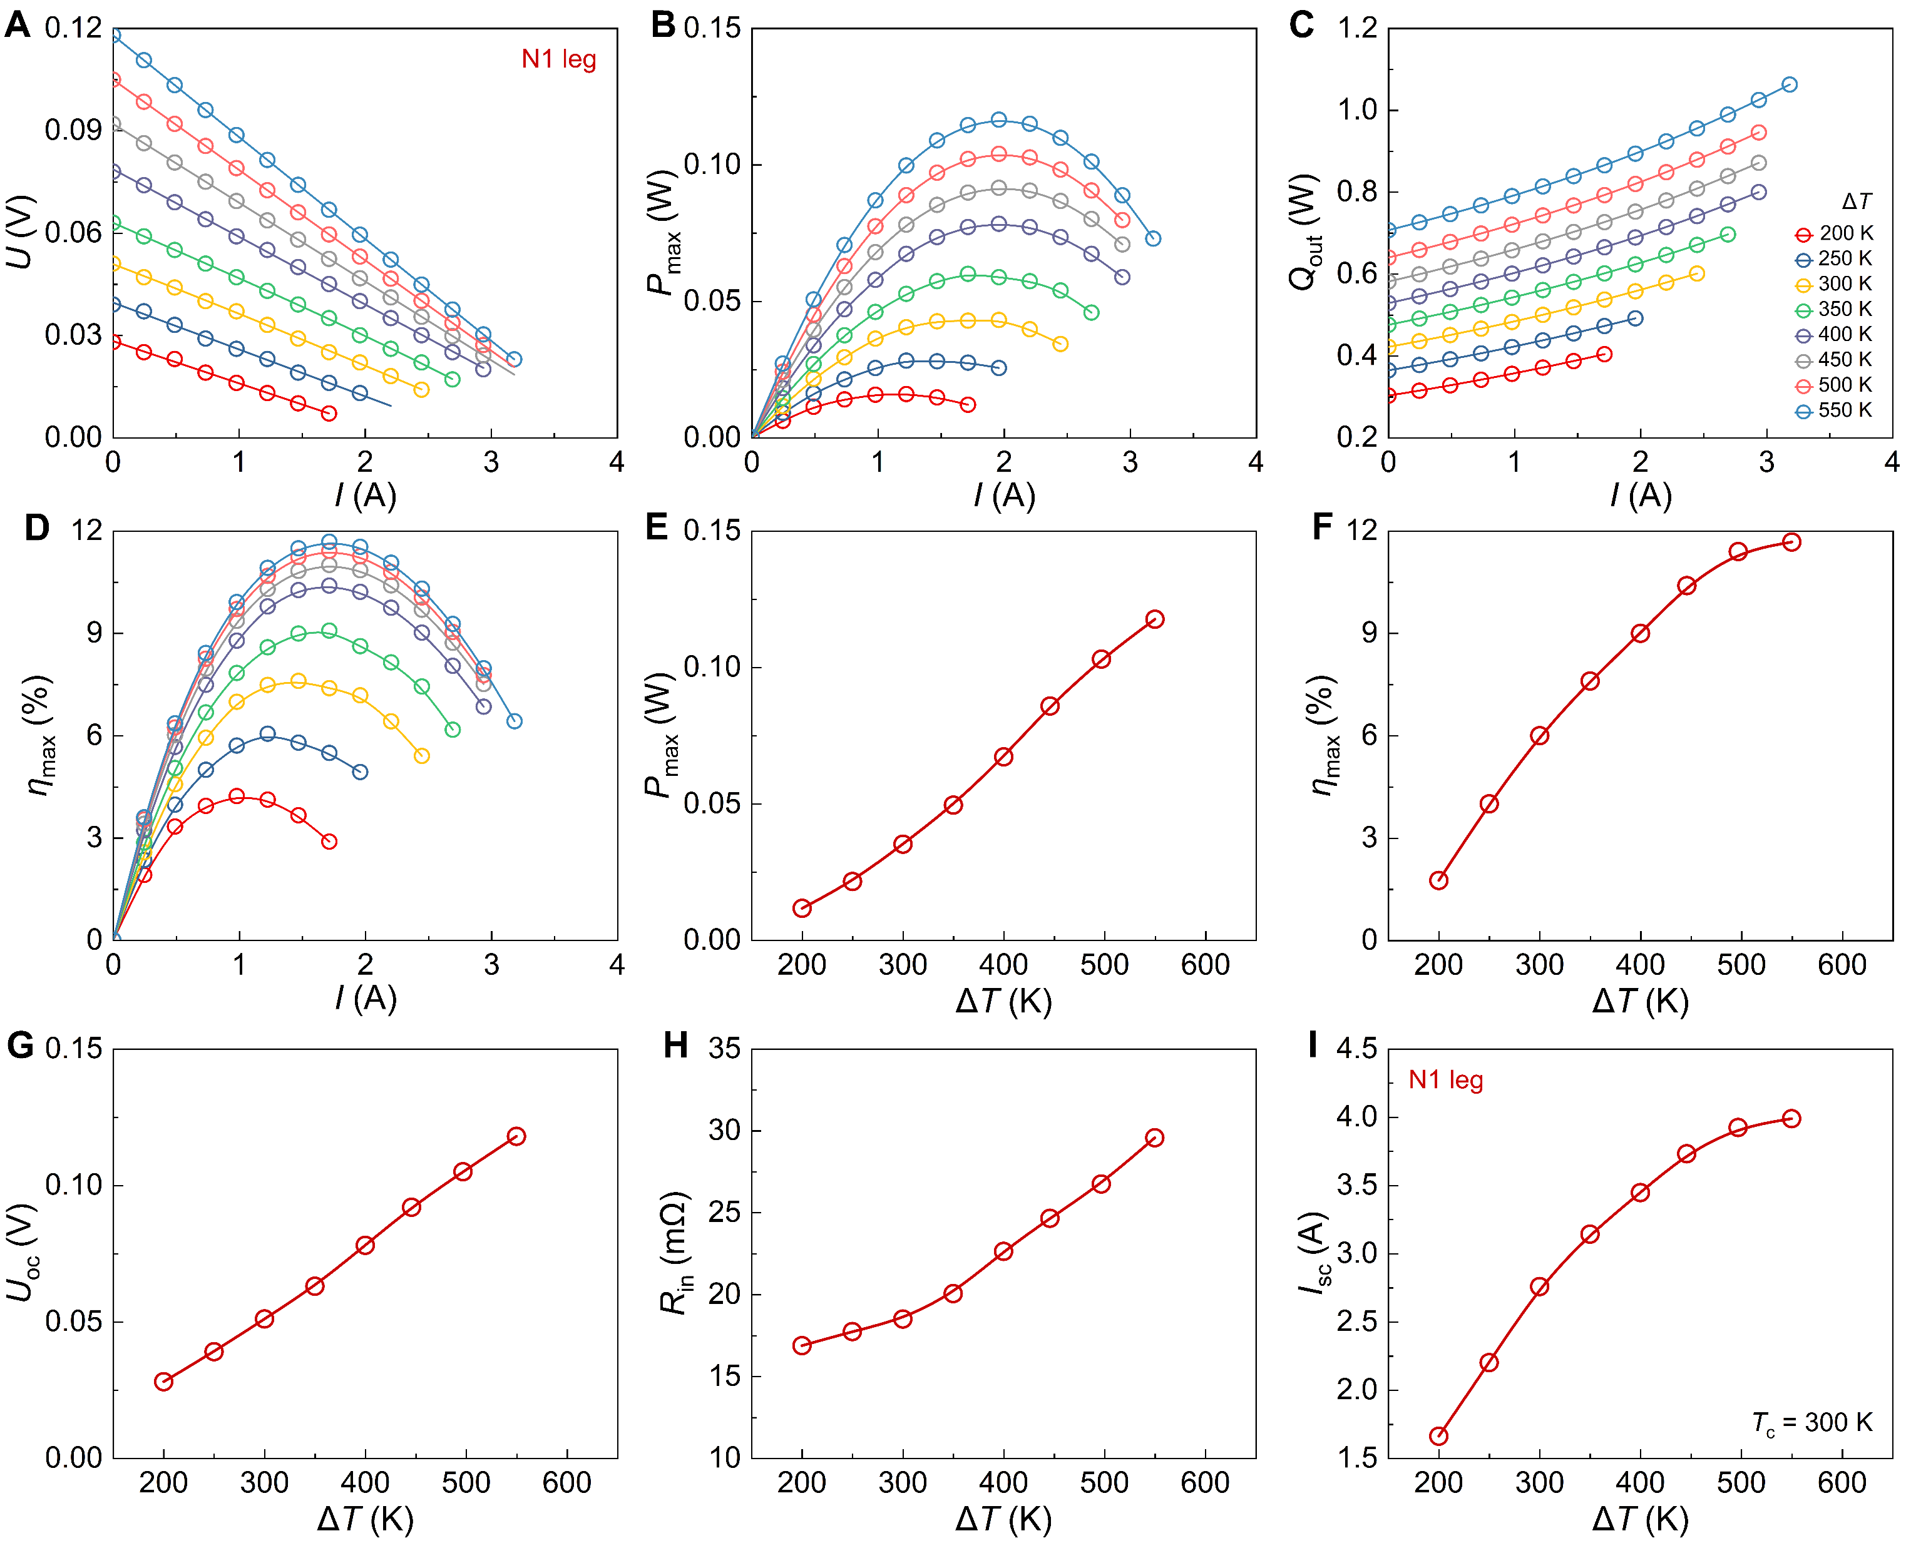
Fig. S10. Thermoelectric conversion performance of the N1 leg. (A) Current-dependent a. output voltage, (B) output power, (C) heat flux, and (D) conversion efficiency as functions of current at different temperature differences. (E) Maximum output power, (F) maximum efficiency, (G) open-circuit voltage, (H) internal resistance, and (I) short-circuit current as a functions of temperature difference.
- Thermoelectric conversion performance of the N2 leg
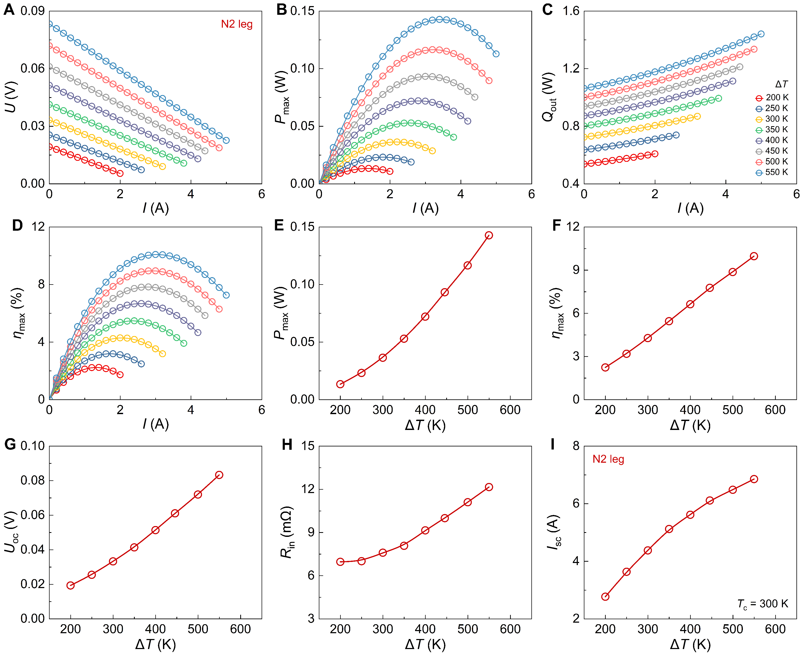
Fig. S11. Thermoelectric conversion performance of the N2 leg. (A) Current-dependent a. output voltage, (B) output power, (C) heat flux, and (D) conversion efficiency as functions of current at different temperature differences. (E) Maximum output power, (F) maximum efficiency, (G) open-circuit voltage, (H) internal resistance, and (I) short-circuit current as a functions of temperature difference.
- Thermoelectric conversion performance of the N5 leg
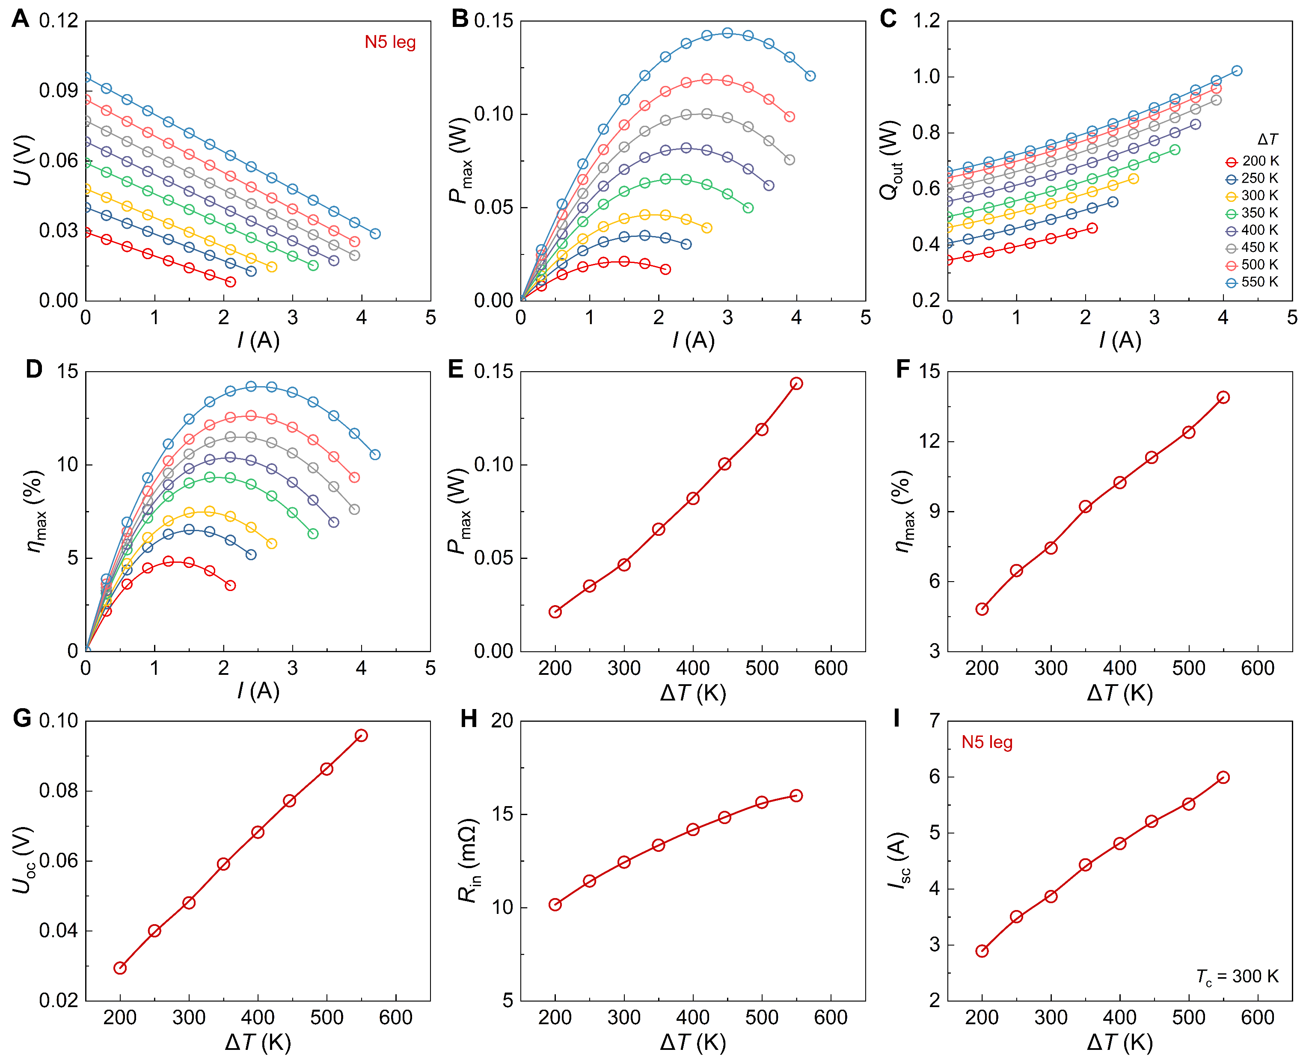
Fig. S12. Thermoelectric conversion performance of the N5 leg. (A) Current-dependent a. output voltage, (B) output power, (C) heat flux, and (D) conversion efficiency as functions of current at different temperature differences. (E) Maximum output power, (F) maximum efficiency, (G) open-circuit voltage, (H) internal resistance, and (I) short-circuit current as a functions of temperature difference.
- The fabrication of PbTe TE modules
Fig. S13. The fabrication of PbTe thermoelectric modules. (A) Direct Bonded Copper (DBC), 3 μm of Ag was deposited on the hot side. (B) Solder spreading. Silver nanoparticle paste (Ag NP paste) was used as the hot-side solder, and Sn42Bi58 was used as the cold-side solder. (C) Module assembly, in which an aluminum mount and a metal grid were employed as an alignment fixture to precisely position the thermoelectric legs onto the electrodes of the DBC substrates. (D) The soldering process was conducted using a soldering fixture placed on a hot plate at 563 K for 10 min.
- Measurement setup for thermoelectric conversion performance of TE modules
Fig. S14. Measurement setup for thermoelectric conversion performance of PbTe modules. (A) Experimental setup for thermoelectric conversion performance measurement. (B) The measured module. Its interior is filled with silica aerogel to block thermal radiation.
- Thermoelectric conversion performance of the A_{p} = A_{n} module (P1, N1);
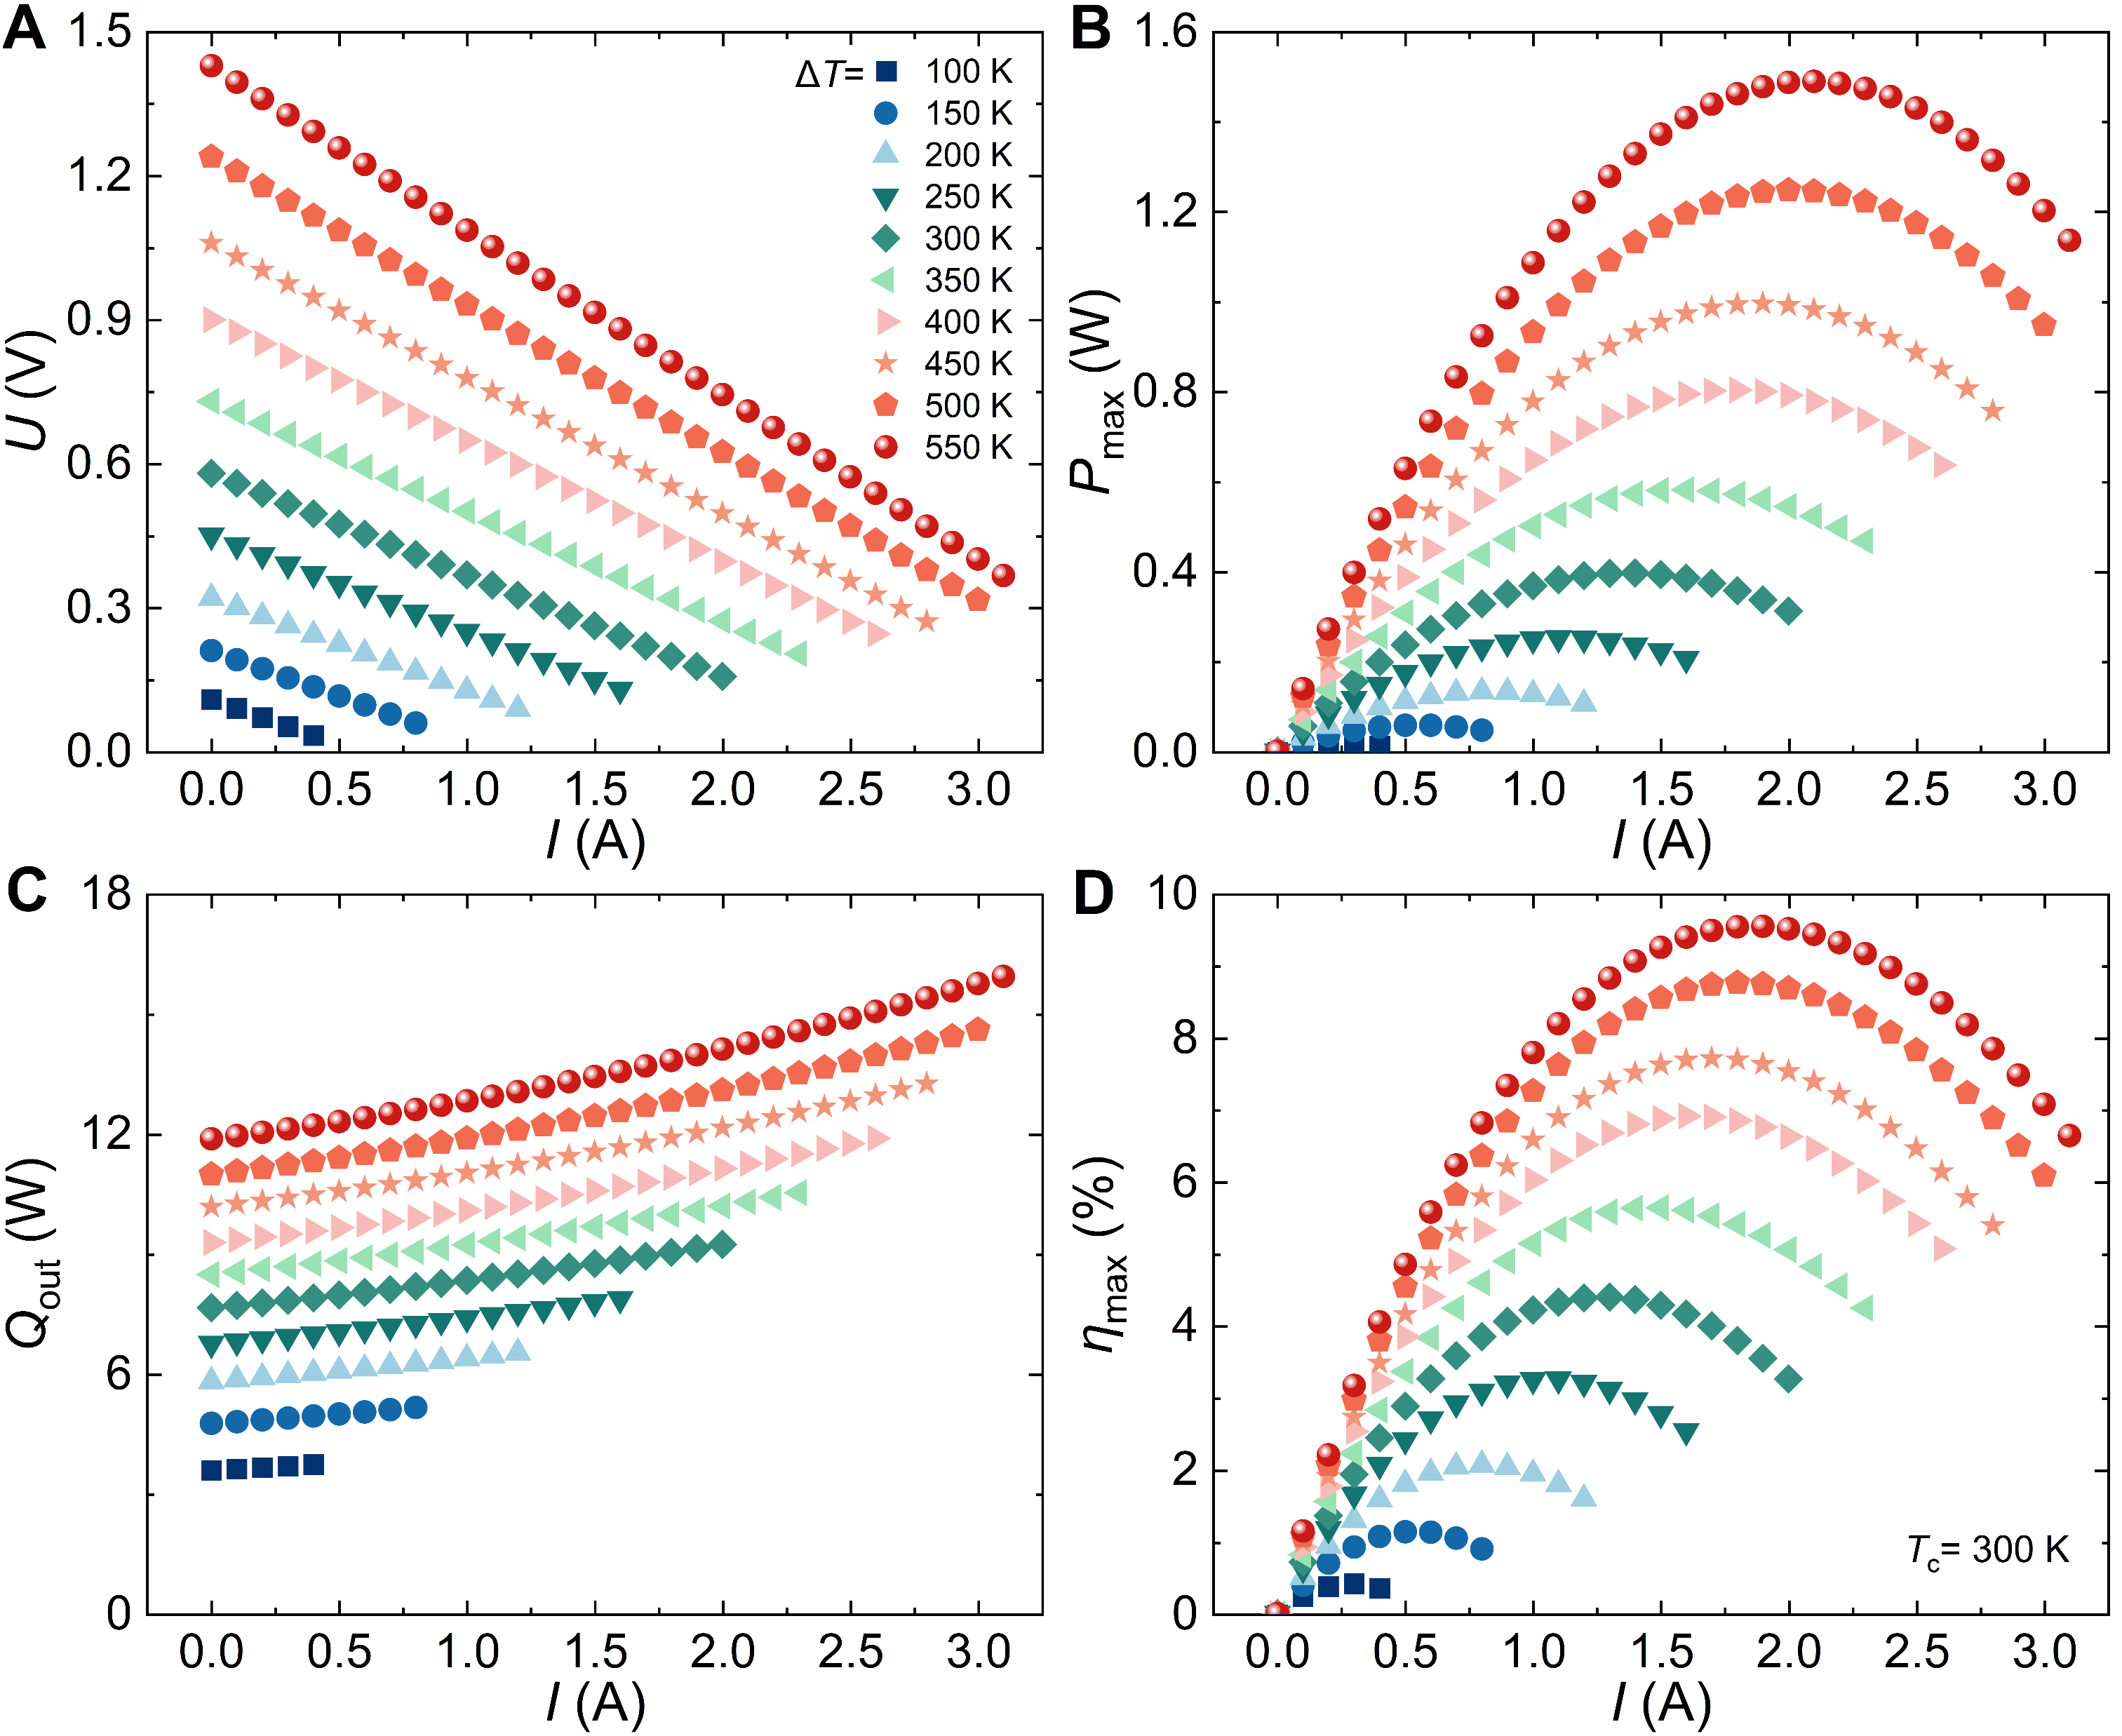
Fig. S15. Thermoelectric conversion performance of the A_{p} = A_{n} module (P1, N1). Current-dependent (A) output voltage, (B) output power, (C) heat flow, and (D) conversion efficiency under several temperature differences.
- Thermoelectric conversion performance of the module (P1, N1)
Fig. S16. Thermoelectric conversion performance of the module (P1, N1). Current-dependent (A) output voltage, (B) output power, (C) heat flow, and (D) conversion efficiency under several temperature differences.
- Temperature-dependent thermoelectric conversion performance of A_{p} = A_{n} module and module (P1, N1)
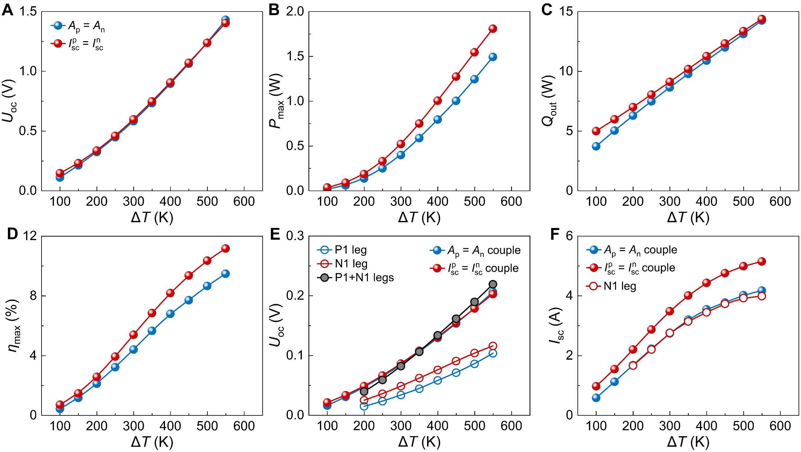
Fig. S14. Temperature-dependent thermoelectric conversion performance of A_{p} = A_{n} module and module (P1, N1). (A) Output voltage, (B) output power, (C) heat flow, (D) conversion efficiency, (E) output voltage of P1, N1, P1-N1 couple, (F) short-circuit current as functions of temperature difference.
- Reproducibility verification of the thermoelectric conversion performance of the A_{p} = A_{n} module (P1, N1)
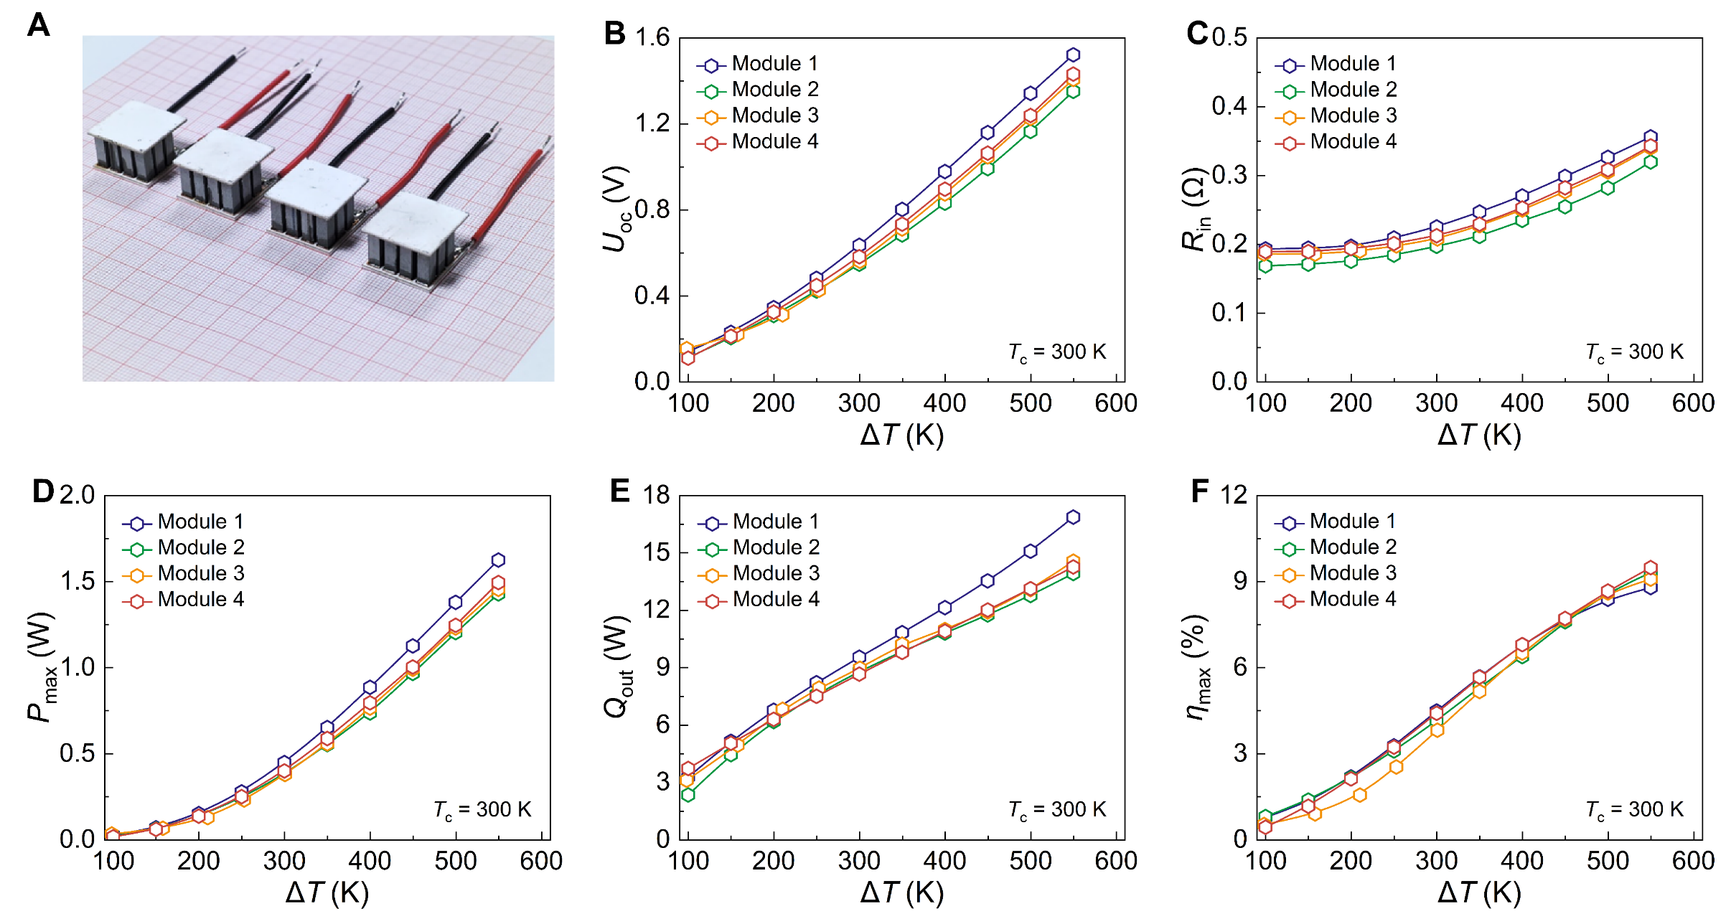
Fig. S15. Temperature-dependent thermoelectric conversion performance of four A_{p} = A_{n} modules (P1, N1). (A) Photograph of the module. (B). Output voltage, (C) internal resistance, (D) output power, (E) heat flow, and (F) conversion efficiency as functions of temperature difference.
- Short-circuit current for four A_{p} = A_{n} modules (P1, N1) composed of P1 leg and N1 leg
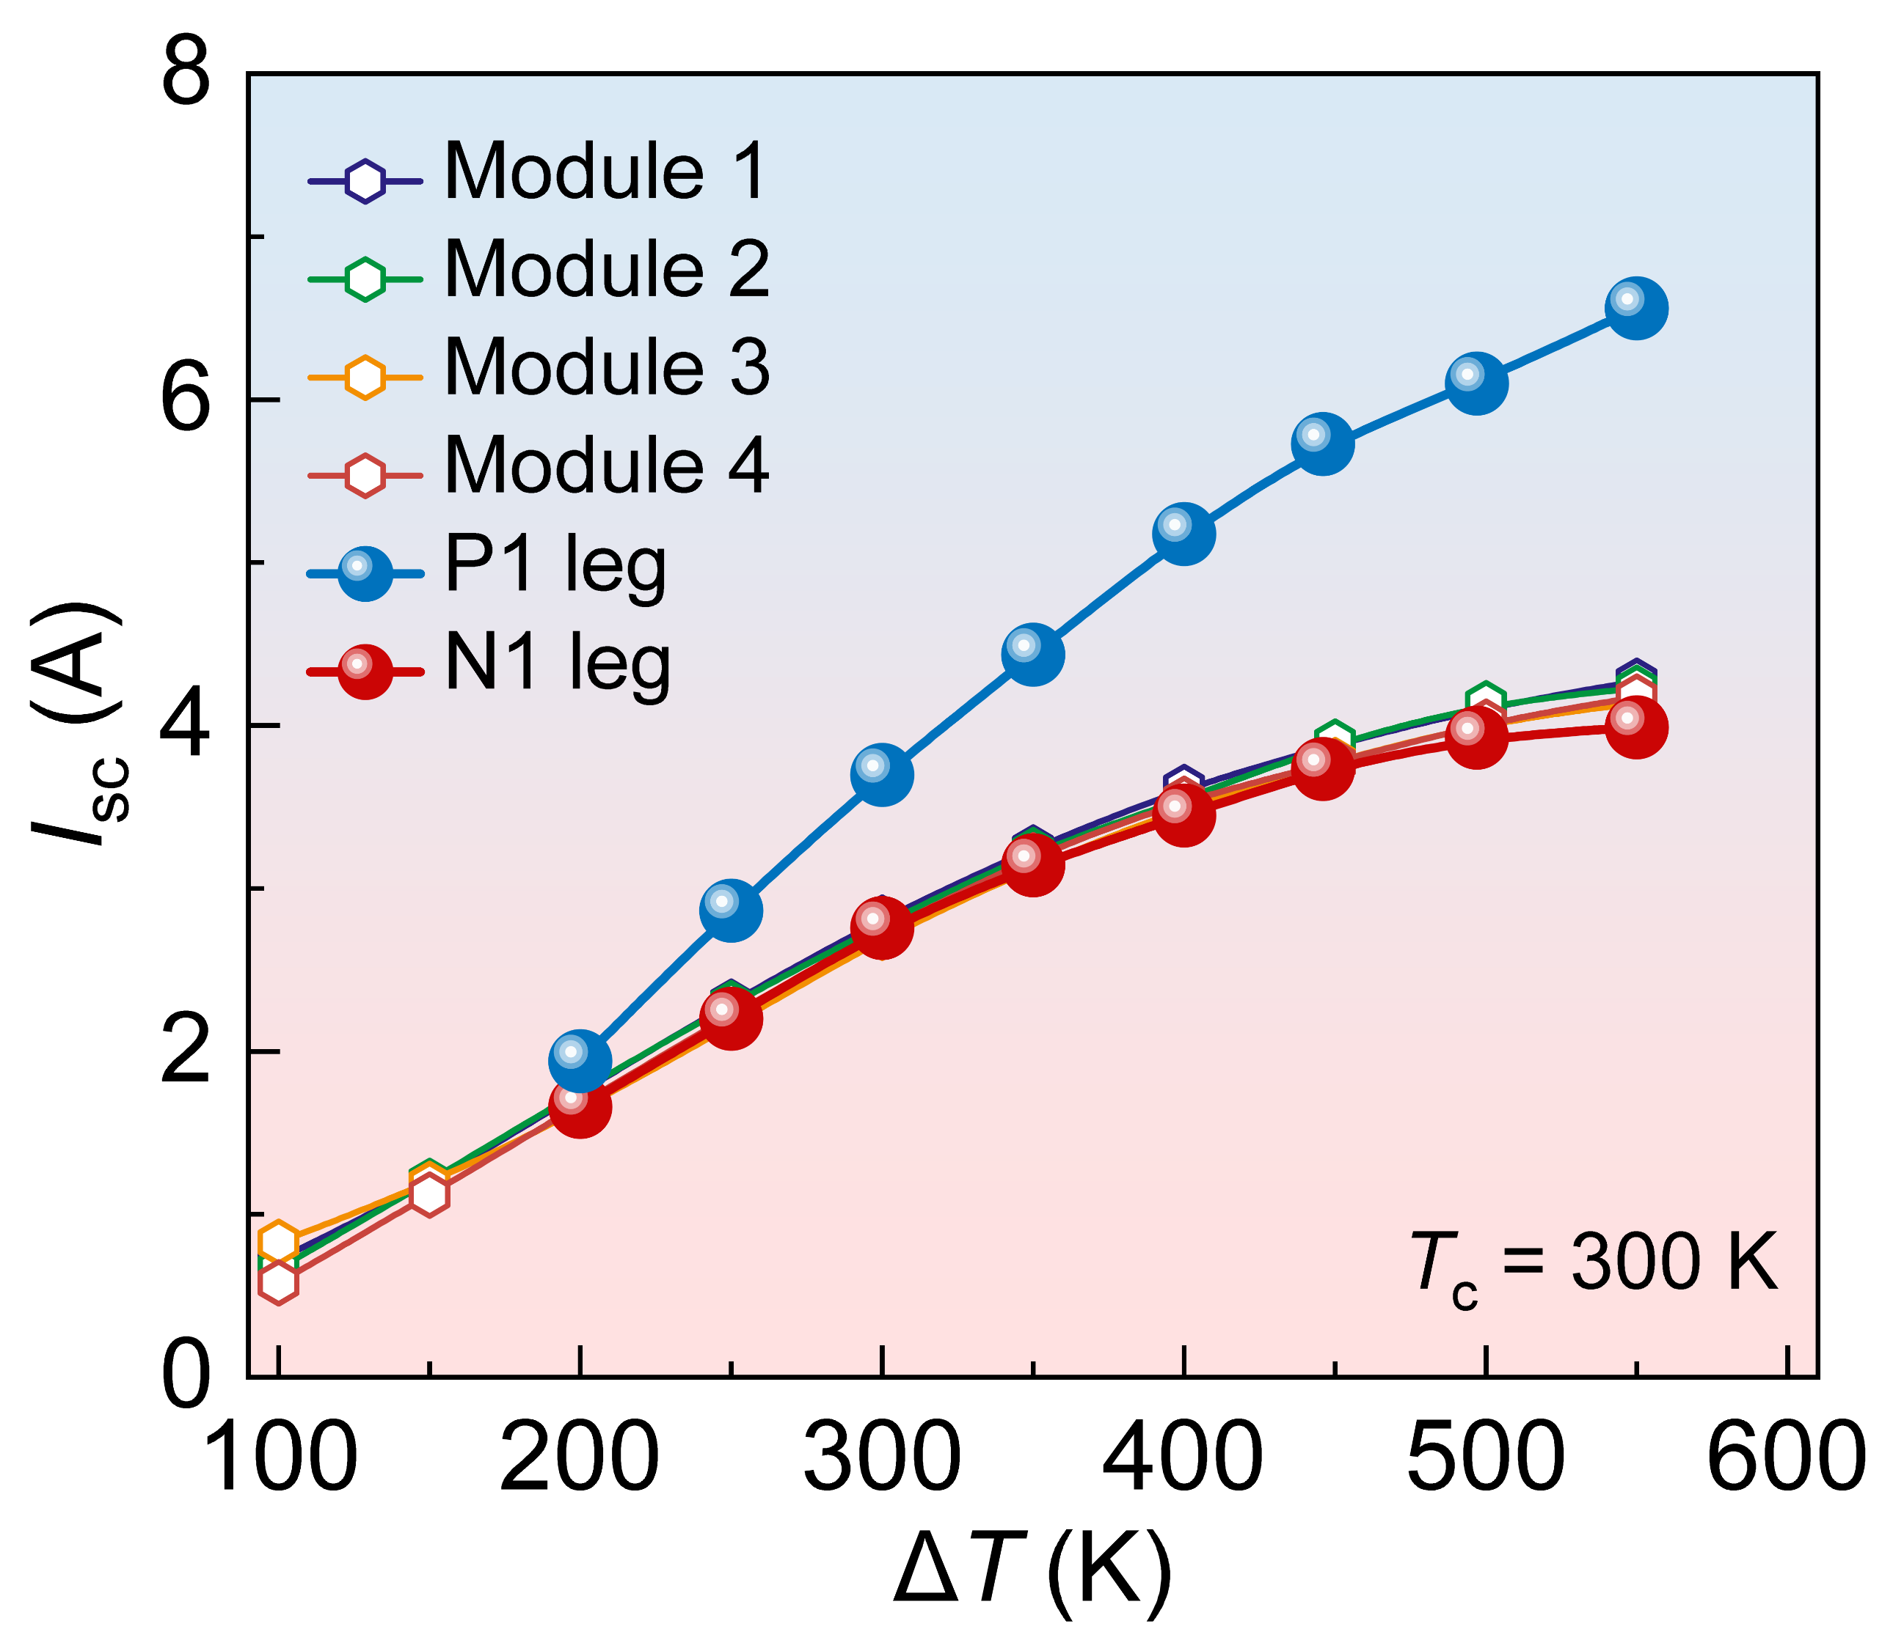
Fig. S16. Short-circuit current as a function of temperature difference for four A_{p} = A_{n} modules (P1, N1) composed of P1 leg and N1 leg.
- Thermoelectric conversion performance of the (P1, N2) module
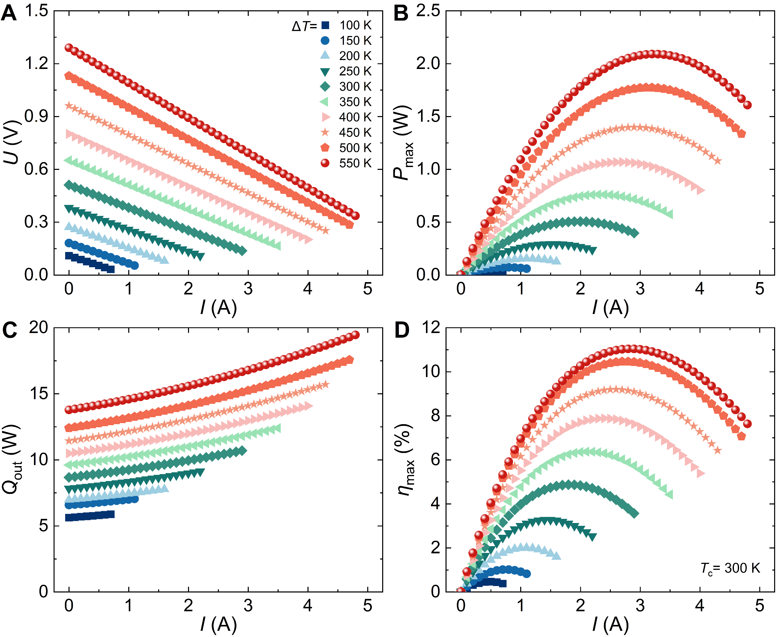
Fig. S17. Thermoelectric conversion performance of the (P1, N2) module. Current-dependent (A) output voltage, (B) output power, (C) heat flow, and (D) conversion efficiency under several temperature differences.
- Thermoelectric conversion performance of the (P6, N2) module
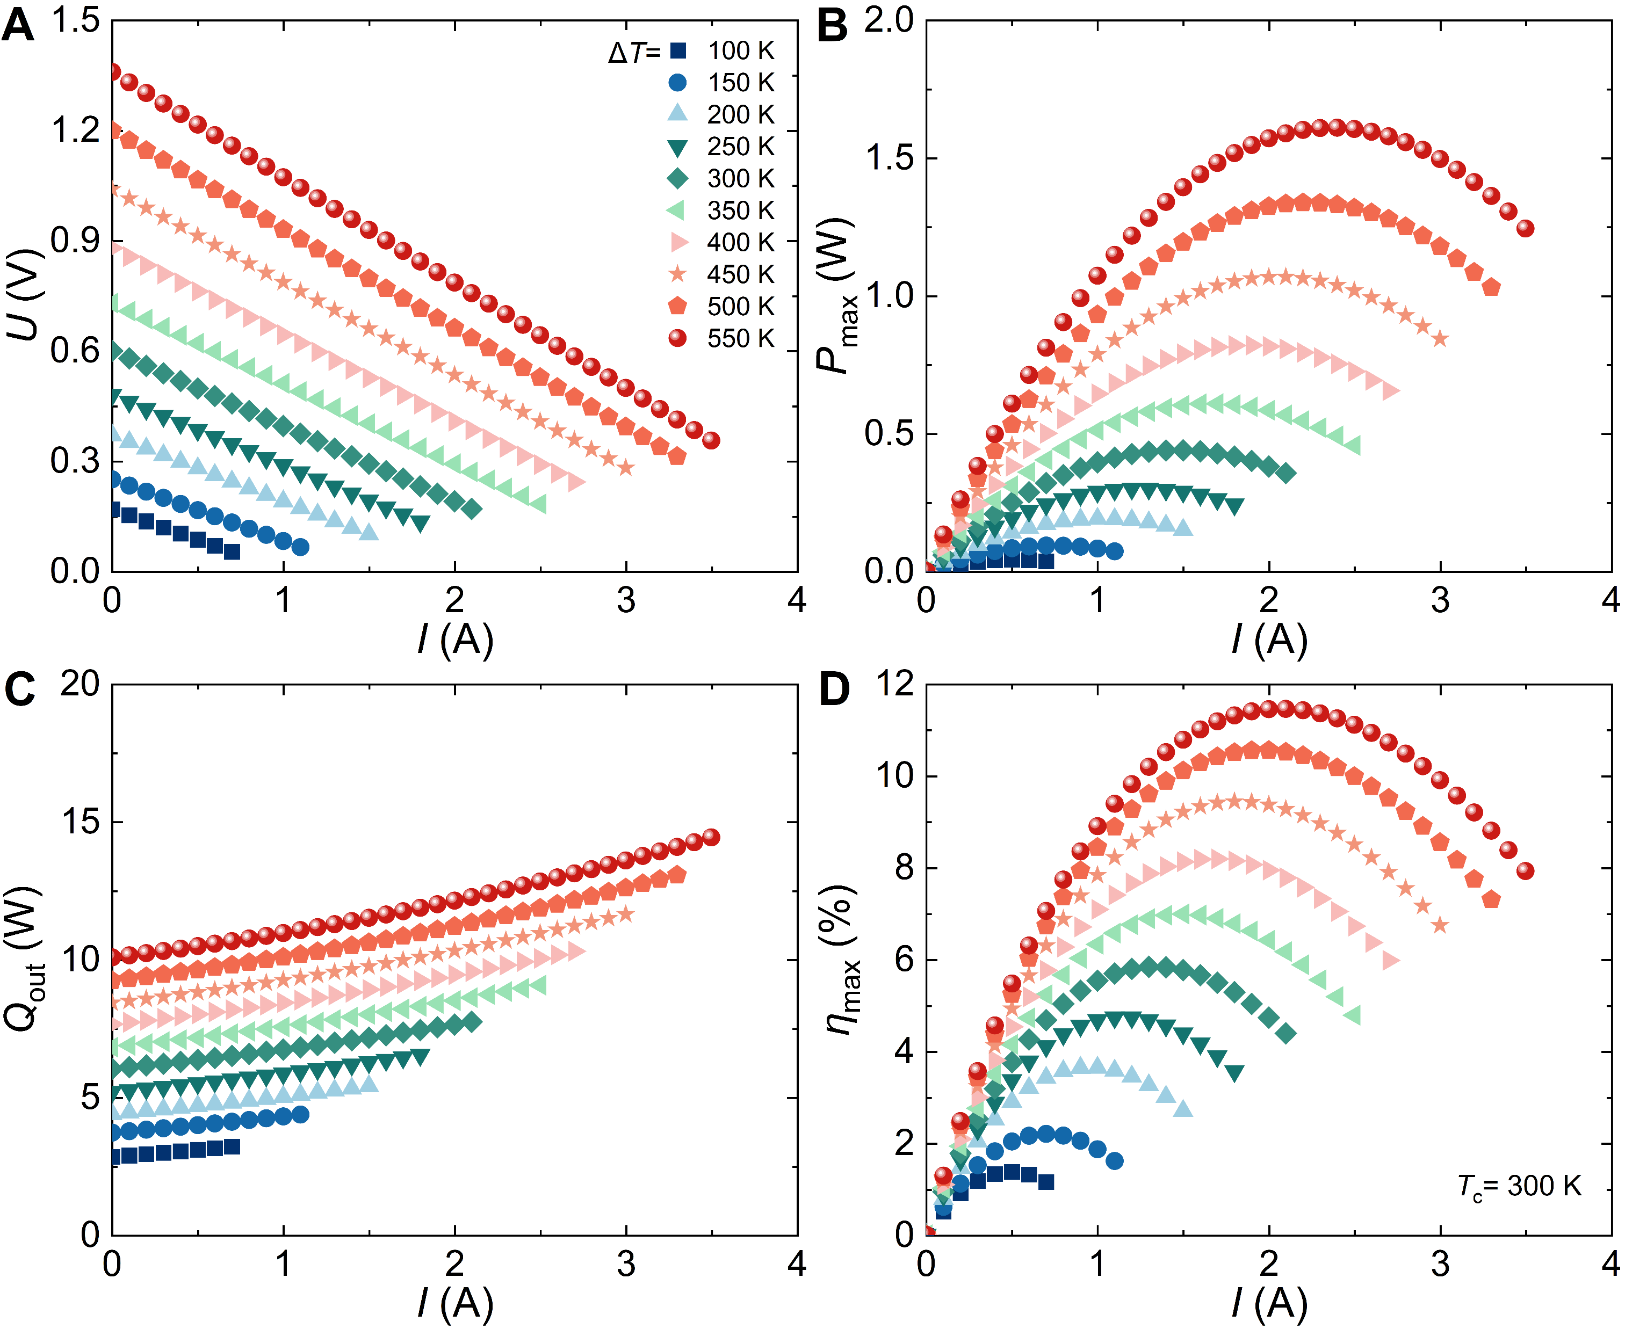
Fig. S18. Thermoelectric conversion performance of the (P6, N2) module. Current-dependent (A) output voltage, (B) output power, (C) heat flow, and (D) conversion efficiency under several temperature differences.
- Thermoelectric conversion performance of the (P4, N5) module
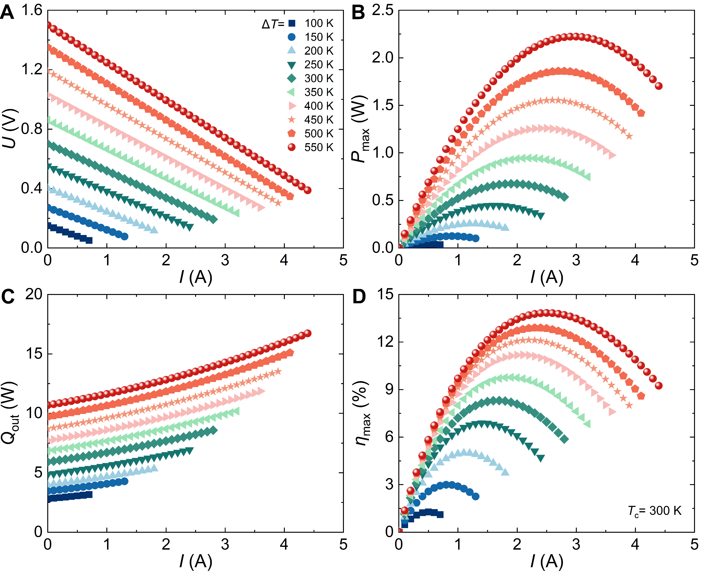
Fig. S19. Thermoelectric conversion performance of the (P4, N5) module. Current-dependent (A) output voltage, (B) output power, (C) heat flow, and (D) conversion efficiency under several temperature differences.
- Optical image of the thermoelectric module (P6, N5)
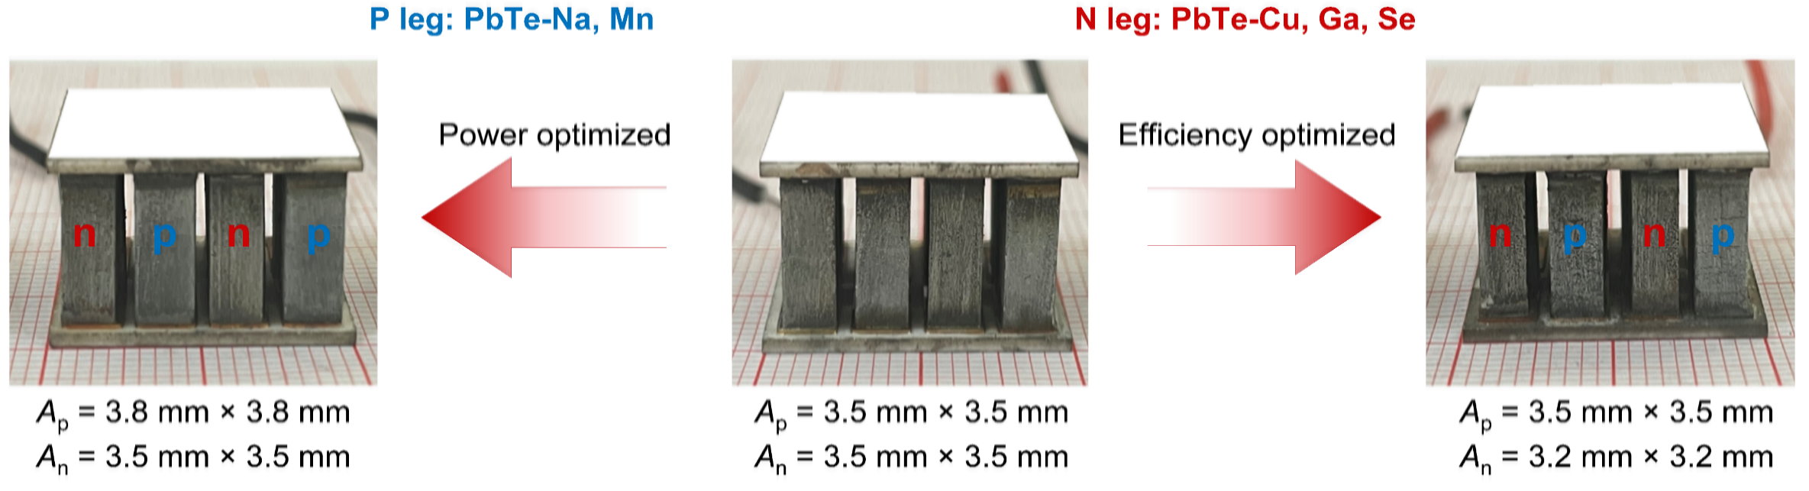
Fig. S20. Optical image of the thermoelectric module (P6, N5). The middle one is the unoptimized module, the left one is the power-optimized module, and the right one is the efficiency-optimized module.
- Thermoelectric conversion performance of the A_{p} = A_{n} module (P6, N5)
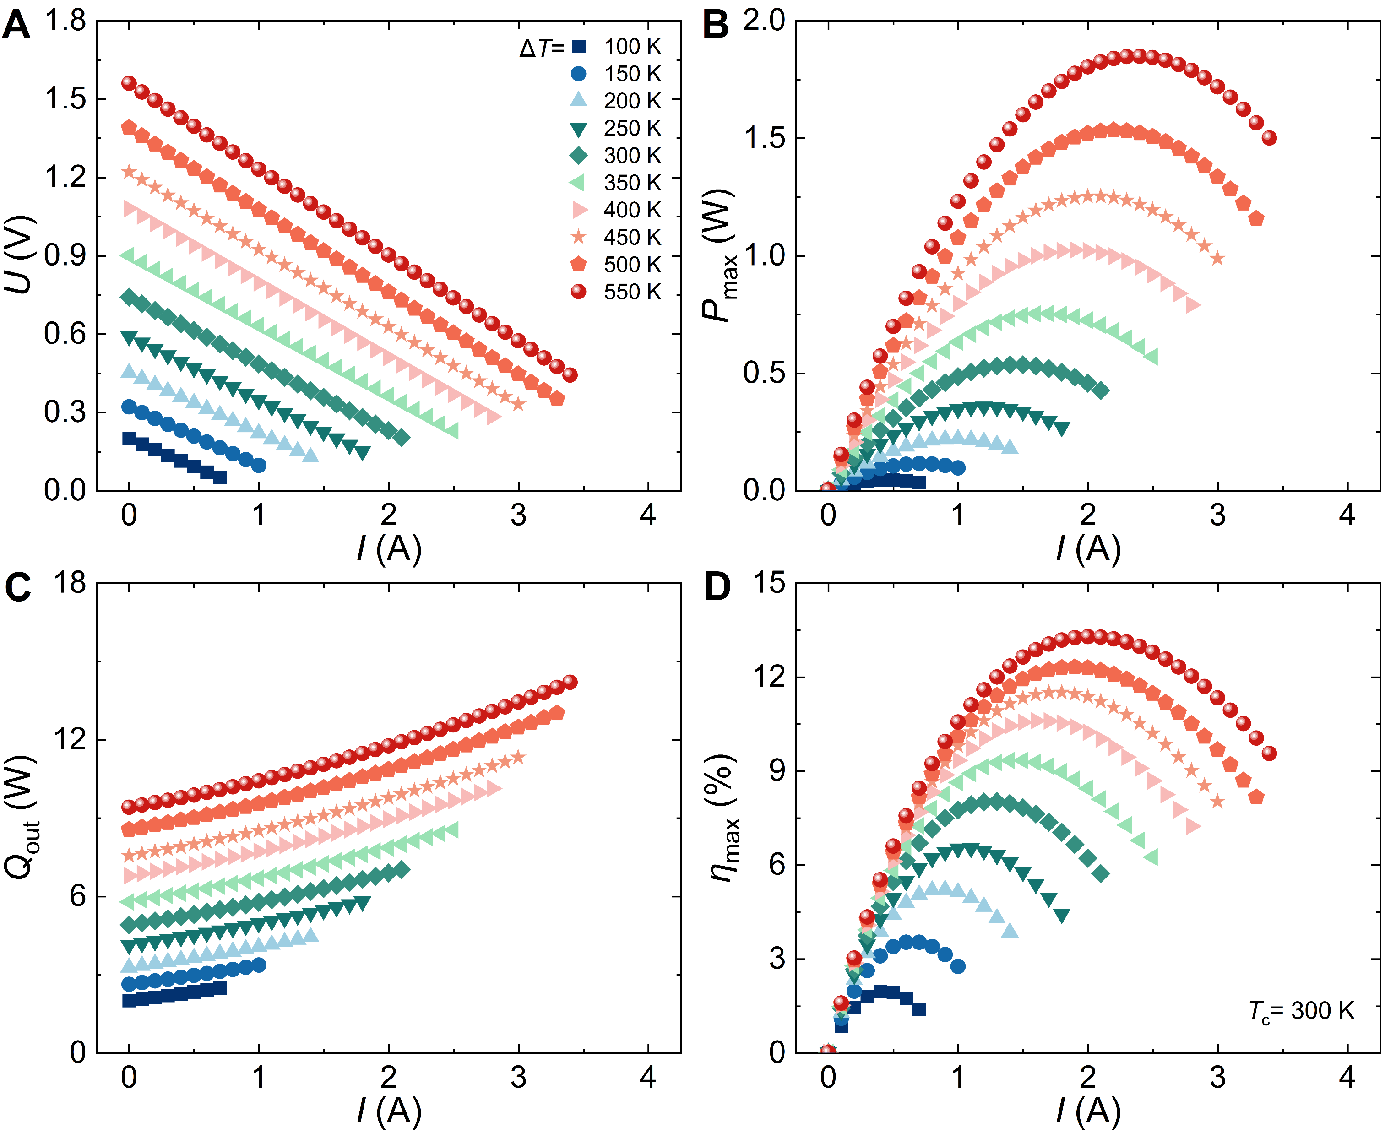
Fig. S21. Thermoelectric conversion performance of the A_{p} = A_{n} module (P6, N5). Current-dependent (A) output voltage, (B) output power, (C) heat flow, and (D) conversion efficiency under several temperature differences.
- Thermoelectric conversion performance of the power optimized module (P6, N5)
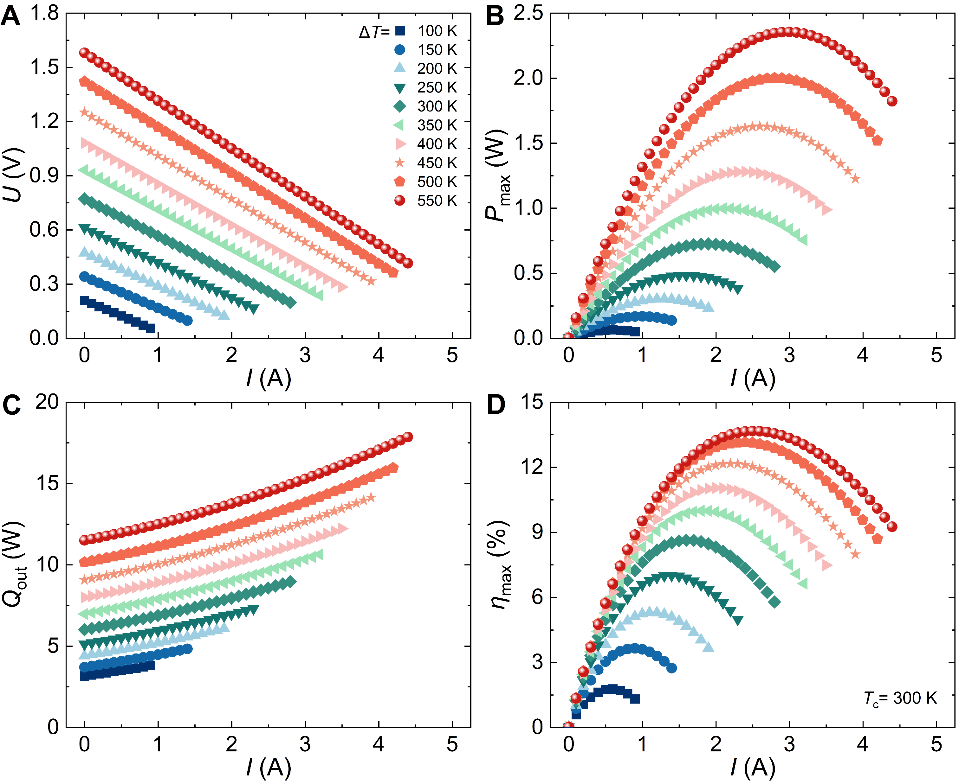
Fig. S22. Thermoelectric conversion performance of the power optimized module (P6, N5). Current-dependent (A) output voltage, (B) output power, (C) heat flow, and (D) conversion efficiency under several temperature differences.
- Thermoelectric conversion performance of the efficiency optimized module (P6, N5)
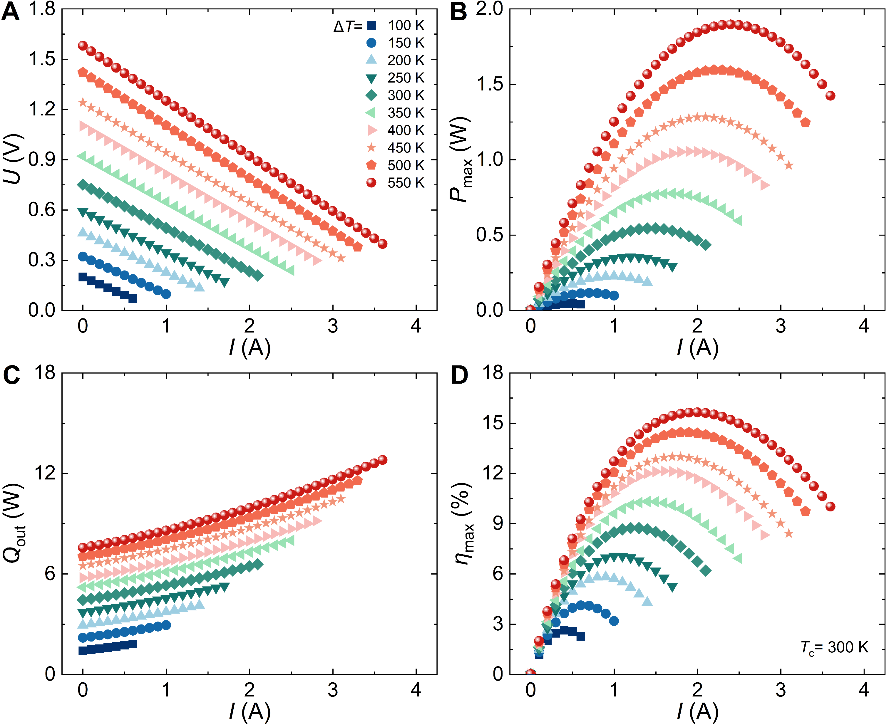
Fig. S23. Thermoelectric conversion performance of the efficiency optimized module (P6, N5). Current-dependent (A) output voltage, (B) output power, (C) heat flow, and (D) conversion efficiency under several temperature differences.
- Temperature-dependent open-circuit voltage and short-circuit current for the A_{p} = A_{n} module, the power-optimized module, and the efficiency-optimized module (P6, N5)
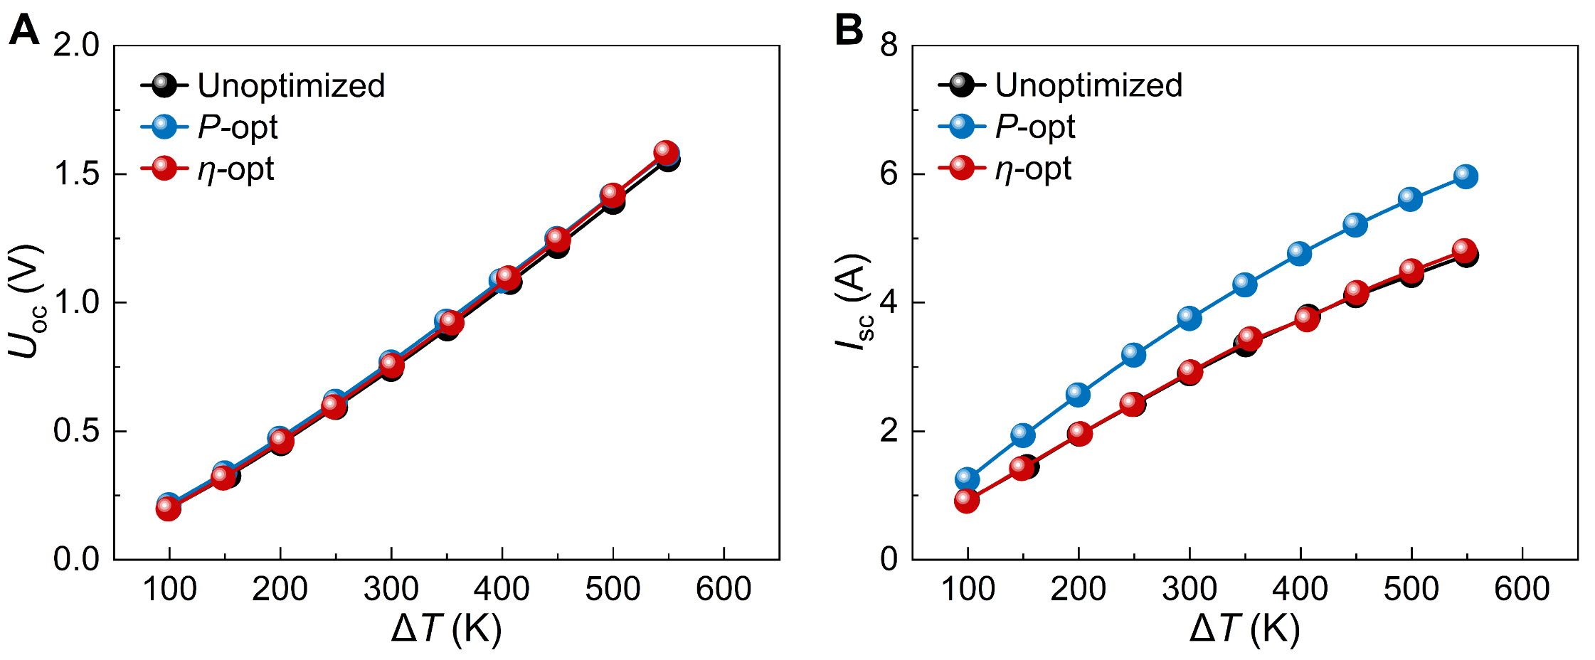
Fig. S24. Temperature-dependent open-circuit voltage and short-circuit current for the A_{p} = A_{n} module, the power-optimized module, and the efficiency-optimized module (P6, N5). (A) Open-circuit voltage, (B) short-circuit current.
- Setting parameters for the finite element simulation of the TE module
Table S1 Finite element simulation setting parameters.
Parameter | Value
Cross-sectional area of p-type leg (A_{p}) | 3.5 × 3.5 mm²
Cross-sectional area of p-type leg (A_{n}) | 3.5 × 3.5 mm²
Length of p-type legs | 10 mm
Length of n-type legs | 10 mm
Thickness of copper electrode | 0.3 mm
Contact resistivity of p-type legs | 10 μΩ cm²
Contact resistivity of n-type legs | 10 μΩ cm²
Thermal contact resistance at the hot side of p-type legs | 4000 W m⁻² K⁻¹
Thermal contact resistance at the hot side of n-type legs | 4000 W m⁻² K⁻¹
Range of external resistance | 0.0001~0.1 Ω
Cold-side temperature of p-type legs | 300 K
Cold-side temperature of n-type legs | 300 K
Hot-side temperature of p-type legs | 400~850 K
Hot-side temperature of n-type legs | 400~850 K

- Simulation of thermoelectric conversion performance for single leg
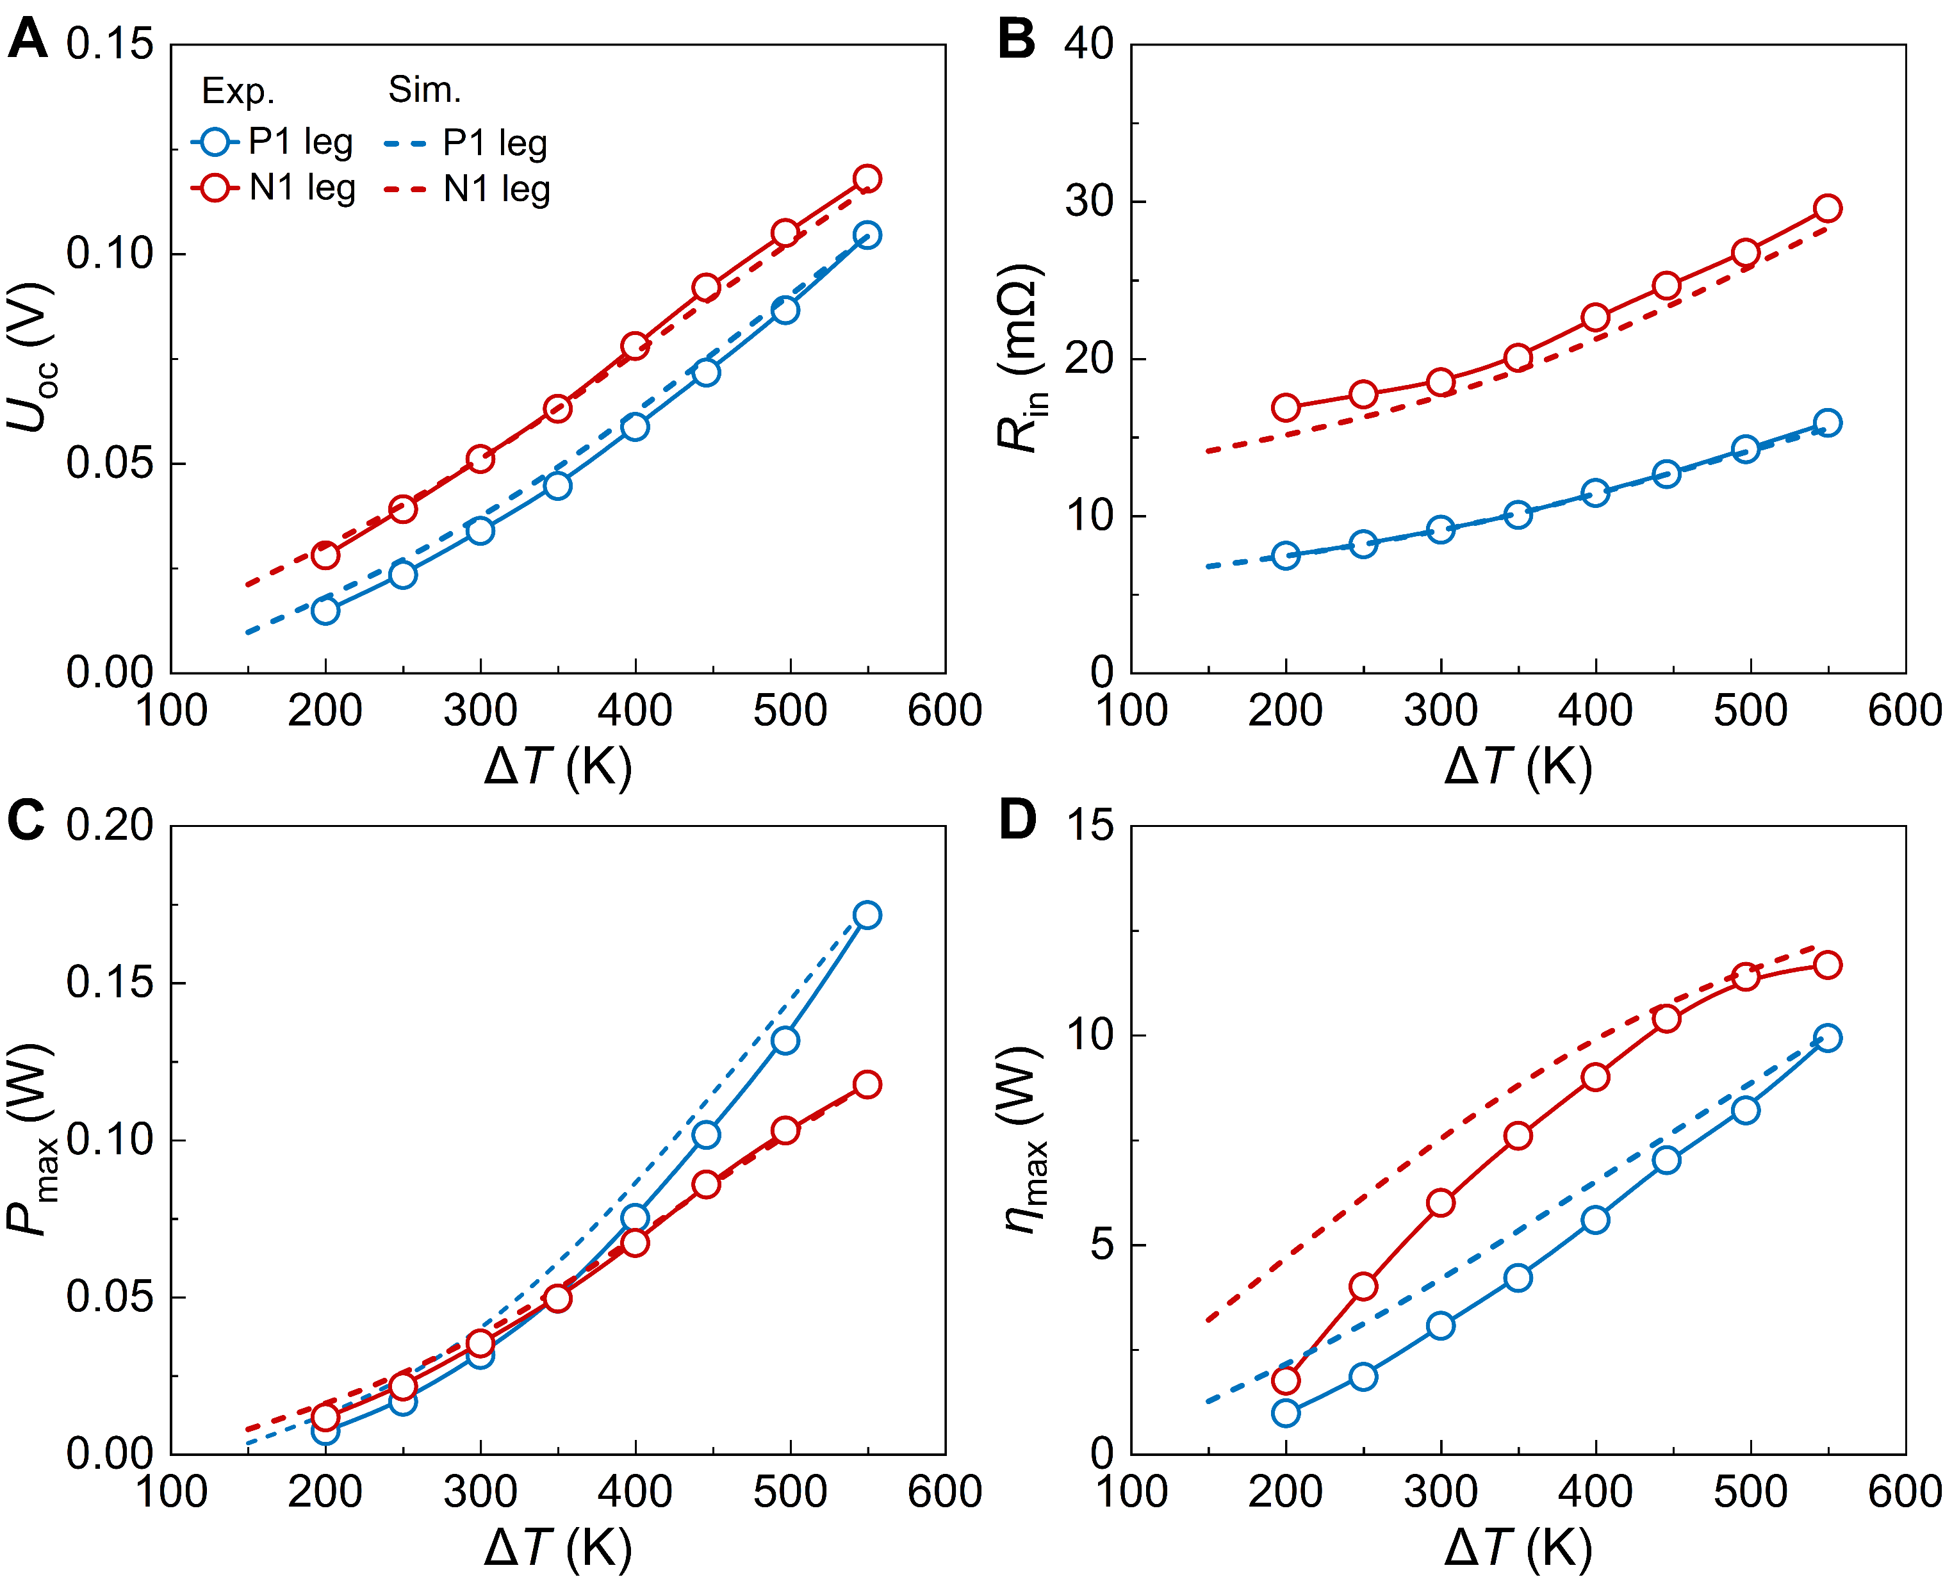
Fig. S25. Simulation of thermoelectric conversion performance for Pb_{0.87}Ge_{0.12}Sb_{0.01}Te leg and Pb_{0.98}Na_{0.02}Te leg. (A) Open-circuit voltage, (B) internal resistance, (C) maximum output power, and (D) maximum efficiency.
- Simulation of thermoelectric conversion performance for P1-N1 couple
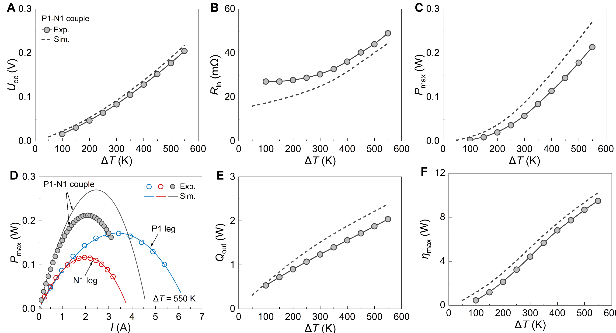
Fig. S26. Simulation of thermoelectric conversion performance for P1-N1 couple (A_{p} = A_{n}) composed of P1 leg and N1 leg. (A) Open-circuit voltage, (B) internal resistance, (C) maximum output power, (E) heat flow, and (F) maximum efficiency. (D) Output power of P1 and N1 thermoelectric legs and the P1-N1 thermocouple as a function of current at a temperature difference of 550 K.
- Simulation of temperature distribution on TE legs and P-N couple under short-circuit condition
Fig. S27. Simulation of temperature distribution on P1 leg, N1 leg, and P1-N1 couple under short-circuit condition. (A) Simulated models of the TE leg and TE couple. An external resistance below 0.1 mΩ is regarded as an approximate short-circuit condition. Temperature distribution along the height of (B) the p-type leg and (C) the n-type leg in the single-leg and P-N couple.
- Method for calculating the voltage distribution in the thermoelectric leg for the single-leg and TE-couple models
T_{p-leg}(x) = –2.1×10⁻¹⁶x⁵+1.5×10⁻⁸x⁴−0.28x³+4.5x²+32.1x+301.5 | (1)
T_{p-couple}(x) = –1.1×10⁻⁸x⁵+2.9×10⁻⁷x⁴−0.07x³+2.8x²+28.5x+300.7 | (2)
T_{n-leg}(x) = 8×10⁻⁹x⁵–1.9×10⁻⁷x⁴−0.32x³+3.1x²+52.7x+302.7 | (3)
T_{n-couple}(x) = 3.2×10⁻⁹x⁵–6.3×10⁻⁸x⁴−0.37x³+2.3x²+65.5x+299.4 | (4)
σ _{p} (T) = 5.1×10⁻¹⁸T⁵−1.4×10⁻¹⁴T⁴−9.5×10⁻⁶T³+0.027T²−24.5T+7753.7 | (5)
σ _{n} (T) = −1.6×10⁻¹⁰T⁵+4.7×10⁻⁷T⁴−5.2×10⁻⁴T³+0.28T²−73.4T+8557.1 | (6)
σ_{p-leg}(x) = 0.018x⁵−0.796x⁴+11.2x³−36.4x²−341.9x+2560.7 | (7)
σ_{p-couple}(x) = 0.018x⁵−0.796x⁴+11.2x³−36.4x²−341.9x+2560.7 | (8)
σ_{n-leg}(x) = 8×10⁻⁹x⁵–1.9×10⁻⁷x⁴−0.32x³+3.1x²+52.7x+302.7 | (9)
σ_{n-couple}(x) = 3.2×10⁻⁹x⁵–6.3×10⁻⁸x⁴−0.37x³+2.3x²+65.5x+299.4 | (10)
 | (11)
where x represents the position along the thermoelectric leg, from the cold side (x = 0 mm) to the hot side (x = 10 mm). T_{p-leg}(x), T_{p-couple}(x), T_{n-leg}(x), and T_{n-couple}(x) denote the height-dependent temperature of the p- and n-type legs in the single-leg model and within the TE couple, respectively. σ _{p} (T) and σ _{n} (T) are the temperature-dependent electrical conductivities of p- and n-type legs, respectively, for T in the range 300–850 K. σ_{p-leg}(x), σ_{p-couple}(x), σ_{n-leg}(x), and σ_{n-couple}(x) denote the height-dependent voltage of the p- and n-type legs in the single-leg model and within the TE couple, respectively. U(x) is the voltage, A is the cross-sectional area of the TE leg, and I_{sc} is the short-circuit current of TE leg.
- Average zT and short-circuit current of PbTe thermoelectric materials
Table S2 Average zT and short-circuit current of PbTe thermoelectric materials.
Component | zT_{avg} (300 – 850 K) | I_{sc} (A) (3.5×3.5×10mm³, ΔT = 550 K)
n₁:PbTe-Ge_{0.12} | 0.86 | 3.98
n₂:PbTe-Ge_{0.08} | 0.73 | 6.80
n₃:PbTe-PbI₂ | 0.83 | 7.50
n₄:N-PbTe-Ga, Ge | 0.85 | 4.16
n₅:N-PbTe-Cu, Ga, Se | 1.01 | 5.99
p₁:PbTe-Na | 0.83 | 6.56
p₂:PbTe-Na, Mn, S, Se | 1.05 | 7.30
p₃:PbTe-Na, Sr | 1.13 | 8.36
p₄:PbTe-Na, Ge | 1.19 | 5.98
p₅:PbTe-Na, AgInSe₂ | 1.25 | 8.08
p₆:PbTe-Na, Mn | 1.35 | 4.73

- Reported efficiencies and average zT values of representative PbTe-based thermoelectric modules
Table S3. Reported efficiencies and average zT values of representative PbTe-based thermoelectric modules.
 | module type | η_{max} (%) | ΔT | zT_{avg} (300~850 K)
² | PbTe | 10.5% | 553K | P：1.64，N：1.03
² | PbTe/Bi₂Te₃ | 15.5% | 554 K | P：1.79，N：1.22
¹ | PbTe | ~11% | 550 K | P：1.20，N：0.79
³ | PbTe/PbTe | 9.3% | 550 K | P：1.26，N：0.98
³ | PbTe/ Bi₂Te₃ | 12.5% | 550 K | P：1.45，N：1.16
⁴ | p-PbTe+ Bi₂Te₃; n-PbSe | 12.3% | 507 K | P：1.26，N：1.22
⁵ | PbS/PbTe | 8.0% | 565 K | P：1.26，N：0.82
⁵ | Bi₂Te₃ + PbS/PbTe | 11.2% | 585 K | P：1.45，N：1.03
⁶ | PbTe | 8.5% | 590 K | P：1.09，N：0.74
⁷ | PbTe | 8.8% | 570 K | P：1.05，N：0.81
⁷ | Bi₂Te₃ + PbTe | 11% | 590 K | P：1.23，N：0.96

- References
1 Yin, L. et al. Low-temperature sintering of Ag nanoparticles for high-performance thermoelectric module design. Nat. Energy 8, 665-674 (2023).
2 Jia, B. et al. Pseudo-nanostructure and trapped-hole release induce high thermoelectric performance in PbTe. Science 384, 81-86 (2024).
3 Jia, B. et al. Realizing high thermoelectric performance in non-nanostructured n-type PbTe. Energy Environ. Sci. 15, 1920-1929 (2022).
4 Jiang, B. et al. High-entropy-stabilized chalcogenides with high thermoelectric performance. Science 371, 830-834 (2021).
5 Jiang, B. et al. Realizing high-efficiency power generation in low-cost PbS-based thermoelectric materials. Energy Environ. Sci. 13, 579-591 (2020).
6 Jood, P., Ohta, M., Yamamoto, A. & Kanatzidis, M. G. Excessively Doped PbTe with Ge-Induced Nanostructures Enables High-Efficiency Thermoelectric Modules. Joule 2, 1339-1355 (2018).
7 Hu, X. et al. Power Generation from Nanostructured PbTe-based Thermoelectrics: Comprehensive Development from Materials to Modules. Energy Environ. Sci. 9, 517-529 (2016).

