Table S1. Definitions of each ACE subtype. 2
Table S2. Total life expectancy (TLE), disability free life expectancy (DFLE), and disability life expectancy (DLE) at age 45 years by cumulative burden of adverse childhood experiences (ACEs). 6
Table S3. Associations between burden of adverse childhood experiences (ACEs) and risk of disability and all-cause mortality. 8
Table S4. Associations between subtypes of adverse childhood experiences (ACEs) and risk of disability and all-cause mortality. 9
Table S5. Sensitivity analyses of associations between burden of adverse childhood experiences (ACEs) and risk of disability and all-cause mortality. 11
Table S6. Sensitivity analyses of total life expectancy (TLE), disability free life expectancy (DFLE) and disability life expectancy (DLE) at age 45 years by low and high burden of adverse childhood experiences (ACEs). 12
Table S7. Stratified analyses of associations between burden of adverse childhood experiences (ACEs) and risk of disability and all-cause mortality. 13
Figure S1. Flow chart of participants included and excluded in the analyses. Abbreviations: ACEs, adverse childhood experiences; ADL, Activity of Daily Living. 18
Figure S2. Transition pathways between disability free status, presence of disability and mortality. 19
Figure S3. Adjusted total life expectancy (TLE), disability free life expectancy (DFLE), and disability life expectancy (DLE) at a given age from 45 years to 85 years by low and high burden of adverse childhood experiences (ACEs). 20

Table S1. Definitions of each ACE subtype.
ACE subtype | ACE-related item | Questionnaire source
- Childhood adverse family situation | 1.1 Parental death | Either of the parents of participant was dead before he/she was 17 years:  - Is your biological mother/father alive?  - In what year did she/he pass away or how old was she/he then?
- Childhood adverse family situation | 1.2 Parental divorce | Parents of participant were divorced before he/she was 17 years:  - Were your biological parents divorced?  - What was your age when your parents’ divorce/ During what age range did this occur?
- Childhood adverse family situation | 1.3 Parental insufficient raising | Parents of participant spent no time raising him/her before he/she was 17 years:  - Before you were age 17, was it your biological father/mother, adopted father/mother or step father/mother who spent the most time raising you?
- Childhood adverse family situation | 1.4 Parental substance abuse | Parents of participant ever had alcoholism or drug, gambling during his/her childhood:  - During the years you were growing up, which one of the followings did your female/male guardian ever have?
- Childhood adverse family situation | 1.5 Parental anxiety | Parents of participant often felt nervous and anxious during his/her childhood:  - During your childhood did your female/male guardian often feel nervous and anxious?
- Childhood adverse family situation | 1.6 Parental depression | Parents of participant showed continued signs of sadness or depression that lasted 2 weeks or more during his/her childhood:  - During the years you were growing up, had your female/male guardian showed continued signs of sadness or depression that lasted 2 weeks or more?
- Childhood adverse family situation | 1.7 Parental adverse relationship | Parents of participant often quarreled or beat up each other during his/her childhood:  - Did your parents often quarrel?  - Have your father ever beat up your mother?  - Have your mother ever beat up your father?
- Childhood family abuse | 2.1 Parental violence | Participant was ever hit by parents during his/her childhood:  - When you were growing up, did your female/male guardian ever hit you?
- Childhood family abuse | 2.2 Adverse parental relation | Parents of participant had adverse relationship with each other during his/her childhood:  - How would you rate the relationship your parents had with each other when you were growing up?
- Childhood family abuse | 2.3 Childhood unfair treatments | Parents of participant treated his/her siblings better during his/her childhood:  - Did your female/male guardian treat your siblings better than you when you were growing up?
- Childhood adverse personal situation | 3.1 Childhood adverse economy | Participant family’s financial situation was worse off compared to average family in the same community/village during his/her childhood:  - When you were a child before age 17, compared to average family in the same community/village at that time, how was your family’s financial situation?
- Childhood adverse personal situation | 3.2 Childhood adverse health conditions | Participant was confined to bed or home/hospitalized for a month or more during his/her childhood:  - Before you were 15 years or old (including 15 years old), because of a health condition, were you ever confined to bed or home/hospitalized for a month or more?
- Childhood adverse personal situation | 3.3 Childhood disease | Participant was less healthy compared to other children of the same age during his/her childhood:  - Before you were 15 years old (including 15 years old), would you say that compared to other children of the same age?
- Childhood adverse personal situation | 3.4 Childhood starvation | Participant family did not have enough food to eat during his/her childhood:  - When you were a child before age 17 was there ever a time when your family did not have enough food to eat?
- Childhood insufficient companions | 4.1 Childhood loneliness | Participant often felt lonely for not having friends during his/her childhood:  - When you were a child, how often did you feel lonely for not having friends?
- Childhood insufficient companions | 4.2 Childhood insufficient friendship | Participant had no good friend during his/her childhood:  - When you were a child, did you have a good friend?
- Childhood adverse communities | 5.1 Childhood adverse environment | Neighborhood of the place where participant lived as a child was not clean and attractive:  - Was the neighborhood of the place where you lived as a child very clean and attractive?
- Childhood adverse communities | 5.2 Childhood adverse neighbor relation | Neighborhood of the place where participant lived as a child was not close-knit:  - Were the neighbors of the place where you lived as a child very close-knit?
- Childhood violence | 6.1 Childhood bully | Participant was picked on or bullied by kids during his/her childhood:  - When you were a child, how often were you picked on or bullied by kids in your neighborhood?
- Childhood violence | 6.2 Childhood crime | Participant was ever arrested or taken into custody by the police during his/her childhood:  - Before you were 17 years old, were you ever arrested or taken into custody by the police?
Abbreviations: ACEs, adverse childhood experiences.

Table S2. Total life expectancy (TLE), disability free life expectancy (DFLE), and disability life expectancy (DLE) at age 45 years by cumulative burden of adverse childhood experiences (ACEs).
ACE burden | Adjusted LE*, years
ACE burden | TLE | DFLE, (%) | DLE, (%)
Overall
0-1 | 44.9 | 34.6(77.1) | 10.3(22.9)
2 | 45.7 | 32.4(71.0) | 13.3(29.0)
3 | 46.0 | 31.1(67.5) | 15.0(32.5)
4 | 47.3 | 29.9(63.3) | 17.4(36.8)
5 | 43.0 | 25.6(59.7) | 17.3(40.3)
6 | 33.6 | 20.0(59.5) | 13.6(40.5)
Initial state of disability free
0-1 | 44.9 | 34.8(77.5) | 10.1(22.5)
2 | 45.8 | 32.7(71.5) | 13.0(28.5)
3 | 46.1 | 31.4(68.2) | 14.7(31.8)
4 | 47.4 | 30.3(64.0) | 17.0(36.0)
5 | 43.0 | 26.1(60.8) | 16.9(39.2)
6 | 33.9 | 20.8(61.3) | 13.1(38.7)
Initial state of disability
0-1 | 43.8 | 31.7(72.3) | 12.1(27.7)
2 | 45.1 | 29.9(66.3) | 15.2(33.7)
3 | 45.5 | 28.4(62.5) | 17.1(37.5)
4 | 46.7 | 27.2(58.2) | 19.5(41.8)
5 | 42.6 | 23.3(54.6) | 19.4(45.5)
6 | 32.7 | 17.0(52.0) | 15.7(48.0)
*Sex, education level, time-varying residence, time-varying marital status, time-varying employment status, and time-varying household income per capita were adjusted. Abbreviations: ACEs, adverse childhood experiences; DFLE, disability free life expectancy; DLE, disability life expectancy; TLE, total life expectancy.

Table S3. Associations between burden of adverse childhood experiences (ACEs) and risk of disability and all-cause mortality.
Transition | OR (95%CI)
Transition | Low ACE burden | High ACE burden
Unadjusted
From disability free to disability | Ref | 1.53 (1.39, 1.68)
From disability free to mortality | Ref | 1.85 (1.43, 2.39)
From disability to disability free | Ref | 0.76 (0.68, 0.86)
From disability to mortality | Ref | 1.75 (1.41, 2.18)
Adjusted*
From disability free to disability | Ref | 1.53 (1.40, 1.68)
From disability free to mortality | Ref | 1.69 (1.31, 2.18)
From disability to disability free | Ref | 0.77 (0.69, 0.87)
From disability to mortality | Ref | 1.66 (1.33, 2.07)
*Sex, education level, time-varying residence, time-varying marital status, time-varying employment status, and time-varying household income per capita were adjusted. Abbreviations: ACEs, adverse childhood experiences; CI, confidence interval; DFLE, disability free life expectancy; DLE, disability life expectancy; LE, life expectancy; OR, odds ratio, Ref, reference.

Table S4. Associations between subtypes of adverse childhood experiences (ACEs) and risk of disability and all-cause mortality.
ACE subtypes | Adjusted OR (95%CI) *
ACE subtypes | Absent | Present
Childhood adverse family situation
From disability free to disability | Ref | 1.39 (1.30, 1.49)
From disability free to mortality | Ref | 1.00 (0.81, 1.25)
From disability to disability free | Ref | 0.84 (0.77, 0.92)
From disability to mortality | Ref | 0.97 (0.76, 1.25)
Childhood family abuse
From disability free to disability | Ref | 1.17 (1.10, 1.24)
From disability free to mortality | Ref | 1.05 (0.87, 1.26)
From disability to disability free | Ref | 0.87 (0.81, 0.94)
From disability to mortality | Ref | 1.16 (0.95, 1.41)
Childhood adverse personal situation
From disability free to disability | Ref | 1.51 (1.39, 1.64)
From disability free to mortality | Ref | 1.00 (0.79, 1.27)
From disability to disability free | Ref | 0.92 (0.82, 1.04)
From disability to mortality | Ref | 1.09 (0.83, 1.44)
Childhood insufficient companions
From disability free to disability | Ref | 1.15 (1.08, 1.22)
From disability free to mortality | Ref | 0.97 (0.80, 1.19)
From disability to disability free | Ref | 0.93 (0.86, 1.01)
From disability to mortality | Ref | 1.16 (0.93, 1.45)
Childhood adverse communities
From disability free to disability | Ref | 1.22 (1.12, 1.33)
From disability free to mortality | Ref | 1.18 (0.91, 1.53)
From disability to disability free | Ref | 0.78 (0.69, 0.87)
From disability to mortality | Ref | 1.58 (1.27, 1.97)
Childhood violence
From disability free to disability | Ref | 1.39 (1.29, 1.51)
From disability free to mortality | Ref | 1.37 (1.08, 1.75)
From disability to disability free | Ref | 0.83 (0.75, 0.92)
From disability to mortality | Ref | 1.58 (1.28, 1.96)
*Sex, education level, time-varying residence, time-varying marital status, time-varying employment status, and time-varying household income per capita were adjusted. Abbreviations: ACEs, adverse childhood experiences; CI, confidence interval; DFLE, disability free life expectancy; DLE, disability life expectancy; LE, life expectancy; OR, odds ratio, Ref, reference.

Table S5. Sensitivity analyses of associations between burden of adverse childhood experiences (ACEs) and risk of disability and all-cause mortality.
Transition | Adjusted OR (95%CI) *
Transition | Low ACE burden | High ACE burden
From disability free to disability | Ref | 1.53 (1.39, 1.68)
From disability free to mortality | Ref | 1.70 (1.31, 2.19)
From disability to disability free | Ref | 0.77 (0.69, 0.87)
From disability to mortality | Ref | 1.65 (1.32, 2.06)
*Sex, education level, time-varying residence, time-varying marital status, time-varying employment status, and time-varying household income per capita, time-varying smoking, time-varying drinking, and time-varying body mass index were adjusted. Abbreviations: ACEs, adverse childhood experiences; CI, confidence interval; OR, odds ratio, Ref, reference.

Table S6. Sensitivity analyses of total life expectancy (TLE), disability free life expectancy (DFLE) and disability life expectancy (DLE) at age 45 years by low and high burden of adverse childhood experiences (ACEs).
ACE burden | Adjusted LE*, years
ACE burden | TLE | DFLE, (%) | DLE, (%)
Overall
Low | 46.0 | 31.8(69.0) | 14.3(31.0)
High | 38.3 | 23.5(61.3) | 14.8(38.7)
Initial state of disability free
Low | 46.1 | 32.1(69.6) | 14.0(30.4)
High | 38.4 | 24.1(62.6) | 14.4(37.4)
Initial state of disability
Low | 45.5 | 29.1(64.0) | 16.4(36.0)
High | 37.5 | 20.6(55.0) | 16.9(45.0)
*Sex, education level, time-varying residence, time-varying marital status, time-varying employment status, and time-varying household income per capita, time-varying smoking, time-varying drinking, and time-varying body mass index were adjusted. Abbreviations: ACEs, adverse childhood experiences; DFLE, disability free life expectancy; DLE, disability life expectancy; TLE, total life expectancy.

Table S7. Stratified analyses of associations between burden of adverse childhood experiences (ACEs) and risk of disability and all-cause mortality.
Subgroup | Adjusted OR (95%CI) |  | P _{interaction}
Subgroup | Low ACE burden | High ACE burden | P _{interaction}
By sex
From disability free to disability
Men | Ref | 1.63 (1.42, 1.87) | 0.19
Women | Ref | 1.46 (1.28, 1.66)
From disability free to mortality
Men | Ref | 1.49 (1.07, 2.06) | 0.08
Women | Ref | 2.03 (1.34, 3.08)
From disability to disability free
Men | Ref | 0.76 (0.64, 0.90) | 0.73
Women | Ref | 0.78 (0.66, 0.92)
From disability to mortality
Men | Ref | 1.32 (0.96, 1.81) | 0.03
Women | Ref | 2.04 (1.49, 2.79)
By education
From disability free to disability
Lower than high school | Ref | 1.53 (1.39, 1.68) | 0.80
High school and above | Ref | 1.66 (1.07, 2.60)
From disability free to mortality
Lower than high school | Ref | 1.65 (1.27, 2.14) | 0.39
High school and above | Ref | 2.38 (0.70, 8.09)
From disability to disability free
Lower than high school | Ref | 0.77 (0.68, 0.87) | 0.78
High school and above | Ref | 0.92 (0.51, 1.66)
From disability to mortality
Lower than high school | Ref | 1.63 (1.30, 2.04) | 0.81
High school and above | Ref | 3.87 (1.00, 15.08)
By residence
From disability free to disability
Rural village | Ref | 1.58 (1.41, 1.76) | 0.32
Urban community | Ref | 1.40 (1.16, 1.69)
From disability free to mortality
Rural village | Ref | 1.65 (1.21, 2.25) | 0.80
Urban community | Ref | 1.75 (1.11, 2.77)
From disability to disability free
Rural village | Ref | 0.81 (0.71, 0.93) | 0.07
Urban community | Ref | 0.65 (0.50, 0.84)
From disability to mortality
Rural village | Ref | 1.63 (1.26, 2.12) | 0.76
Urban community | Ref | 1.75 (1.15, 2.66)
By marital status
From disability free to disability
Married or partnered | Ref | 1.62 (1.46, 1.80) | 0.01
Others | Ref | 1.31 (1.06, 1.63)
From disability free to mortality
Married or partnered | Ref | 1.61 (1.18, 2.20) | 0.61
Others | Ref | 1.86 (1.18, 2.94)
From disability to disability free
Married or partnered | Ref | 0.74 (0.64, 0.84) | 0.12
Others | Ref | 0.94 (0.72, 1.22)
From disability to mortality
Married or partnered | Ref | 1.50 (1.14, 1.97) | 0.36
Others | Ref | 1.96 (1.34, 2.87)
By household income per capita
From disability free to disability
Lower than median | Ref | 1.50 (1.35, 1.68) | 0.91
Median and above | Ref | 1.50 (1.26, 1.79)
From disability free to mortality
Lower than median | Ref | 1.62 (1.19, 2.20) | 0.75
Median and above | Ref | 1.95 (1.22, 3.11)
From disability to disability free
Lower than median | Ref | 0.78 (0.67, 0.89) | 0.65
Median and above | Ref | 0.74 (0.58, 0.94)
From disability to mortality
Lower than median | Ref | 1.67 (1.29, 2.16) | 0.76
Median and above | Ref | 1.66 (1.08, 2.56)
*Sex, education level, time-varying residence, time-varying marital status, time-varying employment status, and time-varying household income per capita were adjusted. Abbreviations: ACEs, adverse childhood experiences; CI, confidence interval; OR, odds ratio, Ref, reference.
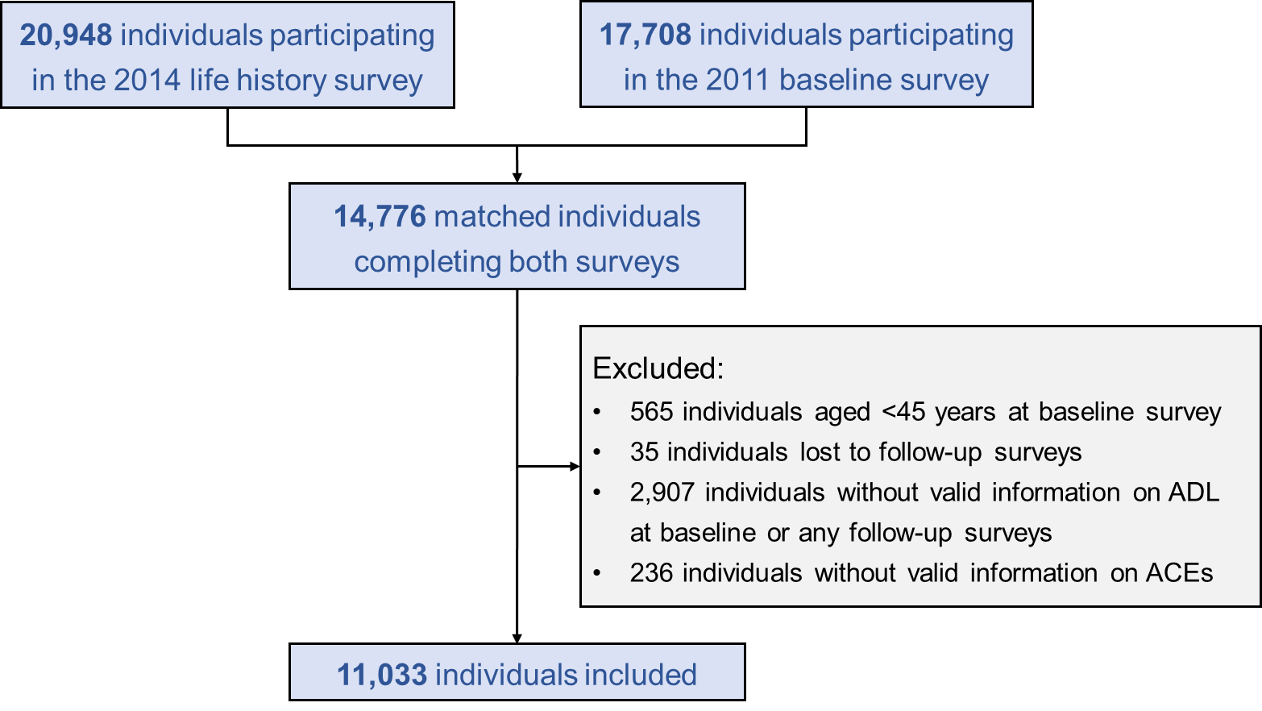

Figure S1. Flow chart of participants included and excluded in the analyses. Abbreviations: ACEs, adverse childhood experiences; ADL, Activity of Daily Living.
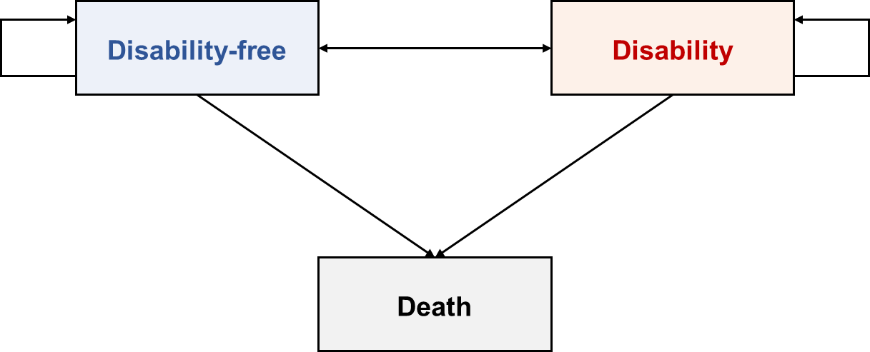

Figure S2. Transition pathways between disability free status, presence of disability and mortality.
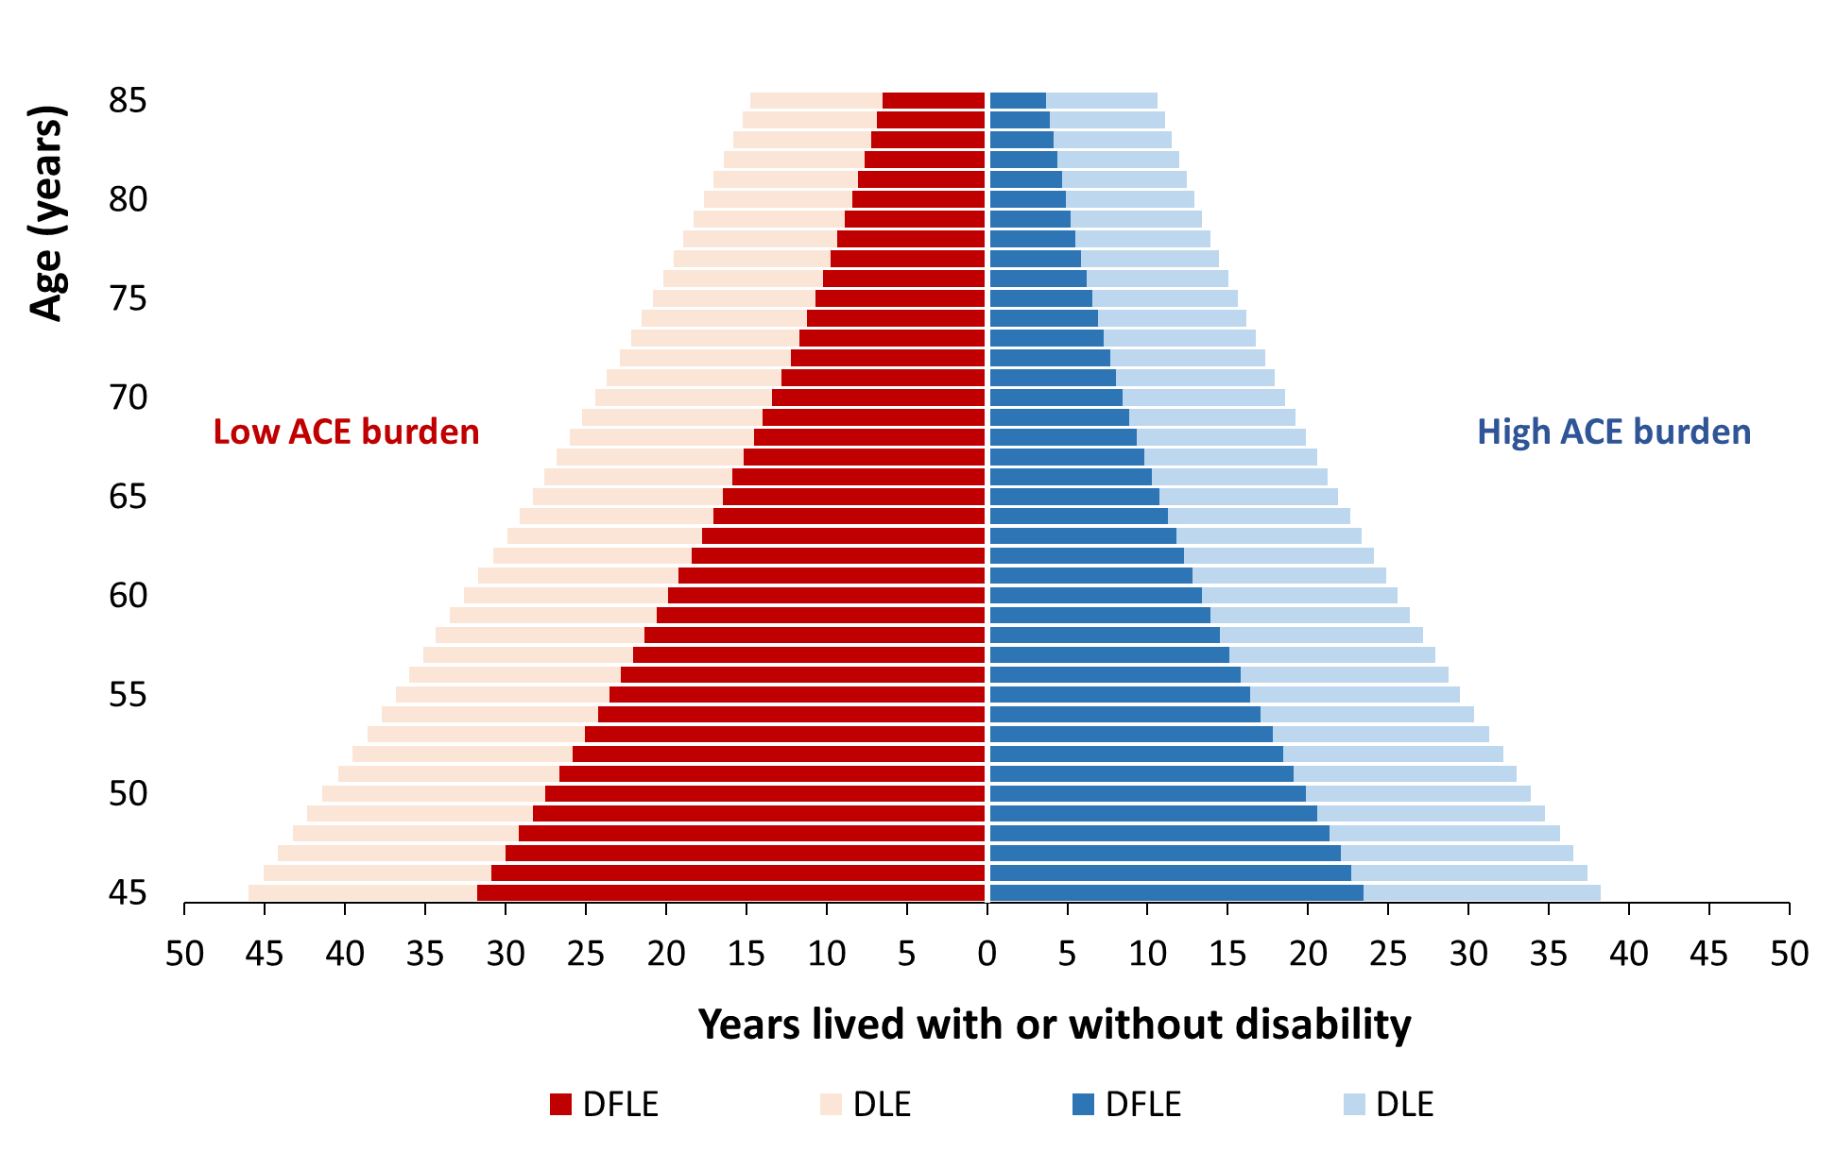

Figure S3. Adjusted total life expectancy (TLE), disability free life expectancy (DFLE), and disability life expectancy (DLE) at a given age from 45 years to 85 years by low and high burden of adverse childhood experiences (ACEs).
Abbreviations: ACEs, adverse childhood experiences; DFLE, disability free life expectancy; DLE, disability life expectancy; LE, life expectancy.

