Supplementary Materials

Supplemental Table 1. Skin Health Knowledge Assessment comprising 12 true/false and multiple-choice questions including topics of skincare, social aspects of skin health, and introductory skin physiology. The response rate for the baseline assessment was 89.0% (n = 57/64).
Question | Response Options
SUN PROTECTIVE BEHAVIOURS & SKINCARE QUESTIONS
You do NOT need to wear sunscreen in the winter because it is less sunny outside. | True  False
Many bad sunburns can increase your risk of skin cancer. | True  False
Which is correct about acne? | Acne can cause scars or dark spots  Acne is caused by stress  Acne is caused by dirty skin  Acne can get better by popping the pimples
Which of the following statements is TRUE about skincare? | It is a good idea to wash your face twice a day, using lukewarm water  Using a harsh face scrub or sponge every day is safe for your skin  Tanning is healthy if you have dark skin  Washing your hair does NOT affect your skin
SOCIAL SKIN HEALTH QUESTIONS
Vitiligo and eczema can make people feel bad about their appearance. | True  False
Filters on social media apps show what someone’s skin really looks like. | True  False
What statement about skin diversity is TRUE? | Everyone who belongs to the same race shares the same skin tone  Skin conditions like birthmarks and moles should be covered up  Skin conditions can affect anyone with any skin colour  It’s not normal for people to have different skin colours or textures
How can you support a classmate who is feeling embarrassed about their skin condition? | Avoid them  Tell them to hide their skin  Tell them it’s not a big deal  Be kind and help them feel accepted
SKIN SCIENCE & MEDICAL QUESTIONS
The more melanin a person has, the darker their skin will be. | True  False
A dermatologist is someone who treats skin, hair and nail conditions. | True  False
Skin damage from the sun can look like which of the following: | Freckles  Age spots and wrinkles  Skin cancer  All of the above
Which of the following is TRUE about eczema? | Eczema causes people to lose colour in their skin.  Eczema is contagious, meaning that it can spread from person to person.  Eczema causes the skin to become itchy and red.  Eczema will usually go away on its own.

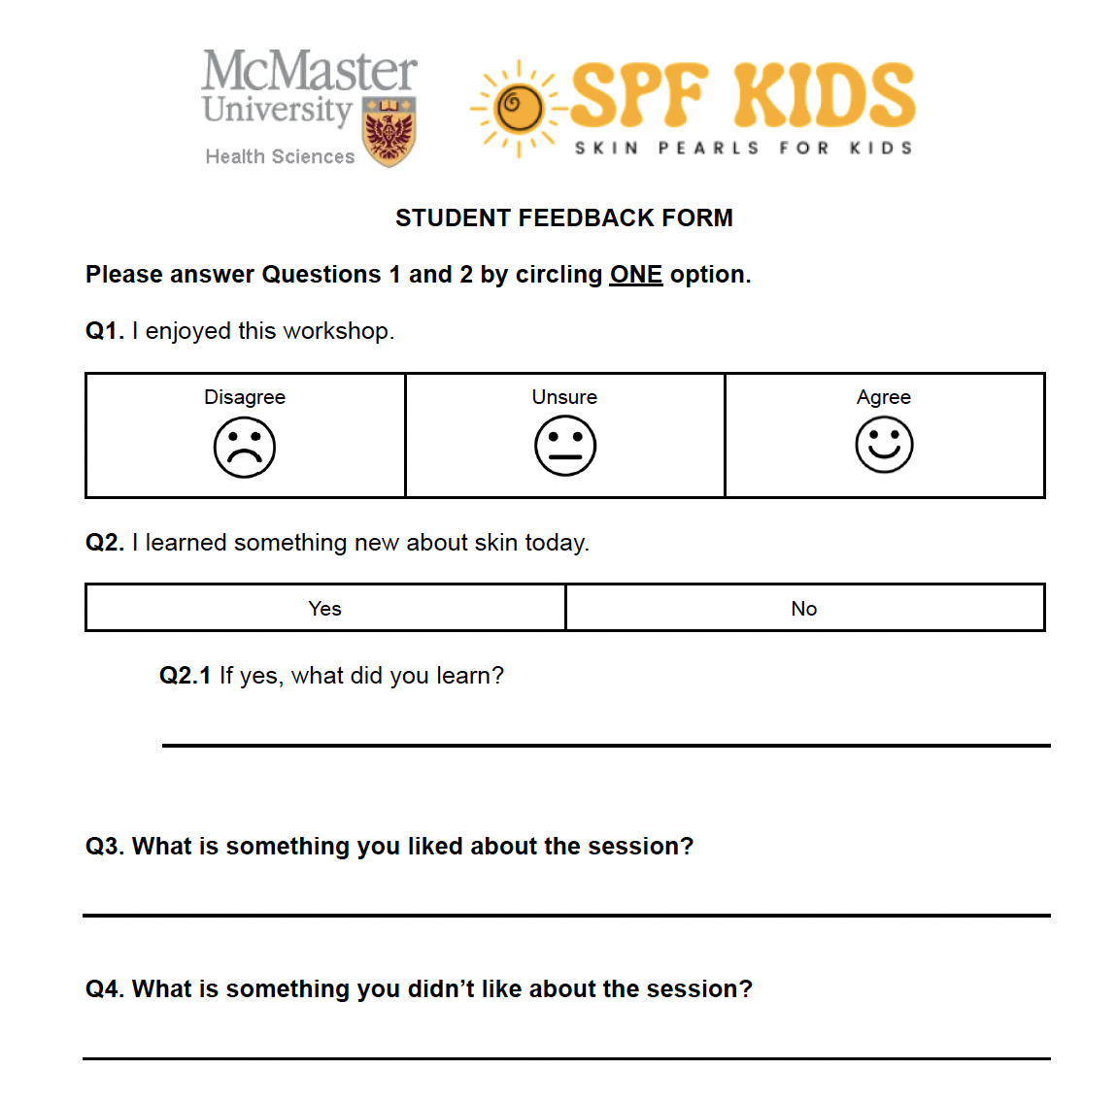
Supplemental Figure 2. Student feedback form provided post-workshop.

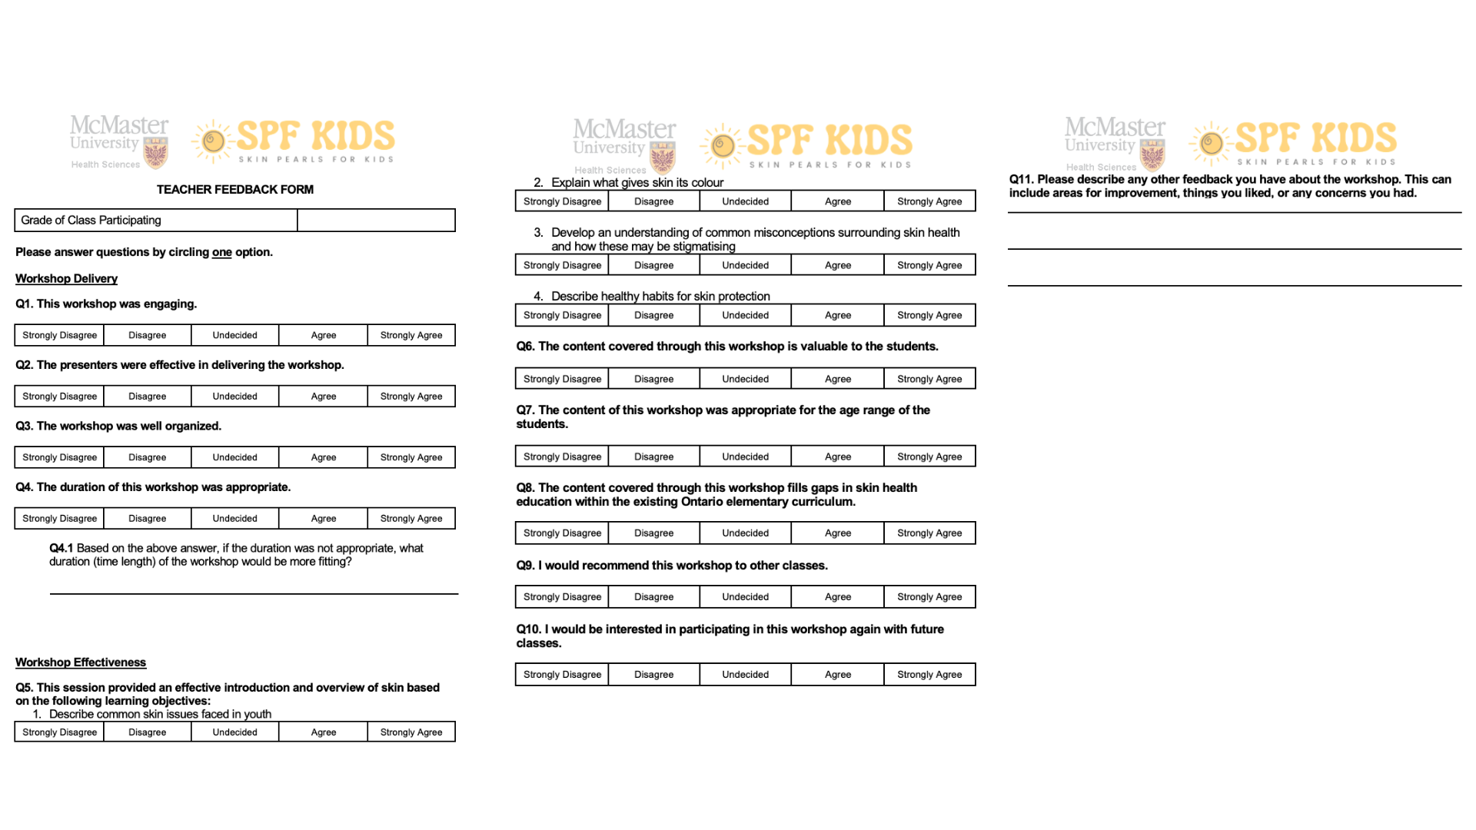
Supplemental Figure 3. Teacher feedback form administered post-workshop.

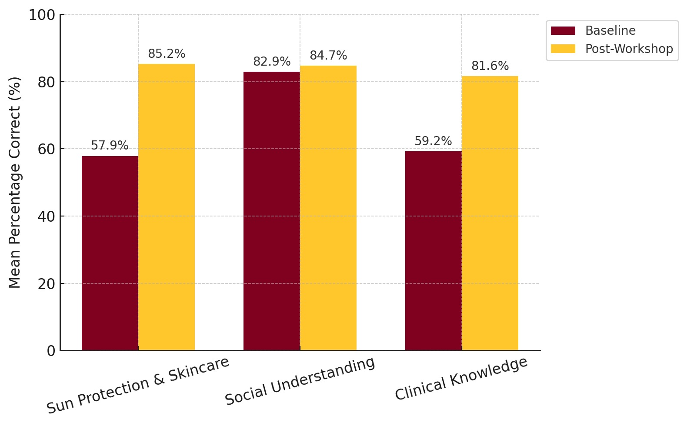
Supplemental Figure 4. Improvement in mean test scores by domain including 1) Sun protection and skincare, 2) Social understanding 3) Clinical knowledge.

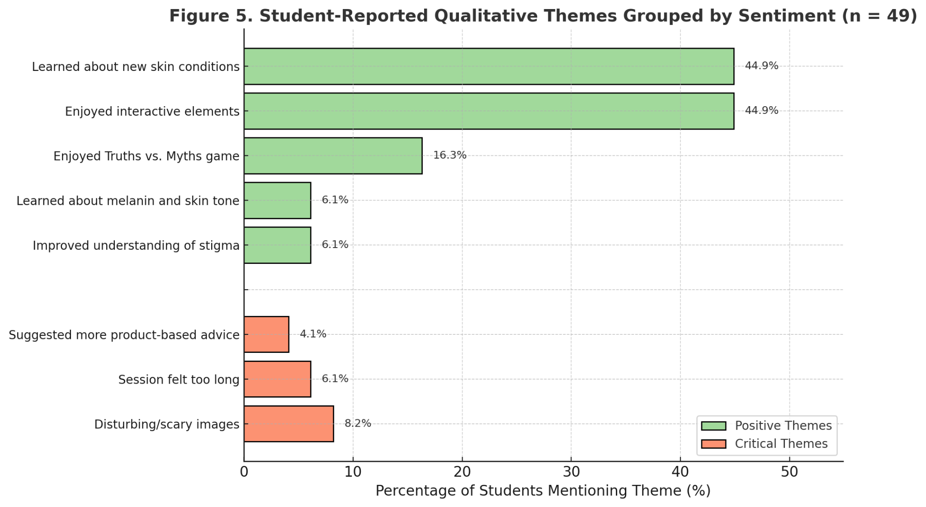
Supplemental Figure 5. Student-reported qualitative themes grouped by sentiment (n = 49).

