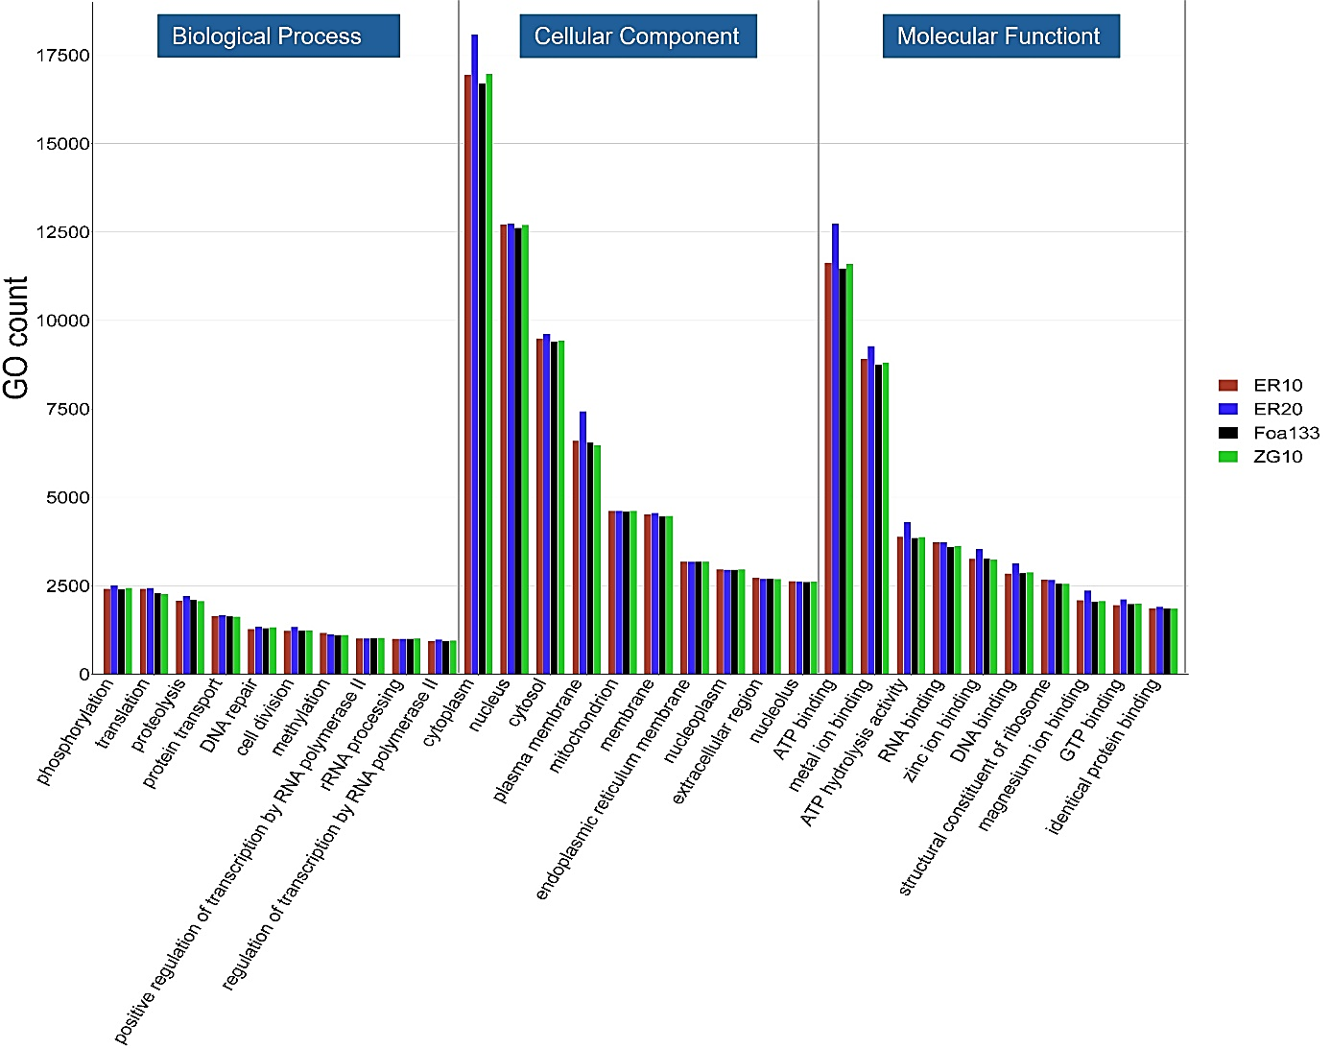
Figure: Functional annotation of predicted genes in four Foa isolates (ER10, Foa133, ZG10, and ER20) using Gene Ontology (GO) classification . The bar charts show the amount of genes attributed to key GO categories across three functional domains: Biological Process: Genes involved in phosphorylation, translation, proteolysis, protein transport, and DNA repair, with varied representation among isolates. Cellular Component: Genes are classified according to their related cellular structures, such as cytoplasm, nucleus, cytosol, plasma membrane, and mitochondrion. ER20 has unusually high gene counts in all compartments. Molecular Function: Indicates genes involved in ATP binding, metal ion binding, ATP hydrolysis activity, RNA binding, and zinc ion binding.

