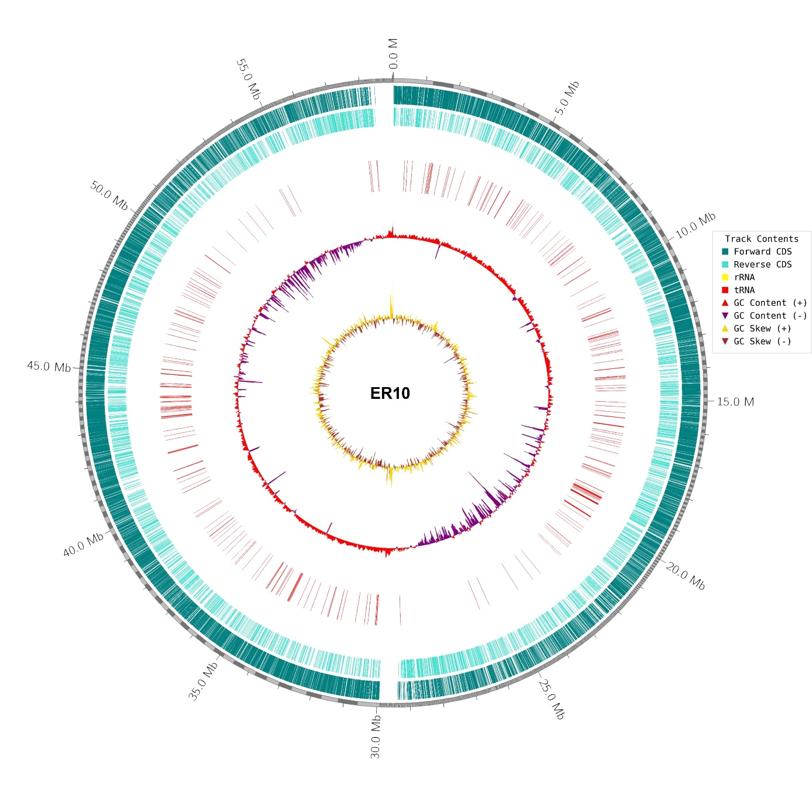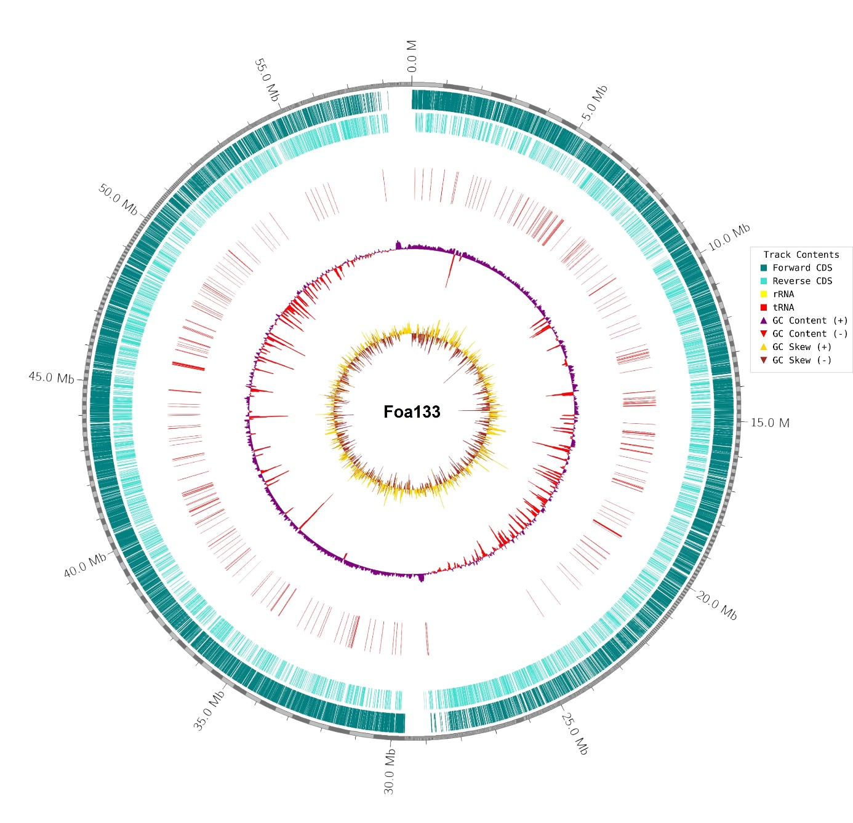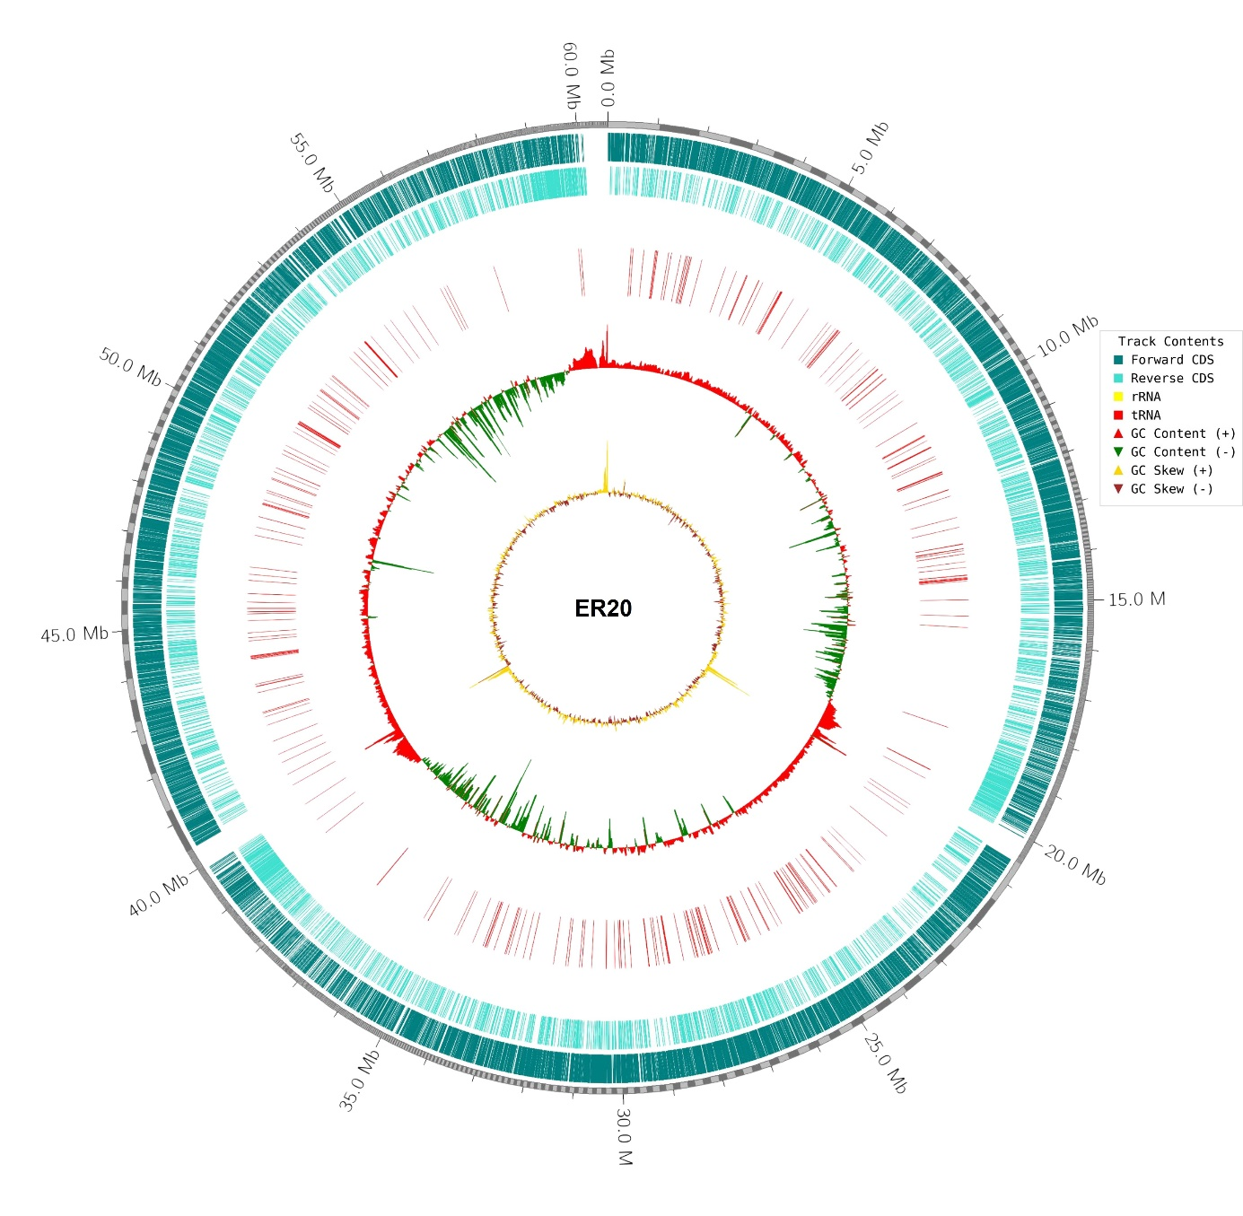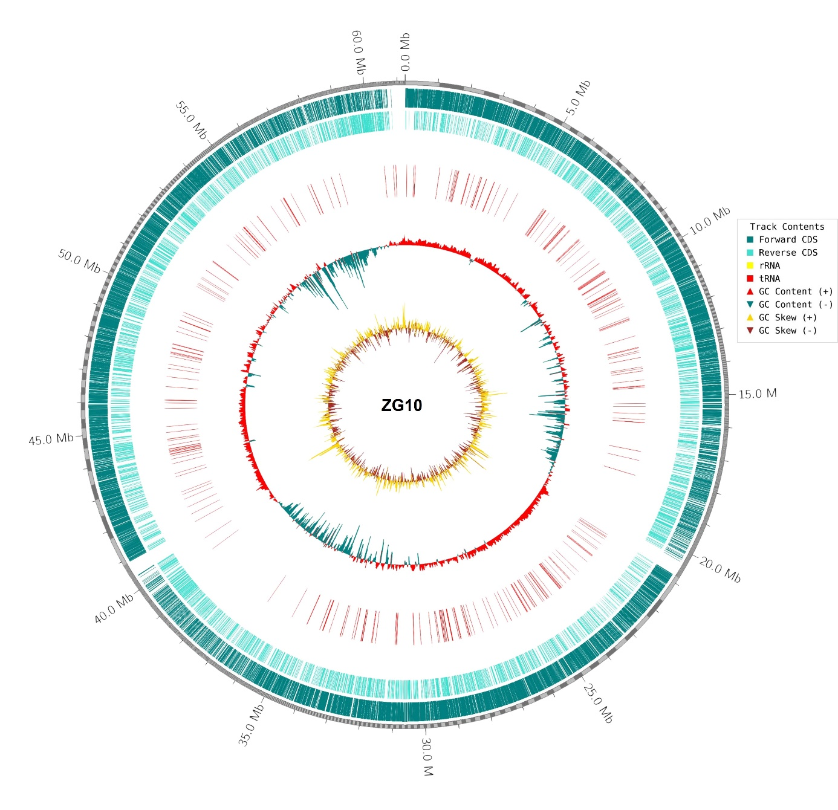
Figure: Circular genome maps of four Foa isolates associated with palm dieback (ZG10, Foa133, ER20, and ER10). The circular graphs depict the genomic and GC properties of each isolate. From the outer to inner rings: Ring 1 (blue and cyan): Forward and reverse coding sequences (CDSs), which show the distribution and density of genes in the genome. Ring 2 (red triangles) represents rRNA genes. Ring 3: GC content (%), with both above- and below-average levels. Ring4: GC skew [(G−C)/(G+C)], with positive and negative skew representing replication origin and termination zones.

