Table 1: Genome Assembly report of ER10
Assembly | scaffolds
# contigs (>= 0 bp) | 18843
# contigs (>= 1000 bp) | 2715
# contigs (>= 5000 bp) | 1139
# contigs (>= 10000 bp) | 719
# contigs (>= 25000 bp) | 378
# contigs (>= 50000 bp) | 242
Total length (>= 0 bp) | 59020947
Total length (>= 1000 bp) | 55105464
Total length (>= 5000 bp) | 51387130
Total length (>= 10000 bp) | 48478166
Total length (>= 25000 bp) | 43176453
Total length (>= 50000 bp) | 38372534
# contigs | 4005
Largest contig | 1206212
Total length | 55972324
GC (%) | 47.45
N50 | 125225
N90 | 6353
auN | 193950.6
L50 | 108
L90 | 961
# N's per 100 kbp | 11.43

Table 2: Genome Assembly report of Foa133
Assembly | scaffolds
# contigs (>= 0 bp) | 18161
# contigs (>= 1000 bp) | 2636
# contigs (>= 5000 bp) | 1099
# contigs (>= 10000 bp) | 658
# contigs (>= 25000 bp) | 357
# contigs (>= 50000 bp) | 234
Total length (>= 0 bp) | 58815883
Total length (>= 1000 bp) | 55014153
Total length (>= 5000 bp) | 51494089
Total length (>= 10000 bp) | 48336564
Total length (>= 25000 bp) | 43736903
Total length (>= 50000 bp) | 39350203
# contigs | 3949
Largest contig | 899468
Total length | 55911599
GC (%) | 47.42
N50 | 131578
N90 | 6737
auN | 215453.2
L50 | 99
L90 | 899
# N's per 100 kbp | 15.95

Table 3: Genome Assembly report of ZG10

Assembly | scaffolds
# contigs (>= 0 bp) | 25176
# contigs (>= 1000 bp) | 2978
# contigs (>= 5000 bp) | 1224
# contigs (>= 10000 bp) | 726
# contigs (>= 25000 bp) | 381
# contigs (>= 50000 bp) | 249
Total length (>= 0 bp) | 61238148
Total length (>= 1000 bp) | 55536929
Total length (>= 5000 bp) | 51504393
Total length (>= 10000 bp) | 47998193
Total length (>= 25000 bp) | 42568755
Total length (>= 50000 bp) | 37866646
# contigs | 4615
Largest contig | 1041656
Total length | 56637595
GC (%) | 47.46
N50 | 103178
N90 | 5618
auN | 200256.4
L50 | 117
L90 | 1124
# N's per 100 kbp | 10.21

Table 4: Genome Assembly report of ER20
Assembly | scaffolds
# contigs (>= 0 bp) | 23866
# contigs (>= 1000 bp) | 2783
# contigs (>= 5000 bp) | 1160
# contigs (>= 10000 bp) | 711
# contigs (>= 25000 bp) | 364
# contigs (>= 50000 bp) | 241
Total length (>= 0 bp) | 60623757
Total length (>= 1000 bp) | 55479377
Total length (>= 5000 bp) | 51642164
Total length (>= 10000 bp) | 48465031
Total length (>= 25000 bp) | 43167624
Total length (>= 50000 bp) | 38740554
# contigs | 4412
Largest contig | 1042163
Total length | 56564080
GC (%) | 47.5
N50 | 125058
N90 | 6050
auN | 216701.7
L50 | 105
L90 | 1027
# N's per 100 kbp | 11.54

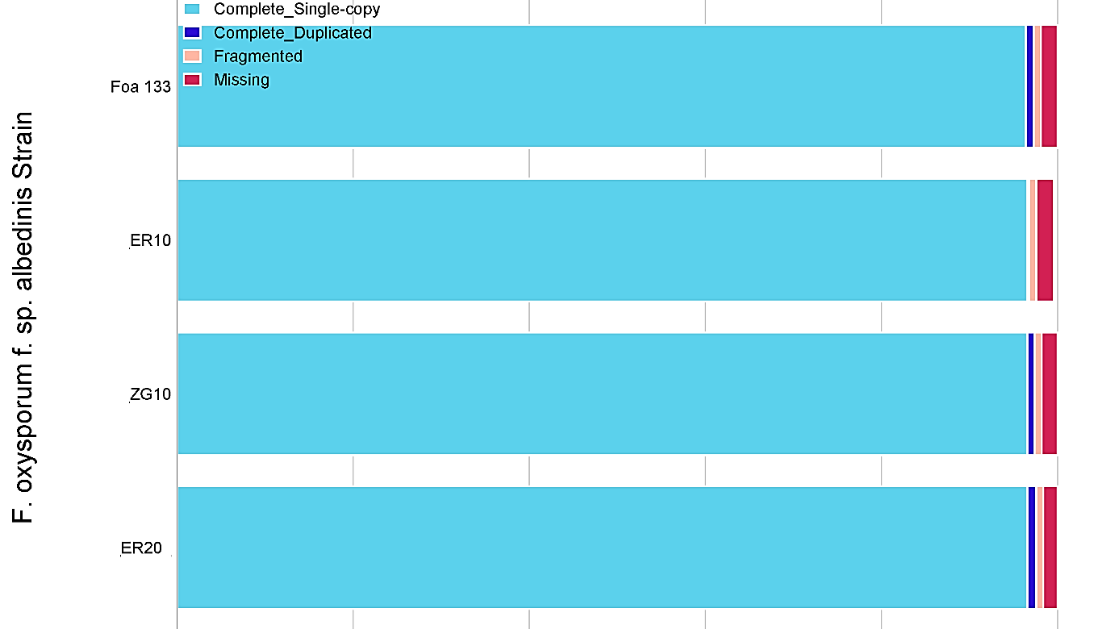
Figure : Benchmarking Universal Single-Copy Orthologs (BUSCO) results

