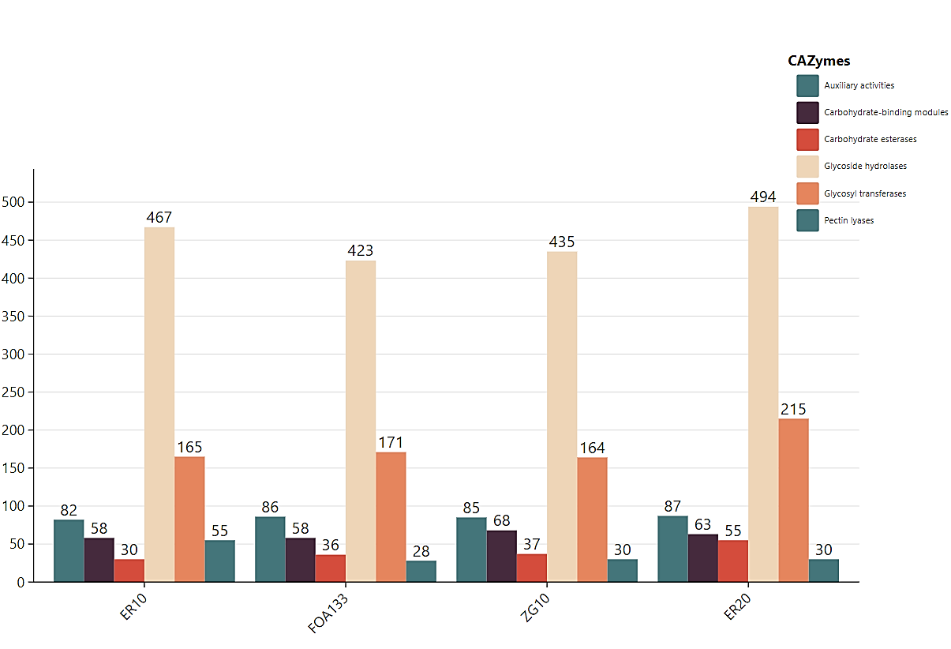
Figure : Repartition of Carbohydrate Active enZymes (CAZymes) repertoire of the Foa strains. Bar chart depicting the total number of carbohydrate-active enzymes (CAZymes) in each isolate. From left to right, each colour represents a CAZyme class. Green represents auxiliary activities; black represents carbohydrate band modules; red represents carbohydrate esterases; beige represents glycoside hydrolases; orange represents glycosyltransferases; and green represents pectin lyases.

