Supplementary Table S1. Comparison of the concentration of bone metabolism regulatory biomarkers in the study group and control.
Variable | Control [n=25] | Study group [n=76] | p
Variable | Me [IQR]  (min-max) | Me [IQR]  (min-max) | p
Activin A [pg/ml] | 437.50 [393.70-498.50]  (140.3-634.8) | 482.60 [408.75-620.20]  (293.3-2614.4) | 0.0260^{b}
Dkk-1 [pg/ml] | 2168.00 [1775-2465]  (1356-5006) | 2954.25 [2041.65-4884.20]  (1286.3-26122.4) | 0.0001^{b}
GDF-15 [pg/ml] | 721.40 [490-1113]  (313.2-2025.0) | 1711.95 [1075.15-3619.65]  (264.2-7908.6) | <0.0001^{b}
β-CTX [ng/ml] | 0.35 [0.25-0.43]  (0.1-0.6) | 0.61 [0.40-0.99]  (0.1-5.0) | <0.0001^{b}
Sclerostin [ng/ml] | 0.68 [0.52-0.86]  (0.4-1.1) | 0.64 [0.49-0.88]  (0.3-2.1) | 0.7800
^{b}- statistically significant result
Abbreviations: β-CTX: β-C-terminal telopeptide, Dkk-1: dickkopf-related protein 1, GDF-15: growth differentiation factor 15, IQR: interquartile range, Me: median

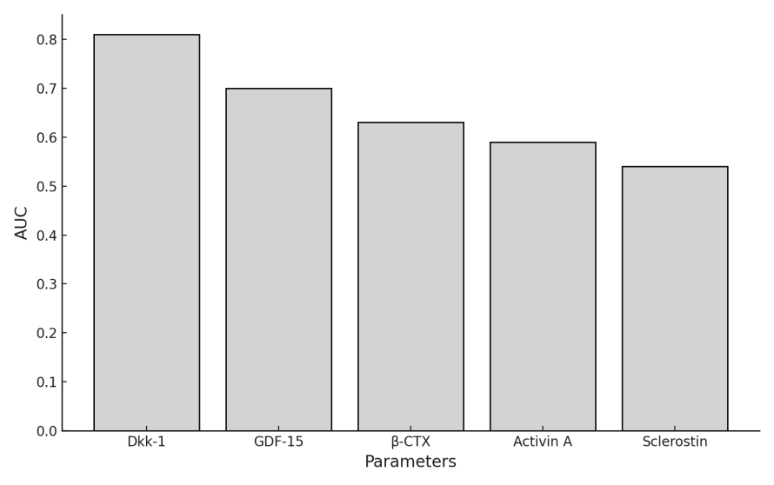
Supplementary Figure S1. Comparison of the AUC values describing the diagnostic usefulness of the studied indicators of metabolic regulation and bone turnover in the detection of bone lesions in patients with PCM. Abbreviations: AUC: area under curve, β-CTX: β-C-terminal telopeptide, Dkk-1: dickkopf-related protein 1, GDF-15: growth differentiation factor 15
Supplementary Table S2. Assessment of the diagnostic usefulness of indicators of bone metabolism regulation and the resorption marker (β-CTX) in detecting bone lesions in PCM patients.
Parameter | Cut off | Sensitivity [%] | Specificity [%] | AUC | 95% CI | p
Activin A [pg/ml] | >426 | 76.8 | 50 | 0.59 | 0.47 to 0.70 | 0.2300
Dkk-1 [pg/ml] | >2046 | 87.5 | 65 | 0.81 | 0.71 to 0.89 | <0.0001^{b}
GDF-15 [pg/ml] | >2359.6 | 48.2 | 95 | 0.70 | 0.59 to 0.80 | 0.0007^{b}
β-CTX [ng/ml] | >0.572 | 62.5 | 65 | 0.63 | 0.52 to 0.74 | 0.0448^{b}
Sclerostin [ng/ml] | ≤0.489 | 37.1 | 93.7 | 0.54 | 0.39 to 0.68 | 0.6260
^{b}- statistically significant result Abbreviations: AUC: area under curve, β-CTX: β-C-terminal telopeptide, CI: confidence interval Dkk-1: dickkopf-related protein 1, GDF-15: growth differentiation factor 15, SE: standard error,

The combination of selected indicators of metabolism regulation and bone turnover in the detection of bone lesions also show high diagnostic utility, namely the combinations of activin A and Dkk-1 (AUC=0.82; 95% CI: 0.71 to 0.9), activin A, Dkk-1 and GDF-15 (AUC=0.84; 95% CI: 0.74 to 0.92), activin A, Dkk-1, GDF-15 and β-CTX (AUC=0.84; 95% CI: 0.74 to 0.92), activin A, Dkk-1, GDF-15, β-CTX and sclerostin (AUC=0.83; 95% CI: 0.7 to 0.92), activin A, β-CTX and Dkk-1 (AUC=0.82; 95% CI:0.71 to 0.9), activin A, sclerostin and Dkk-1 (AUC=0.81; 95% CI: 0.68 to 0.91), activin A, sclerostin, Dkk-1 and GDF-15 (AUC=0.83; 95% CI: 0.70 to 0.92), Dkk-1 and sclerostin (AUC=0.81; 95% CI: 0.68 to 0.91), as well as β-CTX, sclerostin, activin A and Dkk-1 (AUC=0.81; 95% CI: 0.68 to 0.91) (Supplementary Table S3).
Supplementary Table S3. Assessment of the diagnostic usefulness of the combined determination of indicators of metabolic regulation and bone turnover in the detection of bone lesions in patients with PCM.
Examined parameters | AUC | 95% CI
Activin A, Dkk-1  Activin A, Dkk-1, GDF-15  Activin A, Dkk-1, GDF-15, β-CTX  Activin A, Dkk-1, GDF-15, β-CTX, Sclerostin | 0.82  0.84  0.84  0.83 | 0.71-0.90  0.74-0.92  0.74-0.92  0.70-0.92
Activin A, GDF-15  Activin A, GDF-15, Dkk-1  Activin A, GDF-15, Dkk-1, β-CTX  Activin A, GDF-15, Dkk-1, β-CTX, Sclerostin | 0.70  0.84  0.84  0.83 | 0.59-0.80 0.74-0.92 0.74-0.92  0.70-0.92
Activin A, β-CTX  Activin A, β-CTX, Dkk-1  Activin A, β-CTX, Dkk-1, GDF-15  Activin A, β-CTX, Dkk-1, GDF-15, Sclerostin | 0.64  0.82  0.84  0.83 | 0.52-0.74 0.71-0.90  0.74-0.92  0.70-0.92
Activin A, Sclerostin  Activin A, Sclerostin , Dkk-1  Activin A, Sclerostin, Dkk-1, GDF-15  Activin A, Sclerostin, Dkk-1, GDF-15, β-CTX | 0.55  0.81  0.83  0.83 | 0.41-0.69 0.68-0.91  0.70-0.92  0.70-0.92
Dkk-1, GDF-15  Dkk-1, GDF-15, Activin A  Dkk-1, GDF-15, Activin A, β-CTX  Dkk-1, GDF-15, Activin A, β-CTX, Sclerostin | 0.85  0.84  0.84  0.83 | 0.75-0.92 0.74-0.92 0.74-0.92  0.70-0.92
Dkk-1, β-CTX  Dkk-1, β-CTX, Activin A  Dkk-1, β-CTX, Activin A, GDF-15  Dkk-1, β-CTX, Activin A, GDF-15, Sclerostin | 0.82  0.82  0.84  0.83 | 0.71-0.90 0.71-0.90 0.74-0.92  0.70-0.92
Dkk-1, Sclerostin  Dkk-1, Sclerostin, Activin A  Dkk-1, Sclerostin, Activin A, GDF-15  Dkk-1, Sclerostin, Activin A, GDF-15, β-CTX | 0.81  0.81  0.83  0.83 | 0.68-0.91 0.68-0.91  0.70-0.92  0.70-0.92
GDF-15, β-CTX  GDF-15, β-CTX, Activin A  GDF-15, β-CTX, Activin A, Dkk-1  GDF-15, β-CTX, Activin A, Dkk-1, Sclerostin | 0.72  0.72  0.84  0.83 | 0.60-0.81  0.60-0.81 0.74-0.92  0.70-0.92
GDF-15, Sclerostin  GDF-15, Sclerostin, Activin A  GDF-15, Sclerostin , Activin A, Dkk-1  GDF-15, Sclerostin Activin A, Dkk-1, β-CTX | 0.73  0.74  0.83  0.83 | 0.59-0.85  0.60-0.86  0.70-0.92  0.70-0.92
β-CTX, Sclerostin  β-CTX, Sclerostin , Activin A  β-CTX, Sclerostin, Activin A, Dkk-1  β-CTX, Sclerostin, Activin A, Dkk-1, GDF-15 | 0.68  0.68  0.81  0.83 | 0.53-0.80  0.53-0.80 0.68-0.91  0.70-0.92
Abbreviations: AUC: area under curve, β-CTX: β-C-terminal telopeptide, CI: confidence interval Dkk-1: dickkopf-related protein 1, GDF-15: growth differentiation factor 15,
Supplementary Table S4. Comparison of concentrations of parameters regulating bone metabolism and markers of bone turnover in patients with PCM before and after treatment.
Parameter | Before treatment | After treatment | p
Parameter | Me [IQR]  (min-max) | Me [IQR]  (min-max) | p
Activin A [pg/ml] | 472.00  [390.70-605.30]  (293.3-1281.4) | 434.90  [356.50-495.80]  (291.6- 906.3) | 0.1500
Dkk-1 [pg/ml] | 2840.70  [2394.56-3377.10]  (1286.3-26122.4) | 1679.30  [1611.97-2526.16]  (1164-3810.1) | 0.0002^{b}
GDF-15 [pg/ml] | 1325.50  [1011.10-1734.90]  (598.9-7228.2) | 1581.30  [945.30-2691.60]  (664.2-4729.9) | 0.2528
β-CTX [ng/ml] | 0.60  [0.36-0.73]  (0.1-2.8) | 0.10  [0.11-0.22]  (0.1-0.9) | 0.0002^{b}
Sclerostin [ng/ml] | 0.70  [0.45-0.82]  (0.3-1.5) | 0.50  [0.35-0.56]  (0.3-1.1) | 0.0103^{b}
^{b}- statistically significant result Abbreviations: β-CTX: β-C-terminal telopeptide, Dkk-1: dickkopf-related protein 1, GDF-15: growth differentiation factor 15, IQR: interquartile range, Me: median

