Extracting Metal Oxide Redox Thermodynamics from TGA Measurements Requires Moving Beyond the Linearized Van ‘t Hoff Approach
Steven A. Wilson¹, Ellen B. Stechel², Christopher L. Muhich^{1,3}*
¹ Chemical Engineering, School for the Engineering of Matter, Transport, & Energy, Arizona State University, 551 E. Tyler Mall, Tempe Arizona, 85287, USA
² ASU LightWorks® and School of Molecular Sciences, Arizona State University, PO Box 878204, Tempe Arizona, 85287-8204, USA
³ Materials Science & Engineering, School for the Engineering of Matter, Transport, & Energy, Arizona State University, 551 E. Tyler Mall, Tempe Arizona, 85287, USA

* Corresponding Author

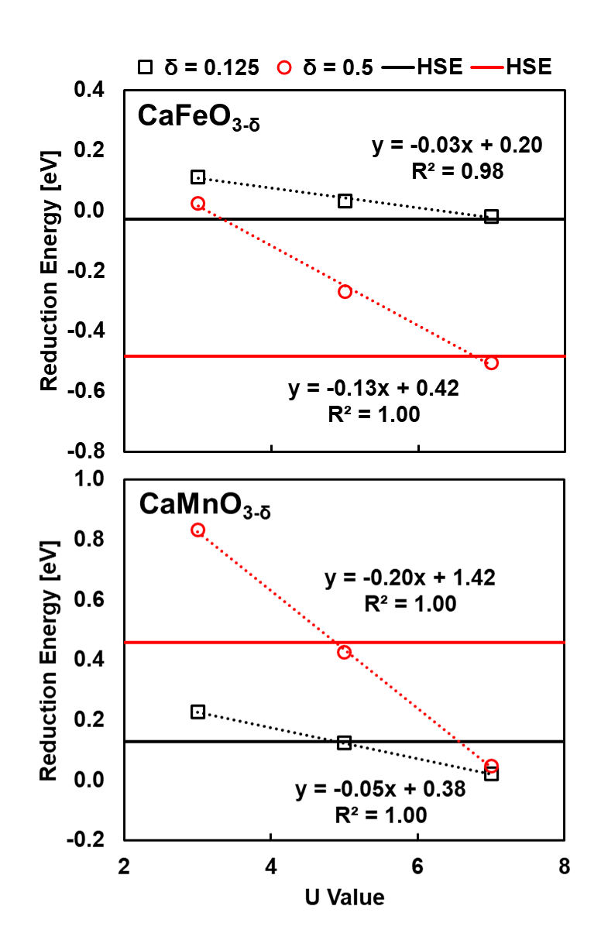
Figure S1: Calculated reduction energy versus Scan U value. Horizontal line is HSE reduction energy value at δ=0.125 (black) and δ=0.5 (red).

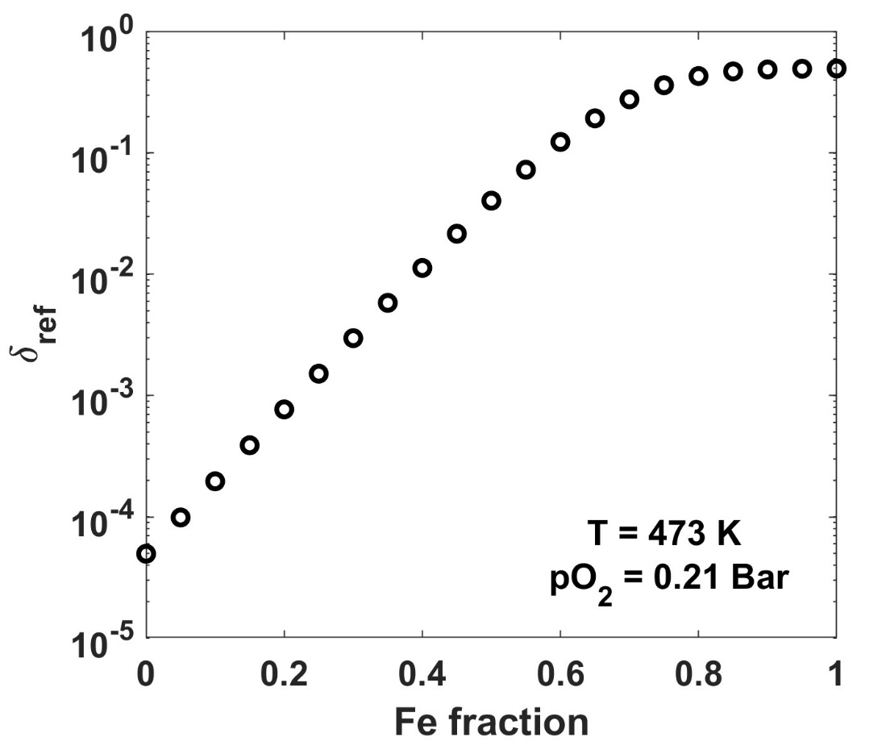
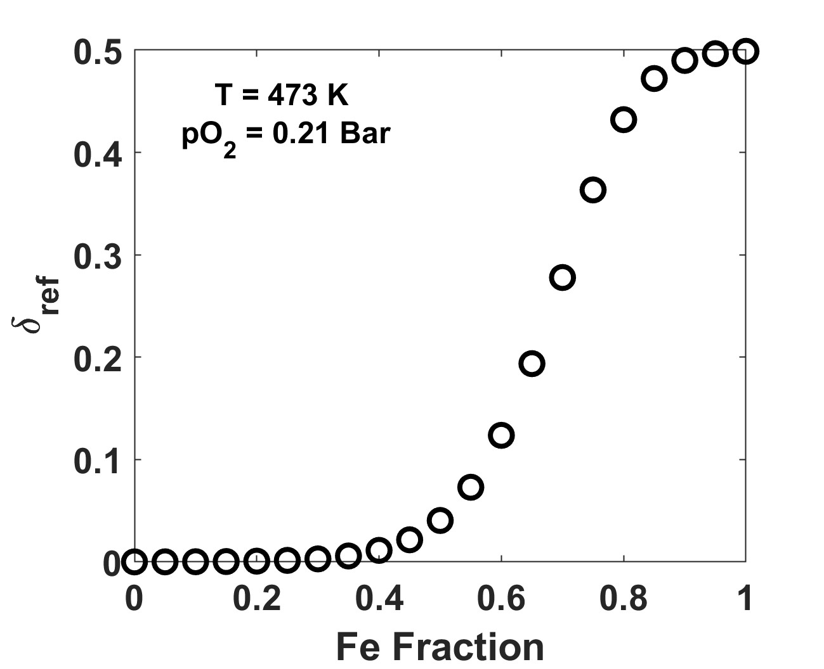
Figure S2: Predicted δ verusus Fe fraction in CFM at T=473 K and 0.21 Bar pO₂.

Table S1: CF-CEF model parameters for CFM system
Parameter | Value
A17 | -1.3575E-04
A19 | 1.3504E-04
A67 | 7.2948E-05
Ho17 | 6.4497E-06
Ho19 | 1.4895E-06
Ho67 | 2.1794E-06
So17 | 6.3224E-04
So19 | 2.2816E-04
So67 | 2.6235E-04
GendA1 | 3.9042E-04
GendA2 | -8.1888E-05
GendHo1 | 3.1985E-05
GendHo2 | 1.4107E-05
GendSo1 | -2.8420E-03
GendSo2 | -5.6829E-04

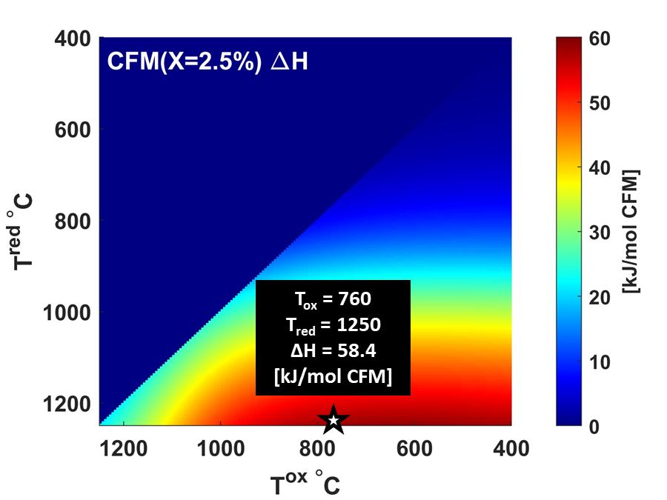
Figure S3: Thermochemical heat storage capacity of CFM x=0.025, Highlighted conditionas at T^{ox} = 760 C at 0.21Bar pO2 and T^{red} = 1250 at 0.001 Bar pO₂

The following is a summary of all the possible excess terms for CEF construction of up to a quinary material, A_{1-x}A’_{x}B_{1-y}B’_{y}O_{3-δ}, with reduction only on the B sublattice:
The gamma functions that control the composition on each sublattice are:
Ya = 1-x
Yap = x
Ybr = 2δ(1-y)
Ybo = (1-2δ)(1-y)
Ybpr = 2δy
Ybpo = (1-2δ)y
Yo_o = 1-δ/3
Yo_Va = δ/3

The excess terms are described using the gamma functions above:
L1 = Yap*Ya*Ybr*Yo_o L2 = Yap*Ya*Ybr*Yo_o*(Ya - Yap)
L3 = Yap*Ya*Ybr*Yo_Va L4 = Yap*Ya*Ybr*Yo_Va*(Ya - Yap)
L5 = Yap*Ya*Ybo*Yo_o L6 = Yap*Ya*Ybo*Yo_o*(Ya - Yap)
L7 = Yap*Ya*Ybo*Yo_Va L8 = Yap*Ya*Ybo*Yo_Va*(Ya - Yap)
L9 = Yap*Ya*Ybpr*Yo_o L10 = Yap*Ya*Ybpr*Yo_o*(Ya - Yap)
L11 = Yap*Ya*Ybpr*Yo_Va L12 = Yap*Ya*Ybpr*Yo_Va*(Ya - Yap)
L13 = Yap*Ya*Ybpo*Yo_o L14 = Yap*Ya*Ybpo*Yo_o*(Ya - Yap)
L15 = Yap*Ya*Ybpo*Yo_Va L16 = Yap*Ya*Ybpo*Yo_Va*(Ya - Yap)
L17 = Ybr*Ybo*Ya*Yo_o L18 = Ybr*Ybo*Ya*Yo_o*(Ybr - Ybo)
L19 = Ybr*Ybo*Ya*Yo_Va L20 = Ybr*Ybo*Ya*Yo_Va*(Ybr - Ybo)
L21 = Ybr*Ybo*Yap*Yo_o L22 = Ybr*Ybo*Yap*Yo_o*(Ybr - Ybo)
L23 = Ybr*Ybo*Yap*Yo_Va L24 = Ybr*Ybo*Yap*Yo_Va*(Ybr - Ybo)
L25 = Ybpr*Ybpo*Ya*Yo_o L26 = Ybpr*Ybpo*Ya*Yo_o*(Ybpr - Ybpo)
L27 = Ybpr*Ybpo*Ya*Yo_Va L28 = Ybpr*Ybpo*Ya*Yo_Va*(Ybpr - Ybpo)
L29 = Ybpr*Ybpo*Yap*Yo_o L30 = Ybpr*Ybpo*Yap*Yo_o*(Ybpr - Ybpo)
L31 = Ybpr*Ybpo*Yap*Yo_Va L32 = Ybpr*Ybpo*Yap*Yo_Va*(Ybpr - Ybpo)
L33 = Ybpr*Ybr*Ya*Yo_o L34 = Ybpr*Ybr*Ya*Yo_o*(Ybr - Ybpr)
L35 = Ybpr*Ybr*Ya*Yo_Va L36 = Ybpr*Ybr*Ya*Yo_Va*(Ybr - Ybpr)
L37 = Ybpr*Ybr*Yap*Yo_o L38 = Ybpr*Ybr*Yap*Yo_o*(Ybr - Ybpr)
L39 = Ybpr*Ybr*Yap*Yo_Va L40 = Ybpr*Ybr*Yap*Yo_Va*(Ybr - Ybpr)
L41 = Ybpo*Ybr*Ya*Yo_o L42 = Ybpo*Ybr*Ya*Yo_o*(Ybr - Ybpo)
L43 = Ybpo*Ybr*Ya*Yo_Va L44 = Ybpo*Ybr*Ya*Yo_Va*(Ybr - Ybpo)
L45 = Ybpo*Ybr*Yap*Yo_o L46 = Ybpo*Ybr*Yap*Yo_o*(Ybr - Ybpo)
L47 = Ybpo*Ybr*Yap*Yo_Va L48 = Ybpo*Ybr*Yap*Yo_Va*(Ybr - Ybpo)
L49 = Ybpo*Ybo*Ya*Yo_o L50 = Ybpo*Ybo*Ya*Yo_o*(Ybo - Ybpo)
L51 = Ybpo*Ybo*Ya*Yo_Va L52 = Ybpo*Ybo*Ya*Yo_Va*(Ybo - Ybpo)
L53 = Ybpo*Ybo*Yap*Yo_o L54 = Ybpo*Ybo*Yap*Yo_o*(Ybo - Ybpo)
L55 = Ybpo*Ybo*Yap*Yo_Va L56 = Ybpo*Ybo*Yap*Yo_Va*(Ybo - Ybpo)
L57 = Ybpr*Ybo*Ya*Yo_o L58 = Ybpr*Ybo*Ya*Yo_o*(Ybpr - Ybo)
L59 = Ybpr*Ybo*Ya*Yo_Va L60 = Ybpr*Ybo*Ya*Yo_Va*(Ybpr - Ybo)
L61 = Ybpr*Ybo*Yap*Yo_o L62 = Ybpr*Ybo*Yap*Yo_o*(Ybpr - Ybo)
L63 = Ybpr*Ybo*Yap*Yo_Va L64 = Ybpr*Ybo*Yap*Yo_Va*(Ybpr - Ybo)
L65 = Yo_o*Yo_Va*Ya*Ybr L66 = Yo_o*Yo_Va*Ya*Ybr*(Yo_o - Yo_Va)
L67 = Yo_o*Yo_Va*Ya*Ybo L68 = Yo_o*Yo_Va*Ya*Ybo*(Yo_o - Yo_Va)
L69 = Yo_o*Yo_Va*Ya*Ybpr L70 = Yo_o*Yo_Va*Ya*Ybpr*(Yo_o - Yo_Va)
L71 = Yo_o*Yo_Va*Ya*Ybpo L72 = Yo_o*Yo_Va*Ya*Ybpo*(Yo_o - Yo_Va)
L73 = Yo_o*Yo_Va*Yap*Ybr L74 = Yo_o*Yo_Va*Yap*Ybr*(Yo_o - Yo_Va)
L75 = Yo_o*Yo_Va*Yap*Ybo L76 = Yo_o*Yo_Va*Yap*Ybo*(Yo_o - Yo_Va)
L77 = Yo_o*Yo_Va*Yap*Ybpr L78 = Yo_o*Yo_Va*Yap*Ybpr*(Yo_o - Yo_Va)
L79 = Yo_o*Yo_Va*Yap*Ybpo L80 = Yo_o*Yo_Va*Yap*Ybpo*(Yo_o - Yo_Va)

