Supplementary Materials for

• Genetic analysis identified candidate genes in canine behavioral evolution

Akiko Tonoike, Ken-ichi Otaki, Go Terauchi, Misato Ogawa, Maki Katayama, Hikari Sakata, Fumina Miyasako, Kazutaka Mogi, Takefumi Kikusui, and Miho Nagasawa*

*Corresponding author. Email: nagasawa@azabu-u.ac.jp

This PDF file includes:

Fig. S1
Table S1–S6

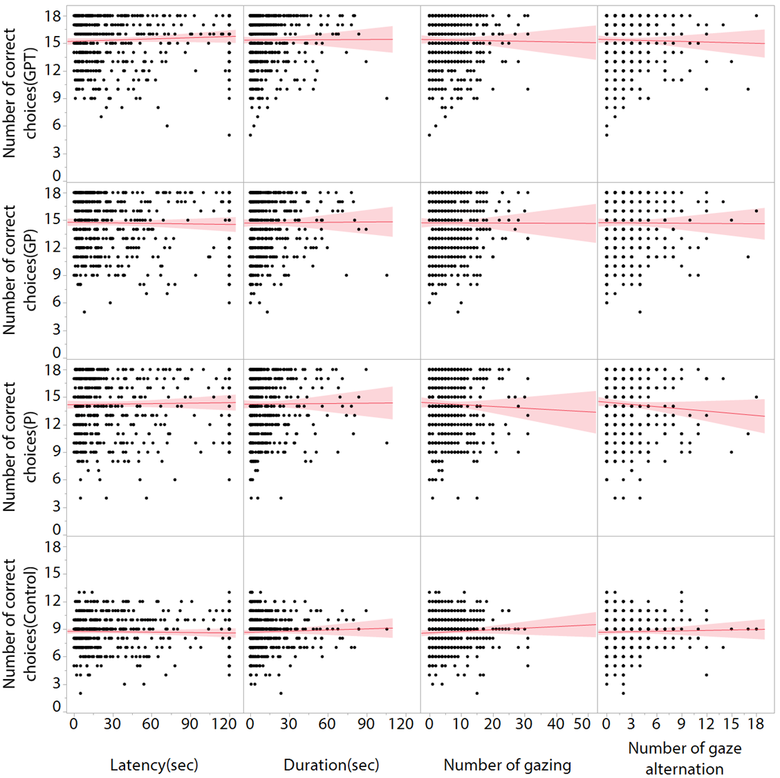
Fig. S1.
Correlation analysis of the behavioral parameters in the two tests (problem solving test and two-way choice test). There were no correlations between them.
Table S1.
The number of dogs in each breeds and the genetically clustered breed groups used for the cognition tests.

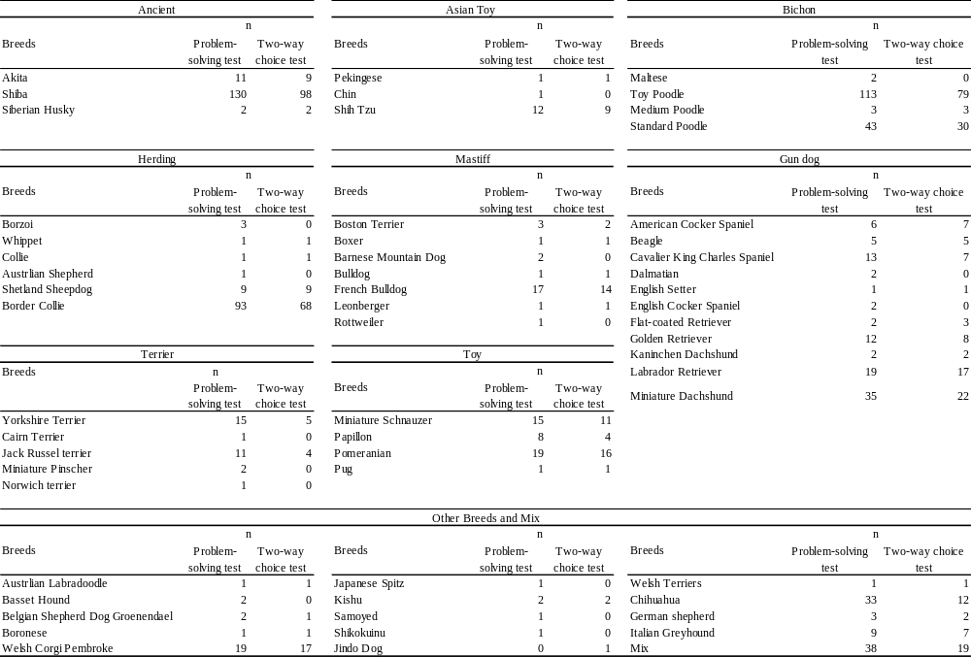

Table S2.
Primers used for PCR amplification to genotype the dog gene polymorphisms.

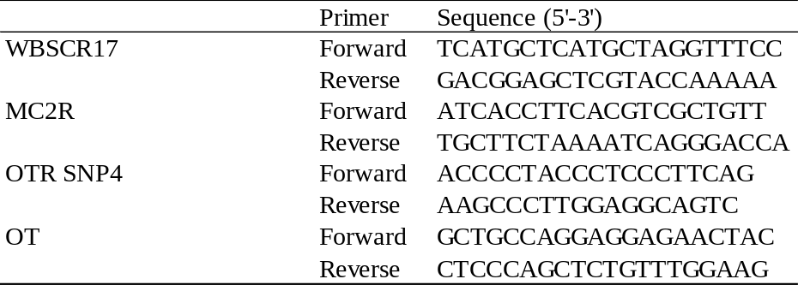

Table S3.
Summary of GLM analysis of Breed groups and Genetic polymorphisms

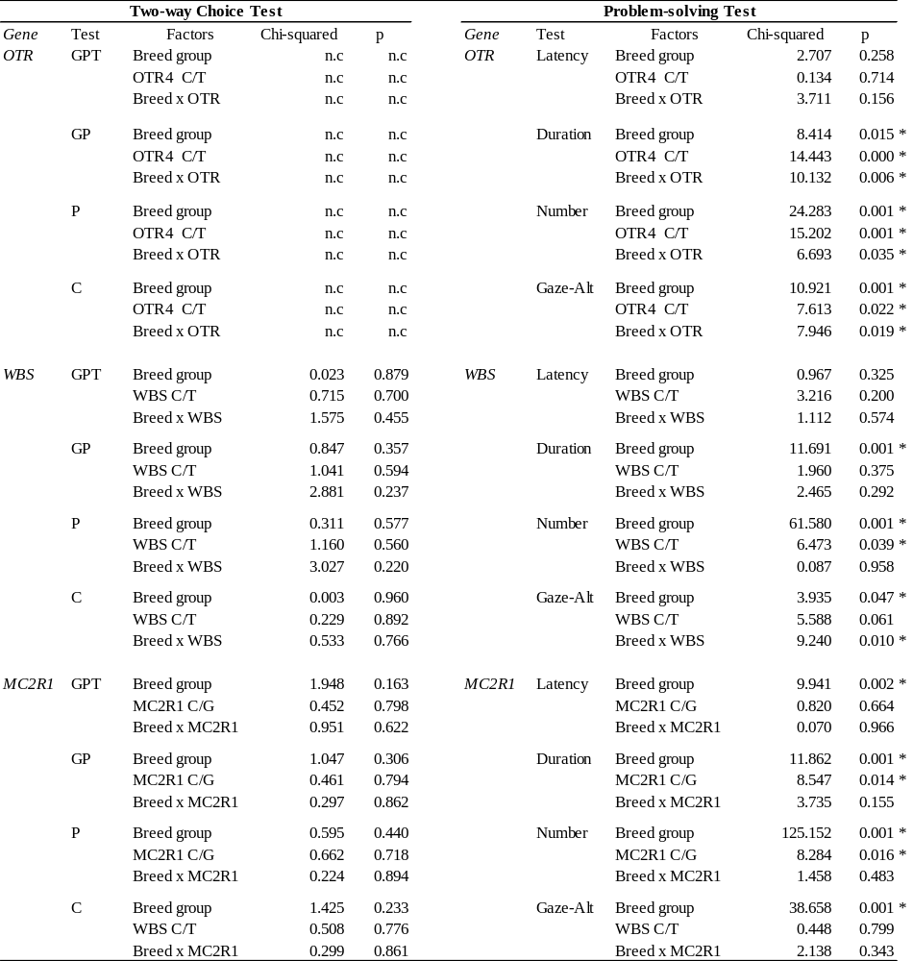
(continued to next page)

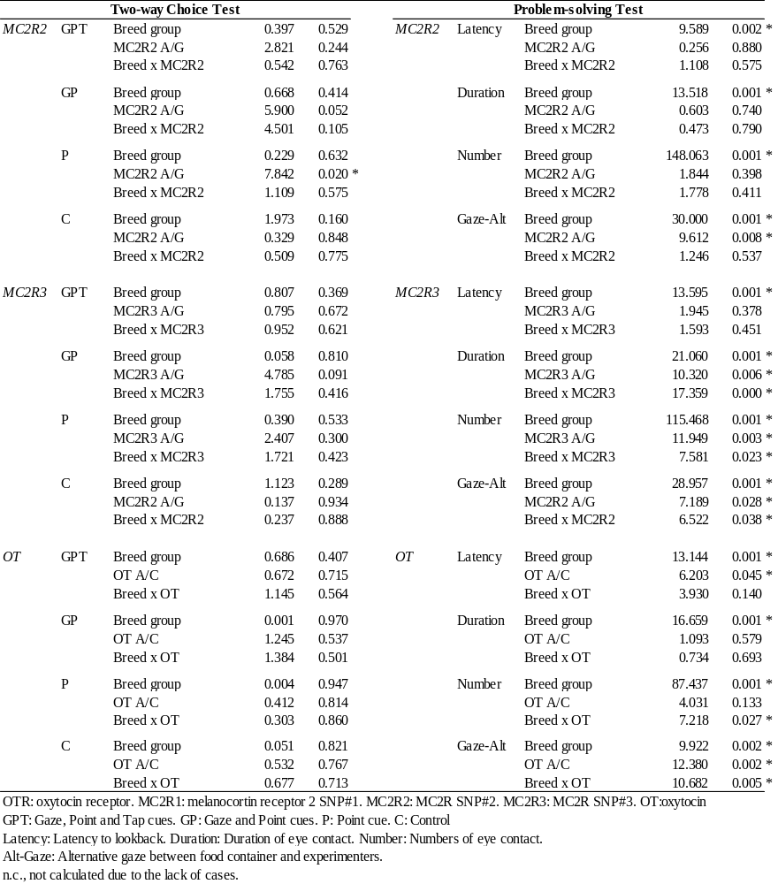

Table S4.
Post-hoc tests of GLM analysis of Breed groups and Genetic polymorphisms

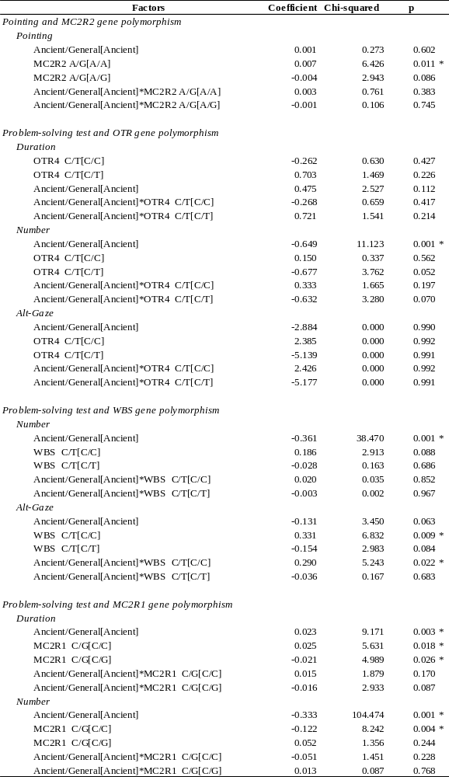
(continued to next page)

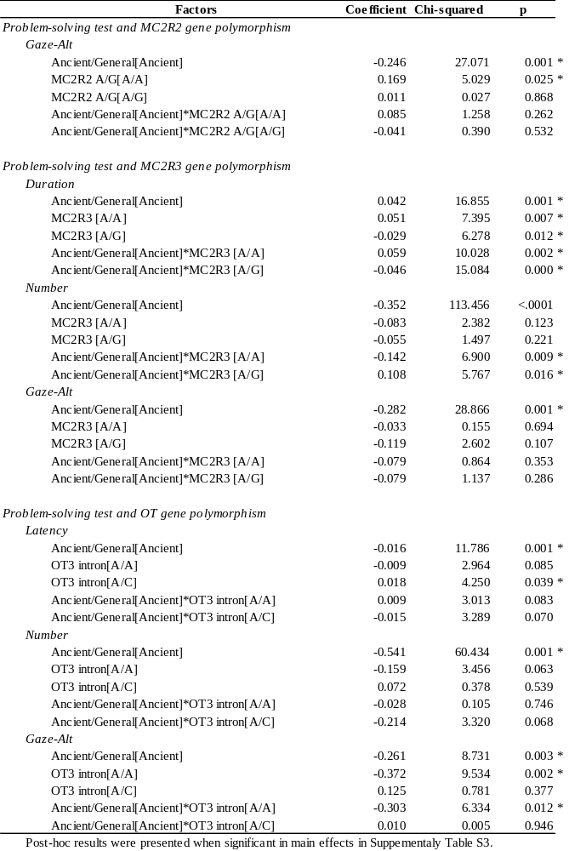

Table S5.
Summary of GLM analysis of basic information of the dogs

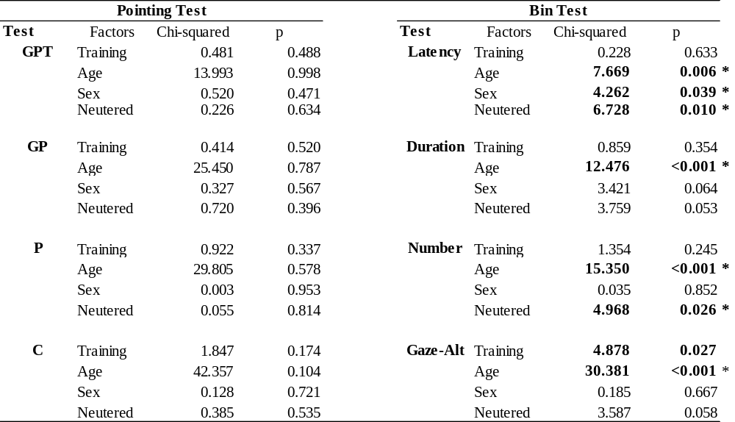

Table S6.
Summary of Chi-squared test of Genetic polymorphisms and Training experience

