Supporting Information for
Outsiders See More than Insiders: Interpersonal Neural and Computational Mechanisms of Friend Advice Interactions Optimizing Mate-Choice Decisions

This PDF file includes:
Supporting text
Figures S1 to S6
Tables S1 to S8
SI References

Supporting Information Text
Group Homogeneity Test Result
To examine the homogeneity of demographic characteristics between advisor groups beyond their current relationship status, we analyzed participants’ baseline demographic variables prior to the experiment. The results indicated no significant group differences on any demographic variable except for the duration of current romantic involvement, which directly reflects advisors’ relational experience and served as the critical between-group factor in this study (Table S1). These findings demonstrate that participants were comparable across all other demographic dimensions, thereby supporting the validity of grouping based on relationship status.
Table S1. Between-group homogeneity test of advisors’ demographic characteristics.
Variable | Single advisors  (n=33) | Advisors in a relationship (n=33) | χ²/t | p | φ/Cohen’d
Gender (Male/Female) | 16/17 | 17/16 | 0.061 | 0.806 | 0.030
Educational Background (Undergraduate/Graduate) | 22/11 | 26/7 | 1.222 | 0.269 | 0.136
Household registration  (Rural /Urban) | 9/24 | 12/21 | 0.629 | 0.428 | 0.098
Age (years) | 21.03±2.22 | 20.39±2.18 | 1.177 | 0.244 | 0.290
Friendship duration (months) | 13.09±3.84 | 13.03±3.70 | 0.065 | 0.948 | 0.016
Previous romantic relationships | 1.67±1.34 | 1.97±2.02 | -0.718 | 0.476 | -0.177
Longest previous relationship (months) | 6.30±4.98 | 7.18±5.24 | -0.698 | 0.488 | -0.172
Current relationship duration (months) | 0 | 18.12±3.70 | -28.153*** | <0.001 | -6.931
Note: Values are reported as mean ± standard deviation (M±SD) for continuous variables and as counts for categorical variables. Independent-sample t tests and χ² tests were conducted to examine group homogeneity. The only significant difference was observed in current relationship duration, which constituted the key between-group variable in this study. ***p< 0.001.

Supporting Information Text
Manipulation Check Result
All dyads reported IOS scores above 5, indicating mutual recognition of close friendship (Figure S1C). IOS scores proved significantly higher in real dyads than in random pairs (5.91±0.81 vs. 1.36±0.48, t₍₂₆₂₎=55.628, p<0.001, Cohen’ d=6.847, Figure S1D), as revealed by a comparison between randomly paired and real dyads. Mean ratings for face stimuli, meanwhile, fell within the midrange of the 1–9 scale, indicating perceptions of moderate attractiveness among both female faces (4.76±1.26, Figure S1A) and male faces (4.72±1.14, Figure S1B), as confirmed by decisionmakers. Through NLP analyses of the advice content, the validity of the experimental manipulation was verified: advice in the positive condition was predominantly associated with positive sentiment (score>0, Figure S1E), while advice in the negative condition was associated with negative sentiment (score<0, Figure S1F). Collectively, these results confirm that advisors largely adhered to task instructions.
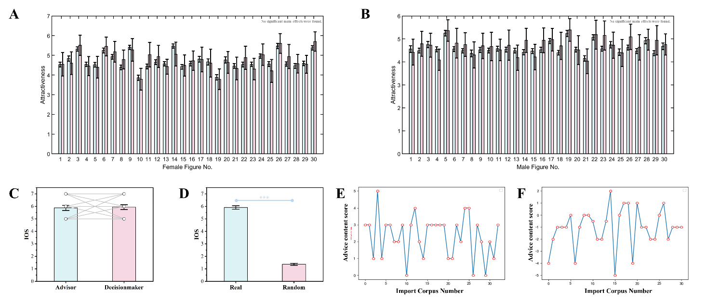
Figure S1. Results of the manipulation check. (A & B) Attractiveness ratings of opposite-sex face stimuli by online participants (nₘₐₗₑ=386, n_{f}ₑₘₐₗₑ=464; light blue rectangles) and decisionmakers in the formal experiment (nₘₐₗₑ=33, n_{f}ₑₘₐₗₑ=33; light red rectangles). Panel A shows ratings provided by male decisionmakers, and Panel B shows those from female decisionmakers. Error bars indicate 95% confidence intervals. No significant differences were observed between online participants and decisionmakers across all face stimuli. (C & D) IOS scores of real dyads and randomly matched dyads. Panel C shows IOS scores within real dyads, and Panel D compares scores between real dyads and label-shuffled random pairs. Dots indicate individual data points, and connecting lines represent paired ratings from advisors and decisionmakers. (E) NLP-derived sentiment trajectories for advice content during the positive-advice condition (example from one dyad). (F) NLP-derived sentiment trajectories for advice content during the negative-advice condition.

Supporting Information Text
Brain-Behavior Correlation Analysis Result
When in-relationship advisors provided positive advice, dyadic ΔINS in the DLPFC–DLPFC, DLPFC–STG, and STG–MTG connections were positively correlated with both △mate-choice intention and the decision optimization parameter β (Pearson’s r> 0.381, ps< 0.029, two-tailed). Conversely, when single advisors provided negative advice, ΔINS in the STG–STG and DLPFC–STG connections were negatively correlated with △mate-choice intention (|Pearson’s r|> 0.455, ps< 0.008, two-tailed), while these same connections, together with the STG–MTG, showed significant positive correlations with β (Pearson’s r> 0.449, ps< 0.009, two-tailed). Correlations under the remaining conditions are shown in Figure S2.
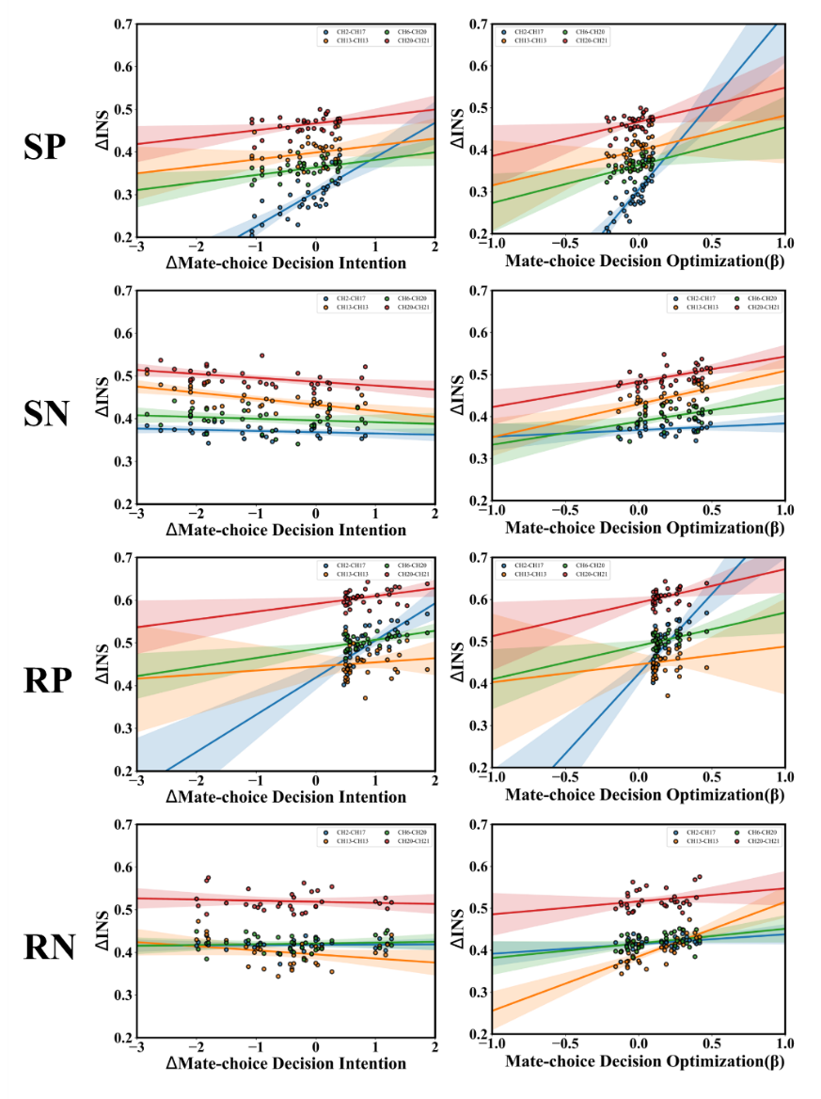
Figure S2. Pearson correlation analyses between significant channel-level ΔINS and behavioral indices of mate-choice decisions. Left column: changes in △mate-choice intention; right column: decision optimization parameter β. Shaded areas indicate 95% confidence intervals.

Supporting Information Text
Details of fNIRS Recording and Corresponding Relationship Between Channels
The experiment was conducted in a dedicated fNIRS laboratory, with each dyad seated face-to-face with each other. Two computer monitors were positioned diagonally to avoid obstructing participants’ view of one another (Figure S3A). A digital recorder (H1Pro, iFlytek Co., Ltd.) was placed at the center of the dyad to capture audio during the advice interaction. Before the task, participants completed a 5-minute resting baseline during which they were instructed to relax and minimize head movements ¹.
Figure S3. Experimental setup and fNIRS optode configuration.(A) Experimental arrangement. Schematic illustration of participants seated face-to-face with diagonally positioned monitors. Neural activity was simultaneously recorded from both individuals during advice interactions using fNIRS. (B) Optode arrays. Probe arrays covering the prefrontal cortex (PFC) and the left temporoparietal junction (TPJ), with 21 measurement channels and their corresponding mappings onto cortical regions.
During the task, two identical fNIRS systems (NirSmartII-3000A, HuiChuang, Beijing; sampling rate = 11 Hz; wavelengths=730 and 850 nm) were simultaneously applied to cover the prefrontal cortex (PFC) and the left temporoparietal junction (TPJ), regions previously implicated in advice interactions ² and mate-choice decision-making ³. For each participant, a 2×5 probe array (five emitters and five detectors, reference optode at Fpz) yielded 13 channels over the PFC, while a second array (four emitters and three detectors, reference optode at T5) produced eight channels over the left TPJ. Probe placement was carefully checked to ensure consistency across participants. Channel-to-cortex correspondence was determined using a 3D digitizer, and locations were registered to standard space via the NIRS-SPM toolbox, yielding Montreal Neurological Institute coordinates and probabilistic mappings to Brodmann areas (Figure S3B).

Supporting Information Text
Hyperparameter optimization
Hyperparameters were tuned through Bayesian optimization in Optuna. We defined candidate ranges for factors such as learning rate, regularization strength, and kernel type. Optuna’s adaptive sampling iteratively explored possible parameter combinations. Optimization aimed to minimize validation loss or maximize classification accuracy. This enabled efficient identification of globally optimal configurations ⁴.
SVR. SVR was implemented using Scikit-learn’s SVR module. Given its sensitivity to hyperparameters, we systematically optimized: (1) kernel type (linear, radial basis function [RBF], polynomial) to capture both linear and nonlinear dependencies; (2) the regularization parameter C to balance model complexity with training error; (3) epsilon (ε), which defines the margin of tolerance for prediction errors; and (4) gamma (γ), which specifies the influence radius of individual samples under RBF and polynomial kernels. Optimization was conducted within the LOOCV framework using Bayesian optimization to minimize mean squared error (MSE) and maximize predictive accuracy. The optimal parameters for each condition are reported in Table S2.
Table S2. Optimal hyperparameters for SVR models across experimental conditions.
Condition | Hyperparameters | Optimal Values
SP | Kernel | rbf
SP | C | 1.2
SP | ε | 0.08
SN | Kernel | rbf
SN | C | 1.5
SN | γ | 0.10
RP | Kernel | rbf
RP | C | 0.9
RP | ε | 0.12
RN | Kernel | rbf
RN | C | 1.8
LDA. Using the Scikit-learn LinearDiscriminantAnalysis module. The approach involved tuning several LDA hyperparameters. Specifically, optimization focused on three: (1) solver, which sets the fitting algorithm (svd, lsqr, eigen); (2) shrinkage, which handles regularization when using shrinkage-compatible solvers (lsqr or eigen) with values None, auto, or a specific float; and (3) store_covariance, which decides if the covariance matrix is stored. For model training and validation, LOOCV was applied. Classification accuracy served as the optimization criterion. Finally, Table S3 summarizes the optimal hyperparameters for each condition.
Table S3. Optimal hyperparameters for LDA models across experimental conditions.
Condition | Hyperparameters | Optimal Values
SP | solver | lsqr
SP | shrinkage | 0.4
SN | shrinkage | 0.3
SN | store_covariance | False
RP | solver | lsqr
RP | store_covariance | True
RN | solver | lsqr
RN | shrinkage | 0.5
KNN. KNN classification was implemented using the KNeighborsClassifier module in Scikit-learn. Hyperparameter optimization focused on three key aspects: (1) n_neighbors, specifying the number of neighbors considered in the voting process; (2) weights, determining whether all neighbors contribute equally (uniform) or are weighted by distance (distance); and (3) metric, defining the distance measure between samples (e.g., Euclidean or Manhattan distance). Parameter tuning was conducted via grid search combined with fivefold cross-validation, aiming to maximize classification accuracy, reduce sensitivity to noisy data, and enhance model generalizability. The optimal hyperparameter settings for each condition are presented in Table S4.
Table S4. Optimal hyperparameters for KNN models across experimental conditions.
Condition | Hyperparameters | Optimal Values
SP | n_neighbors | 11
SP | weights | uniform
SP | metric | euclidean
SN | n_neighbors | 13
SN | metric | manhattan
RP | n_neighbors | 9
RN | metric | manhattan
RF. For different prediction tasks, we implemented RF models using the RandomForestClassifier and RandomForestRegressor modules in Scikit-learn. Hyperparameter optimization focused on four critical parameters: (1) n_estimators, the number of trees in the forest, determining the size of the ensemble; (2) max_depth, the maximum depth of each decision tree, controlling model complexity and capacity; (3) min_samples_split, the minimum number of samples required to split an internal node, regulating tree growth; and (4) max_features, the maximum number of features considered at each split, which introduces randomness to reduce overfitting risk. Randomized search was applied to efficiently explore the hyperparameter space and achieve an optimal balance between prediction accuracy and generalization. Final optimized parameters are reported in Table S5.
Table S5. Optimal hyperparameters for RF models across experimental conditions.
Condition | Hyperparameters | Optimal Values
SP | n_estimators | 200
SN | max_features | log2
RP | min_samples_split | 6
RN | class_weight | balanced_subsample
Naive Bayes. Naive Bayes classification was performed using the GaussianNB module in Scikit-learn. Optimization focused on the var_smoothing parameter, which prevents numerical instability caused by extremely small feature variances. Using the Optuna framework, we defined a search range of [1e−12, 1e−6] and applied LOOCV to select the optimal smoothing value for each condition. Results indicated that relatively small but non-extreme var_smoothing values improved model stability. The final optimal parameter is presented in Table S6.
Table S6. Optimal hyperparameters for Naive Bayes models across experimental conditions.
Condition | Hyperparameters | Optimal Values
SP | var_smoothing | 1e-8
SN | var_smoothing | 5e-8
RP | var_smoothing | 1e-9
RN | var_smoothing | 1e-8

GBM. GBM models were implemented using the GradientBoostingClassifier in Scikit-learn. Hyperparameter optimization targeted: (1) learning_rate, which controls the step size at each iteration; (2) n_estimators, the number of weak learners; (3) max_depth, the maximum depth of individual trees; (4) subsample, the proportion of samples used during training; and (5) min_samples_split and min_samples_leaf, which constrain tree growth. Bayesian optimization with the Optuna framework was employed to identify the most effective parameter configuration. Results showed that a smaller learning_rate combined with a moderate number of estimators and shallow tree structures (2–3 levels) produced the most robust performance across conditions. The final optimal parameters are summarized in Table S7.
Table S7. Optimal hyperparameters for GBM models across experimental conditions.
Condition | Hyperparameters | Optimal Values
SP | learning_rate | 0.08
SP | n_estimators | 250
SP | max_depth | 2
SP | subsample | 0.9
SP | min_samples_split | 3
SP | min_samples_leaf | 2
SN | learning_rate | 0.06
SN | n_estimators | 300
SN | max_depth | 3
SN | subsample | 0.8
SN | min_samples_split | 4
SN | min_samples_leaf | 2
RP | learning_rate | 0.10
RP | n_estimators | 200
RP | max_depth | 2
RP | subsample | 0.9
RP | min_samples_split | 3
RP | min_samples_leaf | 2
RN | learning_rate | 0.05
RN | n_estimators | 320
RN | max_depth | 3
RN | subsample | 0.8
RN | min_samples_split | 4
RN | min_samples_leaf | 3

Multinomial Logistic Regression. Using the LogisticRegression module in Scikit-learn to predict multiclass changes in mate-choice decisions. Unlike binary logistic regression, Multinomial Logistic Regression accommodates three outcome categories within a single model, necessitating careful hyperparameter tuning. Optimization targeted five key parameters: (1) penalty, the type of regularization (L1, L2, or ElasticNet) to prevent overfitting and improve generalization; (2) C, the inverse of regularization strength, balancing model complexity and fit accuracy; (3) solver, the optimization algorithm (e.g., lbfgs, saga) supporting multinomial loss; (4) max_iter, the maximum number of iterations to ensure convergence under complex data; and (5) class_weight, to handle class imbalance. Hyperparameter optimization employed Bayesian search within the Optuna framework, combined with LOOCV for robust evaluation. Model performance was assessed using classification accuracy and macro-averaged F1 scores. Results indicated stable performance across all four experimental conditions, with L2 regularization demonstrating the best generalization in most cases, whereas solver choice varied slightly by context. The final optimal hyperparameter configurations are presented in Table S8.
Table S8. Optimal hyperparameters for Multinomial Logistic Regression models across experimental conditions.
Condition | Hyperparameters | Optimal Values
SP | penalty | l1
SP | C | 0.9
SP | solver | lbfgs
SN | penalty | l2
SN | C | 0.7
SN | max_iter | 600
RP | penalty | l2
RP | solver | lbfgs
RP | max_iter | 500
RN | penalty | l2
RN | C | 0.8
RN | class_weight | balanced

Figures
Figure S4. Validity test of △INS. A total of 1,000 permutation tests were conducted to confirm that task-related INS did not arise by chance. (A–C) Permutation tests for the main effect of advice source. (D&F) Permutation tests for the main effect of advice content valence. (E, & G–I) Permutation tests for interaction effects. The green dashed line indicates the observed F value for real dyads, and the red curve denotes the null distribution.

Figure S5. Comparison of ML model performance across conditions.

Figure S6. Prediction of the decision optimization parameter β using SVR models with 5,000 permutation tests. Results are displayed separately for each experimental condition. Scatter plots illustrate the fit between observed and predicted values, with shaded areas indicating 95% confidence intervals. Histograms show the null distribution of correlation coefficients, with the red dashed line marking the observed r value.

SI References
1 Dai, B. et al. Neural mechanisms for selectively tuning into the target speaker in a naturalistic noisy situation. Nature Communications 9, 2405 (2018).
2 Xie, E. et al. The single- and dual-brain mechanisms underlying the adviser's confidence expression strategy switching during influence management. NeuroImage 270, 119957 (2023).
3 Satpute, A. B., Badre, D. & Ochsner, K. N. Distinct Regions of Prefrontal Cortex Are Associated with the Controlled Retrieval and Selection of Social Information. Cerebral Cortex 24, 1269-1277 (2014).
4 Almarzooq, H. & Bin Waheed, U. Automating hyperparameter optimization in geophysics with Optuna: A comparative study. Geophysical Prospecting 72, 1778-1788 (2024).

