Figure 1. Study Flow Diagram
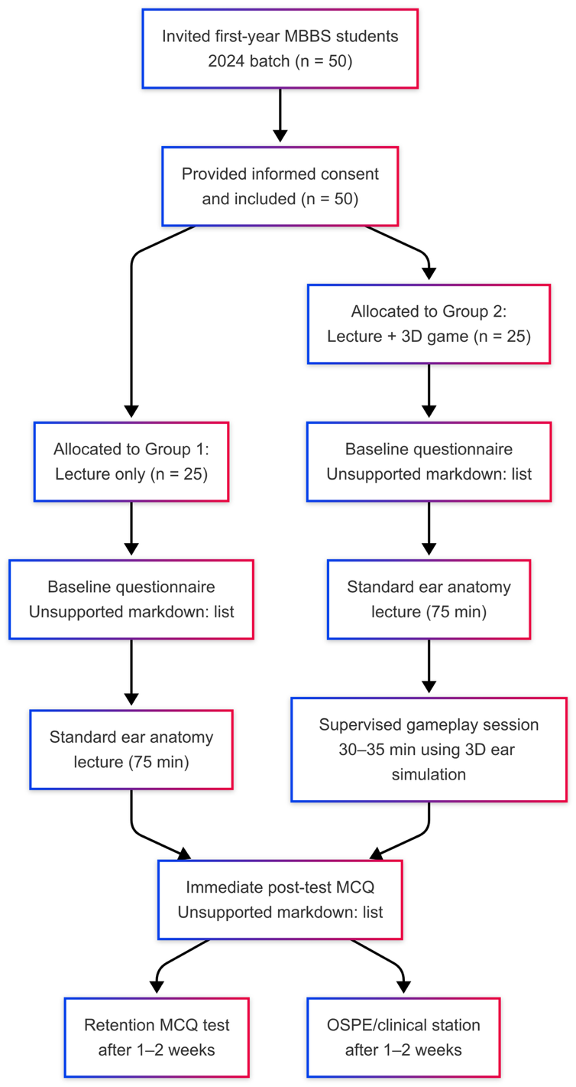
Figure: Flowchart illustrating the study design involving first-year MBBS students (2024 batch, n = 50). Participants were randomized into two groups: Group 1 received a lecture only, while Group 2 received the lecture followed by a supervised 3D ear simulation game. Assessments included baseline tests, immediate post-tests, and follow-up evaluations (MCQ and OSPE) after 1–2 weeks.

Figure 2. Correlation Matrix of Spatial Ability, Game Exposure, and Learning Gains (Intervention Group, n = 25)
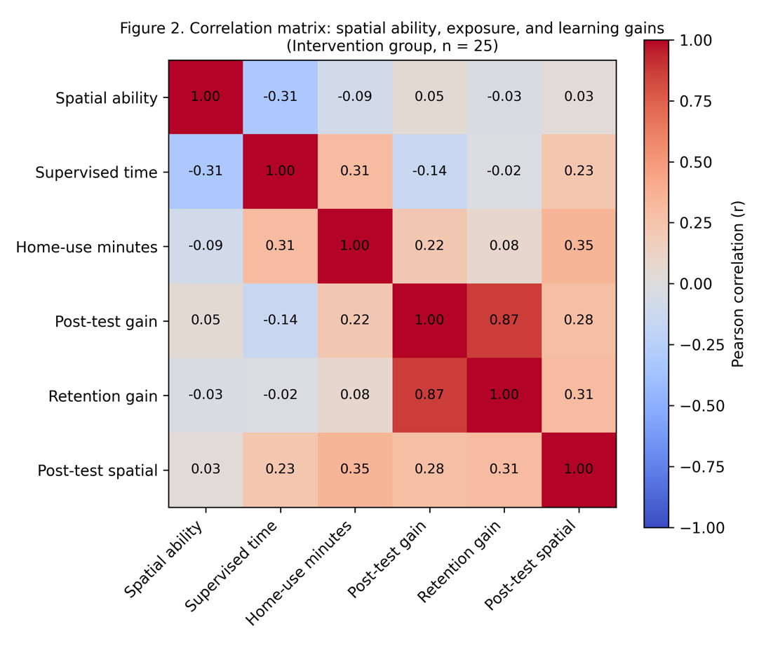
Figure 2. Pearson correlation matrix among spatial ability, supervised game time, extra home-use minutes, pre–post gain, retention gain, and post-test spatial MCQ subscore in the intervention group (n = 25). Cell values show correlation coefficients (r). Darker cells indicate stronger positive (upper right) or negative (lower left) relationships.

