A system dynamics approach to integrated management of a water, agriculture, and tourism nexus in a Mediterranean coastal region under climate change

Supplementary Information
Table A-1. Key variables of water sub-system (VENSIM model description).
No. | Variables | Type | VENSIM model description | Unit
1 | Upstream Groundwater Inflow | Auxiliary | Upstream Return flow | MCM
2 | Upstream Groundwater | Stock | INTEG ( Deep Infiltration Upstream + Upstream Groundwater Inflow - Evaporation Upstream Groundwater - Upstream Groundwater Outflow - Upstream irrigation water needed ) | MCM
3 | Upstream Groundwater Outflow | Auxiliary | (Upstream Groundwater * K1) + Returnflow Downstream - Downstream Groundwater [K1 = 0.90] | MCM
4 | Evaporation Upstream Groundwater | Auxiliary | Upstream Groundwater * (0.10) | MCM
5 | Precipitation | Auxiliary | WITHLOOKUP (Time) ([(2017,0) - (2023,1)] , (2017,0.81) , (2018,0.53) , (2019,0.52) , (2020,0.92) , (2021,0. 73) , (2022,0.8) , (2023,0.56) ) | meters
6 | Evapotranspiration | Auxiliary | WITHLOOKUP (Time) ([(2017,0) - (2023,1.5)] , (2017,1.02) , (2018,1.06) , (2019,1.02) , (2020,1) , (2021,0.98) , (2022,0.99) , (2023,1.05)) | meters
7 | Downstream Groundwater | Stock | INTEG ( Deep Infiltration Downstream + Upstream Groundwater Outflow - Downstream Groundwater Outflow - Evaporation Downstream Groundwater - Outflow sea - Downstream irrigation water needed) | MCM
8 | Downstream Groundwater Outflow | Auxiliary | RANDOM NORMAL ( 0 , 20 , Downstream Groundwater*0.8 , Downstream Groundwater*0.1 , 1 ) | MCM
9 | Wetland Conservation | Auxiliary | MIN ((Downstream Groundwater Outflow*K2),1) [K2 = 0.1] | Dimensionless (DMNL)
10 | Wetland Ecosystem Services | Auxiliary | MIN ( Wetland Conservation * 0.8, 1 ) | DMNL
11 | Runoff | Auxiliary | Precipitation * Surface area (Naderi et al., 2021) | MCM
12 | Evapotranspiration (ET) Impact | Auxiliary | Surface area * Potential Evapotranspiration | MCM
13 | Surface Water | Stock | INTEG ( MAX((Inflow SW-Outflow SW-ET Impact-Net Wheat Water Req),0)) | MCM
14 | Time | Constant | (2017 - 2023) | Year

Table A-2. Key variables of agriculture sub-system. “L” denotes “Liter” (VENSIM model description).
No. | Variables | Type | VENSIM model description | Unit
1 | Olive irrigation | Auxiliary | Olive irrigation water requirement * Conversion factor | L / m²
2 | Groundwater salinity (base value) | Constant | 3.2 | Gram / L
3 | Salt applied (Olive irrigation) | Auxiliary | Groundwater salinity (basevalue Gram / L) * Olive irrigation (L / m2) | Gram / m²
4 | Olive recharge (rain) | Auxiliary | Precipitation * (0.3) * Conversion m to mm (L / m2) | L / m²
5 | Salinity of GW recharge (Olive irrigation) | Auxiliary | ( Salt applied (Olive irrigation) / Olive recharge (L / m2) ) + (Rainfall Infiltration (Gram / L) ) | Gram / L
6 | Tomato irrigation | Auxiliary | Tomato irrigation water requirement * Conversion factor | L / m²
7 | Salt applied (Tomato irrigation) | Auxiliary | Groundwater salinity (basevalue Gram / L) * Tomato irrigation (L / m2) | Gram / m²
8 | Salinity of GW recharge (Tomato irrigation) | Auxiliary | ( Salt applied (Tomato irrigation) / Tomato recharge (L / m2) ) + (Rainfall Infiltration (Gram / L) ) | Gram / L
9 | Artichoke irrigation | Auxiliary | Artichoke irrigation water requirement * Conversion factor | L / m²
10 | Salt applied (Artichoke irrigation) | Auxiliary | Groundwater salinity ( basevalue Gram / L) * Artichoke irrigation (L / m2) | Gram / m²
11 | Salinity of GW recharge (Artichoke irrigation) | Auxiliary | ( Salt applied (Artichoke irrigation) / Artichoke recharge (L / m2) ) + (Rainfall Infiltration (Gram / L) ) | Gram / L
12 | Vineyard irrigation | Auxiliary | Vineyard irrigation water requirement * Conversion factor | L / m²
13 | Salt applied (Vineyard irrigation) | Auxiliary | Groundwater salinity ( basevalue Gram / L) * Vineyard irrigation (L / m2) | Gram / m²
14 | Salinity of GW recharge (Vineyard irrigation) | Auxiliary | ( Salt applied (Vineyard irrigation) / Vineyard recharge (L / m2) ) + (Rainfall Infiltration (Gram / L) ) | Gram / L
15 | Average Salt applied | Auxiliary | (Artichoke Production Area * "Salt applied (Artichoke irrigation G/m2)") + (Olive Production Area * "Salt applied (Olive irrigation)") + (Tomato Production Area * "Salt applied (Tomato irrigation)") + (Vineyard Production Area * "Salt applied (Vineyard irrigation G/m2)") / (Artichoke Production Area+Olive Production Area+Tomato Production Area+Vineyard Production Area+Wheat Production Area) | Gram / m²
16 | Groundwater Salinity (average) | Auxiliary | (Average Salt Applied)/ (AVERAGE ("Artichoke recharge" + "Olive recharge"+ "Tomato recharge" + "Vineyard recharge"+ "Wheat recharge")) | Gram / L

Table A-3. Key variables of tourism sub-system. “DMNL” denotes “Dimensionless” (VENSIM model description).
No. | Variables | Type | VENSIM model description | Unit
1 | Tourism Policy Implementation | Auxiliary | DELAY1 (Tourism programs and policies, Delay Factor) | Dimensionless (DMNL)
2 | Tourism programs and policies | Constant | 0.1 | DMNL
3 | Delay Factor | Constant | 1 | Year
4 | TA max | Constant | 1 | DMNL
5 | Tourism Awareness (TA) | Stock | INTEG (MIN ( 1, Inflow TA-outflow tourism )) (Initial value = 0.1) | DMNL
6 | Inflow TA | Auxiliary | IF THEN ELSE (Tourism Awareness TA < TA max , Yearly TA increase factor * Tourism Awareness TA * Tourism Policy Implementation , 0) | DMNL / Year
7 | Yearly TA increase factor | Auxiliary | RANDOM NORMAL( 0 , 1 , 0.9 , 0.2 , 1) | DMNL / Year
8 | Tourist Attraction | Auxiliary | MIN ((Wetland Ecosystem Services*0.5) + (Tourism Awareness TA*0.2) + (0.3*(Rural Tourism)), 1) | DMNL
9 | Tourists per year | Auxiliary | INTEG (Tourist Attraction * Tourist average number) | Tourists / Year
10 | Economic gain from tourism | Auxiliary | Averge Tourist $ Speding * Tourists per year | $ / Year

Table A-4. Salinity tolerance thresholds and yield impacts for major crops. Note: grams/liter conversion based on one dS/m ≈ 0.64 g/L.
Main crops | Salinity tolerance range (dS/m) | Salinity tolerance range (mS/cm) | Salinity tolerance range (g/L) ,  (1 dS/m ≈ 0.64 g/L) | Yield loss (%) per unit salinity increase beyond threshold | Reference
Artichoke | 4.8-6.1 | 4.8-6.1 | 3.07-3.90 | Approximately 11.5% yield decrease, per dS/m increase above the threshold | (HortScience and 1995, 1995)
Tomato | 2.5-5 | 2.5-5 | 1.60-3.20 | Approximately 10% yield decrease, per dS/m increase above the threshold | (Maas and Hoffman, 1977)
Olive | 4-6 | 4-6 | 2.56-3.84 | Approximately 8% yield decrease, per dS/m increase above the threshold | (Aragüés et al., 2005)
Wheat | 6-8 | 6-8 | 3.84-5.12 | Approximately 7% yield decrease, per dS/m increase above the threshold | (Maas and Hoffman, 1977)
Vineyard | 1.5-4.5 | 1.5-4.5 | 0.96-2.88 | Approximately 9.6% yield decrease, per dS/m increase above the threshold | (Maas and Hoffman, 1977)

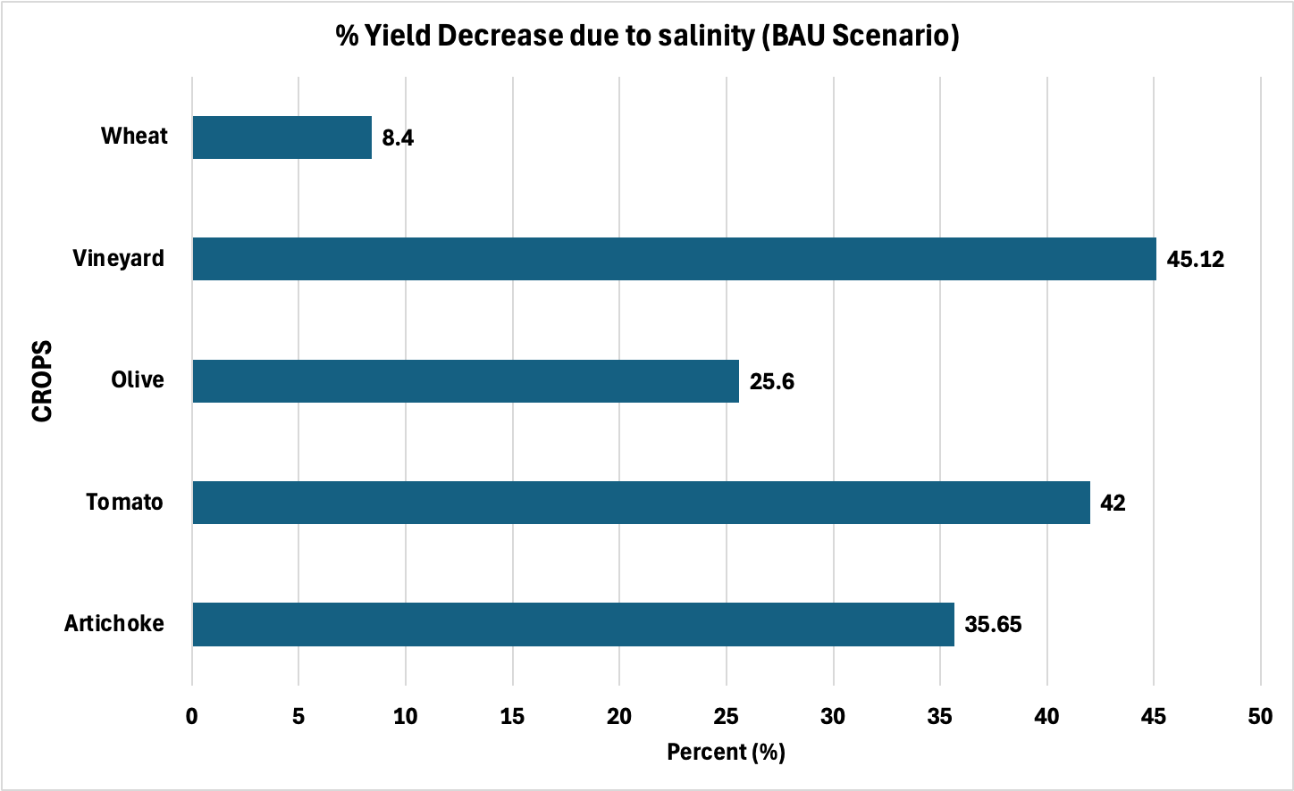
Figure A-1. Percent reduced yield per crop due to salinity.

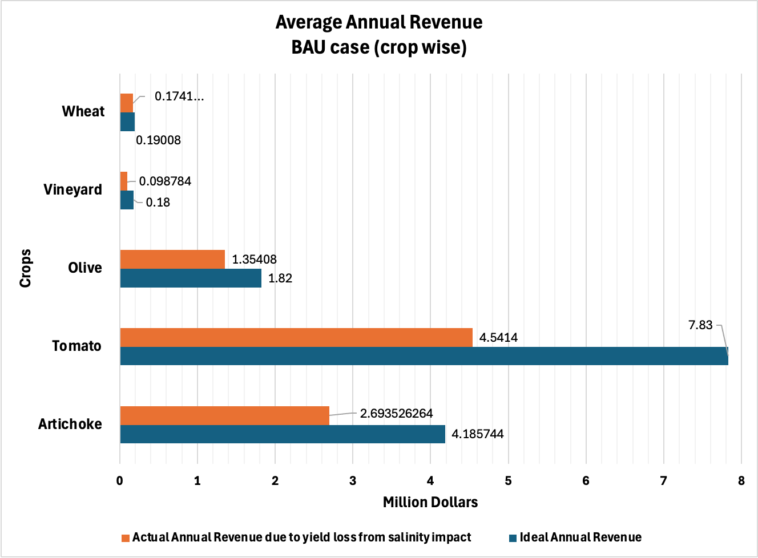
Figure A-2. Crop-wise average revenue in BAU case.
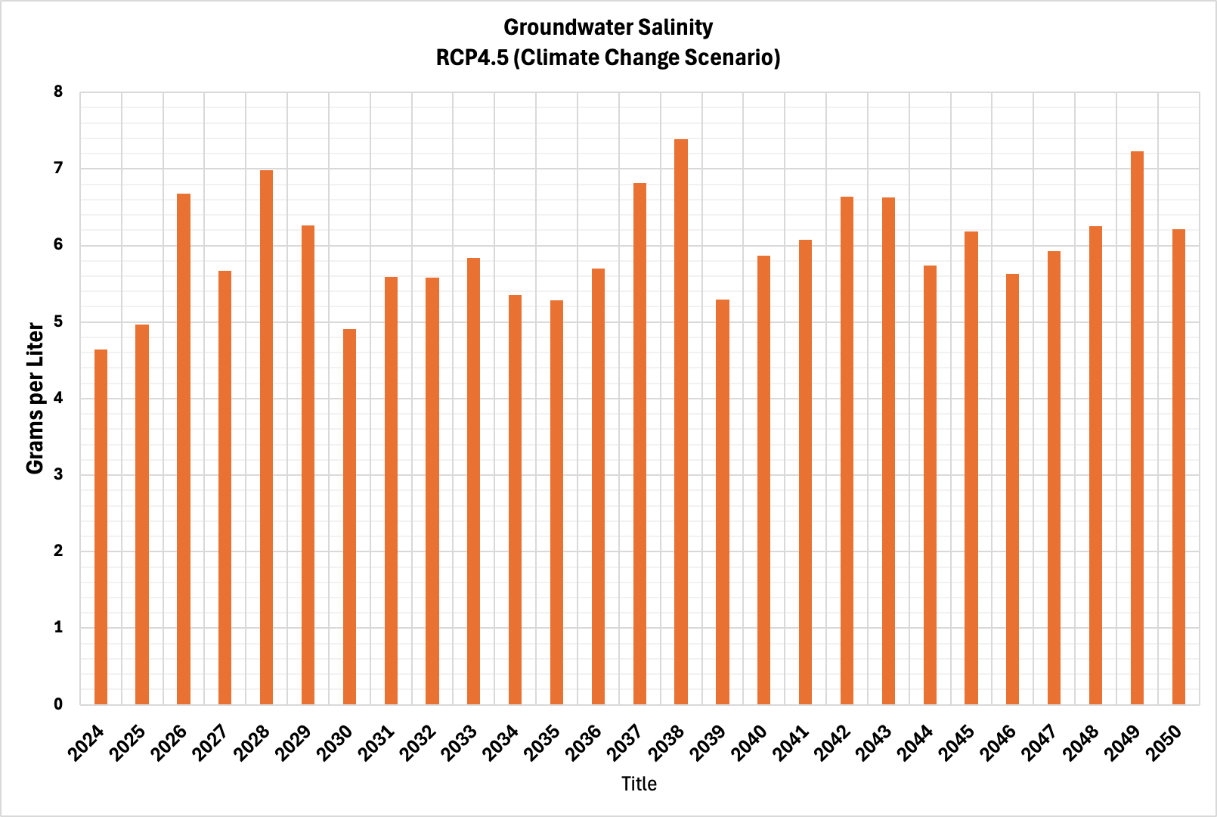
Figure A-3. Average groundwater salinity level per year under climate change scenario RCP4.5.
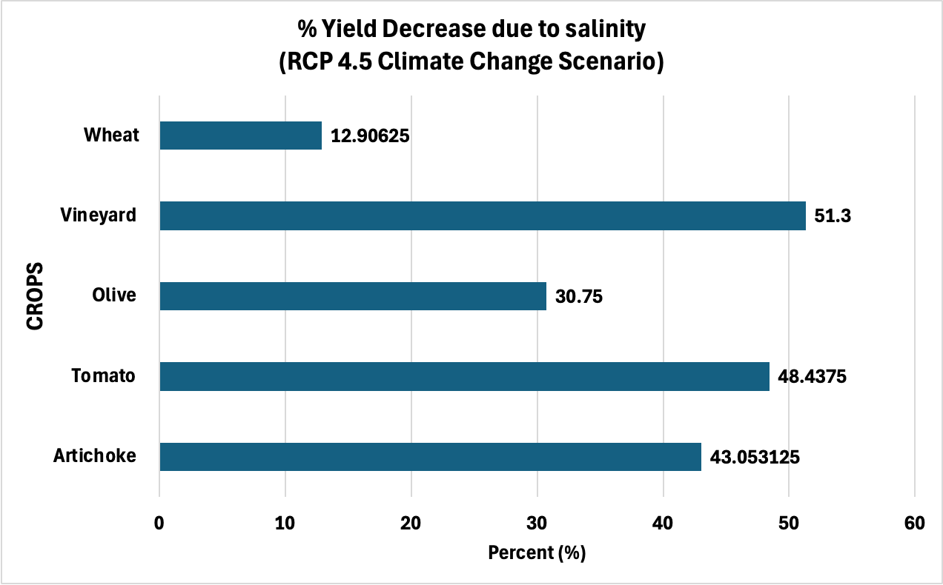
Figure A-4. Crop-wise reduction in yield (%).

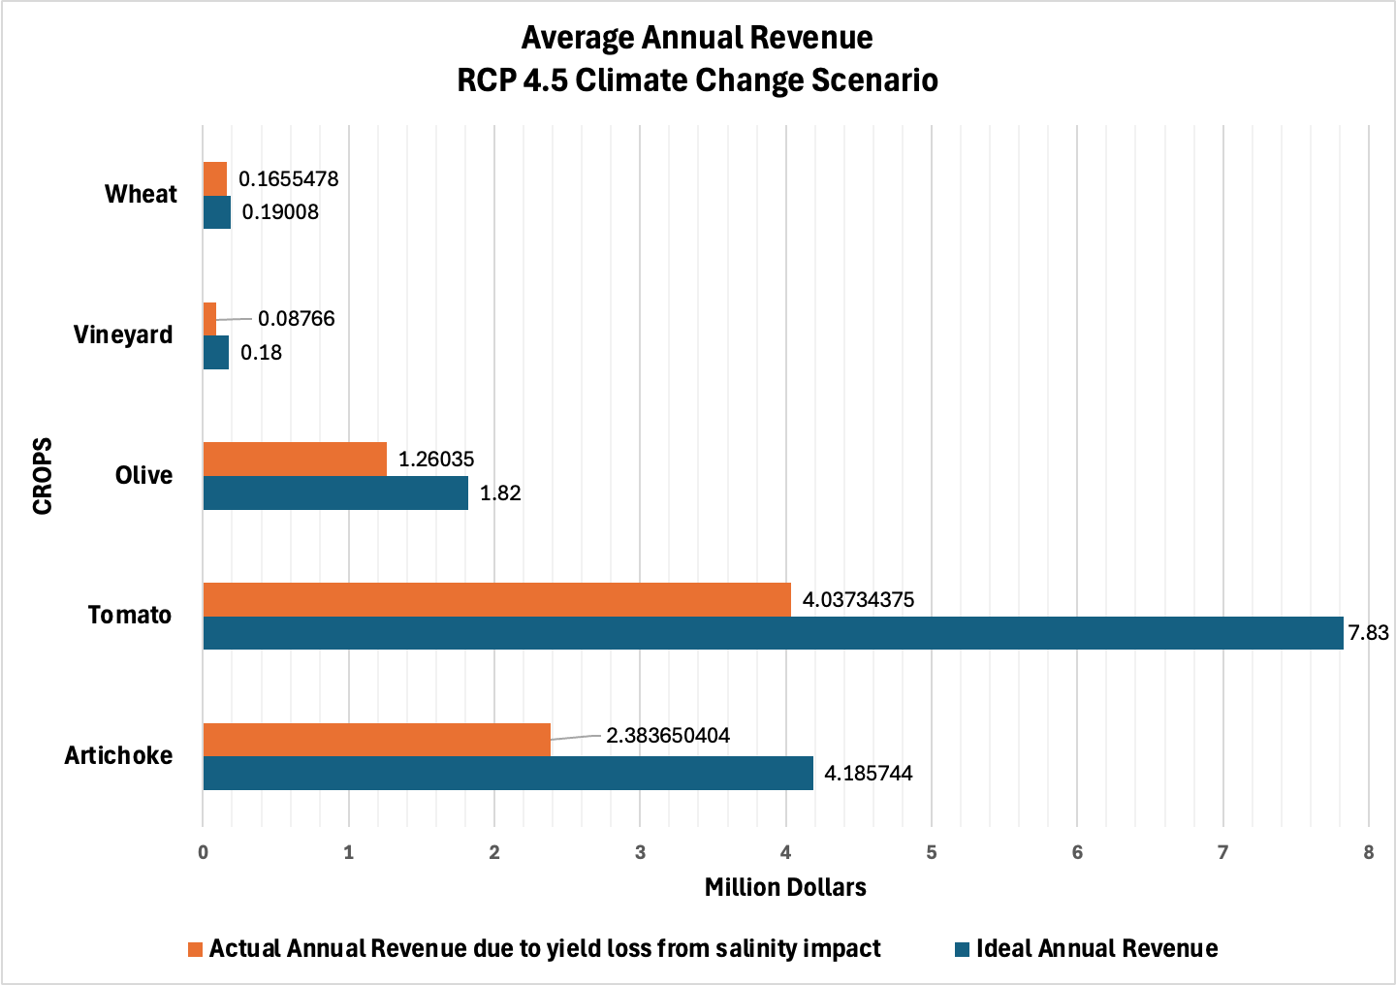
Figure A-5. Crop-wise average revenue per year under climate change scenario RCP4.5.
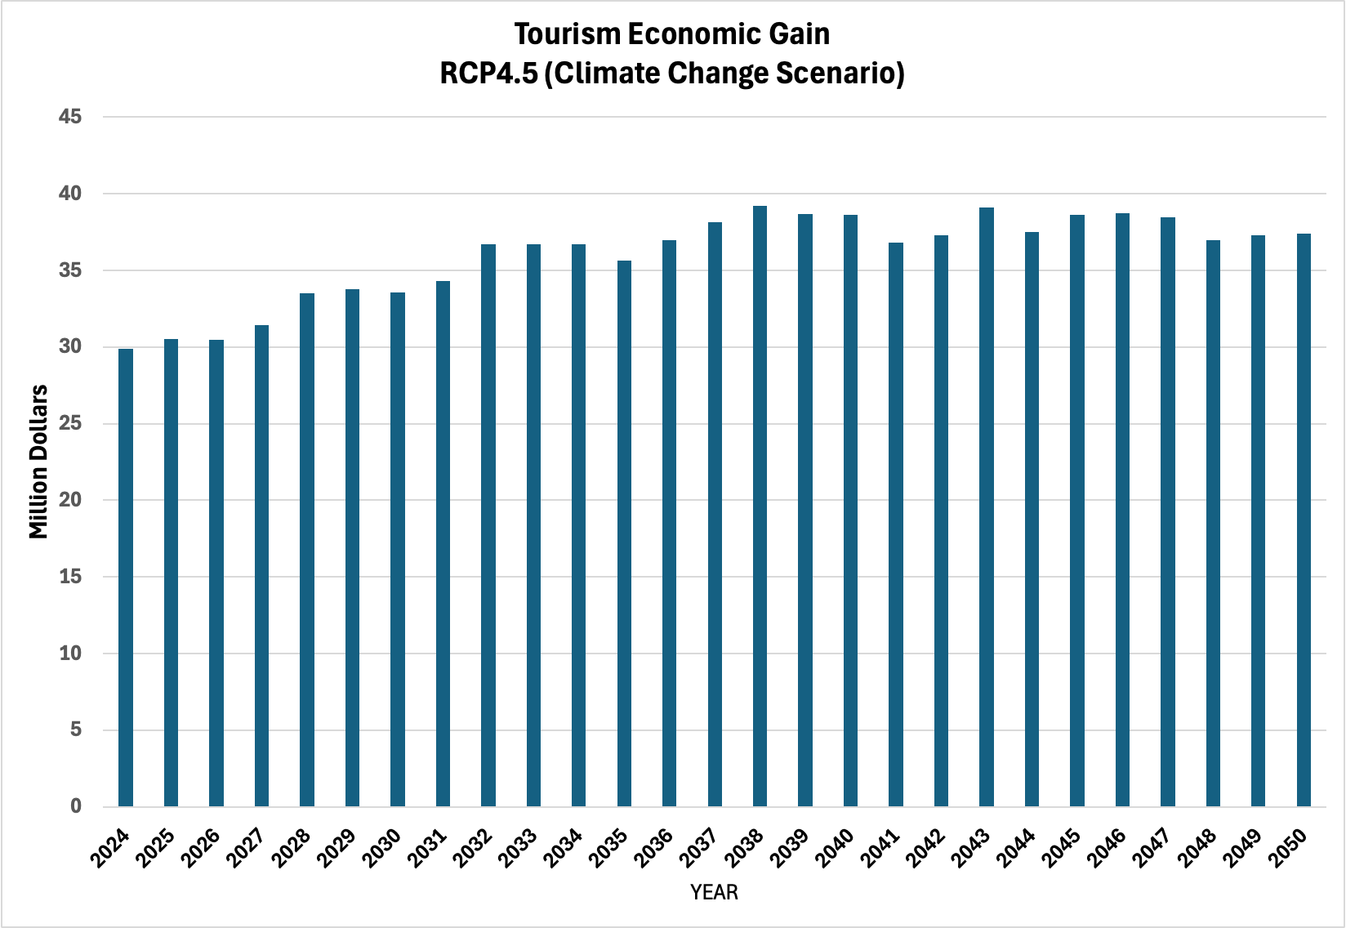
Figure A-6. Economic gain from the tourism sector under climate change scenario RCP4.5.
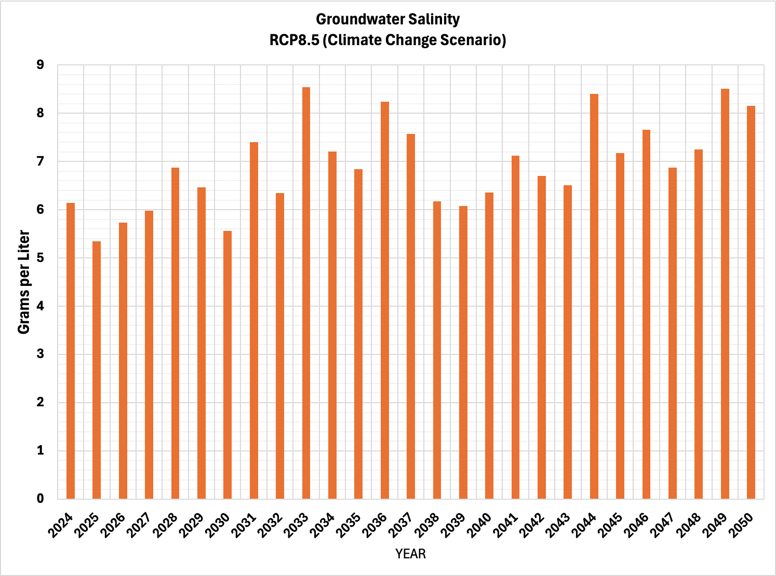
Figure A-7. Average groundwater salinity level per year under climate change scenario RCP8.5.
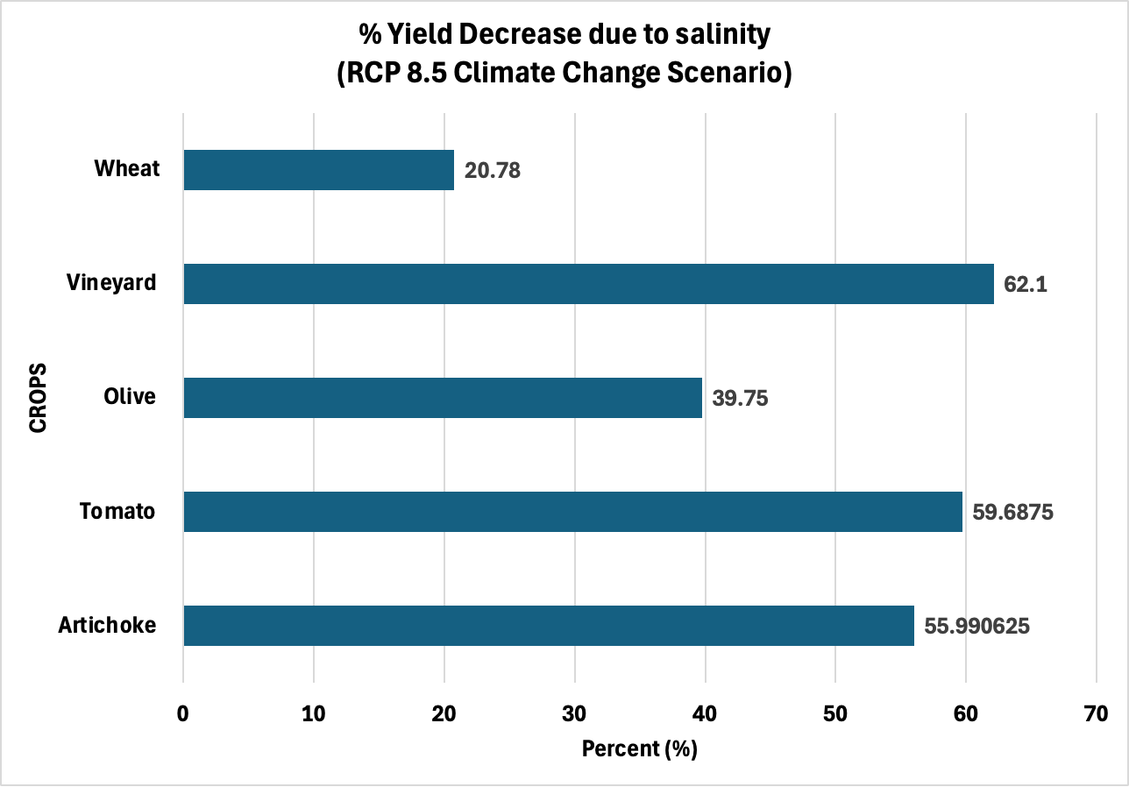
Figure A-8. Crop-wise reduction in yield (%).

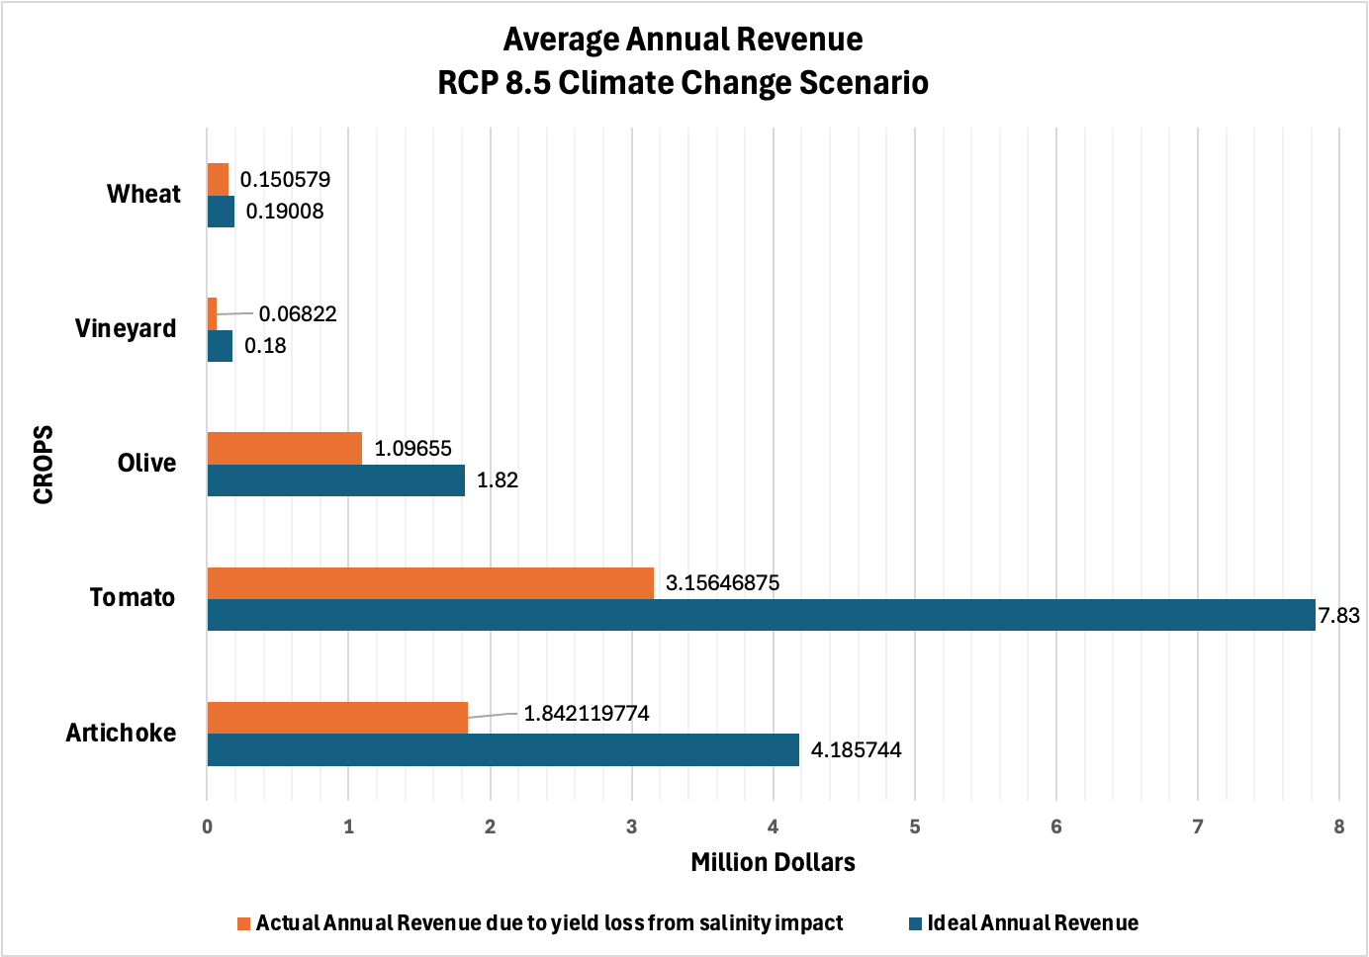
Figure A-9. Crop-wise average revenue per year under climate change scenario RCP8.5.

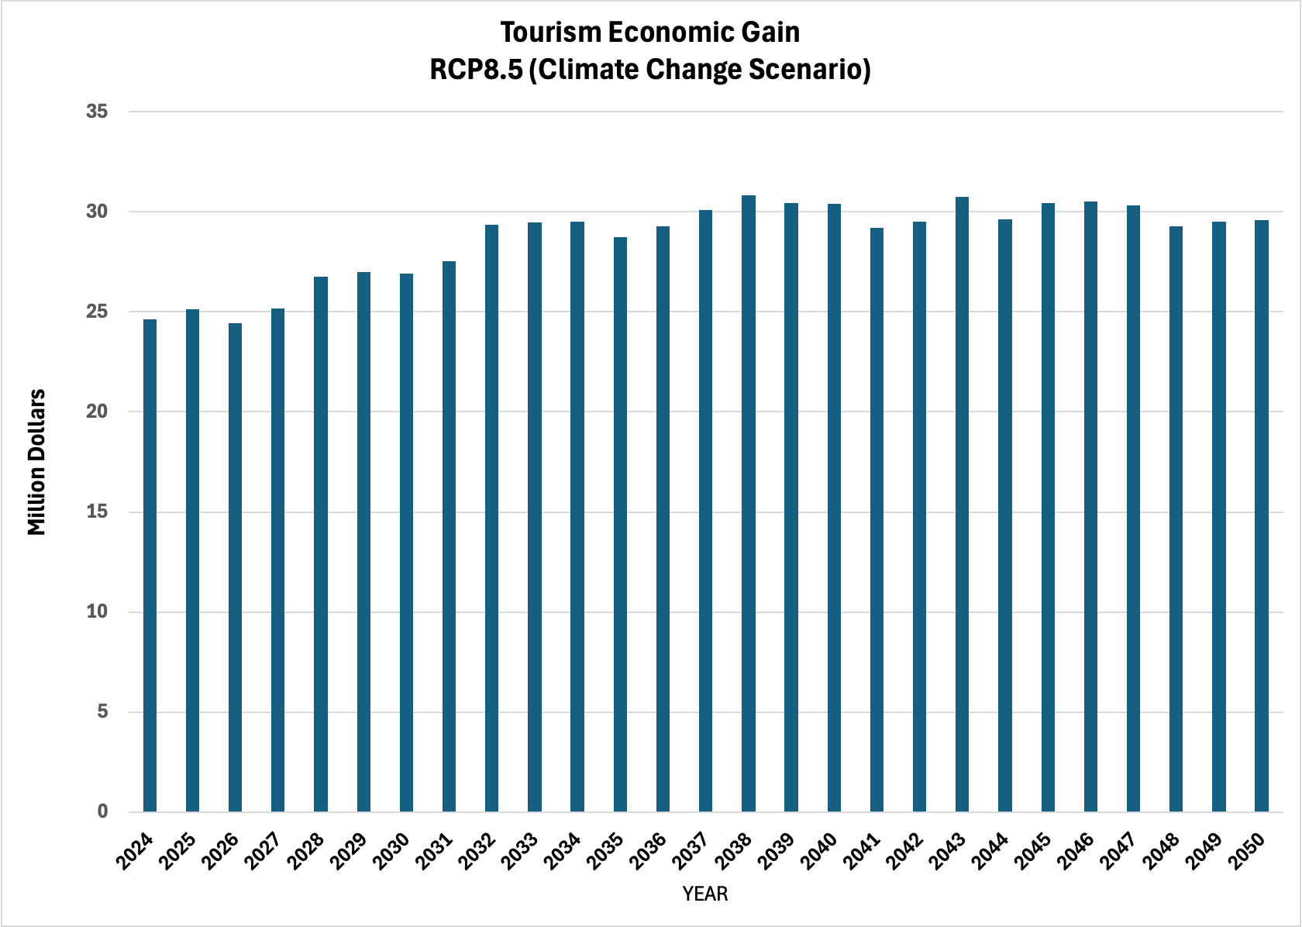
Figure A-10. Economic gain from the tourism sector under climate change scenario RCP8.5.

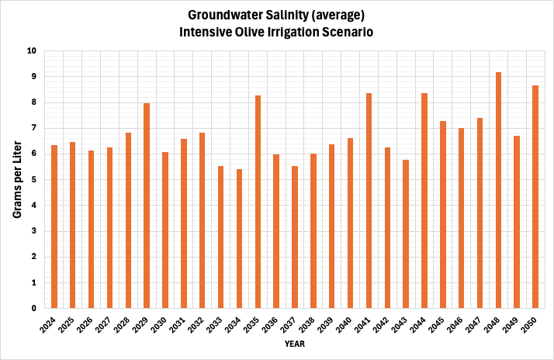
Figure A-11. Average groundwater salinity level per year under intensive olive irrigation scenario.
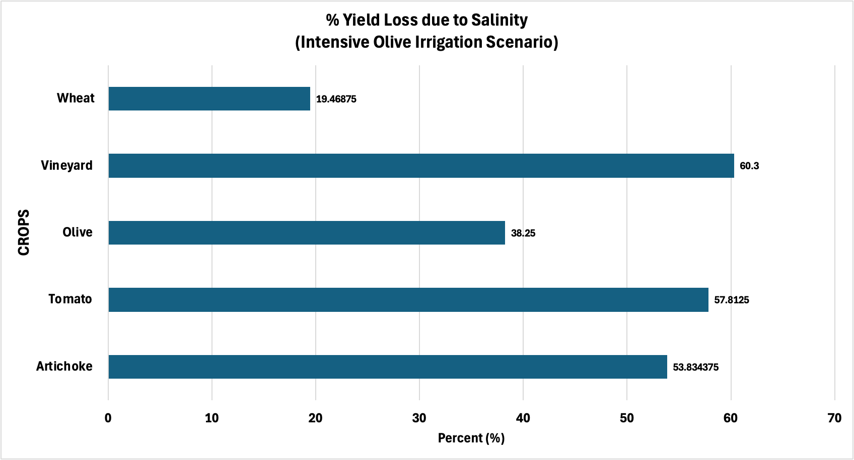
Figure A-12. Crop-wise reduction in yield (%).

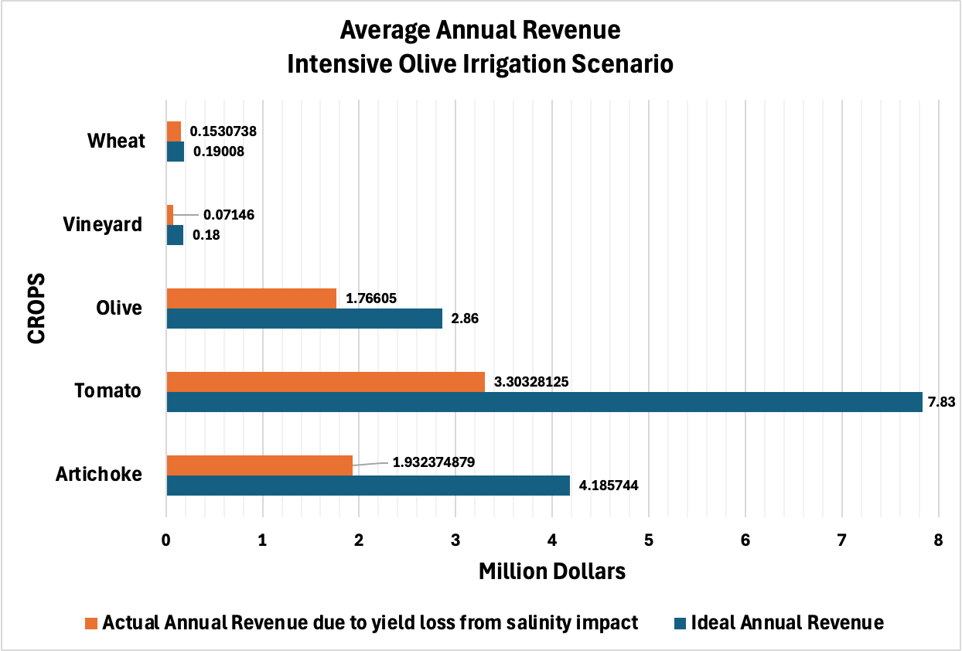
Figure A-13. Crop-wise average revenue per year under intensive olive irrigation scenario.

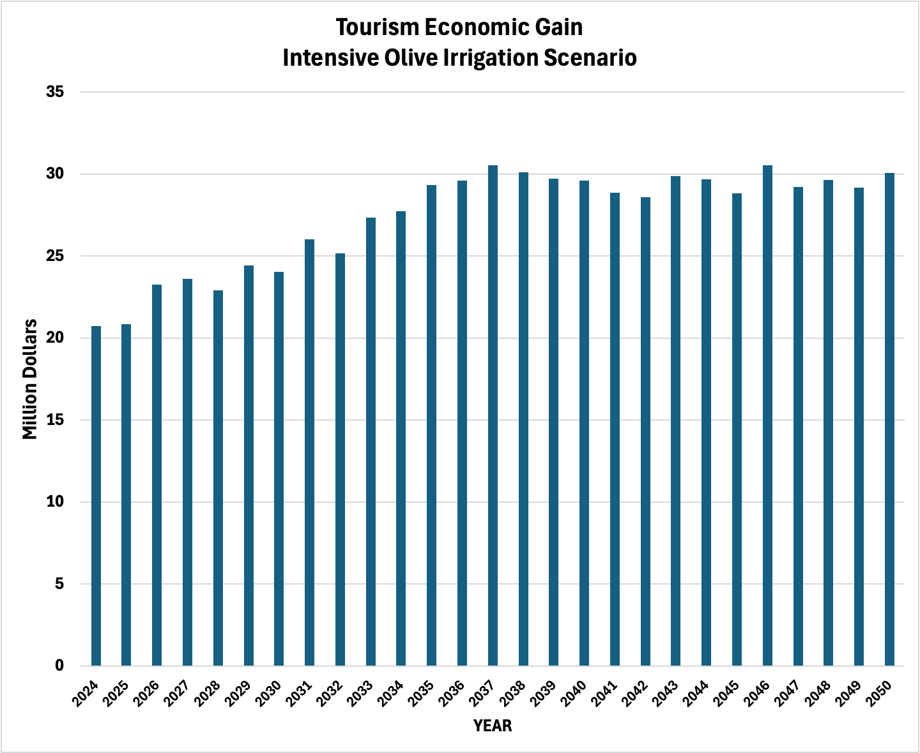
Figure A-14. Economic gain from the tourism sector under an intensive olive irrigation scenario.
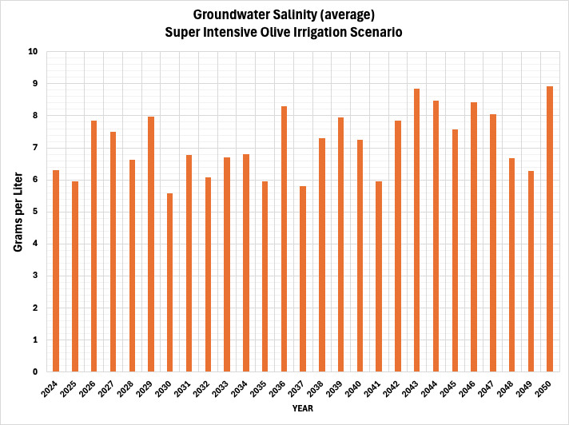
Figure A-15. Average groundwater salinity level per year under super-intensive olive irrigation scenario.
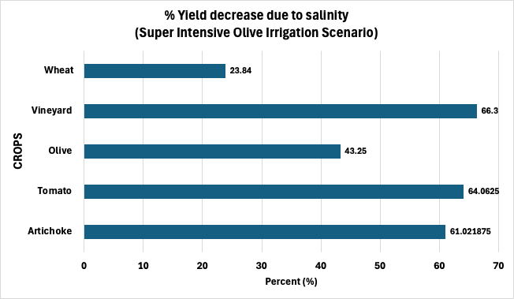
Figure A-16. Crop-wise average revenue per year under the super-intensive olive irrigation scenario.

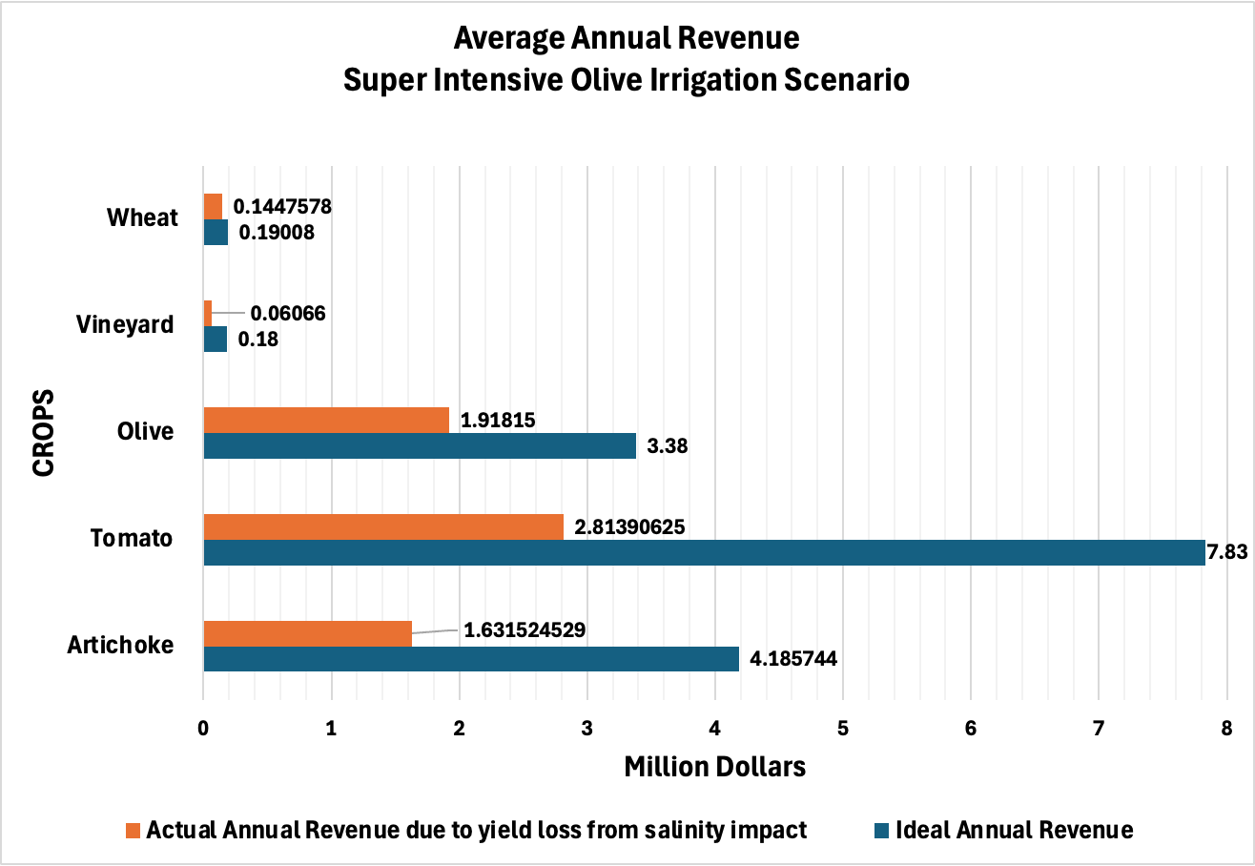
Figure A-17. Crop-wise average revenue per year under the super-intensive olive irrigation scenario.

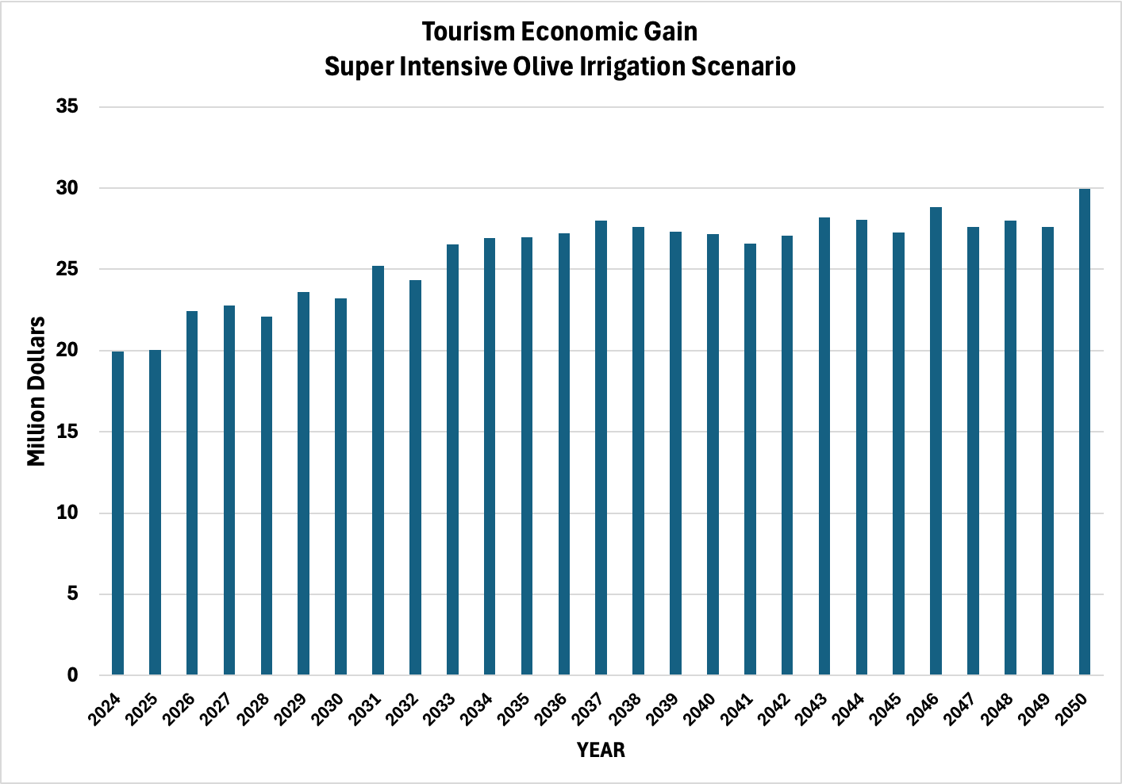
Figure A-18. Economic gain from the tourism sector under the super-intensive olive irrigation scenario.

