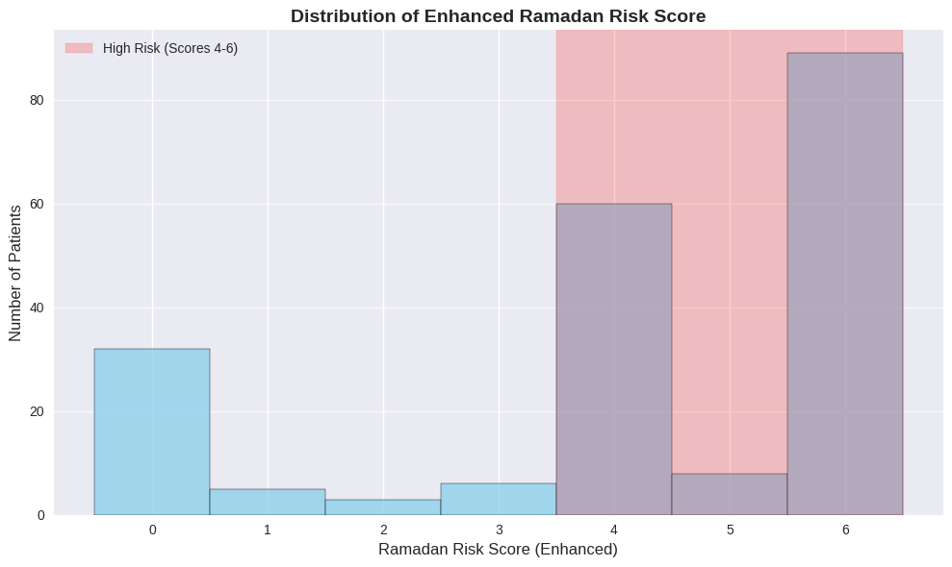
Figure S1. Ramadan Risk Score Distribution
Histogram showing the distribution of Ramadan risk scores (range 0-6) among the study population. The majority of patients (77.3%) scored 4-6, indicating high exposure to Ramadan-associated risk factors including khate chewing, smoking, NSAID use, spicy food consumption, and high-fat diet.

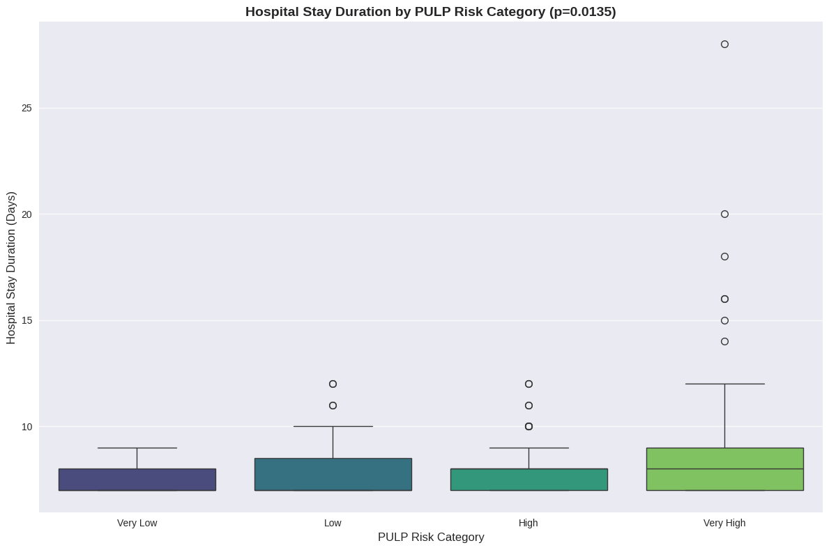
Figure S2. Hospital Stay Duration by PULP Category
Box plot demonstrating the significant increase in hospital stay duration across PULP risk categories (p=0.014). Very high-risk patients (PULP ≥12) show substantially longer and more variable hospital stays compared to lower risk categories.

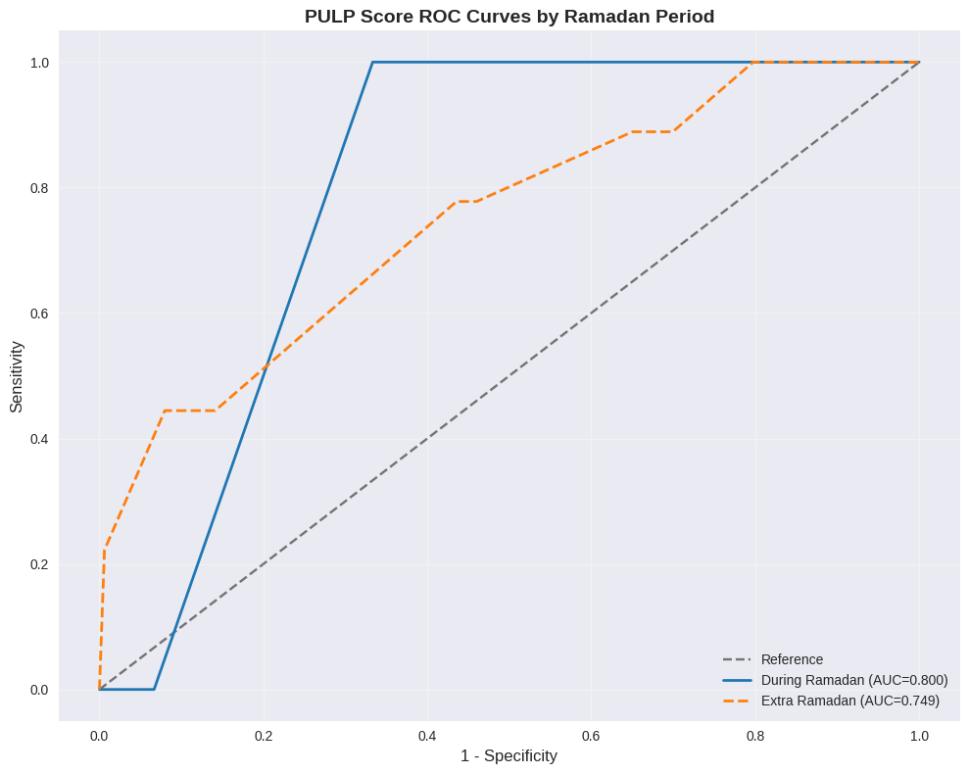
Figure S3. ROC Curves by Ramadan Period
Separate ROC curves for PULP score performance during Ramadan (blue) and extra-Ramadan (red) periods, demonstrating consistent discriminative ability (AUC=0.747 for both) across different temporal contexts.

