Supplementary material 2

Mesenchymal to Epithelial Transition (MET) in Cancer Progression: Insights from logical modeling

Sophia Orozco-Ruiz^{1,2,3}, Marco Ruscone^{1,2,3}, Emmanuel Barillot^{1,2,3}, Olivier Destaing⁴, Laurence Calzone^{1,2,3}

Supplementary Tables 1
Supplementary Text 2
Supplementary Figures 4

Supplementary Tables

Signaling agents | Cell line | Role in colonization
BMP7¹ | MDA-231 (BC) | ?
cAMP² | NAMEC8 (B) | ?
E-selectin expressed on the surface of BM cells³ | SUM159, MDA-MB-231 (BC) | Yes
BMP secreted by CAFs⁴ | MMTV-PyMT (mouse BC) | Yes
Versican by myeloid cells⁵ | MDA-MB-231 (BC) | Yes
CTGF⁶ | SAS and FaDu (HNSCC) | ?
Lumican⁷ | MCF-7, MDA-MB-231 (BC) | ?
Presence of parenchymal liver cells⁸ | DU-145, PC-3 (PC) | ?

Supplementary Table 1: MET driven by microenvironmental factors. Signaling agents identified as MET-promoting factors (column 1) have been studied in cell lines (column 2) and reported to have a role in colonization (column 3). Note that some studies used a specific derivative of the reported cell line and/or further validated their findings in cell lines not reported here. All the cell lines used presented a mesenchymal phenotype, which in some cases was obtained through EMT inducer treatment. BM: Bone Marrow, CAFs: Cancer-Associated Fibroblasts, BC: breast cancer, B: breast tissue, PC: prostate cancer, HNSSC: Head and neck squamous cell carcinoma.

MET factor | Cell line | REF | Downstream targets
p53 | HMEC, MCF12A (B) | ⁹ | Induces miR200
miR200 | NMuMG (mouse B), 4TO7 (BC) | ¹⁰ | –
∆Np63 | UM-UC3 (BLC) | ¹¹ | –
GRHL2 | HMLE (B), MDA-MB-231 (BC) | ¹² | –
OVOL2 | MDA-MB-231 (BC), PC3 (PC) | ^{13,14} | –
OVOL1 | MDA-MB-231 (BC), PC3 (PC) | ¹³ | –
Elf5 | MDA-MB-231 (BC) | ¹⁵ | Represses SNAI2
Klf4 | MDA-MB-231 (BC) | ¹⁶ | Induces ECAD
FBXO22 | MCF10A, MDA-MB-231, Hs578T (BC) | ¹⁷ | Represses SNAI1
EHF | HOC313, TSU (HNSSC), MDA-MB-231 (BC) | ¹⁸ | Represses ZEB1 and ZEB2
CKB | PC3, LN3 (PC) | ¹⁹ | Represses AKT
LINC01133 | HCT116 (CC) | ²⁰ | Represses SRSF6
Claudin 7 | SW620 (CC) | ²¹ | Represses ERK and SRC through Rab25
ID1 | HMLE (B) | ²² | –
C/EBPa | HMLE (B) | ^{23,24} | Induces P63 and represses ZEB1
GATA3 | MDA-MB-231, Hs578T, 4T1 (BC) | ²⁵ | Induces miR-29b, which represses PDGF (RTK)
Reprogramming factors | HOC313, OSC-19 (OSCC) | ²⁶ | Not clear, as it varies according to cell line
miR30a | H1299, Calu-1 (NSCLC) | ^{27,28} | Represses SNAI1 and VIM
RUNX3 | BGC-823, SGC-7901, AGS (GA) | ²⁸ | Represses SNAI1 and VIM through miR30a
Rap1 | MDCK (K) | ²⁹ | Required for cadherin junctions (AdhJunc)
PRRX1a | KPC1, KPC2 (mouse PanC) | ³⁰ | Mechanism not clear

Supplementary Table 2: MET driven by intracellular factors. The intracellular MET-promoting factors (column 1) that have been studied in cell lines (column 2) with the corresponding reference (column 3). Note that the cell lines used in these studies presented a mesenchymal phenotype, which in some cases was obtained through EMT inducer treatment. BC: breast cancer, B: breast tissue, BLC: bladder cancer, PC: prostate cancer, HNSSC: Head and neck squamous cell carcinoma, CC: colorectal carcinoma, OSCC: oral squamous cell carcinoma, GA: gastric adenocarcinoma, PanC: Pancreatic cancer, NSCLC: non-small cell lung cancer, K: transformed kidney cells.

Supplementary Text
In this section, we extend our description of the model, focusing on the roles of some of the proteins in the non-canonical TGFβ pathway that are included in the model.

The role of ERK and AKT in TGFB-EMT programs
Through its downstream effectors, ERK can activate ZEB1³⁵. Both ERK and AKT can phosphorylate and inactivate GSK3β. When active, GSK3β degrades SNAI1/2 and the β-catenin (CTNNB1) that is liberated from its interaction with E-cadherin ^{36,37}. When β-catenin is not degraded, it can translocate to the nucleus and bind with members of the T-cell and lymphoid enhancer (TCF/LEF) factors and further promote EMT^{38,39}. For instance, βcatenin-TCF4 can induce ZEB1 and vimentin and MMT1-MMP^{40–43}. β-catenin-TCF4 can be regulated by miR200 which represses both CTNBB1 and TCF4^{44,45}. AKT can further contribute to EMT by activating NFkB, which subsequently acts as a direct transcriptional activator of SNAI2, ZEB2, and TWIST1^{38,46}. Finally, JNK activates c-Jun, a component of the AP-1 complex which is in turn implicated in the transcriptional upregulation of ZEB1/2⁴⁷ (Figure 2). Of note, ERK can also activate JNK and upregulate the AP-1 complex component Fra-1, highlighting the cooperation between these signaling cascades^{48–50}.

The role of the NRTK

TGFβ is also involved in the activation of non-receptor tyrosine kinases (NRTK) PYK2, FAK, and SRC. On one hand, SRC and FAK cooperate with integrins, such as β3, to phosphorylate TGFβR-II and allow TGFβ to induce MAPK-ERK and other pathways^{31–33}. On the other hand, TGFβ has been shown to increase PYK2 activity, an effect dependent on TGFβR-I, SRC, and SMAD4³⁴ (Figure 2 in the main text and Supplementary Figure 1).

NRTKs are important players of EMT, acting as mediators of several processes: (1) the disorganization of E-cadherin cell-cell contacts ⁵¹, (2) the formation of invadosome, which is a structure crucial for ECM degradation, (3) the basement membrane penetration ⁵², and (4) the activation of several pathways such as Ras-ERK and STAT3 upon signaling through Receptor Tyrosine Kinases (RTKs), which can be activated by several growth factors (GF) and clusters of integrins ^{53–55}. RTKs also activate other pathways, such as PI3K-AKT ⁵⁶. Downstream of integrins and GF, SRC can drive the phosphorylation and destabilization of Adherens Junction, leading to the release of β-catenin from E-cadherin⁵⁷. TGFβ can activate SRC directly through its receptor and by inducing its activators ^{58,59}. For instance, TWIST1 induced by TGFβ-EMT can activate the transcription of PDGFRα (a RTK highly linked to the direct activation of SRC) and its ligand to mediate invadosome formation through the TWIST-PDGFRα-SRC signaling axis⁶⁰.

PYK2 can activate STAT3, which in turn binds to the TWIST1 promoter and activates its transcription^{56,61}. PYK2 forms a positive feedback loop with STAT3, the latter being crucial for PYK2 activation in response to EGF. In this condition, PYK2 cooperates with SRC to activate the ERK pathway⁵⁶. Moreover, EGF and SRC also cooperate to activate STAT3, which further promotes PYK2 signal⁶².

Supplementary Figures
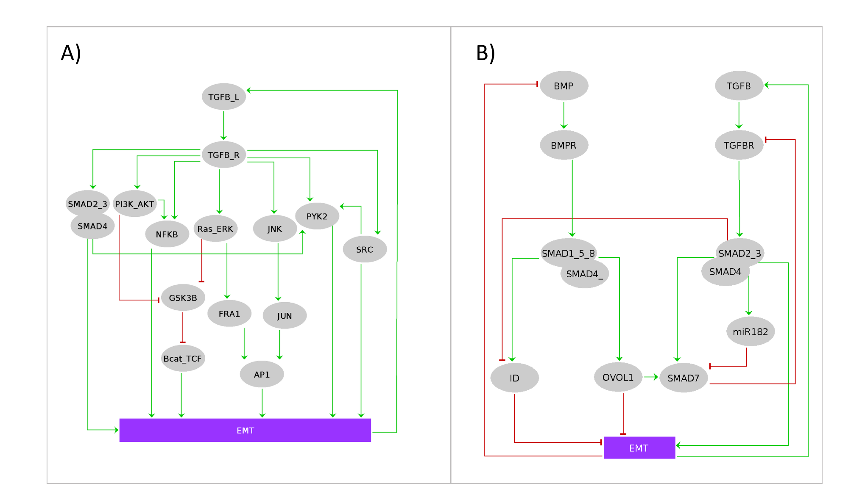
Supplementary Figure 1: A) Main axis of the TGFβ-EMT program. B) BMP and TGFβ interfere with each other. Regulatory network of the interactions between EMT-TFs and some MET drivers.

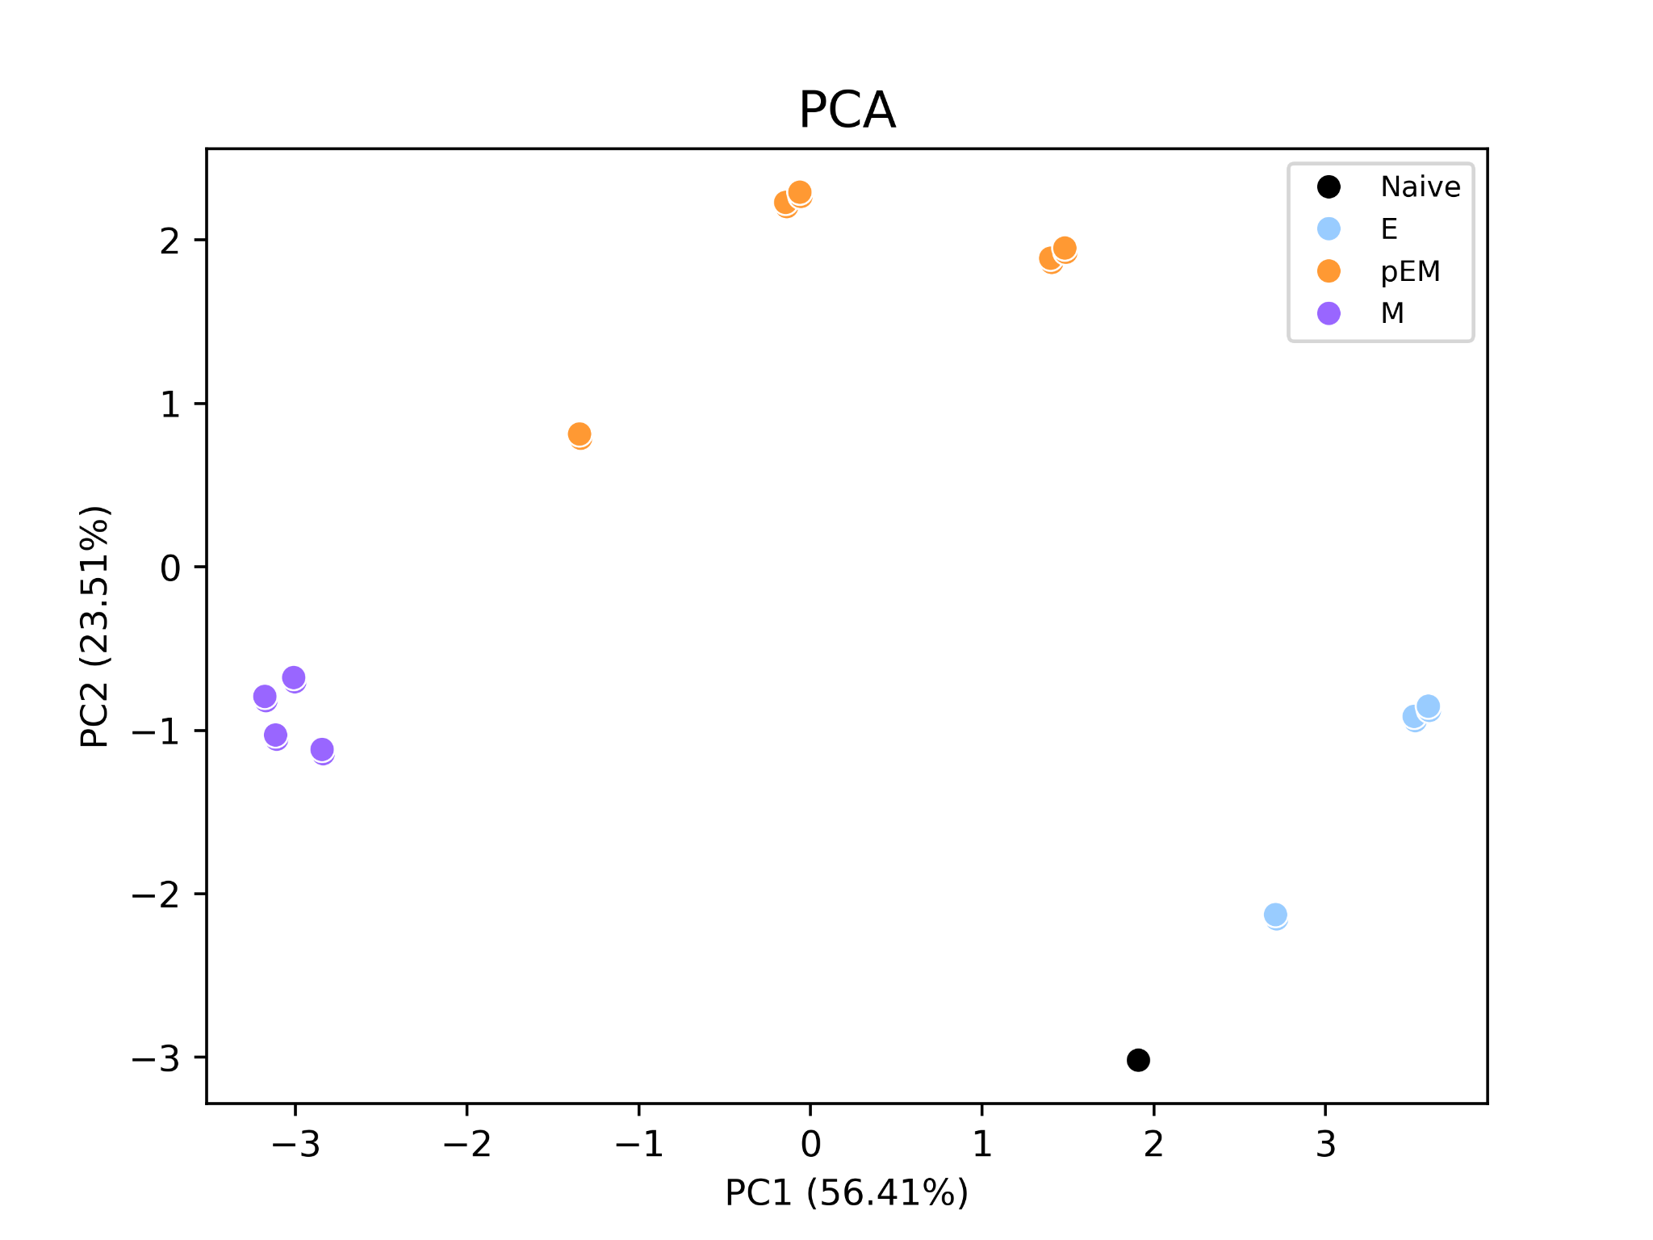
Supplementary Figure 2: PCA plot showing PC1 and PC2 of the model steady states. Color indicates phenotype. Similar stable states cluster together according to the 4 phenotypes defined in the text..
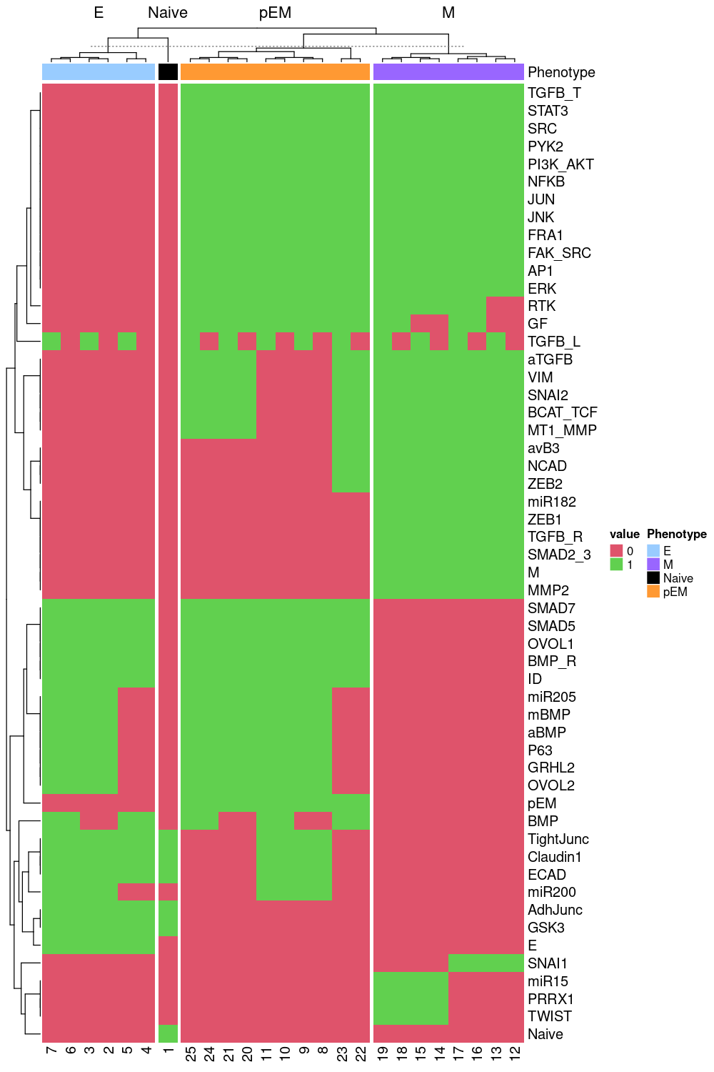
Supplementary Figure 3: The 25 steady states of the model showing all the nodes’s status.

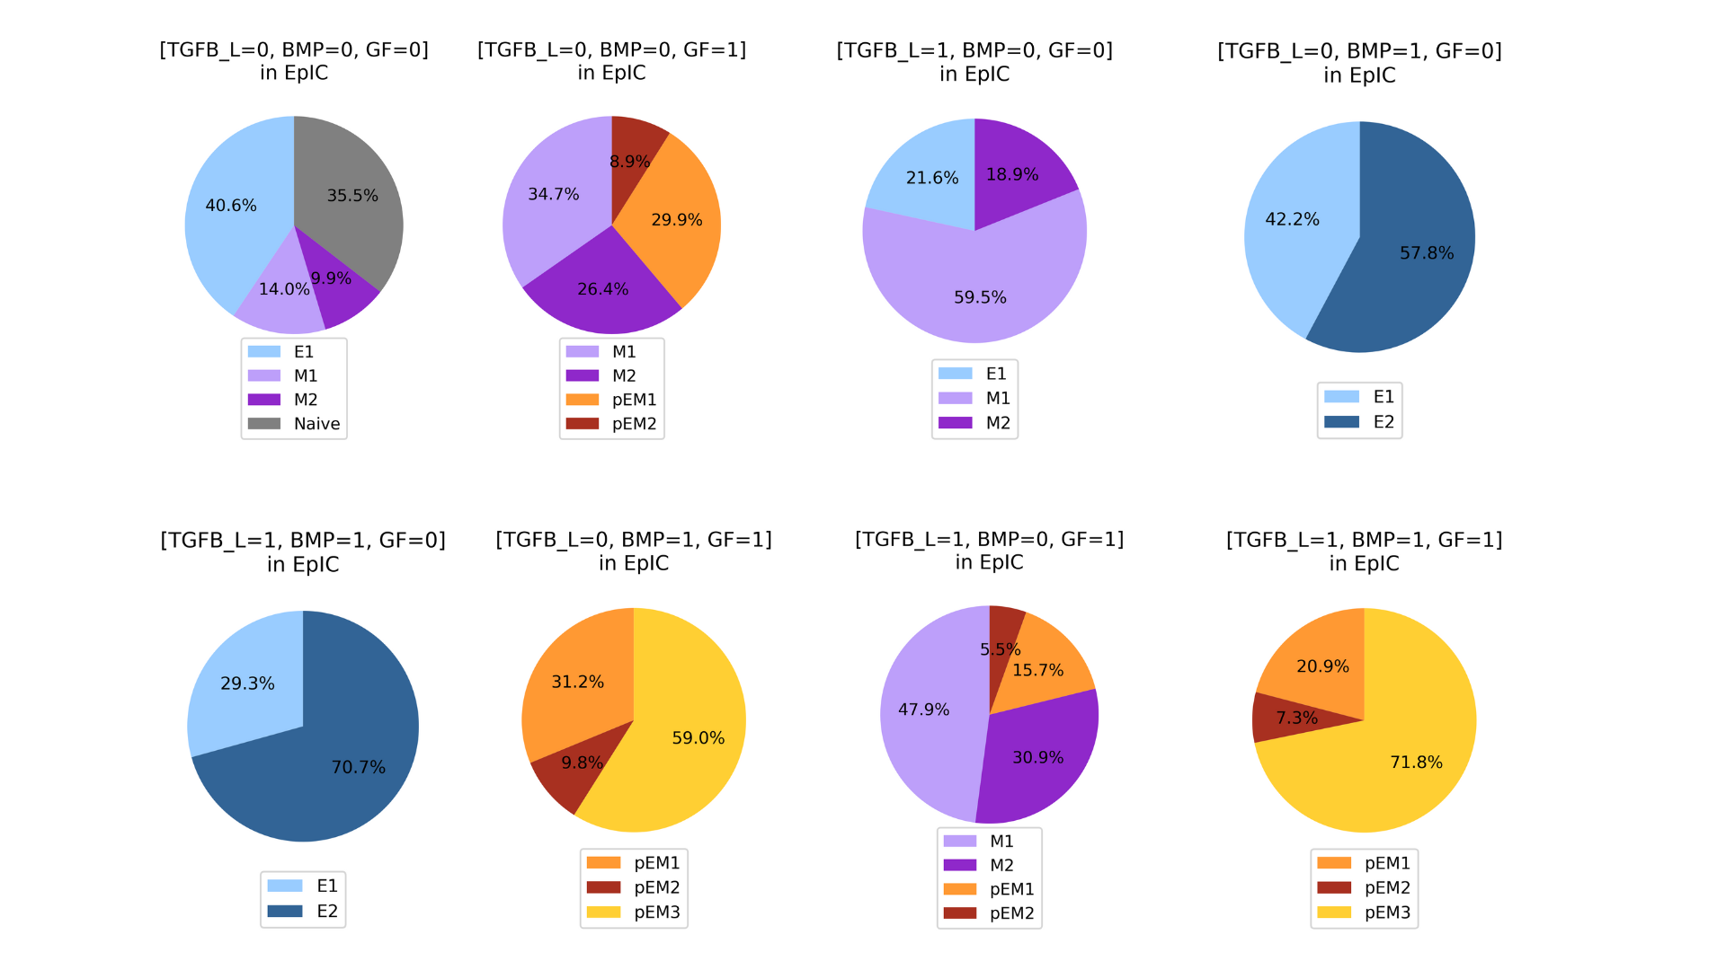Supplementary Figure 4: Final node probabilities of simulations under epithelial initial condition (EpiIC) under different Input combinations.
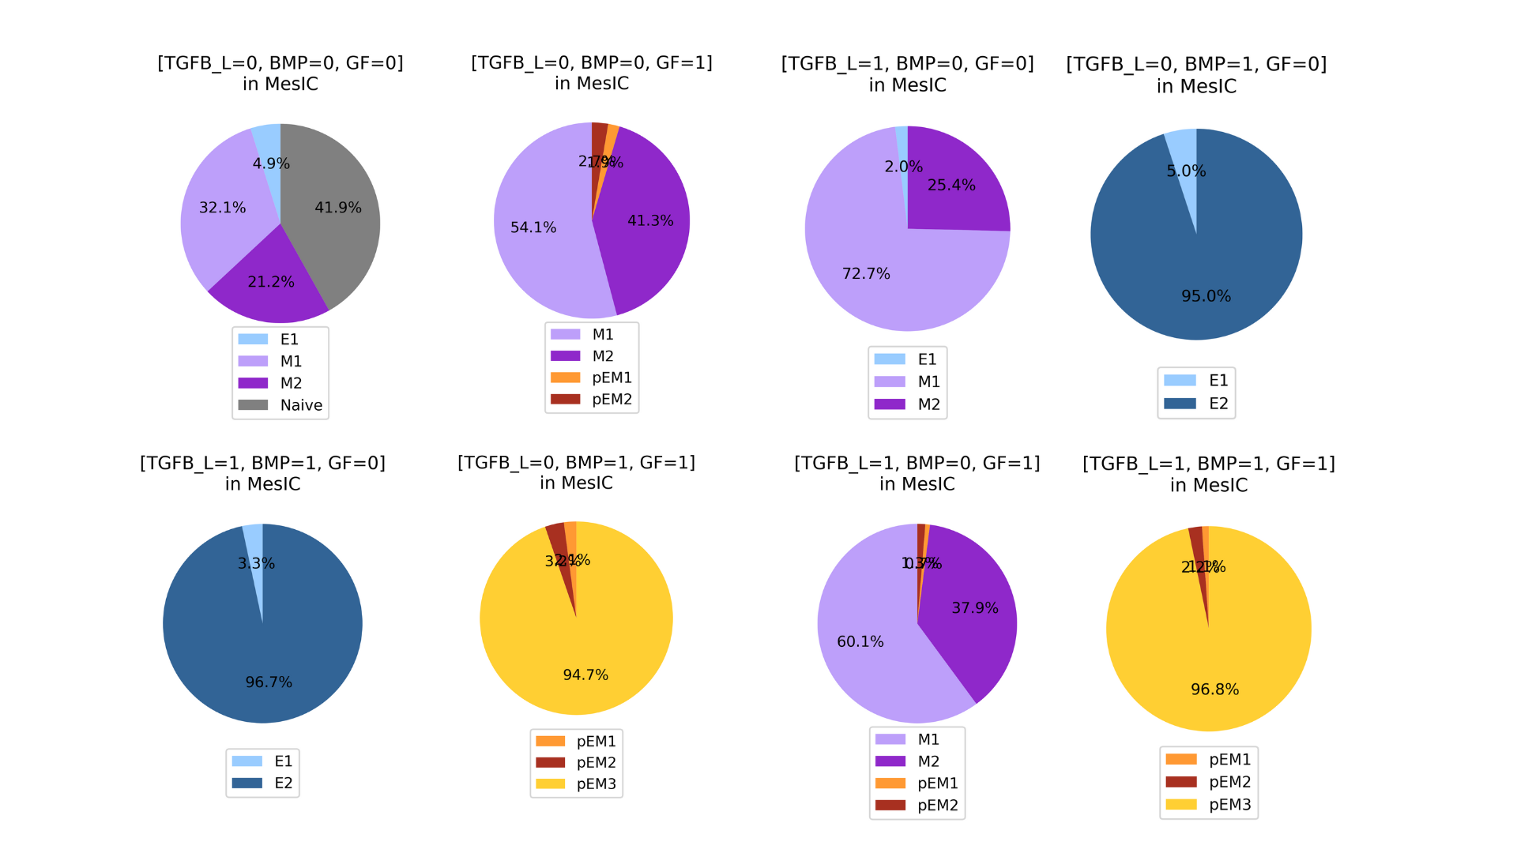

Supplementary Figure 5: Final node probabilities of simulations under mesenchymal initial condition (MesIC) under different Input combinations.

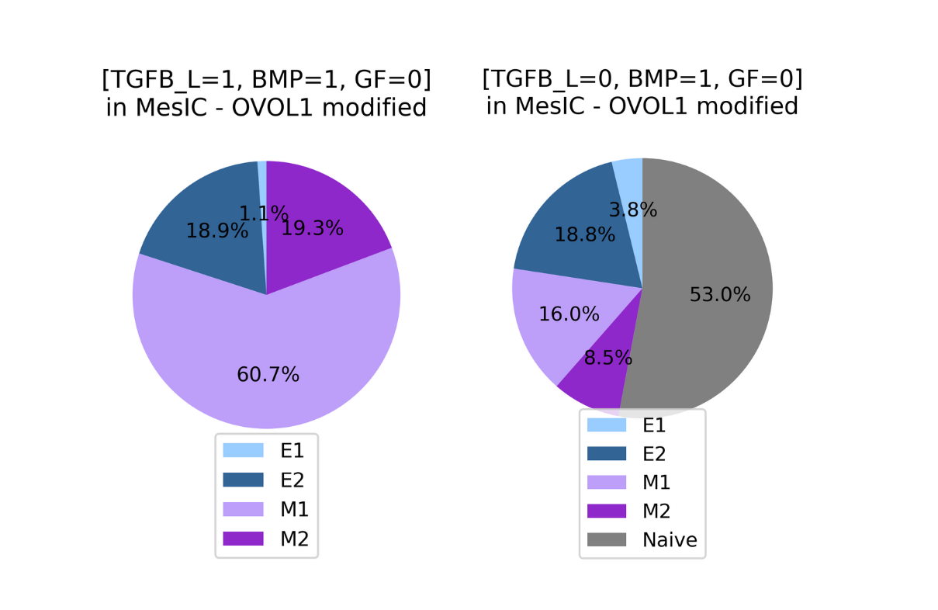
Supplementary Figure 6: Final node probabilities of simulations under mesenchymal initial condition (MesIC) under different Input combinations for OVOL1 modified model.

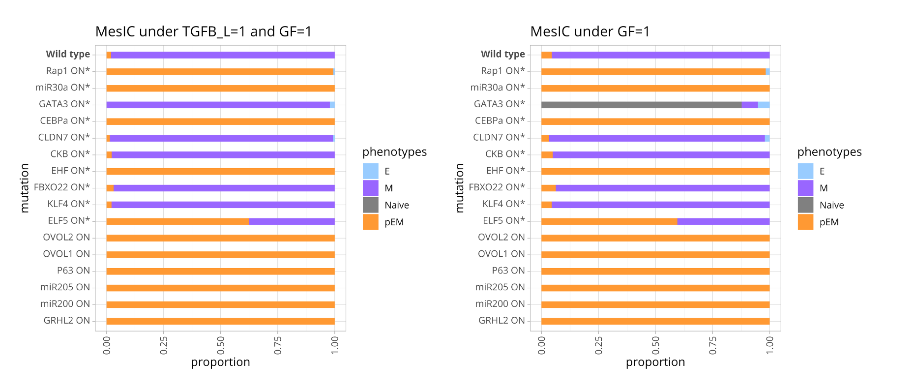
Supplementary Figure 7: Activating mutations of MET drivers. Each row represents the proportion of the final state probabilities, according to the phenotype. Mutations of nodes not included in the network are indicated by *. Mutant simulations were performed in MesIC with inputs TGFB_L=1, BMP=0, GF=1 (left) and TGFB_L=0, BMP=0, GF=1 (right).

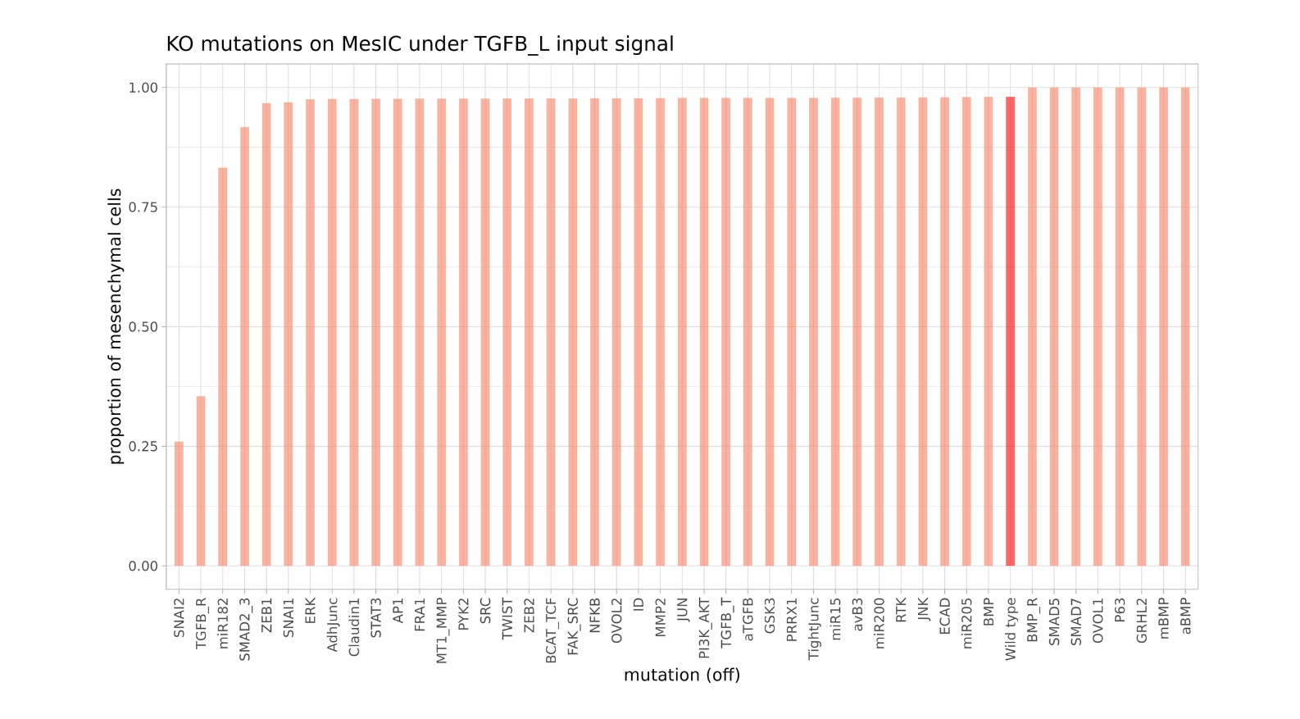
Supplementary Figure 8: Mutations in MesIC generate distinct outcomes. Inactivating mutations in MesIC with inputs (TGFB_L=1, BMP=0, GF=0), wild type is highlighted in red.

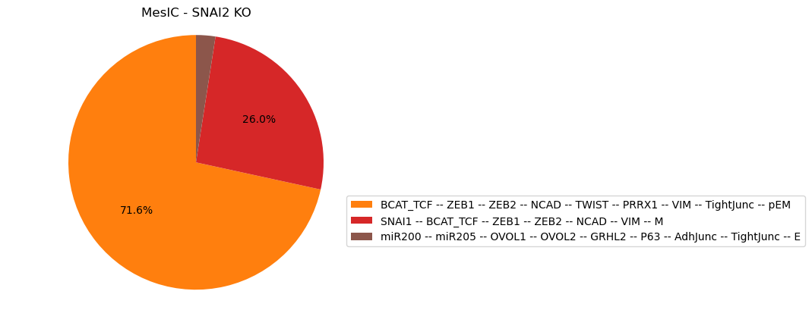
Supplementary Figure 9: Simulation of SNAI2 KO on MesIC under TGFB_L

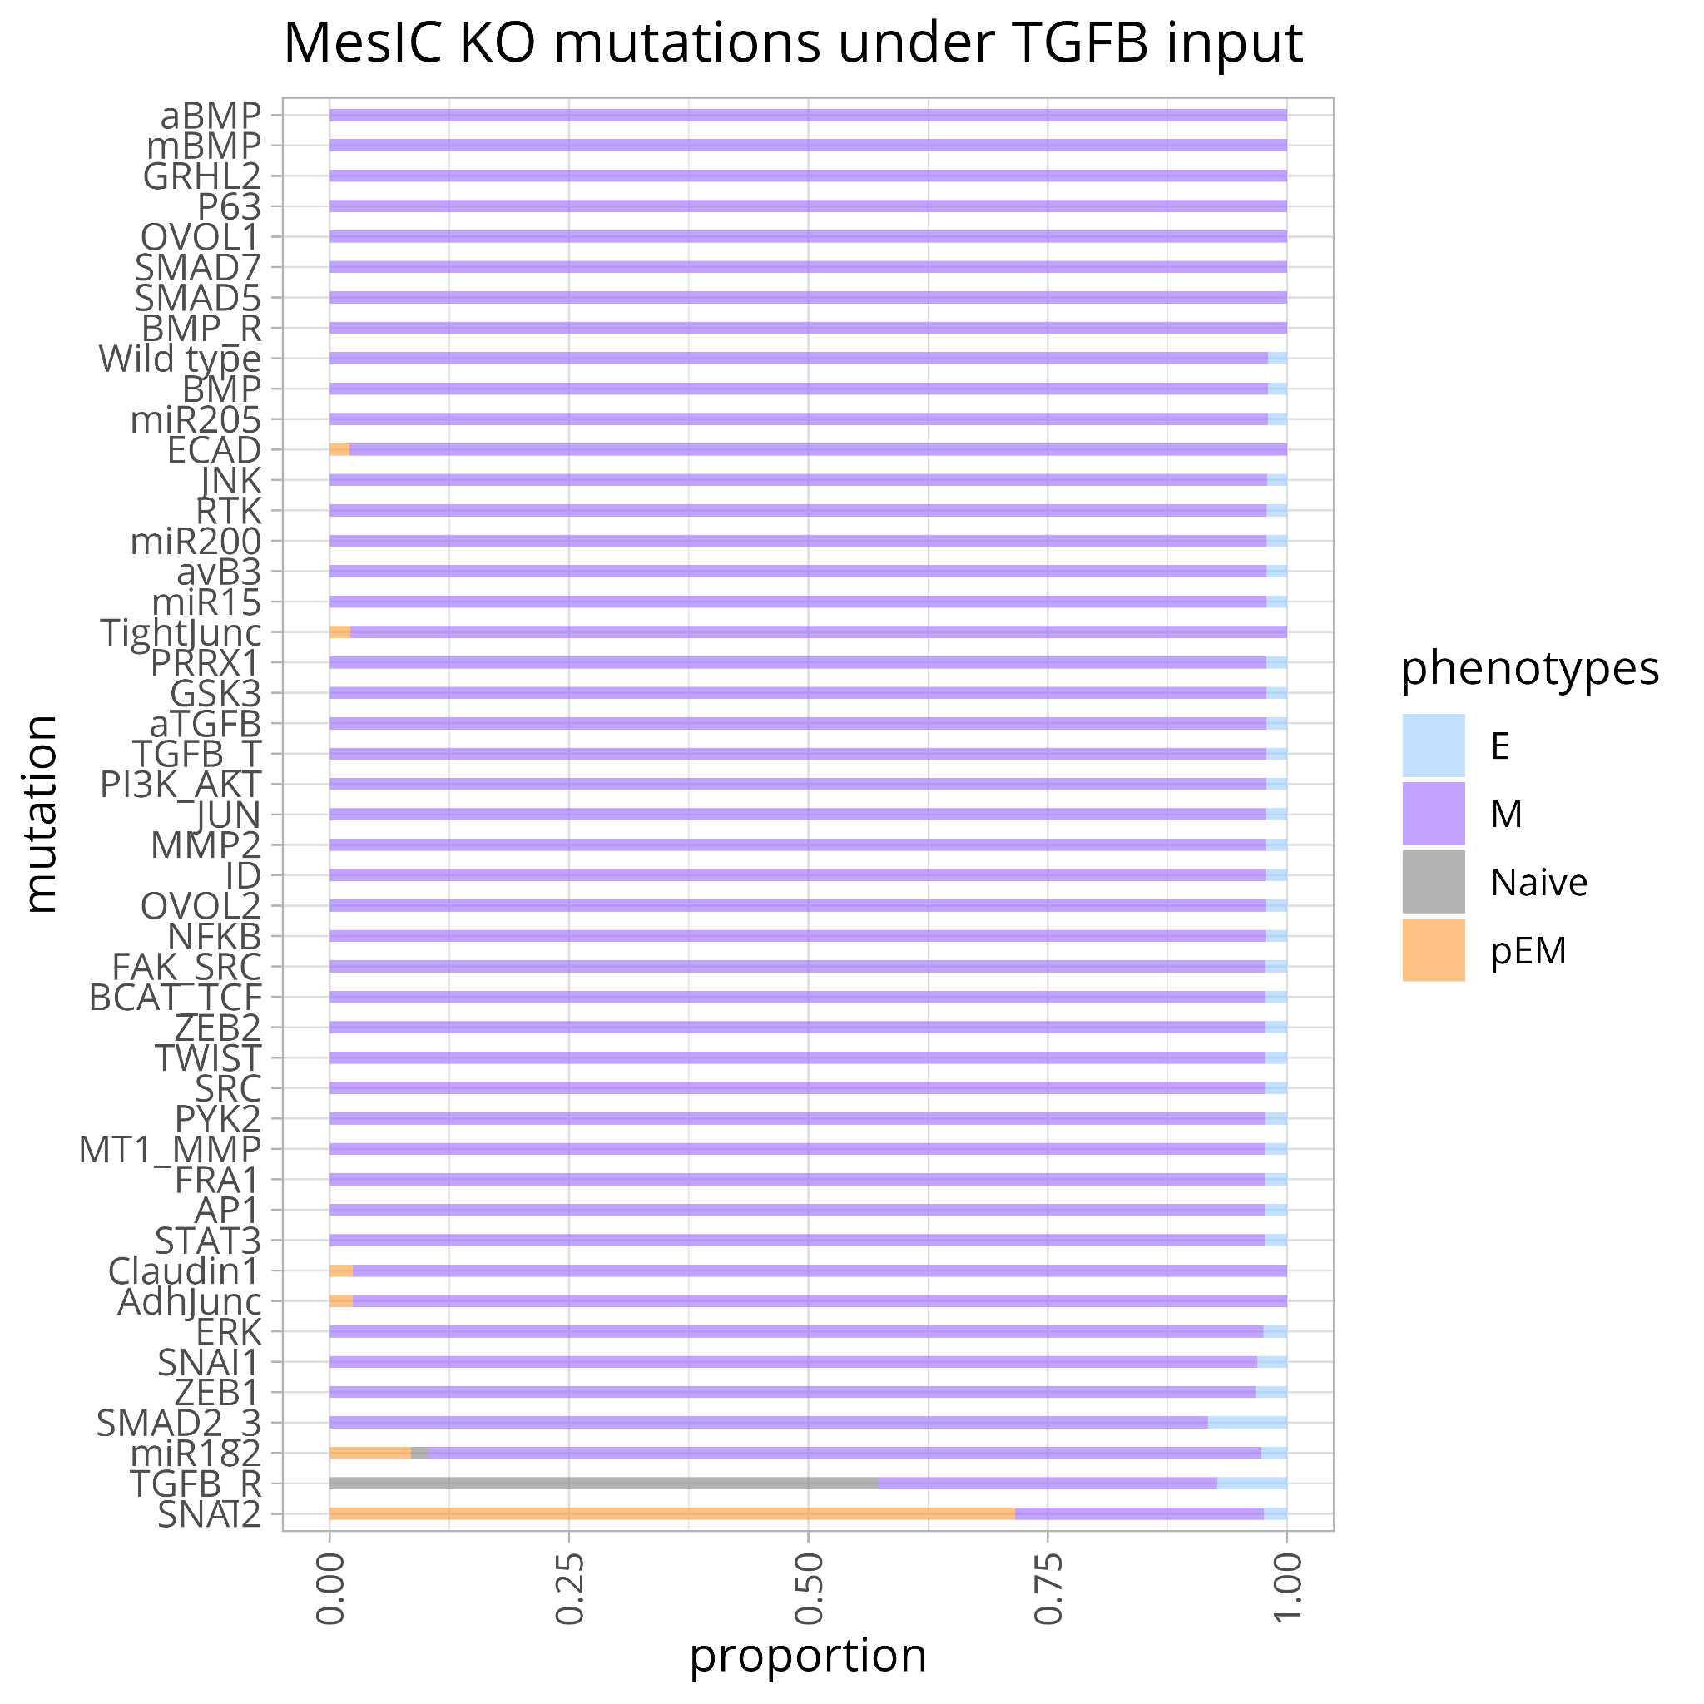
Supplementary Figure 10. Knockouts in MesIC with inputs (TGFB_L=1, BMP=0, GF=0) and their corresponding phenotype.

References
1. Buijs, J. T. et al. Bone Morphogenetic Protein 7 in the Development and Treatment of Bone Metastases from Breast Cancer. Cancer Res. 67, 8742–8751 (2007).
2. Pattabiraman, D. R. et al. Activation of PKA leads to mesenchymal-to-epithelial transition and loss of tumor-initiating ability. Science 351, aad3680 (2016).
3. Esposito, M. et al. Bone vascular niche E-selectin induces mesenchymal–epithelial transition and Wnt activation in cancer cells to promote bone metastasis. Nat. Cell Biol. 21, 627–639 (2019).
4. del Pozo Martin, Y. et al. Mesenchymal Cancer Cell-Stroma Crosstalk Promotes Niche Activation, Epithelial Reversion, and Metastatic Colonization. Cell Rep. 13, 2456–2469 (2015).
5. Gao, D. et al. Myeloid Progenitor Cells in the Premetastatic Lung Promote Metastases by Inducing Mesenchymal to Epithelial Transition. Cancer Res. 72, 1384–1394 (2012).
6. Chang, C.-C. et al. Connective Tissue Growth Factor Activates Pluripotency Genes and Mesenchymal–Epithelial Transition in Head and Neck Cancer Cells. Cancer Res. 73, 4147–4157 (2013).
7. Karamanou, K. et al. Lumican effectively regulates the estrogen receptors-associated functional properties of breast cancer cells, expression of matrix effectors and epithelial-to-mesenchymal transition. Sci. Rep. 7, 45138 (2017).
8. Yates, C. C., Shepard, C. R., Stolz, D. B. & Wells, A. Co-culturing human prostate carcinoma cells with hepatocytes leads to increased expression of E-cadherin. Br. J. Cancer 96, 1246–1252 (2007).
9. Chang, C.-J. et al. p53 regulates epithelial–mesenchymal transition and stem cell properties through modulating miRNAs. Nat. Cell Biol. 13, 317–323 (2011).
10. Korpal, M., Lee, E. S., Hu, G. & Kang, Y. The miR-200 Family Inhibits Epithelial-Mesenchymal Transition and Cancer Cell Migration by Direct Targeting of E-cadherin Transcriptional Repressors ZEB1 and ZEB2*. J. Biol. Chem. 283, 14910–14914 (2008).
11. Tran, M. N. et al. The p63 Protein Isoform ΔNp63α Inhibits Epithelial-Mesenchymal Transition in Human Bladder Cancer Cells. J. Biol. Chem. 288, 3275–3288 (2013).
12. Cieply, B. et al. Suppression of the Epithelial–Mesenchymal Transition by Grainyhead-like-2. Cancer Res. 72, 2440–2453 (2012).
13. Roca, H. et al. Transcription Factors OVOL1 and OVOL2 Induce the Mesenchymal to Epithelial Transition in Human Cancer. PLOS ONE 8, e76773 (2013).
14. Watanabe, K. et al. Mammary Morphogenesis and Regeneration Require the Inhibition of EMT at Terminal End Buds by Ovol2 Transcriptional Repressor. Dev. Cell 29, 59–74 (2014).
15. Chakrabarti, R. et al. Elf5 inhibits the epithelial–mesenchymal transition in mammary gland development and breast cancer metastasis by transcriptionally repressing Snail2. Nat. Cell Biol. 14, 1212–1222 (2012).
16. Yori, J. L., Johnson, E., Zhou, G., Jain, M. K. & Keri, R. A. Krüppel-like Factor 4 Inhibits Epithelial-to-Mesenchymal Transition through Regulation of E-cadherin Gene Expression *. J. Biol. Chem. 285, 16854–16863 (2010).
17. Sun, R. et al. FBXO22 Possesses Both Protumorigenic and Antimetastatic Roles in Breast Cancer Progression. Cancer Res. 78, 5274–5286 (2018).
18. Sakamoto, K. et al. EHF suppresses cancer progression by inhibiting ETS1-mediated ZEB expression. Oncogenesis 10, 1–15 (2021).
19. Wang, Z. et al. CKB inhibits epithelial-mesenchymal transition and prostate cancer progression by sequestering and inhibiting AKT activation. Neoplasia 23, 1147–1165 (2021).
20. Kong, J. et al. Long non-coding RNA LINC01133 inhibits epithelial–mesenchymal transition and metastasis in colorectal cancer by interacting with SRSF6. Cancer Lett. 380, 476–484 (2016).
21. Bhat, A. A. et al. Claudin-7 expression induces mesenchymal to epithelial transformation (MET) to inhibit colon tumorigenesis. Oncogene 34, 4570–4580 (2015).
22. Stankic, M. et al. TGF-β-Id1 Signaling Opposes Twist1 and Promotes Metastatic Colonization via a Mesenchymal-to-Epithelial Transition. Cell Rep. 5, 1228–1242 (2013).
23. Lourenço, A. R. et al. C/EBPɑ is crucial determinant of epithelial maintenance by preventing epithelial-to-mesenchymal transition. Nat. Commun. 11, 785 (2020).
24. Higashikawa, K. et al. Snail-Induced Down-Regulation of ΔNp63α Acquires Invasive Phenotype of Human Squamous Cell Carcinoma. Cancer Res. 67, 9207–9213 (2007).
25. Chou, J. et al. GATA3 suppresses metastasis and modulates the tumour microenvironment by regulating microRNA-29b expression. Nat. Cell Biol. 15, 201–213 (2013).
26. Takaishi, M., Tarutani, M., Takeda, J. & Sano, S. Mesenchymal to Epithelial Transition Induced by Reprogramming Factors Attenuates the Malignancy of Cancer Cells. PLOS ONE 11, e0156904 (2016).
27. Kumarswamy, R. et al. MicroRNA-30a inhibits epithelial-to-mesenchymal transition by targeting Snai1 and is downregulated in non-small cell lung cancer. Int. J. Cancer 130, 2044–2053 (2012).
28. Liu, Z. et al. RUNX3 regulates vimentin expression via miR-30a during epithelial–mesenchymal transition in gastric cancer cells. J. Cell. Mol. Med. 18, 610–623 (2014).
29. Price, L. S. et al. Rap1 Regulates E-cadherin-mediated Cell-Cell Adhesion*. J. Biol. Chem. 279, 35127–35132 (2004).
30. Takano, S. et al. Prrx1 isoform switching regulates pancreatic cancer invasion and metastatic colonization. Genes Dev. 30, 233–247 (2016).
31. Galliher, A. J. & Schiemann, W. P. β3Integrin and Src facilitate transforming growth factor-β mediated induction of epithelial-mesenchymal transition in mammary epithelial cells. Breast Cancer Res. 8, R42 (2006).
32. Wendt, M. K. & Schiemann, W. P. Therapeutic targeting of the focal adhesion complex prevents oncogenic TGF-β signaling and metastasis. Breast Cancer Res. 11, R68 (2009).
33. Galliher, A. J. & Schiemann, W. P. Src Phosphorylates Tyr284 in TGF-β Type II Receptor and Regulates TGF-β Stimulation of p38 MAPK during Breast Cancer Cell Proliferation and Invasion. Cancer Res. 67, 3752–3758 (2007).
34. Wendt, M. K. et al. TGF-β stimulates Pyk2 expression as part of an epithelial-mesenchymal transition program required for metastatic outgrowth of breast cancer. Oncogene 32, 2005–2015 (2013).
35. Sinh, N. D., Endo, K., Miyazawa, K. & Saitoh, M. Ets1 and ESE1 reciprocally regulate expression of ZEB1/ZEB2, dependent on ERK1/2 activity, in breast cancer cells. Cancer Sci. 108, 952–960 (2017).
36. Zhou, B. P. et al. Dual regulation of Snail by GSK-3β-mediated phosphorylation in control of epithelial–mesenchymal transition. Nat. Cell Biol. 6, 931–940 (2004).
37. Kao, S.-H. et al. GSK3β controls epithelial–mesenchymal transition and tumor metastasis by CHIP-mediated degradation of Slug. Oncogene 33, 3172–3182 (2014).
38. Gonzalez, D. M. & Medici, D. Signaling mechanisms of the epithelial-mesenchymal transition. Sci. Signal. 7, re8–re8 (2014).
39. Ding, Q. et al. Erk Associates with and Primes GSK-3β for Its Inactivation Resulting in Upregulation of β-Catenin. Mol. Cell 19, 159–170 (2005).
40. Sánchez-Tilló, E. et al. β-catenin/TCF4 complex induces the epithelial-to-mesenchymal transition (EMT)-activator ZEB1 to regulate tumor invasiveness. Proc. Natl. Acad. Sci. 108, 19204–19209 (2011).
41. Gilles, C. et al. Transactivation of vimentin by beta-catenin in human breast cancer cells. Cancer Res. 63, 2658–2664 (2003).
42. Clark, I. M., Swingler, T. E., Sampieri, C. L. & Edwards, D. R. The regulation of matrix metalloproteinases and their inhibitors. Int. J. Biochem. Cell Biol. 40, 1362–1378 (2008).
43. Hlubek, F., Spaderna, S., Jung, A., Kirchner, T. & Brabletz, T. β-Catenin activates a coordinated expression of the proinvasive factors laminin-5 γ2 chain and MT1-MMP in colorectal carcinomas. Int. J. Cancer 108, 321–326 (2004).
44. Addison, J. B. et al. Functional Hierarchy and Cooperation of EMT Master Transcription Factors in Breast Cancer Metastasis. Mol. Cancer Res. 19, 784–798 (2021).
45. Su, J. et al. MicroRNA-200a suppresses the Wnt/β-catenin signaling pathway by interacting with β-catenin. Int. J. Oncol. 40, 1162–1170 (2012).
46. Pires, B. R. B. et al. NF-kappaB Is Involved in the Regulation of EMT Genes in Breast Cancer Cells. PLOS ONE 12, e0169622 (2017).
47. Bakiri, L. et al. Fra-1/AP-1 induces EMT in mammary epithelial cells by modulating Zeb1/2 and TGFβ expression. Cell Death Differ. 22, 336–350 (2015).
48. Shin, S., Dimitri, C. A., Yoon, S.-O., Dowdle, W. & Blenis, J. ERK2, but not ERK1, induces epithelial to mesenchymal transformation via DEF motif dependent signaling events. Mol. Cell 38, 114 (2010).
49. Zhan, T., Rindtorff, N. & Boutros, M. Wnt signaling in cancer. Oncogene 36, 1461–1473 (2017).
50. Shin, S. et al. ERK2 regulates epithelial-to-mesenchymal plasticity through DOCK10-dependent Rac1/FoxO1 activation. Proc. Natl. Acad. Sci. 116, 2967–2976 (2019).
51. Moitrier, S. et al. Local light-activation of the Src oncoprotein in an epithelial monolayer promotes collective extrusion. Commun. Phys. 2, 1–11 (2019).
52. Saha, T. & Gil-Henn, H. Invadopodia, a Kingdom of Non-Receptor Tyrosine Kinases. Cells 10, 2037 (2021).
53. Gil-Henn, H., Girault, J.-A. & Lev, S. PYK2, a hub of signaling networks in breast cancer progression. Trends Cell Biol. https://doi.org/10.1016/j.tcb.2023.07.006 (2023) doi:10.1016/j.tcb.2023.07.006.
54. Destaing, O., Block, M. R., Planus, E. & Albiges-Rizo, C. Invadosome regulation by adhesion signaling. Curr. Opin. Cell Biol. 23, 597–606 (2011).
55. Cooper, J. & Giancotti, F. G. Integrin Signaling in Cancer: Mechanotransduction, Stemness, Epithelial Plasticity, and Therapeutic Resistance. Cancer Cell 35, 347–367 (2019).
56. Verma, N. et al. PYK2 sustains endosomal-derived receptor signalling and enhances epithelial-to-mesenchymal transition. Nat. Commun. 6, 6064 (2015).
57. Ortiz, M. A. et al. Src family kinases, adaptor proteins and the actin cytoskeleton in epithelial-to-mesenchymal transition. Cell Commun. Signal. 19, 67 (2021).
58. Yakymovych, I., Yakymovych, M., Hamidi, A., Landström, M. & Heldin, C.-H. The type II TGF-β receptor phosphorylates Tyr182 in the type I receptor to activate downstream Src signaling. Sci. Signal. 15, eabp9521 (2022).
59. Noshita, S. et al. A TGF-β-responsive enhancer regulates SRC expression and epithelial–mesenchymal transition-associated cell migration. J. Cell Sci. 136, jcs261001 (2023).
60. Eckert, M. A. et al. Twist1-Induced Invadopodia Formation Promotes Tumor Metastasis. Cancer Cell 19, 372–386 (2011).
61. Lo, H.-W. et al. Epidermal Growth Factor Receptor Cooperates with Signal Transducer and Activator of Transcription 3 to Induce Epithelial-Mesenchymal Transition in Cancer Cells via Up-regulation of TWIST Gene Expression. Cancer Res. 67, 9066–9076 (2007).
62. Wendt, M. K., Balanis, N., Carlin, C. R. & Schiemann, W. P. STAT3 and epithelial–mesenchymal transitions in carcinomas. JAK-STAT 3, e28975 (2014).

