Supplementary Material A
Input Power Analysis
Intercorrelations derived from previous Studies
Variable | X | M1 | M2 | M3 | Y
(X) Maternal depressive symptoms | —
(M1) Involvement | 0.23¹ | —
(M2) Psychological control | 0.27² | 0.10² | —
(M3) Inconsistent Discipline | 0.41³ | 0.00⁴ | 0.05² | —
(Y) Adolescent psychosocial problems | 0.22² | 0.34¹ | 0.25² | 0.24⁵ | —
(SD) | 0.62² | 6.82¹ | 4.85² | 0.56³ | 8.79²
¹Eckshtain et al., 2010
²Papp et al., 2005
³Dette-Hagenmeyer & Reichle, 2014
⁴Essau et al., 2006
⁵Burke et al., 2008

Supplementary Material B
Further demographic Sample Characteristics
 | n | %
Parental education
No further degree / no formal education | 44 | 15.7
Vocational training  University graduation  Marital status  Married, living together  Same-sex marriage, living together  Married, living separately from spouse  Same-sex marriage, living separately  Single  Divorced  Widowed | 66  170  196  6  9  2  34  32  1 | 23.6  60.7  70.0  2.1  3.2  0.7  12.1  11.4  0.4
Relationship to adolescent
Biological mother | 253 | 90.4
Adoptive mother | 6 | 2.1
Partner of parent | 20 | 7.1
Other | 1 | 0.4
Cohabitating with adolescent  Always  Alternating with (ex-)partner | 245  35 | 87.5  12.5
Note. N = 280.

Supplementary Material C
German Translation of the Psychological Control Scale (PCS; Barber et al., 2012)
- Ich versuche immer zu ändern, wie mein Kind denkt oder fühlt
- Ich wechsle das Thema, wann immer mein Kind etwas zu sagen hat.
- Ich unterbreche mein Kind oft.
- Ich gebe meinem Kind die Schuld an den Problemen anderer Familienmitglieder.
- Ich erwähne vergangene Fehler meines Kindes, wenn ich es kritisiere.
- Ich bin weniger freundlich zu meinem Kind, wenn es anderer Meinung ist als ich.
- Ich meide es, mein Kind anzusehen, wenn es mich enttäuscht hat.
- Wenn mein Kind meine Gefühle verletzt hat, rede ich nicht mit ihm, bis es mich wieder zufriedenstellt.

Supplementary Material D
Scatterplots of Study Variables
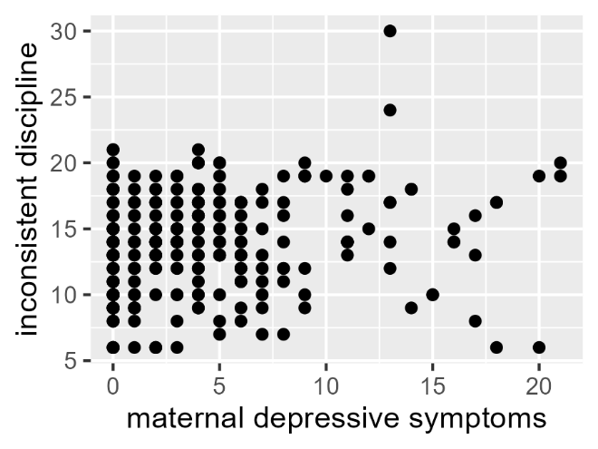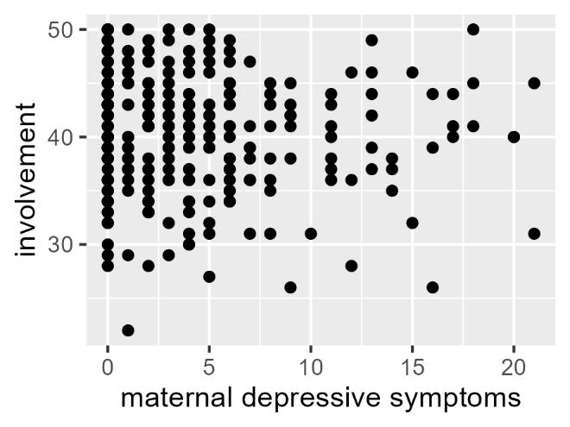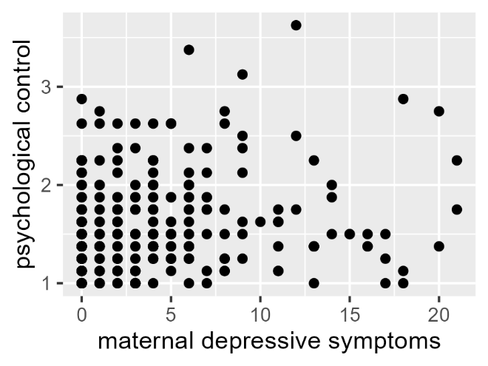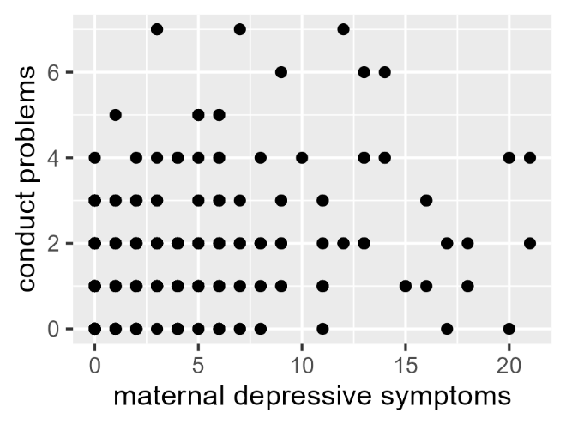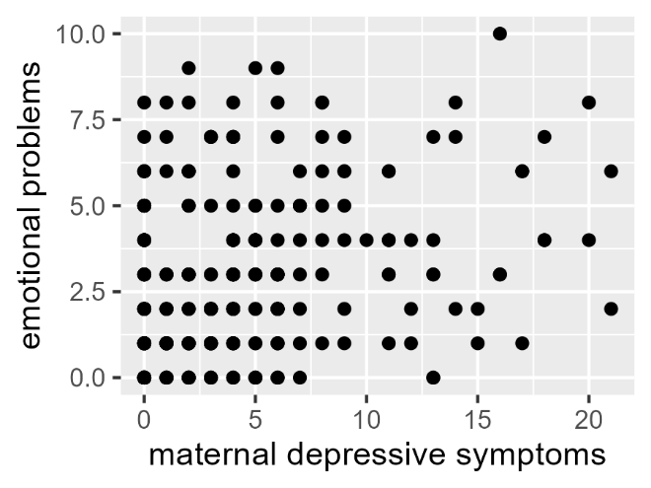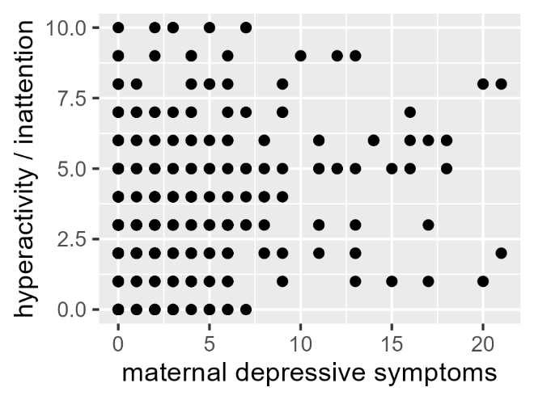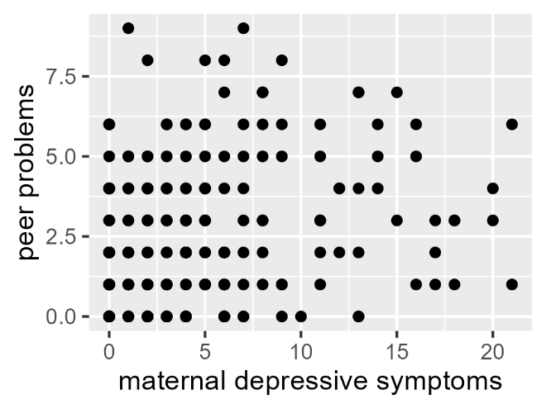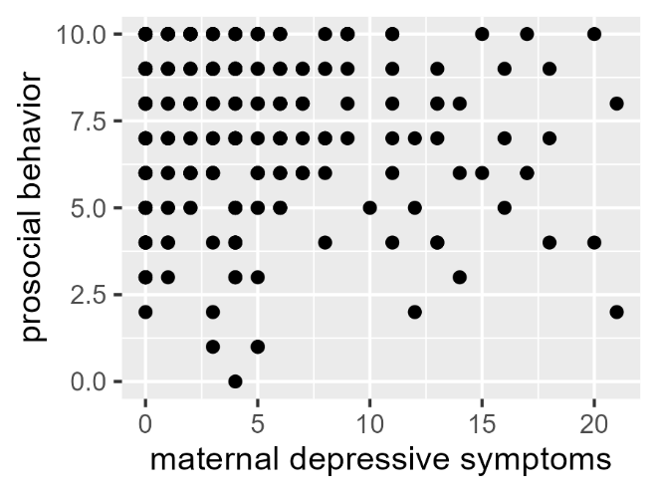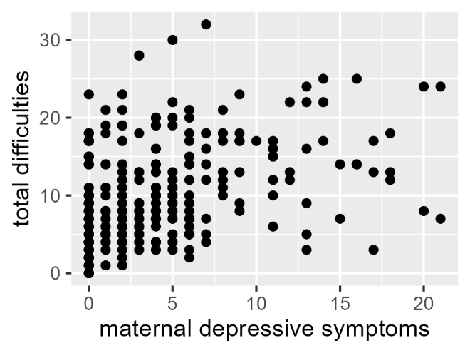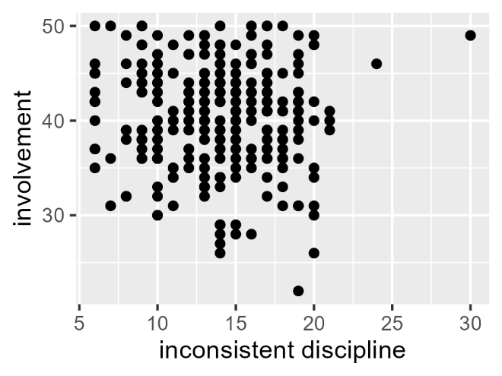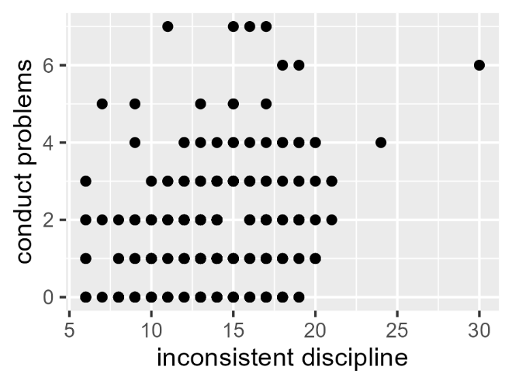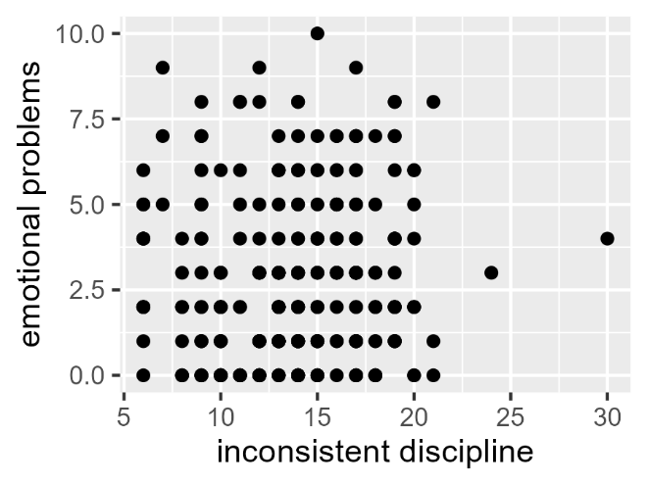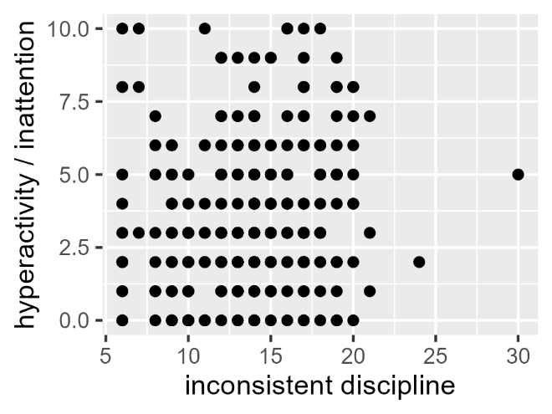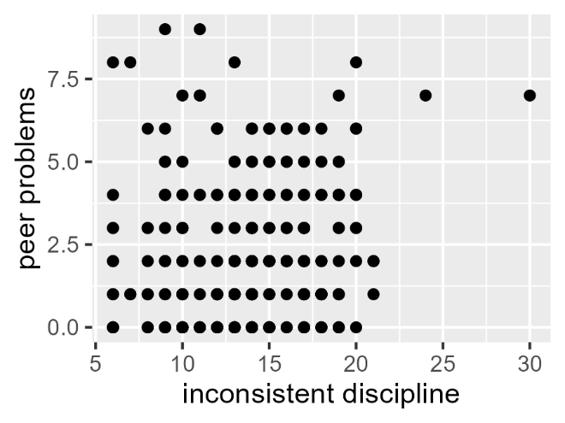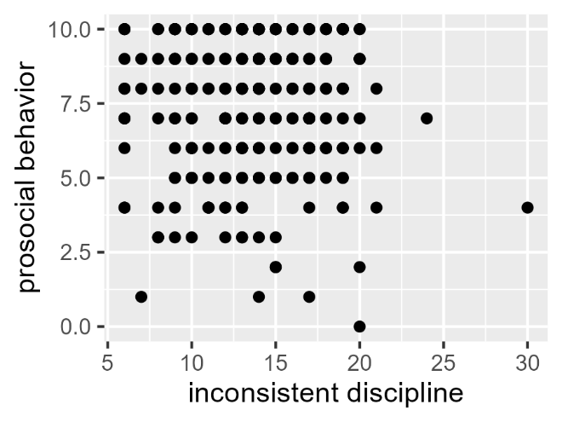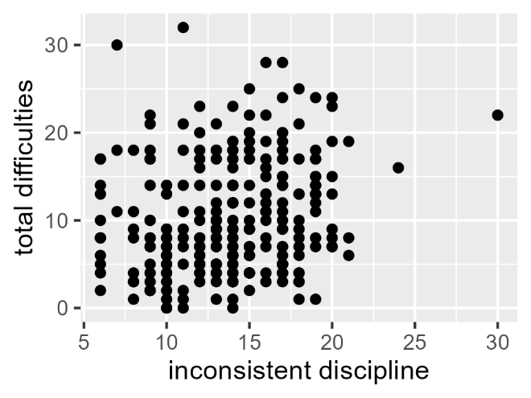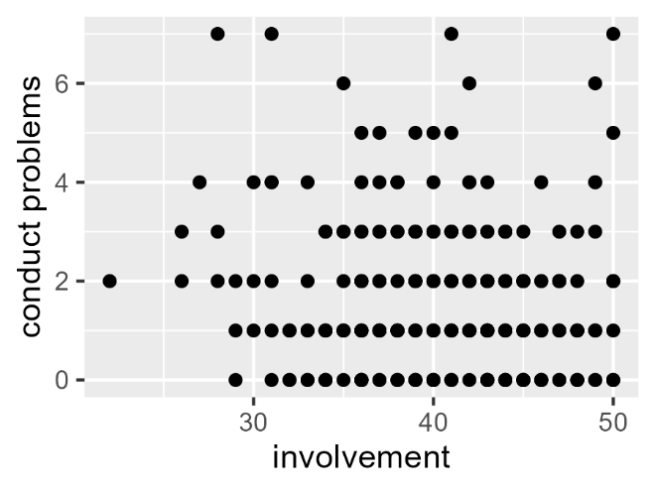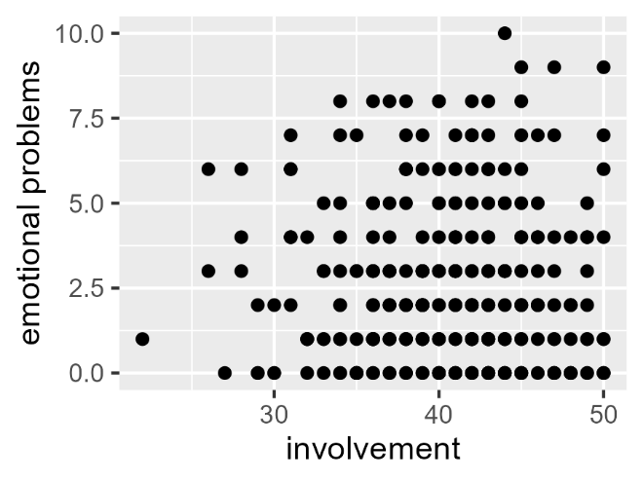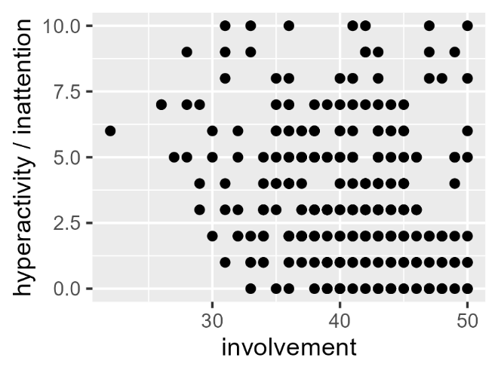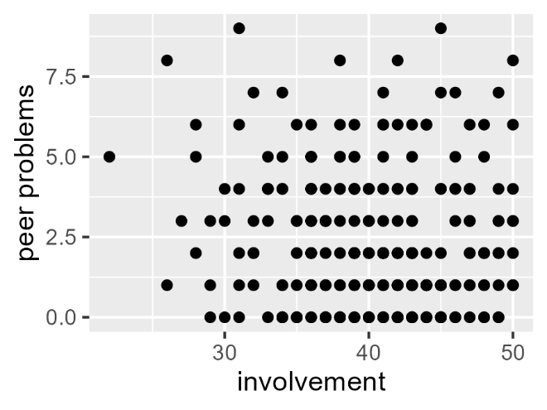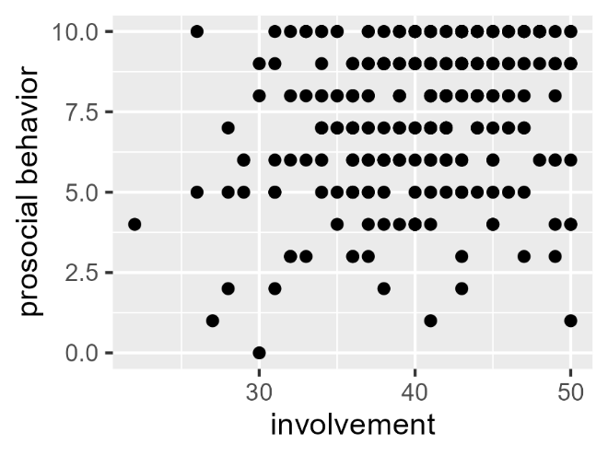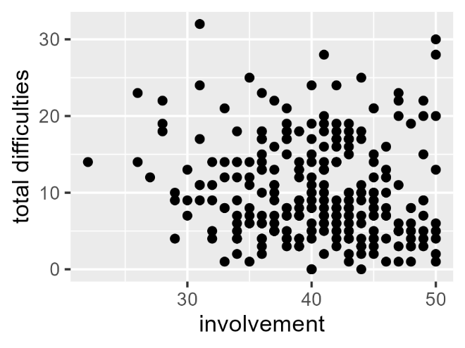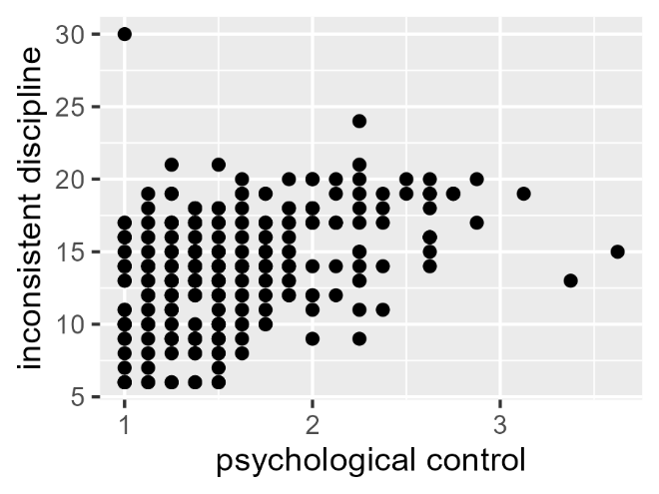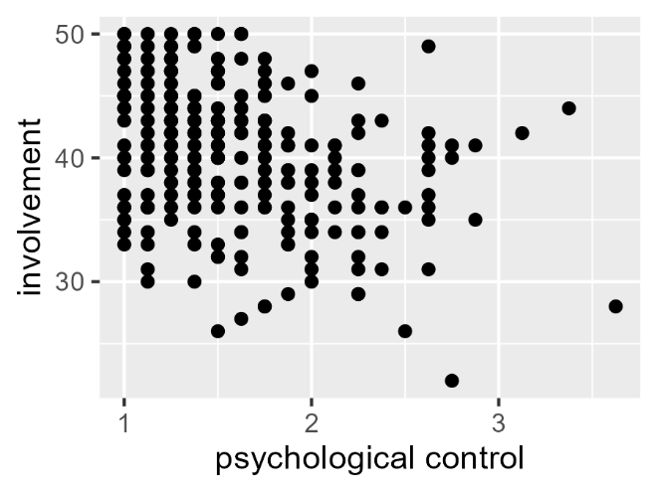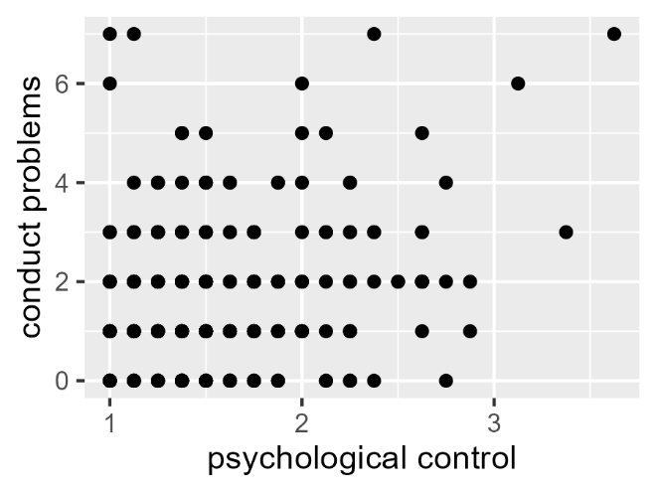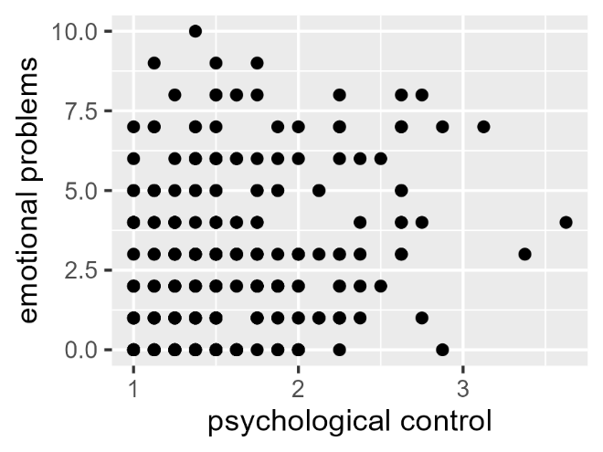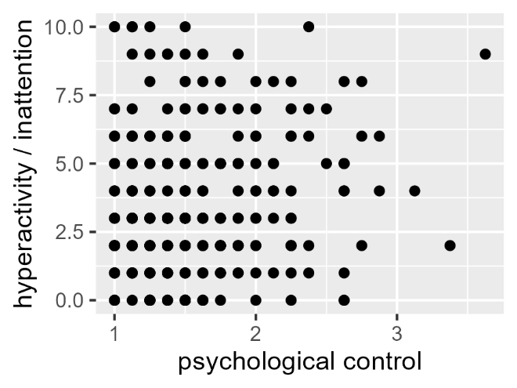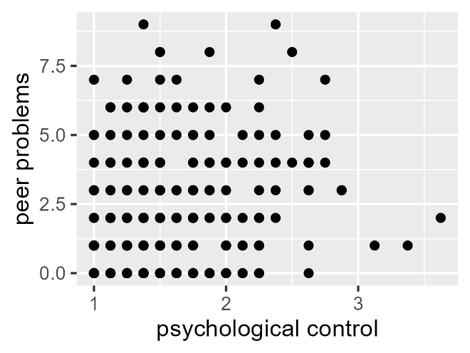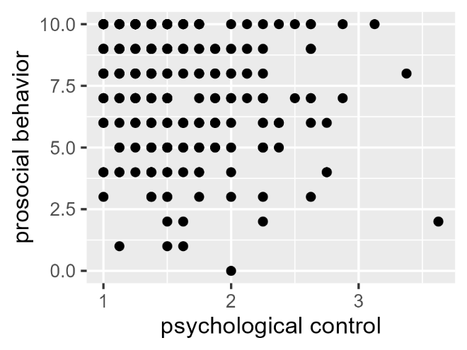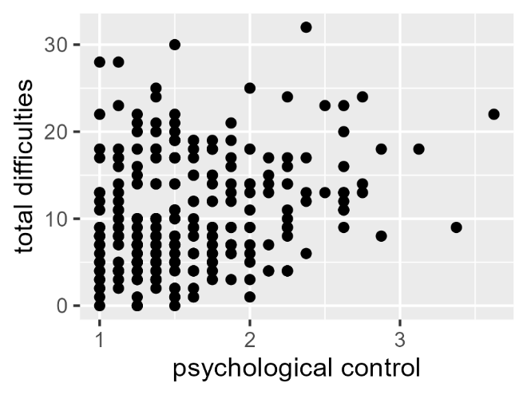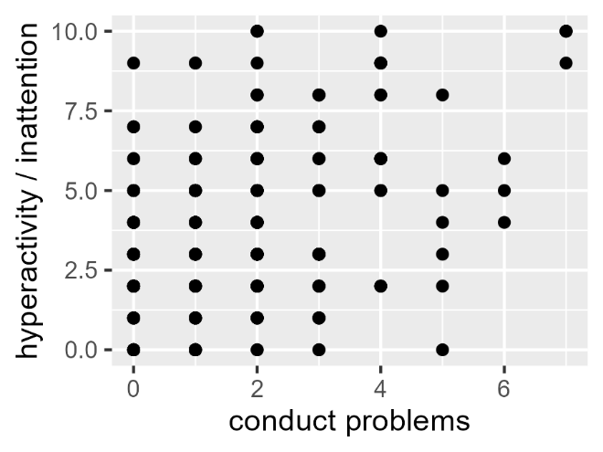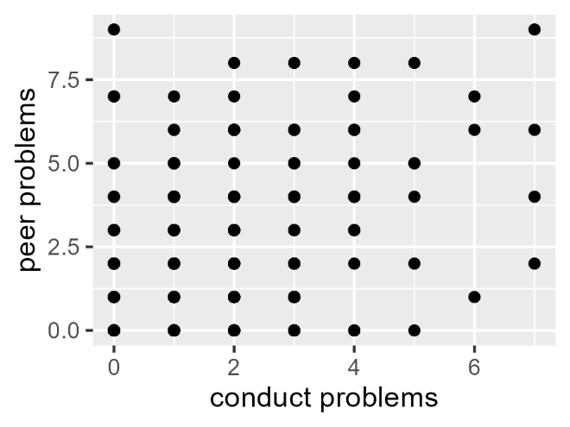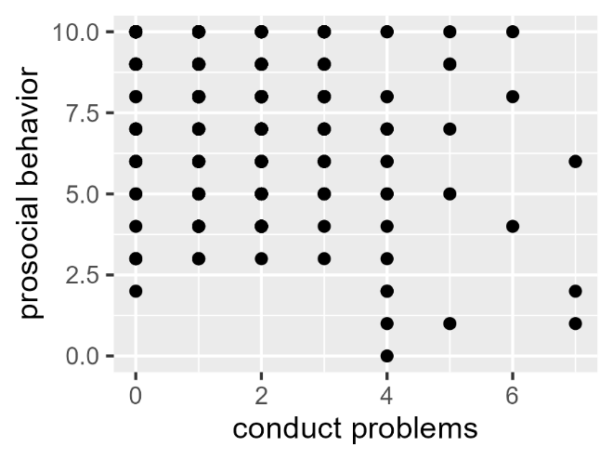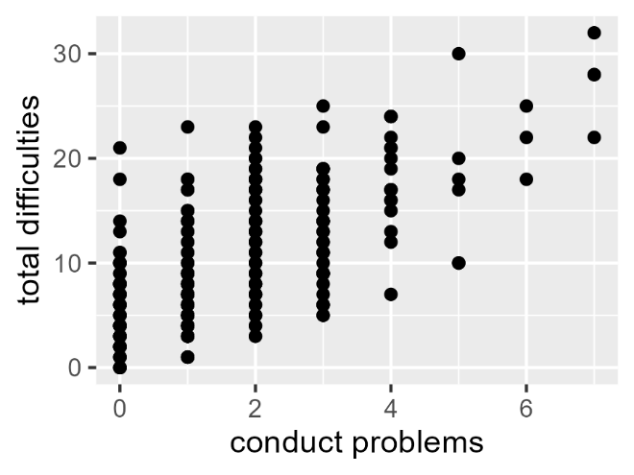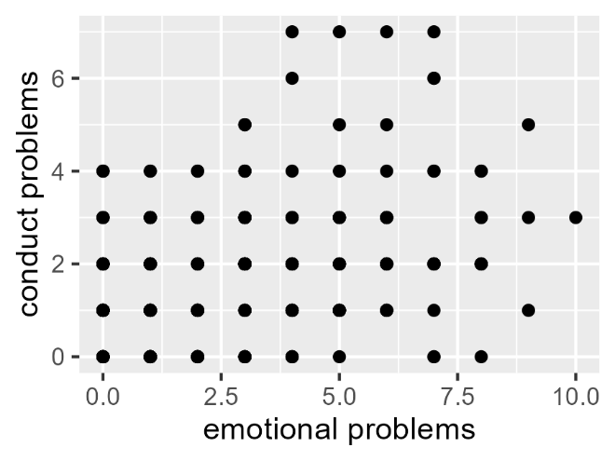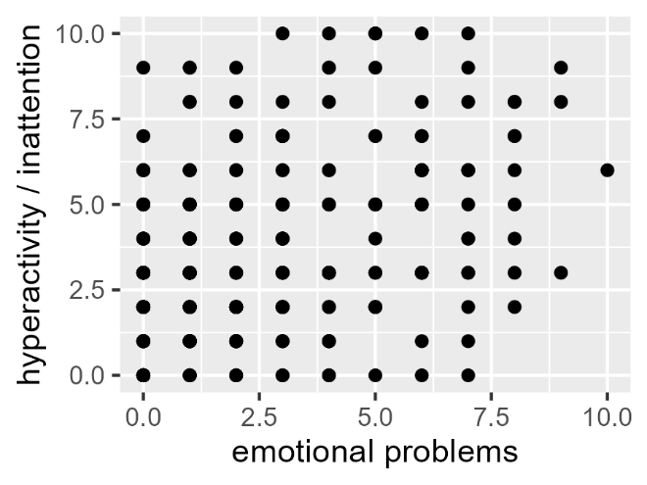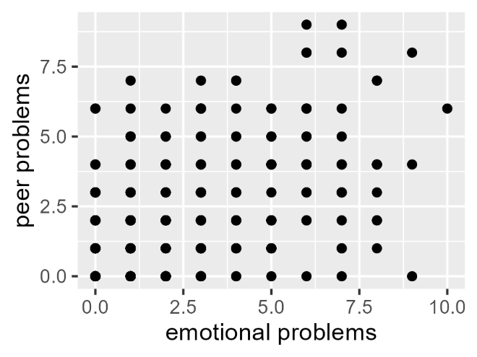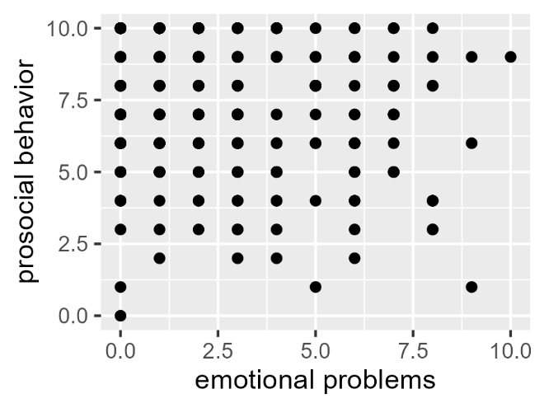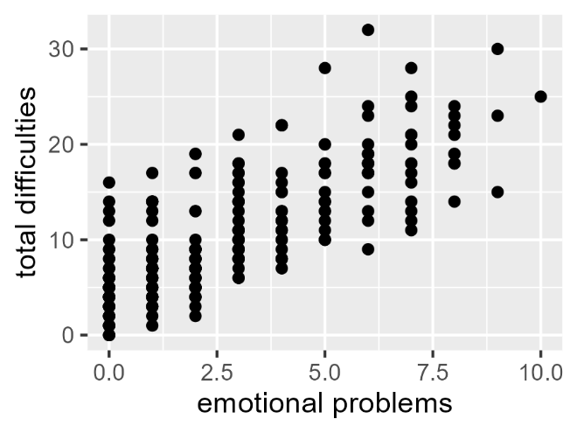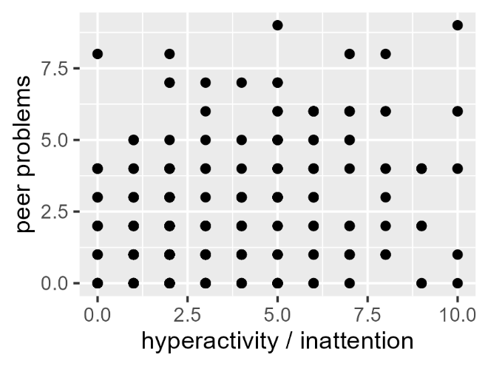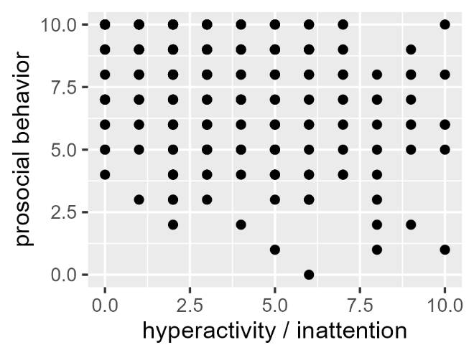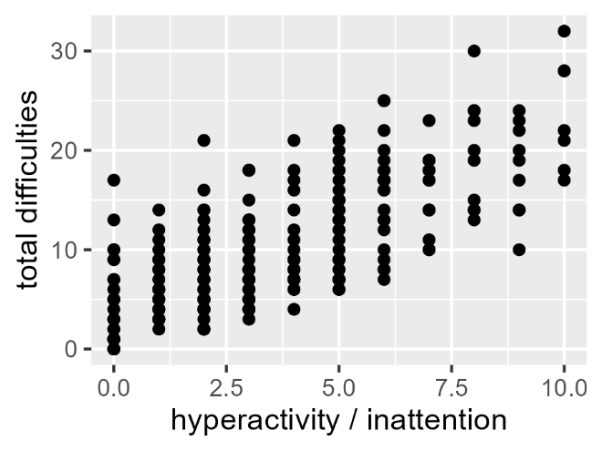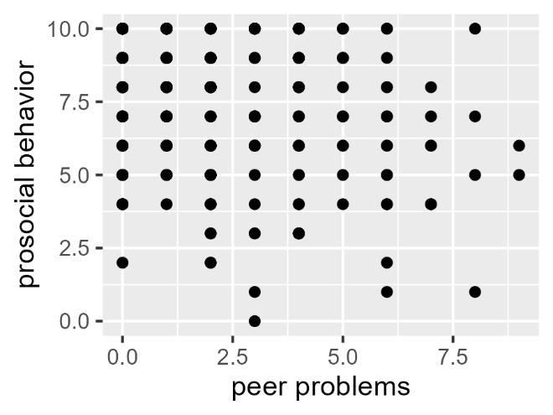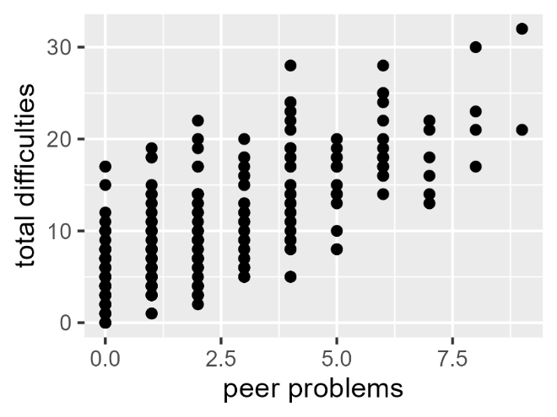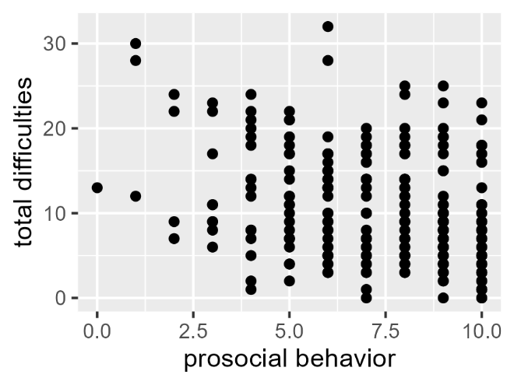

Supplementary Material E
Boxplots of Study Variables
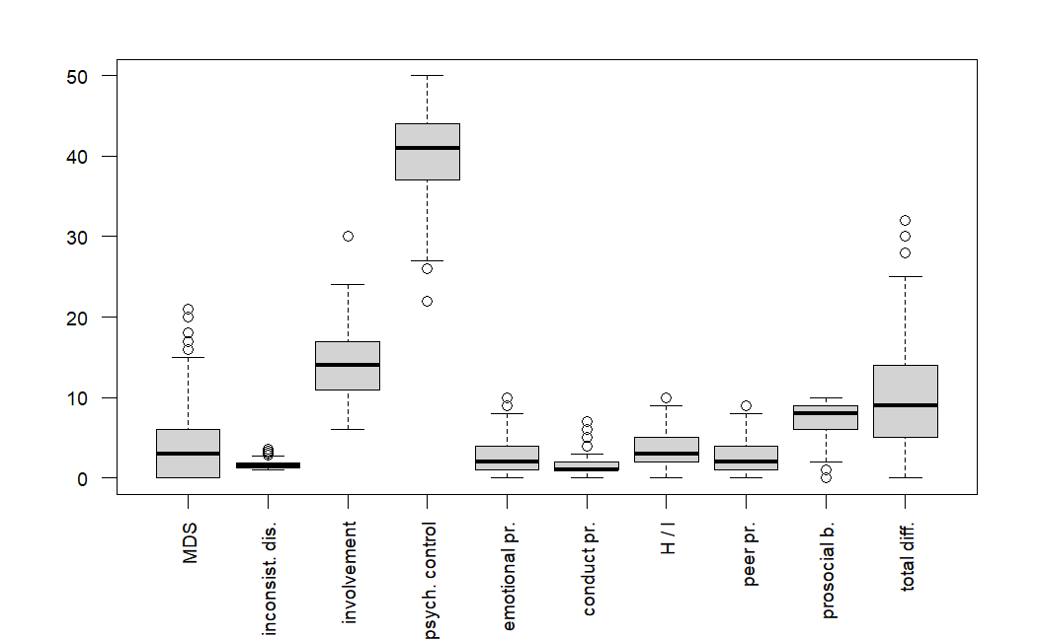
Note. MDS = maternal depressive symptoms, pr. = problems, H / I = hyperactivity / inattention.

Supplementary Material F
Comparison of Demographic Data Between the German and US/UK Samples
Comparison of Metric Data with Independent t-Tests
Variable | German sample |  | US/UK sample |  | t(278) | p
Variable | M | SD | M | SD | t(278) | p
Age parents | 41.32 | 8.45 | 41.95 | 8.72 | -0.52 | .600
Age adolescents | 13.86 | 1.97 | 14.00 | 1.87 | -0.52 | .602
Number of  adolescent’s siblings | 0.99 | 1.10 | 1.04 | 1.21 | -0.32 | .747

Comparison of Nominal Data with Fisher’s Exact Tests
Variable | p
Cohabitation with adolescent | .757
Gender adolescents | .773
Education parentsª | .000**
Relation to adolescent | .896
Marital statusª | .547
Migrant background | .000**

ªFisher’s exact test was used with Monte Carlo Permutation
**p < .01

Supplementary Material G
Comparison of Descriptive Statistics Between the German and US/UK Samples
Variable | German sample |  | US & UK sample |  | t(278) | Unadjusted  p-value | Adjusted  p-value
Variable | M | SD | M | SD | t(278) | Unadjusted  p-value
Maternal depressive symptoms | 4.79 | 5.21 | 4.08 | 4.55 | 1.09 | .277 | 1.000
Psychological control | 1.61 | 0.48 | 14.00 | 0.48 | 0.43 | .668 | 1.000
Inconsistent discipline | 14.31 | 3.76 | 13.63 | 3.82 | 1.30 | .196 | 1.000
Involvement | 40.06 | 5.29 | 40.43 | 5.51 | -0.50 | .618 | 1.000
Emotional problems^{b} | 1.69 | 1.86 | 3.05 | 2.50 | 4.83^{c} | .000** | 0.000**
Conduct problems | 1.76 | 1.19 | 1.64 | 1.58 | 0.58 | .561 | 1.000
Hyperactivity / inattention | 2.73 | 2.21 | 3.91 | 2.66 | -3.35 | .001** | 0.009**
Peer problems | 2.24 | 1.98 | 2.31 | 2.18 | -0.23 | .819 | 1.000
Prosocial behavior | 7.31 | 2.00 | 7.44 | 2.34 | -0.42 | .675 | 1.000
Total difficulties^{b} | 8.42 | 4.88 | 10.91 | 6.64 | -3.36^{d} | .001** | 0.010*

Note. Independent t-tests were conducted if not noted otherwise. P-Values were adjusted via Bonferroni correction.
^{b}Welch’s t test was used as variances were unequal
^{c}degrees of freedom = 162.30, not 278 as in the independent t-tests
^{d}degrees of freedom = 164.11, not 278 as in the independent t-tests
*p < .05.; **p < .01

