Supplementary Material 1

Table S1. Data collection and specimen sampling were used in this study. Marks: "X" indicate that the specimen was included in the respective analysis; "-" indicate that the specimen was not included in the respective analysis.

Collection | Species | Family | Subfamily | Maxilla | Labium | Eye  arrangement
QMS3254 | Barycheloides sp. | Barychelidae | Barychelinae | X | X | X
QMS17750 | Barycheloides alluviophilus | Barychelidae | Barychelinae | X | X | X
QMS19094 | Barycheloides alluviophilus | Barychelidae | Barychelinae | X | X | X
AMNH_ | Barycheloides sp. | Barychelidae | Barychelinae | X | X | X
QMS19100 | Barycheloides concavus | Barychelidae | Barychelinae | X | X | X
QMS19100a | Barycheloides concavus | Barychelidae | Barychelinae | X | X | X
QMS17753 | Barycheloides rufofemoratus | Barychelidae | Barychelinae | X | X | X
QMS19102 | Barycheloides rufofemoratus | Barychelidae | Barychelinae | X | X | X
QMS19097 | Barycheloides rufofemoratus | Barychelidae | Barychelinae | X | X | X
QMS17745 | Barycheloides rufofemoratus | Barychelidae | Barychelinae | X | X | X
MNHN8756 | Cosmopelma decoratum | Barychelidae | Sasoninae (neotropical) | X | X | X
IBSP220109 | Cosmopelma decoratum | Barychelidae | Sasoninae (neotropical) | X | X | X
RMCA127267 | Cyphonisia anulata | Barychelidae | Barychelinae | X | X | X
RMCA120071 | Cyphonisia itombwensis | Barychelidae | Barychelinae | X | X | X

RMCA129769 | Cyphonisia itombwensis | Barychelidae | Barychelinae | X | X | X
RMCA135618 | Cyphonisia itombwensis | Barychelidae | Barychelinae | X | X | X
RMCA135628 | Cyphonisia itombwensis | Barychelidae | Barychelinae | X | X | X
RMCA144496 | Cyphonisia itombwensis | Barychelidae | Barychelinae | X | X | X
RMCA212501 | Cyphonisia maculata | Barychelidae | Barychelinae | X | X | X
RMCA140818 | Cyphonisia maculata | Barychelidae | Barychelinae | X | X | X
RMCA126815 | Cyphonisia obesa | Barychelidae | Barychelinae | X | X | X
RMCA232393 | Cyphonisia obesa | Barychelidae | Barychelinae | X | X | X
RMCA232396 | Cyphonisia obesa | Barychelidae | Barychelinae | X | X | X
RMCA232400 | Cyphonisia obesa | Barychelidae | Barychelinae | X | X | X
RMCA232399 | Cyphonisia obesa | Barychelidae | Barychelinae | X | X | X
RMCA232397 | Cyphonisia obesa | Barychelidae | Barychelinae | X | X | X
RMCA227826 | Cyphonisia obesa | Barychelidae | Barychelinae | X | X | X
RMCA151744 | Cyphonisia obesa | Barychelidae | Barychelinae | X | X | X
RMCA27055 | Cyphonisia obesa | Barychelidae | Barychelinae | X | X | X
RMCA146507 | Cyphonisia obesa | Barychelidae | Barychelinae | X | X | X
QMS51468 | Encyocrypta sp. | Barychelidae | Barychelinae | X | X | X
QMS7131a | Encyocrypta sp. | Barychelidae | Barychelinae | X | X | X
QMS7131b | Encyocrypta sp. | Barychelidae | Barychelinae | X | X | X
QMS7131c | Encyocrypta sp. | Barychelidae | Barychelinae | X | X | X
QMS15484 | Encyocrypta sp. | Barychelidae | Barychelinae | X | X | X
QMS15485 | Encyocrypta sp. | Barychelidae | Barychelinae | X | X | X
QMS15486 | Encyocrypta sp. | Barychelidae | Barychelinae | X | X | X
QMS19092 | Encyocrypta sp. | Barychelidae | Barychelinae | X | X | X
QMS34165 | Encyocrypta sp. | Barychelidae | Barychelinae | X | X | X
QMS34191 | Encyocrypta sp. | Barychelidae | Barychelinae | X | X | X
IBSP111281 | Neodiplothele sp. | Barychelidae | Sasoninae (neotropical) | X | X | X
IBSP108004 | Neodiplothele sp. | Barychelidae | Sasoninae (neotropical) | X | X | X
IBSP108005 | Neodiplothele sp. | Barychelidae | Sasoninae (neotropical) | X | X | X
IBSP108006 | Neodiplothele sp. | Barychelidae | Sasoninae (neotropical) | X | X | X
IBSP165156 | Neodiplothele sp. | Barychelidae | Sasoninae (neotropical) | X | X | X
IBSP165157 | Neodiplothele sp. | Barychelidae | Sasoninae (neotropical) | X | X | X
IBSP165158 | Neodiplothele sp. | Barychelidae | Sasoninae (neotropical) | X | X | X
IBSP165159 | Neodiplothele sp. | Barychelidae | Sasoninae (neotropical) | X | X | X
IBSP165160 | Neodiplothele sp. | Barychelidae | Sasoninae (neotropical) | X | X | X
IBSP165162 | Neodiplothele sp. | Barychelidae | Sasoninae (neotropical) | X | X | X
QMS_ | Idiommata blackwalli | Barychelidae | Barychelinae | X | X | X
QMS_AR52 | Idiommata blackwalli | Barychelidae | Barychelinae | X | X | X

QMS_ | Idiommata blackwalli | Barychelidae | Barychelinae | X | X | X
QMS_ | Idiommata blackwalli | Barychelidae | Barychelinae | X | X | X
QMS_ | Idiommata blackwalli | Barychelidae | Barychelinae | X | X | X
QMS_ | Idiommata blackwalli | Barychelidae | Barychelinae | X | X | X
QMS_ | Idiommata blackwalli | Barychelidae | Barychelinae | X | X | X
QMS_AR52 | Idiommata blackwalli | Barychelidae | Barychelinae | X | - | X
QMS_AR53 | Idiommata blackwalli | Barychelidae | Barychelinae | X | - | X
QMS12523 | Idioctis helva | Barychelidae | Barychelinae | X | X | X
QMS_ | Idioctis helva | Barychelidae | Barychelinae | X | X | X
QMS_ | Idioctis helva | Barychelidae | Barychelinae | X | X | X
QMS12521 | Idioctis helva | Barychelidae | Barychelinae | X | X | X
QMS12522 | Idioctis helva | Barychelidae | Barychelinae | X | X | X
QMS12527 | Idioctis helva | Barychelidae | Barychelinae | X | X | X
QMS12530 | Idioctis helva | Barychelidae | Barychelinae | X | X | X
QMS13529a | Idioctis helva | Barychelidae | Barychelinae | X | X | X
QMS13529b | Idioctis helva | Barychelidae | Barychelinae | X | X | X
QMS54433 | Mandjela commoni | Barychelidae | Barychelinae | X | X | X
QMS1923 | Mandjela commoni | Barychelidae | Barychelinae | X | X | X
QMS1926 | Mandjela commoni | Barychelidae | Barychelinae | X | X | X
QMS1928 | Mandjela commoni | Barychelidae | Barychelinae | X | X | X

QMS1932 | Mandjela commoni | Barychelidae | Barychelinae | X | X | X
QMS1979 | Mandjela commoni | Barychelidae | Barychelinae | X | X | X
QMS1981 | Mandjela commoni | Barychelidae | Barychelinae | X | X | X
QMS18357 | Mandjela commoni | Barychelidae | Barychelinae | X | X | X
QMS19549 | Mandjela commoni | Barychelidae | Barychelinae | X | X | X
QMS19692 | Mandjela commoni | Barychelidae | Barychelinae | X | X | X
IBSP161832 | Neodiplothele irregulares | Barychelidae | Sasoninae (neotropical) | X | X | X
IBSP 161835 | Neodiplothele irregulares | Barychelidae | Sasoninae (neotropical) | X | X | X
IBSP 161836 | Neodiplothele irregulares | Barychelidae | Sasoninae (neotropical) | X | X | X
IBSP 161837 | Neodiplothele irregulares | Barychelidae | Sasoninae (neotropical) | X | X | X
IBSP 161838 | Neodiplothele irregulares | Barychelidae | Sasoninae (neotropical) | X | X | X
IBSP 161848 | Neodiplothele irregulares | Barychelidae | Sasoninae (neotropical) | X | X | X
IBSP 161849 | Neodiplothele irregulares | Barychelidae | Sasoninae (neotropical) | X | X | X
IBSP 161850 | Neodiplothele irregulares | Barychelidae | Sasoninae (neotropical) | X | X | X
IBSP 165102 | Neodiplothele irregulares | Barychelidae | Sasoninae (neotropical) | X | X | X
IBSP 165117 | Neodiplothele irregulares | Barychelidae | Sasoninae (neotropical) | X | X | X
QMS8287 | Nihoa bisianumu | Barychelidae | Barychelinae | X | X | X
QMS8287a | Nihoa bisianumu | Barychelidae | Barychelinae | X | X | X
QMS8287b | Nihoa bisianumu | Barychelidae | Barychelinae | X | X | X
QMS8278d | Nihoa karawari | Barychelidae | Barychelinae | X | X | X
QMS8278 | Nihoa karawari | Barychelidae | Barychelinae | X | X | X
QMS827a | Nihoa karawari | Barychelidae | Barychelinae | X | X | X
QMS827c | Nihoa karawari | Barychelidae | Barychelinae | X | X | X
QMS827b | Nihoa karawari | Barychelidae | Barychelinae | X | X | X
QMS19125 | Nihoa pictipes | Barychelidae | Barychelinae | - | - | X
QMS19062 | Nihoa pictipes | Barychelidae | Barychelinae | - | - | X
QMS54524 | Ozycrypta sp. | Barychelidae | Barychelinae | X | X | X
QMS27420 | Ozycrypta sp. | Barychelidae | Barychelinae | X | X | X
QMS51975 | Ozycrypta sp. | Barychelidae | Barychelinae | X | X | X
QMS57952 | Ozycrypta sp. | Barychelidae | Barychelinae | X | X | X
QMS59555 | Ozycrypta sp. | Barychelidae | Barychelinae | X | X | X
QMS63101 | Ozycrypta sp. | Barychelidae | Barychelinae | X | X | X
QMS59297 | Ozycrypta sp. | Barychelidae | Barychelinae | X | X | X
QMS59297B | Ozycrypta sp. | Barychelidae | Barychelinae | X | X | X
QMS27386 | Ozycrypta sp. | Barychelidae | Barychelinae | X | X | X
QMS46898 | Ozycrypta sp. | Barychelidae | Barychelinae | X | X | X
MNRJ0236 | Paracenobiopelma gerecormophilum | Barychelidae | Sasoninae (neotropical) | X | X | X
MNRJ0236 | Paracenobiopelma gerecormophilum | Barychelidae | Sasoninae (neotropical) | X | X | X
MNRJ0236 | Paracenobiopelma gerecormophilum | Barychelidae | Sasoninae (neotropical) | X | X | X
RMCA127641 | Pisenor leleupi | Barychelidae | Barychelinae | X | X | X
RMCA093110 | Pisenor leleupi | Barychelidae | Barychelinae | X | X | X
RMCA139865 | Pisenor maculata | Barychelidae | Barychelinae | X | X | X
MNHN1876 | Pisenor notius | Barychelidae | Barychelinae | X | X | X
MNHN4529 | Pisenor notius | Barychelidae | Barychelinae | X | X | X
RMCA09253 | Pisenor plicata | Barychelidae | Barychelinae | X | X | X
RMCA092517 | Pisenor tenuistylus | Barychelidae | Barychelinae | X | X | X
RMCA092518 | Pisenor tenuistylus | Barychelidae | Barychelinae | X | X | X
RMCA139899 | Pisenor upembana | Barychelidae | Barychelinae | X | X | X
RMCA13969 | Pisenor upembana | Barychelidae | Barychelinae | X | X | X
QMS27870 | Seoqcrypta jakara | Barychelidae | Barychelinae | X | X | X
QMS95219 | Seoqcrypta jakara | Barychelidae | Barychelinae | X | X | X
QMS_ | Seoqcrypta jakara | Barychelidae | Barychelinae | X | X | X
QMS_ | Seoqcrypta jakara | Barychelidae | Barychelinae | X | X | X
QMS_ | Seoqcrypta jakara | Barychelidae | Barychelinae | X | X | X
QMS_ | Seoqcrypta jakara | Barychelidae | Barychelinae | X | X | X
QMS19542 | Seoqcrypta jakara | Barychelidae | Barychelinae | X | X | X
QMS20026 | Seoqcrypta jakara | Barychelidae | Barychelinae | X | X | X
QMS20476 | Seoqcrypta jakara | Barychelidae | Barychelinae | X | X | X
QMS20474 | Seoqcrypta jakara | Barychelidae | Barychelinae | X | X | X
SMNK 3528 | Strophaeus quillacinga | Barychelidae | Barychelinae | X | X | X
SMNK 3529 | Strophaeus quillacinga | Barychelidae | Barychelinae | X | X | X
SMNK 3530 | Strophaeus quillacinga | Barychelidae | Barychelinae | X | X | X
SMNK 3531 | Strophaeus quillacinga | Barychelidae | Barychelinae | X | X | X
SMNK 3532 | Strophaeus quillacinga | Barychelidae | Barychelinae | X | X | X
SMNK 3533 | Strophaeus quillacinga | Barychelidae | Barychelinae | X | X | X
SMNK 3534 | Strophaeus quillacinga | Barychelidae | Barychelinae | X | X | X
SMNK 3528 | Strophaeus quillacinga | Barychelidae | Barychelinae | X | X | X
SMNK 3533 | Strophaeus quillacinga | Barychelidae | Barychelinae | X | X | X
SMNK 3533 | Strophaeus quillacinga | Barychelidae | Barychelinae | X | X | X
QMS11211 | Sason colemani | Barychelidae | Sasoninae | X | X | X
QMS1312 | Sason colemani | Barychelidae | Sasoninae | X | X | X
QMS9680 | Sason colemani | Barychelidae | Sasoninae | X | X | X
QMS11193 | Sason colemani | Barychelidae | Sasoninae | X | X | X
QMS11203 | Sason colemani | Barychelidae | Sasoninae | X | X | X
QMS11206 | Sason colemani | Barychelidae | Sasoninae | X | X | X
QMS11207 | Sason colemani | Barychelidae | Sasoninae | X | X | X
QMS11208 | Sason colemani | Barychelidae | Sasoninae | X | X | X
QMS11212 | Sason_colemani | Barychelidae | Sasoninae | X | X | X
QMS11208b | Sason colemani | Barychelidae | Sasoninae | X | X | X
MNHN | Sason robustum | Barychelidae | Sasoninae | X | X | X
NHM1899.1.17.1 | Sason robustum | Barychelidae | Sasoninae | X | X | X
MNHN | Sason robustum | Barychelidae | Sasoninae | X | X | X
MNHN | Sason robustum | Barychelidae | Sasoninae | X | X | X
MNHN | Sason robustum | Barychelidae | Sasoninae | X | X | X
MNHN | Sason robustum | Barychelidae | Sasoninae | X | X | X
MNHN | Sason robustum | Barychelidae | Sasoninae | X | X | X
MNHN | Sason robustum | Barychelidae | Sasoninae | X | X | X
MNHN | Sason robustum | Barychelidae | Sasoninae | X | X | X
MNHN | Sason robustum | Barychelidae | Sasoninae | X | X | X
RMCA57324 | Sipalolasma warnantea | Barychelidae | Barychelinae | X | X | X
RMCA122789 | Sipalolasma warnantea | Barychelidae | Barychelinae | X | X | X
RMCA128137 | Sipalolasma warnantea | Barychelidae | Barychelinae | X | X | X
RMCA3489 | Sipalolasma warnantea | Barychelidae | Barychelinae | X | X | X
RMCA120051 | Sipalolasma warnantea | Barychelidae | Barychelinae | X | X | X
RMCA120344 | Sipalolasma warnantea | Barychelidae | Barychelinae | X | X | X
QMS63032 | Trittame loki | Barychelidae | Barychelinae | X | X | X
QMS1611 | Trittame loki | Barychelidae | Barychelinae | X | X | X
QMS25143 | Trittame loki | Barychelidae | Barychelinae | X | X | X
QMS25143A | Trittame loki | Barychelidae | Barychelinae | X | X | X
QMS25931 | Trittame loki | Barychelidae | Barychelinae | X | X | X
QMS2593A | Trittame loki | Barychelidae | Barychelinae | X | X | X
QMS53004 | Trittame loki | Barychelidae | Barychelinae | X | X | X
QMS59962 | Trittame loki | Barychelidae | Barychelinae | X | X | X
QMS56446 | Trittame mccolli | Barychelidae | Barychelinae | X | X | X
QMS27401 | Trittame mccolli | Barychelidae | Barychelinae | X | X | X
NHM1899.3.14.4-13 | Cyrtogrammomma monticola | Theraphosidae | incertae sedis | X | X | X
NHM1899.3.14.4-13 | Cyrtogrammomma monticola | Theraphosidae | incertae sedis | X | X | X
IBSP166186 | Cyrtogrammomma frevo | Theraphosidae | incertae sedis | X | X | X
IBSP165145 | Cyrtogrammomma frevo | Theraphosidae | incertae sedis | X | X | X
IBSP111662 | Cyrtogrammomma frevo | Theraphosidae | incertae sedis | X | X | X
IBSP111663 | Cyrtogrammomma frevo | Theraphosidae | incertae sedis | X | X | X
IBSP111664 | Cyrtogrammomma frevo | Theraphosidae | incertae sedis | X | X | X
IBSP111665 | Cyrtogrammomma frevo | Theraphosidae | incertae sedis | X | X | X
IBSP111666 | Cyrtogrammomma frevo | Theraphosidae | incertae sedis | X | X | X
IBSP111667 | Cyrtogrammomma frevo | Theraphosidae | incertae sedis | X | X | X
IBSP111668 | Cyrtogrammomma frevo | Theraphosidae | incertae sedis | X | X | X
IBSP131715 | Cyrtogrammomma frevo | Theraphosidae | incertae sedis | X | X | X
MPEG007530 | Holothele longipes. | Theraphosidae | Ischnocolinae sensu stricto | X | X | X
MPEG007534 | Holothele longipes. | Theraphosidae | Ischnocolinae sensu stricto | X | X | X
MPEG007523 | Holothele longipes. | Theraphosidae | Ischnocolinae sensu stricto | X | X | X
MPEG007519 | Holothele longipes. | Theraphosidae | Ischnocolinae sensu stricto | X | X | X
MPEG007528 | Holothele longipes. | Theraphosidae | Ischnocolinae sensu stricto | X | X | X
MPEG000211 | Holothele longipes. | Theraphosidae | Ischnocolinae sensu stricto | X | X | X
MPEG007515 | Holothele longipes. | Theraphosidae | Ischnocolinae sensu stricto | X | X | X
MPEG001005 | Holothele longipes. | Theraphosidae | Ischnocolinae sensu stricto | X | X | X
MPEG000982 | Holothele longipes. | Theraphosidae | Ischnocolinae sensu stricto | X | X | X
MPEG008626 | Holothele longipes. | Theraphosidae | Ischnocolinae sensu stricto | X | X | X
CAD1024 | Dolichothele sp. | Theraphosidae | Ischnocolinae latu sensu | X | X | X
CAD1026 | Dolichothele sp. | Theraphosidae | Ischnocolinae latu sensu | X | X | X
CAD1504 | Dolichothele sp. | Theraphosidae | Ischnocolinae latu sensu | X | X | X
CAD1508 | Dolichothele sp. | Theraphosidae | Ischnocolinae latu sensu | X | X | X
CAD1015 | Dolichothele sp. | Theraphosidae | Ischnocolinae latu sensu | X | X | X
CAD1007 | Dolichothele sp. | Theraphosidae | Ischnocolinae latu sensu | X | X | X
CAD1021 | Dolichothele sp. | Theraphosidae | Ischnocolinae latu sensu | X | X | X
CAD1012 | Dolichothele sp. | Theraphosidae | Ischnocolinae latu sensu | X | X | X
CAD1014 | Dolichothele sp. | Theraphosidae | Ischnocolinae latu sensu | X | X | X
CAD1512 | Dolichothele sp. | Theraphosidae | Ischnocolinae latu sensu | X | X | X
CAD247 | Tmesiphantes sp. | Theraphosidae | Ischnocolinae latu sensu | X | X | X
CAD301 | Tmesiphantes sp. | Theraphosidae | Ischnocolinae latu sensu | X | X | X
CAD580 | Tmesiphantes sp. | Theraphosidae | Ischnocolinae latu sensu | X | X | X
CAD581 | Tmesiphantes sp. | Theraphosidae | Ischnocolinae latu sensu | X | X | X
CAD080 | Tmesiphantes sp. | Theraphosidae | Ischnocolinae latu sensu | X | X | X
CAD593 | Tmesiphantes sp. | Theraphosidae | Ischnocolinae latu sensu | X | X | X
CAD089 | Tmesiphantes sp. | Theraphosidae | Ischnocolinae latu sensu | X | X | X
CAD011 | Tmesiphantes sp. | Theraphosidae | Ischnocolinae latu sensu | X | X | X
CAD575 | Tmesiphantes sp. | Theraphosidae | Theraphosinae | X | X | X
Dirk Weinmann private collection | Trichopelma sp. | Theraphosidae | Ischnocolinae sensu stricto | X | X | X
Dirk Weinmann private collection | Trichopelma sp. | Theraphosidae | Ischnocolinae sensu stricto | X | X | X
Dirk Weinmann private collection | Trichopelma sp. | Theraphosidae | Ischnocolinae sensu stricto | X | X | X
Dirk Weinmann private collection | Trichopelma sp. | Theraphosidae | Ischnocolinae sensu stricto | X | X | X
Dirk Weinmann private collection | Trichopelma sp. | Theraphosidae | Ischnocolinae sensu stricto | X | X | X
Dirk Weinmann private collection | Trichopelma sp. | Theraphosidae | Ischnocolinae sensu stricto | X | X | X
Dirk Weinmann private collection | Trichopelma sp. | Theraphosidae | Ischnocolinae sensu stricto | X | X | X
Dirk Weinmann private collection | Trichopelma sp. | Theraphosidae | Ischnocolinae sensu stricto | X | X | X
CAD1167 | Sickius longibulbi | Theraphosidae | Schismatothelinae | X | X | X
CAD1164 | Sickius longibulbi | Theraphosidae | Schismatothelinae | X | X | X
CAD1174 | Sickius longibulbi | Theraphosidae | Schismatothelinae | X | X | X
CAD1161 | Sickius longibulbi | Theraphosidae | Schismatothelinae | X | X | X
CAD1162 | Sickius longibulbi | Theraphosidae | Schismatothelinae | - | X | X
CAD1166 | Sickius longibulbi | Theraphosidae | Schismatothelinae | X | X | X
DZUB1684 | Sickius longibulbi | Theraphosidae | Schismatothelinae | X | X | X
DZUB 284 | Sickius longibulbi | Theraphosidae | Schismatothelinae | X | - | -
DZUB 4365 | Sickius longibulbi | Theraphosidae | Schismatothelinae | X | X | X
CAD1563 | Sickius longibulbi | Theraphosidae | Schismatothelinae | X | X | X
CAD1564 | Sickius longibulbi | Theraphosidae | Schismatothelinae | X | X | X
CAD960 | Catumiri sp. | Theraphosidae | Ischnocolinae latu sensu | X | X | X
CAD961 | Catumiri sp. | Theraphosidae | Ischnocolinae latu sensu | X | X | X
CAD959 | Catumiri sp. | Theraphosidae | Ischnocolinae latu sensu | X | X | X
CAD1275 | Catumiri sp. | Theraphosidae | Ischnocolinae latu sensu | X | X | X
CAD784 | Catumiri sp. | Theraphosidae | Ischnocolinae latu sensu | X | X | X
CAD785 | Catumiri sp. | Theraphosidae | Ischnocolinae latu sensu | X | X | X
MPEG05544 | Guyruita sp. | Theraphosidae | Schismatothelinae | X | X | X
MPEG023311 | Guyruita sp. | Theraphosidae | Schismatothelinae | X | X | X
MPEG023305 | Guyruita sp. | Theraphosidae | Schismatothelinae | X | X | X
MPEG05543 | Guyruita sp. | Theraphosidae | Schismatothelinae | X | X | X
MPEG05542 | Guyruita sp. | Theraphosidae | Schismatothelinae | X | X | X
MPEG023303 | Guyruita sp. | Theraphosidae | Schismatothelinae | X | X | X
MPEG055504 | Guyruita sp. | Theraphosidae | Schismatothelinae | X | X | X
MPEG05547 | Guyruita sp. | Theraphosidae | Schismatothelinae | X | X | -
MPEG023312 | Guyruita sp. | Theraphosidae | Schismatothelinae | - | X | X
MPEG023306 | Guyruita sp. | Theraphosidae | Schismatothelinae | X | X | X
MPEG023300 | Guyruita sp. | Theraphosidae | Schismatothelinae | - | - | X

Supplementary Material 2 Regression analyses
Maxillae
Regression Analysis: Regression Dependent variable(s): Maxillae:
ProcCoord1 ProcCoord2 ProcCoord3 ProcCoord4 ProcCoord5 ProcCoord6 ProcCoord7 ProcCoord8
Independent variable(s): Maxillae:
Centroid Size

Total sample size: 251

Regression Coefficients

 | Centroid Size
x1 | 0,00008647
y1 | 0,00008660
x2 | 0,00004570

y2 | 0,00003774
x3 | -0,00010317
y3 | 0,00000755
x4 | -0,00002900
y4 | -0,00013189

Sums of squares
Total SS: | 1,00497680
Predicted SS: | 0,01923381
Residual SS: | 0,98574299

% predicted: 1,9139%

Permutation test against the null hypothesis of independence Number of randomization rounds: 10000
P-value: 0,0033

Eye arrangement

Regression Analysis: Regression

Dependent variable(s): Eyes:
ProcCoord1 ProcCoord2 ProcCoord3 ProcCoord4
ProcCoord5 ProcCoord6 ProcCoord7 ProcCoord8 ProcCoord9 ProcCoord10 ProcCoord11 ProcCoord12
Independent variable(s): Eyes:
Centroid Size

Total sample size: 255

Regression Coefficients

 | Centroid Size
x1 | -0,00004178
y1 | 0,00005994
x2 | -0,00014861
y2 | -0,00020914
x3 | 0,00004296
y3 | 0,00015579
x4 | -0,00003905
y4 | 0,00014982
x5 | 0,00013572
y5 | -0,00019197

x6 0,00005076
y6 0,00003556

Sums of squares
Total SS: | 8,79924915
Predicted SS: | 0,31120705
Residual SS: | 8,48804210

% predicted: 3,5367%

Permutation test against the null hypothesis of independence Number of randomization rounds: 10000
P-value: 0,0015
Supplementary Material 3 Transformation grids

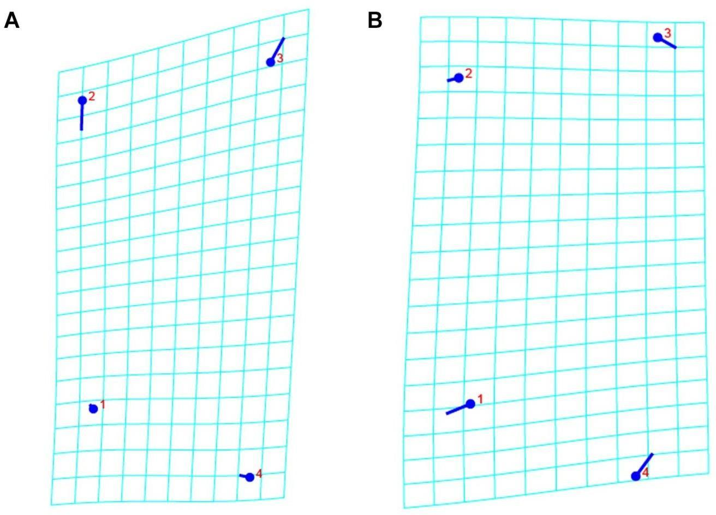

Figure S1. Transformation grid of maxilla. (A) Warp grid represents principal component 1 (PC1). (B) Warp grid represents principal component 2 (PC2).
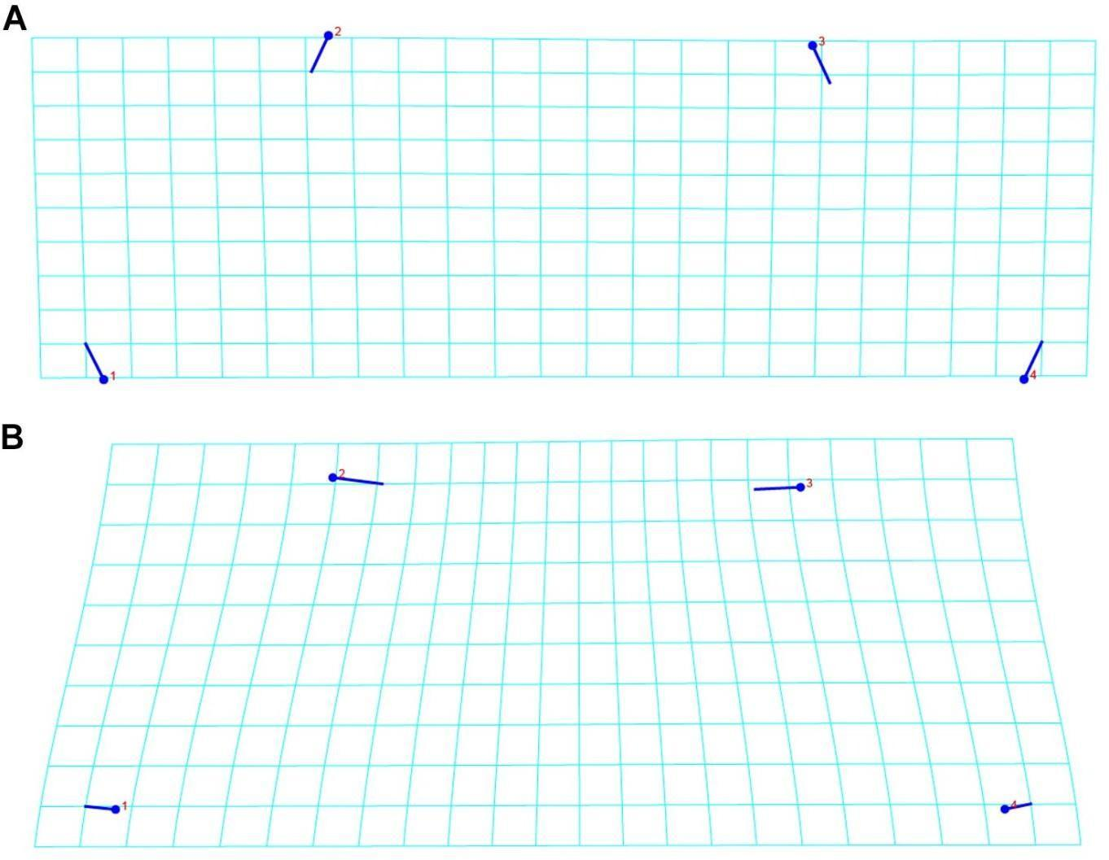

Figure S2. Transformation grid of labium. (A) Warp grid represents principal component 1 (PC1). (B) Warp grid represents principal component 2 (PC2).
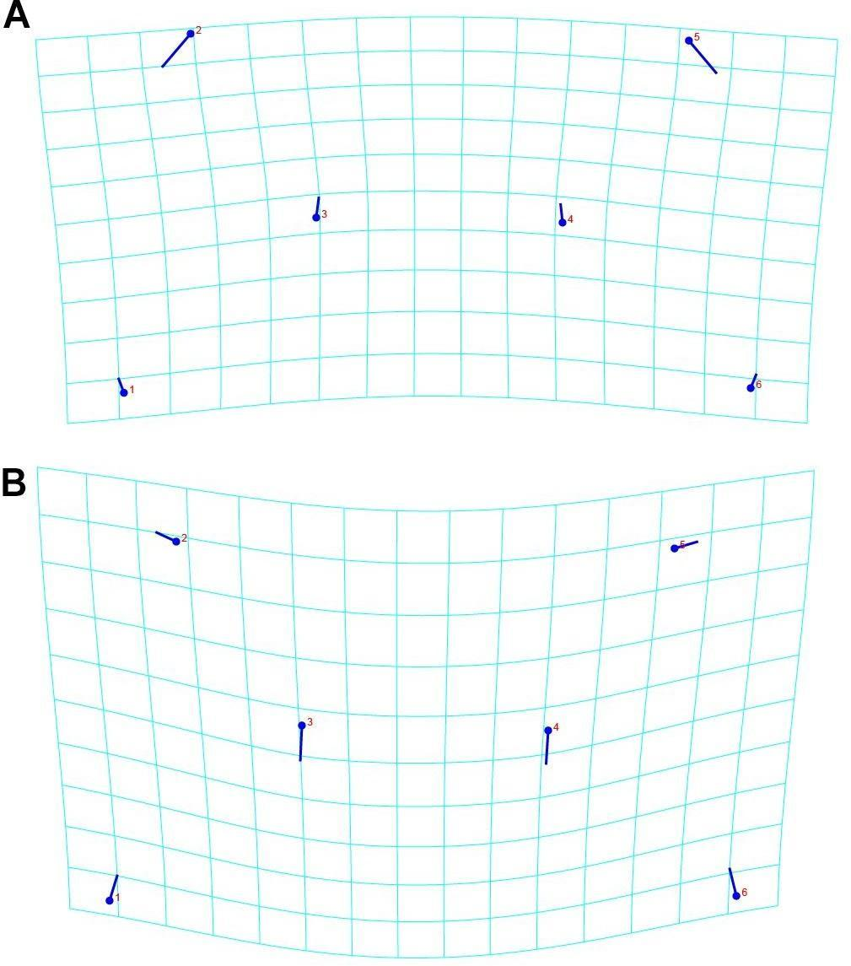

Figure S3. Transformation grid of eye arrangement. (A) Warp grid represents principal component 1 (PC1). (B) Warp grid represents principal component 2 (PC2).
Supplementary Material 4

Table S4. Discriminant analysis and cross-validation comparing groups of Barychelidae (Group 1) and Theraphosidae (Group 2). * p-value: <0.001; ** p-value: 0.0024.
Character | Groups comparated | Analysis | Group 1 | Group 2 | Total
Maxilla | Barychelidae¹ X Theraphosidae²* | DA | 155 | 22 | 177
Maxilla | Barychelidae¹ X Theraphosidae²* | DA | 4 | 70 | 74
Maxilla | Barychelidae¹ X Theraphosidae²* | CV | 154 | 23 | 177
Maxilla | Barychelidae¹ X Theraphosidae²* | CV | 5 | 69 | 74
Maxilla | Barychelinae¹ X Sasoninae²* | DA | 104 | 25 | 129
Maxilla | Barychelinae¹ X Sasoninae²* | DA | 10 | 38 | 48
Maxilla | Barychelinae¹ X Sasoninae²* | CV | 101 | 28 | 129
Maxilla | Barychelinae¹ X Sasoninae²* | CV | 10 | 38 | 48
Maxilla | Sason¹ X Neotropical Sasoninae²* | DA | 22 | 1 | 23
Maxilla | Sason¹ X Neotropical Sasoninae²* | DA | 3 | 22 | 25
Maxilla | Sason¹ X Neotropical Sasoninae²* | CV | 21 | 2 | 23
Maxilla | Sason¹ X Neotropical Sasoninae²* | CV | 5 | 20 | 25
Maxilla | Cyrtogrammomma¹ X Theraphosidae²* | DA | 9 | 3 | 12
Maxilla | Cyrtogrammomma¹ X Theraphosidae²* | DA | 10 | 52 | 62
Maxilla | Cyrtogrammomma¹ X Theraphosidae²* | CV | 9 | 3 | 12

 |  |  | 10 | 52 | 62
Labium | Barychelidae¹ X Theraphosidae²** | DA | 104 | 72 | 176
Labium | Barychelidae¹ X Theraphosidae²** | DA | 28 | 47 | 75
Labium | Barychelidae¹ X Theraphosidae²** | CV | 102 | 74 | 176
Labium | Barychelidae¹ X Theraphosidae²** | CV | 33 | 42 | 75
Labium | Barychelinae¹ X Sasoninae²* | DA | 121 | 7 | 128
Labium | Barychelinae¹ X Sasoninae²* | DA | 5 | 43 | 48
Labium | Barychelinae¹ X Sasoninae²* | CV | 119 | 9 | 128
Labium | Barychelinae¹ X Sasoninae²* | CV | 7 | 41 | 48
Labium | Sason¹ X Neotropical Sasoninae²* | DA | 23 | 0 | 23
Labium | Sason¹ X Neotropical Sasoninae²* | DA | 2 | 23 | 25
Labium | Sason¹ X Neotropical Sasoninae²* | CV | 22 | 1 | 23
Labium | Sason¹ X Neotropical Sasoninae²* | CV | 5 | 21 | 25
Labium | Cyrtogrammomma¹ X Theraphosidae²* | DA | 11 | 1 | 12
Labium | Cyrtogrammomma¹ X Theraphosidae²* | DA | 13 | 50 | 63
Labium | Cyrtogrammomma¹ X Theraphosidae²* | CV | 11 | 1 | 12
Labium | Cyrtogrammomma¹ X Theraphosidae²* | CV | 14 | 49 | 63
Eye arrangement | Barychelidae¹ X Theraphosidae²* | DA | 149 | 31 | 180

 |  |  | 9 | 66 | 75
 |  | CV | 148 | 32 | 180
 |  | CV | 12 | 63 | 75
 | Barychelinae¹ X Sasoninae²* | DA | 126 | 5 | 131
 | Barychelinae¹ X Sasoninae²* | DA | 1 | 48 | 49
 | Barychelinae¹ X Sasoninae²* | CV | 124 | 7 | 131
 | Barychelinae¹ X Sasoninae²* | CV | 4 | 45 | 49
 | Sason¹ X Neotropical Sasoninae²* | DA | 24 | 0 | 24
 | Sason¹ X Neotropical Sasoninae²* | DA | 0 | 25 | 25
 | Sason¹ X Neotropical Sasoninae²* | CV | 24 | 0 | 24
 | Sason¹ X Neotropical Sasoninae²* | CV | 0 | 24 | 25
 | Cyrtogrammomma¹ X Theraphosidae²* | DA | 12 | 0 | 12
 | Cyrtogrammomma¹ X Theraphosidae²* | DA | 0 | 63 | 63
 | Cyrtogrammomma¹ X Theraphosidae²* | CV | 12 | 0 | 12
 | Cyrtogrammomma¹ X Theraphosidae²* | CV | 63 | 0 | 63

Table S4.1. Discriminant function. Tests performed in the discriminant function analysis (non-significant results are indicated with *)

Theraphosidae x Barychelidae |  |  | Barychelinae x Sasoninae
Character | Test | Value | Character | Test | Value
Maxilla | Procrustes distance | 0.06607112 | Maxilla | Procrustes distance | 0.04327886
Maxilla | Mahalanobis distance | 2.1807 | Maxilla | Mahalanobis distance | 1.8330
Maxilla | T-square | 2.481583 | Maxilla | T-square | 117.5365
Labium | Procrustes distance | 0.01702730* | Labium | Procrustes distance | 0.09460153
Labium | Mahalanobis distance | 0.5720 | Labium | Mahalanobis distance | 2.5921
Labium | T-square | 17.2063 | Labium | T-square | 234.5617
Eye arrangement | Procrustes distance | 0.21201597 | Eye arrangement | Procrustes distance | 0.28033659
Eye arrangement | Mahalanobis distance | 1.9924 | Eye arrangement | Mahalanobis distance | 3.2397
Eye arrangement | T-square | 210.1525 | Eye arrangement | T-square | 374.2840
Sason x Neotropical Sasoninae |  |  | Cyrtogrammomma x Theraphosidae
Character | Test | Value | Character | Test | Value
Maxilla | Procrustes distance | 0.08745532 | Maxilla | Procrustes distance | 0.03930683

 | Mahalanobis distance | 2.2999 |  | Mahalanobis distance | 1.9497
 | T-square | 63.3624 |  | T-square | 38.2175
Labium | Procrustes distance | 0.15704375 | Labium | Procrustes distance | 0.06751658
Labium | Mahalanobis distance | 3.2168 | Labium | Mahalanobis distance | 1.7990
Labium | T-square | 123.9602 | Labium | T-square | 32.6221
Eye arrangement | Procrustes distance | 0.20240008 | Eye arrangement | Procrustes distance | 0.31759764
Eye arrangement | Mahalanobis distance | 6.0087 | Eye arrangement | Mahalanobis distance | 10.9515
Eye arrangement | T-square | 442.1014 | Eye arrangement | T-square | 1208.9433

Table S4.2. Canonical Variate Analysis. Tests performed in the Canonical Variate Analysis (non-significant results are indicated with *).

Maxillae
Mahalanobis distances |  |  |  |  |  | Procrustes distances
 | Barychelinae | Cyrtogrammomma | Sason | Neotropical Sasoninae |  |  | Barychelinae | Cyrtogrammomma | Sason | Neotropical Sasoninae
Cyrtogrammomma | 2,0552 |  |  |  |  | Cyrtogrammomma | 0,0531
Sason | 2,5429 | 3,1295 |  |  |  | Sason | 0,0647 | 0,0822
Neotropical Sasoninae | 2,2522 | 1,5074 | 3,1929 |  |  | Neotropical Sasoninae | 0,0584 | 0,0382 | 0,0875
Theraphosidae | 2,8515 | 1,6092 | 4,3878 | 1,6889 |  | Theraphosidae | 0,0737 | 0,0393 | 0,1148 | 0,0411
Labium
Mahalanobis distances |  |  |  |  |  | Procrustes distances
 | Barychelinae | Cyrtogrammomma | Sason | Neotropical Sasoninae |  |  | Barychelinae | Cyrtogrammomma | Sason | Neotropical Sasoninae
Cyrtogrammomma | 1,2975 |  |  |  |  | Cyrtogrammomma | 0,0537
Sason | 2,8398 | 4,0457 |  |  |  | Sason | 0,1038 | 0,1554
Neotropical Sasoninae | 3,0765 | 3,8115 | 2,483 |  |  | Neotropical Sasoninae | 0,1382 | 0,1424 | 0,157
Theraphosidae | 0,812 | 1,8044 | 2,3569 | 2,6101 |  | Theraphosidae | 0,025 | 0,0675 | 0,0891 | 0,1228
Eye arrangement
Mahalanobis distances |  |  |  |  |  | Procrustes distances
 | Barychelinae | Cyrtogrammomma | Sason | Neotropical Sasoninae |  |  | Barychelinae | Cyrtogrammomma | Sason | Neotropical Sasoninae
Cyrtogrammomma | 1,9311 |  |  |  |  | Cyrtogrammomma | 0,0433*
Sason | 2,8868 | 3,3765 |  |  |  | Sason | 0,1865 | 0,1706
Neotropical Sasoninae | 6,8801 | 7,0811 | 5,0508 |  |  | Neotropical Sasoninae | 0,3751 | 0,3556 | 0,2024
Theraphosidae | 6,1817 | 6,2096 | 4,4853 | 1,4232 |  | Theraphosidae | 0,3377 | 0,3176 | 0,1707 | 0,0444

