Title : Burden of Crohn’s Disease in East Asia: A 34-Year Analysis with Projections to 2060
International Journal of Colorectal Disease
Author and institutional affiliations :
Tianqi Liu^{ab*}, Ruixue Li^{abc*}, Zinan Zhao^{b}, Zi Liang^{ab},Tian Zhang^{b}, Fei Zhao^{b}, Yue Wang^{b}, Wenfeng Xu^{b#}, Pengfei Jin^{b#}
*Ruixue Li and Tianqi Liu have contributed equally to this work.
Affiliations:
- Department of Pharmacy Administration and Clinical Pharmacy School of Pharmaceutical Sciences, Peking University, Beijing 100191, P.R. China.
- Department of Pharmacy, Beijing Hospital; National Center of Gerontology; Institute of Geriatric Medicine, Chinese Academy of Medical Sciences; Beijing Key Laboratory of Assessment of Clinical Drugs Risk and Individual Application (Beijing Hospital), Beijing 100730, P.R. China;
- Department of Pharmacy, Xizang Autonomous Region People's Hospital, Xizang 850000, P.R. China;
# Corresponding author: Pengfei Jin and Wenfeng Xu
Pengfei Jin
Department of Pharmacy, Beijing Hospital; National Center of Gerontology; Institute of Geriatric Medicine, Chinese Academy of Medical Sciences; Beijing Key Laboratory of Assessment of Clinical Drugs Risk and Individual Application (Beijing Hospital), Beijing 100730, P.R. China
E-mail address: j790101@163.com
Tel: +86-13811300092
Wenfeng Xu
Department of Pharmacy, Beijing Hospital; National Center of Gerontology; Institute of Geriatric Medicine, Chinese Academy of Medical Sciences; Beijing Key Laboratory of Assessment of Clinical Drugs Risk and Individual Application (Beijing Hospital), Beijing 100730, P.R. China
- mail address: xuwenfenghill@126.com
Tel: +86-18311181512

Supplementary Figure S1 Joinpoint regression analysis of the sex-specific trends in ASPR (per 100,000 population), ASMR (per 100,000 population), and ASDR (per 100,000 population) for thyroid disease from 1990 to 2023 in Republic of Korea.
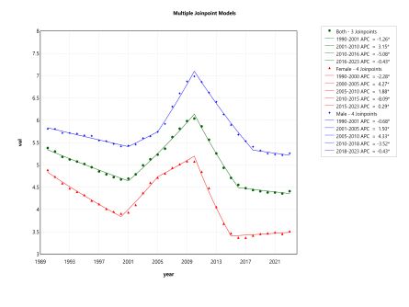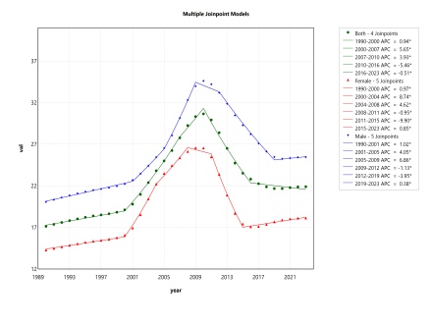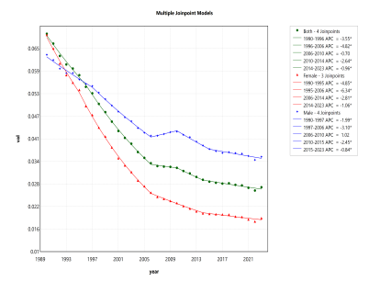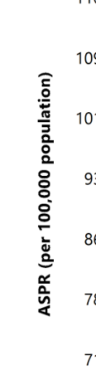
ASPR: age-standardized prevalence rate; ASMR: age-standardized mortality rate; ASDR: age-standardized disability-adjusted life years rate.

Supplementary Figure S2 Joinpoint regression analysis of the sex-specific trends in ASPR (per 100,000 population), ASMR (per 100,000 population), and ASDR (per 100,000 population) for thyroid disease from 1990 to 2023 in Japan.

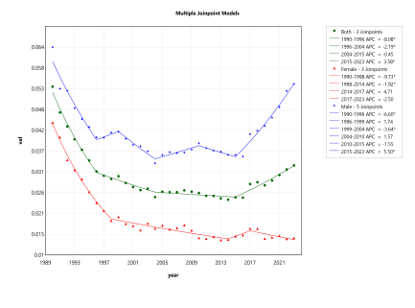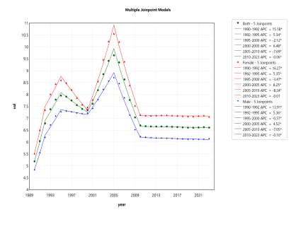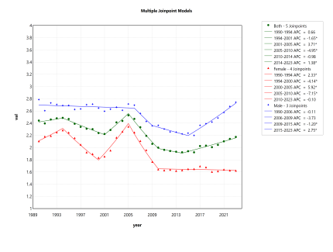

ASPR: age-standardized prevalence rate; ASMR: age-standardized mortality rate; ASDR: age-standardized disability-adjusted life years rate.

Supplementary Figure S3 Joinpoint regression analysis of the sex-specific trends in ASPR (per 100,000 population), ASMR (per 100,000 population), and ASDR (per 100,000 population) for thyroid disease from 1990 to 2023 in China.

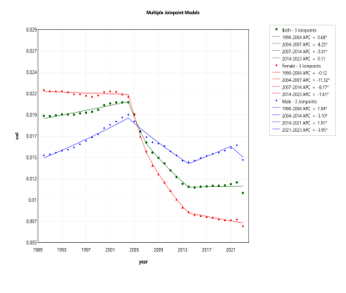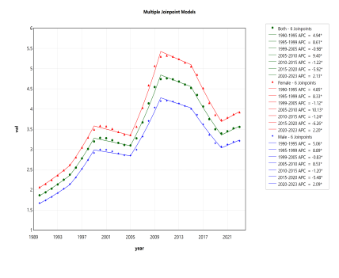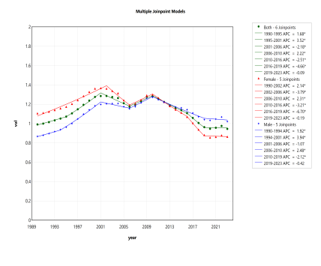
ASPR: age-standardized prevalence rate; ASMR: age-standardized mortality rate; ASDR: age-standardized disability-adjusted life years rate.

Supplementary Table S1 Decomposition analysis of CD burden in China, Japan, and the Republic of Korea

location | sex | cause | measure | Overll difference | Aging | Population | Epidemiological change
Republic of Korea | Male | Crohn's disease | Deaths | 1.68(14.5%) | 4.9  (42.35%) | 4.28  (37.03%) | -7.51  (-64.88%)
Republic of Korea | Female | Crohn's disease | Deaths | -2.8(-23.15%) | 8.13  (67.28%) | 4.01  (33.18%) | -14.94  (-123.61%)
Republic of Korea | Both | Crohn's disease | Deaths | -1.12(-4.74%) | 13.43  (56.76%) | 8.36  (35.35%) | -22.91  (-96.85%)
Republic of Korea | Male | Crohn's disease | DALYs (Disability-Adjusted Life Years) | 462.47(35.59%) | 78.77  (6.06%) | 509.56  (39.21%) | -125.85  (-9.68%)
Republic of Korea | Female | Crohn's disease | DALYs (Disability-Adjusted Life Years) | 154.93(14.93%) | 122.12  (11.77%) | 363.27  (35%) | -330.46  (-31.84%)
Republic of Korea | Both | Crohn's disease | DALYs (Disability-Adjusted Life Years) | 617.4(26.41%) | 194.04  (8.3%) | 870.84  (37.26%) | -447.48  (-19.14%)
Republic of Korea | Male | Crohn's disease | Prevalence | 3977.06(86.79%) | 303.65  (6.63%) | 2128.85  (46.46%) | 1544.56  (33.71%)
Republic of Korea | Female | Crohn's disease | Prevalence | 2891.56(88.8%) | 326.12  (10.01%) | 1450.22  (44.53%) | 1115.23  (34.25%)
Republic of Korea | Both | Crohn's disease | Prevalence | 6868.63(87.62%) | 560.43  (7.15%) | 3564.08  (45.47%) | 2744.13  (35.01%)
Japan | Male | Crohn's disease | Deaths | 30.03(74.73%) | 36.25  (90.2%) | 4.41  (10.97%) | -10.62  (-26.44%)
Japan | Female | Crohn's disease | Deaths | -5.27(-13.84%) | 45.05  (118.35%) | 4.16  (10.93%) | -54.48  (-143.13%)
Japan | Both | Crohn's disease | Deaths | 24.76(31.64%) | 80  (102.24%) | 8.71  (11.13%) | -63.95  (-81.72%)
Japan | Male | Crohn's disease | DALYs (Disability-Adjusted Life Years) | 603.36(32.53%) | 380.88  (20.54%) | 166.35  (8.97%) | 56.13  (3.03%)
Japan | Female | Crohn's disease | DALYs (Disability-Adjusted Life Years) | 46.22(2.93%) | 458.65  (29.11%) | 156.37  (9.93%) | -568.8  (-36.1%)
Japan | Both | Crohn's disease | DALYs (Disability-Adjusted Life Years) | 649.59(18.94%) | 812.91  (23.7%) | 327.81  (9.56%) | -491.13  (-14.32%)
Japan | Male | Crohn's disease | Prevalence | 1753.84(52.42%) | 214.27  (6.4%) | 320.4  (9.58%) | 1219.18  (36.44%)
Japan | Female | Crohn's disease | Prevalence | 2361.58(58.06%) | 225.71  (5.55%) | 480.06  (11.8%) | 1655.81  (40.71%)
Japan | Both | Crohn's disease | Prevalence | 4115.43(55.51%) | 470.9  (6.35%) | 794.79  (10.72%) | 2849.74  (38.44%)
China | Male | Crohn's disease | Deaths | 68.56(110.5%) | 40.56  (65.37%) | 27.68  (44.62%) | 0.31  (0.51%)
China | Female | Crohn's disease | Deaths | -15.22(-17.57%) | 56.76  (65.53%) | 29.63  (34.21%) | -101.61  (-117.31%)
China | Both | Crohn's disease | Deaths | 53.34(35.88%) | 99.73  (67.08%) | 57.59  (38.74%) | -103.97  (-69.94%)
China | Male | Crohn's disease | DALYs (Disability-Adjusted Life Years) | 4145.5(96.1%) | 707.69  (16.41%) | 1845.78  (42.79%) | 1592.02  (36.91%)
China | Female | Crohn's disease | DALYs (Disability-Adjusted Life Years) | 2203.98(42.85%) | 1105.14  (21.49%) | 2031.95  (39.51%) | -933.1  (-18.14%)
China | Both | Crohn's disease | DALYs (Disability-Adjusted Life Years) | 6349.48(67.14%) | 1822.18  (19.27%) | 3875.79  (40.99%) | 651.51  (6.89%)
China | Male | Crohn's disease | Prevalence | 18371.9(189.69%) | 1841.04  (19.01%) | 5301.4  (54.74%) | 11229.46  (115.95%)
China | Female | Crohn's disease | Prevalence | 22194.68(195.84%) | 2391.93  (21.11%) | 6735.82  (59.44%) | 13066.93  (115.3%)
China | Both | Crohn's disease | Prevalence | 40566.58(193.01%) | 4270.36  (20.32%) | 11992.49  (57.06%) | 24303.74  (115.63%)

Supplementary Figure S4 Age-specific numbers and rates (per 100,000 population) of mortality rate number due to CD by gender in 2023. (A) China; (B) Japan; (C) Republic of Korea.

CD: Crohn’s Disease; DALYs: disability-adjusted life years.

