Supporting information
Silk Fibroin-Regulated Biomimetic Mineralization of Ni(OH)₂ for Energy Storage Applications
Siva Kumar Ramesh,† Seog Woo Rhee, *,† and Jinkwon Kim*,†
† Department of Chemistry, Kongju National University, 56 Gongjudaehak-ro, Gongju-si, Chungnam-do 32588, Republic of Korea
*Corresponding author.
Tel.: +82-41-850-8496. Fax: +82-41-850-8613.
E-mail: Jinkwon Kim - jkim@kongju.ac.kr, Seog Woo Rhee - jisanrhee@kongju.ac.kr

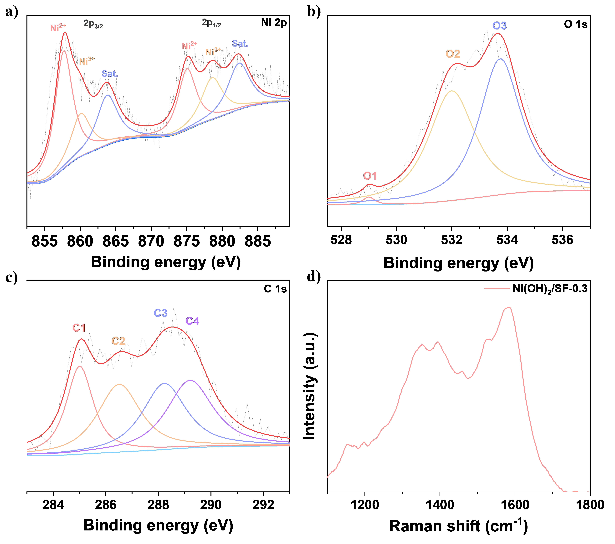
Fig. S1 High-resolution XPS spectra of (a) Ni 2p, (b) O 1s, (c) C 1s and (d) Raman spectra of Ni(OH)₂/SF-0.3.
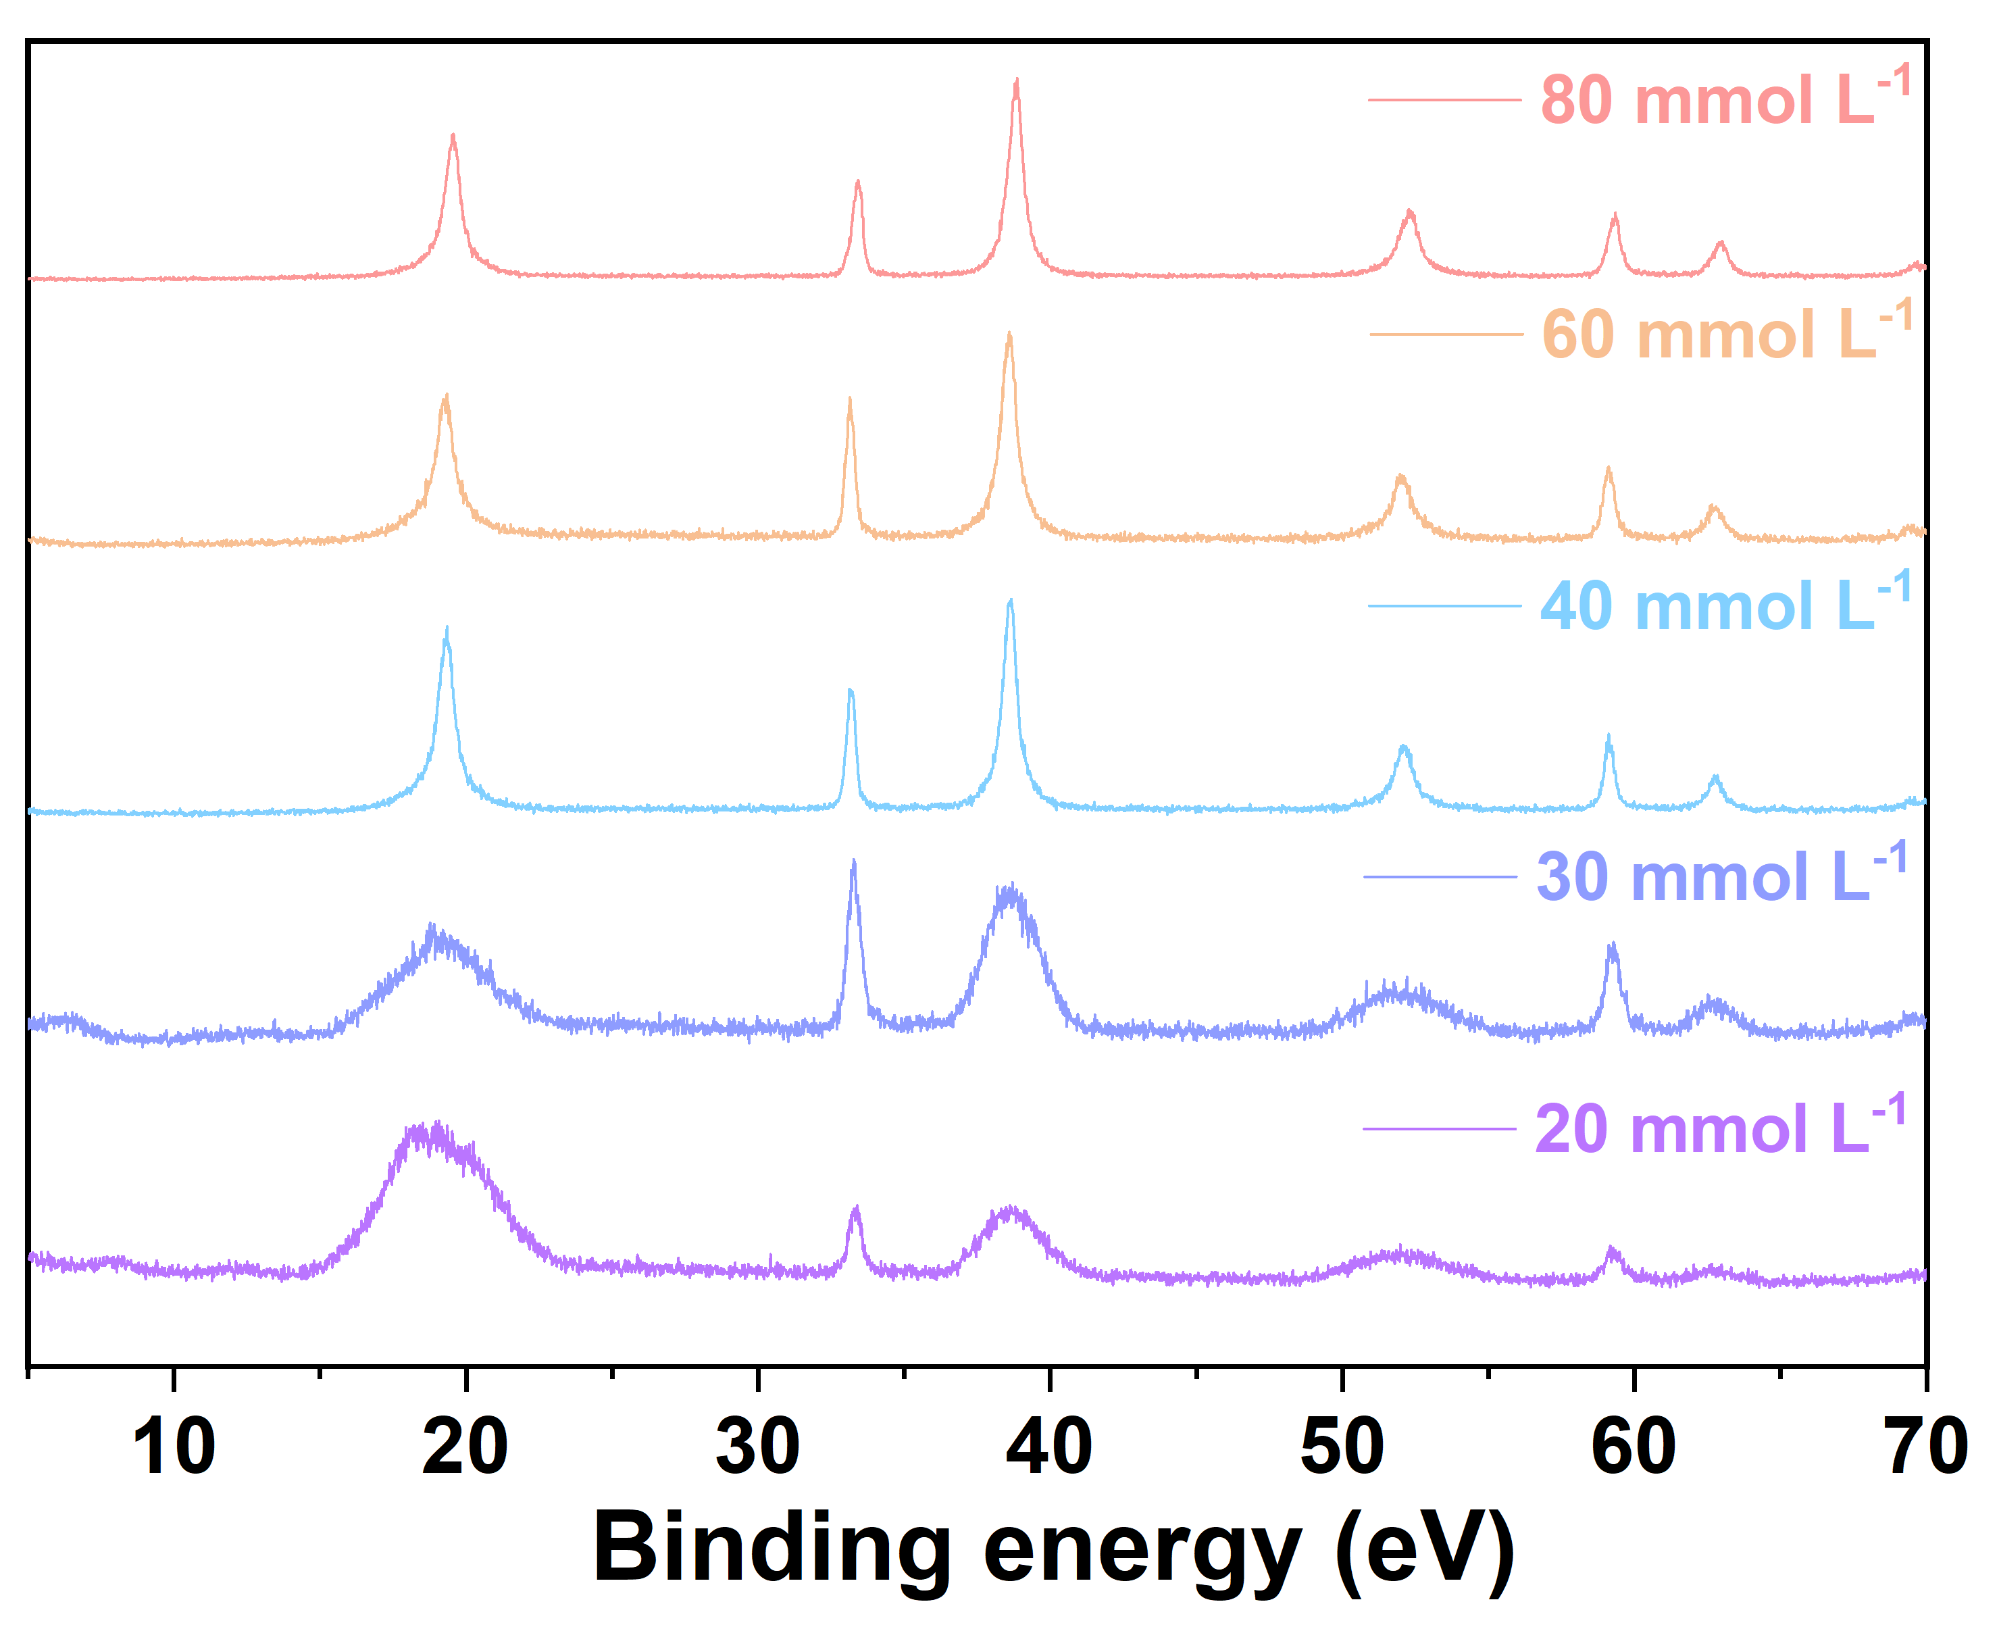
Fig. S2 XRD patterns of biomineralized Ni(OH)₂ using various Ni²⁺ concentrations with constant silk fibroin concentration (0.3% w/v).
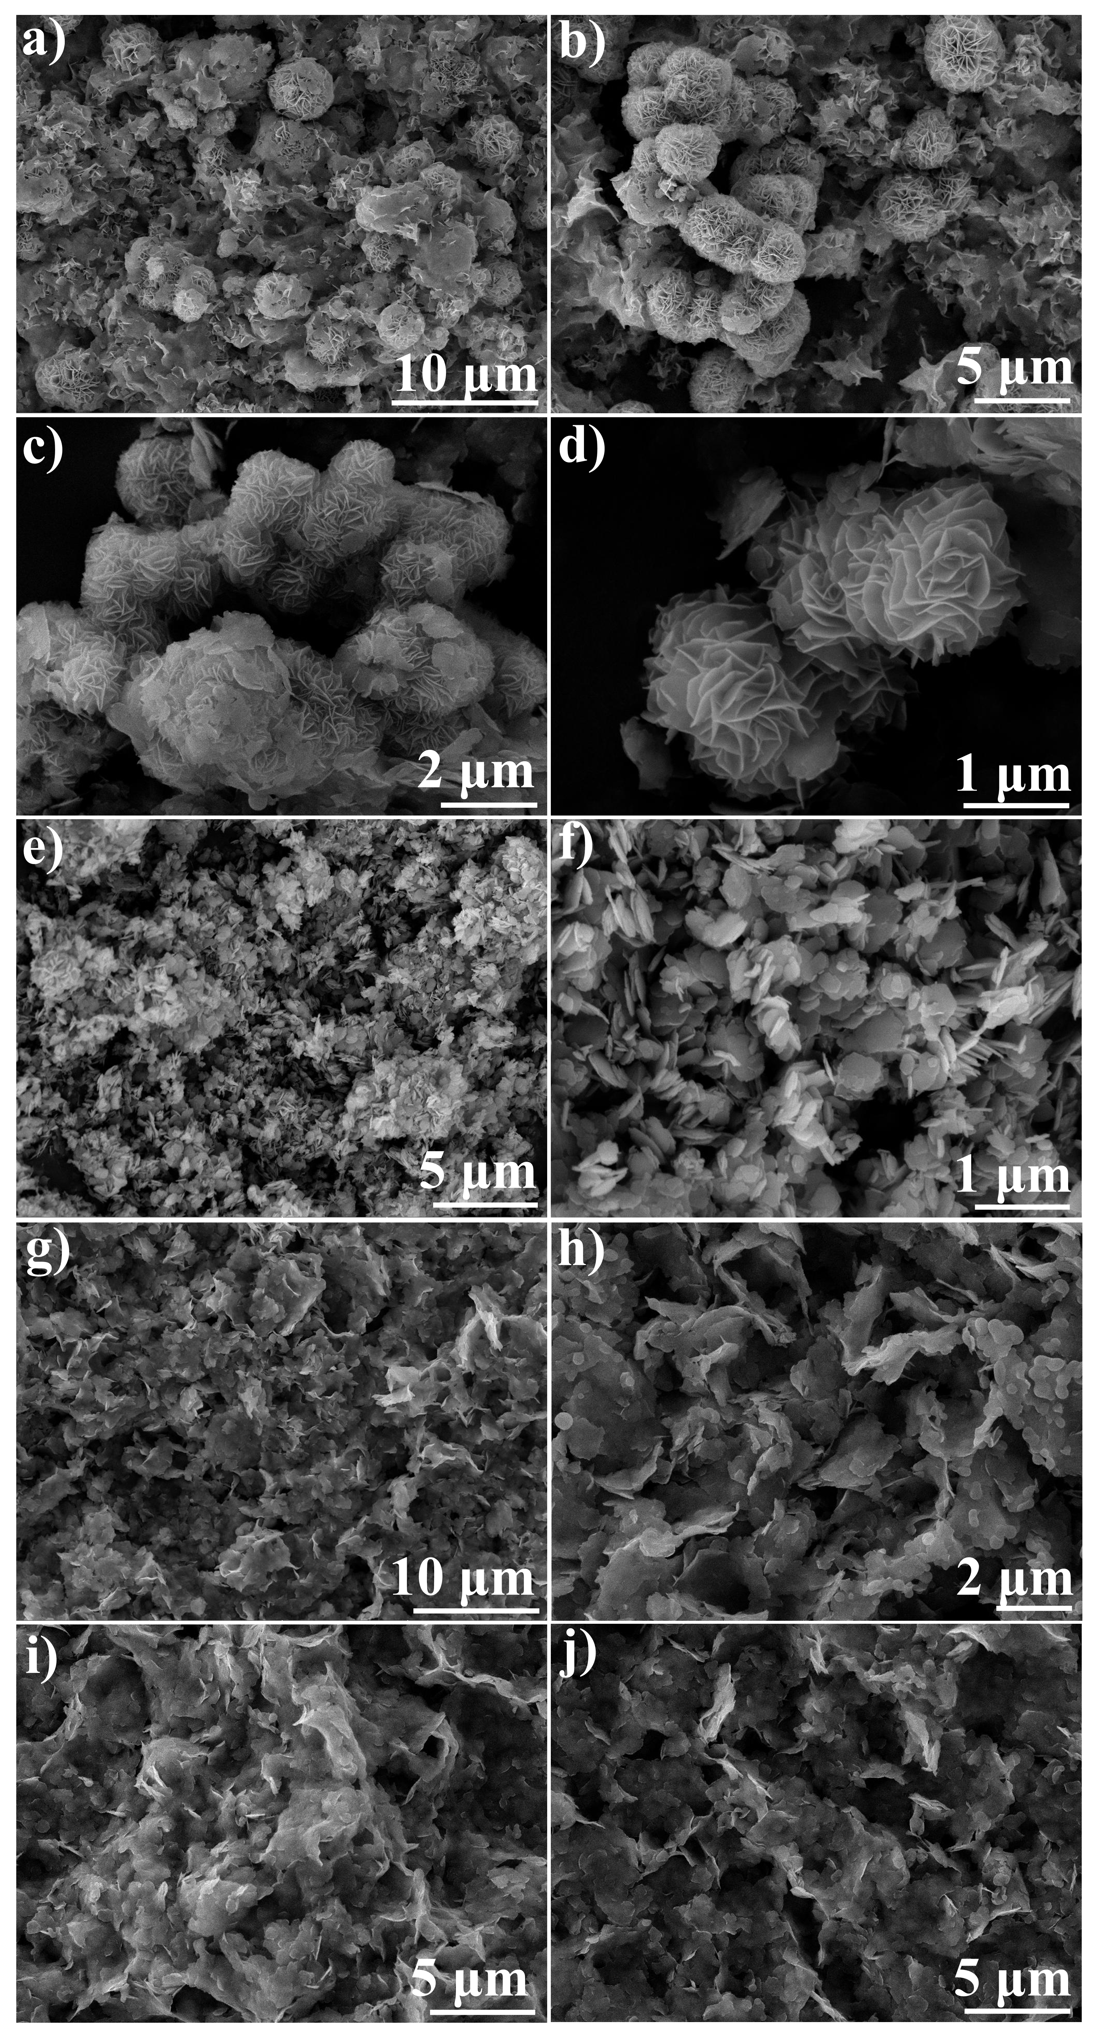
Fig. S3 SEM images of biomineralized Ni(OH)₂ using various nickel precusors (a,b) NiCl₂.6H₂O, (c,d) Ni(CH₃CO₂)₂.4H₂O, (e,f) Ni(NO₃).6H₂O, (g,h) NiSO₄⋅6H₂O, and (i,j) Ni(OCl₄)₂.6H₂O.
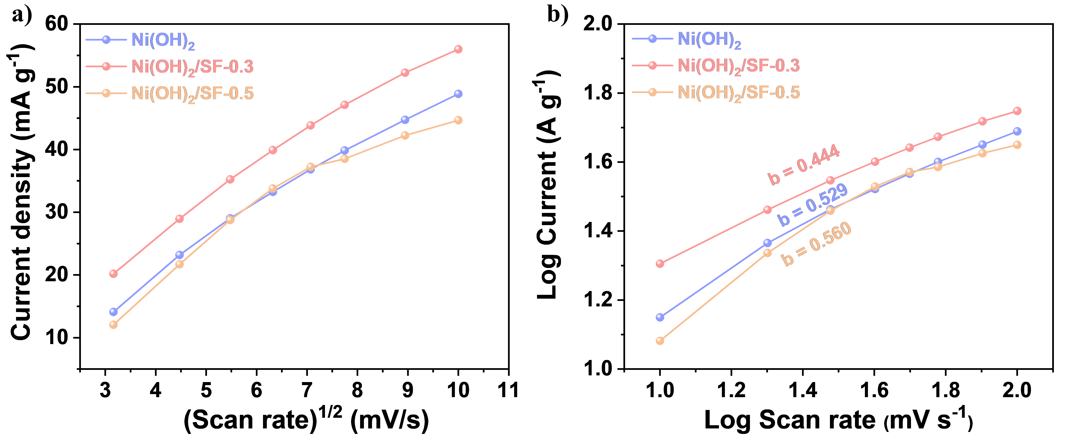
Fig. S4 (a) Plot of peak currents vs square root of scan rate, and (b) Plot of log current vs log scan rate obtained from CV curves of Ni(OH)₂, Ni(OH)₂/SF-0.3, and Ni(OH)₂/SF-0.5.

Table S1 Synthesis parameters under different conditions.
S.No | Ni precursors | Nickel ion concentration | Silk Fibroin concentration | Solvent
Effect of silk fibroin concentration
1 | NiCl₂.6H₂O | 60 mmol L⁻¹ | 0 | 50 ml DI water
2 | NiCl₂.6H₂O | 60 mmol L⁻¹ | 0.1% (w/v) | 50 ml DI water
3 | NiCl₂.6H₂O | 60 mmol L⁻¹ | 0.3% (w/v) | 50 ml DI water
4 | NiCl₂.6H₂O | 60 mmol L⁻¹ | 0.5% (w/v) | 50 ml DI water
Effect of Ni²⁺ ion concentration
5 | NiCl₂.6H₂O | 20 mmol L⁻¹ | 0.3% (w/v) | 50 ml DI water
6 | NiCl₂.6H₂O | 30 mmol L⁻¹ | 0.3% (w/v) | 50 ml DI water
7 | NiCl₂.6H₂O | 40 mmol L⁻¹ | 0.3% (w/v) | 50 ml DI water
8 | NiCl₂.6H₂O | 60 mmol L⁻¹ | 0.3% (w/v) | 50 ml DI water
9 | NiCl₂.6H₂O | 80 mmol L⁻¹ | 0.3% (w/v) | 50 ml DI water
Effect of organic solvents
10 | NiCl₂.6H₂O | 60 mmol L⁻¹ | 0.1% (w/v) | 20 ml Methanol,  30 ml DI water
11 | NiCl₂.6H₂O | 60 mmol L⁻¹ | 0.3% (w/v) | 20 ml Ethanol,  30 ml DI water
12 | NiCl₂.6H₂O | 60 mmol L⁻¹ | 0.5% (w/v) | 20 ml Ethanol,  30 ml DMF
Effect of nickel precursors
13 | NiCl₂.6H₂O | 60 mmol L⁻¹ | 0.3% (w/v) | 50 ml DI water
14 | Ni(NO₃).6H₂O, | 60 mmol L⁻¹ | 0.3% (w/v) | 50 ml DI water
15 | NiSO₄.7H₂O, | 60 mmol L⁻¹ | 0.3% (w/v) | 50 ml DI water
16 | Ni(OCl₄)₂.6H₂O | 60 mmol L⁻¹ | 0.3% (w/v) | 50 ml DI water
17 | Ni(CH₃CO₂)₂.4H₂O | 60 mmol L⁻¹ | 0.3% (w/v) | 50 ml DI water

Table S2 Specific capacity at different current densities ranging from 0.5 to 1 Ag⁻¹.
Specific capacity values (mAh g⁻¹)
Current (A g⁻¹) | Ni(OH)₂ | Ni(OH)₂/SF-0.3 | Ni(OH)₂/SF-0.5
0.5 | 157.5 | 170 | 127.5
1 | 135.55 | 168.33 | 88.33
2 | 120 | 144.44 | 64.44
3 | 105 | 131.66 | 51.66
5 | 91.66667 | 111.11 | 41.66
7 | 81.66 | 108.88 | 35
10 | 72.22 | 94.44 | 33.33

Table S3 Energy storage performances of Ni-based electrodes. The specific capacity (mAh g⁻¹) values with “~” are calculated from specific capacitance or specific capacity (F g⁻¹ or C g⁻¹).
S.No. | Electrode Material | Electrolyte | Current Density (Ag⁻¹) | Specific Capacity (mAh g⁻¹) | References
1 | Ni(OH)₂/SF-0.3 | 2 M KOH | 1 | 168.33 | This Work
2 | Ni(OH)₂@CoS/NF |  | 1 | 136.25 | 1
3 | ZnCo₂O₄@Ni(OH)₂ | 3 M KOH | 1 | ~141.8 | 2
4 | Ni(OH)₂-rGO composite-1  Ni(OH)₂-rGO composite-5  Ni(OH)₂-rGO composite-10 | 6 M KOH | 2 | 83.89  99.44  63.89 | 3
5 | NiO-CNT | 1 M KOH | 1 | 155 | 4
6 | NiCo₂O₄ | 3 M KOH | 1 | 112 | 5
7 | Ni_{0.7}Co_{0.2}Mn_{0.1}LDH-N  Ni_{0.7}Co_{0.2}Mn_{0.1}LDH-A  Ni_{0.7}Co_{0.2}Mn_{0.1}LDH-S | 6 M KOH | 1 | ~166.1  ~103.05  ~30.8 | 6
8 | Ni₃S₂ | 1 M KOH | 0.2 | 148 | 7
9 | CuO–NiO/CNT | 2 M KOH | 1 | ~80.73 | 8

REFERENCES
(1) Y. Yang, H. Zhu, H. Meng, W. Ma, C. Wang, F, Ma, Z. Hu, Nickel Foam-Supported Starfish-like Ni(OH)₂@CoS Nanostructure with Obvious Core–Shell Heterogeneous Interfaces for Hybrid Supercapacitors Application. J. Mater. Sci. 56 3280–3295 (2021). https://doi.org/10.1007/s10853-020-05407-7.
(2) X. Han, Y. Yang, J. J. Zhou, Q. Ma, K. Tao, L. Han, Metal–Organic Framework Templated 3D Hierarchical ZnCo₂O₄@Ni(OH)₂ Core–Shell Nanosheet Arrays for High-Performance Supercapacitors. Chem. Eur. J. 24 18106–18114 (2018). https://doi.org/10.1002/chem.201804327.
(3) B. Guo, Y. Gao, Y. Li, K. Liu, X. Lv, C. Mi, L. Liu, M. Li, M. Battery-Type-Behavior-Retention Ni(OH)₂-RGO Composite for an Ultrahigh-Specific-Capacity Asymmetric Electrochemical Capacitor Electrode. ACS Omega 8 6289–6301 (2023). https://doi.org/10.1021/acsomega.2c06207.
(4) X. Wang, M. Li, Y. Wang, B.Chen, Y. Zhu, Y. Wu, A Zn-NiO Rechargeable Battery with Long Lifespan and High Energy Density. J. Mater. Chem. A 3 8280–8283 (2015). https://doi.org/10.1039/c5ta01947h.
(5) J. Wang, Z. Jia, S. Li, Y. Wang, W. Guo, T. Qi, High-Performance Aqueous Rechargeable Batteries Based on Zinc Anode and NiCo₂O₄ Cathode. Bull. of Mater. Sci. 38 1435–1438 (2015). https://doi.org/10.1007/s12034-015-1033-6.
(6) M. Goyal, P. Dahiya, S. Kumar, T. K. Rahul; Mandal, Different Metal Precursor Based Rapid Synthesis of α-Ni(OH)₂-Type Ni-Co-Mn Layered Double Hydroxides and Its Use as Electrodes for High Performance Energy Storage Devices. J. Energy Storage 72 108622 (2023). https://doi.org/10.1016/j.est.2023.108622.
(7) P. Hu, T. Wang, J. Zhao, C. Zhang, J. Ma, H. Du, X. Wang, G. Cui, Ultrafast Alkaline Ni/Zn Battery Based on Ni-Foam-Supported Ni₃S₂ Nanosheets. ACS Appl. Mater. Interfaces 7 26396–26399 (2015). https://doi.org/10.1021/acsami.5b09728.
(8) S. Veeman, S. Karuppuchamy, H₂O₂ Assisted Hydrothermal and Microwave Synthesis of CuO–NiO Hybrid MWCNT Composite Electrode Materials for Supercapacitor Applications. Ceram. Int. 48 26806–26817 (2022). https://doi.org/10.1016/j.ceramint.2022.05.380.

