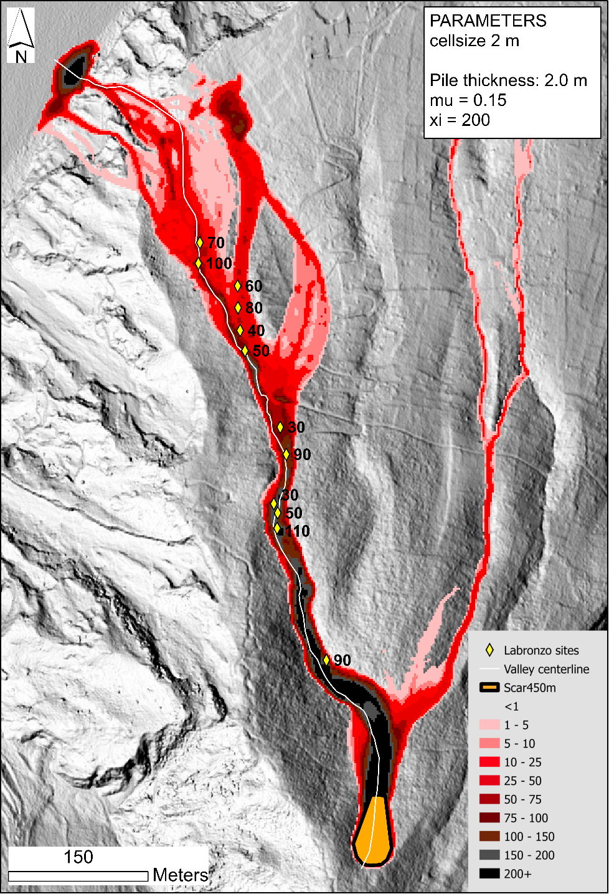
Supplementary Figure S1: Maximum flow thickness (in cm) for a simulation with µ = 0.15 and ξ = 200 m/s² (like Figure 7a), but with an initial pile thickness of 2 m (hence a volume of 4500 m³). The inundation area is similar but the flow is too thick in proximal areas, making this simulation unrealistic.

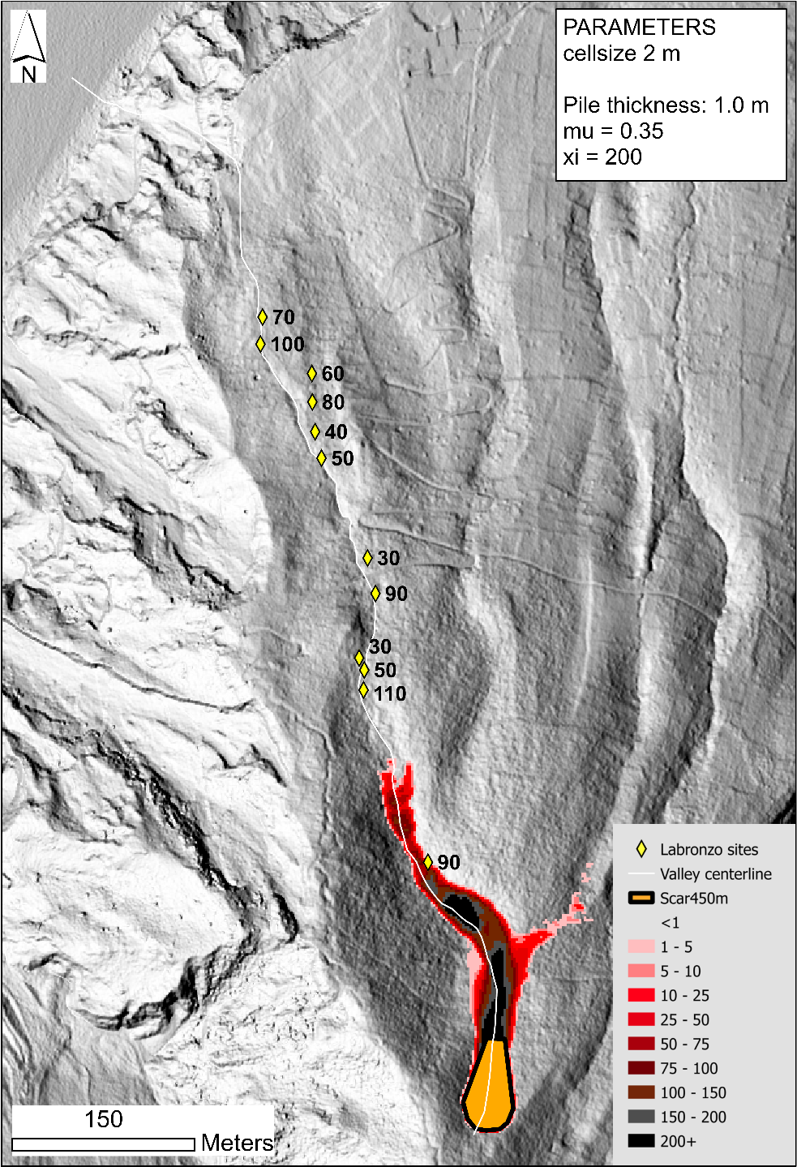
Supplementary Figure S2: Maximum flow thickness (in cm) for a simulation with an initial pile thickness of 1 m and ξ = 200 m/s² (like Figure 7a), but with µ = 0.35. This basal friction is too high and material accumulates uphill. The flow stops too early, never reaching the second most proximal outcrop LB10.

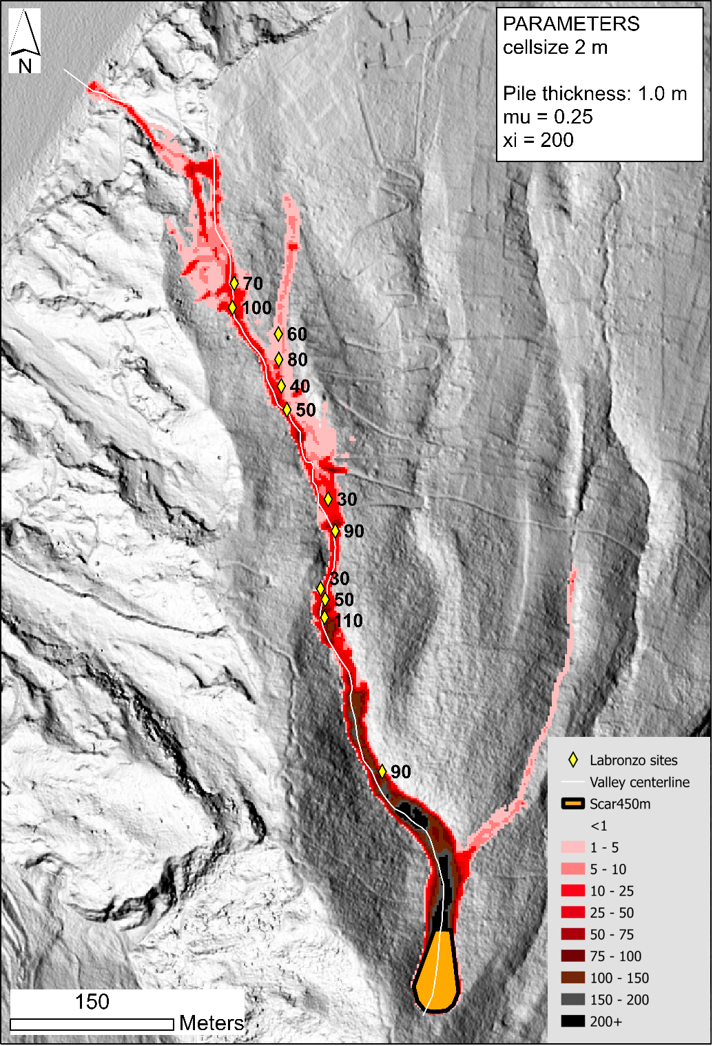
Supplementary Figure S3: Maximum flow thickness (in cm) for a simulation with an initial pile thickness of 1 m and ξ = 200 m/s² (like Figure 7a), but with µ = 0.25. Like Figure S2, this basal friction is too high. Material flows down to distal extents, but the flow generated is too thin, making this rheology unrealistic.

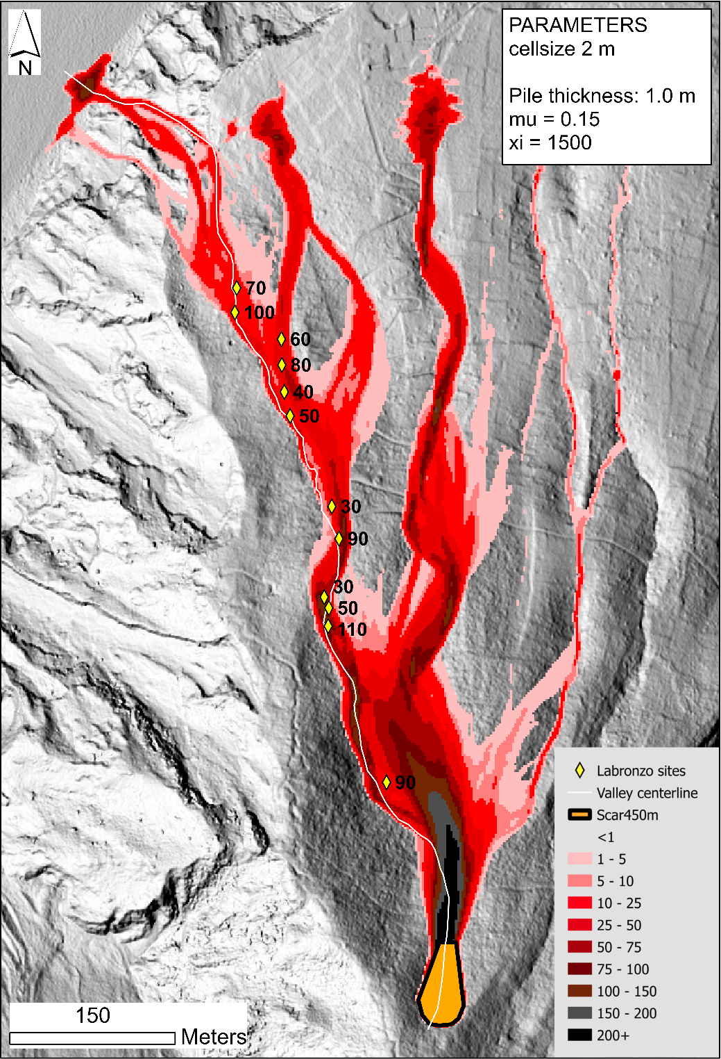
Supplementary Figure S4: Maximum flow thickness (in cm) for a simulation with an initial pile thickness of 1 m and µ = 0.15 (like Figure 7a), but with ξ = 1500 m/s². Despite relatively good matches between the simulation and the deposits, this turbulent dissipation parameter makes the flow extremely turbulent and creates significant overbanking. Consequently, most of the current flows into a basin where no deposits were found. We therefore think that the turbulent dissipation parameter was lower and allowed a better confinement into the valley.

