Materials and methods
Patients enrollment and synovial tissue preparation
All RA patients were selected under the criteria of the American College of Rheumatology (ACR) [1]. Patients diagnosed with trauma who were having soft tissue injuries such as ligament during exercise were treated as normal control. The Institutional of Ethics Committee of the Shanghai Changhai Hospital reviewed and approved the study. All volunteers gave their written informed consent before participation.
Cell isolation and culture
Purified FLS were isolated from synovial tissue of RA and Trauma group patients by enzymatic digestion [2]. In brief, mixed synovial cells were obtained from the small pieces of synovial tissue, followed by digestion of Pancreatic enzyme and Collagenase II. The cells were cultured in DMEM/F12 medium supplemented with 100 U/mL penicillin, 10% fetal bovine serum, and 100 μg/mL streptomycin (fetal bovine serum; Gibco, USA) at 37°C, 5% CO2 humidified incubator. After that, they were harvested for experiments at 4-6 passages.
Cell Infection
Cells were plated into a 6-well plate at a density of 1 × 10⁶/well and incubated for 24 hours. Then, a fresh medium containing lentivirus and 8 μg/mL polyamine (Heyuan, Shanghai, China) were added. The amount of lentivirus added was calculated based on the required multiplicity of infection (MOI) which was determined by preliminary experiments that the best MOI of overexpression-Dvl3 lentivirus (Lv-Dvl3) and control lentivirus (Lv-ctr) was 40. The medium was changed within 24 hours after infection, and 1‰ puromycin (Sigma, St. Louis, MO, USA) was added to the complete medium to kill the WT RA-FLSs. RT-PCR and WB methods were used to determine infection efficiency.
Exosome extraction
RA-FLS was seed into a 10 cm dish. When the cell density reaches 80%, wash the cells twice with PBS and replaced supernatant with serum-free DMEM medium for incubation for another 48h. Collected the supernatant in a centrifuge tube, centrifuged at 2000g for 15min at 4°C, and was filtered into the centrifuge tube through a 0.22um microporous membrane to remove the cell pellets followed by centrifuged at 100000g for 70 min at 4°C. The supernatant was discarded, and the pellet was resuspended in 1-2ml PBS which was centrifuged again at 100000g for 70 min, and the pellet was resuspended with 100ulPBS for later use.
Exosome intervention
RA-FLS was seed into a 12-well plate for 24 hours, followed by administration of exosomes obtained in 1ml fresh medium to each well for incubation for another 24h.
According to the instructions, PKH67 Green Fluorescent Cell Linker Mini Kit has been used to monitor the uptake of exosomes by FLS cells.
Immunohistochemical
Synovial tissue was fixed in 4% paraformaldehyde (PFA) for 48 hours and then analyzed by immunohistochemistry using the previously described[3] protocol. Dvl3 positive cells were counted under a 20×10 microscope and evaluated. The scores were analyzed according to the standards of previous studies (0 = 0-9%, 1 = 10-24%, 2 = 25-49%, 3 = 50-74%, 4 = 75-100%)[4].
The knee joint was fixed in 10% phosphate buffered formalin for 24 hours and decalcified in 14% EDTA-glycerol for 30 days at 37°C followed by embedded in paraffin. H&E and safranin O-fast green staining were performed to examine synovitis and cartilage destruction. The severity of the lesion is evaluated according to published standards [53,54].
Immunocytofluorescence staining
For immunocytofluorescence analysis, FLS on coverslips were washed by PBS and fixed with 4% PFA for 20 min, followed by permeabilization with 0.4% Triton X-100 and blocking the non-specific binding with 10% normal goat serum in 0.1 M PBS. Cells were incubated with corresponding primary and second antibodies and counter stained with Hoechst33342 (sigma). Fluorescence images were captured by fluorescence (DXM1200, Nikon), and quantified with image-pro Plus (media cybernetics). The following antibodies were used: Anti-Vimentin antibody (Abcam), anti-Dvl3 antibody (Abcam), anti-CD68 antibody (sigma). After washing, second antibodies (Jackson immune Research laboratories, Inc.)
Western blot analysis
Western blot was performed by standard protocol with proper antibodies. Briefly, Proteins from infected RA-FLSs or tissues were extracted using NP40lysis buffer, separated by SDS-PAGE, and electrotransferred to PVDF membranes. Membranes were blocked with 5% non-fat milk in 1×TBST and then incubated overnight with primary antibodies as previously described. Anti-GAPDH (Sigma) was also incubated as control. After incubated with HRP-conjugated secondary antibodies, immunoreactive bands were visualized by chemiluminescence reagents (BIORAD).
Cell viability assay
Cell Count Kit-8 (Dojindo, Kumamoto, Japan) was used to detect the effect of Lv-Dvl3 exosomes on cell viability. The exosomes treated RA-FLSs were incubated in 96-well plates (8 × 103 cells/well) for 24 hours with 10 ng/mL TNF-α. Rinse the cells with PBS, add 10μL of CCK-8 solution, 90μL of DMEM/well. After incubation for 12h or 24h at 37°C, the absorbance of the culture supernatant was measured at a wavelength of 450 nm with a spectrophotometer.
TUNEL assay
apoptosis in situ was detected by specific labeling of nuclear DNA fragmentation (TUNEL) using the In Situ Cell Death Detection Kit (Roche) according to the manufacturer's protocol. Briefly, cells or tissues prepared as described for immunocytofluorescence were immersed and incubated in a TUNEL reaction mixture at 37℃ for 60 min. Quantification of cell apoptosis was accomplished by counting the percentage of TUNEL positive cells of total cells under a fluorescence microscope.
Real-time RT-PCR
For RT-PCR, total RNA was extracted from synovial tissue and FLSs using Trizol RNA isolation reagent (Invitrogen) according to the manufacturer's protocol. RNA from each sample was incubated with reverse transcriptase according to the manufacturer's protocol using random hexamer primers to synthesis cDNA. Real-time PCR was performed by IQ5 sequence detection systems (bio rad). Expression of GAPDH in cDNA samples was used as control. The 2−ΔΔCt method was used for the quantification of the relative mRNA expression levels. The following primers used for real-time RT-PCR were shown in Table 1:
Table 1. Primers used in RT-PCR for dictation of indicated gene
Gene |  | Sequence (5’-3’)
Dvl3 | Forward primer | ACCTTGGCGGACTTTAAGGG
Dvl3 | Reverse primer | AGCTTGGCATTGTCATCCGA
IL-1β | Forward primer | AGCCATGGCAGAAGTACCTG
IL-1β | Reverse primer | TGAAGCCCTTGCTGTAGTGG
IL-6 | Forward primer | GTCCAGTTGCCTTCTCCC
IL-6 | Reverse primer | GCCTCTTTGCTGCTTTCA
IL-8 | Forward primer | AGCCTTCCTGATTTCTGC
IL-8 | Reverse primer | AATTCTCAGCCCTCTTCA
IL-17 | Forward primer | TAATGGCCCTGAGGAATGGC
IL-17 | Reverse primer | AGGAAGCCTGAGTCTAGGGG
IL-21 | Forward primer | CTGTCCTCTAGAACACACGGA
IL-21 | Reverse primer | CTGTCCTCTAGAACACACGGA
TNF-α | Forward primer | CACAGTGAAGTGCTGGCAAC
TNF-α | Reverse primer | AGGAAGGCCTAAGGTCCACT
VEGF | Forward primer | ACGAAAGCGCAAGAAATCCC
VEGF | Reverse primer | GGAGGCTCCAGGGCATTAGA
PI3K | Forward primer | CTTACCAAGAATGGCTCG
PI3K | Reverse primer | TTTACCCACGCTACAGGA
AKT | Forward primer | GCCGACGTGGCTATTGTGA
AKT | Reverse primer | GCCGACGTGGCTATTGTGA
MMP-3 | Forward primer | TGAGGACACCAGCATGAACC
MMP-3 | Reverse primer | TGAGGACACCAGCATGAACC
MMP-9 | Forward primer | GTGCTGGGCTGCTGCTTTGCTG
MMP-9 | Reverse primer | GTGCTGGGCTGCTGCTTTGCTG
MMP-13 | Forward primer | CATGAGTTCGGCCACTCCTT
MMP-13 | Reverse primer | CCTCGGAGACTGGTAATGGC
GAPDH | Forward primer | ACAACTTTGGTATCGTGGAAGG
GAPDH | Reverse primer | GCCATCACGCCACAGTTTC
ELISA assay
The supernatant of exosomes treated RA-FLSs was cultured for 24h in the presence of 10ng/mL TNF-α (Propotec, USA), and then the levels of TNF-α, IL-1β, IL-17, and IL-21 were detected by ELISA kit. CIA mouse serum was tested by the Multi-Analyte flow analysis kit (Biolegend, USA).
Cell migration and invasion
According to the previous report[5], the wound healing process was analyzed by phase contrast microscope (Leitz, German) at 0 and 24 hours. cell migration was calculated based on the healing area at different time points with image J.
According to previous research, Transwell cell migration test was performed by using Transwell invasion chamber (Corning, USA) in a 24-well plate. the number of RA-FLSs in 5 randomly selected fields in each well was counted. The cell migration rate is the average number of invading cells compared to the Lv-ctr exosomes group.
Transwell cell invasion test was used to detect the invasion ability of RA-FLSs. After embedded with matrix gel the chamber was placed into a cell incubator until the gel is fully solidified. The following steps are the same as in the Transwell migration experiment.
Induction and evaluation of CIA
8-week-old DBA/1 male mice were purchased from Shanghai Laboratory Animal Center (China) and maintained at 21°C under a 12 h light/dark cyclesubcutaneous. All animal operations and handling have been approved by the Animal Care and Use Committee of Changhai Hospital. The CIA mouse model was prepared according to the described methods[6].
Clinical arthritis and the mechanical withdraw threshold (MWT) were observed and tested the day after the second immunization according to the arthritis score[6] and the reported method[7], and each evaluation was repeated every four days.
Double luciferin reporter gene assay
Ra-FLS transfected 48 hours after the plasmid was discarded as supernatant, and washed 2-3 times with PBS. Add 200μl cell lysate to each well and vibrate at room temperature for 20min. Sample was assessed according to pervious reported [8].
Statistical Analysis
All of the data are from at least three independent experiments and presented as the mean standard error. Statistical analyses were made using ANOVA or Student’s t-test. All significant differences were considered at P<0.05.
Reference
1. Aletaha, D., et al., 2010 Rheumatoid arthritis classification criteria: an American College of Rheumatology/European League Against Rheumatism collaborative initiative. Arthritis Rheum, 2010. 62(9): p. 2569-81.
2. Liang, J.J., et al., ZNRF3 Regulates Collagen-Induced Arthritis Through NF-kB and Wnt Pathways. Inflammation, 2020. 43(3): p. 1077-1087.
3. Kato, Y., et al., Establishment of an Anticetacean Podoplanin Monoclonal Antibody PMab-237 for Immunohistochemical Analysis. Monoclon Antib Immunodiagn Immunother, 2019. 38(3): p. 108-113.
4. Liu, X.Z., et al., Dishevelled2 promotes apoptosis and inhibits inflammatory cytokine secretion in rheumatoid arthritis fibroblast-like synoviocytes through crosstalk with the NF-κB pathway. Oncotarget, 2017. 8(8): p. 12649-12663.
5. Li, G., et al., SIRT1 inhibits rheumatoid arthritis fibroblast-like synoviocyte aggressiveness and inflammatory response via suppressing NF-κB pathway. Biosci Rep, 2018. 38(3).
6. Brand, D.D., K.A. Latham, and E.F. Rosloniec, Collagen-induced arthritis. Nat Protoc, 2007. 2(5): p. 1269-75.
7. Zhang, X., et al., MicroRNA-144 relieves chronic constriction injury-induced neuropathic pain via targeting RASA1. Biotechnol Appl Biochem, 2020. 67(2): p. 294-302.
8. Liu, B., et al., MicroRNA-188 aggravates contrast-induced apoptosis by targeting SRSF7 in novel isotonic contrast-induced acute kidney injury rat models and renal tubular epithelial cells. Ann Transl Med, 2019. 7(16): p. 378.

Supplement figure
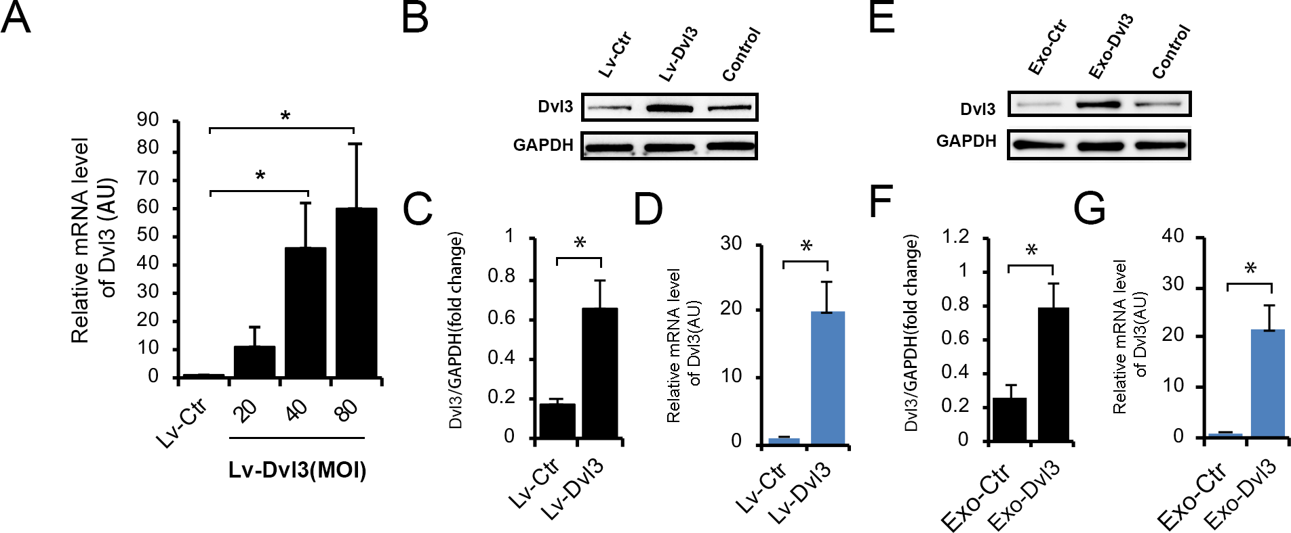
S fig.1 Exosomes extracted from RA-FLS which was infected by lentivirus successfully altered the expression level of Dvl3 in target RA-FLS. (A) After exploration, the MOI of lentivirus transfection was determined at 40. (B, C) The protein level of Dvl3 in the RA-FLS transfected by indicated lentivirus was determined by WB. (D) The mRNA level of Dvl3 in exosome harvested from indicated group of RA-FLS supernatant was detected by RT-PCR. (E-G) The protein and mRNA level of Dvl3 in the target RA-FLS treated by indicated exosomes. Values are shown as mean ± SD (n=6). *P <0.05.
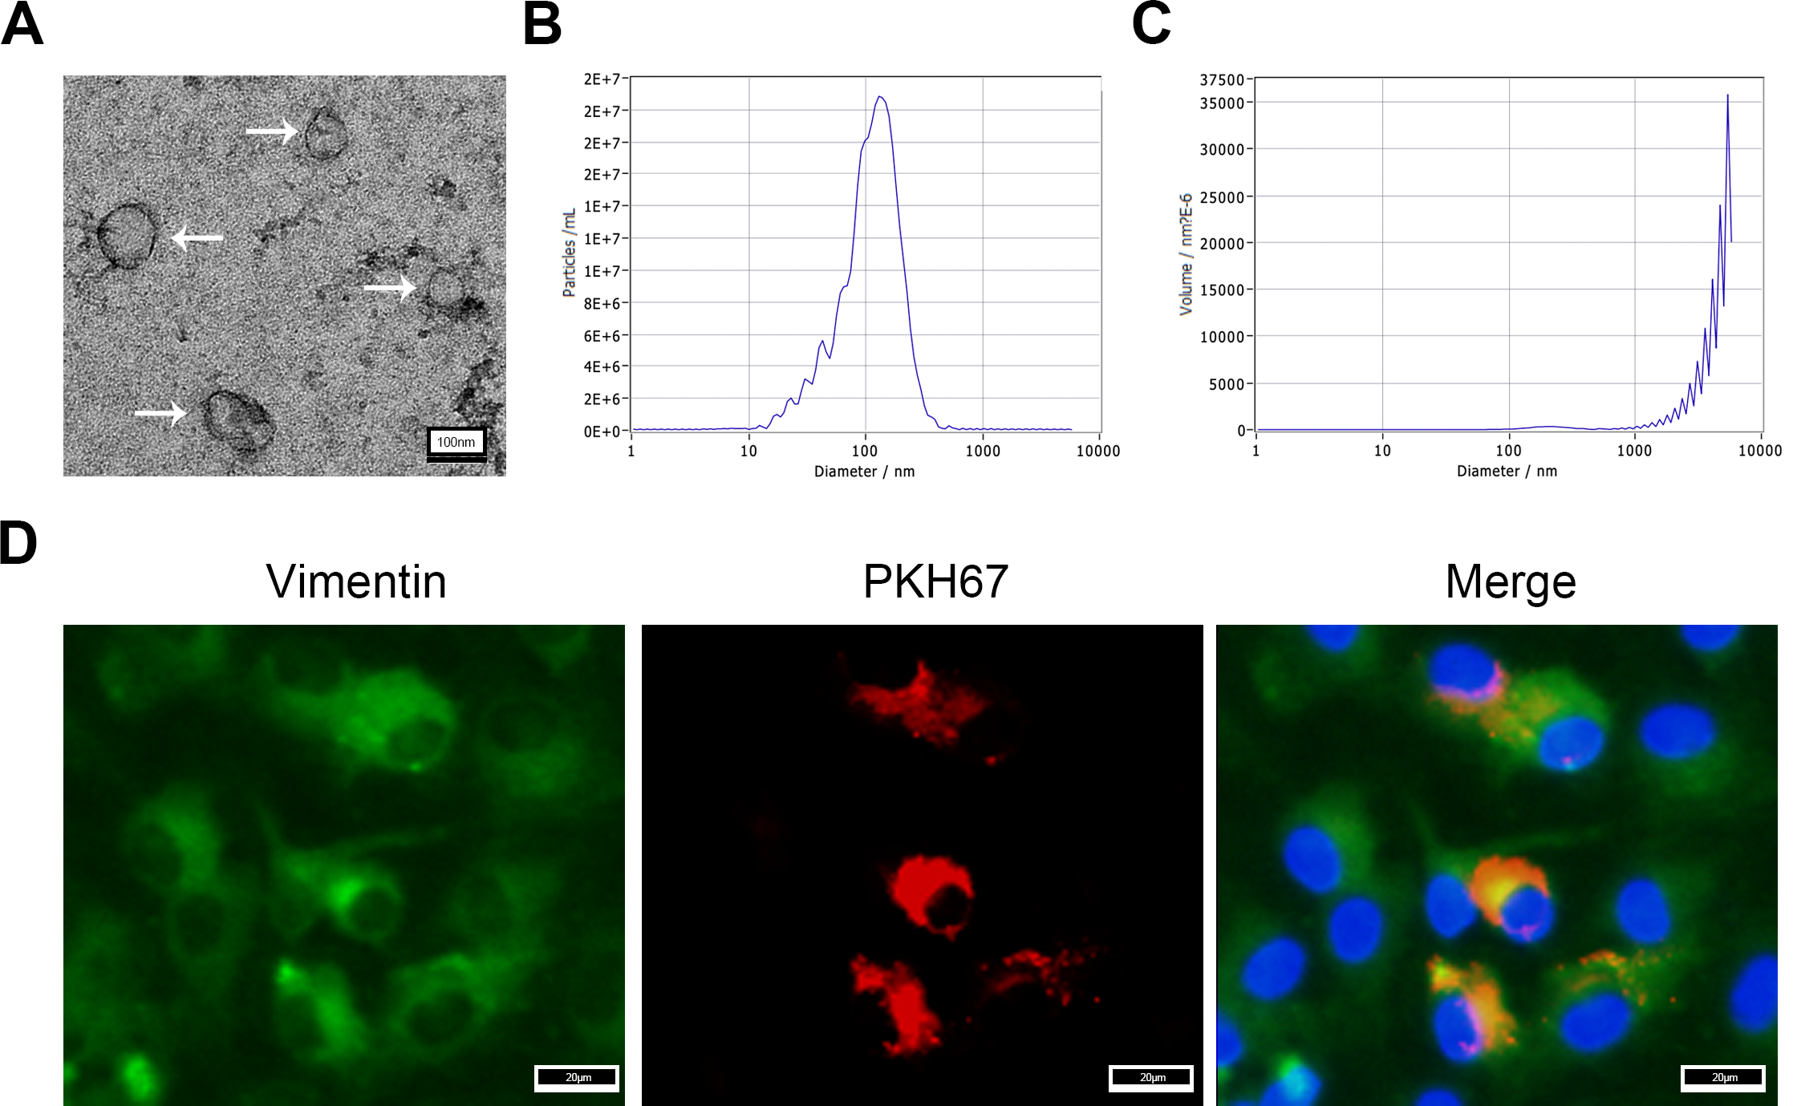
S fig.2 Exosomes harvested from supernatant of RA-FLS was uptake by target RA-FLS. (A) Exosomes extracted from the supernatant of RA-FLS were shown as round or concave spherical vesicles (arrow indicated) under electron microscopy; Scale bar, 20nm. (B, C) The particle size analysis results of extracted exosomes. (D) The exosomes were uptake by RA-FLS were observed under microscopy by PKH67 staining; Scale bar, 20μm.
S fig.3 Exosomes derived from FLS with high Dvl3 expression successfully altered the expression level of Dvl3 in synovium of CIA mice. (A, B) The protein level of Dvl3 in the synovium tissues of CIA mice intervened by indicated exosomes was determined by WB. (C) The mRNA level of Dvl3 in synovium tissues of CIA mice from indicated group was detected by RT-PCR. Values are shown as mean ± SD (n=6). *P <0.05.
S fig.4 Plasmid of Dvl3 overexpression successfully up-regulated the expression level of Dvl3 in target RA-FLS. (A, B) The protein level of Dvl3 in the RA-FLS transfected by Dvl3-OE or Ctrl plasmid was determined by WB. (C) The mRNA level of Dvl3 in RA-FLS from indicated group was detected by RT-PCR. Values are shown as mean ± SD (n=6). *P <0.05; **P <0.01.

