Supplementary information
Defect-engineered chiral bubble domains and topological Hall effect in the Kagome ferromagnet Co_{3+x}Sn_{2-x}S₂

Dilanath Adhikari^{1, *}, Chanyoung Lee^{2, *}, Yusuff Adeyemi Salawu¹, Jinyoung Yun², Yeonkyu Lee², Jun Zhou^{3,4}, Yuwaraj K. Kshetri^{5, 6}, Geunsik Lee⁷, Jeehoon Kim^{2†}, Heon-Jung Kim^{1, 8, †}

1Department of Physics, Graduate School, Daegu University, Gyeongbuk 38453, Republic of Korea
2Department of Physics, Pohang University of Science and Technology, Pohang 37673, Republic of Korea
3Future Energy Acceleration & Translation (FEAT), Strategic Research & Translational Thrust (SRTT), A*STAR Research Entities, 1 Fusionopolis Way #20-10 Connexis North Tower, Singapore 138632, Republic of Singapore
4Institute of Materials Research and Engineering (IMRE), Agency for Science, Technology and Research (A*STAR), 2 Fusionopolis Way, Innovis #08-03, Singapore 138634, Republic of Singapore
5Research Center for Green Advanced Materials, Sun Moon University, Chungnam 31460, Republic of Korea
6Department of Semiconductor Materials Engineering, Sun Moon University, Chungnam 31460, Republic of Korea
7Department of Chemistry, College of Natural Science, Ulsan National Institute of Science and Technology, Ulsan 44919, Republic of Korea
8Department of Materials-Energy Science and Engineering, College of Engineering, Daegu University, Gyeongbuk 38453, Republic of Korea.

† jeehoon@postech.ac.kr and hjkim76@daegu.ac.kr
* equal contributions
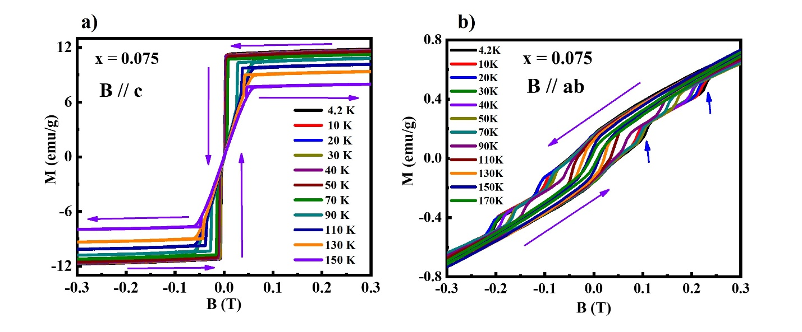
Supplementary Figure 1 Low field M-H loop for Co_{3+x}Sn_{2-x}S₂ x = 0.075. a) and b) M-H loop for B//c and B//ab, respectively, at various temperatures below T_{c} with in ± 0.3 T. The violet arrow shows the magnetic field (B) sweeping direction. The blue arrow in b) shows the metamagnetic-like transition below 110 K.

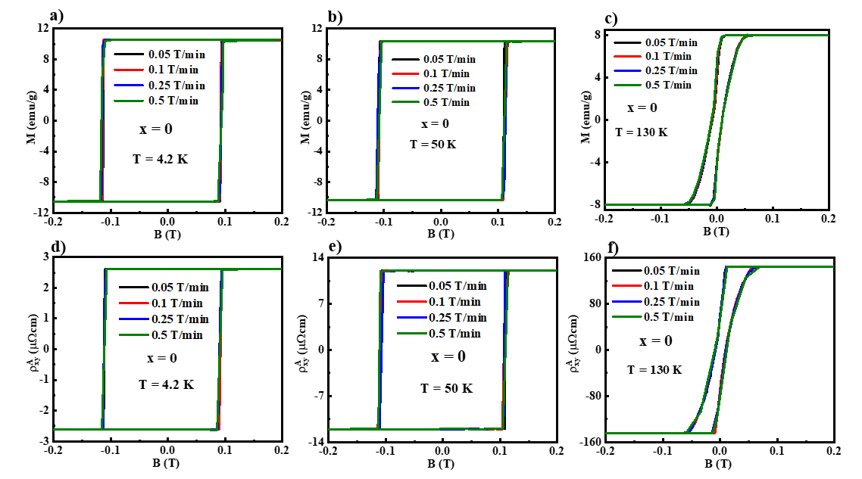
Supplementary Figure 2 Field ramp rate-dependent M-H and Hall measurement for the x = 0 sample. a)-c) M-H loops at 4.2, 50, and 130 K, respectively, when ramp rates of 0.05 T/min (black), 0.1 T/min (red), 0.25 T/min (blue), and 0.5 T/min (green) were applied. d)-f) Corresponding Hall resistivity.

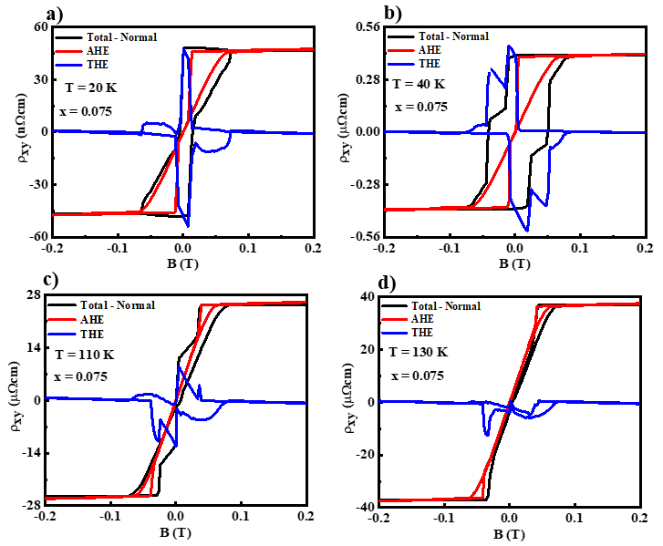
Supplementary Figure 3 Extraction of topological Hall effect (THE) for the x = 0.075 sample. a)-d) Extraction of THE for 20, 40, 110, and 130 K, respectively. The black is the corrected Hall resistivity after subtraction of the linear ordinary Hall resistivity from the total Hall resistivity. The red is the anomalous Hall resistivity (AHE) estimated from magnetization (M), assuming AHE is proportional to M. And blue is the extracted THE where the AHE is subtracted from the corrected Hall resistivity.

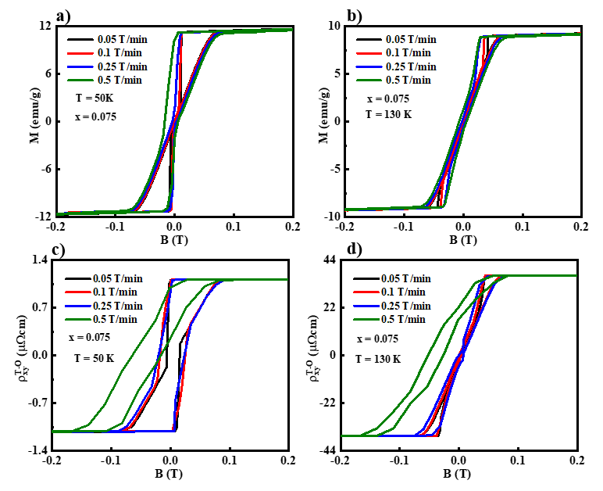
Supplementary Figure 4 Field ramp rate-dependent M-H and Hall measurement for the x = 0.075 sample. a) and b) M-H loops at 50 and 130 K, respectively, when ramp rates of 0.05 T/min (black), 0.1 T/min (red), 0.25 T/min (blue), and 0.5 T/min (green) were applied. c) and d) Corresponding Hall resistivity.

