Supporting Information for:
Turn-key super-resolution mapping of cell receptor force orientation and magnitude using a commercial structured illumination microscope

Aaron Blanchard¹, Dale J. Combs², Joshua M. Brockman¹, Anna V. Kellner¹, Roxanne Glazier¹, Hanquan Su², Rachel L. Bender², Alisina Bazrafshan², Wenchun Chen^{3,4}, M. Edward Quach^{3,4}, Renhao Li^{3,4}, Alexa L. Mattheyses⁵, & Khalid Salaita^{1,2}

¹Wallace H. Coulter Department of Biomedical Engineering, Georgia Institute of Technology and Emory University, Atlanta, Georgia 30322, USA
²Department of Chemistry, Emory University, 1515 Dickey Drive, Atlanta, Georgia 30322, USA
³Aflac Cancer and Blood Disorders Center, Children's Healthcare of Atlanta,
⁴Department of Pediatrics, Emory University School of Medicine
⁵Department of Cell, Developmental, and Integrative Biology, University of Alabama at Birmingham, Birmingham, Alabama, 35294, USA
*Address correspondence to: k.salaita@emory.edu

Contents

I. Materials and Methods 3
Materials 3
Preparation of supported lipid bilayer (SLB) functionalized microparticles. 3
Isolation and handling of platelets 3
Culture and handling of 3T3 fibroblast cells 3
Surface preparation 4
DNA strand hybridization 4
Structured illumination microscopy (SIM) 4
Standard resolution image processing 4
Preparation of illumination profile correction images 5
Super-resolution image processing 5
Timelapse processing 6
Primary T cell isolation and use 6
Gold nanoparticle surface preparation 6
II. Supplemental Figures 8
Figure S1: Analysis of DiI-doped SLB-coated microspheres imaged using SIM microscope. 8
Figure S2: Azimuthal angle maps of 15 representative platelets. 10
Figure S3: Reproduction of previous finding that platelets exhibit two distinct zones of force orientation. 11
Figure S4: Results of Monte Carlo simulations of force orientation measurement. 12
Figure S5: Extended analysis of Monte Carlo simulation results. 13
Figure S6: Dependence of measured $⟨θ⟩$ on measured $ϕ$ values. 14
Figure S7: Quantification of tension area 15
Figure S8: Quantification of the alignment parameter and primary axis of contraction 16
Figure S9: Quantification of the alignment parameter and primary axis of contraction 17
Figure S10: Simulated photobleaching suggests that increasing alignment is likely not a photobleaching-induced artifact. 18
Figure S11: Measurement of experimental photobleaching and expected effect on results 19
Figure S12: Comparison of SIM-MFM signal produced by T-cell receptor and platelet integrin forces 21
III. Table S1 – Oligonucleotide sequences 23
IV. Supplemental Note 1 – Derivation of equations for analytical orientation measurement 24
V. Supplemental Note 2 – Description of analysis of T-cell receptor SIM-MFM data 26
VI. References 27

Materials and Methods

Materials
Unless otherwise stated, all materials were purchased from Sigma-Aldrich or ThermoFisher and used without additional purification.

Preparation of supported lipid bilayer (SLB) functionalized microparticles.
SLB-functionalized microparticles were prepared as previously described¹. Small unilamellar vesicles (SUVs) with (average diameter of 100 nm) were prepared via lipid extrusion. Briefly, 4 mg mL⁻¹ of 1,2-dioleoyl-sn-glycero-3-phosphocholine lipid (DOPC) (Avanti Polar Lipids Inc., Alabaster, Alabama) was diluted in ∼500 μL chloroform in a round-bottom flask. The chloroform was removed via rotary evaporation, resulting in the formation of a thin lipid film. The lipid film was then dried under a steam of N₂ and subsequently hydrated with 3 mL of milli-Q water and sonicated prior to three freeze-thaw cycles to reduce multi-lamellarity. The lipid solution was then extruded 10 times through a 80 nm polycarbonate filter using 10 mL LIPEX extruder (Northern Lipids/TRANSFERRA Nanosciences Inc.). Extruded SUVs were clearer and less translucent than their precursors, suggesting unilamellar structure. SUVs were stored at 4 °C and then used within 4–6 weeks.
To prepare SLB-coated microparticles, 100 μL 1 mg mL⁻¹ 5 μm silica beads (product #: SS06N, Bangs Laboratories, Fishers, Indiana) were mixed with 100 μL of SUVs and equilibrated on a rocker for 15 min at room temperature. The supported lipid bilayer (SLB) beads were purified via three successive 5 min spin in a benchtop centrifuge at 2,000 r.p.m. After each spin, the supernatant was removed via pipette aspiration and was replaced with 1 mL of 1× PBS. The SLB-functionalized beads were then incubated with 5 μM DiI (product #: CN-1006 Thermo Fisher Scientific, Waltham, Massachusetts) for 15 min. The DiI-loaded SLB functionalized beads were separated from free DiI with three successive 5 min spins, with each spin followed by supernatant aspiration and replacement with 1x PBS as before. The final volume was 100 µL. The mixture was vortexed, and 2 µL of SLB-functionalized beads were then diluted in 1 mL of 1x PBS to ensure that particles would be spatially isolated. The diluted beads were then vortexed and 100 µL were transferred to one clean well of a flow chamber (product #: µ-Slide VI 0.4, Ibidi, Verona, Wisconsin).

Isolation and handling of platelets
Experiments were performed with platelets drawn from human volunteers. Blood was drawn from volunteers according to IRB-approved protocols (Emory University, Institutional Review Board) in complete compliance with ethical regulations. Informed consent was obtained prior to blood draw from all subjects. Venous blood was drawn from the arm of human volunteers in two 3 mL portions, the first portion discarded. Next, 0.75 mL of Anticoagulant citrate dextrose (ACD) solution (0.75 mL) was added to the second portion. The mixture of whole blood and ACD was then spun at 140 RCF for 12 min. The lowest centrifuge acceleration and braking settings were used to avoid platelet activation. The platelet-rich plasma was collected, combined with 10% ACD (v/v) and 3uM Prostaglandin E1, and spun at 900 RCF for 5 min with the lowest centrifuge acceleration and braking settings. The platelet-poor plasma was aspirated following the spin. Then, the platelets were suspended gently in 2 mL 1× Tyrode’s buffer with 0.1% BSA w/v. Finally, platelets were allowed to settle for ∼1 h at room temperature before the start of each experiment, which allowed them to return to a resting state. Platelets were used within 8 hours. To add platelets to surfaces, the platelets were gently inverted multiple times to promote dispersion and were added in 10-20 µL increments until the desired surface density was reached to the imaging chamber, which was loaded with 1x Tyrode’s buffer. Experiments with platelets were repeated five times using different donors and surface preparations to ensure reproducibility of the technique. Platelets were imaged between 10 min and 2 hr after plating.

Culture and handling of 3T3 fibroblast cells
NIH 3T3 cells were cultured to 75% confluency in Dulbecco modified essential medium (DMEM) supplemented with 10% (v/v) fetal bovine serum and 2.1 mM L-Glutamine, 1000 µg/L streptomycin, and 10000 IU/L penicillin G. Cells used in different experiments were derived from different subcultures. Cells were removed from culture flasks and replated to DNA hairpin-functionalized surfaces within 20 min. For removal from flasks, cells were removed using a trypsin solution (Corning) containing 0.25% (wt/vol) trypsin, sodium bicarbonate, and 2.21 mM EDTA. The cells were then centrifuged at 218 rcf, pelleted and resuspended in the same medium. Next, the cells were transferred to and plated on DNA hairpin-functionalized surfaces at a density of 20,000 cells/cm². Cells were imaged between 10 and 60 min after plating. Experiments with 3T3 fibroblasts were repeated three times using different surface preparations to ensure reproducibility of the technique.

Surface preparation
Glass coverslips with thicknesses of 0.17 mm – either 25 mm x 75 mm rectangular coverslips (product #: 10812, Ibidi, Verona, Wisconsin) or 25 mm diameter round coverslips (product #: 48382-085, VWR, Radnor, Pennsylvania) – were cleaned via sonication in ethanol for 10 min and then dried in an oven at a temperature of 100 ˚C for 20 min. The dried coverslips were then exposed in piranha acid (a solution of 30% (v/v) H2O2 in concentrated H2SO4) (Caution! This solution is extremely corrosive and explosive in contact with organics!) for 10 min. Coverslips were then rinsed six times with water and then rinsed three times with ethanol. The rinsed coverslips were then functionalized with amine groups. This was achieved by incubating slides in 3% (v/v) (3-aminopropyl)triethoxysilane in ethanol for one hour. Next, the slides were washed three times with ethanol, baked in an oven at 100 ˚C for 20 min, and then washed 3 times with ethanol. The slides were then baked in a 100 ˚C oven (again) for 20 min. A solution of 2 mg/ml Biotin-NHS in anhydrous DMSO was then placed onto the dried slides, which were then sealed with parafilm in plastic petri dishes and stored at room temperature for 12 hours or longer. These surfaces were then used within two weeks of preparation. On the day of use, the biotinylated coverslips were sonicated in ethanol for 15 seconds, rinsed with ethanol, and dried with N₂. Round slides were then mounted into round imaging chambers (product #: A7816, ThermoFisher, Waltham, Massachusetts) and immediately immersed in 1xPBS. Rectangular slides were attached to Ibidi sticky slides (product #: 80606, Ibidi, Verona, Wisconsin), and each of the six wells were immediately immersed in 1x PBS. Next, the mounted surfaces were rinsed 5 times with 1xPBS, passivated for 45 min with a solution of 1 mg/ml BSA in 1xPBS, washed again with 1xPBS, incubated in 0.05 mg/mL streptavidin in 1xPBS for 1 hr, and washed once more with 1xPBS. Finally, the streptavidin-functionalized surfaces were incubated with 20 nM hybridized DNA hairpin probes in 1xPBS for 1 hr, washed again with 1xPBS, and washed with 3 volumes of imaging buffer. Cells were then plated onto the surfaces for imaging.

DNA strand hybridization
Modified DNA oligonucleotides were hybridized together at concentrations of 200 nM (for the hairpin strand) and 220 nM (for two handle strands) in 1xPBS, representing a molar ratio of 1.1:1.0:1.1 anchor-strand/hairpin-strand/ligand-strand. Strand sequences, which were purchased from integrated DNA technologies (Coralville, Iowa) are shown in Table S1. Annealing was carried out by heating to 95˚C, then cooling to 25 ˚C at a rate of 1.3 ˚C/min in a Perkin-Elmer GeneAmp 2400 ® thermocycler. Annealed probes were diluted in 1xPBS before being added to streptavidin-functionalized surfaces.

Structured illumination microscopy (SIM)
SIM images were acquired on a Nikon N-SIM system equipped with a CFI Apo ×100 1.49 NA objective, an Andor iXon EMCCD (60 nm per pixel - DU-897, Andor Technology, UK), and 488 nm and 561 nm solid-state lasers. Cells were generally identified using low laser illumination power to avoid photobleaching. Before each image the focus was manually adjusted until the stripe pattern of the illumination profile could be clearly observed in the fluorescent background. For each N-SIM image, fifteen or nine images of a sample were acquired in different phases (via the built-in 3D SIM and 2D SIM modes, respectively). For timelapse imaging, the Nikon Elements software “ND acquisition” feature was used to save several platelet-containing locations on the surface and then initiate a long multipoint timelapse. We found that, while there was some xy-drift, the z-focus of all locations was generally preserved for the full duration of these acquisitions.

Standard resolution image processing
Raw .nd2 Files from SIM acquisitions were opened in MATLAB 2018b using the bfopen MATLAB function (Bioformats package²). Raw images were originally in a 3x5 montage form, wherein the 15 images that make up a single acquisition are concatenated directly together. Reconstruction was only performed on 3D SIM acquisitions, which exhibited clearer striping patterns than 2D SIM on our microscope. Each raw montage was loaded into MATLAB, and the CCD background of 200 intensity units was subtracted from it. The background-subtracted montage was then divided by a background correction montage to account for intensity variations between and within individual images (see below). Finally, the 1st percentile of the montage (calculated using MATLAB’s quantile function) was subtracted from the entire montage, and all negative values were set to zero. (This previous step was skipped when processing timelapses and during the photobleaching analysis discussed in Fig. S10). This background-corrected montage was then saved into a text file for subsequent super-resolution image processing (see Super-resolution image processing below). Next, the montage was split into 15 individual images. Each set of five images acquired at a common polarization angle was then averaged, resulting in three images – one corresponding to each of the three polarization angles ($α_{1}$, $α_{2}$, and $α_{3}$). These three images were then used to calculate $I_{max}$, $ϕ$, and $θ$ using equations 6-7 in the main text.

Preparation of illumination profile correction images
Background correction images were generated on the day of the experiment by collecting at least six SIM acquisitions with the microscope focused onto the bottom of a Chroma slide or a surface with 100% open tension probes, which were prepared by adding a “opening strand” (which is complementary to the full hairpin) during the DNA strand hybridization step. Each acquisition produced a 3x5 montage of images. All montages were opened into MATLAB, baseline (200 a.u.) subtracted, and smoothed with a rolling ball filter (using MATLAB’s imfilter command) with a 3-pixel radius. The filtered montages were then averaged together. Finally, the montage was normalized to the mean value of the entire montage. This process was repeated each time an experiment was performed.

Super-resolution image processing
Background-corrected montages (see Standard resolution image processing above) were opened in Fiji – a version of ImageJ that includes several additional built-in plugins – for SIM reconstruction. The text file was then imported as a montage into ImageJ (File>Import>Text Image…). The montage was then separated into an imagestack using ImageJ’s “montage to stack” function (Image>Stacks>Tools>Montage to Stack…). SIM reconstruction was then performed on the stack using the fairSIM plugin (fairSIM is a separate ImageJ plugin that must be installed separately because it is not included in Fiji). A new fairSIM reconstruction was opened (Plugins>fairSIM>New Reconstruction) with the following settings: Type/Img.Seq=p,z,a (OMX); beams=3; angles=3; phases=5. The image stack was then imported into the fairSIM reconstruction with the following settings: Pixel size=41.7 nm (or 83.4 nm if images were acquired with 2x2 binning); background subtraction: no. Next, an optical transfer function (OTF) approximation was run using the following settings: NA=1.4; $λ=561$ (or 488 for GFP); Comp: a=0.30.
Parameter estimation was then run using an iterative process: First, the default settings were used (Band to use for shift vector est.=2; Region to exclude from fit=0.6) to run parameter estimation. Following parameter estimation, fairSIM outputs three modulation estimates (mod. est.) in the parameter fit summary. A mod. est. of 1 denotes perfect parameter estimation, while lower numbers denote poorer parameter estimations. If all three mod. est. values were greater than 0.7, then the parameter estimation was used. If not, the parameter estimation settings were adjusted and parameter estimation was re-run iteratively. First, “Band to use for shift vector” (which can either be 1 or 2) was changed to 1. Then, Region to exclude from fit (which can be 0.2, 0.3, 0.4, 0.5, 0.6, 0.7, or 0.8) was altered. If any of the 14 setting combinations resulted in all three mod. est. values being greater than 0.7, then the parameter estimation was used for SIM reconstruction. If none of the combinations resulted in all three mod. est. values exceeding 0.3, the dataset was deemed inadequate for super-resolution reconstruction. Otherwise the parameter estimation that maximized the minimum of the three mod. est. values was used.
Reconstruction was then run using the following settings: OTF attenuation=off; Intermediate results=full; Output=raw values; Filter type=Wiener filter; Wiener parameter=0.05; APO cutoff=2; APO bend=0.9; RL iterations=5. The reconstruction output includes three stacks of images, one of which is titled “Spatial Images”, which includes 16 images corresponding to various final and intermediate results of the reconstruction. Four of the images in this image stacked were saved as text images (File>Save As>Text Image…): “(a0: band 0)”; “(a1: band 0)”; “(a2: band 0)”; and “(full result)”.
Error Simulations
We adapted a Monte Carlo simulation process described in ref. 3 in MATLAB 2019b. In these simulations, we generate ideal data for a given $(ϕ, θ, I_{max})$combination using eqns. (4-5) in the main text, add in noise, and then calculate $ϕ^{*}$, $θ^{*}$, and$I_{max}^{*}$ (where $*$ denotes the value measured) using eqn. (6). We repeat this process ~30,000 times, using randomly generated noise values each time. We then quantified systematic error ($σ$) and random error ($ε$) for $θ$ and $ϕ$, as follows:
$$\begin{aligned}ε_{ϕ}=\left\langle |ϕ-ϕ^{*}|\right\rangle \#\left(7a\right)\end{aligned}$$
$$\begin{aligned}σ_{ϕ}=ϕ-\left\langle ϕ^{*}\right\rangle \#\left(7b\right)\end{aligned}$$
$$\begin{aligned}ε_{θ}=\left\langle \left|θ-θ^{*}\right|\right\rangle \#\left(7c\right)\end{aligned}$$
$$\begin{aligned}σ_{θ}=θ-\left\langle θ^{*}\right\rangle \#\left(7d\right)\end{aligned}$$
This process is described in greater detail in the online methods section in ref. ³.

Timelapse processing
Each timelapse was processed to account for stage drift and photobleaching using an automated MATLAB code. First, each image in each timelapse was processed as described in Standard resolution image processing (except for the last sentence, which describes calculating force orientation). Second, drift correction was performed by using MATLAB’s built-in “imregtform” command with the default multimodal settings to measure drift between successive pairs of images. Following each calculation, the later image in the pair was then translated using the built-in MATLAB function “imwarp”, ultimately resulting in a timelapse with very small amounts of drift. Next, a large, platelet-free rectangular region of each timelapse was manually selected. The average fluorescence intensity within this region was then calculated for each timepoint. The background intensity vs. time curve was then fit to an exponential decay function. Finally, the entire timelapse was normalized to the exponential decay function, which largely corrects for photobleaching. Finally, the drift- and photobleaching-corrected timelapses were used to calculate $ϕ$ and $I_{max}$. Additional post-processing of timelapse data was performed using methods described in Figs. S7, S8, S10, and S11.

Primary T cell isolation and use
All animals were housed and bred under proper IACUC protocols at the Division of Animal Resources at Emory University. Briefly, OT1 mice were sacrificed and the spleen was harvested for T cell isolation. OT1 T cells were purified using a Miltenyi Biotec CD8a+ T cell isolation kit (130-104-075) following their standard protocol. Isolated T cells were stored on ice in Hanks’ Balanced Salt Solution (Millipore Sigma, H8264) until use. T cells were seeded on surfaces at a density of 200,000 cells/mL in Hanks’ Balanced Salt Solution and allowed to spread on the surface for 10 minutes prior to image acquisition. All T-cell data presented in this work was obtained from T-cells collected from a single mouse. However, T-cells were imaged on three independent surfaces, and a platelet experiment was performed on the same day to confirm proper alignment of the microscope system. In addition, numerous unpublished experiments performed using the original MFM technique yielded the same polarization-independence observed in this work.

Gold nanoparticle surface preparation
Gold nanoparticle surfaces were functionalized as described previously (Ma et al. 2019. PNAS, Liu et al. 2016, PNAS). Briefly, No. 2 glass coverslips were sonicated with nanopure water for 5 minutes and then sonicated with 200 proof ethanol for 5 minutes in a Teflon rack. Slides were then placed in an 80° C oven until all ethanol had evaporated. Slides were submerged in a fresh piranha solution (3:1 mixture of H₂SO₄ and H₂0₂, CAUTION: EXTREMELY HOT AND HIGHLY EXPLOSIVE IF MIXED WITH ORGANICS) for 30 minutes. After 30 minutes, slides were transferred to a beaker containing 40 mL nanopure water and rinsed 6 times. Slides were then rinsed 3 times in 200 proof ethanol to remove all water and incubated in a 3% APTES (Millipore Sigma, 440140) solution in 40 mL of 200 proof ethanol for 1 hour at room temperature. Surfaces were then washed 3 times in 200 proof ethanol and cured in an 80°C oven for 30 minutes. The now amine-modified surfaces were placed in a petri dish lined in parafilm and coated with 200 uL of 0.5% w/v lipoic acid-PEG-NHS (Biochempeg, HE039023-3.4K) and 2.5% w/v mPEG-NHS (Biochempeg, MF001023-2K) in 0.1M NaHCO₃ for 1 hour. The PEG solution was rinsed off of slides with nanopure water, and slides were placed back in petri dishes and coated with 1 mg/mL of sulfo-NHS-acetate (Thermo Fisher Scientific, 26777) in 0.1 M NaHCO₃ for 30 minutes. Surfaces were rinsed with nanopure water and incubated with a 20 nM solution of gold nanoparticles (Nanocomposix, custom synthesized, 8.8 nm diameter, tannic acid modified) for 30 minutes. During this incubation, 4.7 pN hairpin, Cy3B, and BHQ2 strands that form the DNA hairpin probe construct were mixed and annealed at a ratio of 1.1:1:1 in 1M NaCl at a 300 nM concentration. After annealing, an additional 2.7 μM of the BHQ2 strand was added to the DNA solution for better quenching. The gold nanoparticle solution was rinsed off of slides using nanopure water after incubation. Then, 100 uL of the annealed DNA solution was sandwiched between two slides and incubated overnight at 4°C. The next day, slides were washed in 1x PBS and 64 μg/mL of streptavidin (Rockland, S000-01) in PBS was added to each slide for 1 hour. Slides were washed again with 1x PBS and 40 μg/mL of biotinylated anti-CD3ε (BioLegend, 100304) was added to slides for 1 hour. Slides were rinsed with 1x PBS and mounted in imaging chambers. Hanks’ Balanced Salt Solution was immediately added to the imaging chambers to prevent slides from drying. Surface quality was confirmed by fluorescence intensity and then used for experiments immediately after.

Supplemental Figures
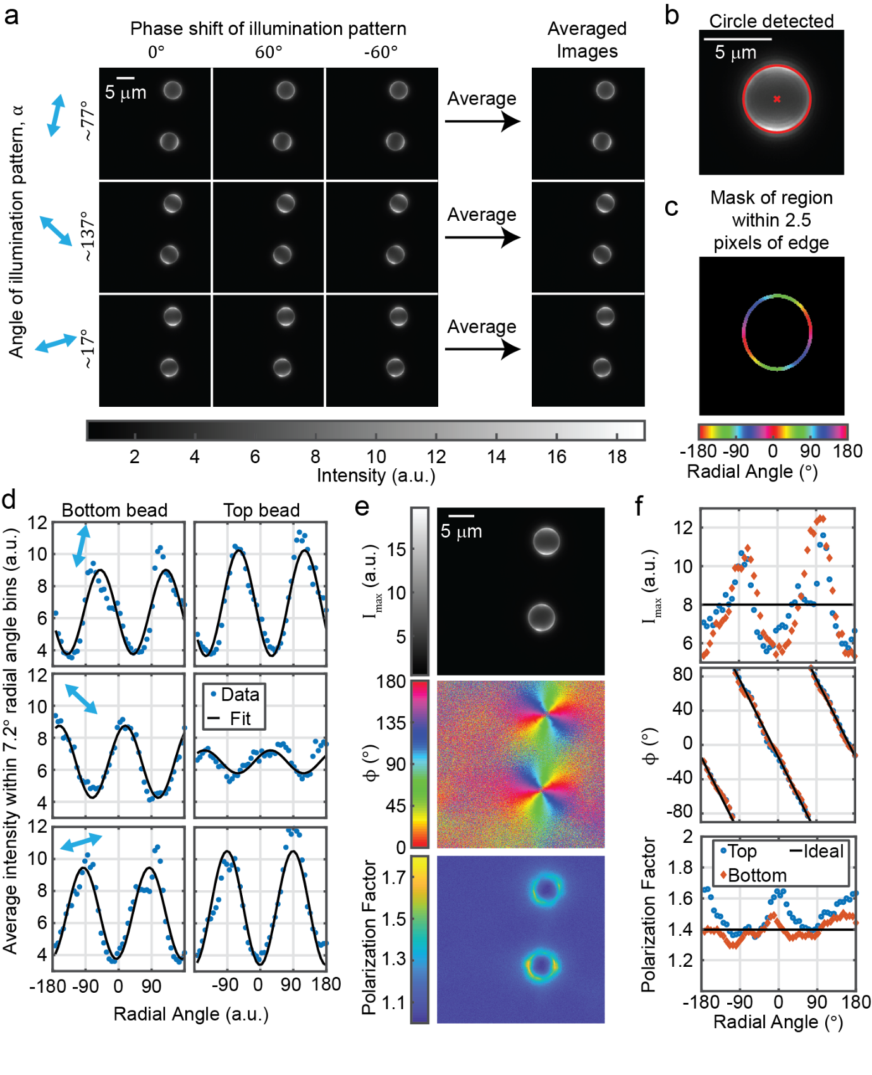

Figure S1: Analysis of DiI-doped SLB-coated microspheres imaged using SIM microscope.

a) Raw 2D SIM images of DiI-doped supported lipid bilayer (SLB)-coated silica microspheres. b) Automatic detection of spheres using MATLAB’s imfindcircles() command. c) Mask used for subsequent analysis. Mask is colored by the radial angle, which is used as a coordinate for subsequent analysis (in this scenario, $ϕ$ should be equal to the radial angle). d) fluorescence intensity as a function of radial angle for each of the two beads in the image. Each blue point represents the average value within one of 50 bins. e) $I_{max}$, $ϕ$, and the polarization factor ($(A+c)/c$) calculated for every pixel in the image. f) Quantities in e calculated as a function of radial angle is in d. $I_{max}$ and the polarization factor should not exhibit variations with respect to radial angle, but this is likely an artifact due to the index of refraction mismatch between the bead and the surrounding buffer.

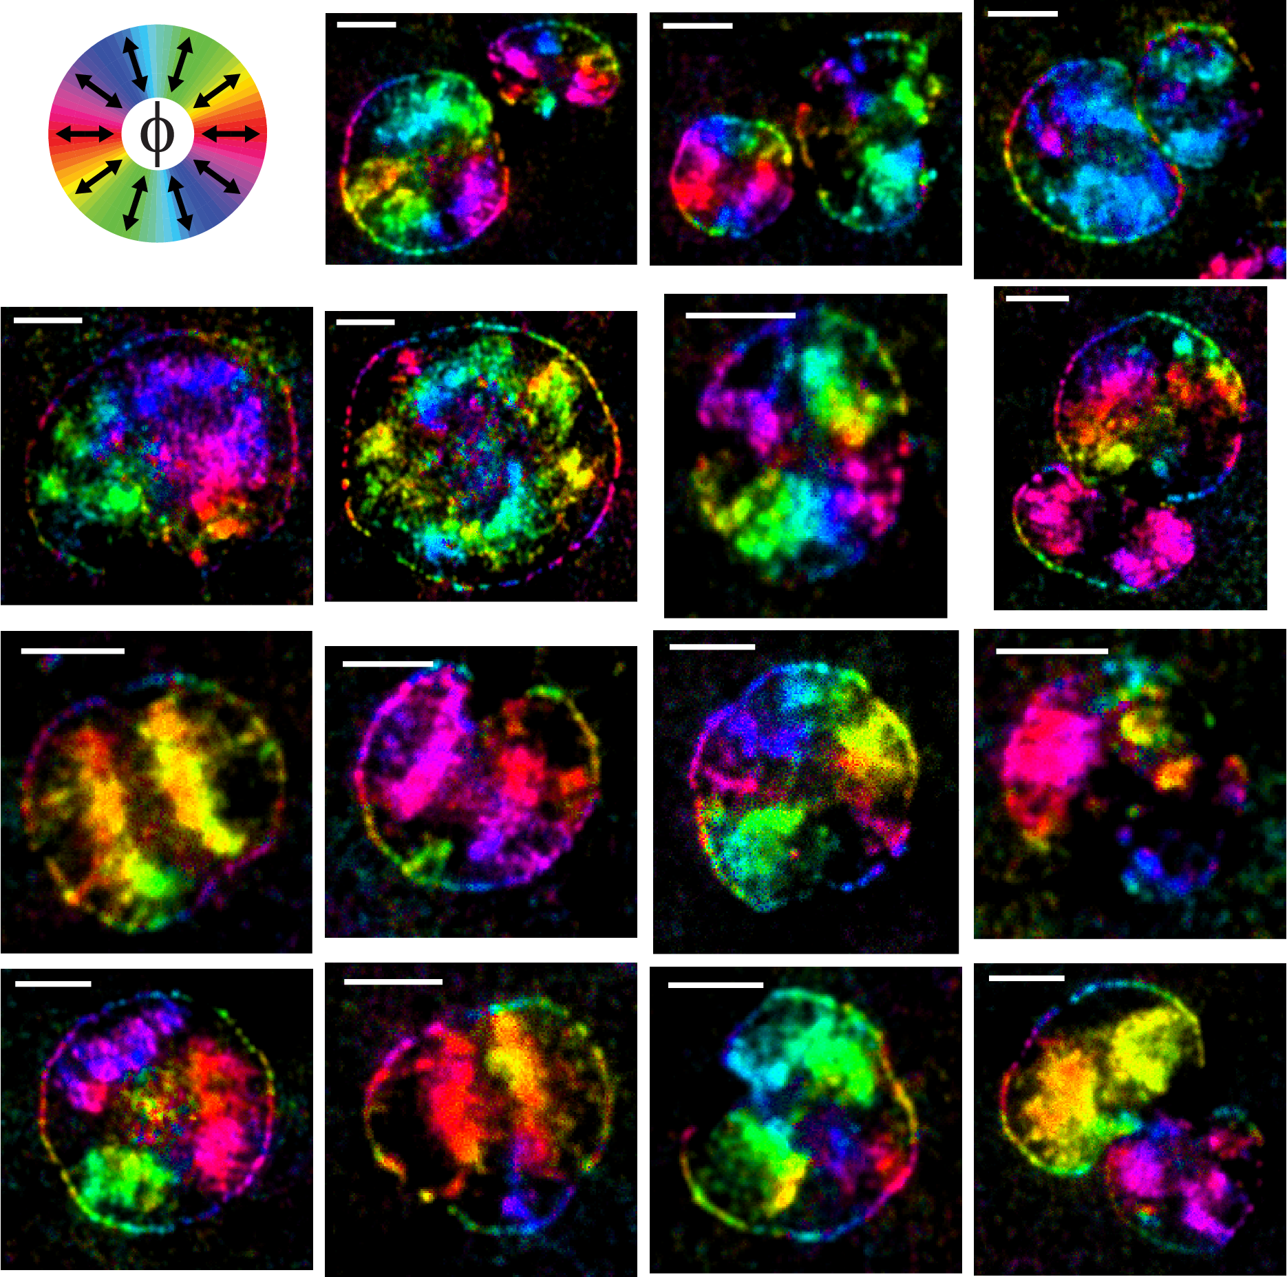

Figure S2: Azimuthal angle maps of 15 representative platelets.

Human platelets were collected and imaged and the images were processed as described in the methods section. Each image shows a color-based $ϕ$ map of one or two platelets. The scale bar for each image denotes 2 micrometers.

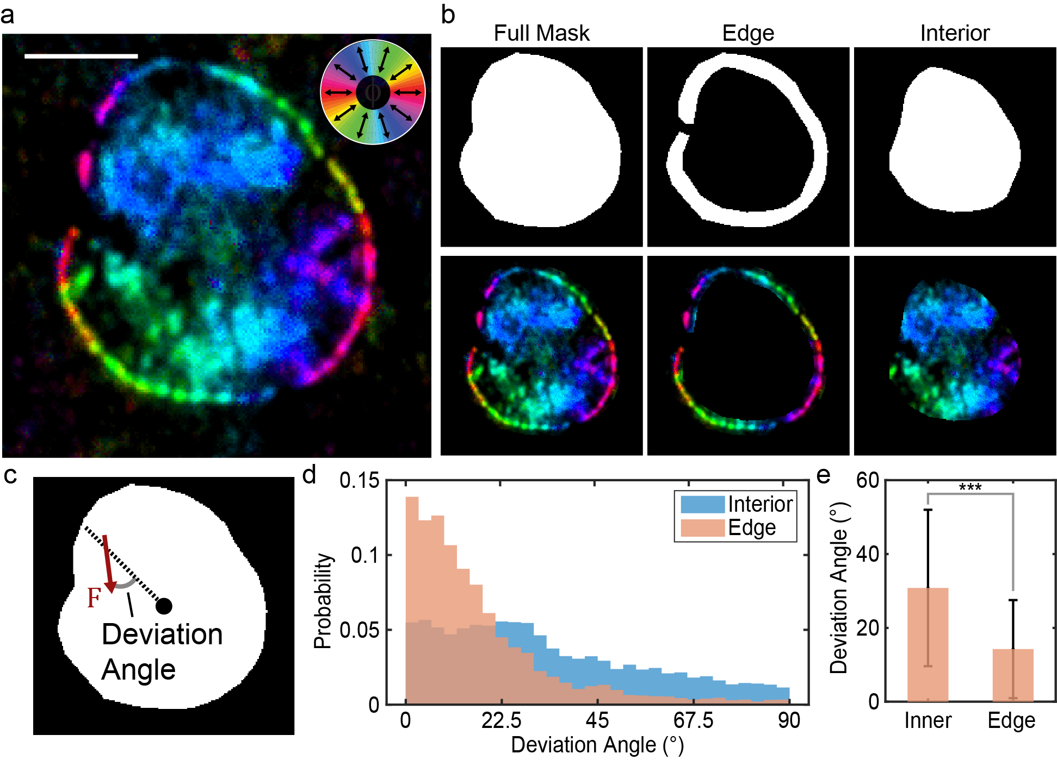

Figure S3: Platelets exhibit two distinct zones of force orientation.

a) Colormap-based $ϕ$-map of a platelet. Scale bar denotes 2 micrometers. b) Hand drawn masks of the full cell, lamellipodial edge, and cell interior (top) with corresponding masked $ϕ$-maps (bottom). c) Depiction of “deviation angle” used to quantify the radiality of platelet integrin traction forces¹ (deviation angle for a given pixel is the angle between the force and the axis that links the mask’s centroid to the pixel’s centroid). d) Probability histogram of deviation angle in the interior and cell edge. e) Comparison of the two populations for this cell. *** denotes p<0.05, Wilcoxon rank-sum test.

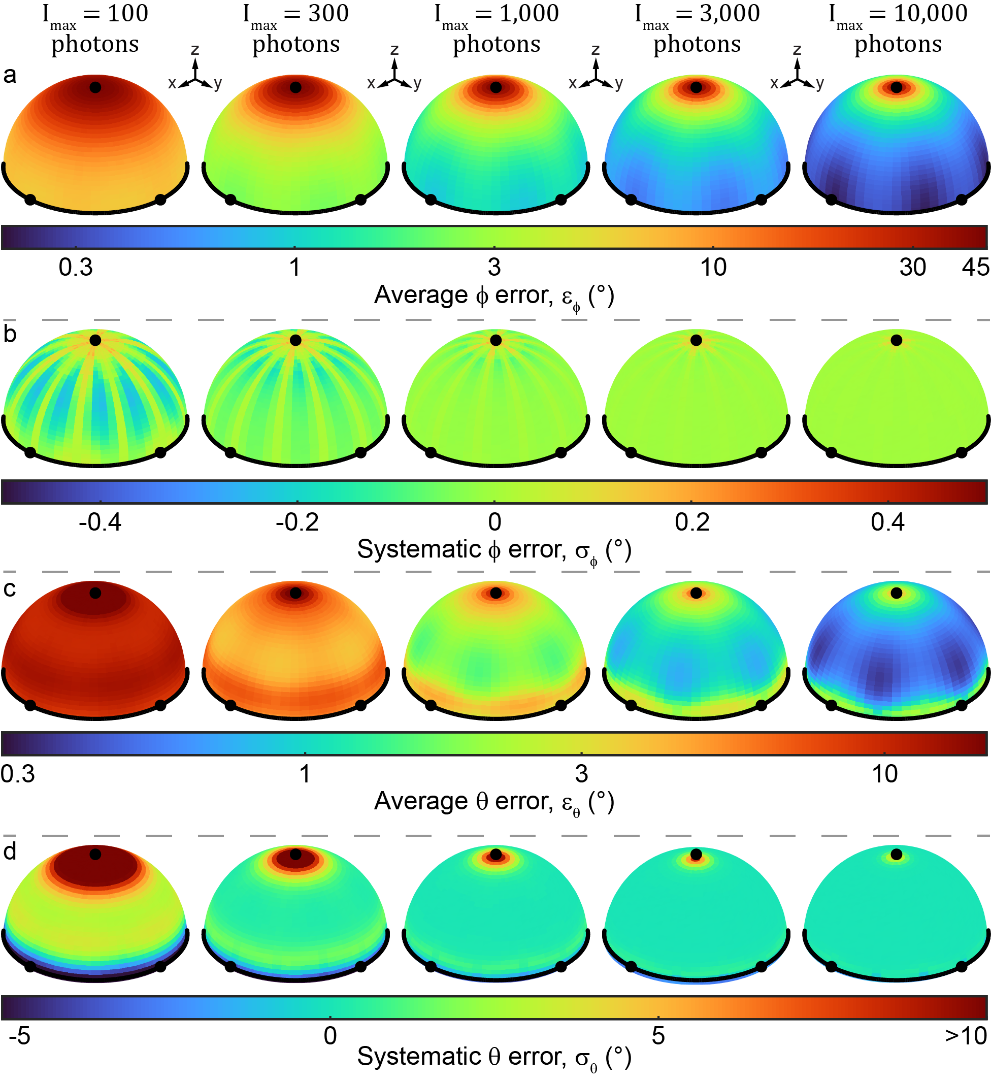

Figure S4: Results of Monte Carlo simulations of force orientation measurement.

Several unit hemispheres are shown. Each hemisphere has three dots denoting the points where the x-, y-, and z-axes intersect with the hemispheres. A black curve also shows the plane of intersection between each hemisphere and the x-y plane. The color of each point on a hemisphere denotes the error of the orientation that passes through that point. Average error and systematic error are shown for $ϕ$ and $θ$ at five different signal-to-noise ratios.
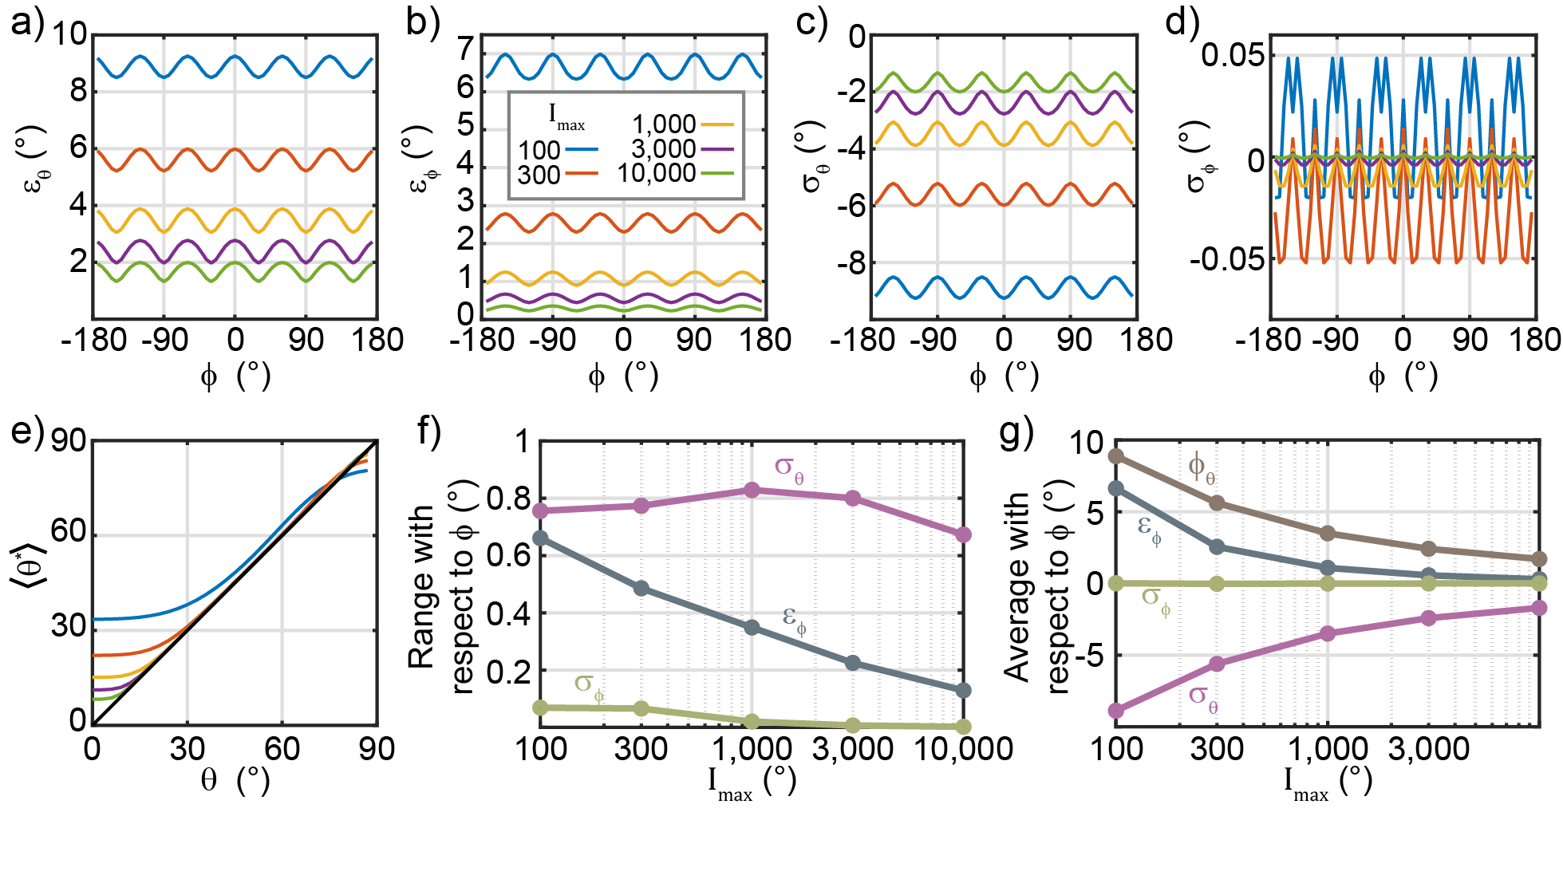

Figure S5: Extended analysis of Monte Carlo simulation results.

a-d) $ε_{θ}$, $ε_{ϕ}$, $σ_{θ}$, and $σ_{ϕ}$ as a function of $ϕ$ with $θ=90°$ at five different signal-to-noise levels. These results show that all four metrics exhibit small periodic variations with respect to $ϕ$. e) The average measured $θ$ value, $⟨θ^{*}⟩$, as a function of the true $θ$ value. These results show a previously-observed¹ result: $θ$ is biased systematically towards higher values when $θ$ is very low because noise generally causes an increase in the best-fit sinusoid’s amplitude. This effect decreases with increasing signal-to-noise. f) Range of curves shown in a-d showing the amplitude of the variation with respect to $I_{max}$. The curve for $ε_{θ}$ is not shown because $σ_{θ}=-ε_{θ}$ when $θ=90°$, making the two range curves equivalent. g) Average of $ε_{θ}$, $ε_{ϕ}$, $σ_{θ}$, and $σ_{ϕ}$ curves shown in a-d as a function of $I_{max}$, showing that all four types of error decrease with increasing signal-to-noise.

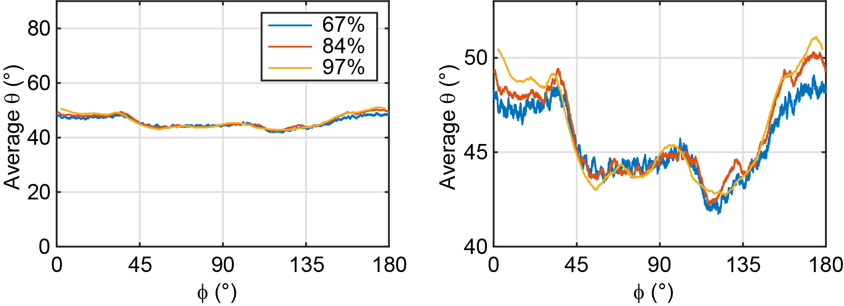

Figure S6: Dependence of measured $⟨θ⟩$ on measured $ϕ$ values.

A 500-point rolling average of $θ$ values accumulated from 37 platelet images as a function of $ϕ$. Plot is shown with the y-axis spanning the full range of potential $θ$ values (left) and a zoom in on the curves (right). Three curves are shown, with thresholds cutoffs set as the 67th, 84th, and 97th percentiles of the accumulated dataset’s intensity values. The similarity between the curves shows that the slight variation with respect to $ϕ$ is not an artifact of the selected signal threshold cutoff.
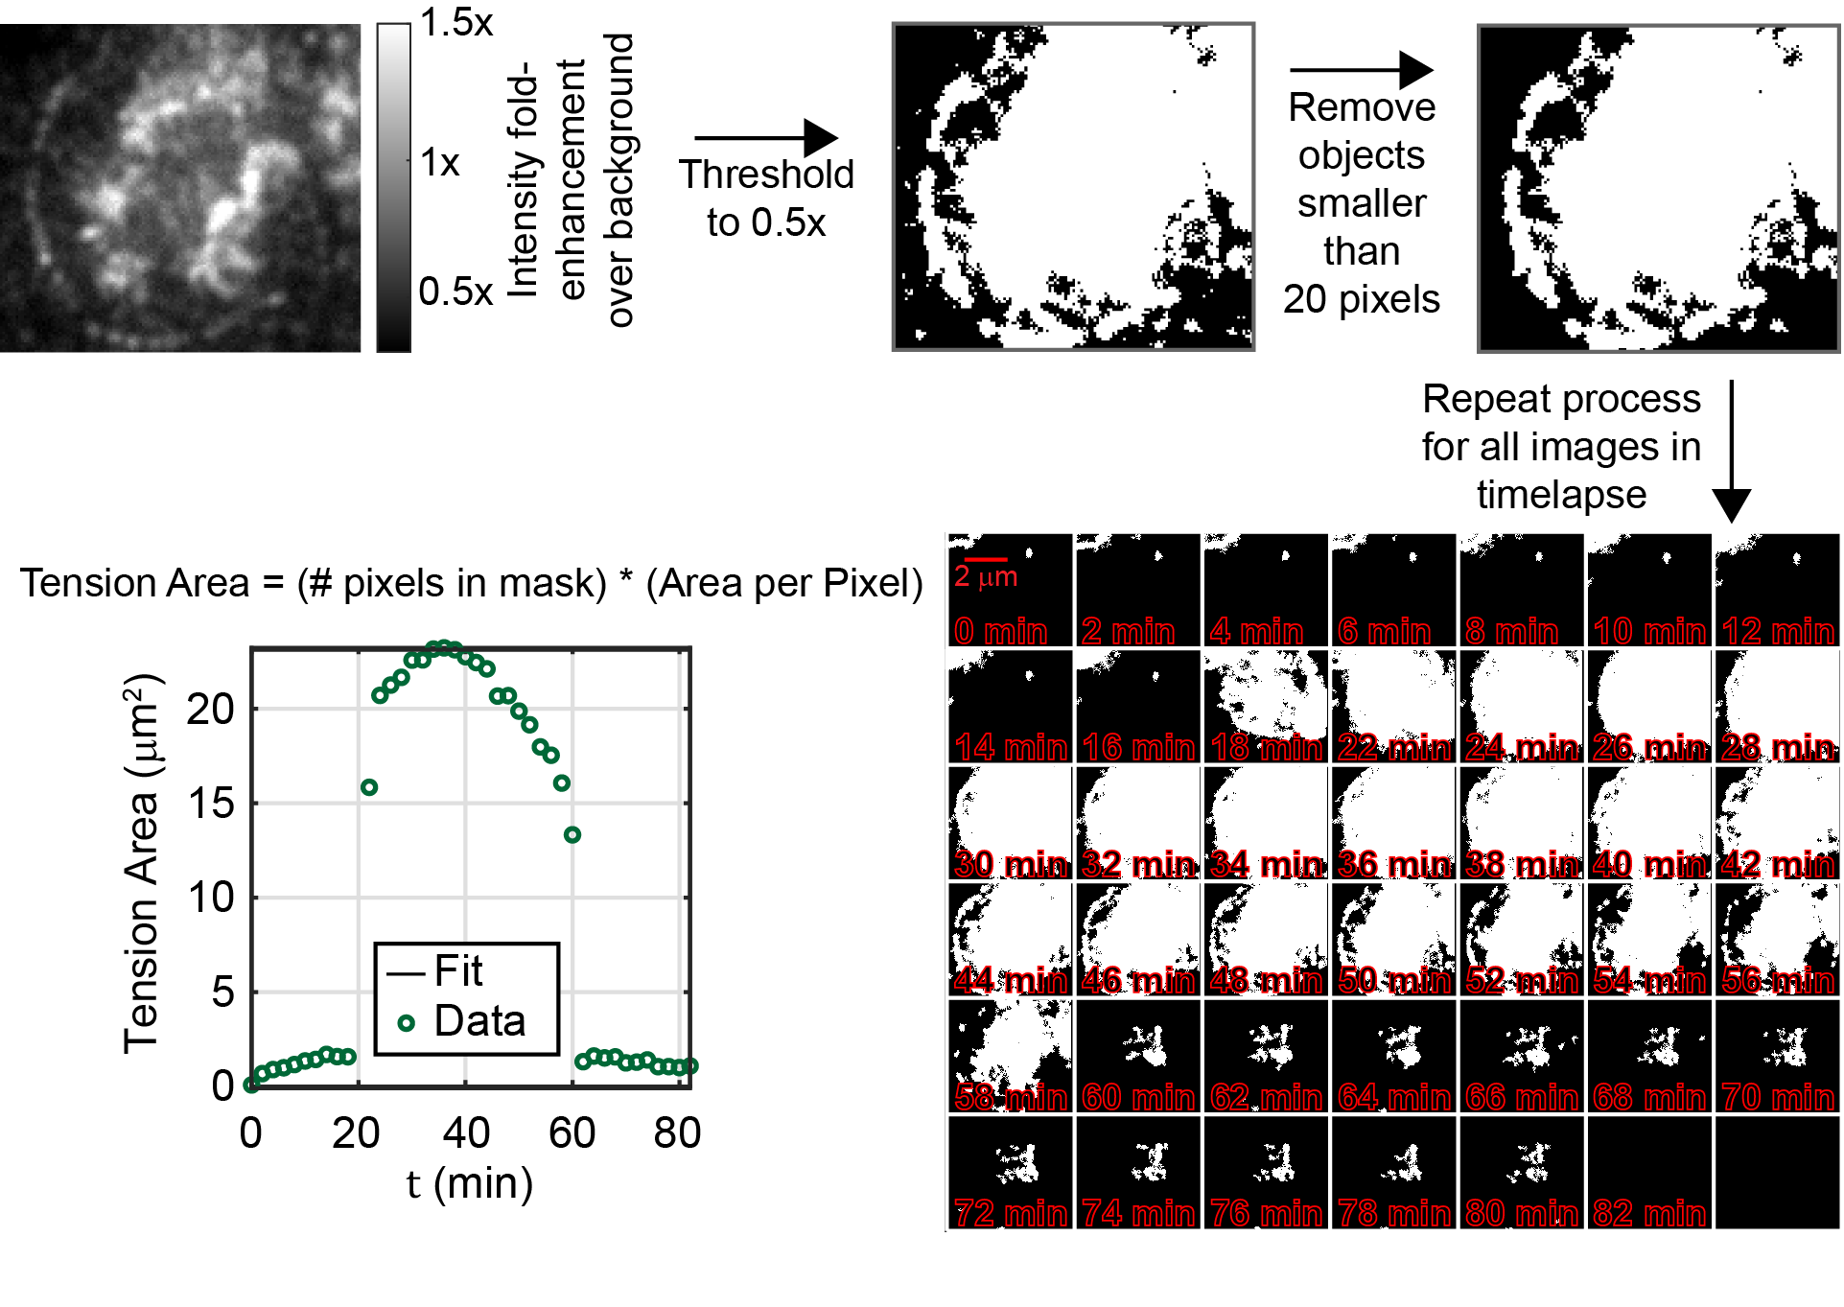

Figure S7: Quantification of tension area

Tension area ($T$) was quantified using a thresholding-based process shown here. And $I_{avg}$ image was first thresholded such that pixels with a greater than 50% increase in intensity compared to background were kept. Then, Objects smaller than 20 pixels were removed. This simple two-step combination produces a mask that retains the vast majority of molecular tension signal, yet simultaneously discards cell-free background pixels with high fidelity. Tension area was then calculated by multiplying the number of pixels in the mask by the area per pixel (equal to (41.7 nm)²). For timelapse quantification of tension area, this process was repeated on each image in the stack.

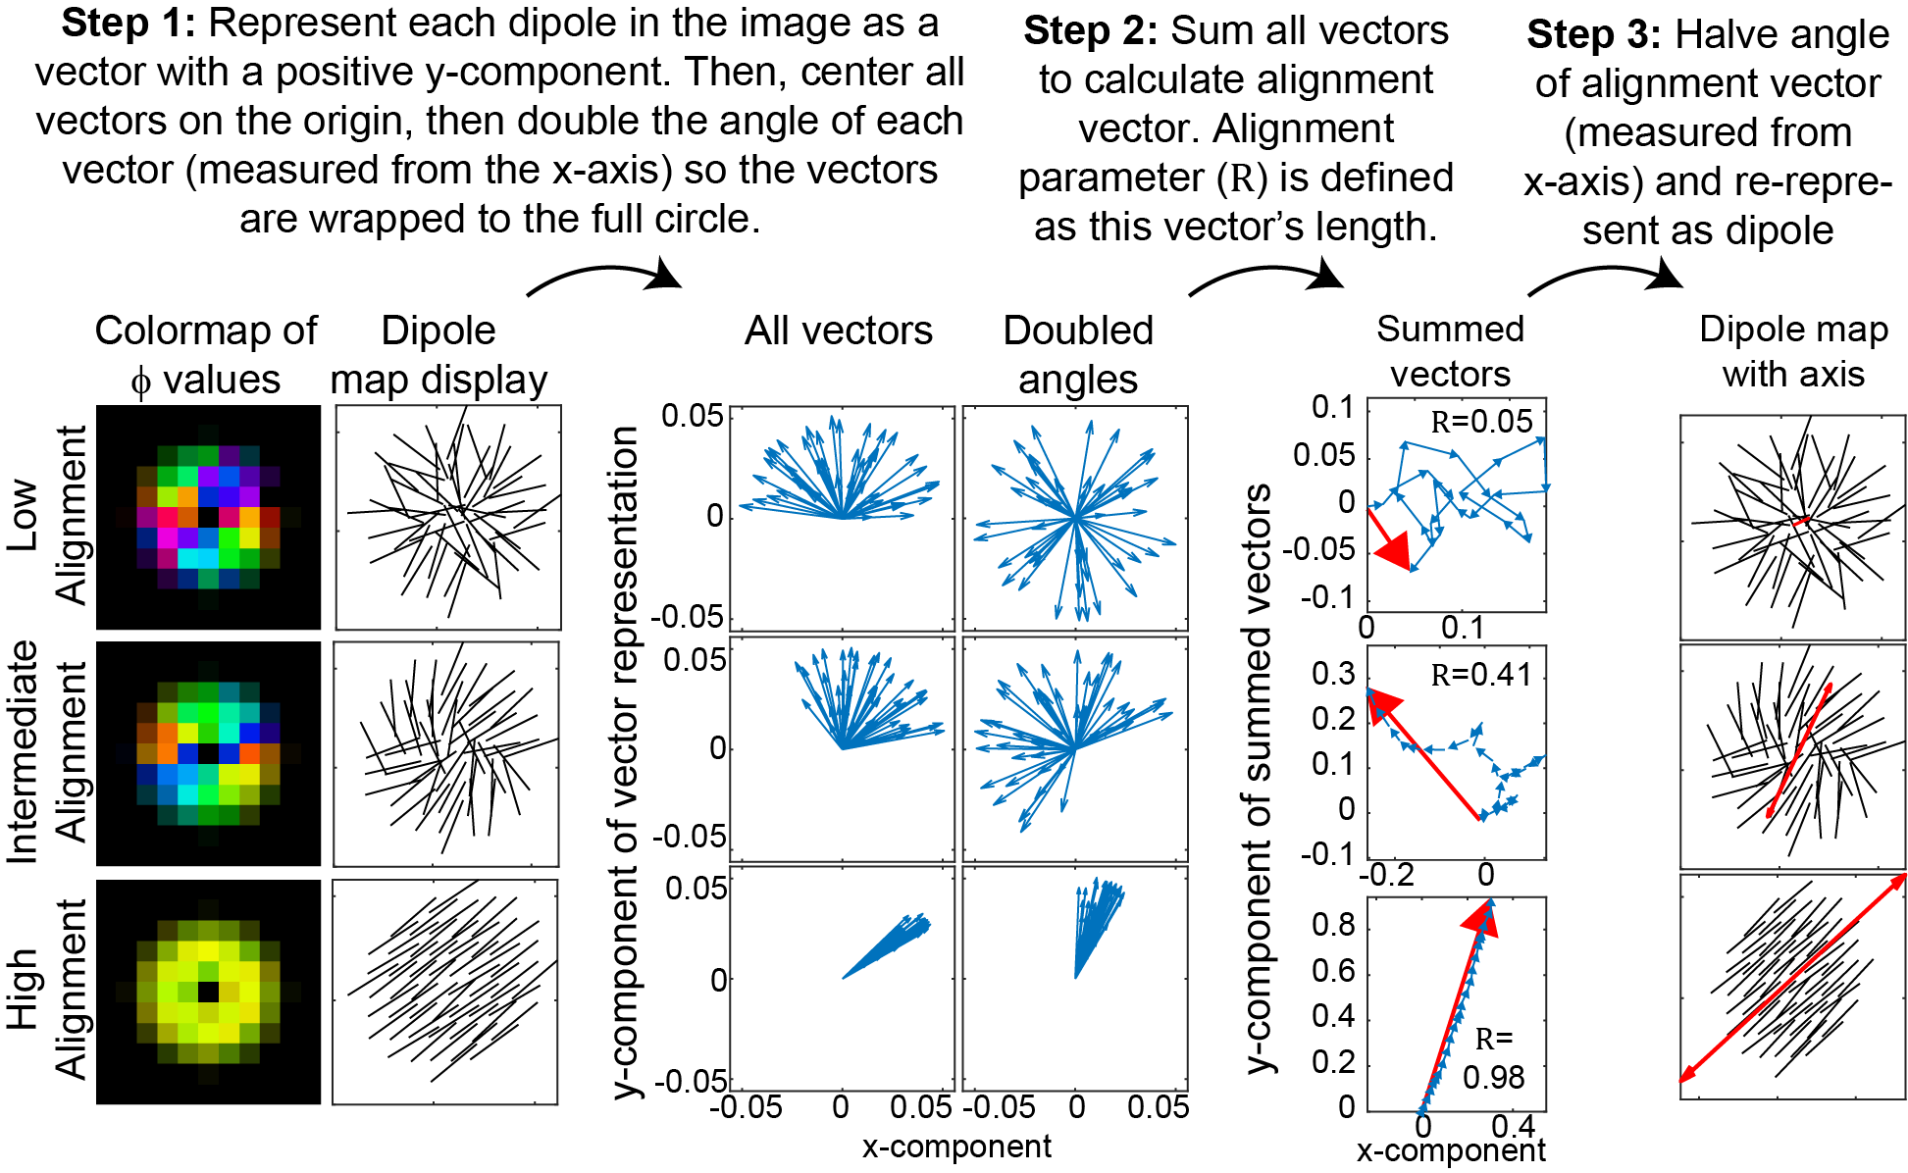

Figure S8: Quantification of the alignment parameter and primary axis of contraction

The alignment parameter⁴ ($R$) and the axis of contraction were determined via a process described in the figure.

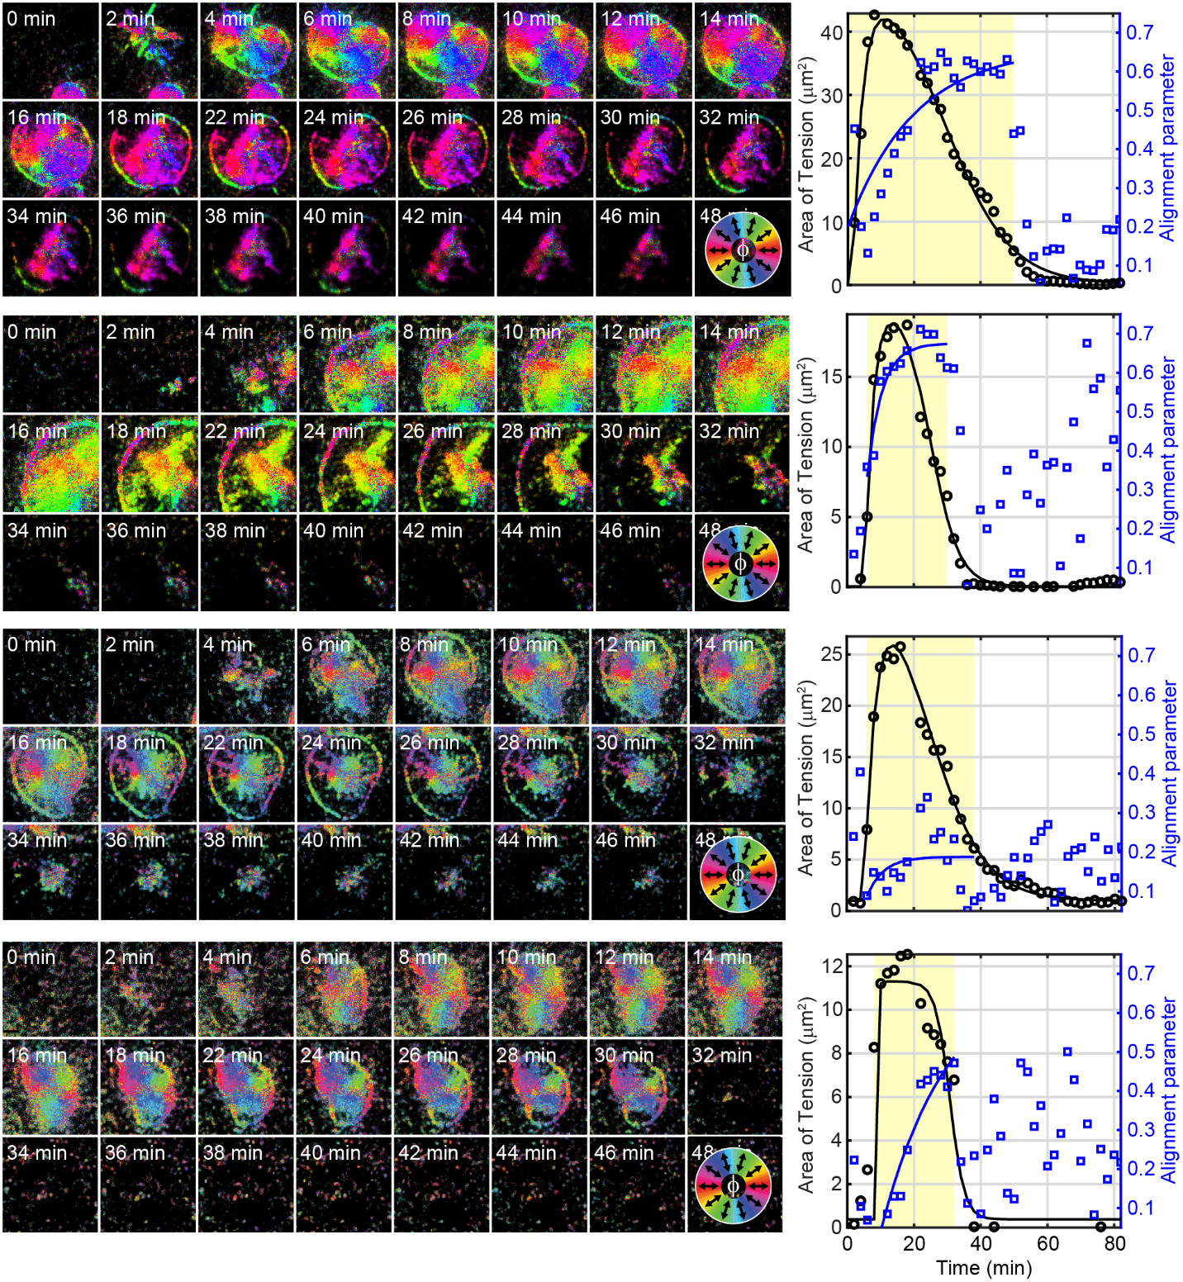

Figure S9: Quantification of the alignment parameter and primary axis of contraction

Four example timelapses of platelets spreading on surfaces, exhibiting gradual increases in alignment. For each timelapse, tension area (black circles) and the calculated alignment parameter (blue circles) are plotted on the right.

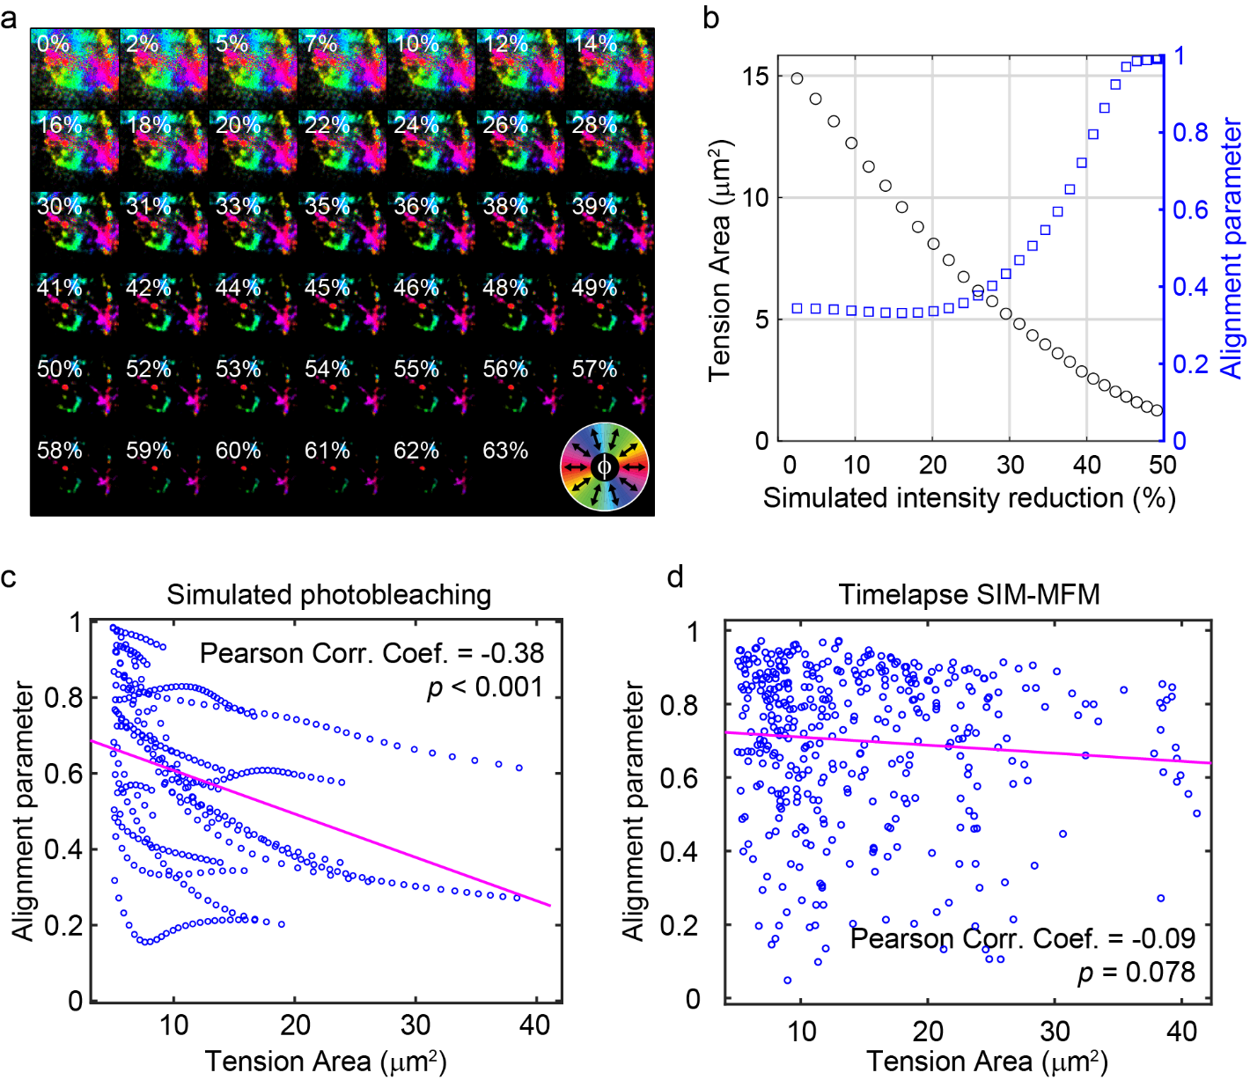

Figure S10: Simulated photobleaching suggests that increasing alignment is likely not a photobleaching-induced artifact.

a) Simulated photobleaching as performed by gradually scaling the fluorescence intensity of an image. A montage of images is shown, each depicting the platelet shown in Fig. 4a at $t=22 min$ with its intensity reduced by an amount denoted in the image (e.g. 32% reduction). As the intensity is decreased, certain regions of the image fail to persist through the intensity cutoff and become excluded from the $R$ and $T$ calculations. b) Tension area ($T$) and the alignment parameter ($R$) measured as a function of the amount of simulated photobleaching. While $T$ decreases monotonically, $R$ stays constant until about 25% intensity reduction, at which point it begins to increase to and eventually converge towards $R=1$. c) A Pearson’s correlation analysis of $R$ and $T$ including all datapoints from simulated photobleaching of all 22 increasing-alignment platelets at their timepoint of initial adhesion revealed a highly significant negative correlation between $T$ and $R$. This analysis included only simulated photobleaching conditions where $T>5 μm^{2}$. d) In contrast, a Pearson’s correlation analysis of all datapoints from the same 28 platelets at timepoints between $t_{attach}$ and $t_{attach}+t_{detach}$ revealed no significant correlation between $T$ and $R$. Therefore, it does not appear that photobleaching is meaningfully resulting in artificially-increased $R$ values.
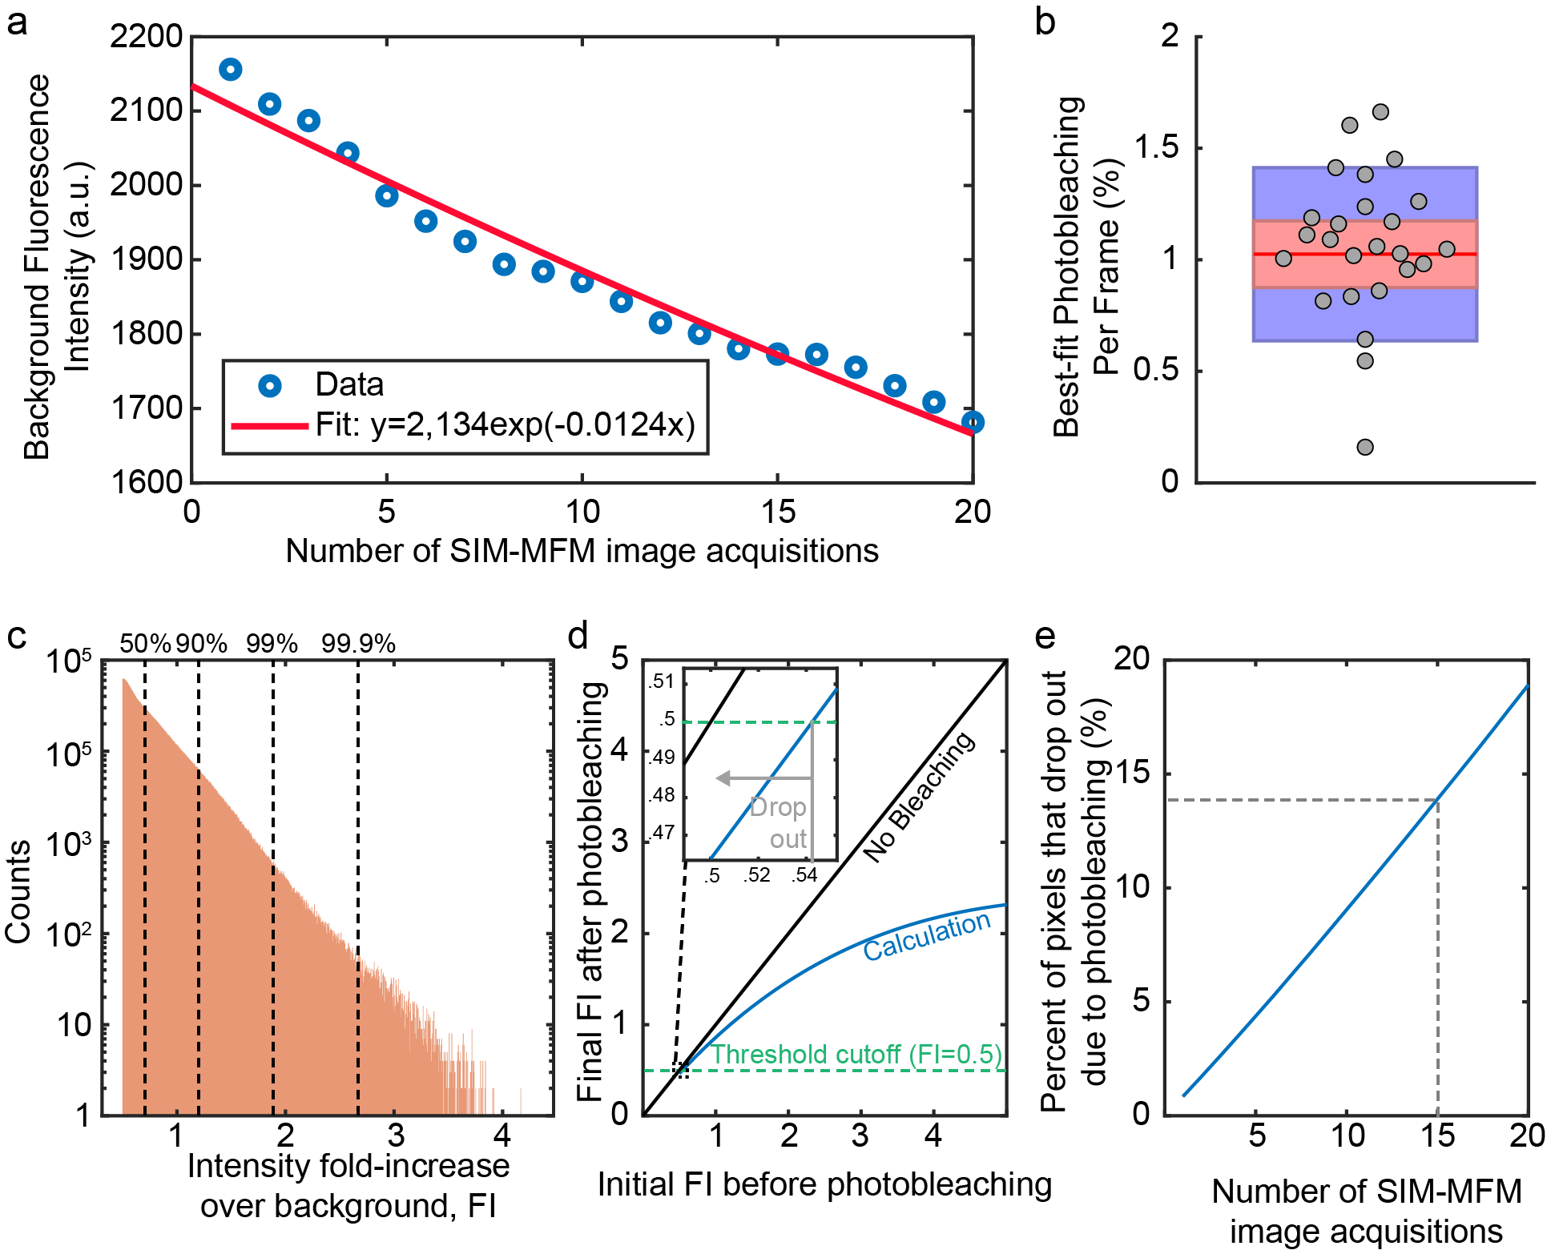

Figure S11: Measurement of experimental photobleaching and expected effect on results

a) The fluorescence intensity of the quenched tension sensor background (with the 200 a.u. camera baseline subtracted) was measured by averaging $I_{avg}$ within a platelet-free region of a SIM-MFM timelapses (blue circles). Photobleaching was then quantified by fitting an exponential decay function to the average background intensity (red curve). The exponential decay rate constant of $k_{bleach,bkrd}=0.0124$ corresponds to 1.24% photobleaching per SIM-MFM acquisition. b) Boxplot showing the best-fit percent photobleaching per SIM-MFM acquisition for 25 different timelapses (gray circles). An average (red line) of ~1% was measured. Red shading denotes standard error of the mean and purple denotes 95% confidence interval. c) Histogram (with logarithmic y-axis) of intensity fold-increase over background ($FI$) of all pixels included in the 81 masked platelet timelapses collected for this work. Vertical dotted lines denote the 50th, 90th, 99th, and 99.9th percentiles of $FI$. d) Plot of expected $FI$ after photobleaching ($FI_{after}$) as a function of $FI$ before photobleaching ($FI_{before}$) due to 15 full SIM-MFM acquisitions (blue curve). The threshold of $FI=0.5$ used in the masking procedure is shown with a green dashed line, and a black line shows $FI_{after}=FI_{before}$. This calculation was performed using an estimate of 1% photobleaching of the quenched background per acquisition as shown in b. Opened tension probes are expected to bleach more rapidly than quenched probes, so the rate of photobleaching of opened tension probes can be calculated from the quenching efficiency (QE):
$$k_{bleach}=\frac{k_{bleach,bkrd}}{1-QE}$$

If tension probes within a local region corresponding to a single pixel are considered from a population level and assumed to exchange between acquisitions (this assumption is reasonable because the integrin-ligand bond lifetime is generally known⁵ to be on the order of 10 seconds and our images are taken at an interval of 2 minutes) can also be calculated from the quenching efficiency:

$$FI=\frac{I}{I_{bkrd}}-1=\frac{p_{open}}{1-QE}$$

where $p_{open}$ is the proportion of tension probes open within a given region and $I_{bkrd}$ is the intensity of the fluorescent background. $FI_{after}$ can be expressed as a function of $p_{open}$, $k_{bleach}$, and $FI_{before}$:

$$FI_{after}=FI_{before}\left(1-{\left(1-p_{open}k_{bleach}\right)}^{n}\right)$$

where $n$ denotes the number of SIM-MFM acquisitions. This equation simplifies such that $QE$, which was previously measured as ~97% (ref. ⁶), drops out of the equation:

$$FI_{after}=FI_{before}\left(1-{\left(1-FI\left(1-QE\right)\frac{k_{bleach,bkrd}}{1-QE}\right)}^{n}\right)$$
$$FI_{after}=FI_{before}\left(1-{\left(1-k_{bleach,bkrd}FI\right)}^{n}\right)$$

We used this equation to calculate $FI_{after}$ as a function of $FI_{before}$. Our results show that pixels with higher $FI_{before}$ exhibit larger extents of photobleaching, but only the dimmest pixels (those with $FI_{before}$<~0.54) transition below the $FI=0.5$ cutoff due to photobleaching and drop out of the masking procedure. e) A plot of the percent of pixels that drop out (assuming a distribution of $FI_{before}$ shown in c) of the masking procedure due to photobleaching as a function of $n$, showing a linear trend with a slope of 0.93% drop-out per image. Dotted line shows that at $n=15$, ~14% of pixels drop out of the masking procedure due to photobleaching.

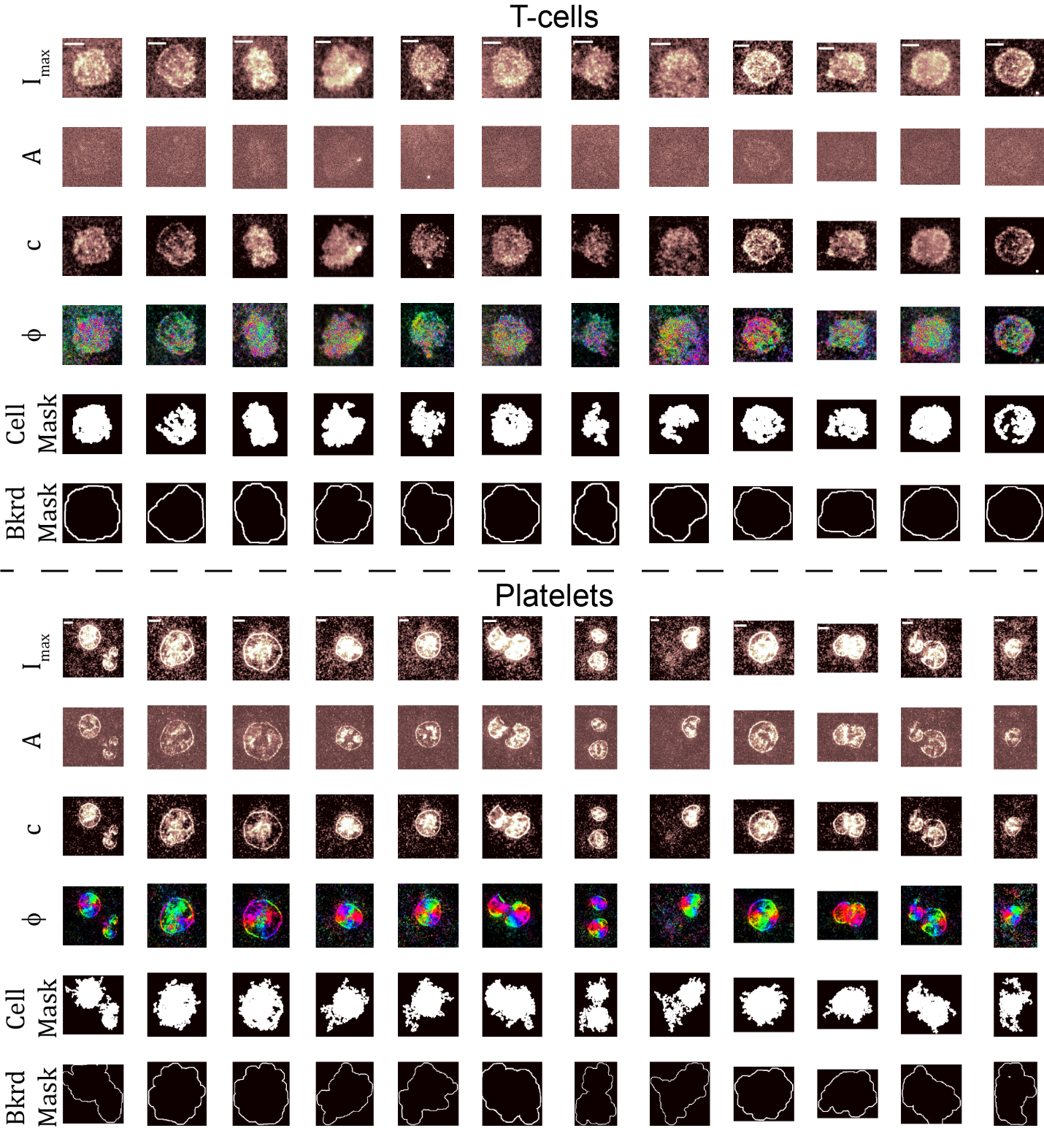

Figure S12: Comparison of SIM-MFM signal produced by T-cell receptor and platelet integrin forces

This figure is divided in two sections that have the same structure. The top half of the figure shows representative T-cell data, while the bottom half shows representative data for platelets, which serve as a control. Each panel shows twelve representative cells (one in each platelet) and has 6 rows corresponding to $I_{max}$, $A$, $c$, $ϕ$, and the cell and background masks used to quantify $⟨A⟩$ and $⟨c⟩$ within the cells and the cell-free background. Notably, the T-cell $A$ images show signal that is barely distinguishable from background, while platelet $A$ images show substantially brighter signal than background. Additionally, the $ϕ$ images for the T-cells show no distinguishable spatial pattern because the low $A$ values result in $ϕ$ values that are noise-dominated.

Table S1 – Oligonucleotide sequences

Name | Sequence (5’-3’)
cRGDfK-presenting strand | 5’-/5Hexynyl/-TTT GCT GGG CTA CGT GGC GCT CTT-/3AmMO/-3’
Anchor strand for glass | 5’-/BHQ 1/-CGC ATC TGT GCG GTA TTT CAC TTT-/3Bio/-3’
Hairpin strand for glass | 5’-GTG AAATAC CGC ACA GAT GCG TTT GTA TAA ATG TTT TTT TCA TTT ATA C TTT AAG AGC GCC ACG TAG CCC AGC-3’
Opening strand | GTATAAATGAAAAAAACATTTATAC
pMHC-presenting strand | /5AmMC6/-CGC ATC TGT GCG GTA TTT CAC TTT-/3Bio/-3
Anchor strand for AuNP | /5ThiolMC6-D/-TTT GCT GGG CTA CGT GGC GCT CTT-/3BHQ_2/-3’
Hairpin for AuNP | 5’-GTG AAA TAC CGC ACA GAT GCG TTT GTA TAA ATG TTT TTT TCA TTT ATA CTTTAA GAG CGC CAC GTA GCC CAG C-3’
The sequences are listed using IDT’s nomenclature. 3Bio = biotin ligated to the 3’ terminus. 5AmMC6 = 5’ amine ligated to the DNA via a 6-carbon linker. 3AmMO = amine linked to the 3’ DNA terminus. 5Hexynyl = 5’ terminal alkyne. 5ThiolMC6-D = protected thiol linked to the 5’ DNA terminus via a 6-carbon linker. BHQ 1 = Black Hole Quencher-1 attached to the 5’ DNA terminus. 3BHQ 2 = Black Hole Quencher 2 attached to the 3’ DNA terminus. Underlined letters denote self-complementary portions of hairpin strands.

Supplemental Note 1 – Derivation of equations for analytical orientation measurement
To obtain a method for calculating force orientation analytically for each set of three intensity measurements ($I_{1}$, $I_{2}$, and $I_{3}$), we consider equations that can be used to represent fluorescence intensity:

$$\begin{aligned}I_{1}=A\sin^{2}\left(α_{1}-ϕ\right)+c\#\left(1a\right)\end{aligned}$$
$$\begin{aligned}I_{2}=A\sin^{2}\left(α_{2}-ϕ\right)+c\#\left(1b\right)\end{aligned}$$
$$\begin{aligned}I_{3}=A\sin^{2}\left(α_{3}-ϕ\right)+c\#\left(1c\right)\end{aligned}$$

where $α$ is the polarization angle of the excitation beam, $ϕ$ is the azimuthal angle of the force vector, and and $A$and $c$ are scaling constants that are related to the background intensity, number of open tension probes, and the tilt angle of the force ($θ$). Because the three $α$ angles are related to each other by rotations of $60°$, we can re-write these equations simply as:

$$\begin{aligned}I_{1}=A\sin^{2}\left(α_{1}-ϕ\right)+c\#\left(2a\right)\end{aligned}$$
$$\begin{aligned}I_{2}=A\sin^{2}\left(α_{1}+60°-ϕ\right)+c\#\left(2b\right)\end{aligned}$$
$$\begin{aligned}I_{3}=A\sin^{2}\left(α_{1}-60°-ϕ\right)+c\#\left(2c\right)\end{aligned}$$

Applying the half-angle formula yields:

$$\begin{aligned}I_{1}=\frac{A}{2}\left(1-\cos\left(2α_{1}-2ϕ\right)\right)+c\#\left(3a\right)\end{aligned}$$
$$\begin{aligned}I_{2}=\frac{A}{2}\left(1-\cos\left({2α}_{1}+120°-2ϕ\right)\right)+c\#\left(3b\right)\end{aligned}$$
$$\begin{aligned}I_{3}=\frac{A}{2}\left(1-cos\left({2α}_{1}-120°-2ϕ\right)\right)+c\#\left(3c\right)\end{aligned},$$

and rearranging yields:

$$\begin{aligned}I_{1}=\overline{I}-\frac{A}{2}\cos\left(2α_{1}-2ϕ\right)\#\left(4a\right)\end{aligned}$$
$$\begin{aligned}I_{2}=\overline{I}-\frac{A}{2}\cos\left(2α_{1}+120°-2ϕ\right)\#\left(4b\right)\end{aligned}$$
$$\begin{aligned}I_{3}=\overline{I}-\frac{A}{2}\cos\left(2α_{1}-120°-2ϕ\right)\#\left(4c\right)\end{aligned},$$

where

$$\begin{aligned}\overline{I}=\frac{A}{2}+c=\frac{I_{1}+I_{2}+I_{3}}{3}\#\left(5\right)\end{aligned}$$

Applying the identity $\cos\left(a+b\right)=\cos\left(a\right)\cos\left(b\right)+\sin\left(a\right)sin⁡(b)$ yields:

$$\begin{aligned}I_{1}=\overline{I}-\frac{A}{2}\left(\cos\left(2α_{1}\right)\cos\left(2ϕ\right)+\sin\left(2α_{1}\right)\sin\left(2ϕ\right)\right)\#\left(6a\right)\end{aligned}$$
$$\begin{aligned}I_{2}=\overline{I}-\frac{A}{2}\left(\cos\left(2α_{1}+120°\right)\cos\left(2ϕ\right)+\sin\left(2α_{1}+120°\right)\sin\left(2ϕ\right)\right)\#\left(6b\right)\end{aligned}$$
$$\begin{aligned}I_{3}=\overline{I}-\frac{A}{2}\left(\cos\left(2α_{1}-120°\right)\cos\left(2ϕ\right)+\sin\left(2α_{1}-120°\right)\sin\left(2ϕ\right)\right)\#\left(6c\right)\end{aligned}.$$

If we rotate our coordinate system such that $α_{1}=0°$ and re-arrange, we obtain:

$$\begin{aligned}\overline{I}-I_{1}=\frac{A}{2}\cos\left(2ϕ\right)\#\left(7a\right)\end{aligned}$$
$$\begin{aligned}\overline{I}-I_{2}=\frac{A}{2}\left(\cos\left(120°\right)\cos\left(2ϕ\right)+\sin\left(120°\right)\sin\left(2ϕ\right)\right)\#\left(7b\right)\end{aligned}$$
$$\begin{aligned}\overline{I}-I_{3}=\frac{A}{2}\left(\cos\left(-120°\right)\cos\left(2ϕ\right)+\sin\left(-120°\right)\sin\left(2ϕ\right)\right)\#\left(7c\right)\end{aligned}.$$

Merging equations $(7a)$ and $(7b)$ yields:

$$\begin{aligned}\overline{I}-I_{2}=\left(\overline{I}-I_{1}\right)\cos\left(120°\right)+\frac{A}{2}\sin\left(120°\right)\sin\left(2ϕ\right)\#\left(8\right)\end{aligned}$$

Re-arranging, we obtain

$$\begin{aligned}\frac{\overline{I}-I_{2}-\left(\overline{I}-I_{1}\right)\cos\left(120°\right)}{\sin\left(120°\right)}=\frac{A}{2}\sin\left(2ϕ\right)\#\left(9\right).\end{aligned}$$

Dividing equation (9$)$ by equation $(7a)$ rearranging yields

$$\begin{aligned}\tan\left(2ϕ\right)=\frac{\overline{I}-I_{2}-\left(\overline{I}-I_{1}\right)\cos\left(120°\right)}{\left(\overline{I}-I_{1}\right)\sin\left(120°\right)}\#\left(10\right)\end{aligned}$$

and finally, rearranging the equation and adjusting the coordinate system to allow for arbitrary $α_{1}$ yields:

$$\begin{aligned}ϕ=\frac{1}{2}\tan^{-1}\left(\frac{\overline{I}-I_{2}-\left(\overline{I}-I_{1}\right)\cos\left(120°\right)}{\left(\overline{I}-I_{1}\right)\sin\left(120°\right)}\right)+α_{1}\#\left(11\right)\end{aligned}.$$

Now that $ϕ$ is known, $A$ can be solved for by re-arranging equation $(4a)$:

$$\begin{aligned}A=\frac{2\left(\overline{I}-I_{1}\right)}{\cos\left(2α_{1}-2ϕ\right)}\#\left(12\right)\end{aligned}.$$

Next, $c$ can be obtained by re-arranging equation $(1a)$:

$$\begin{aligned}c=I_{1}-A\sin^{2}\left(α_{1}-ϕ\right)\#\left(13\right)\end{aligned}.$$

Finally, $θ$ can be estimated using an equation that we previously derived:

$$\begin{aligned}θ=\cos^{-1}\left(\sqrt{\frac{\frac{I_{max}}{c}-0.069}{1-0.069}}\right)\#\left(14\right)\end{aligned},$$

where

$$\begin{aligned}I_{max}=A+c\#\left(15\right)\end{aligned}.$$

Supplemental Note 2 – Description of analysis of T-cell receptor SIM-MFM data

When using SIM-MFM to image DNA hairpin tension probes opened by the T-cell receptor, we found that T-cells did not exhibit any notable polarization-dependent response. To quantify this finding, we measured the ratio $\left\langle A\right\rangle /(\left\langle c\right\rangle +1)$under cells and in the background. As a control, we also quantified $\left\langle A\right\rangle /(\left\langle c\right\rangle +1)$ for platelets. As stated in the main text, $A$ and $c$ are measures of the fit sinusoid for a given pixel such that $A$ is a measure of the polarization-dependent fluorescence intensity signal and $c$ is a measure of the polarization-independent fluorescence intensity signal – see Fig. S10b. The angle brackets $⟨ ⟩$ denote ensemble averaging, meaning we averaged all recorded $A$ and $c$ values measured under the cell and in the local background near the cell. Because the intensity values are background subtracted we added 1 to $⟨c⟩$ to prevent instabilities in the estimate of the polarization ratio. Higher $\left\langle A\right\rangle /(\left\langle c\right\rangle +1)$ means that the polarization-dependent component of fluorescence intensity is strong, indicating the presence of temporally stable forces with a substantial in-plane component ($θ≫0°$). Conversely, low $\left\langle A\right\rangle /(\left\langle c\right\rangle +1)$ means that the polarization dependent component of fluorescence intensity is weak, which can have multiple interpretations discussed below.
While platelets exhibited large $\left\langle A\right\rangle /(\left\langle c\right\rangle +1)$ values (median of ~0.24), T-cells exhibited a low $\left\langle A\right\rangle /(\left\langle c\right\rangle +1)$ (median of ~0.1) – see Fig. 6c. Measurement of $\left\langle A\right\rangle /(\left\langle c\right\rangle +1)$ values in the cell-free background for both cells types exhibited values similar to that measured under T-cells (median ~0.1). Inspection of maps of $A$ and $c$ show that virtually all T-cell signal is polarization-independent (Fig. S11-12). Together, these results suggest that tension is not oriented in a manner that results in the polarization response needed for MFM to map orientation.

References

1 Brockman, J. M. et al. Mapping the 3D orientation of piconewton integrin traction forces. Nat. Methods 15, 115, doi:10.1038/nmeth.4536 (2017).
2 Linkert, M. et al. Metadata matters: access to image data in the real world. J. Cell Biol. 189, 777-782, doi:10.1083/jcb.201004104 %J Journal of Cell Biology (2010).
3 Blanchard, A. T., Brockman, J. M., Salaita, K. & Mattheyses, A. L. Variable incidence angle linear dichroism (VALiD): a technique for unique 3D orientation measurement of fluorescent ensembles. Opt. Express 28, 10039-10061, doi:10.1364/OE.381676 (2020).
4 in Directional Statistics 13-24 (1999).
5 Zhu, C. & Chen, W. in Single-molecule Studies of Proteins (ed Andres F. Oberhauser) 77-96 (Springer New York, 2013).
6 Zhang, Y., Ge, C., Zhu, C. & Salaita, K. DNA-based digital tension probes reveal integrin forces during early cell adhesion. Nat Commun 5, 5167, doi:10.1038/ncomms6167 (2014).

