Supplementary materials for review
OSF: https://osf.io/2jztk/overview?view_only=f36ddf10e552428d822274c6a4e45da7
Illustrations: AI-generated, anime-style characters (women). Character IDs 1-3 from right to left.
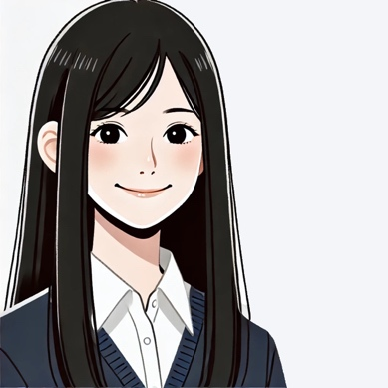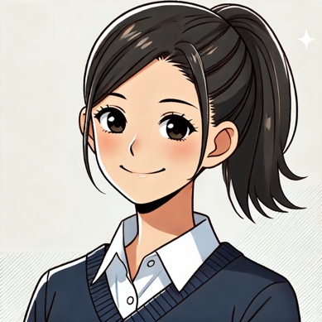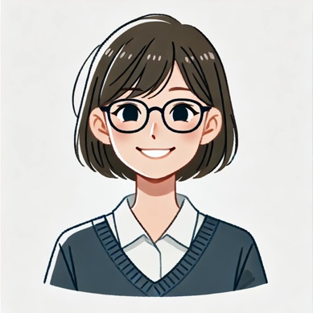
Illustrations: AI-generated, anime-style characters (men). Character IDs 1-3 from right to left.
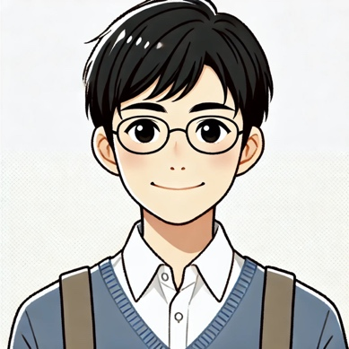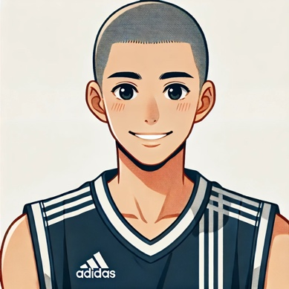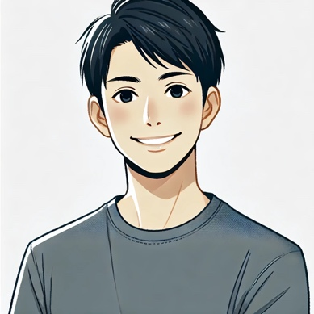
Names for women.

Names for men.
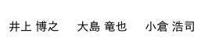

Scripts:
The Japanese scripts were translated into English using Claude (Anthropic, 2025), a large language model. The translations were reviewed by the author for accuracy.
Anthropic. (2025). Claude [Large language model]. https://www.anthropic.com

Scripts for women: The numbers indicate Character ID assigned.
Scenario: Introduction
1 I'm so happy to make a new friend!
2 That pouch is so cute!
3 Want to have lunch together?
1 Do you know any good cafés around here?
2 Want to walk to the station together today?
3 Have you decided on a club yet?
Scenario: Lunchtime
1 This salad has really fresh vegetables.
2 I was craving pasta today.
3 That dessert would look great on Instagram.
1 The cafeteria is crowded today.
2 I'm curious about the new menu.
3 This side dish looks healthy.
Scenario: Break at Part-Time Job
1 The customers today have been really nice.
2 It seems like they added new menu items recently.
3 Can anyone cover my shift tomorrow?
1 I wish I could get a raise.
2 I think I'm finally getting used to working here.
3 I'm tired from the early shift today.
Scenario: Club Activity
1 Should we add more flower decorations?
2 Have you finished proofreading the pamphlet?
3 Does your costume fit?
1 I made a music playlist.
2 What color should the lights be?
3 Where's the stage schedule?
Scenario: Seminar
1 What colors should we use for the graphs?
2 Preparing for questions is important too.
3 Is the projector ready?
1 Should I ask someone to be the timekeeper?
2 Please check the microphone settings.
3 Do we have enough handouts?
Scenario: Café
1 I don't understand his feelings.
2 I get worried when he's friendly with other girls.
3 What kind of date plan do you think is good?
1 His LINE replies are slow.
2 What should I wear?
3 He seems cold lately.
Scenario: Between-class recess
1 How should I write my self-introduction?
2 How do you write a motivation letter?
3 Should I do an internship?
1 Can you teach me how to write a resume?
2 I'm not good at self-analysis.
3 I don't have time to go to information sessions.

Scripts for men: The numbers indicate Character ID assigned.
Scenario: Introduction
1 Hello, nice to meet you.
2 The campus is really big, isn't it?
3 I'm glad we're in the same class.
1 Do you have any plans during the break?
2 Was that test difficult?
3 What anime do you like?
Scenario: Lunchtime
1 This curry is spicy.
2 Are you ready for tomorrow's class?
3 I was craving ramen today.
1 This tempura is nice and crispy.
2 I get sleepy during class.
3 I don't dislike coffee, though.
Scenario: Break at Part-Time Job
1 I think I'm getting used to this job.
2 Today was really busy.
3 What are you doing for your next shift?
1 This uniform is a bit embarrassing.
2 I like the atmosphere of this place.
3 This place gets busy during lunch, doesn't it?
Scenario: Club Activity
1 Is the poster done? Let me see!
2 What should we do for the venue decorations?
3 Let's split up and prepare together.
1 How should we distribute the pamphlets?
2 Let's decide on the food stall menu.
3 Where should we put the donation box?
Scenario: Seminar
1 Let's check the slide design.
2 How long is the presentation again?
3 Do we have enough copies of the handouts?
1 What order should we present in?
2 Let's redo the data graphs.
3 Let's do another rehearsal.
Scenario: Café
1 I don't understand her feelings.
2 How should I confess my feelings?
3 I want to ask her out but I'm nervous.
1 What should I talk about to make it fun?
2 I'm struggling to choose a gift.
3 I want to talk to her more.
Scenario: Between-class recess
1 Can you help me practice for interviews?
2 The application form is difficult.
3 Should I buy a new suit?
1 How can I stop being nervous at interviews?
2 I'm worried about group discussions.
3 How's your industry research going?

Common scripts for second training (women and men): The numbers indicate Character ID assigned.
1 Working hard is fun!
2 Do you need a reason for not wanting to lose?
3 It's okay to be a fake hero.
1 Of course, we're friends after all.
2 That's why I'll make a miracle happen.
3 If you don't fight, you can't win.

