Extended Data
Extended Data Figures and Tables

- Extended Data Figure 1. Flow diagram of study cohort selection for the target trial emulation
- Extended Data Figure 2. Unadjusted overall survival and treatment-free survival curves by COVID-19 vaccine arms
- Extended Data Figure 3. Unadjusted overall survival and treatment-free survival curves by COVID-19 vaccine initiation strategy and timing
- Extended Data Figure 4. Adjusted subgroup analyses of overall survival and treatment-free survival by COVID-19 vaccination vs no-vaccination strategy, stratified by pandemic and post-pandemic
- Extended Data Figure 5. Adjusted overall survival curves by COVID-19 vaccination vs no-vaccination strategy within 200 days of ICI initiation.
- Extended Data Figure 6. Adjusted overall survival curves by Flu vaccination vs no-vaccination strategy within 100 days of ICI initiation.

- Extended Data Table 1. Description of a target randomized control trial and the corresponding trial emulation
- Extended Data Table 2. List of query codes for cancer diagnoses, immunotherapy, chemotherapy, COVID-19 vaccination, influenza vaccination, and comorbidity index.
- Extended Data Table 3: Patients baseline characteristics by cancer type and by vaccination arms
- Extended Data Table 4. Unadjusted one-year, two-year and three-year restricted mean survival time difference (ΔRMST), risk ratio (RR) and hazard ratio (HR) for the vaccination vs no-vaccination strategy.
- Extended Data Table 5. Adjusted restricted mean survival time difference (ΔRMST) and risk ratio (RR) for the vaccination vs no-vaccination strategy across cancer types estimated from the target trial emulation at one-, two- and three-years.
- Extended Data Table 6. Variation in ICI treatments between vaccinated and unvaccinated groups by cancer type.

Extended Data Figure 1. Flow diagram of study cohort selection for the target trial emulation.

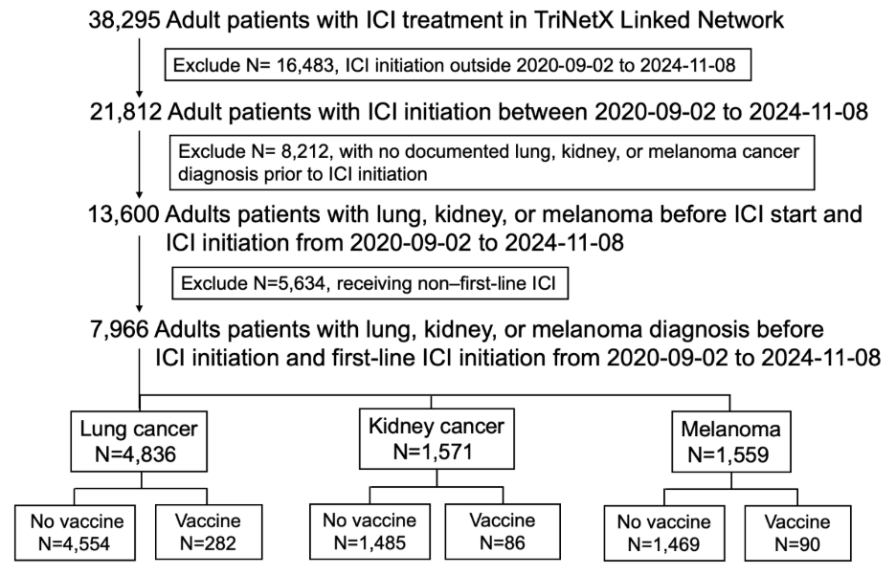

Among the 38,295 adult patients with Immune Checkpoint Inhibitor (ICI) treatment in TriNetX Linked Network, encompassing 29 U.S. health systems and representing contemporary oncology practice from 2015–2025 (data extracted on Apr 2025), we excluded 1) 16,483 individuals who initiated ICI treatment outside 2020-09-02 to 2024-11-08; 2) 8,212 participants with no documented lung, kidney, or melanoma cancer diagnosis prior to ICI initiation; and 3) 5,634 participants who received non-first-line ICI treatment. The main analysis cohort included 7,966 adults with lung, kidney, or melanoma cancer diagnosis before ICI initiation who received first-line ICI therapy between September 2, 2020, and November 8, 2024. Among these patients, 4,836 had lung cancer diagnosis, 1,571 had kidney cancer and 1,559 had melanoma. Among 4,836 lung cancer participants, 282 received a COVID-19 mRNA vaccine within the 100-day grace period before or after ICI initiation (vaccinated group), and 4,554 did not (unvaccinated group). For kidney cancer, 86 participants were in the vaccinated group and 1,485 in the unvaccinated group; for melanoma, 90 were vaccinated and 1,469 were unvaccinated.

Extended Data Figure 2. Unadjusted overall survival and treatment-free survival curves by COVID-19 vaccine arms
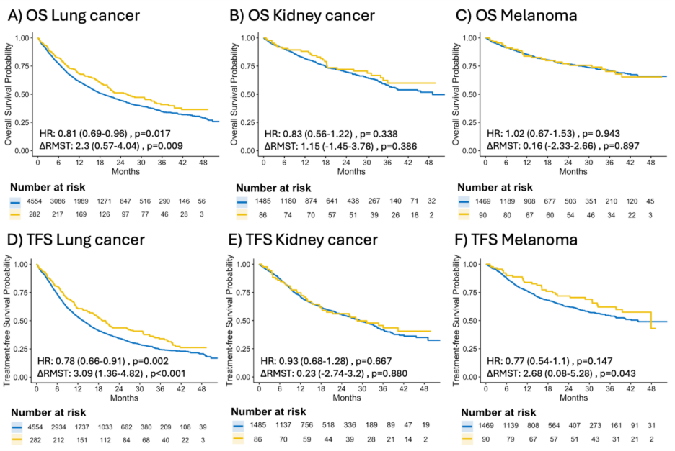

The outcomes included A-C) overall survival probability and D-F) treatment-free survival probability, with A) and D) lung cancer, B) and E) kidney cancer, and C) and F) melanoma. The x-axis of each figure was the month since first-line ICI initiation. The curves were colored by the treatment group (blue: no vaccine and yellow: vaccine). The number of participants at risk at each time point were listed below each figure. The hazard ratio (HR; vaccinated vs. unvaccinated) and the 3-year restricted mean survival time difference (ΔRMST; vaccinated minus unvaccinated), along with corresponding p-values, were estimatedThe figures were generated by Simon Mackuh Survival curves to accommodate time-varying vaccination dates within 100 days of ICI initiation.

Extended Data Figure 3. Unadjusted overall survival and treatment-free survival curves by COVID-19 vaccine initiation strategy and timing.
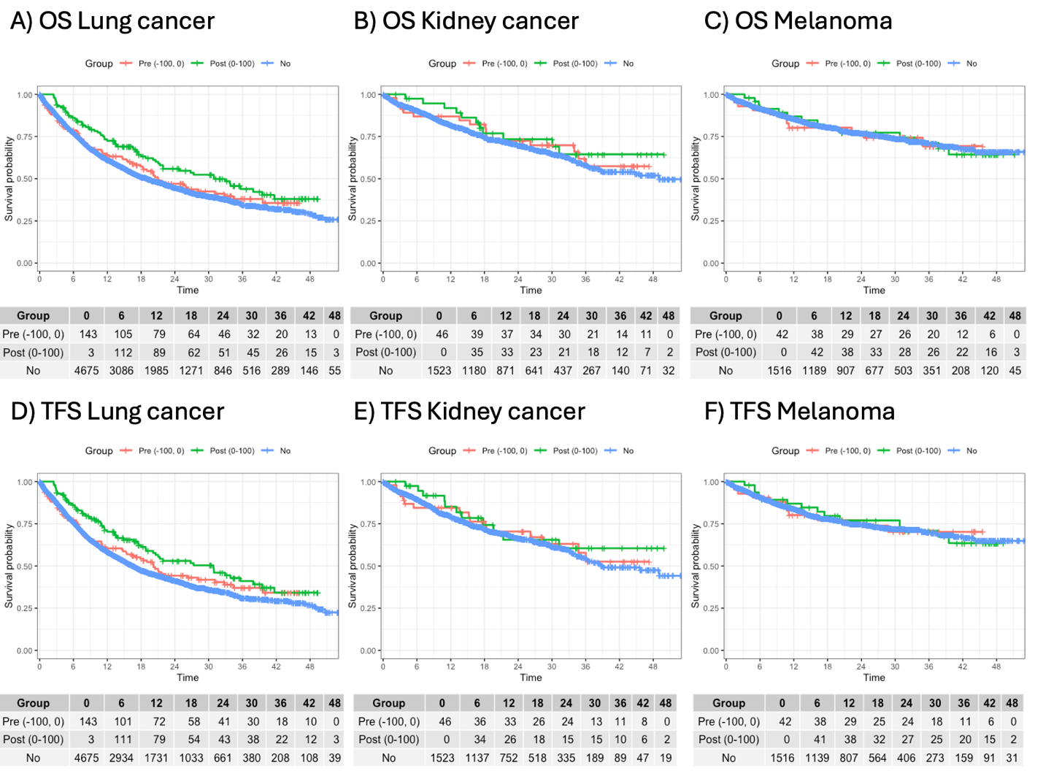

The outcomes included observed A-C) overall survival probability and D-F) treatment-free survival probability, with A) and D) lung cancer, B) and E) kidney cancer, and C) and F) melanoma. The x-axis of each figure was the month since first-line ICI initiation. The curves were colored by the COVID-19 vaccine initiation strategy and timing (blue: no vaccine, red: vaccine within 100 days before ICI initiation and green: vaccine within 100 days after ICI initiation). The number of participants at risk at each time point were listed in the table below each figure. The figures were generated by Simon Mackuh Survival curves to accommodate time-varying vaccination dates between 0-100 days post ICI initiation.

Extended Data Figure 4. Adjusted subgroup analyses of overall survival and treatment-free survival by COVID-19 vaccination vs no-vaccination strategy, stratified by pandemic and post-pandemic
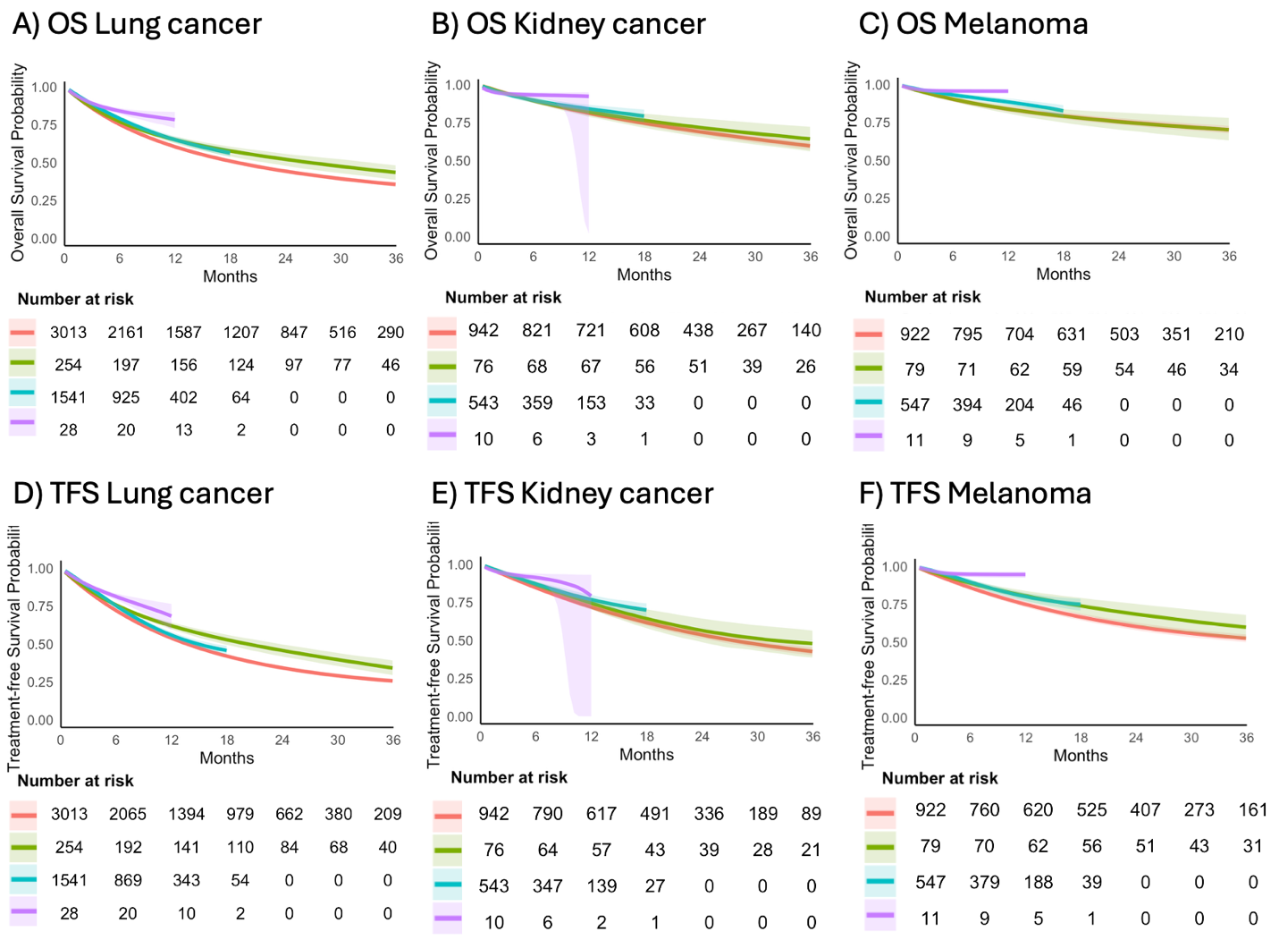

The outcomes included A-C) overall survival probability and D-F) treatment-free survival probability, with A) and E) lung cancer, B) and F) kidney cancer, and C) and F) melanoma. The x-axis of each figure was the month since first-line ICI initiation. The curves were colored by the COVID-19 vaccine initiation strategy and pandemic (red: pandemic and no vaccine, green: pandemic and vaccine, blue: post-pandemic and no vaccine, and purple: post-pandemic and vaccine). The overall survival and treatment-free survival probabilities were estimated in the target trial emulation. Shaded areas represented the 95% confidence intervals constructed using bootstrap replications. The number of participants at risk at each time point were listed below each figure.

Extended Data Figure 5. Adjusted overall survival curves by COVID-19 vaccination vs no-vaccination strategy within 200 days of ICI initiation.
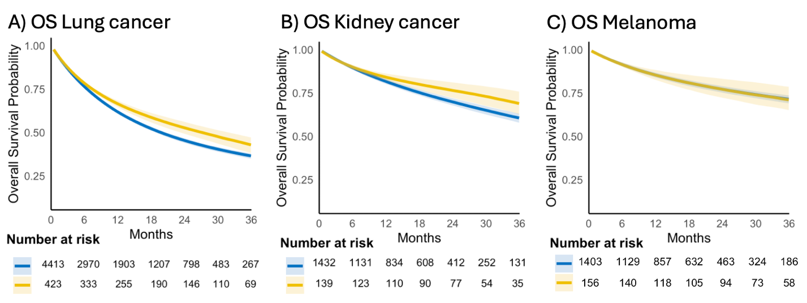

The outcomes included overall survival for A) lung cancer, B) kidney cancer, and C) melanoma. The x-axis of each figure was the month since first-line ICI initiation. The curves were colored by the COVID-19 vaccine initiation strategy within 200 days of ICI initiation (blue: no vaccine and yellow: vaccine). The overall survival probabilities were estimated in the target trial emulation. Shaded areas represented the 95% confidence intervals constructed using bootstrap replications. The number of participants at risk at each time point were listed below each figure.
Extended Data Figure 6. Adjusted overall survival curves by Flu vaccination vs no-vaccination strategy within 100 days of ICI initiation.
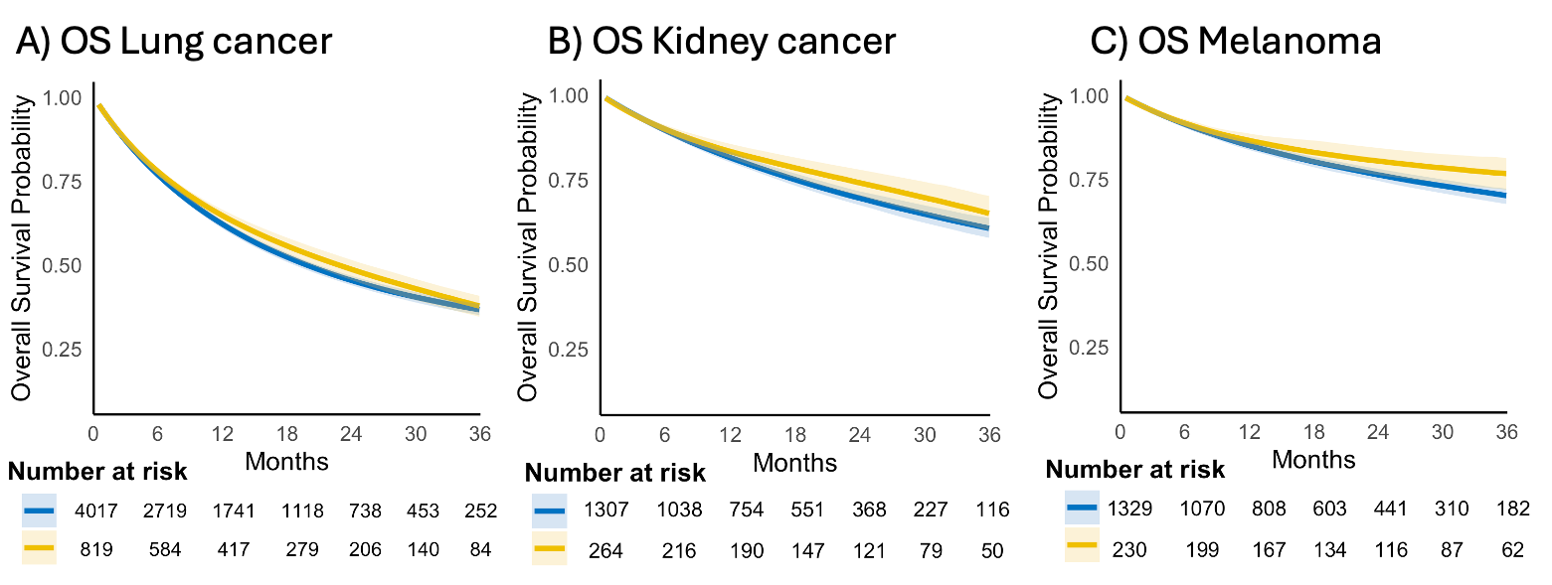

The outcomes included overall survival for A) lung cancer, B) kidney cancer, and C). The x-axis of each figure was the month since first-line ICI initiation. The curves were colored by the Flu vaccine initiation strategy within 100 days of ICI initiation (blue: no vaccine and yellow: vaccine). The overall survival probabilities were estimated in the target trial emulation. Shaded areas represented the 95% confidence intervals constructed using bootstrap with 500 replications. The number of participants at risk at each time point were listed below each figure.

Extended Data Table 1. Description of a target randomized control trial and the corresponding trial emulation
Study element | Target trial | Emulated trial (observational study)
Eligibility criteria | Diagnosed with three types of cancer (lung cancer, kidney cancer, and melanoma) before ICI initiation | Diagnosed with three types of cancer (lung cancer, kidney cancer, and melanoma) in TriNetX before ICI initiation between 2015-2024.
Eligibility criteria | Received at least one dose of an ICI as part of first-line systemic therapy between 2020-09-02 and 2024-11-08. | Received at least one dose of an ICI as part of first-line systemic therapy between 2020-09-02 and 2024-11-08.
Eligibility criteria | Age ≥ 18 at time of first-line ICI initiation date. | Age ≥ 18 at time of first-line ICI initiation date.
Treatment strategies | Treatment arm: Initiate a COVID-19 mRNA vaccine within 100-day of ICIª initiation.  Control arm: Do not initiate a COVID-19 mRNA vaccine within 100-day of ICI initiation. | Treatment arm^{b}: Initiate a COVID-19 mRNA vaccine within −100 to +100 days of ICI initiation  Control arm: Do not initiate a COVID-19 mRNA vaccine during the interval −100 to +100 days from ICI initiation.
Treatment assignment | Time zero: ICI initiation.  Open label, randomized treatment assignment occurs at time zero. | Time zero: same.  Emulated randomization^{c}.
Outcomes | Primary: Overall survival time  Secondary: Treatment-free survival | Same.
Follow-up | Starts at randomized treatment assignment (time zero) and ends at death, end of clinical follow-up, or 2025-02-16, whichever occurs first. | Start at time zero and ends at date of death (as recorded in TriNetX Research Network), end of follow-up, or 2025-02-16, whichever occurs first.
Causal contrast | Intention-to-treat effect. | Observational analog of intention-to-treat effect.
Statistical analysis | Intention-to-treat effect analysis, accounting for censoring. | Intention-to-treat effect analysis, accounting for censoring and baseline confounding.
a. ICI, Immune checkpoint inhibitors.
b. Vaccinations occurring −100 to 0 days are treated as baseline initiation, equivalent to day-0 initiation in the target trial. Vaccinations 0 to +100 days count as grace-period initiation.
c. Emulated randomization was achieved by cloning individuals and applying inverse probability of censoring weights (IPCW) to account for deviations from the assigned treatment strategy.
Extended Data Table 2. List of query codes for cancer diagnoses, immunotherapy, chemotherapy, COVID-19 vaccination, influenza vaccination, and comorbidity index.
Cancer Diagnosis
Lung cancer | ICD-10-CM: C34 | Malignant neoplasm of bronchus and lung
Melanoma | ICD-10-CM: C43 | Malignant melanoma of skin
Kidney cancer | ICD-10-CM: C64 | Renal cell carcinoma: Malignant neoplasm of kidney, except renal pelvis
Immunotherapy
Pembrolizumab | RxNorm:1547545 | Pembrolizumab
 | HCPCS: J9271 | Procedure: Injection, Pembrolizumab
Ipilimumab | RxNorm: 1094833 | Ipilimumab
 | HCPCS: J9228 | Procedure: Injection, Ipilimumab
Tremelimumab | RxNorm: 2619313 | Tremelimumab
Nivolumab | RxNorm: 1597876 | Nivolumab
 | HCPCS: J9299 | Procedure: Injection, Nivolumab
Cemiplimab | RxNorm: 2058826 | Cemiplimab
 | HCPCS: J9119 | Procedure: Injection, Cemiplimab
Dostarlimab | RxNorm: 2539967 | Dostarlimab
 | HCPCS: J9272 | Procedure: Injection, Dostarlimab
Atezolizumab | RxNorm: 1792776 | Atezolizumab
 | HCPCS: J9022 | Procedure: Injection, Atezolizumab
Avelumab | RxNorm: 1875534 | Avelumab
 | HCPCS: J9023 | Procedure: Injection, Avelumab
Durvalumab | RxNorm: 1919503 | Durvalumab
 | HCPCS: J9173 | Procedure: Injection, Durvalumab
Relatlimab | RxNorm: 2596773 | Relatlimab
Covid 19 mRNA Vaccine
Pfizer mRNA vaccine | CPT: 0001A-0004A, 0021A, 0022A, 0034A, 0051A-0054A, 0064A, 0071A-0074A, 0081A-0083A, 0091A-0094A, 91300, 91305, 91312, 91313, 91320, 91321  CVX: 208, 300  RxNorm: 2610319, 2610347, 2623382
Moderna mRNA vaccine | CPT: 0011A-0013A, 0104A, 0111A-0113A, 0124A, 0134A, 0144A, 0154A, 0164A, 91301, 91306, 91314, 91315, 91322  CVX: 207, 301  RxNorm: 2610328, 2623378
Other mRNA vaccine | CPT: 0031A, 0041A-0042A, 0044A, 0173A-0174A, 91302-91304, 91307-91311, 91316-91319  CVX: 210, 212, 213, 217-219, 221, 227-230, 302, 308, 309, 310-312, 500-520  ICD-10-PCS: XW013S6, XW013T6, XW013U6, XW013V7, XW013W7, XW023S6, XW023T6, XW023U6, XW023V7, XW023W7
Flu Vaccine
Flu vaccine | RxNorm: Z23; CPT: 90656, 90658, 90660, 90653, 90756
Chemotherapy
Cisplatin | RxNorm: 2555
Carboplatin | RxNorm: 40048
Pemetrexed | RxNorm: 68446
 | HCPCS: J9305
Paclitaxel | RxNorm: 56946
Gemcitabine | RxNorm: 12574
 | HCPCS: J9201
Etoposide | RxNorm: 4179
Irinotecan | RxNorm: 51499
Methotrexate | RxNorm: 6851
Vinblastine | RxNorm: 11198
Doxorubicin | RxNorm: 3639
Docetaxel | RxNorm: 72962
5-Fluorouracil | RxNorm: 4492 | Fluorouracil
Leucovorin | RxNorm: 6313
Oxaliplatin | RxNorm: 32592
 | HCPCS: J9263
Capecitabine | RxNorm: 194000
Dacarbazine | RxNorm: 3098
 | HCPCS: J9130
Temozolomide | RxNorm: 37776
Floxuridine | RxNorm: 4488
 | HCPCS: J9200
Epirubicin | RxNorm: 3995
Vinorelbine | RxNorm: 39541
 | HCPCS: J9390
Ifosfamide | RxNorm: 5657
Vascular Endothelial Growth Factor-Tyrosine Kinase Inhibitors (VEGF-TKI)
Sunitinib | RxNorm: 357977
Pazopanib | RxNorm: 714438
Sorafenib | RxNorm: 1242999
Axitinib | RxNorm: 1363268
Cabozantinib | RxNorm: 1603296
Lenvatinib | RxNorm: 495881
Tivozanib | RxNorm: 2534233
Charlson Comorbidity Index score
Myocardial infarction | ICD-10: I21, I22, I25.2
Congestive heart failure | ICD-10: I50, I11.0, I13.0, I13.2
Peripheral vascular disease | ICD-10: I70, I71, I73.1, I73.9, I77.1
Cerebrovascular disease | ICD-10: I60–I69, G45
Dementia | ICD-10: F00–F03, G30
Chronic obstructive pulmonary disease | ICD-10: J40–J47, J60–J67
Connective tissue disease | ICD-10: M05, M06, M31.5, M32–M34, M35.1, M35.3, M36.0
Peptic ulcer disease | ICD-10: K25-K28
Liver disease (mild) | ICD-10: B18, K70.0–K70.3, K70.9, K71.3–K71.5, K73, K74.0–K74.2, K76.0
Diabetes mellitus | ICD-10: E10.9, E11.9, E13.9
Diabetes mellitus with end-organ damage | ICD-10: E10.2–E10.7, E11.2–E11.7, E13.2–E13.7
Hemiplegia | ICD-10: G81, G82
Chronic kidney disease (moderate to severe) | ICD-10: N18.4–N18.6, N19, I12.0, I13.1
Liver disease (moderate to severe) | ICD-10: K72.9, K76.6, K70.4, K71.1, K74.3–K74.6
Malignancy (metastatic) | ICD-10: C77-C80
Leukemia (included in solid cancer) | ICD-10: C91-C95
Lymphoma (included in solid cancer) | ICD-10: C81–C85, C88
Acquired immunodeficiency syndrome | ICD-10: B20-B22, B24, Z21

Extended Data Table 3: Patients baseline characteristics by cancer type and by vaccination arms
 | Lung cancer |  | Kidney cancer |  | Melanoma
 | No Vaccine  (N=4,554) | Vaccine  (N=282) | No Vaccine  (N=1,485) | Vaccine  (N=86) | No Vaccine  (N=1,469) | Vaccine  (N=90)
Age at ICI initiation (mean (SD))ª | 63.83 (9.37) | 63.22 (9.15) | 61.10 (10.43) | 61.66 (9.35) | 58.65 (13.54) | 60.31 (11.63)
Pandemic (2020-May, 2023), N (%) | 3013 (66.2) | 254 (90.1) | 942 (63.4) | 76 (88.4) | 922 (62.8) | 79 (87.8)
Male, N (%) | 2509 (55.1) | 149 (52.8) | 1063 (71.6) | 67 (77.9) | 881 (60.0) | 53 (58.9)
Race, N (%)
White | 2430 (53.4) | 143 (50.7) | 786 (52.9) | 41 (47.7) | 983 (66.9) | 64 (71.1)
Black | 685 (15.0) | 54 (19.1) | 108 (7.3) | 5 (5.8) | 31 (2.1) | 1 (1.1)
Asian and other | 454 (10.0) | 24 (8.5) | 206 (13.9) | 15 (17.4) | 88 (6.0) | 5 (5.6)
Unknown | 985 (21.6) | 61 (21.6) | 385 (25.9) | 25 (29.1) | 367 (25.0) | 20 (22.2)
Ethnicity, N (%)
Hispanic or Latino | 142 (3.1) | 10 (3.5) | 157 (10.6) | 14 (16.3) | 42 (2.9) | 2 (2.2)
Not Hispanic or Latino | 3121 (68.5) | 185 (65.6) | 989 (66.6) | 53 (61.6) | 1124 (76.5) | 72 (80.0)
Unknown | 1291 (28.3) | 87 (30.9) | 339 (22.8) | 19 (22.1) | 303 (20.6) | 16 (17.8)
Marital status, N (%)
Married | 1429 (31.4) | 70 (24.8) | 584 (39.3) | 30 (34.9) | 594 (40.4) | 38 (42.2)
Single | 1431 (31.4) | 77 (27.3) | 424 (28.6) | 24 (27.9) | 396 (27.0) | 20 (22.2)
Unknown | 1694 (37.2) | 135 (47.9) | 477 (32.1) | 32 (37.2) | 479 (32.6) | 32 (35.6)
CCI (mean (SD))^{b} | 8.88 (3.44) | 9.13 (3.35) | 8.24 (3.68) | 9.26 (2.98) | 7.69 (3.09) | 7.82 (2.86)
Metastatic, N (%) | 3488 (76.6) | 220 (78.0) | 1036 (69.8) | 74 (86.0) | 1108 (75.4) | 71 (78.9)
Concurrent chemo, N (%) | 2938 (64.5) | 174 (61.7) | 70 (4.7) | 2 (2.3) | 46 (3.1) | 1 (1.1)
ICI type, N (%)^{c}
Anti-PD1 | 3395 (74.5) | 225 (79.8) | 1457 (98.1) | 84 (97.7) | 1421 (96.7) | 89 (98.9)
Anti-PDL1 | 1233 (27.1) | 60 (21.3) | 37 (2.5) | 2 (2.3) | 17 (1.2) | 1 (1.1)
Vaccine timing, N (%)
Pre-index | 0 (0.0) | 138 (48.9) | 0 (0.0) | 40 (46.5) | 0 (0.0) | 48 (53.3)
Post-index | 0 (0.0) | 144 (51.1) | 0 (0.0) | 46 (53.5) | 0 (0.0) | 42 (46.7)
Vaccine brand, N (%)
Pfizer | 0 (0.0) | 225 (79.8) | 0 (0.0) | 69 (80.2) | 0 (0.0) | 67 (74.4)
Moderna | 0 (0.0) | 105 (37.2) | 0 (0.0) | 42 (48.8) | 0 (0.0) | 42 (46.7)
Vaccine shots in window, N (%)
1 | 0 (0.0) | 176 (62.4) | 0 (0.0) | 56 (65.1) | 0 (0.0) | 56 (62.2)
2 | 0 (0.0) | 99 (35.1) | 0 (0.0) | 27 (31.4) | 0 (0.0) | 34 (37.8)
3 | 0 (0.0) | 4 (1.4) | 0 (0.0) | 3 (3.5) | 0 (0.0) | 0 (0.0)
4 | 0 (0.0) | 3 (1.1) | 0 (0.0) | 0 (0.0) | 0 (0.0) | 0 (0.0)
Vaccine window, N (%)
-100 to -30 | 0 (0.0) | 94 (33.3) | 0 (0.0) | 34 (39.5) | 0 (0.0) | 24 (26.7)
-30 to 0 | 0 (0.0) | 50 (17.7) | 0 (0.0) | 12 (14.0) | 0 (0.0) | 18 (20.0)
0 to 30 | 0 (0.0) | 42 (14.9) | 0 (0.0) | 11 (12.8) | 0 (0.0) | 11 (12.2)
30 to 100 | 0 (0.0) | 96 (34.0) | 0 (0.0) | 29 (33.7) | 0 (0.0) | 37 (41.1)
Median follow up, mo (range) | 20.1 (0, 53.1) | 32.9 (0.9, 49.4) | 20.9 (0, 53.0) | 34.7 (2.3, 49.9) | 21.3 (0, 53.1) | 36.2 (4.1, 51.2)
Median OS, mo [95% CI]^{d} | 18.9 (17.5, 20.5) | 25.6 (20.5, 33.9) | NA (NA, NA) | NA (NA, NA) | NA (NA, NA) | NA (NA, NA)
a. ICI: immune checkpoint inhibitor.
b. CCI: Charlson Comorbidity Index.
c. ICI type was defined as backbone anti-PD1 (Nivolumab, Pembrolizumab, Cemiplimab, or Dostarlimab), anti-PDL1 (Atezolizumab, Avelumab or Durvalumab).
d. The median OS cannot be calculated for kidney and melanoma cancer because the 50% survival rate has not reached.

Extended Data Table 4. Unadjusted one-year, two-year and three-year restricted mean survival time difference (ΔRMST), risk ratio (RR) and hazard ratio (HR) for the vaccination vs no-vaccination strategy.
Cancer Type | RMSTª Vax (mo) | RMST No-Vax (mo) | RMST Difference (mo) | P Value^{b} | Risk Vax | Risk No-Vax | Risk Ratio | P Value^{b} | Hazard Ratio^{c} | P Value^{b}
1-year Overall Survival
Lung | 9.87 (9.44-10.31) | 9.35 (9.23-9.47) | 0.53 (0.08-0.97) | 0.022 | 0.32 (0.27-0.38) | 0.39 (0.38-0.41) | 0.82 (0.69-0.98) | 0.026 | - | -
Kidney | 11.06 (10.47-11.64) | 10.81 (10.66-10.97) | 0.25 (-0.36-0.85) | 0.423 | 0.12 (0.05-0.19) | 0.19 (0.16-0.21) | 0.65 (0.36-1.16) | 0.141 | - | -
Melanoma | 11.12 (10.61-11.63) | 11.02 (10.88-11.16) | 0.1 (-0.44-0.63) | 0.724 | 0.16 (0.08-0.24) | 0.15 (0.13-0.16) | 1.11 (0.68-1.81) | 0.668 | - | -
1-year Treatment-free Survival
Lung | 9.59 (9.15-10.03) | 8.93 (8.81-9.05) | 0.66 (0.21-1.12) | 0.004 | 0.4 (0.34-0.45) | 0.47 (0.45-0.49) | 0.84 (0.73-0.97) | 0.021 | - | -
Kidney | 10.39 (9.71-11.06) | 10.33 (10.17-10.5) | 0.05 (-0.65-0.75) | 0.887 | 0.25 (0.16-0.35) | 0.29 (0.27-0.32) | 0.87 (0.6-1.27) | 0.478 | - | -
Melanoma | 11.07 (10.54-11.6) | 10.53 (10.37-10.7) | 0.53 (-0.02-1.09) | 0.057 | 0.16 (0.08-0.24) | 0.24 (0.21-0.26) | 0.68 (0.42-1.09) | 0.111 | - | -
2-year Overall Survival
Lung | 17.05 (16.01-18.08) | 15.56 (15.28-15.84) | 1.49 (0.42-2.56) | 0.007 | 0.49 (0.43-0.55) | 0.56 (0.54-0.57) | 0.88 (0.78-1) | 0.041 | - | -
Kidney | 20.49 (19.05-21.94) | 19.83 (19.43-20.23) | 0.67 (-0.83-2.16) | 0.382 | 0.28 (0.18-0.38) | 0.3 (0.28-0.33) | 0.92 (0.65-1.3) | 0.632 | - | -
Melanoma | 20.77 (19.37-22.17) | 20.68 (20.31-21.05) | 0.09 (-1.35-1.54) | 0.900 | 0.23 (0.14-0.32) | 0.23 (0.21-0.26) | 0.99 (0.67-1.47) | 0.967 | - | -
2-year Treatment-free Survival
Lung | 15.85 (14.81-16.9) | 14 (13.72-14.27) | 1.86 (0.78-2.94) | 0.001 | 0.57 (0.5-0.63) | 0.66 (0.64-0.67) | 0.86 (0.78-0.96) | 0.005 | - | -
Kidney | 17.85 (16.13-19.58) | 17.8 (17.35-18.25) | 0.05 (-1.73-1.83) | 0.954 | 0.44 (0.33-0.55) | 0.45 (0.42-0.48) | 0.98 (0.77-1.25) | 0.884 | - | -
Melanoma | 20.31 (18.89-21.74) | 18.73 (18.29-19.16) | 1.59 (0.1-3.08) | 0.037 | 0.28 (0.18-0.38) | 0.38 (0.35-0.41) | 0.75 (0.53-1.04) | 0.087 | - | -
3-year Overall Survival
Lung | 22.61 (20.93-24.28) | 20.3 (19.85-20.76) | 2.3 (0.57-4.04) | 0.009 | 0.59 (0.52-0.66) | 0.66 (0.63-0.68) | 0.9 (0.82-1) | 0.048 | 0.81 (0.69-0.96) | 0.017
Kidney | 28.72 (26.21-31.22) | 27.56 (26.86-28.27) | 1.15 (-1.45-3.76) | 0.386 | 0.38 (0.26-0.49) | 0.42 (0.38-0.46) | 0.9 (0.68-1.19) | 0.457 | 0.83 (0.56-1.22) | 0.338
Melanoma | 29.71 (27.3-32.12) | 29.54 (28.89-30.2) | 0.16 (-2.33-2.66) | 0.897 | 0.3 (0.19-0.4) | 0.29 (0.26-0.32) | 1.03 (0.74-1.43) | 0.851 | 1.02 (0.67-1.53) | 0.943
3-year Treatment-free Survival
Lung | 20.58 (18.91-22.25) | 17.49 (17.06-17.93) | 3.09 (1.36-4.82) | <0.001 | 0.66 (0.6-0.73) | 0.76 (0.74-0.78) | 0.87 (0.8-0.95) | 0.002 | 0.78 (0.66-0.91) | 0.002
Kidney | 23.91 (21.04-26.78) | 23.68 (22.92-24.45) | 0.23 (-2.74-3.2) | 0.880 | 0.54 (0.43-0.66) | 0.58 (0.54-0.62) | 0.94 (0.77-1.14) | 0.508 | 0.93 (0.68-1.28) | 0.667
Melanoma | 28.36 (25.87-30.85) | 25.68 (24.93-26.43) | 2.68 (0.08-5.28) | 0.043 | 0.38 (0.27-0.49) | 0.46 (0.42-0.49) | 0.83 (0.63-1.09) | 0.175 | 0.77 (0.54-1.1) | 0.147
a. RMST: Restricted Mean Survival Time.
b. Significance was determined by Bonferroni corrected alpha at 0.017. Significant results were bolded.
c. Hazard ratios were estimated from Cox regression models throughout follow-up

Extended Data Table 5. Adjusted restricted mean survival time difference (ΔRMST) and risk ratio (RR) for the vaccination vs no-vaccination strategy across cancer types estimated from the target trial emulation at one-, two- and three-years.

Cancer Type | RMSTª Vax (mo) | RMST No-Vax (mo) | RMST Difference (mo) | P Value^{b} | Risk Vax | Risk No-Vax | Risk Ratio | P Value^{b}
3-year Overall Survival^{c}
Lung | 22.95 (22.03-23.76) | 20.62 (20.29-20.97) | 2.33 (1.41-3.23) | <0.001 | 0.55 (0.5-0.6) | 0.64 (0.62-0.65) | 0.86 (0.79-0.94) | 0.004
Kidney | 29.29 (28.12-30.65) | 27.74 (27.24-28.24) | 1.55 (0.33-2.89) | 0.018 | 0.3 (0.23-0.38) | 0.39 (0.37-0.42) | 0.77 (0.58-0.97) | 0.020
Melanoma | 29.79 (28.51-31.2) | 29.52 (29.05-29.98) | 0.26 (-1.08-1.55) | 0.740 | 0.28 (0.2-0.35) | 0.29 (0.27-0.31) | 0.95 (0.7-1.21) | 0.748
3-year Treatment Free Survival^{c}
Lung | 21.04 (20.1-22.09) | 17.83 (17.5-18.17) | 3.21 (2.21-4.22) | <0.001 | 0.64 (0.59-0.69) | 0.74 (0.73-0.75) | 0.87 (0.8-0.93) | <0.001
Kidney | 25.57 (23.79-27.25) | 23.98 (23.43-24.54) | 1.59 (-0.24-3.22) | 0.096 | 0.48 (0.39-0.58) | 0.56 (0.53-0.58) | 0.87 (0.7-1.04) | 0.16
Melanoma | 28 (26.54-29.56) | 25.73 (25.19-26.28) | 2.26 (0.62-4.05) | 0.018 | 0.38 (0.28-0.46) | 0.46 (0.43-0.48) | 0.82 (0.61-1) | 0.048
2-year Overall Survival^{c}
Lung | 16.94 (16.51-17.33) | 15.75 (15.56-15.97) | 1.19 (0.76-1.59) | <0.001 | 0.45 (0.42-0.49) | 0.55 (0.53-0.56) | 0.83 (0.76-0.9) | <0.001
Kidney | 20.5 (19.97-21.08) | 19.9 (19.63-20.19) | 0.6 (0.06-1.16) | 0.032 | 0.23 (0.18-0.28) | 0.3 (0.28-0.32) | 0.78 (0.61-0.95) | 0.004
Melanoma | 20.79 (20.21-21.38) | 20.67 (20.41-20.91) | 0.11 (-0.48-0.67) | 0.696 | 0.22 (0.16-0.27) | 0.23 (0.21-0.25) | 0.95 (0.72-1.2) | 0.716
2-year Treatment Free Survival^{c}
Lung | 16.07 (15.62-16.57) | 14.25 (14.04-14.46) | 1.82 (1.35-2.32) | <0.001 | 0.53 (0.48-0.57) | 0.65 (0.64-0.66) | 0.81 (0.74-0.87) | <0.001
Kidney | 18.81 (17.96-19.59) | 18.03 (17.71-18.36) | 0.78 (-0.09-1.53) | 0.068 | 0.39 (0.32-0.46) | 0.44 (0.42-0.47) | 0.87 (0.72-1.04) | 0.14
Melanoma | 20.02 (19.36-20.71) | 18.81 (18.48-19.11) | 1.21 (0.47-1.93) | 0.008 | 0.29 (0.22-0.36) | 0.38 (0.36-0.4) | 0.77 (0.59-0.96) | 0.012
1-year Overall Survival^{c}
Lung | 9.67 (9.56-9.77) | 9.41 (9.33-9.51) | 0.26 (0.17-0.34) | <0.001 | 0.33 (0.31-0.35) | 0.38 (0.37-0.39) | 0.86 (0.81-0.91) | <0.001
Kidney | 10.88 (10.74-11.01) | 10.82 (10.71-10.92) | 0.06 (-0.04-0.16) | 0.232 | 0.16 (0.13-0.18) | 0.18 (0.17-0.2) | 0.87 (0.75-1) | 0.048
Melanoma | 11.02 (10.88-11.15) | 11 (10.9-11.1) | 0.02 (-0.09-0.14) | 0.684 | 0.14 (0.12-0.17) | 0.15 (0.14-0.16) | 0.97 (0.81-1.15) | 0.688
1-year Treatment Free Survival^{c}
Lung | 9.49 (9.37-9.59) | 9.02 (8.94-9.11) | 0.46 (0.37-0.56) | <0.001 | 0.36 (0.34-0.38) | 0.45 (0.44-0.46) | 0.81 (0.76-0.85) | <0.001
Kidney | 10.57 (10.4-10.73) | 10.35 (10.23-10.46) | 0.22 (0.08-0.35) | <0.001 | 0.23 (0.2-0.27) | 0.27 (0.25-0.28) | 0.87 (0.75-1.01) | 0.068
Melanoma | 10.87 (10.73-11.01) | 10.54 (10.43-10.65) | 0.32 (0.19-0.44) | <0.001 | 0.18 (0.15-0.2) | 0.23 (0.22-0.25) | 0.76 (0.63-0.89) | 0.004
a. RMST: Restricted Mean Survival Time.
b. Significance was determined by Bonferroni corrected alpha at 0.017. Significant results were bolded.
c. All results were estimated from pooled logistic regression for all patients using inverse probability of censoring weights.

Extended Data Table 6. Variation in ICI Treatments Between Vaccinated and Unvaccinated Groups by Cancer Type.
 |  | Overall | No vaccine | Vaccine | P value
Lung | N | 4836 | 4554 | 282
Lung | Anti-PD1 mono, N (%) | 3272 (67.7) | 3070 (67.4) | 202 (71.6) | 0.160
Lung | Anti-PDL1 mono, N (%) | 1211 (25.0) | 1154 (25.3) | 57 (20.2) | 0.063
Lung | Anti-PD1+chemo, N (%) | 2109 (43.6) | 1989 (43.7) | 120 (42.6) | 0.759
Lung | Anti-PDL1+chemo, N (%) | 867 (17.9) | 820 (18.0) | 47 (16.7) | 0.625
Kidney | N | 1571 | 1485 | 86
Kidney | Anti-PD1 mono, N (%) | 1102 (70.1) | 1047 (70.5) | 55 (64.0) | 0.242
Kidney | Anti-PDL1 mono, N (%) | 30 (1.9) | 28 (1.9) | 2 (2.3) | 1.000
Kidney | Anti-PD1+Ipilimumab, N (%) | 426 (27.1) | 397 (26.7) | 29 (33.7) | 0.196
Kidney | Nivolumab mono, N (%) | 282 (18.0) | 261 (17.6) | 21 (24.4) | 0.143
Kidney | Nivolumab+Ipilimumab, N (%) | 426 (27.1) | 397 (26.7) | 29 (33.7) | 0.196
Kidney | VEGF-TKIª, N (%) | 654 (41.6) | 609 (41.0) | 45 (52.3) | 0.050
Melanoma | N | 1559 | 1469 | 90
Melanoma | Anti-PD1 mono, N (%) | 890 (57.1) | 836 (56.9) | 54 (60.0) | 0.642
Melanoma | Nivolumab mono, N (%) | 334 (21.4) | 308 (21.0) | 26 (28.9) | 0.100
Melanoma | Anti-PD1+Ipilimumab, N (%) | 588 (37.7) | 555 (37.8) | 33 (36.7) | 0.921
Melanoma | Nivolumab+Ipilimumab, N (%) | 583 (37.4) | 550 (37.4) | 33 (36.7) | 0.972
- VEGF-TKI: vascular endothelial growth factor-tyrosine kinase inhibitors, including Sunitinib, Pazopanib,Sorafenib, Axitinib, Cabozantinib, Lenvatinib, and Tivozanib

