Supplementary Material

5 km

Figure S1. The Marginalization Index (MI) across the SLPMA reflects the degree of socioeconomic deprivation experienced by communities. Developed by Consejo Nacional de Población and based on census data from INEGI, the MI incorporates indicators related to education, housing, income, and access to basic services. Areas classified as having very low marginalization exhibit the highest levels of access to services, education, and income. Regions with low marginalization maintain good access but still face some indicators of deprivation. Medium marginalization corresponds to communities with notable gaps in service provision, educational attainment, and income. High marginalization is associated with severe limitations in access to essential services and typically includes rural or geographically isolated areas. Very high marginalization denotes the most extreme levels of deprivation, often characterized by poverty, inadequate infrastructure, and limited opportunities for social and economic advancement.

Figure S2. Indoor air quality data collected in Classroom 5-C at Filomeno Mata Elementary School during epidemiological week 23 of 2023 (hot season), spanning Monday through Friday. Measurements of CO₂, PM_{2.5}, temperature, and relative humidity were recorded at one-minute intervals during class hours (08:00-14:00 h). Colored lines indicate the duration of classroom occupancy for each day of the week.

Figure S3. Boxplot of ventilation scores for the 106 school spaces included in the study, illustrating the distribution and variability of ventilation performance across classrooms and other monitored rooms

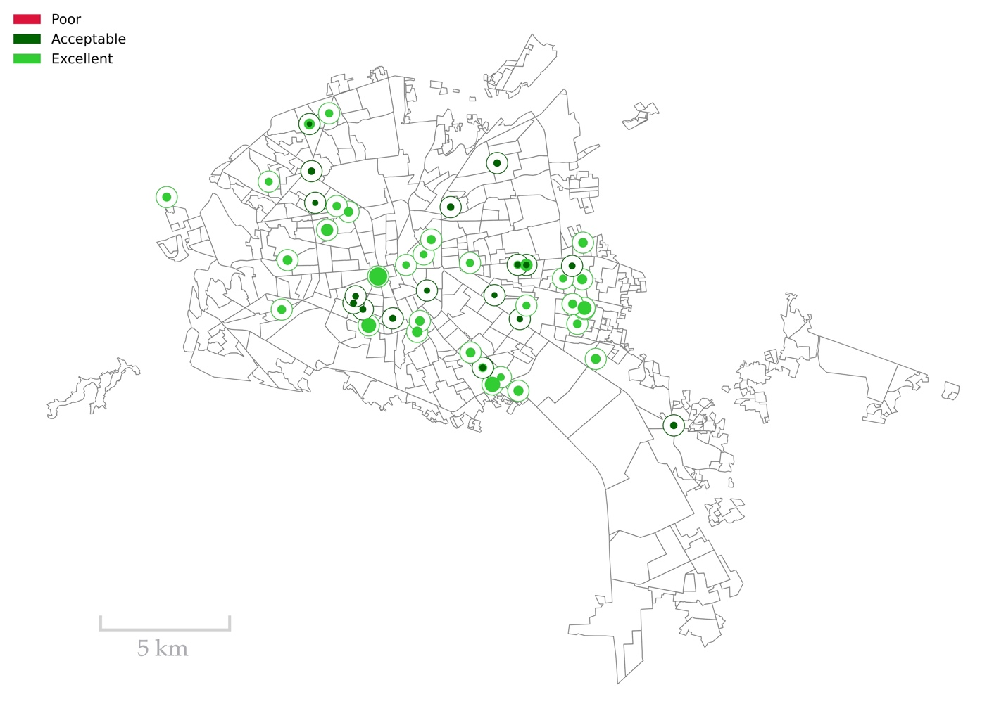

Figure S4. The map displays the ventilation score for each of the 76 classrooms included in the study, represented by colored circles. Ventilation scores range from a minimum of 0.98 to a maximum of 12.12, with an average value of 2.85. Circle color denotes the corresponding IAQ classification: red indicates poor IAQ, dark green represents acceptable IAQ, and light green signifies excellent IAQ.

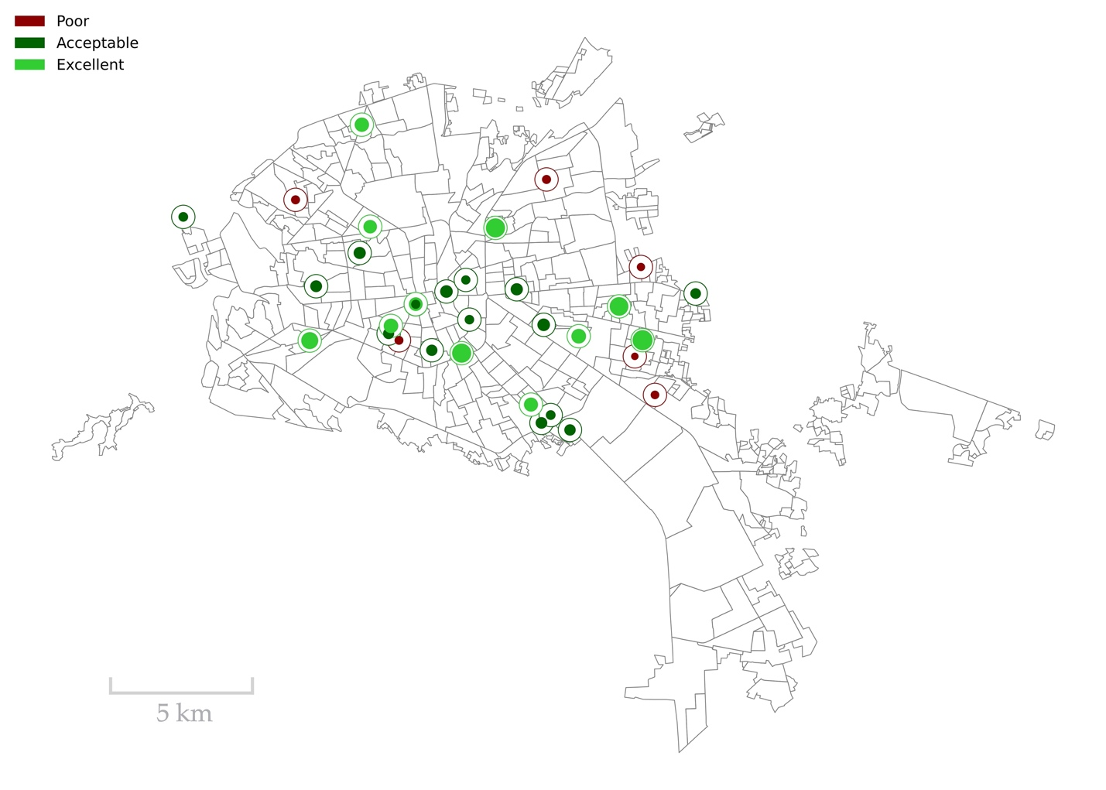

Figure S5. The map presents the ventilation score for each of the 33 additional rooms included in the study, represented by colored circles. Scores range from a minimum of 0.65 to a maximum of 4.87, with an average of 1.94. Circle color reflects the corresponding IAQ classification: red denotes poor IAQ, dark green indicates acceptable IAQ, and light green signifies excellent IAQ.

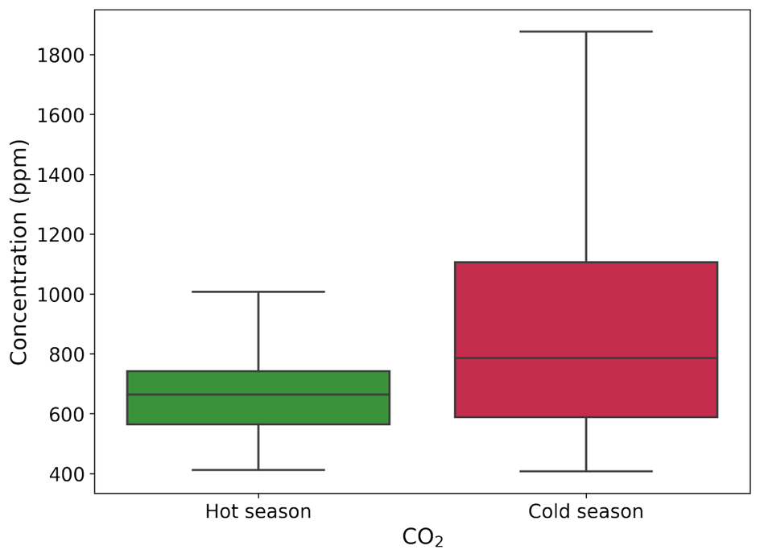
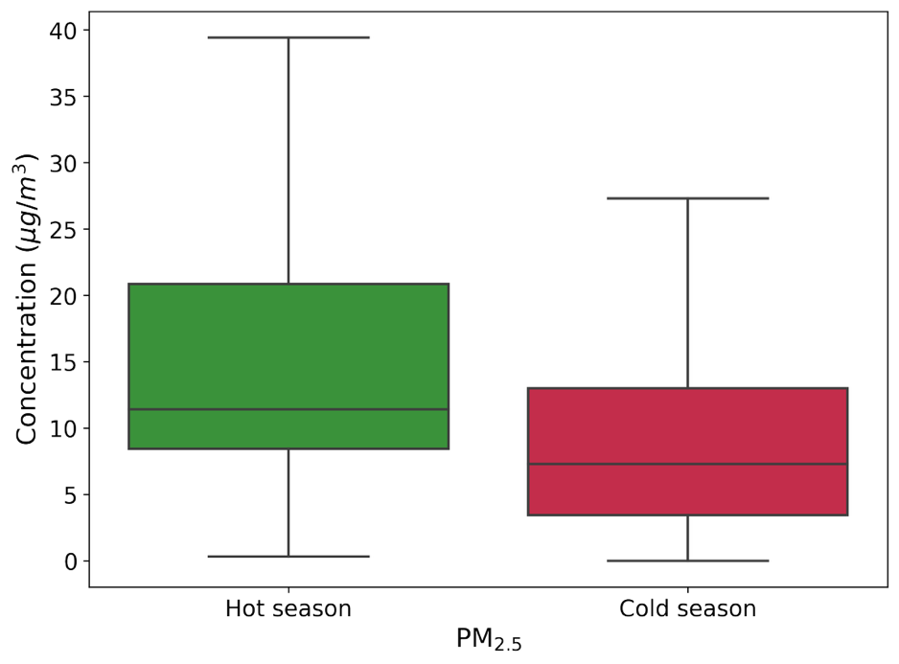

Figure S6. Boxplots of CO₂ and PM_{2.5} concentrations across hot and cold seasons for the 106 school spaces included in the study. The figure illustrates seasonal variability in IAQ, highlighting shifts in pollutant levels associated with climatic conditions and ventilation behavior.

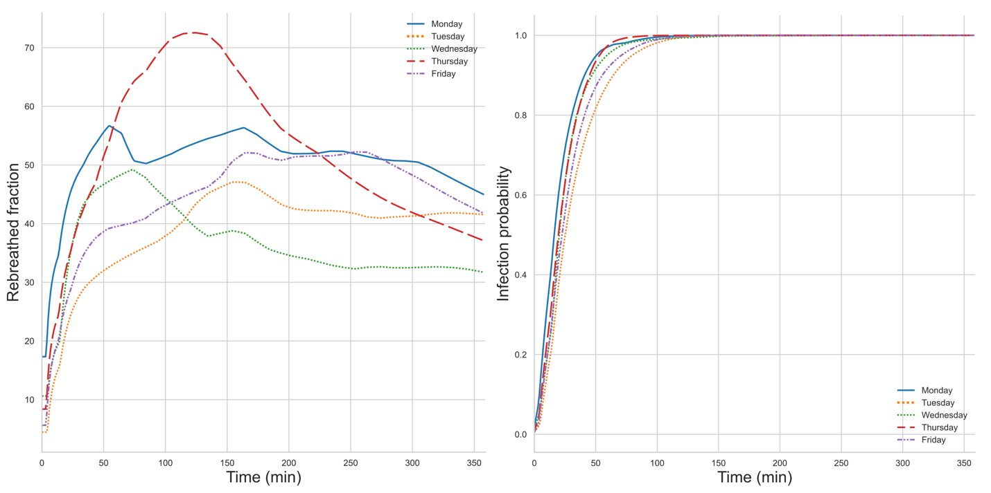

Figure S7. Top: Indoor CO₂ concentrations measured at Mariano Jiménez Elementary School during epidemiological week 48 (Monday to Friday). Bottom-left: Estimated rebreathed air fraction derived from CO₂ levels. Bottom-right: Infection probability for susceptible individuals, calculated using a dose-response model informed by the observed CO₂ data.

Figure S8. Spatial distribution of pollution sources (top) and emission sources (bottom) as a function of buffer radius. The figure presents the cumulative count of georeferenced sources located within concentric buffer zones extending from 100 to 3,000 meters around each school, in 100-meter increments. This multi-scale analysis reveals how source density evolves with increasing spatial coverage, suggesting a potential emission pressure in contexts where direct outdoor particulate matter measurements are lacking.

Figure S9. Location of the 53 elementary schools within the SLPMA included in our study. Schools are indicated as red circles.

Table S1. Geometric features of classrooms and other rooms.
Classrooms (N = 73)
Features | Mean | Std | Min | 25% | 50% | 75% | Max
Windows | 5.80 | 2.03 | 3.00 | 4.00 | 6.00 | 7.00 | 11.00
Length (m) | 7.39 | 1.28 | 5.79 | 6.09 | 7.84 | 7.90 | 13.29
Width (m) | 6.39 | 1.18 | 3.33 | 5.75 | 5.97 | 7.79 | 9.54
Height (m) | 3.29 | 0.61 | 2.08 | 2.97 | 3.31 | 3.46 | 6.78
A (m2) | 46.47 | 8.75 | 26.31 | 44.60 | 45.84 | 47.76 | 91.26
V (m3) | 169.21 | 149.69 | 74.13 | 136.40 | 151.81 | 157.73 | 1388.50
O (N) | 26.36 | 7.65 | 10.00 | 22.00 | 25.00 | 30.00 | 70.00
O/A (N/m2) | 1.13 | 0.33 | 0.22 | 0.91 | 1.09 | 1.28 | 1.99
O/V (N/m3) | 0.17 | 0.05 | 0.03 | 0.15 | 0.17 | 0.21 | 0.31
Other rooms (N = 33)
Features | Mean | Std | Min | 25% | 50% | 75% | Max
Windows | 5.48 | 4.19 | 1.00 | 3.00 | 5.00 | 7.00 | 24.00
Length (m) | 8.31 | 2.56 | 2.84 | 7.19 | 7.86 | 10.15 | 14.10
Width (m) | 6.34 | 1.75 | 1.81 | 5.55 | 5.91 | 7.78 | 9.98
Height (m) | 3.16 | 0.46 | 2.48 | 2.77 | 3.09 | 3.43 | 4.46
A (m2) | 53.53 | 23.75 | 10.48 | 41.99 | 46.07 | 65.13 | 101.30
V (m3) | 168.60 | 74.67 | 29.03 | 119.02 | 155.94 | 218.11 | 316.00
O (N) | 27.4 | 11.0 | 3.00 | 21.00 | 26.00 | 30.00 | 61.00
O/A (N/m2) | 1.07 | 0.37 | 0.03 | 0.75 | 1.12 | 1.28 | 2.00
O/V (N/m3) | 0.17 | 0.06 | 0.08 | 0.11 | 0.18 | 0.22 | 0.34

Table S2. Overall summary statistics for CO₂ and PM_{2.5} concentrations across school spaces
Pollutant | Season | Mean | Std | CV | Min | 25% | 50% | 75% | Max
CO₂ (ppm) | Hot | 666.67 | 142.40 | 0.21 | 412.20 | 564.13 | 664.41 | 741.42 | 1226.38
CO₂ (ppm) | Cold | 894.45 | 389.61 | 0.44 | 407.31 | 588.44 | 786.18 | 1105.44 | 3069.85
PM_{2.5} ($g$/m³) | Hot | 14.66 | 10.26 | 0.70 | 0.34 | 8.44 | 11.41 | 20.85 | 58.76
PM_{2.5} ($g$/m³) | Cold | 9.67 | 12.57 | 1.30 | 2.01 | 3.45 | 7.28 | 13.01 | 853.26

Table S3. Cold season 2023, indoor CO₂ measurements in 11 schools
School | Epidemiological week 48, CO₂ (ppm)
School | Day | Mean | Std | CV | Min | 25% | 50% | 75% | Max | $$∆C$$
ASG | M | 711.6 | 121.6 | 0.17 | 512.0 | 638.3 | 705.1 | 754.3 | 1020.0 | 53.5
ASG | T | 707.6 | 148.9 | 0.21 | 511.0 | 552.4 | 713.3 | 847.9 | 996.4 | 0.0
ASG | W | 586.6 | 47.9 | 0.08 | 489.5 | 539.0 | 587.0 | 638.4 | 681.1 | 0.0
ASG | Th | 579.9 | 56.9 | 0.10 | 501.0 | 538.1 | 564.1 | 601.5 | 701.9 | 0.0
ASG | F | 591.7 | 52.6 | 0.09 | 509.6 | 535.1 | 592.0 | 642.1 | 697.0 | 0.0
JMJ | M | 922.1 | 213.5 | 0.23 | 505.8 | 831.5 | 951.9 | 1109.6 | 1211.7 | 494.8
JMJ | T | 882.6 | 155.1 | 0.18 | 451.9 | 822.7 | 874.0 | 937.1 | 1296.1 | 191.7
JMJ | W | 768.4 | 161.3 | 0.21 | 23.5 | 665.2 | 716.0 | 846.2 | 1126.3 | 174.2
JMJ | Th | 830.6 | 362.3 | 0.44 | 86.2 | 532.1 | 661.1 | 1190.8 | 1540.1 | 411.5
JMJ | F | 884.4 | 249.4 | 0.28 | 50.8 | 679.6 | 947.0 | 1047.1 | 1448.2 | 406.6
HC | M | 990.3 | 400.9 | 0.40 | 435.2 | 666.3 | 894.4 | 1217.5 | 1798.3 | 404.3
HC | T | 1058.0 | 467.5 | 0.44 | 462.0 | 624.1 | 1000.5 | 1497.3 | 1832.7 | 502.3
HC | W | 887.6 | 297.7 | 0.34 | 475.5 | 617.0 | 897.2 | 1014.1 | 1625.2 | 197.2
HC | Th | 724.7 | 114.5 | 0.16 | 492.6 | 641.2 | 719.6 | 798.9 | 1088.1 | 615.0
HC | F* | --- | --- | --- | --- | --- | --- | --- | --- | ---
VFS | M | 977.9 | 469.1 | 0.48 | 469.1 | 622.0 | 807.2 | 1197.2 | 1989.3 | 531.1
VFS | T | 1044.0 | 570.4 | 0.55 | 470.3 | 574.6 | 820.6 | 1331.1 | 2508.0 | 676.3
VFS | W | 701.7 | 142.0 | 0.20 | 466.4 | 560.9 | 711.4 | 843.5 | 917.7 | 0.0
VFS | Th | 861.9 | 255.9 | 0.30 | 483.3 | 596.8 | 875.6 | 1089.8 | 1484.7 | 388.8
VFS | F | 683.6 | 109.2 | 0.16 | 491.6 | 637.4 | 650.1 | 733.8 | 935.5 | 0.0
AM | M | 898.9 | 232.7 | 0.26 | 461.6 | 725.1 | 881.4 | 1074.3 | 1429.7 | 365.2
AM | T | 1288.2 | 391.0 | 0.30 | 528.2 | 1036.7 | 1241.6 | 1618.0 | 2102.2 | 1148.2
AM | W | 978.0 | 227.5 | 0.23 | 565.5 | 794.4 | 909.9 | 1167.6 | 1627.2 | 499.3
AM | Th | 1080.3 | 309.2 | 0.29 | 464.9 | 861.5 | 1111.4 | 1321.9 | 1680.1 | 812.5
AM | F | 1127.6 | 571.2 | 0.51 | 479.0 | 635.3 | 880.1 | 1658.0 | 2163.6 | 752.8
JAB | M | 883.1 | 441.2 | 0.50 | 420.4 | 524.2 | 717.9 | 1161.6 | 1738.4 | 416.5
JAB | T | 969.2 | 557.6 | 0.58 | 439.2 | 518.1 | 769.0 | 1183.4 | 2379.7 | 610.2
JAB | W | 634.3 | 131.6 | 0.21 | 429.6 | 506.8 | 645.7 | 742.1 | 861.2 | 0.0
JAB | Th | 801.8 | 247.5 | 0.31 | 450.6 | 532.1 | 817.0 | 1030.1 | 1433.6 | 314.2
JAB | F | 594.9 | 110.1 | 0.19 | 440.1 | 523.2 | 599.6 | 635.6 | 855.5 | 0.0
FM | M | 961.9 | 353.9 | 0.37 | 523.1 | 716.0 | 792.9 | 1167.4 | 1849.3 | 497.0
FM | T | 876.5 | 310.3 | 0.35 | 504.8 | 634.9 | 778.3 | 1098.1 | 1595.6 | 480.8
FM | W | 912.1 | 259.6 | 0.28 | 536.0 | 703.1 | 848.9 | 1137.4 | 1403.9 | 408.1
FM | Th | 907.1 | 334.7 | 0.37 | 534.4 | 697.7 | 785.9 | 1071.3 | 1739.1 | 386.9
FM | F | 869.8 | 306.3 | 0.35 | 499.1 | 585.1 | 816.2 | 1090.4 | 1670.6 | 392.0
FS | M | 959.8 | 267.6 | 0.28 | 527.7 | 706.0 | 1043.9 | 1178.7 | 1404.8 | 627.1
FS | T | 1236.9 | 499.4 | 0.40 | 518.8 | 658.5 | 1394.3 | 1670.4 | 1911.4 | 976.2
FS | W | 941.0 | 190.0 | 0.20 | 510.8 | 808.5 | 1039.3 | 1070.9 | 1122.4 | 709.8
FS | Th | 1164.1 | 303.6 | 0.26 | 476.1 | 940.6 | 1219.3 | 1330.0 | 1633.5 | 981.8
FS | F | 881.4 | 191.0 | 0.22 | 507.9 | 730.8 | 857.2 | 1018.8 | 1315.2 | 311.6
FN | M | 1384.3 | 379.2 | 0.27 | 538.8 | 1150.0 | 1502.1 | 1649.2 | 1928.3 | 1255.9
FN | T | 828.2 | 209.7 | 0.25 | 530.2 | 673.4 | 789.1 | 1026.0 | 1169.9 | 306.7
FN | W | 1056.0 | 289.0 | 0.27 | 531.1 | 842.0 | 1114.5 | 1334.3 | 1542.6 | 682.2
FN | Th | 1070.6 | 247.5 | 0.23 | 564.3 | 854.6 | 1169.0 | 1224.0 | 1462.5 | 819.4
FN | F | 521.7 | 11.1 | 0.02 | 499.4 | 513.8 | 522.0 | 531.9 | 540.0 | 0.0
DJM | M | 985.6 | 322.1 | 0.33 | 466.6 | 742.5 | 956.0 | 1128.5 | 1836.4 | 770.9
DJM | T | 862.0 | 293.7 | 0.34 | 455.7 | 611.7 | 805.7 | 1066.6 | 1415.7 | 561.4
DJM | W | 604.5 | 111.1 | 0.18 | 442.6 | 530.6 | 572.9 | 681.1 | 821.6 | 352.7
DJM | Th | 762.6 | 210.8 | 0.28 | 419.5 | 596.7 | 731.2 | 818.7 | 1221.6 | 352.7
DJM | F | 985.6 | 322.1 | 0.33 | 466.6 | 742.5 | 956.0 | 1128.5 | 1836.4 | 216.1
IZ | M | 984.6 | 411.9 | 0.42 | 417.2 | 630.1 | 828.5 | 1329.5 | 1822.9 | 616.1
IZ | T | 886.0 | 282.1 | 0.32 | 446.4 | 661.8 | 861.0 | 1008.4 | 1648.0 | 344.0
IZ | W | 809.5 | 275.3 | 0.34 | 430.3 | 630.0 | 737.7 | 975.3 | 1368.8 | 305.2
IZ | Th | 641.6 | 179.5 | 0.28 | 445.1 | 518.8 | 564.0 | 688.9 | 1051.8 | 86.1
IZ | F | 707.9 | 176.6 | 0.25 | 417.3 | 590.0 | 667.6 | 766.1 | 1113.7 | 94.6
Mean excess CO₂ (∆C) in ppm/min. School names: Antonio Soto y Gama (ASG), José Mariano Jiménez (JMJ), Herculano Cortés (HC), Vespertina Francisco Sarabia (VFS), Aurelio Manríquez (AM), Jose Antelmo Barrón (JAB), Filomeno Mata (MA), Francisco Sarabia (FS), Ferrocarriles Nacionales (FN), Dolores Jiménez y Muro (DJM), Ignacio Zaragoza (IZ). Mean ($μ$), Standard Deviation ($σ$), Variation Coefficient (CV). The average of the CO₂ variation coefficient (CV) across schools is $0.29±0.12$. *HC School closed on Friday, EW 48. The average $ΔC$ across classrooms is $416.7±308.6$.

Table S4. Hot season 2023, CO₂ measurements in 11 schools
School | Epidemiological week 23, CO₂ (ppm)
School | Day | Mean | Std | CV | Min | 25% | 50% | 75% | Max | $$∆C$$
ASG | M | 701.0 | 127.0 | 0.18 | 520.0 | 565.3 | 723.6 | 778.3 | 966.6 | 0.0
ASG | T | 665.1 | 120.8 | 0.18 | 507.4 | 538.0 | 678.6 | 757.8 | 898.8 | 0.0
ASG | W | 691.3 | 130.4 | 0.19 | 498.7 | 579.0 | 687.3 | 780.5 | 963.5 | 0.0
ASG | Th | 825.0 | 154.4 | 0.19 | 521.4 | 696.0 | 849.3 | 940.8 | 1091.4 | 210.0
ASG | F | 679.1 | 117.3 | 0.17 | 513.9 | 621.0 | 621.0 | 701.6 | 935.2 | 0.0
JMJ | M | 696.4 | 165.2 | 0.24 | 442.7 | 540.8 | 713.9 | 830.8 | 1014.0 | 0.0
JMJ | T | 653.6 | 168.8 | 0.26 | 428.3 | 487.7 | 654.9 | 769.2 | 1002.4 | 0.0
JMJ | W | 460.5 | 77.2 | 0.17 | 426.7 | 436.1 | 438.8 | 443.6 | 776.3 | 0.0
JMJ | Th | 686.8 | 160.3 | 0.23 | 453.3 | 524.3 | 700.8 | 833.4 | 1016.5 | 0.0
JMJ | F | 637.1 | 123.7 | 0.19 | 434.8 | 507.4 | 687.5 | 734.5 | 865.2 | 0.0
HC | M | 766.4 | 127.6 | 0.17 | 578.1 | 631.6 | 793.1 | 853.8 | 1040.6 | 0.0
HC | T | 738.5 | 126.5 | 0.17 | 569.3 | 602.8 | 763.0 | 835.6 | 979.2 | 0.0
HC | W | 774.4 | 136.2 | 0.18 | 573.7 | 625.5 | 754.2 | 863.3 | 1052.4 | 0.0
HC | Th | 910.7 | 160.9 | 0.18 | 587.5 | 770.2 | 936.9 | 1052.5 | 1189.3 | 0.0
HC | F | 753.1 | 118.5 | 0.16 | 584.8 | 703.6 | 703.6 | 760.7 | 1012.5 | 0.0
VFS | M | 662.5 | 90.8 | 0.14 | 533.5 | 555.5 | 686.2 | 737.5 | 823.4 | 0.0
VFS | T | 664.1 | 88.7 | 0.13 | 539.1 | 558.5 | 690.4 | 729.8 | 810.1 | 0.0
VFS | W | 644.2 | 68.9 | 0.11 | 539.4 | 560.4 | 679.6 | 698.5 | 741.0 | 0.0
VFS | Th | 622.2 | 71.0 | 0.11 | 525.7 | 543.8 | 664.8 | 691.1 | 709.0 | 0.0
VFS | F | 596.7 | 36.2 | 0.06 | 531.7 | 568.5 | 595.8 | 629.6 | 672.4 | 0.0
AM | M | 613.6 | 119.7 | 0.20 | 456.5 | 497.7 | 597.8 | 696.9 | 940.2 | 0.0
AM | T | 556.1 | 88.1 | 0.16 | 433.0 | 460.9 | 588.1 | 634.8 | 693.9 | 0.0
AM | W | 537.0 | 92.4 | 0.17 | 429.2 | 451.6 | 494.5 | 632.3 | 734.4 | 0.0
AM | Th | 493.2 | 59.0 | 0.12 | 430.6 | 442.6 | 481.3 | 532.1 | 698.7 | 0.0
AM | F | 435.5 | 22.7 | 0.05 | 412.2 | 426.9 | 429.9 | 433.8 | 526.6 | 0.0
JAB | M | 705.1 | 43.3 | 0.06 | 626.4 | 663.9 | 707.0 | 743.3 | 776.0 | 0.0
JAB | T | 754.2 | 55.2 | 0.07 | 632.7 | 717.6 | 752.6 | 804.1 | 837.8 | 0.0
JAB | W | 645.0 | 5.2 | 0.01 | 631.7 | 642.0 | 646.7 | 647.8 | 654.9 | 0.0
JAB | Th | 718.0 | 26.5 | 0.04 | 649.9 | 703.9 | 717.9 | 741.5 | 768.2 | 0.0
JAB | F | 666.7 | 6.2 | 0.01 | 649.5 | 662.1 | 666.5 | 672.9 | 675.8 | 0.0
FM | M | 613.6 | 119.7 | 0.20 | 456.5 | 497.7 | 597.8 | 696.9 | 940.2 | 0.0
FM | T | 556.1 | 88.1 | 0.16 | 433.0 | 460.9 | 588.1 | 634.8 | 693.9 | 0.0
FM | W | 537.0 | 92.4 | 0.17 | 429.2 | 451.6 | 494.5 | 632.3 | 734.4 | 0.0
FM | Th | 493.2 | 59.0 | 0.12 | 430.6 | 442.6 | 481.3 | 532.1 | 698.7 | 0.0
FM | F | 435.5 | 22.7 | 0.05 | 412.2 | 426.9 | 429.9 | 433.8 | 526.6 | 0.0
FS | M | 646.4 | 92.5 | 0.14 | 530.8 | 553.9 | 658.1 | 690.3 | 960.1 | 0.0
FS | T | 612.5 | 60.2 | 0.10 | 520.3 | 556.4 | 622.8 | 658.2 | 723.1 | 0.0
FS | W | 578.0 | 33.4 | 0.06 | 521.8 | 543.0 | 590.9 | 603.1 | 622.3 | 0.0
FS | Th | 607.0 | 58.1 | 0.10 | 527.1 | 542.1 | 624.4 | 663.6 | 694.1 | 0.0
FS | F | 536.0 | 6.5 | 0.01 | 524.2 | 529.9 | 537.6 | 541.8 | 545.6 | 0.0
FN | M | 694.5 | 29.8 | 0.04 | 664.1 | 681.1 | 692.0 | 703.0 | 933.0 | 0.0
FN | T | 714.5 | 23.8 | 0.03 | 680.5 | 693.8 | 708.8 | 733.5 | 764.4 | 0.0
FN | W | 709.2 | 24.5 | 0.03 | 674.2 | 686.3 | 706.2 | 733.1 | 751.5 | 0.0
FN | Th | 706.2 | 15.1 | 0.02 | 680.7 | 695.2 | 702.0 | 710.5 | 738.7 | 0.0
FN | F | 706.3 | 9.1 | 0.01 | 683.4 | 701.1 | 709.4 | 712.5 | 720.2 | 0.0
DJM | M | 613.6 | 119.7 | 0.20 | 456.5 | 497.7 | 597.8 | 696.9 | 940.2 | 0.0
DJM | T | 556.1 | 88.1 | 0.16 | 433.0 | 460.9 | 588.1 | 634.8 | 693.9 | 0.0
DJM | W | 537.0 | 92.4 | 0.17 | 429.2 | 451.6 | 494.5 | 632.3 | 734.4 | 0.0
DJM | Th | 493.2 | 59.0 | 0.12 | 430.6 | 442.6 | 481.3 | 532.1 | 698.7 | 0.0
DJM | F | 435.5 | 22.7 | 0.05 | 412.2 | 426.9 | 429.9 | 433.8 | 526.6 | 0.0
IZ | M | 664.4 | 123.6 | 0.19 | 463.7 | 543.5 | 694.6 | 723.2 | 1035.2 | 17.3
IZ | T | 455.3 | 60.6 | 0.13 | 425.8 | 436.6 | 440.0 | 443.6 | 743.7 | 0.0
IZ | W | 686.9 | 133.5 | 0.19 | 450.9 | 545.4 | 728.5 | 814.0 | 859.3 | 0.0
IZ | Th | 605.2 | 114.2 | 0.19 | 439.3 | 493.9 | 612.8 | 701.3 | 810.2 | 0.0
IZ | F | 571.0 | 104.0 | 0.18 | 421.0 | 470.1 | 560.7 | 666.9 | 734.1 | 0.0
Mean excess CO₂ (∆C) in ppm/min. School names: Antonio Soto y Gama (ASG), José Mariano Jiménez (JMJ), Herculano Cortés (HC), Vespertina Francisco Sarabia (VFS), Aurelio Manrique (AM), Jose Antelmo Barrón (JAB), Filomeno Mata (MA), Francisco Sarabia (FS), Ferrocarriles Nacionales (FN), Dolores Jiménez y Muro (DJM), Ignacio Zaragoza (IZ). Mean ($μ$), Standard Deviation ($σ$), Variation Coefficient (CV). The average of the CO₂ variation coefficient (CV) across schools is $0.13±0.07$. The average $ΔC$ across classrooms is $4.3±28.4$.

Table S5. Cold season 2023, PM_{2.5} measurements in 11 schools
School | Epidemiological week 48, PM_{2.5} ($g$/m³)
School | Day | Mean | Std | Min | 25% | 50% | 75% | Max
ASG | M | 15.8 | 6.6 | 4.6 | 11.5 | 16.8 | 21.7 | 25.5
ASG | T | 10.6 | 3.5 | 7.4 | 8.4 | 8.9 | 11.5 | 19.4
ASG | W | 5.4 | 1.4 | 3.2 | 4.4 | 5.3 | 6.0 | 9.1
ASG | Th | 16.0 | 2.9 | 7.7 | 13.5 | 15.5 | 18.9 | 20.4
ASG | F | 12.3 | 7.6 | 1.7 | 2.5 | 16.9 | 18.8 | 20.6
JMJ | M | 9.4 | 5.0 | 2.2 | 4.8 | 9.2 | 13.8 | 18.6
JMJ | T | 8.7 | 2.8 | 5.0 | 7.0 | 7.8 | 9.6 | 16.7
JMJ | W | 17.5 | 84.4 | 1.0 | 2.8 | 4.3 | 5.5 | 853.3
JMJ | Th | 9.3 | 2.5 | 4.5 | 7.3 | 9.5 | 11.0 | 14.6
JMJ | F | 9.0 | 4.1 | 1.2 | 8.6 | 10.7 | 11.6 | 14.0
HC | M | 8.4 | 4.8 | 0.6 | 2.7 | 9.2 | 11.6 | 18.7
HC | T | 9.5 | 2.5 | 1.8 | 8.4 | 10.0 | 11.3 | 13.4
HC | W | 18.8 | 8.8 | 2.9 | 9.6 | 21.9 | 25.5 | 33.7
HC | Th | 25.2 | 13.1 | 3.5 | 17.0 | 25.0 | 36.4 | 53.1
HC | F | 3.0 | 0.0 | 3.0 | 3.0 | 3.0 | 3.0 | 3.0
VFS | M | 9.8 | 5.2 | 2.2 | 4.8 | 9.3 | 14.3 | 19.5
VFS | T | 9.2 | 3.0 | 4.8 | 7.3 | 8.1 | 9.9 | 17.1
VFS | W | 13.8 | 50.3 | 0.9 | 2.9 | 4.5 | 5.7 | 456.9
VFS | Th | 9.7 | 2.5 | 4.7 | 7.7 | 10.0 | 11.4 | 14.6
VFS | F | 9.6 | 4.0 | 1.1 | 9.3 | 11.1 | 12.2 | 14.2
AM | M | 8.4 | 4.8 | 0.6 | 2.7 | 9.2 | 11.6 | 18.7
AM | T | 9.5 | 2.5 | 1.8 | 8.4 | 10.0 | 11.3 | 13.4
AM | W | 18.8 | 8.8 | 2.9 | 9.6 | 21.9 | 25.5 | 33.7
AM | Th | 25.2 | 13.1 | 3.5 | 17.0 | 25.0 | 36.4 | 53.1
AM | F | 3.0 | 0.0 | 3.0 | 3.0 | 3.0 | 3.0 | 3.0
JAB | M | 18.0 | 11.2 | 5.6 | 13.4 | 16.5 | 18.8 | 74.2
JAB | T | 13.1 | 7.3 | 3.4 | 6.8 | 9.5 | 20.0 | 25.6
JAB | W | 11.9 | 5.4 | 3.0 | 7.6 | 11.8 | 14.7 | 22.5
JAB | Th | 9.1 | 3.8 | 5.1 | 6.0 | 6.8 | 11.8 | 17.1
JAB | F | 17.3 | 1.9 | 14.0 | 15.2 | 17.6 | 18.6 | 21.4
FM | M | 2.1 | 0.4 | 1.4 | 1.8 | 2.0 | 2.4 | 4.1
FM | T | 2.3 | 0.9 | 0.9 | 1.6 | 2.0 | 3.0 | 4.6
FM | W | 2.6 | 0.9 | 0.6 | 1.7 | 2.5 | 3.4 | 4.5
FM | Th | 6.6 | 2.9 | 2.4 | 4.2 | 5.5 | 9.5 | 11.5
FM | F | 4.5 | 1.2 | 2.5 | 3.6 | 4.4 | 5.6 | 7.1
FS | M | 13.5 | 4.1 | 4.0 | 13.2 | 14.9 | 16.3 | 17.7
FS | T | 16.2 | 4.4 | 8.9 | 12.3 | 16.8 | 20.4 | 21.9
FS | W | 6.5 | 2.2 | 3.9 | 4.5 | 5.9 | 7.9 | 10.6
FS | Th | 16.5 | 1.4 | 14.8 | 15.3 | 15.9 | 17.7 | 19.7
FS | F | 5.7 | 6.9 | 2.0 | 2.7 | 3.0 | 3.9 | 34.2
FN | M | 10.8 | 4.8 | 2.5 | 6.9 | 11.5 | 14.5 | 17.5
FN | T | 10.0 | 1.7 | 7.1 | 8.5 | 9.9 | 11.5 | 12.8
FN | W | 22.8 | 11.0 | 5.7 | 13.2 | 24.6 | 29.9 | 42.0
FN | Th | 23.3 | 7.3 | 7.1 | 22.2 | 24.8 | 28.8 | 31.6
FN | F | 9.1 | 1.4 | 6.5 | 8.3 | 9.2 | 10.4 | 11.3
DJM | M | 5.4 | 4.9 | 2.6 | 3.3 | 4.2 | 4.8 | 26.6
DJM | T | 7.0 | 4.0 | 3.4 | 4.7 | 5.2 | 7.8 | 21.8
DJM | W | 4.8 | 3.0 | 1.2 | 2.3 | 5.4 | 6.5 | 14.7
DJM | Th | 4.3 | 1.3 | 2.5 | 3.1 | 4.2 | 5.9 | 6.4
DJM | F | 4.6 | 0.7 | 3.3 | 4.0 | 4.7 | 5.1 | 5.7
IZ | M | 5.5 | 4.9 | 2.6 | 3.4 | 4.1 | 5.4 | 26.2
IZ | T | 7.4 | 3.8 | 3.9 | 5.4 | 5.9 | 7.8 | 20.2
IZ | W | 5.2 | 3.4 | 1.2 | 2.1 | 5.6 | 7.3 | 16.7
IZ | Th | 4.0 | 1.1 | 2.2 | 3.3 | 3.9 | 4.6 | 6.2
IZ | F | 4.7 | 0.8 | 3.4 | 3.9 | 4.6 | 5.5 | 6.7
School names: Antonio Soto y Gama (ASG), José Mariano Jiménez (JMJ), Herculano Cortés (HC), Vespertina Francisco Sarabia (VFS), Aurelio Manrique (AM), Jose Antelmo Barrón (JAB), Filomeno Mata (MA), Francisco Sarabia (FS), Ferrocarriles Nacionales (FN), Dolores Jiménez y Muro (DJM), Ignacio Zaragoza (IZ).

Table S6. Hot season 2023, PM_{2.5} measurements in 11 schools
School | Epidemiological week 48, PM_{2.5} ($μg$/m³)
School | Day | Mean | Std | Min | 25% | 50% | 75% | Max
ASG | M | 9.5 | 0.0 | 9.5 | 9.5 | 9.5 | 9.5 | 9.5
ASG | T | 14.0 | 5.5 | 9.4 | 9.5 | 10.7 | 17.6 | 29.0
ASG | W | 18.8 | 3.4 | 11.8 | 16.2 | 19.3 | 21.7 | 23.9
ASG | Th | 8.7 | 5.1 | 3.7 | 3.7 | 8.3 | 12.3 | 18.5
ASG | F | 1.6 | 0.1 | 1.3 | 1.5 | 1.5 | 1.5 | 2.0
JMJ | M | 28.2 | 8.3 | 17.3 | 23.3 | 25.5 | 27.8 | 57.1
JMJ | T | 30.0 | 5.0 | 22.8 | 24.9 | 29.9 | 34.9 | 41.1
JMJ | W | 29.2 | 2.1 | 25.2 | 27.9 | 29.0 | 30.2 | 34.5
JMJ | Th | 28.7 | 7.6 | 16.7 | 23.7 | 28.3 | 30.3 | 46.9
JMJ | F | 22.5 | 8.0 | 7.9 | 14.4 | 27.9 | 28.8 | 29.9
HC | M | 12.0 | 1.3 | 10.2 | 11.2 | 11.8 | 12.5 | 18.9
HC | T | 11.1 | 2.3 | 6.8 | 9.6 | 11.3 | 12.7 | 15.3
HC | W | 11.5 | 1.9 | 7.7 | 10.4 | 11.0 | 12.9 | 16.6
HC | Th | 22.5 | 3.6 | 9.8 | 20.6 | 23.5 | 24.7 | 27.6
HC | F | 34.0 | 10.5 | 15.7 | 27.0 | 33.4 | 42.0 | 58.4
VFS | M | 2.0 | 7.2 | 9.5 | 10.8 | 12.3 | 15.8 | 2.0
VFS | T | 2.3 | 7.6 | 13.0 | 15.0 | 15.7 | 17.9 | 2.3
VFS | W | 5.7 | 5.4 | 6.6 | 10.6 | 17.8 | 22.6 | 5.7
VFS | Th | 2.8 | 5.4 | 6.6 | 10.5 | 11.8 | 14.8 | 2.8
VFS | F | 2.5 | 5.2 | 6.7 | 10.6 | 11.5 | 12.1 | 2.5
AM | M | 9.5 | 0.0 | 9.5 | 9.5 | 9.5 | 9.5 | 9.5
AM | T | 14.0 | 5.5 | 9.4 | 9.5 | 10.7 | 17.6 | 29.0
AM | W | 18.8 | 3.4 | 11.8 | 16.2 | 19.3 | 21.7 | 23.9
AM | Th | 8.7 | 5.1 | 3.7 | 3.7 | 8.3 | 12.3 | 18.5
AM | F | 1.6 | 0.1 | 1.3 | 1.5 | 1.5 | 1.5 | 2.0
JAB | M | 12.0 | 4.8 | 7.1 | 9.7 | 12.1 | 12.9 | 54.1
JAB | T | 9.5 | 3.2 | 4.9 | 6.1 | 10.6 | 11.7 | 18.6
JAB | W | 9.2 | 1.3 | 7.0 | 8.4 | 9.0 | 9.9 | 14.8
JAB | Th | 19.3 | 3.6 | 12.2 | 16.8 | 18.4 | 21.6 | 28.8
JAB | F | 32.3 | 14.7 | 14.4 | 18.8 | 26.4 | 45.6 | 58.8
FM | M | 11.7 | 3.6 | 6.4 | 7.2 | 13.2 | 14.9 | 16.6
FM | T | 16.7 | 5.9 | 8.2 | 11.8 | 16.2 | 19.2 | 30.8
FM | W | 15.1 | 8.2 | 5.5 | 7.2 | 13.8 | 20.8 | 33.1
FM | Th | 10.4 | 4.0 | 5.5 | 6.7 | 10.4 | 11.8 | 22.8
FM | F | 9.8 | 2.6 | 5.0 | 8.4 | 10.6 | 11.1 | 14.8
FS | M | 12.6 | 4.8 | 6.1 | 7.6 | 12.3 | 15.3 | 22.5
FS | T | 10.6 | 6.5 | 3.4 | 3.8 | 9.0 | 17.1 | 19.9
FS | W | 2.8 | 1.8 | 1.0 | 1.7 | 2.1 | 2.8 | 7.8
FS | Th | 3.1 | 5.9 | 0.8 | 1.2 | 1.7 | 2.2 | 35.8
FS | F | 1.7 | 0.6 | 0.6 | 1.3 | 1.6 | 1.9 | 3.2
FN | M | 10.7 | 1.0 | 8.9 | 10.1 | 10.6 | 11.1 | 14.9
FN | T | 9.9 | 2.1 | 5.8 | 8.4 | 10.1 | 11.3 | 14.1
FN | W | 10.2 | 1.6 | 7.0 | 9.2 | 9.9 | 11.2 | 15.0
FN | Th | 20.0 | 3.1 | 8.8 | 18.4 | 20.9 | 22.1 | 24.1
FN | F | 30.6 | 9.3 | 14.8 | 24.2 | 29.8 | 37.6 | 51.3
DJM | M | 3.7 | 1.2 | 1.4 | 2.5 | 4.1 | 4.6 | 5.8
DJM | T | 3.8 | 1.0 | 1.7 | 2.6 | 4.2 | 4.6 | 5.5
DJM | W | 2.6 | 1.1 | 0.3 | 1.7 | 3.1 | 3.5 | 4.2
DJM | Th | 6.1 | 1.0 | 3.5 | 5.2 | 6.6 | 6.9 | 7.7
DJM | F | 1.3 | 0.9 | 0.3 | 0.6 | 0.8 | 2.4 | 3.1
IZ | M | 28.2 | 8.3 | 17.3 | 23.3 | 25.5 | 27.8 | 57.1
IZ | T | 30.0 | 5.0 | 22.8 | 24.9 | 29.9 | 34.9 | 41.1
IZ | W | 29.2 | 2.1 | 25.2 | 27.9 | 29.0 | 30.2 | 34.5
IZ | Th | 28.7 | 7.6 | 16.7 | 23.7 | 28.3 | 30.3 | 46.9
IZ | F | 22.5 | 8.0 | 7.9 | 14.4 | 27.9 | 28.8 | 29.9
School names: Antonio Soto y Gama (ASG), José Mariano Jiménez (JMJ), Herculano Cortés (HC), Vespertina Francisco Sarabia (VFS), Aurelio Manrique (AM), Jose Antelmo Barrón (JAB), Filomeno Mata (MA), Francisco Sarabia (FS), Ferrocarriles Nacionales (FN), Dolores Jiménez y Muro (DJM), Ignacio Zaragoza (IZ).

Table S7. Models fit to the infection probability curves.
Season | Day | A | B | $$t(P_{0.95})$$
Hot | M | 0.9699 | 0.0261 | 149.09
Hot | T | 0.9542 | 00246 | 219.93
Hot | W | 0.9699 | 0.0231 | 139.42
Hot | Th | 1.0061 | 0.0245 | ---
Hot | F | 0.9431 | 0.0283 | 118.25
Cold | M | 1.0112 | 0.0252 | 111.66
Cold | T | 1.0124 | 0.0251 | 111.06
Cold | W | 1.0126 | 0.0248 | 112.47
Cold | Th | 0.9802 | 0.0190 | 182.60
Cold | F | 1.0103 | 0.0261 | 107.84
$P(t)=A(1-e^{-Bt})$, $t(P)=-\frac{1}{B}log(1-\frac{P}{A})$.

Table S8. Stationary pollution sources within a 3 km radius of the 53 sampled schools
Source type (N) | Number of pollution sources
Source type (N) | Mean | Std | Min | 25% | 50% | 75% | Max
All (666) | 110.1 | 52.0 | 0 | 82 | 114 | 146 | 183
Gas stations (143) | 27.9 | 14.0 | 0 | 23 | 29 | 37 | 51
Biomass (123) | 24.9 | 15.5 | 0 | 14 | 25 | 40 | 52
Carpentry shops (90) | 18.8 | 11.6 | 0 | 9 | 16 | 30 | 38
Solvent shops (62) | 13.7 | 8.2 | 0 | 8 | 14 | 21 | 26
Brick kilns (129) | 9.5 | 19.1 | 0 | 1 | 3 | 5 | 89
Chemical factories (50) | 7.0 | 3.9 | 0 | 5 | 7 | 9 | 15
Mining operations (25) | 3.8 | 2.7 | 0 | 2 | 4 | 5 | 10
Incinerators (15) | 1.5 | 1.6 | 0 | 0 | 1 | 3 | 5
Paper factories (7) | 1.0 | 1.0 | 0 | 1 | 1 | 1 | 4
High traffic areas (3) | 0.9 | 0.9 | 0 | 0 | 1 | 2 | 3
Pesticide factories (7) | 0.5 | 0.7 | 0 | 0 | 0 | 1 | 2
Cement factories (6) | 0.3 | 1.0 | 0 | 0 | 0 | 0 | 3
Landfills (6) | 0.1 | 0.3 | 0 | 0 | 0 | 0 | 1
Emission sources (160) | 9.8 | 9.5 | 0 | 2.25 | 8 | 12 | 45
Streets (52413) | Number of streets within 100 (m)
Streets (52413) | 8.4 | 3.2 | 3 | 6 | 9 | 10 | 16
Brick kilns operating in the SLPMA constitute the primary emission sources of hazardous air pollutants, including heavy metals, and copper, sulfur, and zinc organic compounds. These toxic substances are associated with neurocognitive deficits in children, particularly reduced intellectual quotients, and may increase cancer risk. Mining operations In SLPMA are managed by Industrial Minera México, S.A. de C.V. (IMMSA), which primarily extracts zinc, copper, lead, silver, and gold.

Table S9. Emission sources within a 3 km radius of the 53 sampled schools
Emission type (N) | Number of emission sources
Emission type (N) | Mean | Std | Min | 25% | 50% | 75% | Max
Arsenic² (27) | 1.8 | 1.9 | 0 | 0 | 2 | 3 | 11
Benzene² (5) | 0.4 | 0.7 | 0 | 0 | 0 | 1 | 3
Carbon dioxide (138) | 8.6 | 8.5 | 0 | 2 | 7 | 12 | 40
Cadmium¹ (46) | 4.5 | 4.7 | 0 | 1 | 3 | 5 | 20
Cadmium² (27) | 4.5 | 4.7 | 0 | 1 | 3 | 5 | 20
Cyanide¹ (49) | 4.8 | 4.6 | 0 | 1 | 3 | 6 | 18
Chrome¹ (49) | 4.5 | 4.5 | 0 | 1 | 3 | 6.8 | 17
Chrome² (25) | 2.3 | 2.3 | 0 | 0 | 2 | 3 | 10
Dioxins (5) | 0.8 | 0.8 | 0 | 0 | 1 | 1 | 2
Formaldehyde (5) | 0.4 | 0.6 | 0 | 0 | 0 | 1 | 2
Furanos (2) | 0.3 | 0.5 | 0 | 0 | 0 | 0 | 2
Mercury¹ (43) | 3.7 | 3.6 | 0 | 1 | 3 | 5 | 8
Mercury² (26) | 2.4 | 2.4 | 0 | 0 | 2 | 3 | 10
Mercury³ (15) | 1.7 | 1.9 | 0 | 0 | 1 | 2 | 17
Nickel¹ (52) | 4.1 | 4.0 | 0 | 1 | 3 | 5 | 18
Nickel² (27) | 1.8 | 2.0 | 0 | 0 | 2 | 3 | 12
Nickel³ (5) | 0.7 | 1.2 | 0 | 0 | 0 | 1 | 5
Nitrogen Dioxide (7) | 0.4 | 0.5 | 0 | 0 | 0 | 1 | 2
Nitrous oxide (7) | 0.2 | 0.4 | 0 | 0 | 0 | 0 | 1
Lead¹ (59) | 5.0 | 5.0 | 0 | 1 | 3 | 6.75 | 21
Lead² (26) | 2.4 | 2.9 | 0 | 0 | 1 | 3 | 12
Lead³ (12) | 0.7 | 1.0 | 0 | 0 | 0 | 2 | 4
Toluene (12) | 0.1 | 0.1 | 0 | 0 | 0 | 0 | 1
Xylene (2) | 0.1 | 0.1 | 0 | 0 | 0 | 0 | 1
Pollutants are categorized as: Arsenic¹ (dusts, respirable particulates, vapors, fumes); Arsenic² (compounds dust); Cadmium¹ (respirable particulates, vapors, fumes); Cadmium² (compounds); Cyanide¹ (organic/inorganic); Chromium¹ (compounds); Chromium² (soluble compounds); Mercury¹ (compounds); Mercury² (soluble compounds); Mercury³ (dusts, respirable particulates, vapors, fumes); Nickel¹ (compounds); Nickel² (soluble compounds); Nickel³ (dusts, respirable particulates, vapors, fumes); Lead¹ (compounds); Lead² (soluble compounds); Lead³ (dusts, respirable particulates, vapors, fumes). Single-source emissions (data not shown) include: 1,1,1-trichloroethane, acetaldehyde, HCFC-22 (chlorodifluoromethane), acrolein, biphenyl, butadiene, polymeric diphenylmethane diisocyanate, dioxane, styrene (phenylethylene), sulfur hexafluoride, hydrofluorocarbons, methylene bis (phenyl isocyanate), and toluene diisocyanate.

